Department of Artificial Intelligence & Machine Learning
Industrial Visit Report on Aivanta Technologies Pvt. Ltd.

Event Details :
Title of the Event: Industrial Visit to Aivanta Technologies Pvt. Ltd.
Organized By: Department of Artificial Intelligence & Machine Learning
Resource Person: Industry Professionals at Aivanta Technologies
Head of Department: Information was not available in the provided WhatsApp conversation or uploaded documents.
Venue: Hinjawadi, Pune
Date: 6th August 2026
Time: Information was not available in the provided WhatsApp conversation or uploaded documents.
Participants: 64 students

Introduction
The Department of Artificial Intelligence & Machine Learning (AIML) organized an industrial visit to Aivanta Technologies Pvt. Ltd., Pune, to provide students with practical exposure to real-world AI and ML applications.
This visit aimed to bridge the gap between academic curriculum and industry requirements, offering students a firsthand look at the professional environment and the latest technological advancements in the field of AI.
Objectives
The objectives of the industrial visit were:
1. To provide students with practical exposure to real-world AI and ML applications.
2. To bridge the gap between academic curriculum and industry requirements.
3. To understand the lifecycle of AI project development and deployment.
4. To gain insights into current industry trends and career pathways in the AI domain.
Visit Proceedings
The visit began with a warm welcome from the Aivanta Technologies team, followed by an overview of the company's core competencies. The session flow included technical presentations, facility tours, and interactive discussions. Experts delivered insights on Generative AI and LLMs, while students actively participated by asking questions about project deployment and industry-oriented workflows.
The sessions were conducted by experienced professionals at Aivanta Technologies Pvt. Ltd. who possess deep expertise in AI project development, data analytics, and predictive modeling. They provided valuable guidance on the skills expected in the industry and the current trends shaping the AI landscape.
A total of 64 students from the Second and Third years of the AIML department participated in the visit. The students showed great enthusiasm and engagement throughout the sessions, demonstrating a keen interest in bridging their academic knowledge with practical industry applications.
Topics Covered
1. Artificial Intelligence & Machine Learning applications
2. Generative AI and Large Language Models
3. Computer Vision and Natural Language Processing
4. Data Analytics and predictive modelling
5. AI project development and deployment
6. Industry-oriented tools, technologies, and workflows
Schedule Summary
1. Information was not available in the provided WhatsApp conversation or uploaded documents.
Learning Outcomes
After the industrial visit, students were able to:
1. Enhanced understanding of practical AI/ML implementation.
2. Familiarity with industry-standard tools and technologies.
3. Improved awareness of professional expectations and skill sets required for AI careers.
4. Insight into the transition from academic theory to real-world predictive modeling.
Key Highlights
1. Direct interaction with industry experts at a leading tech firm.
2. Exposure to advanced topics like Generative AI and LLMs.
3. Comprehensive overview of the AI project development lifecycle.
4. Successful coordination of 64 students across two academic years.
Benefits
1. Exposure to real-world AI project environments.
2. Networking opportunities with industry professionals.
3. Better understanding of career pathways in the AI sector.
4. Enhanced motivation for project-based learning.
Conclusion
The industrial visit to Aivanta Technologies was a highly productive endeavor that successfully exposed students to the professional landscape of Artificial Intelligence. By witnessing the application of theoretical concepts in a real-world environment, students gained a clearer perspective on their future career trajectories.
The event effectively fostered a culture of experiential learning and professional networking, which is essential for the holistic development of engineering students.
AI Executive Summary
The Department of AIML successfully conducted an industrial visit to Aivanta Technologies, Pune, on 6th August 2026. Attended by 64 students, the visit focused on bridging the gap between academic theory and industry practice. Key sessions covered Generative AI, LLMs, Computer Vision, and AI project deployment. The visit provided students with valuable insights into industry workflows and career expectations, fostering a deeper understanding of the AI landscape. The event was a significant step in enhancing experiential learning for the students.
Acknowledgement
The department sincerely appreciates the industry experts at Aivanta Technologies for their time and knowledge sharing. We also extend our gratitude to the faculty coordinators, Dr. Pooja Nair, Prof. Kunal Joshi, and Prof. Snehal Patil, for their efforts in organizing this visit, and to the student volunteers for their active participation.
Industrial Visit Photographs
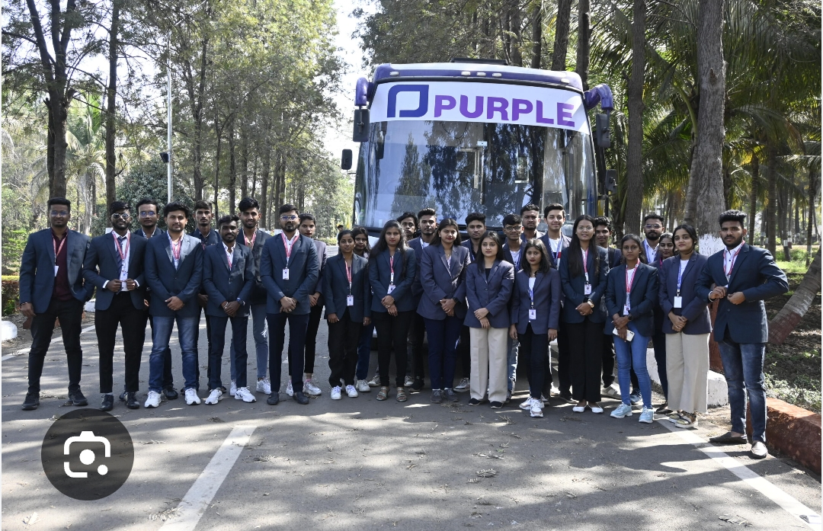
Group photograph of the AIML students and faculty coordinators during the industrial visit to Aivanta Technologies, Pune.

