Department of Artificial Intelligence & Machine Learning
Workshop Report on Generative AI & Prompt Engineering

Event Details :
Title of the Event: Generative AI & Prompt Engineering: From Fundamentals to Real-World Applications
Organized By: Department of Artificial Intelligence & Machine Learning
Resource Person: Mr. Arvind Menon, AI Solutions Architect, NextGen Technologies Pvt. Ltd.
Head of Department: Information was not available in the provided WhatsApp conversation or uploaded documents.
Venue: AI Innovation Lab, [Institute Name]
Date: 4th August 2026
Time: 10:00 AM – 4:00 PM
Participants: 72 students

Introduction
The Department of Artificial Intelligence & Machine Learning (AIML) organized a hands-on workshop to bridge the gap between theoretical AI concepts and industry-standard practices.
The workshop focused on Generative AI and Prompt Engineering, aiming to prepare students for the current demands of the AI-driven job market.
Objectives
The objectives of the workshop were:
1. Understand the fundamentals of Generative AI and LLMs.
2. Master prompt engineering techniques for better model output.
3. Learn to implement Retrieval-Augmented Generation (RAG).
4. Discuss ethical AI usage.
Workshop Proceedings
The workshop commenced with an introduction to the current state of Generative AI. Mr. Arvind Menon led the session, providing a detailed overview of LLMs. The flow was highly interactive, with the speaker demonstrating various prompt engineering strategies. Students were encouraged to experiment with these techniques in real-time, leading to a highly engaging learning environment.
Mr. Arvind Menon, an AI Solutions Architect at NextGen Technologies Pvt. Ltd., provided expert insights. His background in industry-level AI solutions allowed him to provide practical examples and professional advice to the students.
A total of 72 students from the second and third years of the AIML department participated. The engagement level was high, with students actively participating in the hands-on activities and discussions.
Topics Covered
1. Generative AI and Large Language Models (LLMs)
2. Prompt engineering techniques
3. AI-powered productivity tools
4. Retrieval-Augmented Generation (RAG)
5. Responsible and ethical use of AI
Schedule Summary
1. Information was not available in the provided WhatsApp conversation or uploaded documents.
Learning Outcomes
After attending the workshop, students were able to:
1. Proficiency in prompt engineering.
2. Understanding of RAG architecture.
3. Knowledge of ethical AI practices.
Key Highlights
1. Expert-led training by an industry professional.
2. Hands-on learning environment.
3. Comprehensive coverage of modern AI topics.
Benefits
1. Enhanced technical skills for students.
2. Exposure to industry-standard AI tools.
3. Better understanding of real-world AI applications.
Conclusion
The workshop successfully achieved its goals of providing students with practical AI skills.
The department looks forward to organizing more such industry-oriented sessions in the future.
AI Executive Summary
The Department of AIML conducted a one-day workshop on Generative AI and Prompt Engineering on August 4th, 2026. Led by Mr. Arvind Menon, the event provided 72 students with hands-on experience in LLMs, prompt engineering, and RAG. The workshop successfully bridged academic learning with industry requirements, emphasizing ethical AI usage.
Acknowledgement
We thank Mr. Arvind Menon for his valuable time and expertise. We also extend our gratitude to the faculty coordinators, student volunteers, and all participants for making this event a success.
Workshop Photographs
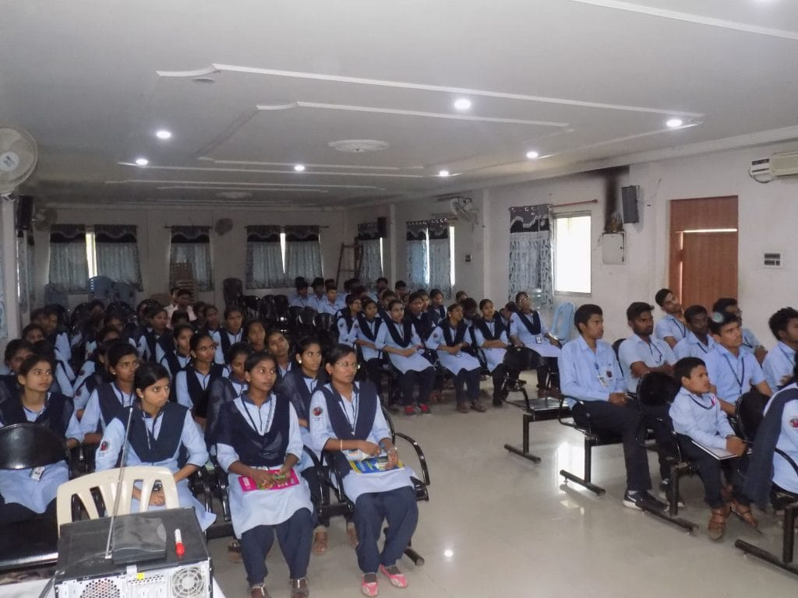
Students attending the hands-on workshop on Generative AI & Prompt Engineering in the AI Innovation Lab.

