Department of Artificial Intelligence & Machine Learning (AIML)
Workshop Report on Generative AI & Prompt Engineering

Event Details :
Title of the Event: Generative AI & Prompt Engineering: From Fundamentals to Real-World Applications
Organized By: Department of AIML
Resource Person: Mr. Arvind Menon, AI Solutions Architect, NextGen Technologies Pvt. Ltd.
Head of Department: Information was not available in the provided WhatsApp conversation or uploaded documents.
Venue: AI Innovation Lab, [Institute Name]
Date: 4th August 2026
Time: 10:00 AM – 4:00 PM
Participants: 72 students

Introduction
The Department of Artificial Intelligence & Machine Learning (AIML) organized a hands-on workshop to address the growing demand for expertise in Generative AI. This initiative aimed to provide students with a deep dive into the mechanisms of Large Language Models and the art of prompt engineering.
By inviting an industry expert, the department sought to provide students with exposure to real-world applications, ensuring they are well-equipped to handle the challenges of the modern AI-driven industry.
Objectives
The objectives of the workshop were:
1. To provide students with a comprehensive understanding of Generative AI and Large Language Models (LLMs).
2. To teach advanced prompt engineering techniques for effective AI interaction.
3. To explore the practical applications of AI-powered productivity tools.
4. To introduce the concept of Retrieval-Augmented Generation (RAG) in real-world scenarios.
5. To emphasize the responsible and ethical use of AI technologies.
Workshop Proceedings
The workshop began with a formal welcome address, setting the stage for a day of intensive learning. Mr. Arvind Menon initiated the session by outlining the current landscape of Generative AI, followed by a detailed walkthrough of LLM architectures.
The proceedings were highly interactive, with the speaker encouraging students to participate in live demonstrations. The flow of the session transitioned from foundational concepts to complex practical applications, ensuring that students could follow the progression of the technology effectively.
Mr. Arvind Menon, an AI Solutions Architect at NextGen Technologies Pvt. Ltd., served as the resource person. With his extensive background in AI architecture, he provided students with unique insights into how AI is being deployed in enterprise environments. His ability to simplify complex technical concepts made the session highly effective for the student audience.
The workshop saw active participation from 72 students across the second and third years of the AIML department. The students demonstrated high levels of engagement, particularly during the hands-on segments, where they actively applied the techniques discussed by the resource person.
Topics Covered
1. Generative AI and Large Language Models (LLMs)
2. Prompt engineering techniques
3. AI-powered productivity tools
4. Retrieval-Augmented Generation (RAG)
5. Responsible and ethical use of AI
6. Building practical AI solutions
Schedule Summary
1. 10:00 AM - 11:30 AM: Fundamentals of Generative AI and LLMs
2. 11:30 AM - 01:00 PM: Advanced Prompt Engineering Techniques
3. 01:00 PM - 02:00 PM: Lunch Break
4. 02:00 PM - 03:30 PM: RAG and Practical AI Solutions
5. 03:30 PM - 04:00 PM: Ethical AI and Q&A
Learning Outcomes
After attending the workshop, students were able to:
1. Students gained practical knowledge of Generative AI architectures.
2. Enhanced technical skills in crafting effective prompts for LLMs.
3. Understanding of how to integrate RAG into AI applications.
4. Increased awareness of ethical considerations in AI development.
Key Highlights
1. Expert-led session by an industry professional from NextGen Technologies.
2. Hands-on approach focusing on real-world application building.
3. Comprehensive coverage from fundamentals to advanced RAG concepts.
4. Active participation of 72 students from second and third years.
Benefits
1. Bridge the gap between academic theory and industry-standard AI practices.
2. Enhanced student employability through exposure to cutting-edge AI tools.
3. Development of critical thinking skills regarding AI ethics and implementation.
Conclusion
The workshop successfully achieved its goal of empowering students with the skills necessary to excel in the field of Generative AI. The blend of expert knowledge and hands-on practice provided a holistic learning experience.
The department remains committed to organizing such industry-aligned events to ensure that students remain competitive in the global AI landscape.
AI Executive Summary
The Department of AIML conducted a one-day workshop on Generative AI and Prompt Engineering, led by Mr. Arvind Menon of NextGen Technologies. The event, attended by 72 students, focused on bridging the gap between academic theory and industry practice. Key topics included LLMs, prompt engineering, RAG, and ethical AI. The workshop provided students with hands-on experience and practical insights, significantly enhancing their technical capabilities in the rapidly evolving AI sector.
Acknowledgement
The department extends its sincere gratitude to Mr. Arvind Menon for his valuable time and expertise. We also thank the faculty coordinators, student volunteers, and all participants for their dedication and contribution to the success of this workshop.
Workshop Photographs
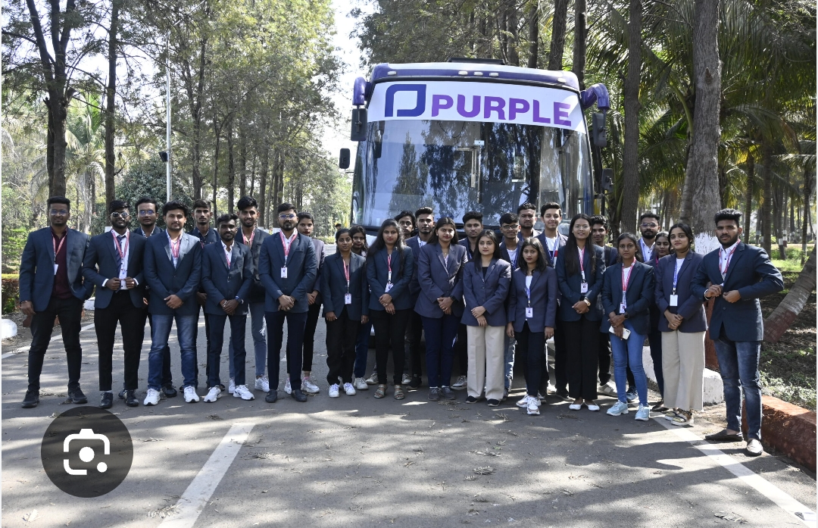
Participants of the Generative AI workshop gathered for a group photograph.

