Department of Computer Science & Engineering
Placement Achievement Report

Event Details :
Title of the Event: Placement Achievement: Prathamesh Pawar
Organized By: D Y Patil College of Engineering & Technology, Kolhapur
Resource Person: Not Applicable
Head of Department: Information was not available in the provided WhatsApp conversation or uploaded documents.
Venue: D Y Patil College of Engineering & Technology, Kolhapur
Date: 2026-08-08
Time: Information was not available in the provided WhatsApp conversation or uploaded documents.
Participants: Information was not available in the provided WhatsApp conversation or uploaded documents.

Introduction
The Department of Computer Science & Engineering at D Y Patil College of Engineering & Technology, Kolhapur, maintains a strong focus on student career development and industry integration. The department consistently strives to equip students with the technical skills and professional acumen required to succeed in the corporate world.
This report documents the recent placement of student Prathamesh Pawar at Tata Consultancy Services (TCS), highlighting the institution's commitment to facilitating successful career transitions for its graduates.
Objectives
The objectives of the workshop were:
1. To recognize and celebrate the professional success of students.
2. To document placement statistics for departmental records.
3. To motivate students by showcasing successful placement outcomes.
Workshop Proceedings
The announcement was made via the official department communication channel. The event involved the formal recognition of the student's achievement through a digital congratulatory poster, which was shared with the department faculty and student body to acknowledge the hard work and dedication of the student.
Not applicable as this was a placement announcement rather than a workshop or guest lecture.
The announcement was shared with the student community, serving as a source of motivation and encouragement for peers to pursue similar career goals.
Topics Covered
1. Not applicable.
Schedule Summary
1. Information was not available in the provided WhatsApp conversation or uploaded documents.
Learning Outcomes
After attending the workshop, students were able to:
1. Validation of the department's placement training effectiveness.
2. Increased awareness of industry salary benchmarks.
3. Boost in student morale.
Key Highlights
1. Student: Prathamesh Pawar
2. Company: TCS
3. Package: 3.5 LPA
Benefits
1. Enhanced institutional reputation.
2. Motivation for junior students.
3. Strengthening of industry-academia relations.
Conclusion
The placement of Prathamesh Pawar at TCS is a commendable achievement that reflects the quality of education at D Y Patil College of Engineering & Technology.
The department remains dedicated to fostering an environment that supports student growth and professional excellence.
AI Executive Summary
This report details the successful placement of Prathamesh Pawar, a student from the Department of Computer Science & Engineering at D Y Patil College of Engineering & Technology, Kolhapur, at Tata Consultancy Services (TCS) with a package of 3.5 LPA. The achievement highlights the institution's commitment to student career development and serves as a significant milestone for the department.
Acknowledgement
The department acknowledges the efforts of the placement cell and the faculty members who have supported the students in their professional journey. We congratulate Prathamesh Pawar on his success.
Workshop Photographs
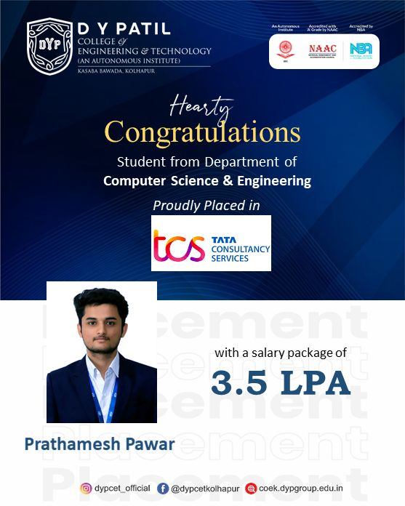
Congratulatory poster for Prathamesh Pawar's placement at TCS.

