Department of Artificial Engineering & Machine Learning
Placement Achievement Report

Event Details :
Title of the Event: Placement Achievement of Sana Mujawar
Organized By: D Y Patil College of Engineering & Technology, Kolhapur
Resource Person: N/A
Head of Department: Information was not available in the provided WhatsApp conversation or uploaded documents.
Venue: D Y Patil College of Engineering & Technology, Kolhapur
Date: 2026-08-04
Time: Information was not available in the provided WhatsApp conversation or uploaded documents.
Participants: Information was not available in the provided WhatsApp conversation or uploaded documents.

Introduction
The Department of Artificial Engineering & Machine Learning at D Y Patil College of Engineering & Technology, Kolhapur, is committed to achieving excellence in technical education and professional development.
This report highlights the recent success of a student in securing a high-value placement, reflecting the department's success in preparing students for the modern workforce.
Objectives
The objectives of the workshop were:
1. To recognize and celebrate student success in campus placements.
2. To document placement statistics for departmental records.
Workshop Proceedings
The announcement was shared via the official departmental communication channel. The event serves as a formal recognition of the student's hard work and the department's successful placement initiatives.
N/A
The announcement reached the student body, serving as a motivational factor for all students currently pursuing their degrees.
Topics Covered
1. N/A
Schedule Summary
1. Information was not available in the provided WhatsApp conversation or uploaded documents.
Learning Outcomes
After attending the workshop, students were able to:
1. Validation of the department's academic and training strategies.
2. Increased motivation among students to pursue high-package opportunities.
Key Highlights
1. Placement at Movate.
2. Salary package of 9 LPA.
Benefits
1. Boosts institutional branding.
2. Encourages peer-to-peer learning and motivation.
Conclusion
The placement of Sana Mujawar is a proud moment for the department.
The department continues to focus on excellence in AI and ML education to ensure future successes.
AI Executive Summary
This report documents the successful placement of Sana Mujawar from the Department of Artificial Engineering & Machine Learning at D Y Patil College of Engineering & Technology, Kolhapur. Sana has been placed at Movate with a salary package of 9 LPA. This achievement highlights the department's commitment to academic excellence and industry-aligned training, serving as a significant motivator for the student community.
Acknowledgement
The department acknowledges the efforts of the placement cell and the faculty members who have guided the students throughout their academic journey.
Workshop Photographs
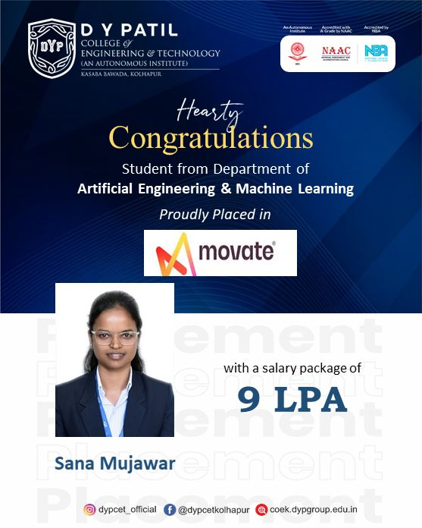
Official congratulatory poster for Sana Mujawar's placement at Movate.

