Department of Computer Science & Engineering (AIML)
Achievement Report on NPTEL Pre-Doctoral Research Fellowship Selection

Event Details :
Title of the Event: Recognition of Alumni Achievement
Organized By: D Y Patil College of Engineering & Technology, Kolhapur
Resource Person: N/A
Head of Department: Information was not available in the provided WhatsApp conversation or uploaded documents.
Venue: D Y Patil College of Engineering & Technology, Kolhapur
Date: 2026-08-04
Time: Information was not available in the provided WhatsApp conversation or uploaded documents.
Participants: Information was not available in the provided WhatsApp conversation or uploaded documents.

Introduction
The Department of Computer Science & Engineering (AIML) takes immense pride in the academic success of its alumni. This report documents the recognition of Mr. Pratik Chougule, a 2025-26 batch alumnus, for his selection as an NPTEL Pre-Doctoral Research Fellow.
This achievement reflects the department's dedication to fostering research-oriented mindsets among students, particularly in the rapidly evolving field of Artificial Intelligence.
Objectives
The objectives of the workshop were:
1. To celebrate the academic success of department alumni.
2. To promote research culture within the department.
3. To highlight the importance of NPTEL and IIT-based research opportunities.
Workshop Proceedings
The announcement was made via official communication channels within the department group. The event serves as a formal recognition of the student's hard work and the department's role in his academic journey.
Not applicable as this is an achievement recognition event.
The announcement reached the entire department group, serving as a motivational highlight for all current students.
Topics Covered
1. Artificial Intelligence for Healthcare
2. Machine Learning
3. Deep Learning
4. Medical AI
Schedule Summary
1. Information was not available in the provided WhatsApp conversation or uploaded documents.
Learning Outcomes
After attending the workshop, students were able to:
1. Students gained insight into the potential for research careers in AI.
2. Increased awareness of the NPTEL Pre-Doctoral fellowship program.
Key Highlights
1. Selection of Mr. Pratik Chougule at IIT Ropar.
2. Focus on high-impact research in Healthcare AI.
Benefits
1. Boosts department morale.
2. Encourages students to pursue research-based higher education.
Conclusion
The department congratulates Mr. Pratik Chougule on this prestigious selection.
We remain committed to nurturing talent that contributes to the advancement of technology at the national level.
AI Executive Summary
This report details the selection of Mr. Pratik Chougule, a CSE (AIML) alumnus, as an NPTEL Pre-Doctoral Research Fellow at IIT Ropar. His research focuses on AI for Healthcare. This achievement is a significant milestone for the department, reflecting its academic quality and commitment to research.
Acknowledgement
The department acknowledges the efforts of the faculty in guiding students and thanks the administration for providing an environment conducive to research and academic excellence.
Workshop Photographs
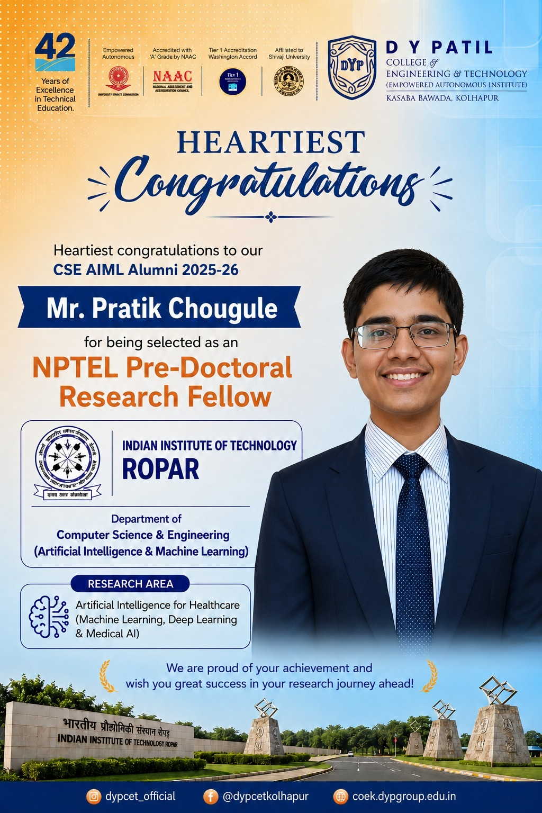
Congratulatory poster for Mr. Pratik Chougule's selection as an NPTEL Pre-Doctoral Research Fellow at IIT Ropar.

