Department of Artificial Intelligence and Machine Learning
Achievement Report on Student Professional Selection

Event Details :
Title of the Event: Selection of Student as Trainer at Fuel Organization
Organized By: D Y Patil College of Engineering & Technology, Kolhapur
Resource Person: Mr. Shubham Narute (Student Trainer)
Head of Department: Information was not available in the provided WhatsApp conversation or uploaded documents.
Venue: D Y Patil College of Engineering & Technology, Kolhapur
Date: 2026-08-08
Time: Information was not available in the provided WhatsApp conversation or uploaded documents.
Participants: Information was not available in the provided WhatsApp conversation or uploaded documents.

Introduction
The Department of Artificial Intelligence and Machine Learning at D Y Patil College of Engineering & Technology consistently strives to produce industry-ready graduates. This report documents the professional achievement of Mr. Shubham Narute, a final-year student who has been selected as a trainer.
The selection by Fuel Organization validates the department's focus on high-demand technical skills such as Python Full Stack development and Machine Learning.
Objectives
The objectives of the workshop were:
1. To acknowledge student excellence in technical domains.
2. To promote industry-academia collaboration.
3. To motivate students to pursue professional training roles.
Workshop Proceedings
The announcement was made via the official department communication channel. The proceedings involved the recognition of Mr. Shubham Narute's selection for a 15-day training assignment at the Fuel Organization, where he will serve as a subject matter expert in Python Full Stack and Machine Learning.
Mr. Shubham Narute is a final-year B.Tech AIML student at DYPCET, Kolhapur. His selection as a trainer at Fuel Organization demonstrates his advanced technical proficiency and communication skills in the field of software development and AI.
The achievement serves as a motivation for the entire student body, encouraging them to engage deeply with the curriculum and seek professional opportunities.
Topics Covered
1. Python Full Stack Development
2. Machine Learning
Schedule Summary
1. Training Duration: 15 Days (Training Assignment).
Learning Outcomes
After attending the workshop, students were able to:
1. Practical application of Python and ML concepts.
2. Professional experience in a corporate training environment.
3. Financial recognition through a stipend of ₹40,000.
Key Highlights
1. Selection as a Trainer at Fuel Organization.
2. Stipend of ₹40,000.
3. 15-day professional assignment.
Benefits
1. Enhanced professional network.
2. Real-world teaching experience.
3. Validation of technical skills.
Conclusion
The selection of Mr. Shubham Narute is a proud moment for the department. It highlights the success of our pedagogical approach in preparing students for competitive roles.
We anticipate that this success will inspire other students to excel in their respective technical domains.
AI Executive Summary
Final Year AIML student Mr. Shubham Narute has been selected as a Python Full Stack and Machine Learning Trainer at Fuel Organization. This 15-day assignment, which includes a stipend of ₹40,000, serves as a significant achievement for the student and the department, showcasing the effectiveness of the college's technical training programs.
Acknowledgement
The department acknowledges the efforts of the faculty in mentoring students and thanks the Fuel Organization for providing this opportunity to our student.
Workshop Photographs
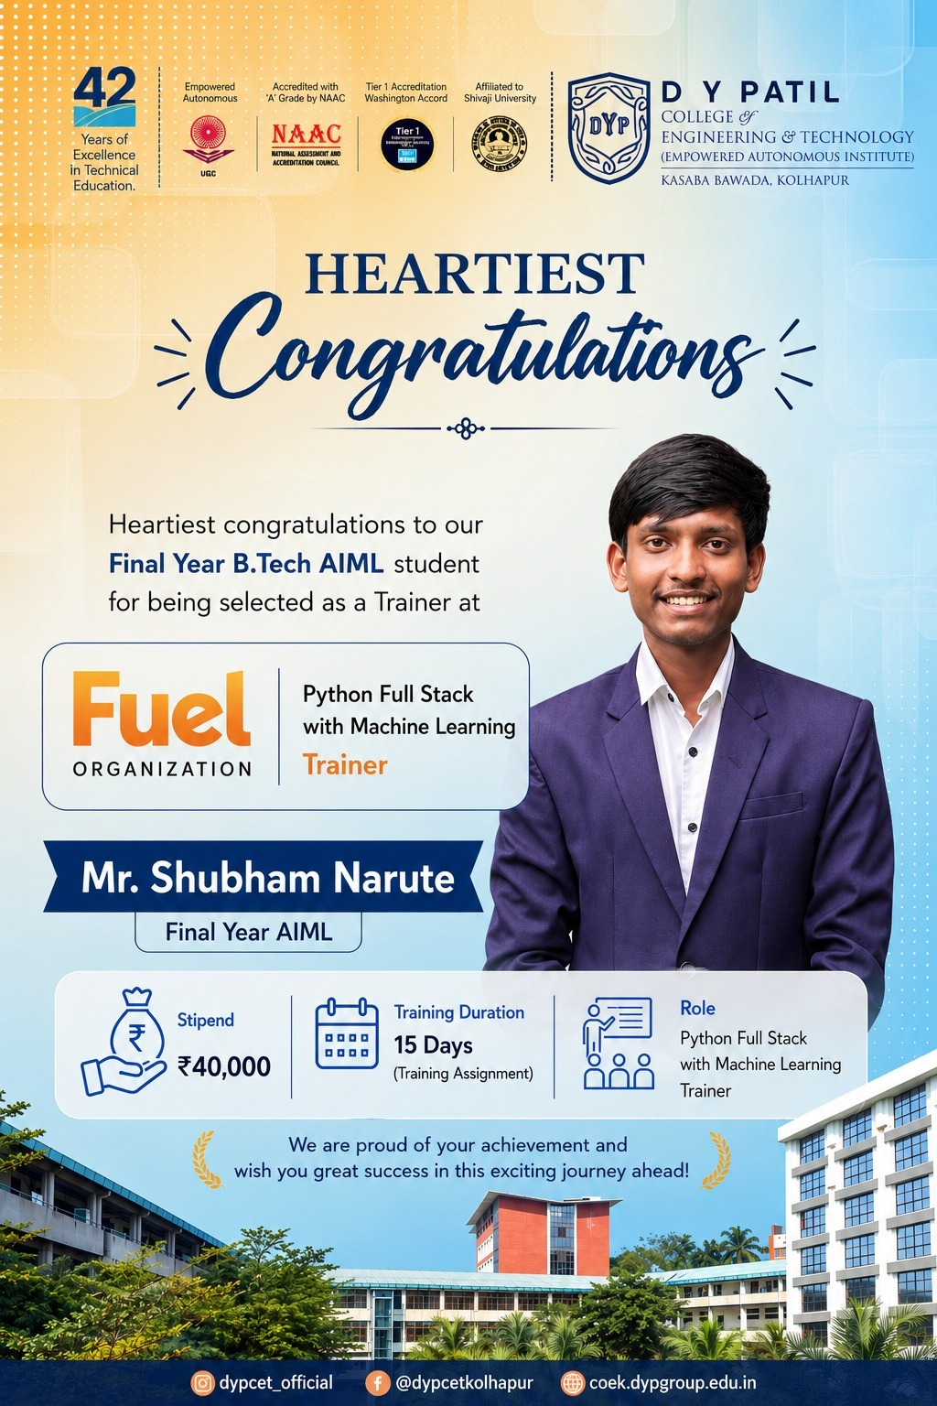
Official announcement poster for Mr. Shubham Narute's selection as a trainer at Fuel Organization.

