Department of Artificial Intelligence & Machine Learning (AIML)
Workshop Report on Microsoft Azure Cloud Infrastructure

Event Details :
Title of the Event: Microsoft Azure Cloud Infrastructure: The Future of Cloud Computing and Job Prospects
Organized By: Department of AIML, East West University
Resource Person: Dr. Mahesh Patil
Head of Department: Prof. Siddheshwar Patil
Venue: Information was not available in the provided WhatsApp conversation or uploaded documents.
Date: 2026-08-03
Time: Information was not available in the provided WhatsApp conversation or uploaded documents.
Participants: 50

Introduction
The Department of Artificial Intelligence & Machine Learning (AIML) at East West University organized a specialized workshop on Microsoft Azure Cloud Infrastructure. This event was aimed at providing students with a deep dive into the cloud ecosystem, which is currently a cornerstone of modern software development and enterprise infrastructure.
The workshop served as a bridge between academic curriculum and industrial expectations, focusing on the practical deployment of cloud services and the strategic importance of cloud certifications in the current job market.
Objectives
The objectives of the workshop were:
1. To introduce students to the core components of Microsoft Azure.
2. To explain the lifecycle of cloud infrastructure deployment.
3. To provide insights into industry-standard best practices.
4. To outline career paths and certification requirements for cloud professionals.
Workshop Proceedings
The workshop commenced with an introduction to the significance of cloud computing in the current technological landscape. Dr. Mahesh Patil led the session, providing a detailed overview of Azure services and their real-world applications. The proceedings were highly interactive, with the speaker encouraging students to ask questions regarding infrastructure scalability and security. The session flow was structured to move from foundational concepts to advanced deployment techniques, ensuring that all participants could follow the technical progression.
Dr. Mahesh Patil served as the resource person for the workshop. He possesses extensive knowledge in cloud infrastructure and industry practices. His delivery was tailored to provide students with actionable insights, focusing on both the technical 'how-to' of Azure and the strategic 'why' behind cloud adoption in modern enterprises.
The workshop saw active participation from approximately 50 students. The engagement was evident through the interactive nature of the session, where students participated in discussions regarding cloud technologies and their future applications. The presence of faculty members further encouraged a professional and academic atmosphere.
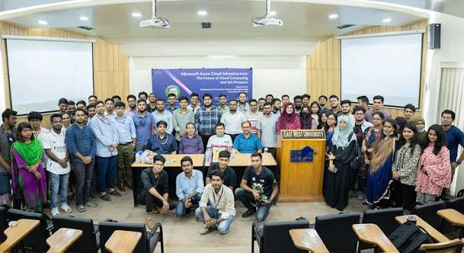
Group photograph of the participants, faculty, and the speaker during the Microsoft Azure Cloud workshop.
Topics Covered
1. Microsoft Azure Cloud Services
2. Cloud Infrastructure Management
3. Deployment Techniques
4. Industry Best Practices
5. Cloud Certifications
6. Career Opportunities in Cloud Computing
Schedule Summary
1. Information was not available in the provided WhatsApp conversation or uploaded documents.
Learning Outcomes
After attending the workshop, students were able to:
1. Students gained a clear understanding of Microsoft Azure infrastructure.
2. Participants learned about the practical deployment of cloud services.
3. Students became aware of the necessary certifications to boost their employability in the cloud sector.
Key Highlights
1. Expert session by Dr. Mahesh Patil.
2. Strong support from the HOD and faculty members.
3. High level of student engagement and interaction.
4. Comprehensive coverage of both technical and career-oriented topics.
Benefits
1. Exposure to industry-relevant cloud technologies.
2. Guidance on professional certification paths.
3. Enhanced understanding of the current job market in the cloud domain.
Conclusion
The workshop was a successful endeavor that provided students with valuable insights into the world of Microsoft Azure. By combining technical knowledge with career guidance, the event effectively prepared students for the challenges of the IT industry.
The department looks forward to conducting more such sessions to ensure continuous learning and professional development for its students.
AI Executive Summary
This workshop, organized by the AIML department at East West University, focused on Microsoft Azure Cloud Infrastructure. Led by Dr. Mahesh Patil, the event provided 50 students with a comprehensive overview of cloud services, deployment, and career prospects. The session was highly interactive, emphasizing the importance of industry certifications and practical cloud skills. The event was supported by the HOD and faculty, marking a successful collaboration between academia and industry expertise.
Acknowledgement
We extend our sincere gratitude to Dr. Mahesh Patil for his insightful session. We also thank our HOD, Prof. Siddheshwar Patil, for his constant support and guidance. Finally, we appreciate the faculty members and the 50 students whose enthusiastic participation made this workshop a success.
Workshop Photographs

Group photograph of the participants, faculty, and the speaker during the Microsoft Azure Cloud workshop.

