Department of Artificial Intelligence & Machine Learning (AIML)
Workshop Report on Microsoft Azure Cloud Infrastructure

Event Details :
Title of the Event: Microsoft Azure Cloud Infrastructure: The Future of Cloud Computing and Job Prospects
Organized By: Department of Artificial Intelligence & Machine Learning (AIML)
Resource Person: Dr. Mahesh Patil
Head of Department: Prof. Siddheshwar Patil
Venue: Information was not available in the provided WhatsApp conversation or uploaded documents.
Date: 2026-08-03
Time: Information was not available in the provided WhatsApp conversation or uploaded documents.
Participants: 50 students

Introduction
The Department of Artificial Intelligence & Machine Learning (AIML) organized a specialized workshop focused on Microsoft Azure Cloud to enhance the technical proficiency of its students.
The event aimed to provide a comprehensive understanding of cloud infrastructure and its critical role in modern computing, aligning with the department's goal of industry-ready education.
Objectives
The objectives of the workshop were:
1. To impart knowledge on Microsoft Azure Cloud services.
2. To explain cloud infrastructure and deployment techniques.
3. To discuss industry best practices and professional certifications.
4. To provide insights into career opportunities in cloud computing.
Workshop Proceedings
The workshop commenced with a formal welcome, followed by an in-depth technical session led by Dr. Mahesh Patil. The session was highly interactive, with the speaker effectively balancing theoretical concepts with practical industry applications. Students engaged in active discussions, making the learning process dynamic and collaborative.
Dr. Mahesh Patil served as the resource person for the workshop. He brought extensive expertise in Microsoft Azure Cloud services, providing students with valuable insights into cloud infrastructure, deployment techniques, and the evolving landscape of the cloud computing industry.
Approximately 50 students from the AIML department participated in the workshop. The students showed great enthusiasm and actively engaged with the speaker, contributing to a highly productive and successful event.
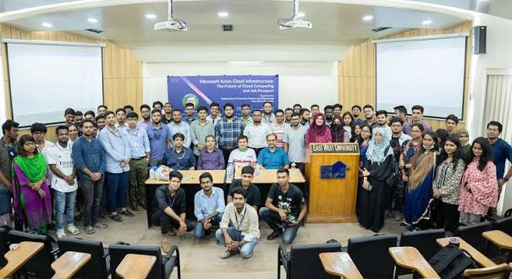
Group photograph of the participants, faculty, and speaker during the Microsoft Azure Cloud workshop.
Topics Covered
1. Microsoft Azure Cloud services
2. Cloud infrastructure design
3. Deployment techniques
4. Industry best practices
5. Professional certification pathways
6. Career opportunities in cloud computing
Schedule Summary
1. Information was not available in the provided WhatsApp conversation or uploaded documents.
Learning Outcomes
After attending the workshop, students were able to:
1. Students gained a clear understanding of Azure Cloud infrastructure.
2. Participants learned about industry-standard deployment techniques.
3. Students became aware of the importance of cloud certifications for career advancement.
Key Highlights
1. Expert session by Dr. Mahesh Patil.
2. Presence of HOD Prof. Siddheshwar Patil.
3. High student engagement and interactive session format.
Benefits
1. Bridging the gap between academic curriculum and industry requirements.
2. Enhanced awareness of professional growth opportunities in cloud computing.
Conclusion
The workshop successfully achieved its objectives, providing students with a solid foundation in Microsoft Azure Cloud.
The department remains committed to organizing such events to ensure students are well-prepared for the professional world.
AI Executive Summary
This workshop on Microsoft Azure Cloud, organized by the AIML Department, provided 50 students with essential knowledge on cloud infrastructure and career prospects. Led by Dr. Mahesh Patil, the session covered technical deployment, industry best practices, and certification pathways, fostering a deeper understanding of cloud computing in a real-world context.
Acknowledgement
We sincerely thank Dr. Mahesh Patil for his valuable time and expertise. We also extend our gratitude to our HOD, Prof. Siddheshwar Patil, for his constant support, and to all faculty members and students for their active participation.
Workshop Photographs

Group photograph of the participants, faculty, and speaker during the Microsoft Azure Cloud workshop.

