Department of Artificial Intelligence & Machine Learning (AIML)
Workshop Report on Microsoft Azure Cloud Infrastructure

Event Details :
Title of the Event: Microsoft Azure Cloud Infrastructure: The Future of Cloud Computing and Job Prospects
Organized By: Department of Artificial Intelligence & Machine Learning (AIML)
Resource Person: Dr. Mahesh Patil
Head of Department: Prof. Siddheshwar Patil
Venue: East West University
Date: 2026-08-03
Time: Information was not available in the provided WhatsApp conversation or uploaded documents.
Participants: 50

Introduction
The Department of Artificial Intelligence & Machine Learning (AIML) at East West University organized a specialized workshop on Microsoft Azure Cloud Infrastructure to address the growing demand for cloud computing skills in the industry.
The workshop aimed to provide students with a comprehensive overview of cloud services, infrastructure management, and the strategic importance of cloud adoption in modern enterprise environments.
Objectives
The objectives of the workshop were:
1. To impart technical knowledge on Microsoft Azure Cloud services.
2. To explain cloud infrastructure and deployment methodologies.
3. To provide insights into industry best practices.
4. To guide students on certification paths and career opportunities in the cloud domain.
Workshop Proceedings
The workshop commenced with an introduction to the significance of cloud computing in the current technological era. Dr. Mahesh Patil delivered a structured session covering the core components of Azure Cloud. The proceedings were highly interactive, with the speaker encouraging students to participate in discussions regarding real-world cloud applications. The session flow transitioned from fundamental cloud concepts to advanced deployment techniques, ensuring a holistic learning experience for all attendees.
Dr. Mahesh Patil served as the resource person for the workshop. He brought extensive knowledge of Microsoft Azure services and industry-standard practices to the session. His delivery was focused on practical application, ensuring that students understood not just the 'how' but also the 'why' behind cloud infrastructure decisions.
The workshop saw active participation from 50 students. The engagement level was high, with students demonstrating keen interest in the technical aspects of cloud computing and its future prospects. The presence of faculty members further encouraged a professional and academic atmosphere.
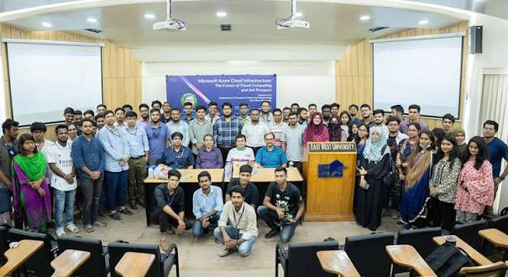
We are delighted to share that the Department of Artificial Intelligence & Machine Learning (AIML) successfully organized an insightful workshop on Microsoft Azure Cloud.
The workshop was conducted by Dr. Mahesh Patil Sir, who shared valuable knowledge on Microsoft Azure Cloud services, cloud infrastructure, deployment techniques, industry best practices, certifications, and career opportunities in cloud computing. The session was highly interactive and provided participants with practical insights into cloud technologies and their real-world applications.
The workshop was graced by the presence of our respected Head of Department, Prof. Siddheshwar Patil Sir, along with all the faculty members of the AIML Department. Around 50 students actively participated in the workshop, making it an engaging and successful learning experience.
We sincerely thank Dr. Mahesh Patil Sir, our respected HOD Prof. Siddheshwar Patil Sir, all the faculty members, and every student for their enthusiastic participation and suppo

Group photograph of the participants and faculty members during the Microsoft Azure Cloud workshop.
Topics Covered
1. Microsoft Azure Cloud services overview
2. Cloud infrastructure architecture
3. Deployment techniques
4. Industry best practices
5. Professional certification pathways
6. Career opportunities in cloud computing
Schedule Summary
1. Information was not available in the provided WhatsApp conversation or uploaded documents.
Learning Outcomes
After attending the workshop, students were able to:
1. Proficiency in understanding Azure cloud infrastructure.
2. Knowledge of deployment techniques.
3. Clarity on career paths and industry requirements.
4. Enhanced awareness of cloud certification benefits.
Key Highlights
1. Expert guidance from Dr. Mahesh Patil.
2. Strong support from the HOD and AIML faculty.
3. High student attendance and engagement.
4. Comprehensive coverage of both technical and career-oriented topics.
Benefits
1. Students gained practical insights into cloud technologies.
2. Improved understanding of industry-standard deployment practices.
3. Increased awareness of professional certification importance.
Conclusion
The workshop successfully achieved its goal of educating students on the critical aspects of Microsoft Azure Cloud.
The event served as a valuable bridge between academic curriculum and industry expectations, leaving students better prepared for their professional careers.
AI Executive Summary
The AIML department at East West University conducted a successful workshop on Microsoft Azure Cloud Infrastructure. Led by Dr. Mahesh Patil, the session provided 50 students with essential insights into cloud services, deployment, and career prospects. The event was highly interactive, fostering a strong learning environment supported by the department's faculty.
Acknowledgement
We extend our sincere gratitude to Dr. Mahesh Patil for his valuable time and expertise. We also thank our HOD, Prof. Siddheshwar Patil, for his constant support, and all the faculty members and students who contributed to the success of this event.
Workshop Photographs

Group photograph of the participants and faculty members during the Microsoft Azure Cloud workshop.

We are delighted to share that the Department of Artificial Intelligence & Machine Learning (AIML) successfully organized an insightful workshop on Microsoft Azure Cloud.
The workshop was conducted by Dr. Mahesh Patil Sir, who shared valuable knowledge on Microsoft Azure Cloud services, cloud infrastructure, deployment techniques, industry best practices, certifications, and career opportunities in cloud computing. The session was highly interactive and provided participants with practical insights into cloud technologies and their real-world applications.
The workshop was graced by the presence of our respected Head of Department, Prof. Siddheshwar Patil Sir, along with all the faculty members of the AIML Department. Around 50 students actively participated in the workshop, making it an engaging and successful learning experience.
We sincerely thank Dr. Mahesh Patil Sir, our respected HOD Prof. Siddheshwar Patil Sir, all the faculty members, and every student for their enthusiastic participation and suppo

