ACCURE CODE
Complete Deployment, Model Configuration & CLI Guide
Document Version | Product Release | Publisher / Scope | Target Environments
2.0.0 (Production) | v1.1.2 | Accure Inc. / Accure Code Team | AccureIQx, VS Code, Cursor, Terminal (CLI)

Executive Summary
Accure Code is an enterprise-grade autonomous AI coding agent designed to operate both as an interactive extension inside Visual Studio Code (and compatible IDEs such as Cursor and VSCodium) and as a high-performance standalone Command Line Interface (CLI). The distributed VSIX package (version 1.1.2) is a self-contained bundle that delivers both the VS Code Webview client and the precompiled, multiplatform native Accure CLI engine.
ℹ️ NOTE: Package Architecture Notice
The VSIX archive is a standard zip package containing the full compiled CLI binary (`accure` on macOS/Linux, `accure.exe` on Windows) alongside tree-sitter AST syntax parsers. Users can run Accure Code entirely inside VS Code, or invoke the bundled binary directly from any terminal.

1. Downloading the VSIX Package from GitHub
―――――――――――――――――――――――――――――――――――――――――――――
Accure Code releases are published directly to the official GitHub repository under the Releases section. Each release includes the pre-packaged `.vsix` distribution asset.
1.1 Official Repository & Release Links
- Repository URL: https://github.com/Accure-Inc/accure-code
- Releases Page: https://github.com/Accure-Inc/accure-code/releases
- Target Release Assets: accure-code-1.1.2.vsix (Latest Stable) or accure-code-1.1.1.vsix
1.2 Method A: Downloading via Web Browser (GUI)
Step 1: Navigate to the Releases page Open your web browser and navigate to https://github.com/Accure-Inc/accure-code/releases.
Step 2: Select the Target Release Locate the latest release card (e.g., Release 1.1.2 or 1.1.1).
Step 3: Expand the Assets Accordion At the bottom of the release notes, click on the 'Assets' dropdown if it is not already expanded.
Step 4: Download the VSIX file Click on accure-code-1.1.2.vsix (or the specific version desired). Save the file to a known folder (such as your ~/Downloads directory).
1.3 Method B: Downloading via GitHub CLI (gh)
If you have the GitHub CLI installed and authenticated, you can download the release asset directly with a single command:
# Terminal / Bash
# Download the 1.1.2 release VSIX asset into your current working directory
gh release download v1.1.2 --repo Accure-Inc/accure-code --pattern '*.vsix'
# Or download the previous 1.1.1 release:
gh release download v1.1.1 --repo Accure-Inc/accure-code --pattern '*.vsix'

1.4 Method C: Downloading via curl or wget
For headless Linux servers or automated provisioning scripts, use curl or wget to fetch the asset:
# Terminal / Bash
# Download via curl (following redirects with -L):
curl -L -O https://github.com/Accure-Inc/accure-code/releases/download/v1.1.2/accure-code-1.1.2.vsix
# Verify download file size:
ls -lh accure-code-1.1.2.vsix

💡 TIP: Asset Size Note
The VSIX file size is approximately 100MB – 180MB because it bundles standalone native binary executables and Tree-Sitter WebAssembly grammars for 40+ programming languages.

2. Installing the VSIX in Visual Studio Code
―――――――――――――――――――――――――――――――――――――――――――――
Visual Studio Code supports installing extensions from local `.vsix` packages through either its graphical interface or the command line.
2.1 Graphical Interface Installation (VS Code UI)
Step 1: Launch VS Code Open Visual Studio Code on your system.
Step 2: Open the Extensions View Click the Extensions icon in the left-hand Activity Bar, or press Ctrl+Shift+X (Windows/Linux) or Cmd+Shift+X (macOS).
Step 3: Open More Actions Menu In the top-right corner of the Extensions sidebar, click the 'Views and More Actions' button (represented by three horizontal dots '...').
Step 4: Select 'Install from VSIX...' From the context menu, choose the 'Install from VSIX...' option.
Step 5: Choose the File In the system file dialog, navigate to your downloaded accure-code-1.1.2.vsix file and click 'Install'.
Step 6: Reload / Restart Window Once the installation finishes, a notification will appear stating 'Completed installing extension Accure Code from VSIX'. If prompted, click 'Reload Window' (or press Cmd/Ctrl+Shift+P and type 'Developer: Reload Window').
2.3 Verifying the Installation
- Activity Bar Icon: A new Accure Code icon will appear on your primary Activity Bar (left sidebar).
- Chat Sidebar: Clicking the Accure Code icon reveals the autonomous agent sidebar with session history, terminal execution badges, and the model selector.
- Command Palette: Press Cmd/Ctrl+Shift+P and type 'Accure Code' to see all available commands, such as 'Accure Code: Focus on Chat View' and 'Accure Code: Open Settings'.
3. Configuring the Accure Model in VS Code
―――――――――――――――――――――――――――――――――――――――――――――
Accure Code features native integration with the Accure platform (AccureIQx), allowing you to route tasks through your enterprise Accure Models, Accure Gateway, or direct private LLM instances. The model and agent persona can be configured via the chat UI or through global VS Code configuration.
3.1 Accure Model Architecture & Defaults
Click Accure Code icon > Click the model arrow (as shown in the figure below) > Search for Accure > Click on the gear icon next to the model’s name > provide the model Id, URL and API Key. You can configure any vLLM or OpenAI compatible models.
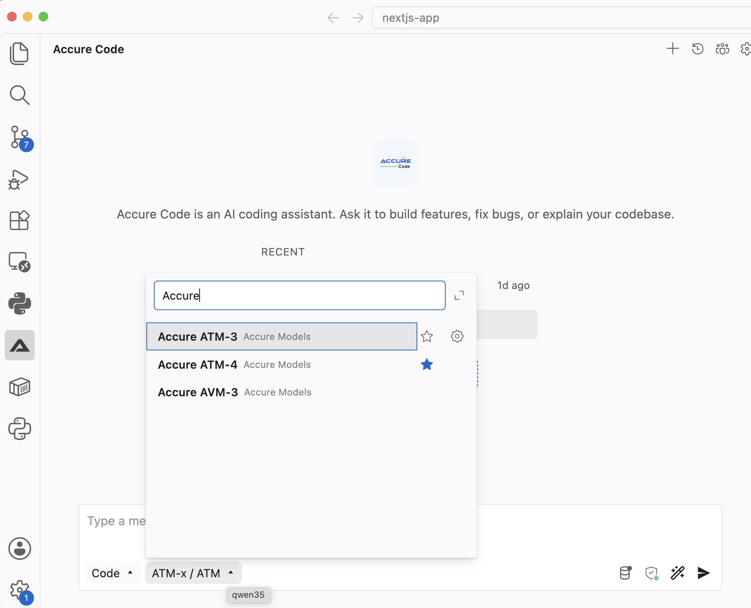
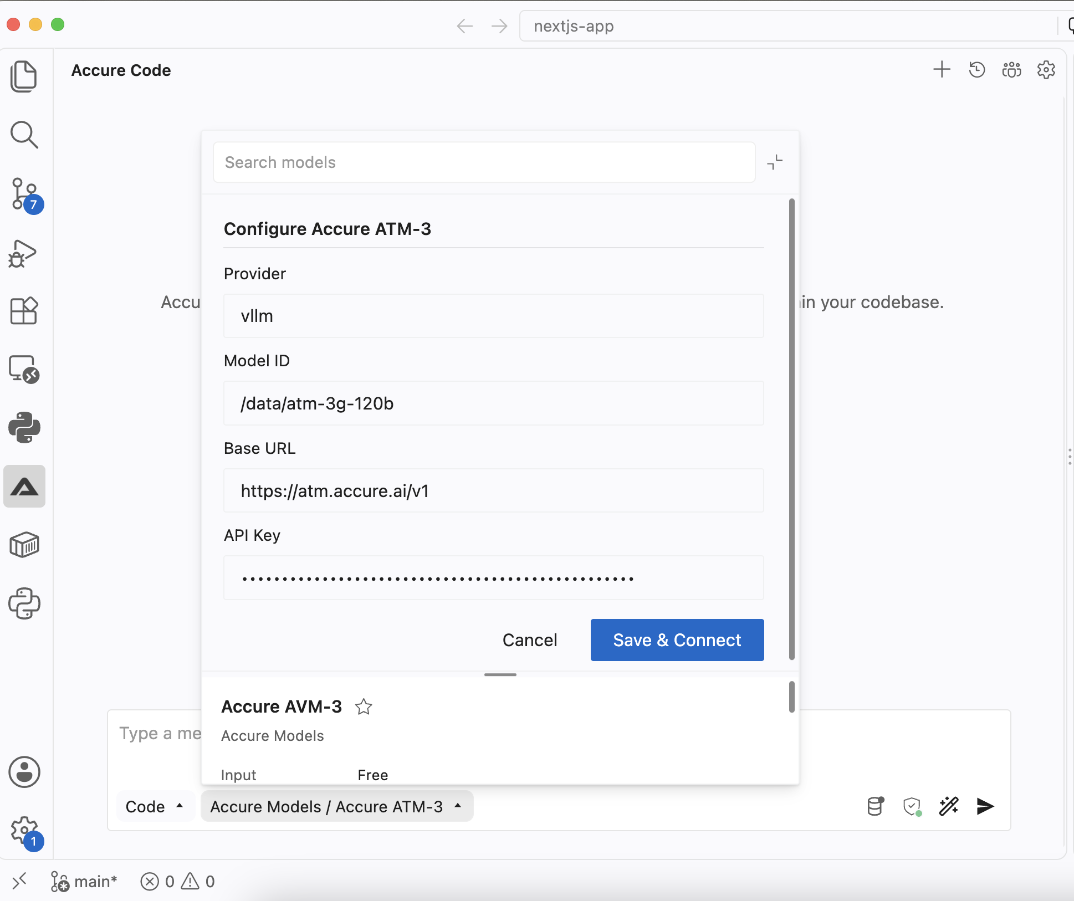
4. Running Accure Code as a CLI
―――――――――――――――――――――――――――――――――――――――――――――
The Accure Code VSIX package bundles the full, standalone native CLI binary (`accure`). The CLI contains the entire agent runtime, session manager, TUI interface, and headless HTTP/SSE server. You can run this CLI directly from your terminal using either of the two methods detailed below.
4.1 Option 1: Running the CLI from the Installed VS Code Extension
If you have already installed the VSIX within VS Code (Section 2), VS Code has already unpacked the binary into your extensions folder. You do not need to download or compile anything else.
Binary Location by Operating System:
- macOS / Linux: ~/.vscode/extensions/accure.accure-code-1.1.2/bin/accure
- Windows: %USERPROFILE%\.vscode\extensions\accure.accure-code-1.1.2\bin\accure.exe
Step 1: Test Direct Execution
# Terminal / Bash
# macOS / Linux test execution:
~/.vscode/extensions/accure.accure-code-1.1.2/bin/accure --help
# Check CLI version:
~/.vscode/extensions/accure.accure-code-1.1.2/bin/accure --version

Step 2: Create a Global Symlink (Run 'accure' from anywhere)
To make `accure` executable anywhere in your terminal without typing the full path, link it into `~/.local/bin` or `/usr/local/bin`:
# Terminal / Bash
# Create ~/.local/bin if it does not exist:
mkdir -p ~/.local/bin
# Create a symbolic link pointing to the extension binary:
ln -sf ~/.vscode/extensions/accure.accure-code-1.1.2/bin/accure ~/.local/bin/accure
# Verify ~/.local/bin is in your PATH in ~/.zshrc or ~/.bashrc:
echo 'export PATH="$HOME/.local/bin:$PATH"' >> ~/.zshrc
source ~/.zshrc

4.2 Option 2: Extracting Standalone from VSIX (No VS Code Required)
Because a `.vsix` file is simply a standard zip archive, you can extract and run the CLI on servers, Docker containers, or workstations that do not have Visual Studio Code installed.
macOS and Linux Extraction Steps:
# Terminal / Bash
# 1. Unzip the bin folder directly from the downloaded VSIX file:
unzip -q accure-code-1.1.2.vsix "extension/bin/*" -d /tmp/accure-pkg
# 2. Create a permanent home for the Accure CLI tools:
mkdir -p ~/.local/lib/accure ~/.local/bin
# 3. Copy the binary AND the tree-sitter grammars folder:
cp -r /tmp/accure-pkg/extension/bin/* ~/.local/lib/accure/
# 4. Ensure execute permissions on the binary:
chmod +x ~/.local/lib/accure/accure
# 5. Create a symlink to your PATH:
ln -sf ~/.local/lib/accure/accure ~/.local/bin/accure
# 6. Clean up temporary files:
rm -rf /tmp/accure-pkg

⚠️ IMPORTANT: Critical Directory Structure Requirement
It is essential to copy the entire `tree-sitter/` directory alongside the `accure` binary. The CLI requires these WebAssembly grammars to perform syntax analysis and AST codebase indexing. Do not move the `accure` binary without its accompanying `tree-sitter/` directory.

Windows (PowerShell) Extraction Steps:
# PowerShell (Windows)
# 1. Extract the VSIX archive using PowerShell:
Copy-Item .\accure-code-1.1.2.vsix .\accure-code-1.1.2.zip
Expand-Archive -Path .\accure-code-1.1.2.zip -DestinationPath .\accure-pkg -Force
Remove-Item .\accure-code-1.1.2.zip
# 2. Test running the CLI binary:
.\accure-pkg\extension\bin\accure.exe --help
# 3. Add the bin folder to your user PATH environment variable:
$BinPath = (Resolve-Path .\accure-pkg\extension\bin).Path
[Environment]::SetEnvironmentVariable('Path', $env:Path + ';' + $BinPath, [EnvironmentVariableTarget]::User)

4.3 Essential CLI Commands & Common Workflows
Once installed, the `accure` CLI offers rich agentic workflows from the terminal:
CLI Command | Description | Usage Example
accure | Launches the interactive Terminal UI (TUI) in the current directory. | accure
accure run <prompt> | Executes an autonomous task non-interactively and exits. | accure run "Refactor users API"
accure -m <model> | Specifies the model provider and model ID. | accure -m accureiqx/accureiqx-default
accure auth | Interactive menu to manage AI providers and API credentials. | accure auth
accure serve | Spawns a headless HTTP/SSE server (same backend VS Code uses). | accure serve --port 8000
accure models | Lists all available and configured models across providers. | accure models
accure session | List, resume, fork, or export past coding sessions. | accure session list
accure mcp | Discovers and manages Model Context Protocol servers. | accure mcp list

Running with the Accure Model via CLI:
# Terminal / Bash
# Launch interactive TUI using the AccureIQx model:
accure -m accureiqx/accureiqx-default
# Run a specific prompt with the Accure model non-interactively:
accure run -m accureiqx/accureiqx-default "Analyze codebase for memory leaks"

5. Troubleshooting & Frequently Asked Questions
―――――――――――――――――――――――――――――――――――――――――――――
5.1 Permission Denied on Binary Execution
On Unix platforms (macOS / Linux), unzipping archives may sometimes strip the executable bit from binaries. Run the following command to restore execution permissions:
# Terminal
chmod +x ~/.vscode/extensions/accure.accure-code-1.1.2/bin/accure

5.2 Tree-Sitter WASM Directory Resolution
If you encounter an error stating that tree-sitter grammars cannot be found, ensure the `tree-sitter` directory is in the same folder as the binary, or manually define the environment variable in your shell profile:
# Terminal / Bash
export ACCURECODE_TREE_SITTER_WASM_DIR="$HOME/.local/lib/accure/tree-sitter"

5.3 Handling Future Version Upgrades (e.g. 1.1.3+)
When upgrading from 1.1.1 or 1.1.2 to a future release, update your symlink to point to the new extension version folder:
# Terminal / Bash
# Update symlink to point to the newly installed release:
ln -sf ~/.vscode/extensions/accure.accure-code-<NEW_VERSION>/bin/accure ~/.local/bin/accure

