# Shipments

**Overview**

The Shipments section is designed to manage and monitor shipments within the system. It includes two main views: Pending and Shipped, allowing clear and structured control of the status of each shipment.

**Main features**

## Available Views

* Pending: Displays a list of shipments that have not yet been processed or shipped.
* Shipped: Displays a list of shipments that have already been managed and marked as shipped.

## Navigation between views

Users can switch between the Pending and Shipped tabs to view the items corresponding to each status.

## Pending

List of Pending Shipments:

* A list of shipments not yet processed is displayed.

Each row includes the following information:

* ID: Unique identifier for the shipment.
* Shipment Number: Shipment reference code or number.
* Action Buttons:
* Information: Provides additional details about the shipment. When clicked, a pop-up or modal box opens with relevant information.
* Labels: Generates and allows you to download labels for the corresponding shipment.
* Send: Changes the shipment status to “Sent” and automatically moves it to the Sent tab.
* Delete: Allows you to delete this shipment. TKE will be notified that the ASN needs to be deleted. All packages included in this shipment will appear again in “Pending Shipment”.

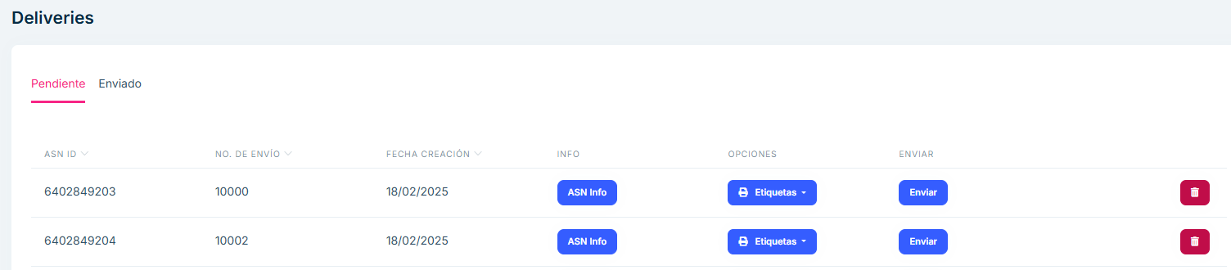

image

## Sent

Sent Shipments List:

Similar to the Pending tab list, but shows only shipments that have already been processed and sent.

Each row includes:

* ID: ASN identifier.
* Shipment Number: Shipment code or reference number.
* Shipment date.
* Action buttons:
* Information: Provides additional details about the shipment. When clicked, a pop-up or modal box opens with relevant information.
* Labels: Generates and allows you to download labels (item, box, pallet, and packing slip) for the corresponding shipment.
* Shipped: Shipment status information.

This view acts as a record of completed shipments, allowing you to consult them at any time.

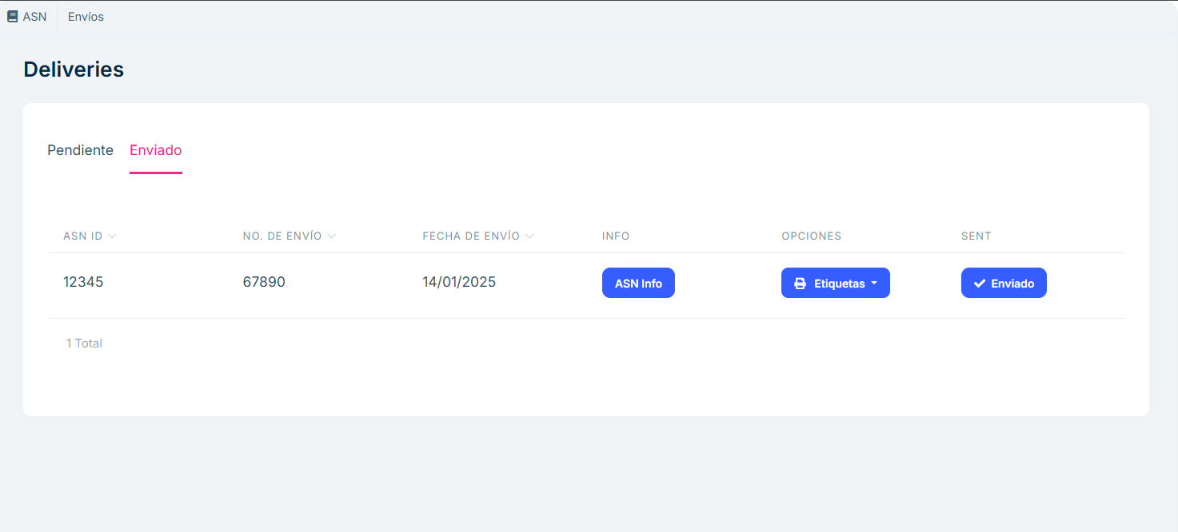

image

## Frequently asked questions

What information is displayed in the Shipments section?

The Shipments section has two main tabs:

Pending: Displays shipments that have not yet been processed, with the following information: Shipment ID. Shipment Number. Action Buttons: Info, Labels, and Send . Shipped: Displays shipments that have already been processed, with the same information fields.

What actions can I perform from the “Pending” tab?

From the Pending tab, you can:

View detailed shipment information by selecting the Info button. Generate labels for items and boxes using the Labels button. Mark a shipment as complete and move it to the Shipped tab using the Send button.

How can I view a shipment that has already been processed?

To view already processed shipments:

Go to the Shipped tab. Find the shipment you need. Select the shipment to view its information or generate labels again.

What does the “Information” button do?

The Information button displays ASN details for the selected shipment.

What happens when I press the “Send” button in the Pending tab?

When I press the Send button:

The status of the shipment changes from “Pending” to “Sent.” The shipment is automatically moved from the Pending tab to the Sent tab. This change ensures a clear record of completed shipments.

Can I generate labels for already completed shipments?

Yes, from the Sent tab, you can generate labels again using the Labels button associated with each shipment.

What is the difference between the “Pending” and “Sent” tabs?

Pending: Contains shipments that have not yet been processed or completed. These can be managed with actions such as send and generate labels.

Sent: Contains shipments that have already been processed and marked as completed. Here you can only check the details or generate labels again.