# Tenant

The tenant field allows the selection of the particular company that we want to access. It is important to note that each client/supplier has its own tenant, which is the name of the company in capital letters. Before logging in, we must choose the appropriate tenant.

We will press the “Change” button on the login page and a drop-down menu will appear where we must enter the name of our company in capital letters.

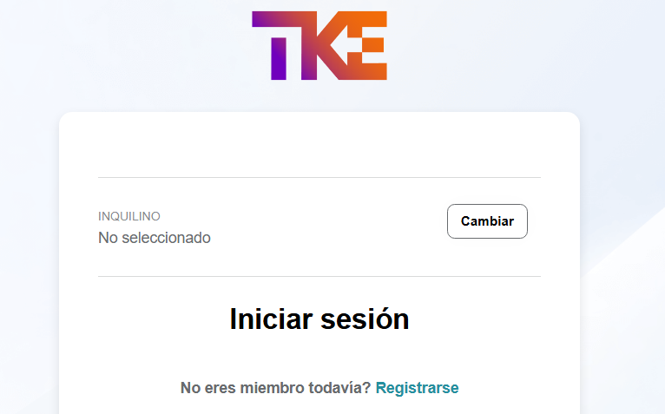

Captura_de_pantalla_2025-01-14_152158