# User management

## User creation

To access the user management screen, in the menu we must press “Administration”, “Identity management” and “Users”.

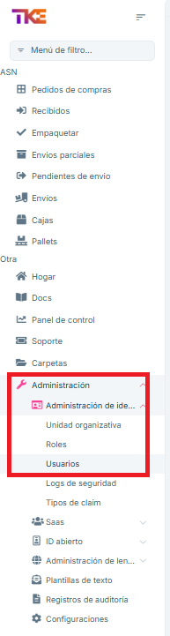

image

Once inside, we can see a list of all existing users.

To create new users, we will press the “New User” button in the upper right corner.

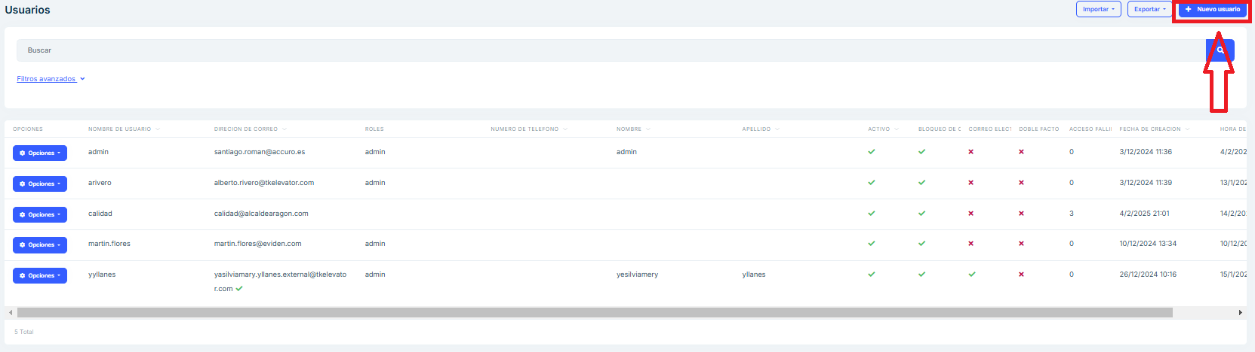

image

This will open a form where we must enter the following data:

* Username:
* First and last name
* Password
* Email address

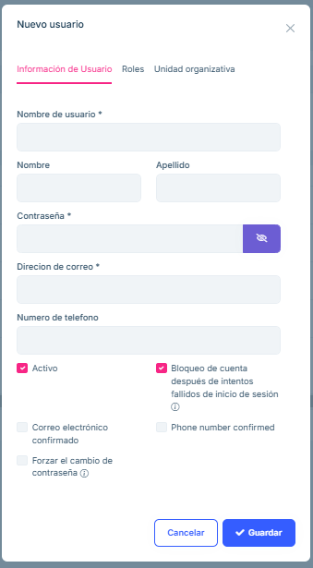

image

Additionally, we will have to grant the user the necessary permissions. To do this, we will click on the “Roles” tab and select “admin”.

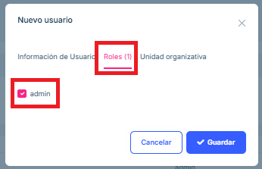

image

Finally we click “Save”

## User editing

By clicking the “Actions” drop-down menu, a multitude of options about the user will be displayed.

We will mainly use “Edit” to modify user data and “Delete” to delete the user.

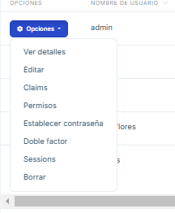

image