ANALYSIS OF FLUID FLOW PATTERNS DURING CARBON DIOXIDE ABSORPTION IN BROMOTHYMOL BLUE IN A CELL WITH DIRECTIONAL PERMEABILITY

Clarice Sombra de Medeiros and Dr. Bjornar Sandnes

Research Centre  
College of Engineering

Swansea University

Swansea UK

802194@swansea.ac.uk

Abstract— The aim of this project is to evaluate the relationship between permeability, which measures the ability of a porous medium to allow fluids to pass through, and the behavior of the convection patterns of a fluid flow. In addition, we apply it in the context of carbon dioxide storage in saline aquifers, to reduce greenhouse gas emissions and hence attenuate climate change effects. In order to vary and assess the permeability,  5 experiments with different rotation angles were performed in a fluid flow cell with carbon dioxide saturated water.  At first, the injected CO2 started to dissolve into the water gradually by a diffusion process, and this process generated a layer of CO2 saturated water.  Due to the mass transfer between CO2 and the yellow layer formed, the density of the layer increased and became greater than the water below it. Then, it was generated a gravitational unstable stage and therefore it produced convection currents.  In this work, it was also used 3D printing technology to devise an arrangement of small ABS barriers. In fact, these barriers comprised the route of the fluid. Test were conducted to evaluate the time-lapse imaging and investigate finger patterns by image processing and analysis.

Keywords—CO2 storage, convection flow patterns; 3D printingstyle; directional permeability

# Introduction

## 3D printing technology

Three-dimensional(3D) printing, or additive manufacturing is a process of producing 3D solid objects from a digital model using a layer-by-layer (LBL) process [1].

The first step of this process is to create a design model using a 3D modeling software. Then, the file is converted to .stl(surface tessellation language) computer format and, furthermore, sliced into series of parallel layers. These slice design files are sent to a 3D printer. Thus, it reproduces these slices layer by layer until the structure of the model is completed [2]. See Figure 1.



Figure 1*.* 3D model slicing [2].

All the samples are build by extrusion with the support of a print head nozzle, from where the molten thermoplastic comes out over a smooth, flat, horizontal process platform [3].

There are several raw materials for 3D printer and the most common are the thermoplastics, particularly the acrylonitrile-butadiene-styrene (ABS). ABS is made by polymerizing styrene and acrylonitrile in the presence of poly-butadiene and its chemical formula is (C8H8·C4H6·C3H3N). Figure 2 depicts the monomer of ABS. For more details, the reader may refer to [4]. Additionally, ABS has a good level of strength, impact resistance and toughness and it also has excellent properties of chemical and heat resistance [5].



Figure 2. Monomer of ABS [4]

## Carbon dioxide rentention in underground reservoirs

Carbon dioxide capture and sequestration (CCS) in geological reservoirs is a research area which is becoming increasingly important since it is a promising mitigation measure that can contribute substantially to reduce greenhouse gas emissions and hence attenuate climate change effects. To enhance the standard methods for CO2 storage in deep reservoirs and verify if that is a suitable option for large-scale application around the world, first we need to do an overview of how it can be retained underground [9].

There are many methods of storing CO2 into brine aquifers: as a separate supercritical phase, as trapped gas, as dissolved in the aqueous phase; or as solid minerals [10]. In this project we will focus on the third method.

First, CO2 is injected at superficial conditions to avoid two phase flow. Because of the critical temperature and pressure for CO2, which are 31.048C and 7.382 MPa, at least 800m of aquifer depth is required to maintain the supercritical pressure [9].

At first, the injected CO2 started to dissolve into the water gradually by a diffusion process, and this process generated a layer of CO2 saturated water.  Due to the mass transfer between the fresh CO2 injected and underlying brine in aquifer, the density of the layer increased and became greater than the water below. As a result of this local density increase, convection currents starts to appear, making the CO2-saturated brine moves downwards and eventually, increasing the rate of CO2 dissolution. This process is also referred as density-driven convection [11].

The Rayleigh number (*Ra*) is a formula used to relate the rate of fluid convection with the rate of diffusive transport. The Rayleigh number is calculated as:

*Ra* = (1)

Where k is effective permeability, g is acceleration of gravity, h is height of the cell, Δ𝜌 is the excess density between CO2-brine and brine, 𝜇 is the viscosity, *D* diffusivity. The concentration gradient of CO2 into the water will change over time since CO2 tends to dissolves and diffuses. At first, diffusion governs the process of CO2 mixing and convection does not affect the flow significantly. After a while the effect of natural convection increases as the density gradient gets higher and then the fluid flow is dominated by convection. Hence, it leads to an increase of Rayleigh number, which depends mainly on the aquifer permeability at stable conditions of temperature and pressure. Thus, for higher Rayleigh numbers, fingers grow faster [12].

## C.Hydraulic Conductivity

Hydraulic conductivity (symbolized by the letter K) can be defined as the ability with which the water flows through soil.It is a very importantproperty which is deeply related to the size of the pores in a heterogeneous porous media and state of packing of the particles on the underground [13,14].

Moreover, this property is also frequently related to the permeability. It is obtained by the ratio of the superficial velocity of water flowing through the soil area and the hydraulic gradient. This definition is in accordance with Darcy’s law which is a basic equation used to describe groundwater flow [15]:

K = υ/i (2)

Where υ is the specific discharge determined by the flow continuity equation:

Q = υ x *A*. (3)

Here Q stands for the volumetric flow rate through the cross-sectional area of the sample. [14,15]

There are 2 main types of permeability test methods that are used to determine the hydraulic conductivity. The former is the constant head experiment and the former is the falling head experiment.The set up for the liquid flow for each type of experiment represents the major difference between the two of them. The constant head experiment, which was used in this project, operates in a steady-state flow regime. This type of method is more used in coarse-grained soils samples such as clean sands and gravels. The formula to calculate the saturated hydraulic conductivity (Ksat) is given by:

Ksat = (4)

Where *V* stands for the measured volume of water that flows through the cell during the time *t.*The difference in time from the initial measurement to the final measurement of V is given in terms of *t*. *A* refers to the cross sectional area of the core sample and correspondsto the product of the gap size and length of the cell. *L* is the length of the sample, and *h* is the constant vertical distance between the syringe head level and the beaker over flow level [14].

# Methods and Materials

# *A.Materials*

Here, a TAZ 4 3D printer was used to produce small barriers and create the route of fluid flow. Fig.3 illustrates the 3D printer, we have applied to our process.

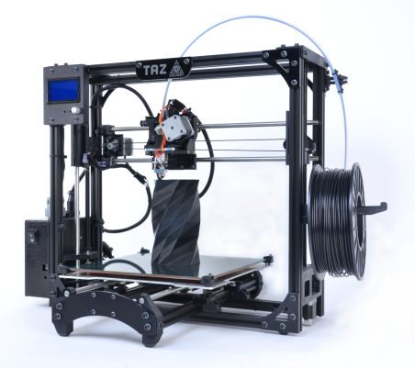

Figure 3. TAZ 4 3D Printer [6].

The gap between each barrier is 1mm and it was used white color ABS. In the first step of the experiment, we have used the Google SketchUp (a free 3D modeling software) to designa 3D model with small barriers in a circular arrangement. Then, we converted model into a *.stl* file format to be loaded into Slicer (a free open source software which provides functionalities for data processing such as segmentation, registration and three-dimensional visualization of multimodal data). In the sequence g-code file is exported and the Pronterface (3D printer controller software developed by Kliment) connected the printer to the computer to outputthe g-code file desired, i.e. to print it.

In order to overcome frequent software bugs, we replaced both the Slicer and Pronterface by Cura (which is a software developed by Ultimaker).

Initially, we planned to use the 3D printer to print a circular arrangement with very small rectangular barriers directly on the surface of a polycarbonate(PC) plate. Then, we covered it with another PC plate, such that the gap between the both plates would be equal to the height of the barriers (2mm). And a rubber seal ring was used for waterproofing the flow cell. The reason for choosing the PC is that it is highly transparent to visible light (with better light transmission than many kinds of glass). Moreover, it affords high impact-resistance, however it has low scratch-resistance. In fact, it was required an extreme care to avoid scratches on the surface of the plate because they damage the acquired images.Thus, this problem affects the image processing and analysis step performed by Image J, a Java-based image processingprogram developed by the U.S. National Institute of Health.

During the preliminary tests to produce the cell for the experiment, we have used two square plates, each one measuring 24x24cm and 2cm thick. The former has 4 holes (each one with 4.8mm diameter) positioned in the middle of each side of the square and 2 cm distant from the edge. In the latter, which has not holes, it was printed the small ABS barriers directly on the surface of polycarbonate, equally distant from each other by 2mm. It is worth noting that their spatial distribution follows thepattern designed in the Google SketchUp.

CNPq – Conselho Nacional de Desenvolvimento Científico e Tecnológico

In order to ensure that the ABS layers would be well sticked to the surface of the PC plates, during the printing process, we tested several methods to improve the adhesion of ABS on the surface of polycarbonate.

At first, acetone was used to smooth the ABS printed surface, remove layer lines and furthermore eliminate gaps between layers during the printing process.Thus, it avoided fluid seep in andit provided that the ABS sticks on the surface of the polycarbonate. In fact, it was not suitable for this purpose, because it dissolved the surface of PC and, thus, reduced the plate transparency. Then, we have used glue stick and hairspray to replace the acetone. Overall, the results were not satisfactory. As a matter of fact, the bed could not be heated due to problems with bending. And it was not possible to heat the bed, otherwise the polycarbonate plate would no longer be flat. In all tests, the bed remained at room temperature.

Ultimately,it was designed a circular layer made of ABS with the same color as the barriers, with a diameter of 20cm and 1mm height was designed under the barriers. Thus, it ensured that they would remain stuck to the support during the printing process.

The final step replaced the polycarbonate plates by an acrylic plate with similar dimensions. The other plate was replaced by a glass plate measuring 25 x 25 cm since it is flatter and smoother than the polycarbonate.

In the sequence a Bromothymol Blue (BTB) solution, a pH indicator provided by Sigma-Aldrich (CASnumber 34722-90-2 and molecular weight: 646.36 g/mol) were used to visualize the process of CO2 injection and absorption into the water and the consequently formation of the fingers. And the BTB visual transition interval is:pH 6.0 (yellow) - pH 6.7 (green) - pH 7.6 (blue). The solution was prepared using 1L of deionized water and 210 mg of BTB. In order to adjust the pH of the solution, we have added a few drops of 0.1 mol solution of NaOH. In the end, the experiment achieved a final value of pH equal to 8.4.

The images were captured using a digital camera Nikon D7000 16. 2MP DX-Format CMOS Digital SLR with time-lapsing settings.

The carbon dioxide was injected into the cell by a syringe pump model Alladin-1000, which enabled the flow rate to be adjusted to 0.5mL/min

*B. Methods – Set up*

The first step of the set up was the cell assembly.

Three of the four holes were sealed with a double-sided tape made of silicon with 0.5mm of thickness, and only one hole remained open. The circular support with the barriers was adjusted on top of the polycarbonate plate, according to the desired angle. Moreover, the experiments were performed in duplicate for 5 different angleswhich include 0o,30o, 45o, 60oand 90o). See Fig. 4.

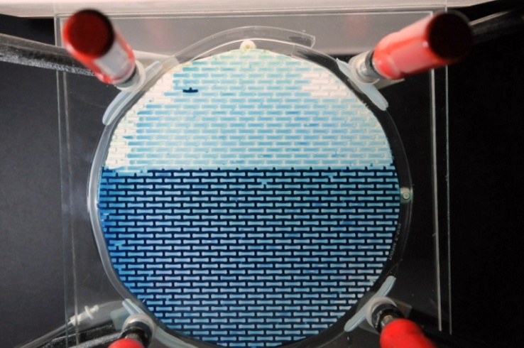

180o-θ

**Y**

**X**

Figure 4. Representation of the rotation angle (θ) of the barriers.

A rubber seal ring sealed the cell and then a glass plate measuring 25 x 25cm was placed on top of the arrangement. Four clamps were positioned at each corner of the cell to guarantee that the sealing would make it waterproof. These clamps are also of great importance to disassemble the cell at the end of each experiment.

Once assembled, the cell was placed in a vertical position and a plug was added to the upper inlet, which is the hole that was left open.

When the preparation setting for the fluid flow reaction test is concluded, BTB was injected from top inlet.

A syringe of 26.4 mm of diameter with fresh carbon dioxide was placed on syringe pump and the injection speed was set to 0.5mL/min to maintain a stagnant layer of CO2 over the water.A black frame was placed immediately behind the cell and a lamp was put in front of the cell to lightening the picturesand provide high contrast image. Fig. 5 illustrates this experimental set up.

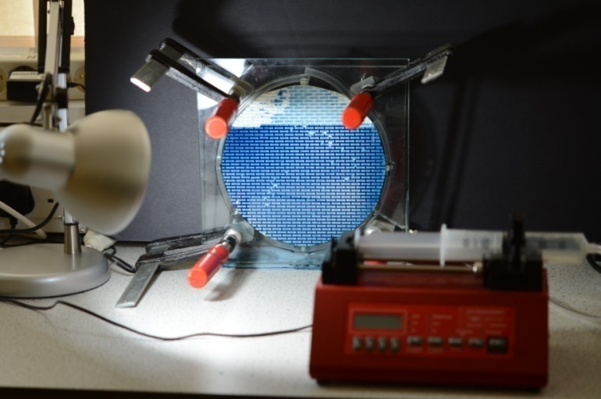

**Pump**

**Cell**

**Lamp**

Figure 5. Experimental set up.

A camera,attached toa support, was placed in front of the cell and set with time-lapse imaging settings to record changing reactions every thirty seconds and until all the CO2 in the syringe was consumed. All the tests were done under room temperature and pressure conditions.

*D. Permeability and Laboratory Methodology for Determining Hydraulic Conductivity Constant*

One syringe with a capacity of 60 mL located in a higher level and coupled to a funnel on the top of itwas taped to a pole at a convenient height.In order accomplish a reasonable steady-state flow of water, the bottom outlet of the syringe was connected to the upper inlet of the cell prototype with a flexible tube to let the water that entered into the cell flow freely. Another tube connected a hole at the bottom of the cell to a beaker located at the lowest level of the arrangement. The Syringe was used as an upper reservoir with water supply until the level of the water inside the cell was stabilized. A chronometer was turned on and stopped when the volume collected by the aforementioned beaker connected to the outlet in the bottom of the cell reached a value corresponding to 100mL.

Then, the experiment achieved a hydraulic head difference (*h*) equal to 92cm. The experiment was performed with the barriers positioned vertically and then horizontally. For each case, the experiment was repeated twice in order to obtain an average time between the initial and final measurements of the corresponding volume(100mL). Finally, we have calculated the values for each hydraulic conductivity. The average values for vertical and horizontalconductivity were 0.2528cm/s and 0.2218cm/s, respectively. According to these results, we can infer that the hydraulic conductivity in this experiment isisotropic.

In fact, this is an approximate measure since the interior of the cell is a homogeneous porous mediaand it did not represent the inside structure of an aquifer.

## E.Analysis Procedure

For the performance evaluation and analysis, the image sequence was imported using the menu ‘File’ and choosing the option ‘Import > Image Sequence’. After that, another window is opened with the first picture of the sequence. In order to measure the value of the area of interest (the region of the *fingers*), it was used the ‘Image Calculator’ tool from menu ‘Process’, to subtract each photo in the sequence that was imported(‘Image1’) from the first picture (Ímage2’). Then, we select the ‘Subtract’ option from the Operation: popup menu. The ‘Create New Window’ box is checked to create a new image sequence to hold the result, otherwise, the result of the operation replaces some or all of ‘Image1. And a straight line selection tool is used for a line selection that corresponds to a ‘Known Distance’. The command ‘Set Scale’ in the ‘Analyze Menu’ is used to define spatial scale of the active image such that measurement results can be presented in the calibrated unit, such as millimeters. Accordingly, ImageJ automatically fill in the distance in pixels based on the length of the line selection. The next step is to crop the image, but firstly it is used the circular selection tool to select the desired area. Thus, we set the ‘Threshold’ tool (menu Image>Adjust) to segment the image into features of interest or foreground and background. Consequently, the region to be measured is highlighted. Features that are thresholded are displayed in red and background is displayed in gray scale. The B&W option for ‘Threshold Color’ option is chosen to switch to a mode where features are displayed in black and background in white and the ‘Color Space’ mode chosen was the HSB. The box Dark Background is checked because the features in the foreground are lighter than the background. The command ‘Noise’ in the Process Menu is used to smooth the images and reduce the noise. The chosen filter was the ‘Despeckle’ option which is a median filter. After that, the option ‘Remove Outliers’ also in the Noise Submenu is used to replace a pixel by the median of the pixels in the surrounding if it deviates from the median by more than a certain value (the threshold).

In order to measure the area and the perimeter of the image, it was used the ‘Analyze Particle tool’, but to use this feature, the image has be prior converted to 8-bit grayscale ( the pixels values in the image are either 0 (white) or 255 (black) by using the ‘Type’ command in the Image Menu. ImageJ converts 16-bit and 32-bit images and stacks to 8-bits by linearly scaling from min-max to 0-255, where min and max are the two values displayed in the brightness and contrast tool. Pixels with a value less than the minimum are displayed in black and those with a value greater than the maximum are displayed in white as Fig.6 displays.

Finally, the command ‘Analyze Particles’ is used to measure the area and the perimeter on the binary image. It performs by scanning the image or selection until it finds the edge of an object. Then, it outlines the object by using the wand tool, that measures it using the Measure command, and fills it to make it invisible, then resumes scanning until it reaches the end of the image or selection [8].

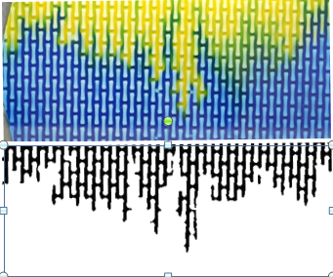

Figure 6: 8-bit image conversion from a cell with angle of rotation counter-clockwise equal to 90 degrees

# Results and Discussions

## Dynamics – Convective Flow

Figures 7 to 11 show the finger pattern formation in each experiment performed with different rotation angles. The second picture of each sequence shows the formation of the yellow layer and the initial concentration distribution of CO2 absorbed into the water, 15 minutes after the beginning of the experiment. We have observed that this process is mainly controlled by the diffusion. However, it could to see in the meanwhile that well-defined convection fingers started to appear and grow independently of one another and slowly interacting to each other. This can be explained by the absorption of carbon dioxide that leads to a dense fluid on top of a less dense fluid, then the dense fluid starts to sink into the less dense fluid. We have also observed that fingers tend to grow in the same direction of barriers, following the path of least resistance. This experiment also revealed that when the angle of rotation is closer to 90 degrees, fingers are likely to appear faster, confirming the directionality of the permeability of the cell influenced in the fluid flow patterns. In addition, two big yellow fingers grew along the side route without the barriers suggesting that the fluid followed the path of least resistance.

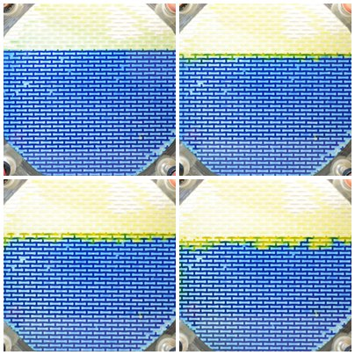

Figure 7. Experiment performed with angle of 0 degrees

  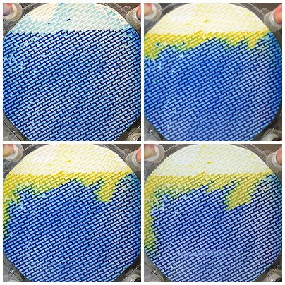Figure8.Experiment performed with angle of 30 degrees

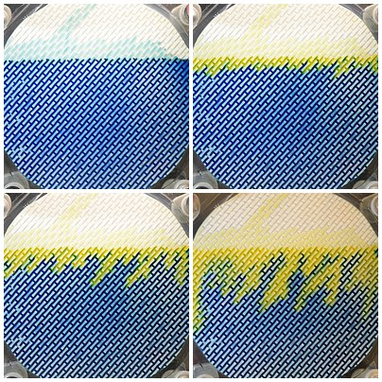

Figure 9. Experiment performed with angle of 45 degrees

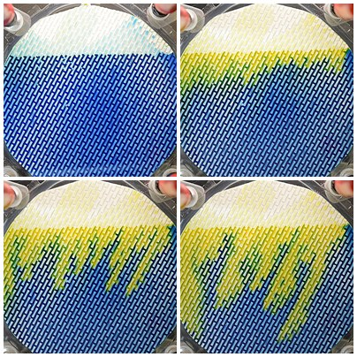

Figure 10. Experiment performed with angle of 60 degrees

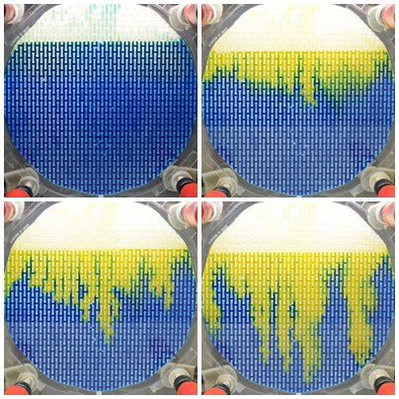

Figure 11. Experiment performed with angle of 90 degrees

*B. Analysis and Measurements*

*I.Rate of convection*

The yellow area formed during the process was isolated and measured using ImageJ software in order to measure its increase as time goes by. The measure results were used to plot a graph of area variation versus time as Figure 12 shows. From the graph, we can infer that the rate of convection is affected by the permeability since the rotation angle, in this experiment, was 90 degrees (permeability reached its maximum value). Thus, fingers developed faster than in the experiment with rotation angle equal to zero degree, i.e. lower permeability.

Figure 12. Area rate through time for 0, 45 and 90 degrees.

## II.Correlation between permeability and width of the fingers

Figure 13. Width variation through time for 0, 45, 90 degrees.

The average finger width was measured by using an approximation of the finger to a rectangle, as follows

*W = A\**2*/S* (5)

Where *W* is the width of the fingers, *A* stands for the yellow area and *S* is the perimeter of the yellow area or the length of its border.

The average width values are plotted in Figure 13 and furthermore they are related to three rotation angles. Our results confirmed that there is a correlation between the finger width and the permeability of the cell. Actually, it was confirmed by the experiment with low permeability (angle equals to zero degree) presented less fingers which were wider. On the other hand, in the experiment with 90 degrees appeared more fingers which were thinner.

## III. Development direction of fingers

For the experiments performed for 30o, 45o and 60o it was measured the approximate value for the difference between the average angle formed between the fingers and the x-axis (α) and the angle of rotation of the barriers (θ) ,as it can be seen in Figures 14 – 15 and Table1 . It was noticed that the maximum value is for the case where the angle is 45 degrees. To explain that, we can suggest that density has been shown to have a important role in the mixing of CO2 in water and also promotes further dissolution.

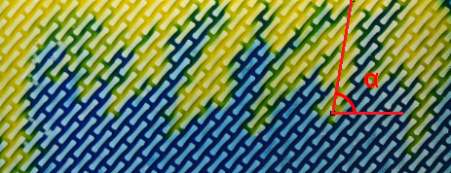

**X**

Figure 14. Representation of the angle α formed between the finger and x axis. .

| θ | 0 | 30o | 45o | 60o | 90o |
| --- | --- | --- | --- | --- | --- |
| α | - | 42,31o | 58,85o | 68,42o | - |
| α-θ | - | 12,31o | 13,85o | 8,42o | - |

Figure 15. Graph of (α – θ) versus the rotation angle (θ).

##### Conclusion

In this project, we have developed a methodology to evaluate the influence and relationship between permeability and the convection patterns of a fluid flow.

From the results, we concluded that the rate of convection can be affected by the permeability by adjusting the rotation angle. We also observed that fingers appeared faster for rotation angle greater than zero degree, which corresponds to the lower permeability and they were wider than the ones that appeared in the experiment with rotation angles equal to 90 degrees. Thus, we also conclude that there is a correlation between the finger width and the permeability of the cell.

Further research will investigate the use of barriers with smaller dimension displaced in different arrangements in order to analyze and correlate “fingers” formed with the disposal of these barriers.

A great problem faced in this project was the fact that the cell was not totally waterproof due to the rubber ring used around the cell. In fact, it did not present proper dimensions and therefore it did not provide a good sealing. For that reason, the level of BTB did not remain constant and altered the image analysis and hence many experiments had to be redone.

To overcome this problem, we plan to eventually use another rubber ring with an appropriate diameter, placed on the top of a circular wedge-shaped hole on the surface of the acrylic plate. Hence, it guarantees a waterproof coating and it prevents the fluid leakage through the bottom of the cell. This approach may also guarantee that the gap throughout the cell will be uniform. All this will contribute to make results more reliable.

##### Acknowledgments

This research was sponsored by Conselho Nacional de pesquisa e Desenvolvimento Tecnológico (CNPq). I wish to acknowledge Swansea University for the opportunity to develop this project, in particular my tutor, Dr. Björnar Sandnes, for the support and guidance throughout the project. Many thanks to Dr. Benjy Marks and Dr. James Campbell for technical support during experimental procedures. Finally, I wish to acknowledge everyone from the Working Shop for the help with material supply for the production of the cell prototype used in the project .

##### References

1. *Rapid prototyping (RP), rapid manufacturing (RM), 3D Printing,* http://www.formula1-dictionary.net/rapid_prototyping.html
2. Pati F, Shim J-H, Lee J-S, Cho D-W. 3D printing of cell-laden constructs for heterogeneous tissue regeneration. Manufacturing Letters. 2013;1(1):49-53.
3. E. Sachs, M.J. Cima, J. Cornie. *CIRP Ann*., 39/1 (1990), pp. 204–210
4. *Reprap,* http://fr.flossmanuals.net/_booki/reprap/reprap.pdf, pp. 45
5. Wang F, Hong RY, Feng WG, Badami D, Zeng K. Electrical and mechanical properties of ABS/EPDM composites filled with carbon black. Materials Letters. 2014;125(0):48-50.
6. Aleph Objetts **I**. LulzBotTM TAZ 4 User Manual. 626 W 66th Street, Lovelad, Colorado 80538 USA: Aleph Objects, Inc
7. Almarcha C, Trevelyan PMJ, Riolfo LA, Zalts A, El Hasi C, D'Onofrio A, et al. Active Role of a Color Indicator in Buoyancy-Driven Instabilities of Chemical Fronts. Journal of Physical Chemistry Letters. 2010;1(4):752-7.
8. ImageJ.<http://rsb.info.nih.gov/ij/docs/menus/>(accessed July 28th of 2014)
9. Ghanbari S, Al-Zaabi Y, Pickup GE, Mackay E, Gozalpour F, Todd AC. Simulation of CO2 storage in saline aquifers. Chemical Engineering Research & Design. 2006;84(A9):764-75.
10. Ranganathan P, Farajzadeh R, Bruining H, Zitha PLJ. Numerical Simulation of Natural Convection in Heterogeneous Porous media for CO2 Geological Storage. Transport in Porous Media. 2012;95(1):25-54.
11. Farajzadeh R, Salimi H, Zitha PLJ, Bruining H. Numerical simulation of density-driven natural convection in porous media with application for CO2 injection projects. International Journal of Heat and Mass Transfer. 2007;50(25-26):5054-64.
12. Kneafsey TJ, Pruess K. Laboratory Flow Experiments for Visualizing Carbon Dioxide-Induced, Density-Driven Brine Convection. Transport in Porous Media. 2010;82(1):123-39.

[13] Ghidaoui MS, Kolyshkin AA. Some global properties of flow in a heterogeneous isotropic porous medium.Mechanics Research Communications. 1999;26(2):161-6.

[14] Hassanzadeh H, Pooladi-Darvish M, Keith DW. Stability of a fluid in a horizontal saturated porous layer: effect of non-linear concentration profile, initial, and boundary conditions. Transport in Porous Media. 2006;65(2):193-211.

[15]Liu DAPJ, editor Stability and control of dynamical systems with applications : a tribute to Anthony N. Michel2003; Boston: Birkhäuser.