**Install pfSense onto Router Device**

1. Go to <https://www.pfsense.org/download/> and select the following options below. For “Mirror:”, choose the time zone you are in. Press the download button.

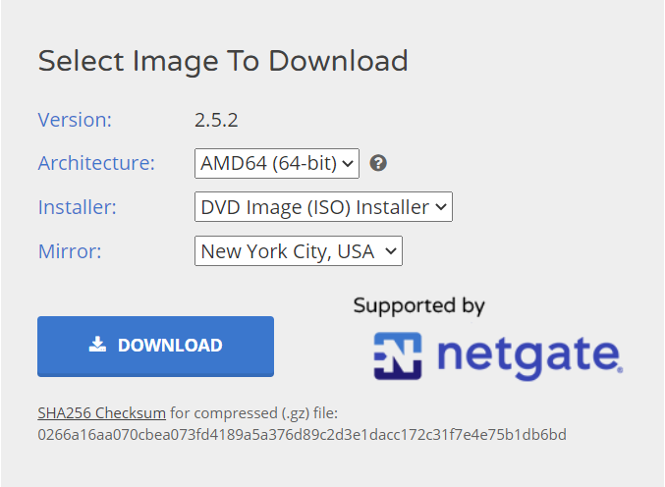

1. If the file downloads as a iso.gz file, extract the file with a file extractor tool (for example, 7-Zip File Manager).
2. Install and setup pfSense on the router device (depends on router device). Use default installation options.

**Install pfBlockerNG onto pfSense**

1. Log into the pfSense UI. Go to the System tab and click on Package Manager.
2. Click on Available Packages and search “pfBlockerNG”.
3. Two options should pop up. Install the version that says “pfBlockerNG-devel”.
4. Watch the Package Installation and exit when it gives a “Success” message.

**Register for MaxMind Key**

1. Go to <https://www.maxmind.com/en/geolite2/signup> and sign up for an account.
2. Log into your account and go to Manage License Keys on the left side of the page.
3. Hit the button that says Generate new license key. Press Yes and Generate a license key and config file. It should look like the image below.

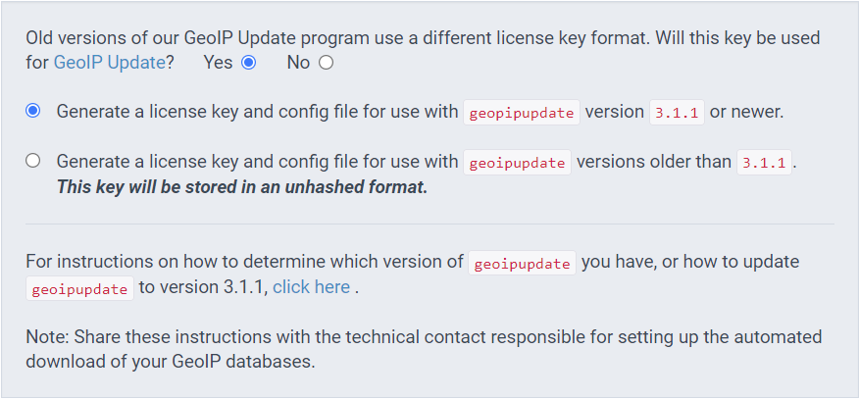

1. Press the Confirm button. It should display an Account/User ID and a License Key.
2. Press Download Config to download a file containing the license key information to ensure that you will have the license key on your device.
3. Copy the License Key (do not include any extra spaces).
4. Log into the pfSense UI.
5. Go to the Firewall tab and click on pfBlockerNG.
6. Click the IP tab within pfBlockerNG.
7. Scroll down until you see the heading that says, “MaxMind GeoIP configuration. Paste your MaxMind License Key into the box where it says, “MaxMind License Key”.
8. Scroll to the bottom of the page and press “Save IP Settings”.

**Block List of Malicious IP Addresses**

1. After requesting a token from STINGAR Admin, you should receive an email with your authentication token and the link to enter into pfBlockerNG.
2. Log into the pfSense UI.
3. Go to the Firewall tab and click on pfBlockerNG.
4. Click the IP tab within pfBlockerNG.
5. Click the IPv4 tab within the IP tab. It should look similar to the image below.

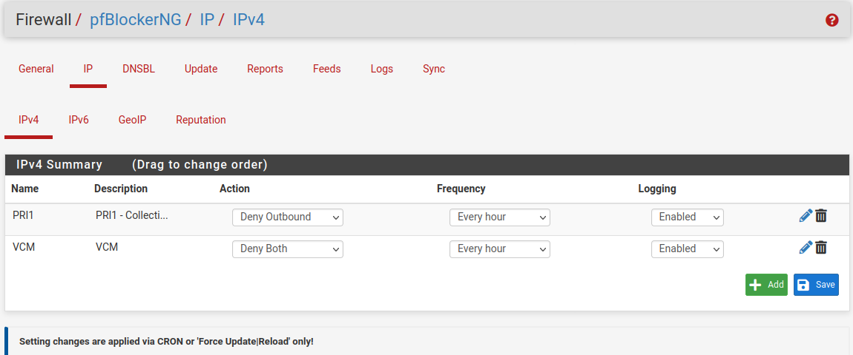

1. Click on the green Add button.
2. Similar to the image below, under Info enter in a Name / Description. Under IPv4 Source Definitions, ensure that the State is ON and paste the link into the Source box. Enter in a Header/Label. Under Settings, set Action to “Deny Both” and Update Frequency to “Every Hour”.

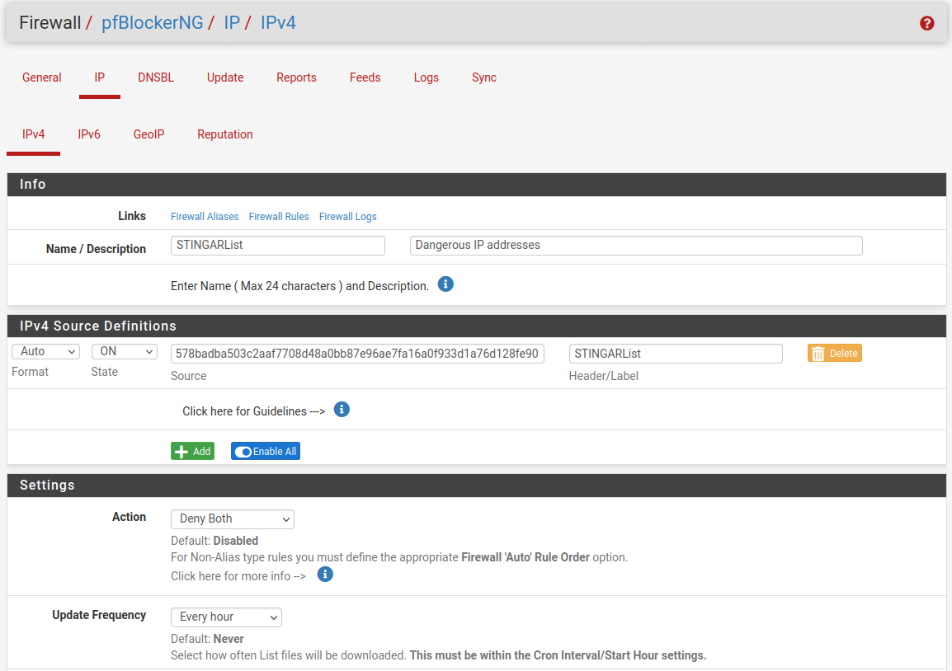

1. Scroll to the bottom of the page and click “Save IPv4 Settings”.
2. Click on the Update tab within pfBlockerNG.
3. Select the “Cron” option and press the Run button.

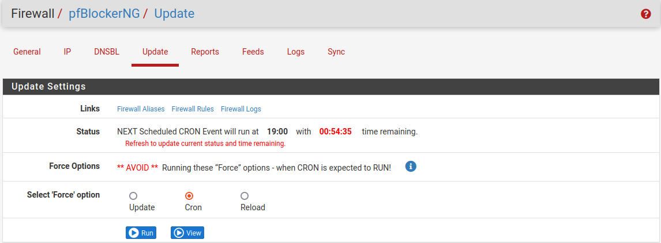

**View Network Traffic & Activity**

1. Go to <http://192.168.1.1:5000/> (Replace “192.168.1.1” with your pfSense IP address.)
2. Login with the default username and password.
   1. Username: user
   2. Password: pfsense
3. Change the default username and password.
4. Log in with your new username and password.
5. View your network activity and IP attackers.