1. Create Database:

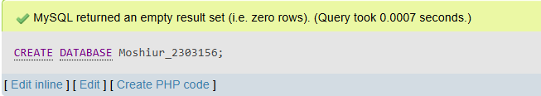

1. CREATE TABLE:

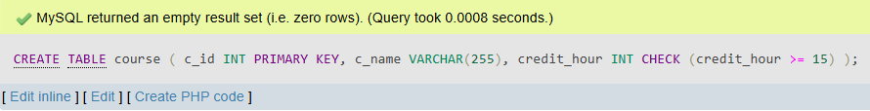

1. Insert value:

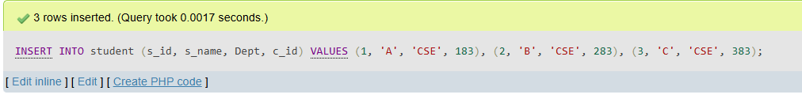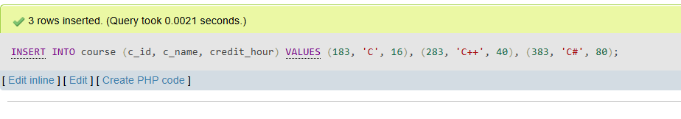

OUTPUT:

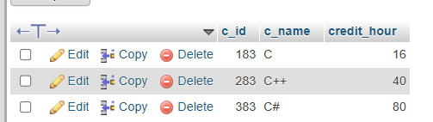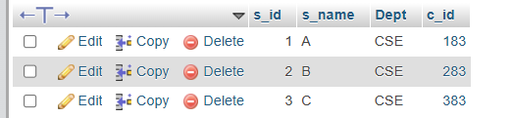

Oder by STATEMENT:

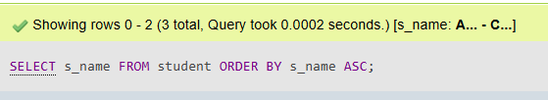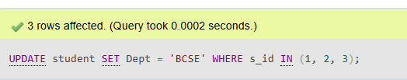  
output:

