ACE INSTITUTE OF MANAGEMENT


Pokhara University
Faculty of Management



Bachelor in Computer System and Information Technology (BCSIT)

Project Proposal for Project II

Submitted by:
Group - 01 (Aayusha Neupane and Siddhartha Siddhi Bajracharya)

Submitted to:
Mr. Sanju Shrestha
Course Name: Project II

Project Proposal: E-Voting System in Nepal

Contents
1
1. Introduction 3
2. Problem Statement 3
3. Objectives 3
4. Literature Review 4
4.1 Introduction 4
4.2 Review of Existing Systems and Theories 4
5. Methodology 5
5.1 Requirement Identification 5
5.2 Feasibility Study 5
5.3 High-Level Design 5
6. Gantt Chart 6
7. Use Case Diagram of E-Voting System in Nepal 7
8. Flowchart of the E-Voting System 8
9. Expected Outcome 9
10. References 9

1. Introduction
The E-voting system is a web-based system which is designed to conduct political elections digitally in a secure, efficient, and transparent manner in Nepal. It allows the registered voters of the country to cast their votes while ensuring the confidentiality. The system replaces traditional physical voting systems with a modern solution which saves time, reduces the cost and minimizes errors.

2. Problem Statement
Currently, Voters face a lot of problems such as:
1.Walking far distances to vote
2.Hectic and tedious voting systems
Which leads to many citizens not being able to vote, or experiencing a hectic and tedious voting experience.
This project aims to create an online approach for voters through which a citizen can vote just a few clicks away.

3. Objectives
- To develop a secure online voting platform
- Ensure a transparent and fair election
- Save time for both the voters and the staff involved
- Provide a real-time vote count with accuracy
- To prevent duplication and illegal voting.

4. Literature Review

4.1 Introduction
Electronic Voting(E-Voting) systems are digital platforms that allow elections to be conducted online instead of traditional paper-based methods. These systems aim to improve efficiency, transparency, accuracy and accessibility in the elections.

4.2 Review of Existing Systems and Theories
Several countries have explored electronic voting systems to improve election efficiency and accessibility.
In 2005, Estonia became the first nation to implement nationwide internet voting. Estonian election officials declared the electronic voting system a success and found that it withstood the test of real-world use.
Research on e-voting systems shows that they can improve:
- Election efficiency
- Faster result generation
- Reduction of manual errors
- Better accessibility for voters
However, studies also identify challenges such as:
- Cybersecurity risks
- Infrastructure requirements
- Public trust in online systems
In the context of Nepal, geographical barriers and limited digital infrastructure highlight the need for a simple and practical e-voting solution.
Therefore, this project focuses on developing a basic academic model of a web-based E-voting system, emphasizing usability, transparency, and efficiency.

5. Methodology

5.1 Requirement Identification
The study and analysis of existing voting systems(electionbuddy, simply voting) along with their limitations. Identification of user needs such as a secure and confidential login system, vote casting, management of the candidates and proper and accurate result generations.

5.2 Feasibility Study
Evaluating the practicality of the system from 3 different perspectives:
Technical Feasibility: checking if the required technology is suitable.
Operational Feasibility: Ensuring that the system is user friendly and a easy UI.
Economic Feasibility: Analyzing the cost-effectiveness of this system compared to the traditional voting system.

5.3 High-Level Design
Designing the system architecture and workflow:
- Define the user module, admin module and database.
- Creating the basic flow (Login to vote to store to count to display results)
- Plan the database structure (the voters, candidates, and the number of votes)
- Outline the interaction between frontend and backend
Development:
- Frontend development and design using HTML, CSS, React and JavaScript.
- Backend development using PHP
- Database using MySQL

Testing:
- Testing of all modules
- Testing security and authentication
- Use testing for the user’s experience and interface

Deployment:
Deploy the system on a local server and make it accessible and usable to users.

6. Gantt Chart
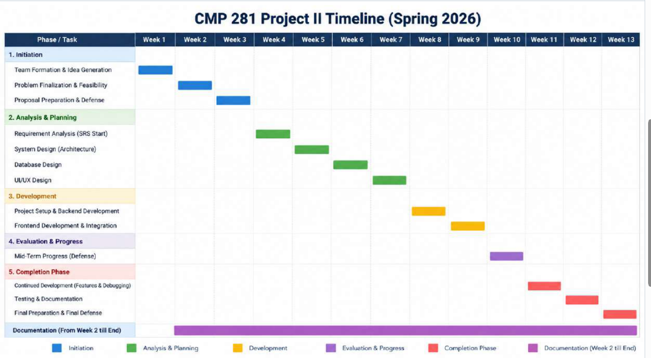

7. Use Case Diagram of E-Voting System in Nepal
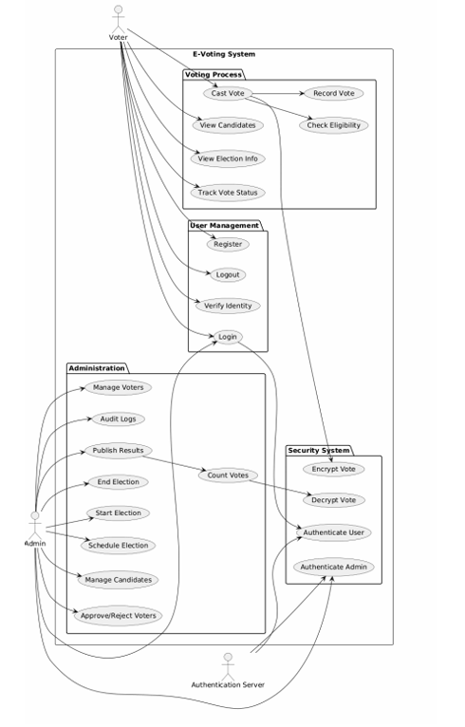

8. Flowchart of the E-Voting System

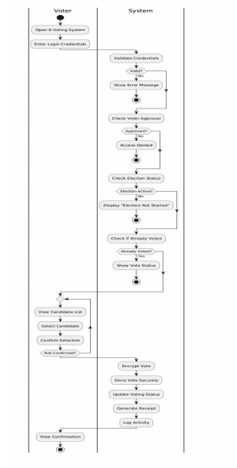

9. Expected Outcome
- A secure and reliable online voting system
- Accurate and real time vote count
- Prevention of fraudulent voting (ensuring one vote per voter)
- Improving cost effectiveness and efficiency to traditional systems.

10. References
Dulal, U. Enhancing Nepal’s Electoral System. (2026). Nepal Policy Institute. https://nepalpolicyinstitute.org/enhancing-nepals-electoral-system/
Election of the President of the Republic. (2026).Valimised. https://www.valimised.ee/?id=11509
Sheeter, L.Estonia forges ahead with e-vote. (2005). http://news.bbc.co.uk/2/hi/europe/4343374.stm

