ACE INSTITUTE OF MANAGEMENT


Pokhara University
Faculty of Management



Bachelor in Computer System and Information Technology (BCSIT)

Project Proposal for Project II
Group-02

Submitted by Submitted to:

Anuska Khatri Sanju Shrestha

Niharika Rajbhandari Pranavi Uprety

Table of Content

Introduction 1
1.1. Background of the Project 1
1.2. Domain Explanation 1
1.3. Context of the Problem 2
Problem Statement 3
2.1. Who is Affected 3
2.2. Impact 3
Objectives 4
Methodology 5
4.1 Requirement Identification 5
4.2. Feasibility Study 5
4.2.1. Technical Feasibility 5
4.2.2. Operational Feasibility 5
4.2.3. Economic Feasibility 6
4.3. High-Level Design 6
Gantt Chart 8
Expected Outcome 9
6.1. What The System Will Deliver 9
6.2. Final Result 9
References 10

i

Introduction

Background of the Project

With the increasing complexity of daily expenses, individuals often struggle to manage their finances effectively. Expense-Tracker is a web-based application designed to help users manage their 11daily financial activities efficiently. The system allows users to manually record their income and expenses, providing full control over their financial data.
It is specifically targeted toward students and working individuals who need a simple, accessible, and private solution for expense tracking. Unlike complex systems, we focus on providing a simplified version that makes managing funds easier. The system also supports group expense splitting, making it easier to track shared expenses among friends or colleagues.

Domain Explanation

This project falls under Financial Technology (FinTech) and personal finance management systems, aiming to improve budgeting and financial awareness.
The proposed system is a web-based application designed to manage personal finances and shared expenses efficiently. It is developed using standard web technologies, including:
    - Frontend: HTML, CSS, JavaScript
    - Backend: PHP
    - Database: MySQL

The system is designed to support:
    - manual tracking of income and expenses

- group expense splitting and settlement

- user authentication and data privacy

- budgeting and financial organisation

Context of the Problem

Many students and young individuals face difficulties in managing their daily finances due to limited income and lack of financial tracking habits. This often results in overspending and poor financial awareness. In addition, when expenses are shared among groups such as roommates, friends, or during trips, it becomes difficult to calculate and settle payments fairly.
Although several expense tracking applications exist, many of them are not suitable for all users because they are either too complicated, require subscriptions, or depend on linking bank accounts, which may raise privacy concerns.

Problem Statement

Despite the availability of digital finance applications, many users still face difficulties in managing their personal and group expenses effectively. Existing systems are often too complex, expensive, or require third-party financial integration, making them less accessible for students and general users.
As a result, there is a need for a simple, affordable, secure, and privacy-focused expense management system that helps users track income, expenses, and shared costs efficiently. A system that gives remainders and motivation on saving your precious money and enhances better usage of it.

Who is Affected

The primary stakeholders affected by this problem are:
    - Students who struggle to manage daily expenses and savings
    - Young professionals handling personal and shared finances
    - Groups of friends or roommates managing shared expenses
    - Individuals concerned about financial privacy and control

Impact

The absence of such a system creates several negative impacts:
    - Poor financial management and overspending
    - Confusion in splitting and settling group expenses
    - Lack of awareness of spending patterns
    - Difficulty in maintaining budgets and savings

Objectives

The main objective of this system is to enable users to accurately track their income and expenses while categorising their spending to gain better financial insights. The system aims to improve financial awareness and support better budgeting habits among users.
The proposed system will achieve the following objectives:

      - To enable users to record daily income and expenses accurately in the system.
      - To categorise transactions into different groups such as food, transport, education, and entertainment.
      - To provide a clear overview of total income, total expenses, and remaining balance.
      - To allow users to set budget limits and monitor their spending against those limits.
      - To generate visual charts of their spending for better decision-making.
      - To support group expense management by allowing users to split and track shared expenses.
      - To ensure data security through user authentication and controlled access.
      - To improve financial awareness by helping users understand their spending patterns.
      - To provide statistical reports about future spendings and concerns based on user’s previous data.

Methodology

Requirement Identification
    - Studying existing expense tracking applications such as Splitwise, Goodbudget, and Spendee
    - Observing common problems faced by students and young professionals in managing expenses
    - Identifying the need for a simple, fast, and user-friendly interface
    - Understanding the importance of features like manual expense entry, budgeting, and group expense splitting

Feasibility Study

Technical Feasibility

All technologies that will be used to develop ExpenseTrack are mature, well-documented and freely available. This project will use the standard web development technologies like HTML, CSS, JavaScript, PHP and SQL, which are common and widely used for building web applications. These technologies are easy to learn, supported by large developer communities, and compatible with most web servers. Hence, the system can be developed without any requirement for expensive tools or specialised hardware.

Operational Feasibility
The system is operationally feasible because it is simple, user-friendly and supports many types of users, including students and individuals. The system will be available without requiring complicated installation, and it can be accessed through any web browser. The system follows familiar design patterns which ensures that target users can adapt to the system without any training.

Economic Feasibility

The system is economically feasible since all the required technologies are free and easily available. This system doesn’t require expensive software licenses, advanced hardware, or third-party financial APIs, which can affect the development and operational costs. Furthermore, maintenance and future upgrades can be performed easily without requiring high investment. Therefore, the system provides an effective and affordable solution for personal and group expense management while delivering valuable financial benefits to users.

High-Level Design
    - System flow

User Input
        - Users enter income, expenses, and group transactions into the system.

Data Processing
        - The system processes and organizes the data based on categories and user input.

Database Storage
        - All financial data is securely stored in the MySQL database.

Output Generation
        - The system displays results such as:
          - Total income and expenses
          - Category-wise spending
          - Budget status
          - Group expense summaries

Dashboard View
        - Users can view financial insights through a clean and interactive dashboard

    - Basic Architecture

Three-Tier Architecture

Tier 1: Presentation Layer (Frontend)

HTML, CSS, and JavaScript files served to the user's browser.

Handles UI rendering, user interaction, form validation.

The dashboard, reports, and all user-facing features live in this layer.

Tier 2 : Application Layer (Backend API)

Node.js/PHP server exposing RESTful API endpoints.

Handles business logic (debt calculation, budget alerts, report generation), authentication.

Data validation before database operations.

Tier 3: Data Layer (Database)
- MySQL or MongoDB database storing all persistent data, including user accounts, transactions, budgets, groups, and settings.
- Queries are optimised for report generation and real-time dashboard updates.

Gantt Chart
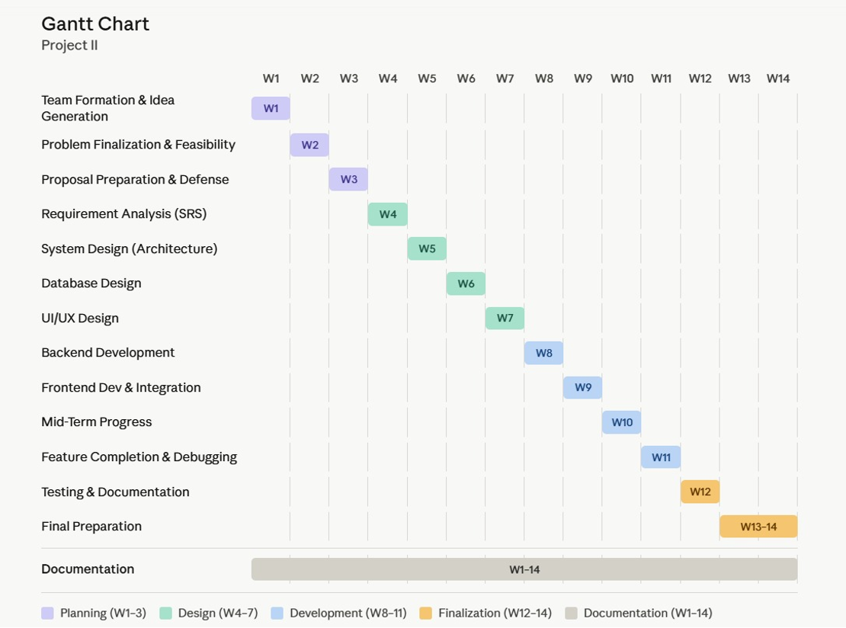
4.1 Project Timeline

Expected Outcome

What The System Will Deliver

A web-based application for tracking income and expenses

Categorisation of transactions for better financial understanding

Budget management features with alerts for overspending

Group expense splitting and settlement functionality

Secure user authentication and data privacy

A clear dashboard showing financial summaries and visual reports

Final Result

After completion, the project will provide:

    - A fully functional expense tracking system accessible through a web browser
    - Easy visualisation of spending patterns and financial status
    - Improved financial awareness and budgeting habits among users
    - A reliable platform for managing both personal and shared expenses
    - A simple, secure, and efficient solution for everyday financial management

References
    - Split expenses with friends. (n.d.). Splitwise. https://www.splitwise.com/

GoodBudget. (2023, May 9). Goodbudget. https://goodbudget.com/
    - Spendee (n.d.). Money Manager & Budget Planner. https://www.spendee.com/

i

