A Project Report on Sikka (Expense Tracker System)

Submitted by:
Pranavi Uprety
Anushka Khatri
Niharika Rajbhandari

Submitted to
Ace Institute of Management
Pokhara University

In partial fulfillment of the requirement for the degree of
Bachelors of Computer System and Information Technology

Kathmandu
June, 2026

SUPERVISOR RECOMMENDATION

This is to certify that this project entitled, “Sikka” prepared and submitted by Pranavi Uprety, Anushka Khatri, Niharika Rajbhandari in partial fulfillment of the requirements of the degree of Bachelor of Computer System and Information Technology (BCSIT) awarded by Pokhara University, has been completed under my supervision. I recommend the same for acceptance by the University.

……………….

Supervisor
Mr. Sanju Shrestha
Ace Institute of Management
CERTIFICATE OF APPROVAL

This project entitled, “Sikka” prepared and submitted by Pranavi Uprety, Anushka Khatri, Niharika Rajbhandari has been examined and is accepted for the award of the degree of Bachelor of Computer System and Information Technology (BCSIT) awarded by Pokhara University.

…..…..…………….. …………………..
Supervisor Examiner
Mr. Sanju Shrestha
Ace Institute of Management

ABSTRACT

The Expense Management System, Sikka, is a web-based application developed using PHP, MySQL, HTML, CSS, and JavaScript. The system enables users to register, authenticate, manage personal financial records, categorize expenses, maintain budgets, and monitor financial activities through a dashboard interface. The project aims to simplify personal financial management through an accessible and secure platform.

ACKNOWLEDGEMENT

We would like to express our sincere gratitude to our project supervisor for their valuable guidance, support, and encouragement throughout the development of the Expense Management System. Their suggestions and feedback greatly contributed to the successful completion of this project.
We are also thankful to the faculty members of ACE Institute of Management, Pokhara University, for providing us with the knowledge and resources necessary for this work. We extend our appreciation to our colleagues and friends for their cooperation and helpful suggestions during the project.
Finally, we would like to thank our parents and family members for their continuous support, motivation, and encouragement. Their belief in us played a significant role in the successful completion of this project.
List of Abbreviations
EMS | Expense Management System
HTML | HyperText Markup Language
CSS | Cascading Style Sheets
PHP | Hypertext Preprocessor
SQL | Structured Query Language
MySQL | My Structured Query Language
DBMS | Database Management System
ERD | Entity Relationship Diagram
DFD | Data Flow Diagram
UI | User Interface
UX | User Experience
API | Application Programming Interface
CRUD | Create, Read, Update, Delete
IDE | Integrated Development Environment
VS Code | Visual Studio Code
XAMPP | Cross-Platform Apache MySQL PHP Perl
Table 1. Abbreviation Table
List of Tables
Table 1. Abbreviation Table 6
Table 3.Database Tables and Attributes 21
Table 4.Relationship Summary 21
Table 5.Data Dictionary 22
Table of Figures
Figure 1.DFD Level 0 21
Figure 2.DFD Level 0 22
Figure 3. DFD Level 1 22
Figure 4. System Architecture Diagram 25
Figure 5.Class Diagram 28
Figure 6.Flowchart 30

Table of Contents
Supervisor Recommendation ..................................................................................... ii
Certificate of Approval .............................................................................................. iii
Abstract ...................................................................................................................... iv
Acknowledgement ...................................................................................................... v
List of Abbreviations ................................................................................................. vi
List of Tables ............................................................................................................ vii
List of Figures ......................................................................................................... viii

CHAPTER 1: INTRODUCTION ............................................................................. 11
1.1 Background of the Study .................................................................................... 11
1.2 Statement of the Problem ................................................................................... 11
1.3 Objectives of the Study ...................................................................................... 12
1.4 Scope of the Study ............................................................................................. 12
1.5 Limitations of the Study ..................................................................................... 13

CHAPTER 2: LITERATURE REVIEW ................................................................. 15
2.1 Introduction ....................................................................................................... 15
2.2 Technologies Used ............................................................................................ 15
2.3 Fundamental Concepts ...................................................................................... 16
2.4 Review of Existing Systems .............................................................................. 16
2.5 Research Gap ..................................................................................................... 17

CHAPTER 3: SYSTEM ANALYSIS AND DESIGN ........................................... 18
3.1 System Analysis ................................................................................................ 18
3.2 Functional Requirements .................................................................................. 18
3.3 Non-Functional Requirements .......................................................................... 18
3.4 Feasibility Analysis .......................................................................................... 19
3.5 Data Modeling ................................................................................................. 19
3.5.1 DFD Level 0 (Context Diagram) .................................................................. 20
3.5.2 DFD Level 1 ................................................................................................. 21
3.6 Database Schema ............................................................................................. 23
3.7 System Design ................................................................................................. 25

CHAPTER 4: IMPLEMENTATION AND TESTING ........................................... 26
4.1 Introduction ........................................................................................................ 26
4.2 Tools Used ......................................................................................................... 26
4.3 Modules of the System ...................................................................................... 27
4.3.1 Registration Module ....................................................................................... 27
4.3.2 Login Module ................................................................................................. 27
4.3.3 Dashboard Module ......................................................................................... 27
4.3.4 Income Management Module ........................................................................ 27
4.3.5 Expense Management Module ...................................................................... 27
4.3.6 Budget Management Module ........................................................................ 27
4.4 Testing ............................................................................................................. 27
4.4.1 Unit Testing .................................................................................................. 28
4.5 Summary .......................................................................................................... 28
4.6 Class Diagram .................................................................................................. 28
4.7 System Flow ..................................................................................................... 29
4.8 Flowchart .......................................................................................................... 30
4.9 Use Case Diagram ............................................................................................ 31
4.10 System Testing ............................................................................................... 32

CHAPTER 5: CONCLUSION AND FUTURE RECOMMENDATIONS
5.1 Lessons Learnt .............................................................. 34
5.2 Conclusion ........................................................................................................ 34
5.3 Future Recommendations ................................................................................. 34

References ............................................................................................................. 35

Appendices ............................................................................................................ 36
Appendix A: Screenshots ...................................................................................... 36
Appendix B: Source Code ..................................................................................... 36
Appendix C: Database Schema ............................................................................. 36
Appendix D: Supervisor Visit Log Sheet .............................................................. 36

CHAPTER 1: INTRODUCTION

1.1 Background of the Study
In the modern digital era, technology has transformed the way individuals and organizations manage their daily activities, including financial management. Effective management of personal finances is essential for maintaining financial stability, achieving savings goals, and making informed spending decisions. However, many individuals still rely on traditional methods such as notebooks, spreadsheets, or manual records to track their income and expenses. These methods are often time-consuming, prone to errors, and difficult to maintain over long periods.
With the increasing availability of web technologies, digital expense management systems have emerged as efficient solutions for tracking financial transactions. Such systems enable users to record, categorize, and monitor their expenses and income in a centralized platform. They provide real-time insights into spending habits, budget utilization, and overall financial health.
The Expense Management System (EMS) is a web-based application developed to simplify personal financial management. The system allows users to record income and expenses, manage spending categories, monitor budgets, and visualize financial information through dashboards and reports. By providing an organized and user-friendly platform, the system helps users improve financial awareness and make better financial decisions.
The project utilizes modern web development technologies such as HTML, CSS, JavaScript, PHP, and MySQL to create a secure and interactive environment for managing personal finances. The system is designed primarily for students, young professionals, and individuals seeking a simple and affordable solution for expense tracking.

1.2 Statement of the Problem
Managing personal finances effectively remains a challenge for many individuals. Traditional methods of expense tracking, including handwritten records and spreadsheets, often lack automation, data visualization, and efficient reporting capabilities. As a result, users may struggle to maintain accurate records of their financial transactions.
Several existing financial management applications provide comprehensive features; however, many of them require subscription fees, involve complex interfaces, or include functionalities that may not be necessary for average users. Students and young professionals, in particular, may find these applications difficult to use or financially inaccessible.
The absence of a simple, secure, and affordable expense management solution can lead to poor budgeting practices, uncontrolled spending, inadequate savings, and a lack of awareness regarding financial habits. Therefore, there is a need for a user-friendly web-based Expense Management System that enables users to efficiently manage their income, expenses, and budgets while providing meaningful financial insights.

1.3 Objectives of the Study
The primary objective of this project is to develop a web-based Expense Management System that assists users in effectively managing their personal finances.
The specific objectives are:
- To design and develop a user-friendly web application for recording and tracking income and expenses.
- To implement a secure user authentication system for protecting user data and maintaining privacy.
- To provide functionalities for managing income, expenses, spending categories, and financial budgets.
- To generate dashboards and visual reports that help users understand their financial activities.
- To improve users' financial awareness by providing organized and accessible financial information.
- To reduce the complexity and errors associated with manual expense tracking methods.
- To provide a centralized platform for managing personal financial records efficiently.

1.4 Scope of the Study
The scope of the Expense Management System focuses on personal financial management through a web-based platform. The system provides various functionalities that allow users to monitor and manage their financial activities efficiently.
The major features included within the scope of the project are:
- User registration and login authentication.
- User profile management.
- Income recording and management.
- Expense recording and management.
- Expense categorization.
- Budget creation and monitoring.
- Dashboard visualization of financial data.
- Monthly and category-wise expense analysis.
- Financial summary reports.
- Secure storage and retrieval of user financial information.
- Responsive web interface accessible through standard web browsers.
The system is intended for individual users and is particularly suitable for students, young professionals, and individuals who wish to improve their personal financial management practices.

1.5 Limitations of the Study
Although the Expense Management System provides essential financial management features, certain limitations exist within the current implementation:
- The system does not support direct integration with banks or financial institutions for automatic transaction synchronization.
- Users must manually enter income and expense data, which may require additional effort and may lead to data entry errors.
- The application requires an active internet connection to access its functionalities.
- The system is limited to registered users and does not provide public access.
- The current version is designed as a web application and does not include a dedicated mobile application.
- Advanced financial forecasting and artificial intelligence-based recommendations are not included.
- Multi-currency support is not available in the current implementation.
- The system does not provide online payment or transaction processing functionalities.
Despite these limitations, the Expense Management System effectively fulfills its primary purpose of helping users monitor, organize, and manage their personal financial activities in a simple and efficient manage.
CHAPTER 2: LITERATURE REVIEW
2.1 Introduction
Expense management is the process of planning, recording, monitoring, and analyzing financial transactions to ensure effective utilization of financial resources. With the increasing use of digital technologies, individuals and organizations are shifting from traditional bookkeeping methods to computerized financial management systems. Personal finance management applications help users track their income and expenses, create budgets, and gain insights into their spending patterns, ultimately improving financial discipline and savings habits.
The Expense Management System developed in this project aims to provide users with a simple and efficient platform for managing personal finances through a web-based application.

2.2 Technologies Used
The development of the Expense Management System utilizes the following technologies:

- HTML (HyperText Markup Language) : HTML is used to structure and organize the content of web pages. It provides the foundation for designing forms, tables, navigation menus, and other interface components.

- CSS (Cascading Style Sheets) : CSS is used to enhance the visual appearance of the application by controlling layouts, colors, fonts, and responsive design elements.

- JavaScript : JavaScript adds interactivity and dynamic functionality to the system, improving user experience through validation, notifications, and responsive user interfaces.

- PHP (Hypertext Preprocessor) : PHP serves as the server-side scripting language responsible for processing user requests, handling authentication, managing data transactions, and communicating with the database.

- MySQL : MySQL is the database management system used to store and retrieve information such as user profiles, income records, expense records, categories, and budget details.

2.3 Fundamental Concepts
- Expense Management: Expense management refers to the process of tracking and controlling expenditures. It enables users to maintain financial records and identify unnecessary spending.
- Personal Finance Management: Personal finance management involves managing income, expenses, savings, and budgets to achieve financial goals and improve financial stability.
- Budgeting: Budgeting is the process of allocating financial resources for specific purposes. It helps users control spending and maintain financial discipline.
- Group Expense Sharing: Group expense sharing allows multiple individuals to divide shared expenses fairly. This concept is useful for roommates, travel groups, and project teams.
- Financial Reporting: Financial reporting provides summaries and visual representations of financial activities, helping users understand their financial status and make informed decisions.
- User Authentication: User authentication ensures that only authorized individuals can access the system through secure login and registration mechanisms.
- Data Security: Data security protects user information from unauthorized access, modification, or loss through proper authentication and database management practices.

2.4 Review of Existing Systems
A. Splitwise
It is a popular expense-sharing application that allows users to split bills and track balances among groups. While it excels in group expense management, it offers limited personal budgeting features.

B. Goodbudget
It is a budgeting application based on the envelope budgeting method. It helps users allocate funds into various spending categories but provides limited group expense-sharing functionality.

C. Spendee
Spendee is a personal finance management application that allows users to track income, expenses, and budgets through an attractive user interface. However, many advanced features require premium subscriptions.

2.5 Research Gap
Most existing financial management systems focus primarily on either personal budgeting or group expense management. Applications that support both functionalities often require paid subscriptions or include complex interfaces that may not be suitable for students and casual users. The proposed Expense Management System addresses this gap by integrating personal expense tracking, budgeting, and group expense management into a single user-friendly and affordable platform.

CHAPTER 3: SYSTEM ANALYSIS AND DESIGN
3.1 System Analysis
System analysis involves studying the existing problem and identifying requirements for the proposed solution. Traditional expense tracking methods rely heavily on manual records, which can be time-consuming and prone to errors. The proposed Expense Management System replaces these methods with an automated database-driven solution that improves accuracy, accessibility, and efficiency.

3.2 Functional Requirements
The system provides the following functional requirements:

- User Registration: Users can create new accounts by providing the required personal information.

- User Login: Registered users can securely access their accounts using authentication credentials.

- Dashboard View: Users can view summaries of income, expenses, budgets, and financial statistics through an interactive dashboard.

- Income Management: Users can add, edit, delete, and monitor income records.

- Expense Management: Users can record, categorize, update, and manage expenses efficiently.

- Budget Management: Users can create budgets, monitor spending limits, and receive insights regarding budget utilization.

  - Non-Functional Requirements
- Security: The system must protect user information through secure authentication and database management.

- Reliability: The system should consistently perform its intended functions without failure.

- Performance: The application should provide quick response times and efficient data processing.

- Usability: The interface should be user-friendly and easy to navigate for users with varying technical backgrounds.

- Availability: The system should be accessible whenever users need to manage their financial information.

- Scalability: The design should support future enhancements and accommodate increasing numbers of users and transactions.

  - Feasibility Analysis
- Technical Feasibility: The project is technically feasible because PHP, MySQL, HTML, CSS, and JavaScript are widely available technologies with extensive community support.

- Operational Feasibility: The system is operationally feasible due to its simple interface and straightforward functionalities that can be easily adopted by users.

- Financial Feasibility: The project requires minimal development cost because it utilizes open-source technologies and freely available development tools.

- Schedule Feasibility: The project can be completed within the academic timeframe allocated for the final project.

3.5 Data Modeling
The system database consists of several entities that interact with one another to manage financial information effectively.
- Users: Stores user account information.
- Income: Stores income records entered by users.
- Expenses: Stores expense transactions.
- Categories: Maintains classifications for income and expenses.
- Budgets: Stores budget information and spending limits.
These entities are interconnected through relationships that ensure accurate storage, retrieval, and management of financial data.

3.5.1 DFD Level 0 (Context Diagram)
The Level 0 DFD represents the entire Expense Management System as a single process interacting with the user.
Components
External Entity
- User
Process
- Expense Management System
Data Flows
- Registration Details
- Login Credentials
- Income Information
- Expense Information
- Budget Information
- Reports and Dashboard Information

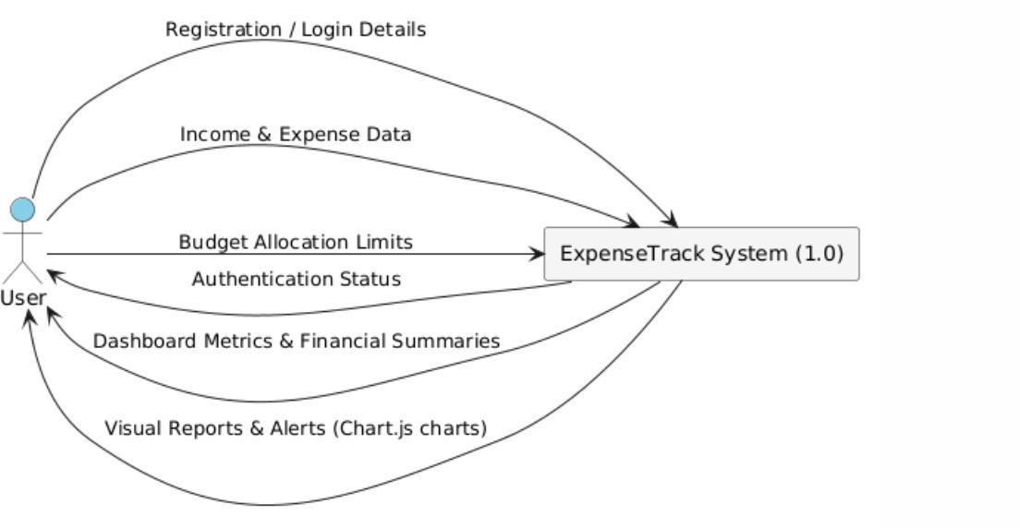
Figure 1.DFD Level 0

3.5.2 DFD Level 1
The Level 1 DFD decomposes the Expense Management System into major processes.
Processes
1. User Management
- User Registration
- User Login
2. Income Management
- Add Income
- View Income Records
3. Expense Management
- Add Expense
- View Expense Records
4. Budget Management
- Set Budget
- Monitor Budget
5. Report Generation
- Dashboard Summary
- Financial Reports

Data Stores
D1 – Users Database
D2 – Income Database
D3 – Expenses Database
D4 – Categories Database
D5 – Budgets Database
Figure 2.DFD Level 0
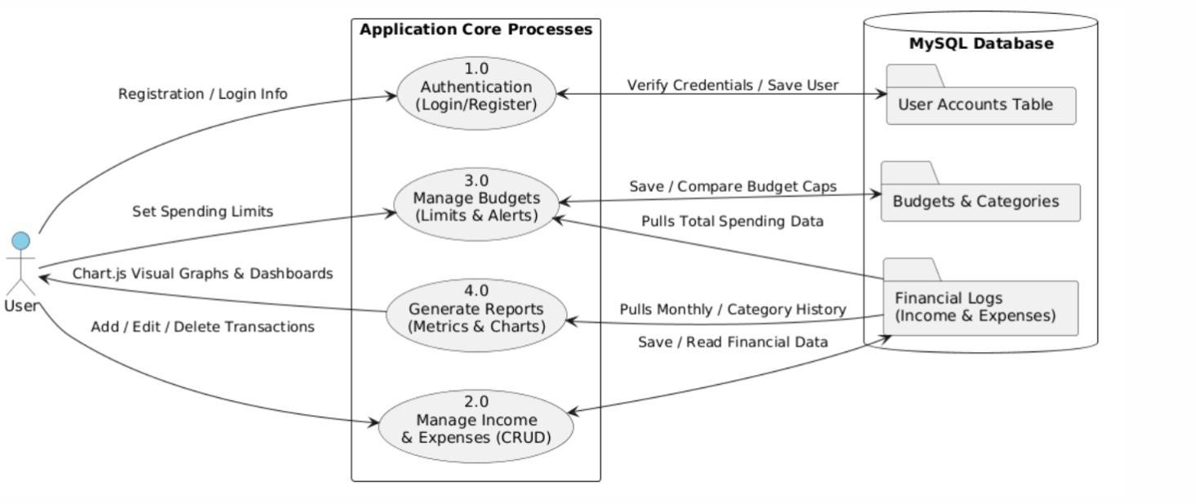
Figure 3. DFD Level 1

3.6 Database Schema:

Table: Database Tables and Attributes
Table Name | Attributes | Description
Users | id (PK), name, email (UNIQUE), password (hashed), created_at | Stores user account information and login credentials.
Categories | id (PK), name | Stores expense categories such as Food, Transportation, Entertainment, etc.
Income | id (PK), user_id (FK → Users.id), amount, source, income_date | Records income transactions of users, including amount, source, and date.
Expenses | id (PK), user_id (FK → Users.id), category_id (FK → Categories.id), amount, expense_date | Stores expense records associated with users and categories.
Budgets | id (PK), user_id (FK → Users.id), category_id (FK → Categories.id), budget_amount | Maintains budget limits set by users for different expense categories.
Table 3.Database Tables and Attributes

Table: Relationship Summary
Parent Table | Child Table | Relationship
Users | Income | One user can have many income records (1:M)
Users | Expenses | One user can have many expense records (1:M)
Users | Budgets | One user can set many budgets (1:M)
Categories | Expenses | One category can contain many expenses (1:M)
Categories | Budgets | One category can have many budget allocations (1:M)
Table 4.Relationship Summary

Table: Data Dictionary
Field Name | Data Type | Key | Description
id | INT | PK | Unique identifier
user_id | INT | FK | References Users table
category_id | INT | FK | References Categories table
name | VARCHAR(100) | - | User or category name
email | VARCHAR(100) | UNIQUE | User email address
password | VARCHAR(255) | - | Hashed password
amount | DECIMAL(10,2) | - | Income or expense amount
source | VARCHAR(100) | - | Source of income
budget_amount | DECIMAL(10,2) | - | Budget limit amount
income_date | DATE | - | Date of income transaction
expense_date | DATE | - | Date of expense transaction
created_at | TIMESTAMP | - | User account creation timestamp
Table 5.Data Dictionary

3.8 System Design:
Three-tier architecture consisting of Presentation Layer, Application Layer, and Database Layer.
System architecture :

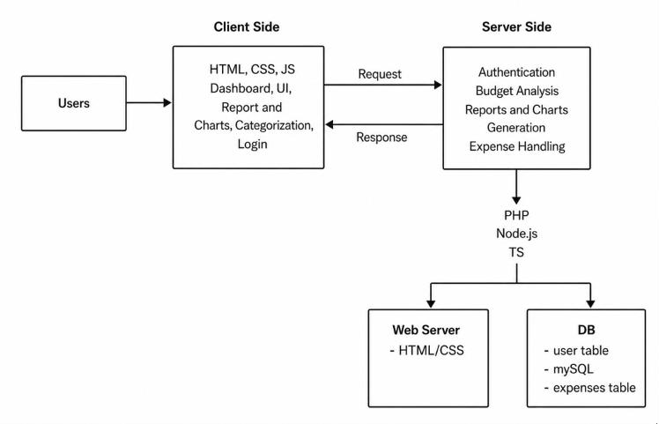
Figure 4. System Architecture Diagram

CHAPTER 4: IMPLEMENTATION AND TESTING
4.1 Introduction
This chapter presents the implementation details of the Expense Management System along with the tools, technologies, modules, and testing strategies used during development. The system was implemented using a combination of frontend, backend, and database technologies to ensure smooth functionality, usability, and data integrity. Proper testing was carried out to verify that each module works as expected and meets the defined requirements.
4.2 Tools Used
The following tools and technologies were used in the development of the system:
Frontend Technologies
- HTML (HyperText Markup Language): Used for structuring web pages and creating user interface components such as forms, tables, and navigation elements.
- CSS (Cascading Style Sheets): Used to design and style the application, ensuring a clean, responsive, and user-friendly interface.
- JavaScript: Used to add interactivity, form validation, and dynamic behavior to enhance user experience.

Backend Technology
- PHP (Hypertext Preprocessor): Used for server-side processing, handling user requests, managing sessions, and connecting the application with the database.
- Database
MySQL: Used as the relational database management system to store and manage all system data including users, income, expenses, categories, and budgets.
- Development and Design Tools
- VS Code (Visual Studio Code): Used as the primary code editor for writing and managing source code.
- XAMPP: Used to provide a local server environment including Apache, MySQL, and PHP for testing and development.
- phpMyAdmin: Used for managing MySQL databases through a graphical user interface.
- Draw.io: Used for designing system diagrams such as flowcharts, data flow diagrams (DFD), and entity relationship diagrams (ERD).
4.3 Modules of the System
The Expense Management System is divided into several functional modules, each responsible for specific operations within the application:
4.3.1 Registration Module
This module allows new users to create an account by providing necessary details such as username, email, and password. It includes input validation to ensure that the data entered is accurate and complete before storing it in the database.
4.3.2 Login Module
The login module authenticates registered users by verifying their credentials. It ensures secure access to the system and prevents unauthorized entry through session management.
4.3.3 Dashboard Module
The dashboard serves as the central interface of the system. It provides users with an overview of their financial status, including total income, total expenses, budget summaries, and graphical representations of spending patterns.
4.3.4 Income Management Module
This module allows users to add, edit, delete, and view income records. It helps users keep track of all sources of income in an organized manner.
4.3.5 Expense Management Module
The expense management module enables users to record and categorize their daily expenses. It supports editing and deletion of records and helps users monitor their spending behavior.
4.3.6 Budget Management Module
This module allows users to set monthly or category-based budgets. It tracks spending against defined limits and helps users maintain financial discipline by preventing overspending.
4.4 Testing
Testing is an essential phase in system development that ensures the application functions correctly and meets user requirements. The system was tested using unit testing techniques to verify individual components.
4.4.1 Unit Testing
Unit testing was performed on individual modules to ensure they function correctly in isolation. The following test cases were executed:
TC01: Login Validation – Pass
The login module successfully validated user credentials and allowed access only to registered users with correct information.
TC02: Registration Validation – Pass
The registration module correctly validated user input fields and successfully stored new user data in the database.
TC03: Database Connection – Pass
The system successfully established a connection with the MySQL database using PHP, ensuring smooth data retrieval and storage operations.
4.5 Summary
The implementation of the Expense Management System was carried out using well-defined modules and modern web technologies. Proper testing ensured that each component functions as expected, resulting in a stable and reliable system. The combination of frontend, backend, and database integration provides a seamless user experience for managing personal finances efficiently.

4.6 Class Diagram

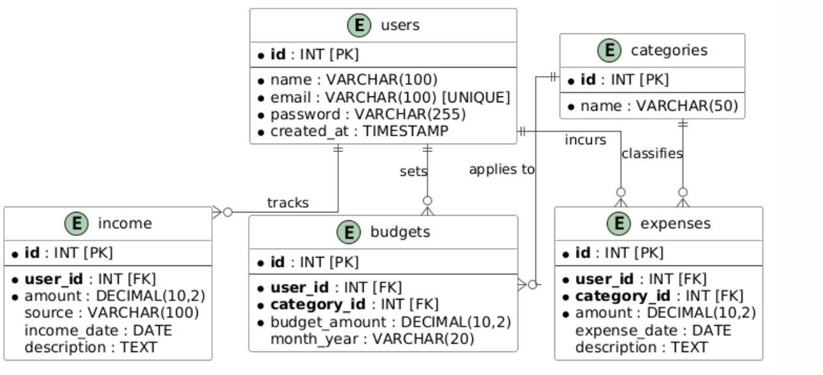
Figure 5.Class Diagram

4.7 System Flow
The system flow of the Expense Management System describes how data moves through the application and how different modules interact with each other. The system follows a structured workflow starting from user authentication to financial data management and reporting.
When a user accesses the system, the first step is registration (for new users) or login (for existing users). During registration, user details are validated and stored in the database. For login, the system verifies credentials and grants access if authentication is successful.
After successful login, the user is redirected to the dashboard, which acts as the central control panel. From the dashboard, users can navigate to different modules such as income management, expense management, and budget management.
In the income module, users can add and manage their income sources. Similarly, in the expense module, users can record and categorize their daily expenses. The budget module allows users to set financial limits and track their spending against those limits.
All transactions are stored in the MySQL database, and the dashboard dynamically retrieves and displays updated financial summaries. The system continuously ensures that user actions are reflected in real time, maintaining data consistency and accuracy.

4.8 Flowchart
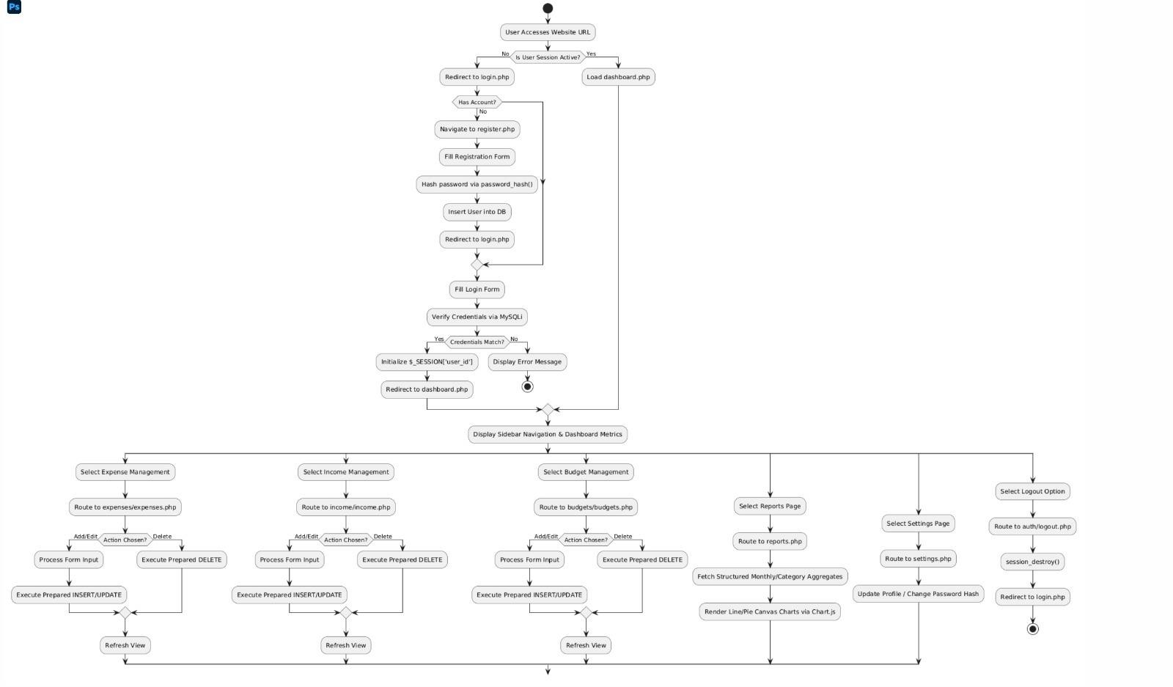
Figure 6.Flowchart
The flowchart of the Expense Management System visually represents the step-by-step flow of operations within the system. It begins with the user accessing the application and proceeds through authentication and system navigation.
  - The process starts.
  - The user chooses either registration or login.
  - If registration is selected, user details are entered, validated, and stored in the database.
  - If login is selected, credentials are verified against stored data.
  - Upon successful login, the user is directed to the dashboard.
  - The user performs operations such as adding, updating, or deleting financial records.
  - All data is stored and retrieved from the database as required.

The system updates the dashboard with real-time summaries.
The process ends when the user logs out.

Note: From the dashboard, the user can select different modules:
- Income Management
- Expense Management
- Budget Management

4.9 Use-Case diagram

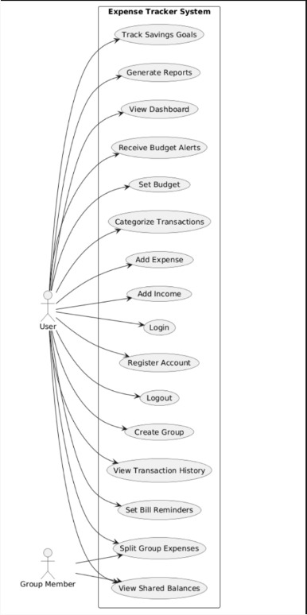
The diagram identifies the interactions between the system and its external actors, namely the User and the Group Member. The User is the primary actor who accesses and utilizes most of the system functionalities to manage personal and shared finances.
The system allows users to register an account and log in securely before accessing its features. Once authenticated, users can add income and expenses, categorize transactions, and set budgets to effectively monitor their financial activities. The system also provides budget alerts to notify users when their spending approaches or exceeds predefined limits.
To assist users in financial planning, the system offers a dashboard that provides an overview of income, expenses, budgets, and savings progress. Users can generate reports to analyze their financial performance and track savings goals over time. Additionally, transaction history can be viewed to review past financial records, and bill reminders can be set to avoid missing payment deadlines.
The system supports collaborative expense management through group functionalities. Users can create groups, split group expenses among members, and view shared balances. The Group Member actor interacts with the system by participating in shared expense activities and viewing balance information related to group transactions.
Overall, the Use Case Diagram demonstrates how the Expense Tracker System enables users to efficiently manage personal finances, monitor budgets, track savings, generate financial reports, and collaborate with others in handling shared expenses.

4.10 System Testing
System testing was conducted to evaluate the overall functionality of the Expense Management System after integrating all individual modules. The main objective of this phase was to ensure that the system works correctly as a complete application and meets all the specified requirements.
During system testing, key functionalities such as user registration, login authentication, dashboard loading, transaction storage, and budget management were carefully tested under different conditions. Each feature was checked for correctness, reliability, and responsiveness.
The user registration module was tested to ensure that new users could successfully create accounts with valid input data, and that invalid or incomplete inputs were properly handled. Similarly, the login module was tested to confirm secure authentication and proper session handling for registered users.
The dashboard functionality was evaluated to ensure that it loads accurately after login and correctly displays updated financial summaries such as total income, total expenses, and budget status. Transaction storage functionality was tested to verify that all income and expense entries are correctly saved and retrieved from the database without data loss or inconsistency.
The budget management feature was also tested to ensure that users can set budgets and track their spending effectively against defined limits. Overall, all major functionalities performed as expected, and the system successfully met its intended operational requirements.

CHAPTER 5: CONCLUSION AND FUTURE RECOMMENDATIONS

5.1 Lessons Learnt:
Requirement analysis, database design, web development, testing procedures, and project documentation.

5.2 Conclusion:
The Expense Management System successfully demonstrates a secure and user-friendly platform for personal financial management. It provides authentication, data management, and dashboard functionalities through a web-based environment.

5.3 Future Recommendations:
Mobile Application Development
AI-Based Expense Prediction
Cloud Synchronization
Multi-Currency Support
Advanced Reporting Dashboard
REFERENCES
Goodbudget. (2025). Goodbudget: Budget tracker and finance management application. https://goodbudget.com
MDN Web Docs. (2025). HTML: HyperText Markup Language. https://developer.mozilla.org/en-US/docs/Web/HTML
MDN Web Docs. (2025). CSS: Cascading Style Sheets. https://developer.mozilla.org/en-US/docs/Web/CSS
MDN Web Docs. (2025). JavaScript Guide. https://developer.mozilla.org/en-US/docs/Web/JavaScript
MySQL. (2025). MySQL documentation. https://dev.mysql.com/doc
PHP Documentation Group. (2025). PHP manual. https://www.php.net/docs.php
Spendee. (2025). Spendee: Personal finance and budget planner. https://www.spendee.com
Splitwise. (2025). Splitwise: Expense sharing and personal finance management. https://www.splitwise.com
Visual Studio Code. (2025). Visual Studio Code documentation. https://code.visualstudio.com/docs
XAMPP. (2025). XAMPP Apache + MariaDB + PHP + Perl. https://www.apachefriends.org

Appendices
Appendix A: Screenshots of XAMPP database pictures:
