ACE INSTITUTE OF MANAGEMENT


Pokhara University
Faculty of Management



Bachelor in Computer System and Information Technology (BCSIT)

A LAB REPORTS ON
Course:Project-II (CMP 281)

Year/Semester: II/IV

Submitted by:
Aashish Karki - 24080262
Kismat giri - 24080282
Sugat katuwal- 24080304

Submitted to:
Mr. Sanju Shrestha
Abstract
Nepal is a country rich in natural beauty, yet a vast number of its most scenic and peaceful destinations remain unknown to both domestic and international travelers. Information about these hidden natural retreats is scattered across social media, travel blogs, and word of mouth, making it difficult for travelers to plan trips effectively. Existing travel platforms such as TripAdvisor, Booking.com, and the Nepal Tourism Board primarily highlight popular destinations like Everest Base Camp, Pokhara, and Kathmandu, leaving lesser-known locations without proper exposure or organized information.
This project, Nepal Travel: Discover Hidden Natural Retreats, proposes the development of a community-driven web platform designed to bridge this gap. The system enables users to discover, explore, and share hidden natural destinations across Nepal, including forests, lakes, hills, waterfalls, and peaceful viewpoints. Key features of the platform include destination search and filtering by region, season, activity, and difficulty level, as well as map integration using Google Maps, user-submitted reviews and photographs, trip planning tools, and personalized destination collections.
The system is developed using HTML, CSS, and JavaScript for the frontend, PHP for backend logic, and MySQL for database management. Following an Agile development methodology, the platform is built to be user-friendly, scalable, and accessible to travelers of all experience levels. The expected outcome is a reliable, centralized travel platform that promotes sustainable tourism, supports local communities, and makes Nepal's hidden natural treasures discoverable to the world.

Acknowledgement
We would like to express our heartfelt gratitude to all those who supported and guided us throughout the successful completion of this project, Nepal Travel: Discover Hidden Natural Retreats.
- We sincerely thank our project supervisor, Mr. Sanju Shrestha, for his continuous guidance, constructive feedback, and valuable suggestions at every stage of this project.
- We extend our gratitude to ACE Institute of Management and Pokhara University for providing us with the opportunity, resources, and academic environment to undertake this project as part of the Bachelor in Computer System and Information Technology (BCSIT) program.
- We would like to thank the Faculty of Management for their constant support and for providing us with the necessary academic foundation to carry out this work.
- Special thanks to our friends and classmates for their cooperation, helpful discussions, and moral support throughout the development process.
- Finally, we acknowledge everyone who contributed directly or indirectly to the completion of this project. Their support has been invaluable.

Table of contents

Acknowledgement 2
2.1 Fundamental Theories and Concepts 10
2.2 Review of Similar Projects and Systems 12
3.1.1 Requirement Analysis 13
3.1.2 Feasibility Analysis 17
3.1.3 Data Modeling 19
3.1.4 Process Modeling 21
3.2 System Design 24
Chapter 4: Implementation and Testing 26
4.1 Implementation 26
4.1.1 Tools Used 26
4.1.2 Implementation Details of Modules 27
4.2 Testing 28
Chapter 5: Conclusion and Future Recommendations 30
5.1 Lessons Learnt 30
5.2 Conclusion 30
5.3 Future Recommendations 31
Appendices 32
References 39

List of figures
Figure 1 : Use case diagram 15
Figure 2: ER Diagram 20
Figure 3: Flowchart 23
Figure 4: System Architecture 25
Figure 5: Login and register page 32
Figure 6: Homepage 33
Figure 7: Add destination form 34
Figure 8: Show destination details 37
Figure 9: Admin panel 38

List of tables

Table 1: Unit test cases 28
Table 2: System test cases 29

Chapter 1: Introduction
1.1 Backgroud
Nepal Travel: Discover Hidden Natural Retreats is a web-based travel discovery platform designed to connect travelers, local communities, and hidden natural destinations across Nepal through a single digital platform. Nepal is widely recognized for its mountains, cultural heritage, and adventurous destinations. However, beyond the popular tourist spots such as Everest Base Camp, Pokhara, and Kathmandu, there exist countless lesser-known natural locations including forests, lakes, waterfalls, hills, and peaceful viewpoints that remain unexplored and under-promoted. These hidden destinations often lack proper visibility, organized information, and digital presence, making it difficult for travelers to discover and plan visits to them.
With the rapid growth of internet access and digital technology, travelers increasingly rely on online platforms for destination research, trip planning, and travel guidance. Most existing platforms such as TripAdvisor, Booking.com, and the Nepal Tourism Board primarily focus on commercial and popular tourist destinations, leaving hidden natural retreats without adequate exposure. Social media platforms like Instagram and TikTok contain scattered travel content but lack proper organization, guidance, and reliability.
The Nepal Travel platform aims to use technology to bridge this gap by providing a centralized, community-driven web system where travelers and locals can discover, share, and review hidden natural destinations. Through this platform, users will be able to search destinations based on region, season, activity type, and difficulty level, access detailed travel information including routes and travel tips, upload reviews and photographs, and organize their personal trip plans. The system also integrates Google Maps for location visualization and navigation support.
Nepal Travel not only helps travelers plan more meaningful and authentic journeys but also supports sustainable tourism development by increasing the visibility of lesser-known destinations. By promoting hidden natural retreats, the platform encourages tourism activities in diverse regions of Nepal, helping local communities gain economic benefits while reducing the overcrowding of popular tourist spots.

1.2 Statement of problem
Many hidden natural destinations in Nepal remain unknown and under-promoted because there is no centralized platform that provides reliable and organized travel information. Most travelers depend on social media, blogs, videos, or word of mouth to discover travel destinations, which often results in confusion, incomplete information, and poor travel decisions. Existing travel systems mainly focus on popular tourist areas and fail to highlight lesser-known natural retreats.
The major problems faced by existing systems are:
1. Lack of Proper Travel Information
- Travelers cannot easily find detailed information about hidden destinations
- Information about routes, transportation, weather, and safety is often incomplete or scattered
- Difficulty in comparing destinations and planning trips effectively
2. Poor Community Interaction
- Limited interaction between travelers and local communities
- Lack of a common platform to share reviews, travel experiences, and recommendations
- Difficulty in receiving updated travel announcements and guidance
3. Manual and Unorganized Data Management
- Travel information is not properly organized in a centralized system
- High chances of outdated, duplicated, or unreliable information
- Difficulty in maintaining records of destinations, reviews, and user contributions
4. Lack of Visibility for Local Destinations
- Many naturally beautiful places remain unexplored and receive little tourism attention
- Local communities do not gain enough economic benefits from tourism activities
- Popular tourist destinations become overcrowded while hidden places remain ignored
5. Difficulty in Trip Planning
- Travelers face challenges while searching for suitable destinations based on season, activities, and difficulty level
- Lack of integrated map and navigation support for remote locations
- Difficulty in saving and organizing travel plans efficiently
Nepal Travel aims to solve these problems by providing a modern travel discovery platform that connects travelers, local communities, and hidden destinations through a single integrated web system.
1.3 Objectives of the study
The main objective of the Nepal Travel: Discover Hidden Natural Retreats system is to design and develop a modern digital travel platform that helps users discover, explore, and organize information about hidden natural destinations across Nepal. The system aims to make travel planning easier, more reliable, and more interactive by using modern web technologies while also promoting sustainable tourism and local destination visibility.
The specific objectives of this project are:
- To develop a centralized travel discovery platform for Nepal
- To promote hidden and lesser-known natural destinations across Nepal
- To provide organized and reliable travel information to users
- To simplify trip planning for travelers of all experience levels
- To support destination search and filtering by region, season, activity, and difficulty
- To integrate maps and route visualization using Google Maps
- To encourage community participation and travel experience sharing
- To improve communication between travelers and local communities
- To increase the visibility of lesser-known tourist destinations
- To promote sustainable tourism and support local economic growth

1.4 Scope of the study
The Nepal Travel project focuses on creating a platform that connects travelers, locals, and hidden natural destinations in one organized system. It mainly includes destination management, user registration and profile management, travel search and filtering, community reviews ,Google Maps integration, and personalized trip planning and bookmarking features.
Users can securely register and log in, with different roles assigned to general travelers and administrators. Travelers can search and explore destinations, read and submit reviews, save places to personal collections, and plan future trips. Administrators can manage destination records, monitor user contributions, and maintain overall platform content.
The system also provides notification and communication features to keep users informed about newly added destinations and travel updates. Overall, the scope is to make hidden natural travel destinations in Nepal more organized, accessible, and discoverable through a modern digital platform.

1.5 Limitations of the Study
- The study is limited by time constraints, which restricted deeper research and full feature development.
- It is based on a student-level project, so it does not include all advanced or enterprise-level functionalities.
- Limited resources in terms of tools, data, and technologies affected the overall depth and scope of the system.
- The system relies on community-contributed data, which may vary in accuracy and completeness in the early stages.
- Real-time features such as live weather updates, dynamic route tracking, and advanced analytics are either limited or not fully implemented.
- Scalability testing and handling of large numbers of concurrent users were not extensively performed.
- The platform currently supports web-based access only and does not include a dedicated mobile application.

Chapter 2: Literature Review

2.1 Fundamental Theories and Concepts

2.1.1 Web-Based Information Systems
Nepal Travel is built on a web-based information system architecture, which allows users to access travel information and platform features through a browser without installing any additional software. Such systems typically follow a client-server architecture where the frontend handles user interaction and the backend manages data processing and storage. This architecture makes the platform easily accessible to travelers and locals across different devices and locations.

2.1.2 User Authentication and Authorization
Authentication ensures that only registered users can access the system, while authorization controls what each user is allowed to do based on their role. In Nepal Travel, this is essential to distinguish between general travelers and administrators. Travelers can search destinations, submit reviews, and manage trip plans, while administrators have additional privileges to manage destination records and monitor platform content.

2.1.3 Travel Discovery and Destination Management Systems
Travel discovery systems are digital platforms designed to help users find, explore, and organize information about travel destinations. They typically include destination databases, search and filtering tools, map integration, and user review features. Such systems improve the accessibility of travel information and help travelers make better trip planning decisions.

2.1.4 Community-Driven Content Systems
Community-driven platforms allow users to contribute content such as reviews, photographs, ratings, and travel tips. This model improves the authenticity and reliability of information available on the platform. Nepal Travel uses this approach to build a growing database of hidden destinations through local knowledge and traveler experiences.

2.1.5 Map Integration and Geolocation Systems
Modern travel platforms integrate map and geolocation services to help users visualize destination locations, explore routes, and navigate to places. Nepal Travel integrates Google Maps to display destination locations, provide route information, and help users identify nearby hidden retreats. Geolocation features significantly improve the overall travel planning experience.

2.1.6 Sustainable Tourism
Sustainable tourism refers to the responsible development and promotion of tourism activities that minimize environmental impact while supporting local communities and economies. Nepal Travel aligns with this concept by promoting lesser-known destinations and distributing tourism activity across diverse regions of Nepal, reducing the overcrowding of popular spots and encouraging local economic growth.

2.2 Review of Similar Projects and Systems
To understand the current approaches used in travel and tourism platforms, several existing systems were studied:
TripAdvisor(https://www.tripadvisor.com)
TripAdvisor is one of the world's most popular travel platforms that provides hotel reviews, travel guides, restaurant recommendations, and tourism information. Users can explore destinations, view ratings, and share travel experiences. However, the platform mainly focuses on commercial and popular tourist destinations, and hidden natural places in Nepal receive very limited visibility on this platform.
Google maps(https://www.google.com/maps)
Google Maps is widely used for navigation, route visualization, and location searching. It provides detailed maps, directions, and location information for users worldwide. Although it is highly effective for navigation purposes, it does not specifically focus on promoting hidden natural destinations or providing organized, tourism-specific community features such as travel tips, seasonal guidance, or destination collections.
Nepal Tourism Board (https://ntb.gov.np)
The Nepal Tourism Board provides official tourism information including destination guides, travel advisories, and promotional content about Nepal. While it serves as a reliable source of general tourism information, it gives significantly less focus to lesser-known and off-the-beaten-path natural destinations, concentrating mostly on popular tourist circuits.
Booking.com (https://booking.com.)
Booking.com is a travel and accommodation platform that allows users to book hotels, flights, and travel services. It provides destination information and customer reviews, but its primary focus is on accommodation and commercial tourism services rather than promoting hidden or community-discovered travel locations.

Chapter 3: System Analysis and Design
3.1 System Analysis

3.1.1 Requirement Analysis
The Nepal Travel system is designed as a web-based travel discovery platform that connects travelers, locals, and hidden natural destinations across Nepal. The main requirements were identified through analysis of existing travel platforms and the problems faced by travelers in discovering lesser-known natural retreats.

- Functional Requirements
Functional requirements describe the main services and operations that the system performs.
1. User Registration and Role Management
- Users can register and log in securely
- Role-based access for Travelers and Administrators
- Different dashboards based on user roles
- Users can manage and update their personal travel profiles
2. Destination Management
- Admin can add, update, and delete travel destinations
- Store destination details such as location, description, best season, difficulty level, and travel tips
- Upload destination images and related travel information
- Display destinations in an organized and accessible manner
3. Search and Filtering System
- Users can search destinations by name or keyword
- Filter destinations based on region, activity type, season, difficulty level, and trip duration
- Advanced search options for more precise travel planning
- Display search results in a clear and organized format
4. Travel Reviews and Community Interaction
- Users can submit reviews and share travel experiences
- Rate destinations and provide recommendations to other travelers
- Community-based interaction among travelers and locals

5. Map Integration and Navigation
- Integration with Google Maps for destination location visualization
- Display routes and provide navigation support
- Help users identify nearby hidden destinations and travel paths
- Show location coordinates and directions for remote places

6. Trip Planning and Bookmark Features
- Users can save favorite destinations to personal collections
- Organize and manage custom trip plans
- Add personal notes to saved destinations
- Easy access to previously viewed and bookmarked destinations

7. Admin Dashboard and Content Management
- Admin dashboard to manage users, destinations, and platform content
- Monitor and moderate user-submitted reviews and photographs
- Maintain destination records and update travel information
- Oversee overall platform activity and user contributions

8. Notification and Communication System
- Notify users about newly added destinations and travel updates
- Alerts for platform announcements and travel advisories
- Communication support between users and administrators

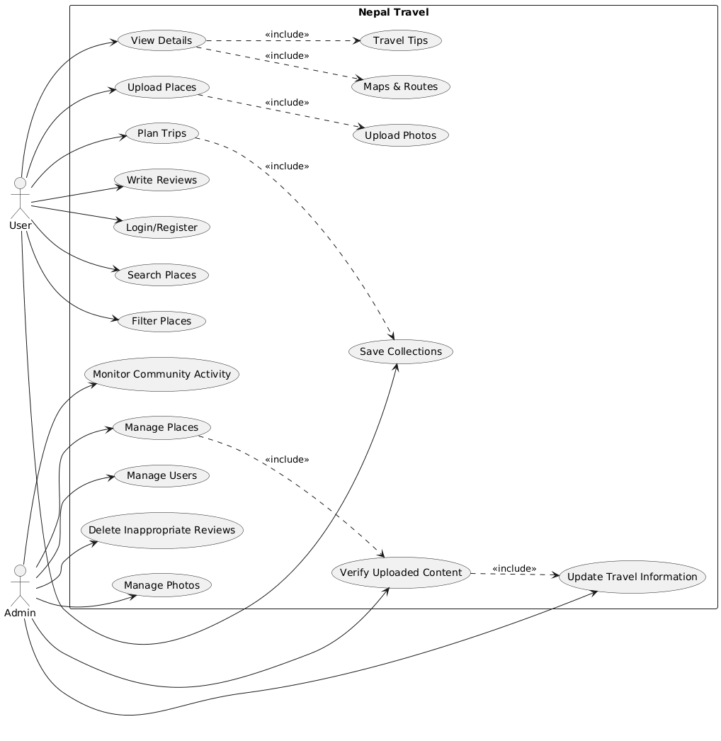
Figure 1 : Use case diagram

- Non-Functional Requirements
Non-functional requirements define the quality and performance standards of the system.
1. Security
- Secure user registration, login, and authentication system
- Protection of user data and personal travel information
- Role-based access control to prevent unauthorized actions
2. Performance
- Fast response time for destination search and filtering
- Efficient handling of multiple simultaneous users
- Smooth system performance during peak usage periods
3. Usability
- Simple, clean, and user-friendly interface for all users
- Easy navigation suitable for travelers of all experience levels
- Responsive design compatible with both desktop and mobile devices
4. Reliability
- Accurate and consistent storage of destination and user information
- Reliable access to travel details, reviews, and maps
- Minimal system downtime to ensure continuous availability
5. Scalability
- System can support an increasing number of users and destination records over time
- New features and travel modules can be added in the future without major restructuring
6. Maintainability
- Easy to update destination information and platform features
- Modular system design for easier maintenance and future improvements

3.1.2 Feasibility Analysis
Feasibility analysis evaluates whether the proposed Nepal Travel system is practical, achievable, and sustainable within the given constraints. The following four aspects were examined:

1. Technical Feasibility
The Nepal Travel system is technically feasible as it can be developed using widely available and well-supported web technologies. The frontend is built using HTML, CSS, and JavaScript, while the backend is developed using PHP with MySQL for database management. Google Maps API is used for map integration and location visualization. These technologies are stable, well-documented, and suitable for building a responsive and feature-rich travel discovery platform. Supporting tools such as Visual Studio Code and GitHub are also used to improve development efficiency and project management. Overall, the technical resources required for this project are accessible and within the team's capabilities.

2. Operational Feasibility
The Nepal Travel system is operationally feasible because it is designed to be simple, intuitive, and accessible for users of all experience levels. Travelers can easily register, search destinations, read and submit reviews, save trip plans, and navigate the platform without requiring any advanced technical knowledge. Administrators can manage destination records and monitor user contributions through a straightforward dashboard. The platform's clean and user-friendly interface ensures that both locals and tourists can operate the system with minimal training or guidance, making it practically viable for everyday use.

3. Financial Feasibility
The Nepal Travel project is financially feasible as it relies entirely on open-source technologies and freely available development tools, requiring minimal financial investment. Technologies such as PHP, MySQL, HTML, CSS, and JavaScript are available at no cost. Google Maps API provides a free usage tier suitable for a student-level project. Hosting and domain costs are minimal and can be managed within a standard academic project budget. Since no expensive software licenses or paid frameworks are required, the overall development cost remains low, making the project economically practical and achievable.

4. Schedule Feasibility
The Nepal Travel system is feasible within the academic project timeline. The project follows a 12-week development schedule divided into clearly defined phases including planning, requirement analysis, UI/UX design, frontend development, backend development, complex integrations, testing and bug fixing, feedback and improvements, and final documentation. By following an Agile development approach with iterative progress, the team can efficiently manage tasks, track milestones, and deliver a functional system within the given timeframe. The phased development plan ensures that work is distributed evenly and completed on schedule.

3.1.3 Data Modeling
The data model for Nepal Travel is designed to support a unified platform where travelers, locals, and administrators interact to discover and share hidden natural destinations across Nepal. It captures user management, destination information, community reviews, photo uploads, route details, and personalized trip collections. The schema ensures proper relationships between all entities while supporting role-based access and community-driven content.
Key Entities and Relationships:
- Users serve as the central identity of the system, storing login credentials, profile information, and role details (user or admin). Users can add places, write reviews, upload photos, and create collections.
- Places represent the hidden natural destinations stored in the system. Each place belongs to a category, is added by a user, and stores details such as name, description, coordinates, region, difficulty, best season, trip length, and activity type.
- Categories organize destinations into groups such as forests, lakes, hills, and waterfalls, each identified by a name and icon.
- Reviews record user feedback on places, including a rating, comment, and timestamp, linking users to the places they have visited.
- Photos store user-uploaded images of destinations, capturing the file path, caption, and upload timestamp linked to both the user and the place.
- Collections allow users to create personalized groups of saved destinations, such as "Weekend Trips" or "Near Kathmandu", with a name and description.
- Saved Places link collections to specific places, allowing users to organize their favorite destinations into custom trip plans with personal notes.

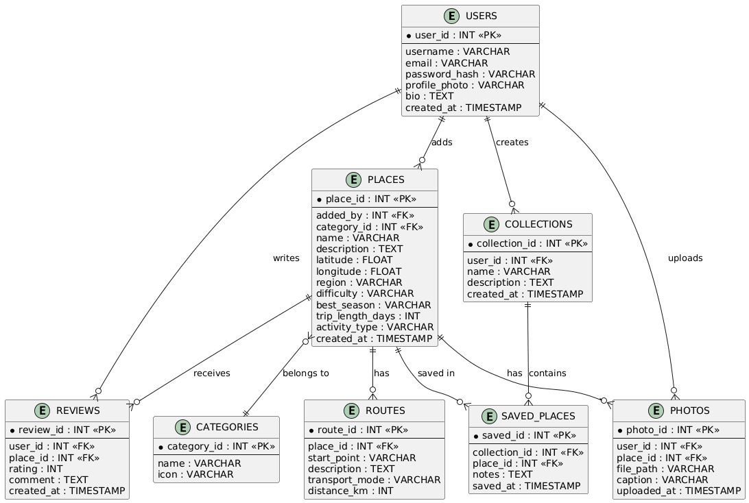
Figure 2: ER Diagram

3.1.4 Process Modeling
Process modeling describes the key workflows and interactions within the Nepal Travel system. It illustrates how users, administrators, and the system interact to achieve the platform's core functionalities. The following are the main processes of the Nepal Travel system:

1. User Registration and Login Process
- New user visits the platform and clicks on the Register option
- User fills in required details such as username, full name, email, and password
- System validates the input and checks for duplicate email or username
- Upon successful validation, the account is created and stored in the database
- User logs in using registered email and password
- System authenticates credentials and grants access to the personalized dashboard
- Admin logs in separately and is redirected to the admin dashboard with management privileges

2. Destination Discovery and Search Process
- User accesses the platform and browses available hidden destinations
- User applies filters such as region, activity type, difficulty level, best season, or trip duration
- System queries the database and returns matching destination results
- User selects a destination to view detailed information including description, photos, routes, and reviews
- Google Maps integration displays the destination location and available routes
- User can view transportation options, distance, and navigation details

3. Review Submission Process
- Registered user navigates to a destination page they have visited
- User clicks on the option to write a review for the destination
- User submits a rating and comment sharing their travel experience
- System validates and stores the review in the database
- The submitted review becomes visible to other travelers on the destination page
- Other users can read reviews to make more informed travel decisions

4. Trip Planning and Collection Management Process
- User browses destinations and finds places they wish to visit
- User saves a destination to a personal collection such as "Weekend Trips" or "Near Kathmandu"
- System stores the saved place under the selected collection linked to the user's account
- User can add personal notes to saved destinations for future reference
- User accesses their profile dashboard to view and manage all saved collections and trip plans
- User can update, reorganize, or remove destinations from their collections at any time

5. Admin Destination and Content Management Process
- Admin logs in and accesses the admin dashboard
- Admin can also adds new hidden destinations by filling in details such as name, location, description, category, difficulty, best season, and activity type
- System stores the destination in the database and makes it visible to all users
- Admin reviews and moderates user-submitted reviews
- Admin updates or removes outdated or inappropriate destination content
- Admin monitors overall platform activity including user registrations, destination additions, and community contributions

6. Notification Process
- System automatically sends notifications to users when new destinations are added in their preferred region
- Users receive alerts about travel updates, platform announcements, and newly uploaded content
- Admin can send announcements and travel advisories to all registered users through the communication system

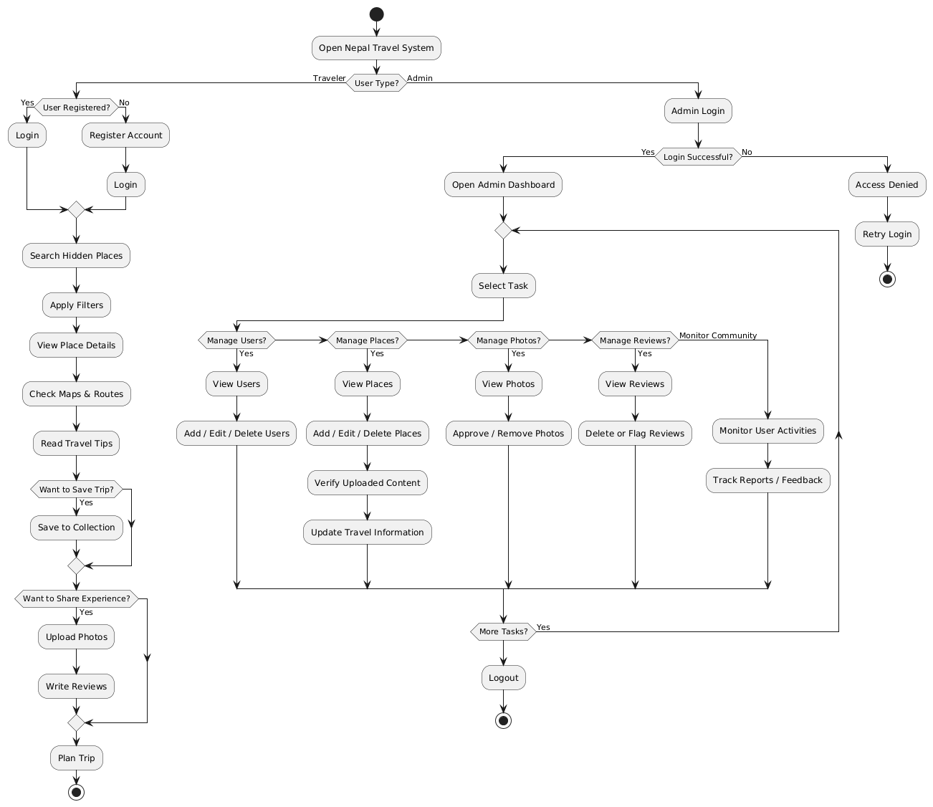
Figure 3: Flowchart

3.2 System Design

3.2.1 Architectural Design
Nepal Travel follows a 3-tier architecture that separates the system into three distinct layers, ensuring better organization, maintainability, and scalability of the platform.

1. Presentation Layer (Frontend)
The presentation layer is the topmost layer of the system that the user directly interacts with. It is built using HTML, CSS, and JavaScript to create a clean, responsive, and user-friendly interface. This layer handles all visual components of the platform including the homepage, destination listing pages, search and filter interface, destination detail pages, review submission forms, trip planning and collection management pages, and the admin dashboard. The presentation layer communicates with the application layer to send user requests and display returned data dynamically.

2. Application Layer (Backend)
The application layer serves as the middle tier of the system and is responsible for processing all business logic and handling communication between the presentation layer and the data layer. It is developed using PHP and handles core functionalities such as user authentication and role management, destination search and filtering logic, review submission and validation, collection and trip plan management, Google Maps API integration, admin content management, and notification handling. All user requests received from the frontend are processed in this layer before interacting with the database.

3. Data Layer (Database)
The data layer is the bottom tier of the system and is responsible for storing, managing, and retrieving all platform data. It is built using MySQL using XAMPP and contains all the database tables including Users, Places, Categories, Reviews, Routes, Collections, Saved Places, and Photos. This layer receives structured queries from the application layer, performs the required database operations, and returns the results back to the application layer for further processing and display.

The 3-tier architecture of Nepal Travel ensures a clear separation of concerns, making the system easier to develop, test, maintain, and scale in the future.

Figure 4: System Architecture
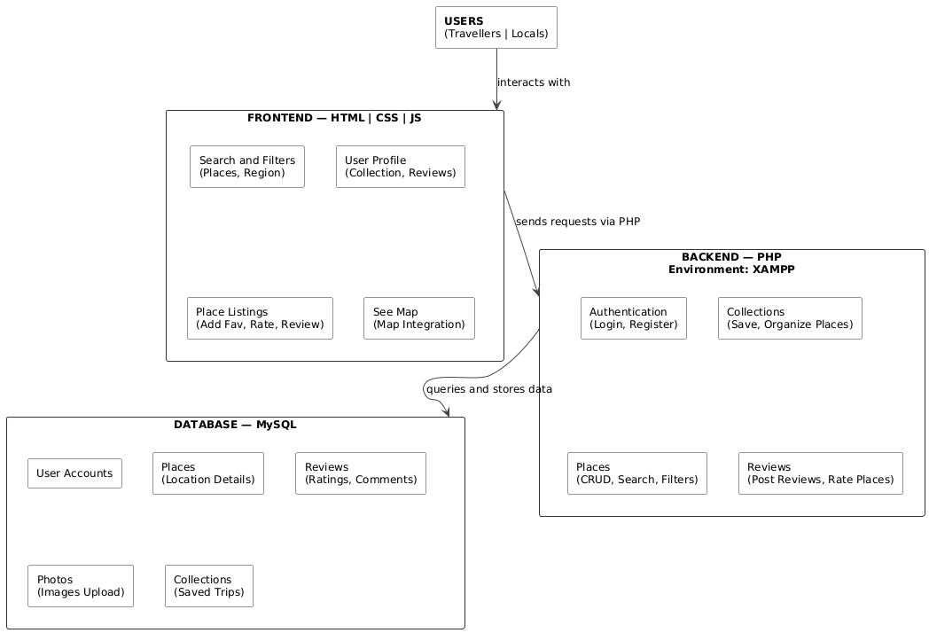

Chapter 4: Implementation and Testing

4.1 Implementation
The Nepal Travel project is currently in the implementation phase. At this stage, the system includes a fully designed user interface (UI) and a semi-completed database schema. The backend logic and full system integration are still under development.
The implementation focuses on:
- Designing responsive web pages for travelers and administrators
- Creating and structuring the relational database
- Preparing system modules for future backend integration

4.1.1 Tools Used
The following tools and technologies were used in the current implementation phase:
Frontend Technologies
- HTML5 for structuring web pages
- CSS3 for styling and responsive design
- JavaScript for dynamic and interactive frontend behavior
Backend Technology
- PHP for server-side logic and processing
Database Platform
- MySQL via phpMyAdmin for database creation and management
Development Environment
- XAMPP as the local server environment for running PHP and MySQL
- Visual Studio Code as the primary code editor
Map Integration
- Google Maps API for location display and route visualization
Browser
- Google Chrome for UI testing and debugging
Version Control
- GitHub for project management and code versioning

4.1.2 Implementation Details of Modules
At this stage, the UI, database, and core backend modules have been implemented.
1. User Interface Module
- Login and registration pages designed and structured
- User dashboard layout created with profile, collections, and trip planning sections
- Admin dashboard layout prepared for destination and content management
- Navigation bar, homepage, and destination listing pages completed
2. Database Module
- Tables created for Users, Reviews, Collections, Saved Places, and notes
- Relationships defined between tables using foreign keys
- Data structure prepared and tested for system integration
- Admin user seeded into the database for initial access
3. Destination Management Module
- Destination listing page designed showing hidden natural places across Nepal
- Destination detail page created displaying name, description, location, season, difficulty, and activity type
- Admin interface prepared for adding, updating, and removing destination records
4. Search and Filter Module
- Search interface designed allowing users to search destinations by keyword
- Filter options prepared for region, activity type, difficulty level, best season, and trip duration
- Filter and search results display page structured and connected to the database
6. Trip Planning and Collections Module
- Save to collection feature implemented allowing users to bookmark destinations
- Personal collections page designed for users to manage their saved trips
- Notes feature prepared allowing users to add personal notes to saved destinations
- Here's the updated Testing section with SN instead of Test Case:

4.2 Testing
- Testing has been performed on the frontend, database structure, and available backend modules to ensure the system functions correctly at the current stage of development.

4.2.1 Unit Testing

Table 1: Unit test cases
SN | Module | Description | Expected Result | Actual Result | Status
1 | User Registration | Register a new user with valid details | Account created successfully | Account created | Passed
2 | User Login | Login with correct email and password | Dashboard accessed | Dashboard loaded | Passed
3 | Invalid Login | Login with incorrect password | Error message displayed | Error message shown | Passed
4 | Search Places | Search destinations by keyword | Matching results displayed | Results displayed | Passed
5 | Filter Places | Filter by region and difficulty | Filtered results returned | Correct results shown | Passed
6 | View Destination | Click on a destination to view details | Detail page loaded with full info | Page loaded correctly | Passed
7 | Write Review | Submit a rating and comment | Review saved and displayed | Review not stored | Partially passed
8 | Save Collection | Save a destination to a collection | Destination saved under collection | Saved successfully | Passed
9 | Admin Add Place | Admin adds a new destination | Destination appears in listing | Place not added correctly | Partially Passed
10 | Database Connection | Verify database tables creation | All tables created correctly | Tables verified | Passed

4.4.2 System Testing

Table 2: System test cases
SN | Description | Expected Result | Actual Result | Status
1 | Check if all pages load correctly without errors | All pages load successfully | All pages loaded | Passed
2 | Check all page links and navigation flow | Pages navigate correctly | Navigation working | Passed
3 | Check input validation on registration and review forms | Invalid inputs show error messages | Validation working | Partially Passed
4 | Verify admin and user access different dashboards | Correct dashboard shown per role | Access control working | Passed
5 | Test search and filter system end to end | Correct destinations returned | Results accurate | Passed
6 | Verify Google Maps loads with correct location pins | Map displays with correct markers | Map not loaded | In progress
7 | Submit a review and verify it appears on destination page | Review displayed after submission | Review not visible | In progress
8 | Save multiple destinations and verify under collections | All saved places appear in collection | Collections working | Passed
9 | Admin updates and deletes a destination | Changes reflected immediately | Updates successful | Passed

Chapter 5: Conclusion and Future Recommendations

5.1 Lessons Learnt
During the development of the Nepal Travel project, several important concepts and skills were learned, including:
- Designing responsive and user-friendly interfaces using HTML, CSS, and JavaScript for a travel discovery platform
- Structuring and managing relational databases using MySQL, including defining relationships between entities such as users, places, reviews, collections, and routes
- Understanding and applying system design concepts such as ER diagrams, use case diagrams, data modeling, and process modeling
- Integrating third-party services such as Google Maps API for location display and route visualization
- Importance of modular development, proper planning, and requirement analysis before beginning implementation
- Understanding the role of community-driven content in building a reliable and authentic travel platform
- Gaining practical experience in working as a team, dividing responsibilities, and managing a project within an academic timeline

5.2 Conclusion
The Nepal Travel: Discover Hidden Natural Retreats project is currently in its early development stage. The user interface design, database structure, and core backend modules have been partially completed. Although the system is not yet fully functional, a strong and well-organized foundation has been properly built for future integration and complete system development.
The project successfully addresses the problem of hidden natural destinations in Nepal remaining undiscovered due to the lack of a centralized and organized travel platform. By combining destination discovery, community reviews, trip planning, map integration, and personalized collections into a single web-based system, Nepal Travel aims to promote sustainable tourism, support local communities, and make travel planning easier and more reliable for all users.
The platform has the potential to grow into a fully functional travel discovery system that connects travelers, locals, and hidden natural destinations across Nepal in a meaningful and impactful way.

5.3 Future Recommendations
To improve and complete the Nepal Travel system in the future, the following enhancements and additions are recommended:
- Complete the backend functionality for all remaining modules including advanced user notifications and communication features
- Develop a dedicated mobile application for Android and iOS to make the platform more accessible to travelers on the go
- Integrate an offline mode allowing users to access saved destination information without an internet connection, which is essential for remote trekking areas
- Implement an advanced recommendation system that suggests destinations based on user preferences, travel history, and search behavior
- Add multilingual support including Nepali language to make the platform accessible to local communities and domestic travelers
- Integrate real-time weather information for each destination to help travelers plan trips according to current conditions
- Develop a community forum or discussion feature where travelers can interact, ask questions, and share detailed travel experiences
- Implement advanced analytics and reporting features for administrators to monitor platform growth, popular destinations, and user engagement
- Strengthen the security system with two-factor authentication and improved data protection measures
- Collaborate with local tourism boards, trekking agencies, and community organizations to expand the database of hidden destinations and ensure information accuracy

Appendices
In this section, screenshots of the Nepal Travel project are included to provide visual evidence of the system's development and functionality. These screenshots represent different parts of the project such as the user interface, including the homepage, login and registration pages, destination listing pages, search and filter modules, destination detail pages, and collections, and the admin dashboard.

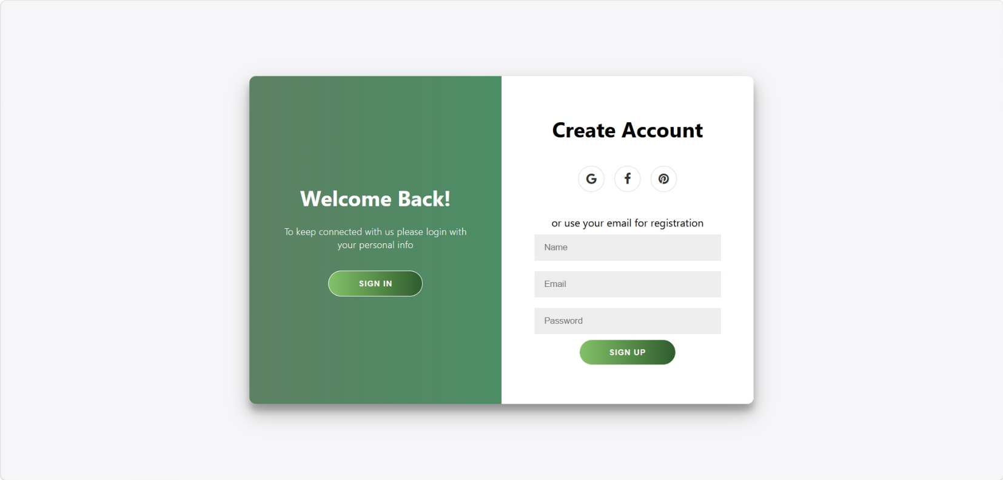
Figure 5: Login and register page

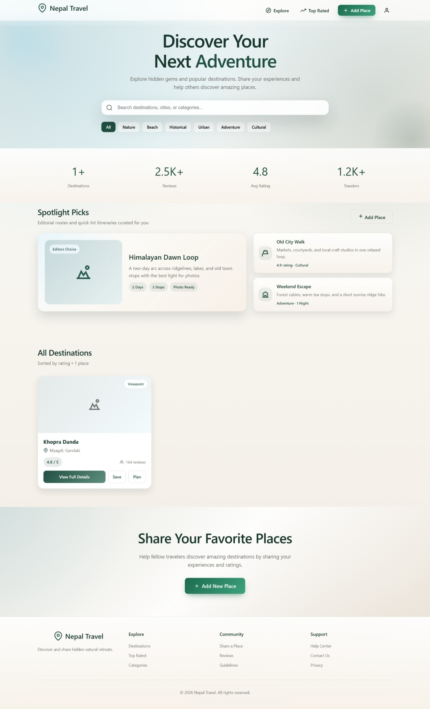
Figure 6: Homepage
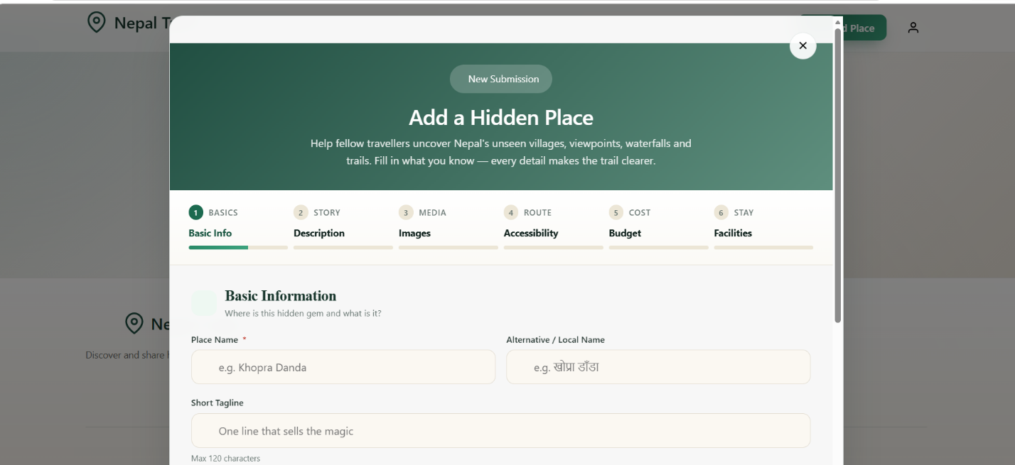
Figure 6: homepage
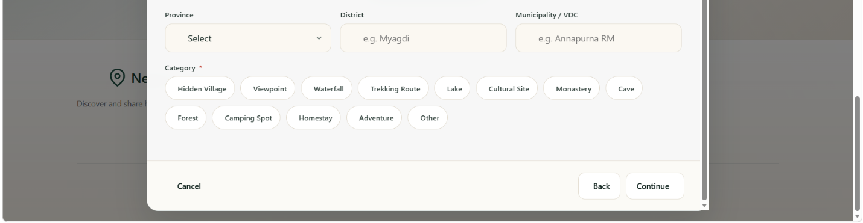
Figure 7: Add destination form

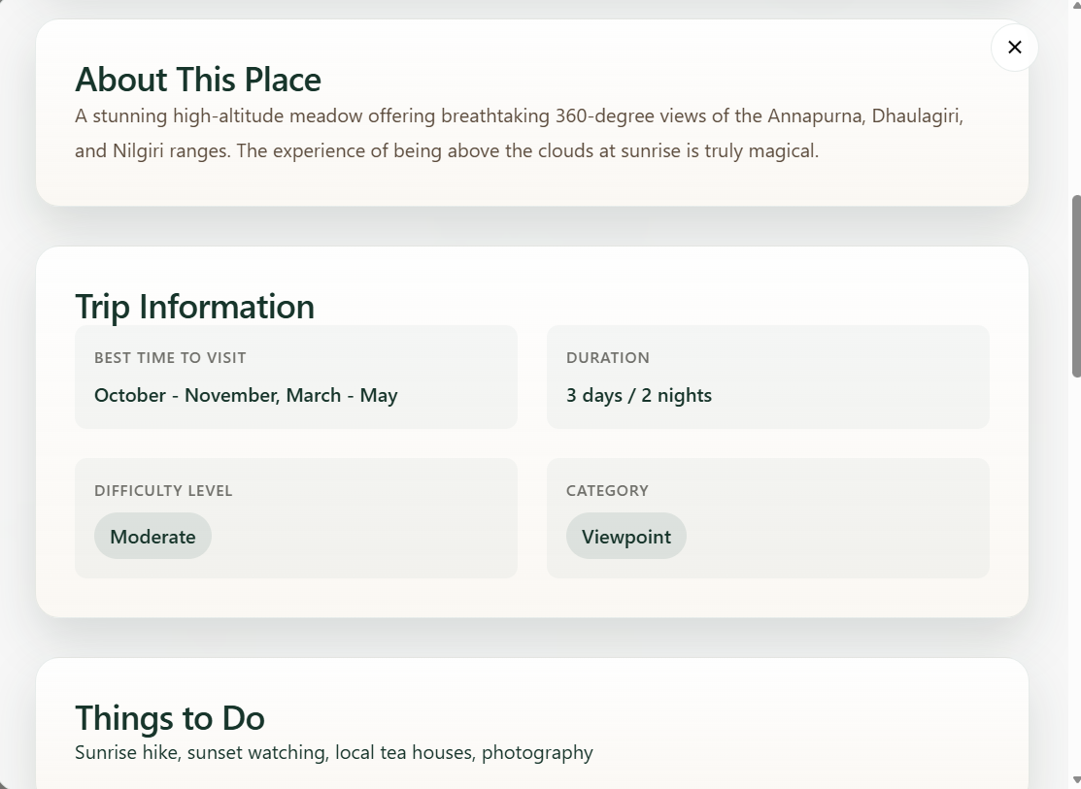
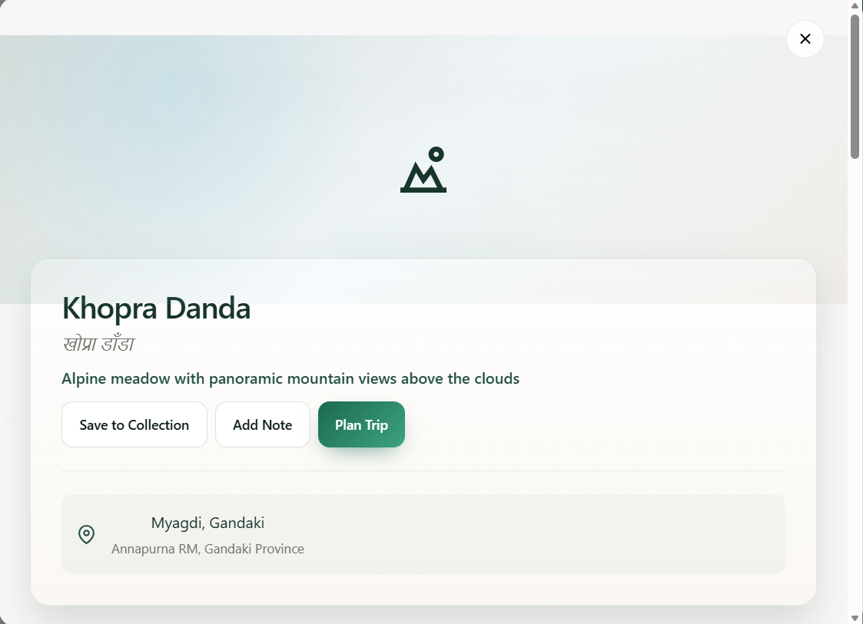
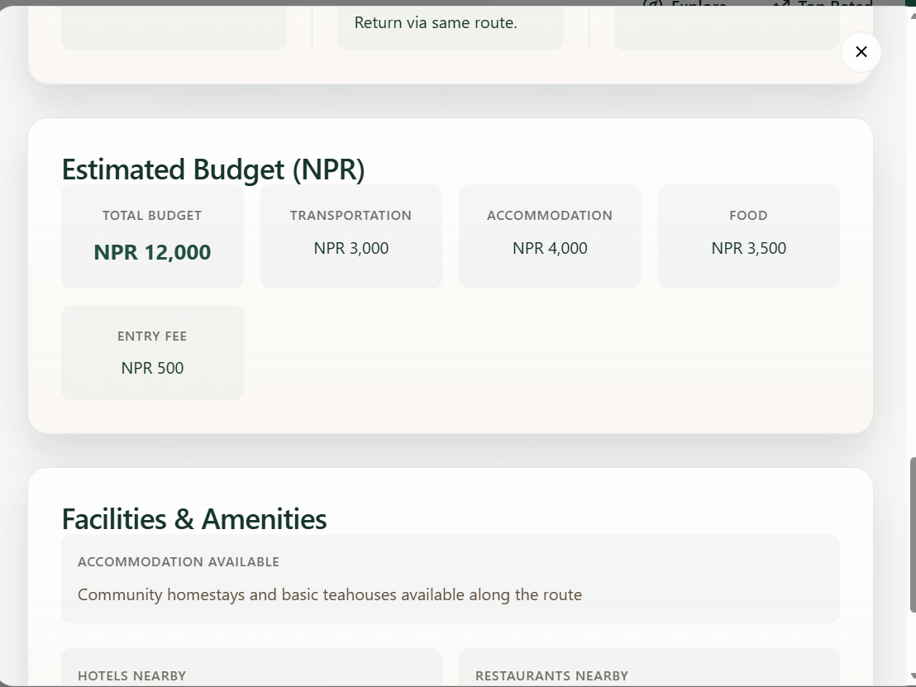
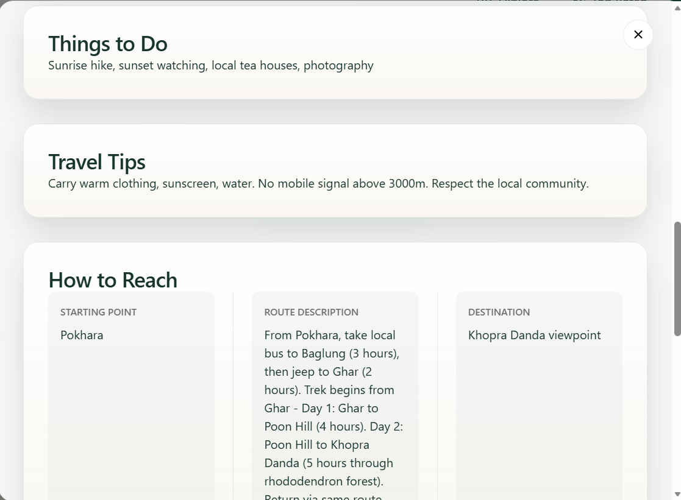
Figure 8: Show destination details

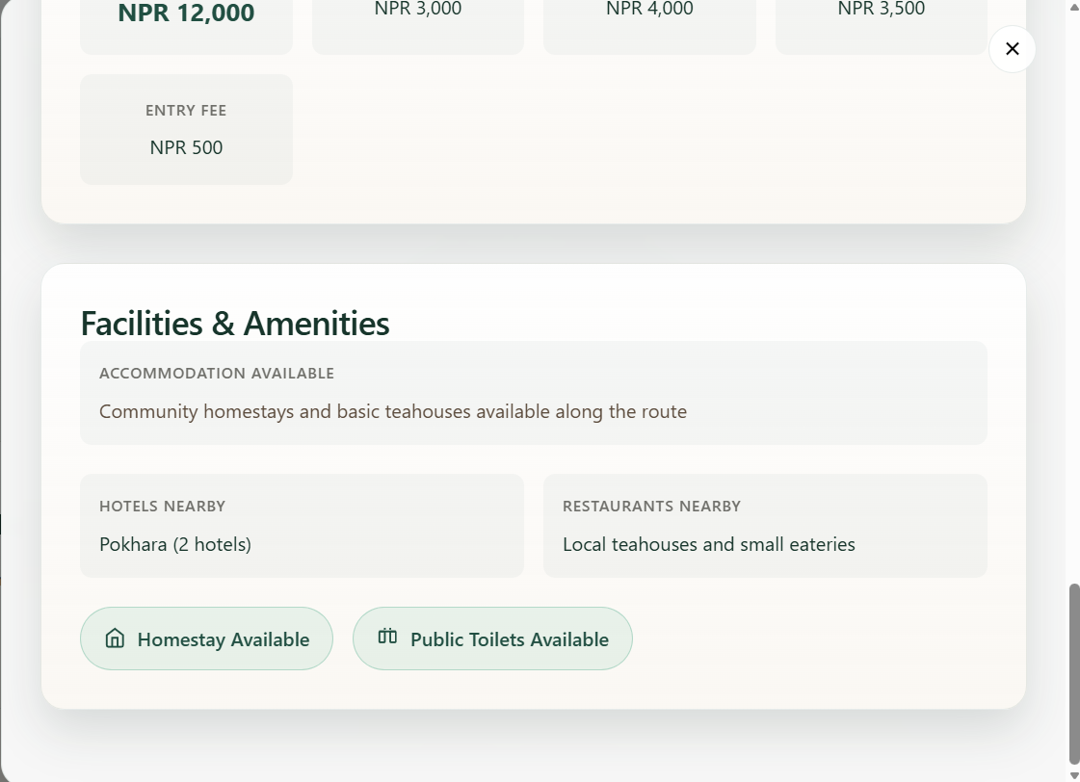

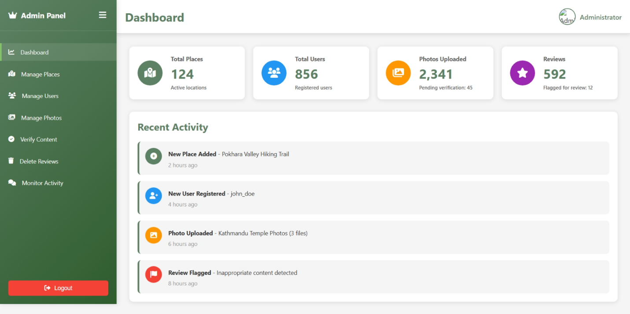
Figure 9: Admin panel

References

- TripAdvisor. (2024). TripAdvisor Travel Platform. Retrieved from https://www.tripadvisor.com
- Nepal Tourism Board. (2024). Official Tourism Information of Nepal. Retrieved from https://ntb.gov.np
- Booking.com. (2024). Booking.com Travel and Accommodation Platform. Retrieved from https://booking.com.
- W3Schools. (2024). HTML, CSS, JavaScript tutorials and references. Retrieved from https://www.w3schools.com
- GitHub. (2024). GitHub Version Control and Project Management. Retrieved from https://www.github.com

