StockSmart
Intelligent Inventory Management System
Database Design Document
MySQL 8 — Production-Ready Schema for Bachelor's Final Year Project
Stack: HTML · CSS · JavaScript · PHP · MySQL · XAMPP · phpMyAdmin

Table of Contents

1. Overview
This document accompanies stocksmart.sql, the complete MySQL 8 database script for the StockSmart Intelligent Inventory Management System. The schema was designed directly against the project's five front-end pages — homepage.html, dashboard.html, products.html, inventory.html, and checkout.php — so that every field rendered on screen maps cleanly to a column in the database, and every sample value already shown in the UI mockups (stock counts, SKUs, order numbers, expiry batches) is reproduced as seed data.
The database contains 14 base tables, 3 reporting views, 2 triggers, and a complete set of seed data covering all six modules: Dashboard, Products, Inventory, Checkout, Alert System, and User Management. The full script has been executed end-to-end against a live MySQL 8.0 server during preparation of this document — every CREATE TABLE, constraint, trigger, and sample query in stocksmart.sql was verified to run without errors before delivery.

1.1 Required Tables and How They Map to Modules
Module | Primary Table(s) | Supporting Tables
Dashboard | — (reads from views) | vw_product_stock_summary, vw_expiry_alerts, activity_logs
Products | products | categories, suppliers
Inventory | inventory | warehouses, product_batches, stock_movements, stock_transfers
Checkout | orders, order_items | customers, stock_movements
Alert System | alerts | vw_product_stock_summary, vw_expiry_alerts
User Management | users | roles, activity_logs

2. Entity Relationship Diagram
The diagram below was generated from the actual PlantUML source (er_diagram.puml, included alongside this document) and rendered against the live schema, so it is guaranteed to match stocksmart.sql exactly. A plain-text equivalent is provided in er_diagram.txt for environments where PlantUML cannot be rendered.
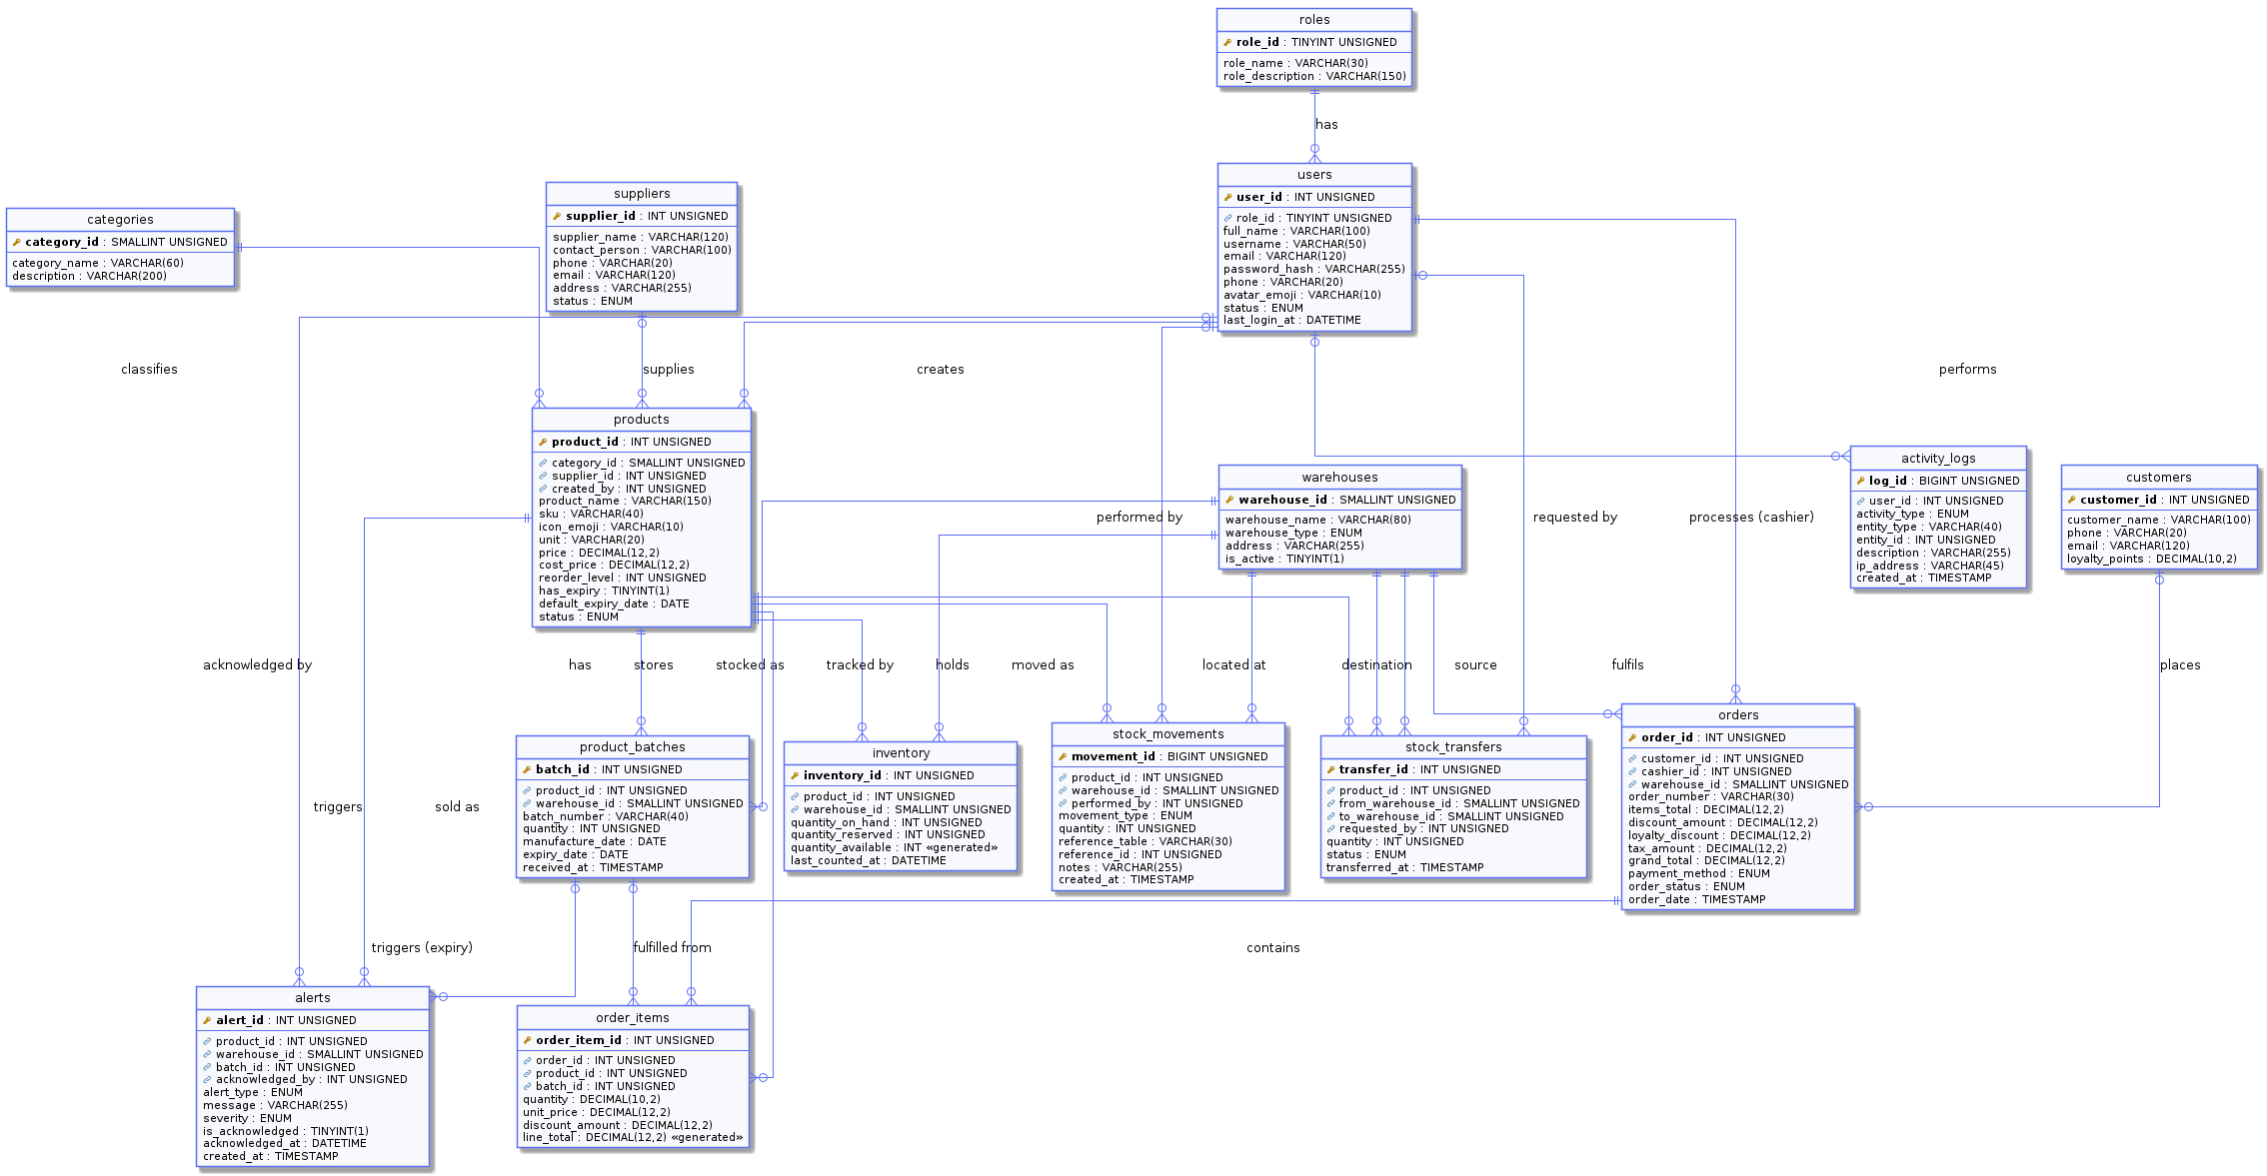
Legend: PK = Primary Key, the small key icon marks foreign keys. Solid lines with a crow's-foot (◄) denote a one-to-many relationship; a circle on a line end denotes optional (nullable) participation.

3. Database Normalization
The schema was designed to satisfy Third Normal Form (3NF) throughout, which is the standard expected for a production-grade relational database and for a Final Year Project viva defence.

3.1 First Normal Form (1NF)
1NF requires that every column hold a single, atomic value, that each row be uniquely identifiable, and that there be no repeating groups of columns.
- Every table has a single-column surrogate primary key (e.g. product_id, order_id) generated by AUTO_INCREMENT, guaranteeing uniqueness.
- No column stores multiple values. For example, a sale that contains several products is not stored as a comma-separated list inside orders — it is split into one row per product in order_items.
- Free-text fields that the front-end mockups used loosely (category, warehouse location) were extracted into their own lookup tables (categories, warehouses) rather than repeated as text in every product/inventory row.

3.2 Second Normal Form (2NF)
2NF requires 1NF plus the elimination of partial dependencies: every non-key column must depend on the whole primary key, not just part of it. This rule matters most for tables with composite keys.
- The inventory table is the clearest example: it has a natural composite key of (product_id, warehouse_id), enforced as a UNIQUE constraint alongside a surrogate inventory_id primary key. Columns such as quantity_on_hand and quantity_reserved depend on both the product and the warehouse together, not on either one alone — satisfying 2NF.
- Product attributes that depend only on the product (price, reorder_level, SKU) live in products, not in inventory, so they are not duplicated once per warehouse.

3.3 Third Normal Form (3NF)
3NF requires 2NF plus the elimination of transitive dependencies: non-key columns must depend only on the primary key, not on other non-key columns.
- category_name and warehouse_name are not stored on the products or inventory rows directly — they are looked up via category_id and warehouse_id, since category_name depends on category_id, not directly on product_id (a transitive dependency that 3NF removes).
- Similarly, supplier contact details live only in suppliers and are referenced from products via supplier_id, so a supplier's phone number is never duplicated across every product they supply.
- order_items.unit_price is a deliberate, justified exception: it is a price snapshot at the time of sale, not a transitive dependency on products.price. Sales history must remain accurate even if the catalogue price later changes, so this denormalization is intentional and standard practice in point-of-sale schemas.
- Generated (computed) columns — inventory.quantity_available and order_items.line_total — are stored as MySQL STORED GENERATED COLUMNS rather than manually duplicated values, so they can never drift out of sync with the columns they are derived from.

4. Relationship Explanation

4.1 One-to-Many Relationships
Parent → Child | Cardinality | Business Meaning
categories → products | 1 : N | Each category groups many products
suppliers → products | 1 : N (optional) | Each supplier can supply many products
warehouses → inventory | 1 : N | Each warehouse holds stock of many products
products → inventory | 1 : N | Each product is stocked across many warehouses
products → product_batches | 1 : N | Each product can have many expiry-tracked batches
orders → order_items | 1 : N | Each sale (order) contains many product line items
customers → orders | 1 : N (optional) | A customer may place many orders; walk-ins have no customer row
users → orders (cashier) | 1 : N | Each staff member can process many sales
products → stock_movements | 1 : N | Every stock change for a product is logged
warehouses → stock_transfers | 1 : N (×2) | A warehouse is the source of many transfers out, and the destination of many transfers in
users → activity_logs | 1 : N (optional) | Each user generates many activity entries

4.2 Many-to-Many Relationship: Products ↔ Warehouses
A product can be stocked in several warehouses, and a warehouse holds many different products — a true many-to-many relationship. This is resolved with the inventory associative (junction) table, which carries its own attributes (quantity_on_hand, quantity_reserved) rather than being a simple link table. The UNIQUE(product_id, warehouse_id) constraint guarantees there is exactly one stock row per product/warehouse pair, matching how inventory.html groups stock by location.

4.3 Referential Actions: CASCADE, RESTRICT, SET NULL
Each foreign key's ON DELETE behaviour was chosen deliberately, not left at a default:
- CASCADE is used where a child row has no meaning without its parent — deleting a product correctly removes its inventory rows, batches, and stock movements (products → inventory, product_batches, stock_movements, stock_transfers, alerts).
- RESTRICT is used to protect historical integrity — a product that has ever appeared in an order_items row, or a warehouse that has ever held inventory or fulfilled an order, cannot be deleted outright. This was verified directly: attempting to delete a product referenced in past sales correctly raises a foreign key error, while a product with no sales history deletes cleanly along with its dependent rows.
- SET NULL is used for optional, non-essential references — if a customer record is deleted, their past orders remain in the database with customer_id set to NULL rather than being destroyed, preserving sales history.

5. Data Flow Explanation
This section traces how data moves through the system for the three core workflows: adding a product, recording a sale, and raising an alert.

5.1 Adding / Editing a Product (Products Module)
- A staff member submits the Add Product form on products.html (name, category, SKU, stock, price).
- PHP inserts a row into products, looking up or creating the matching category_id in categories.
- An initial inventory row is created (or updated via ON DUPLICATE KEY UPDATE) linking the new product_id to a chosen warehouse_id with an opening quantity_on_hand.
- An activity_logs row is written so the change appears in the dashboard's Recent Activity feed.

5.2 Checkout / Sale (Checkout Module)
- The cashier builds a cart in checkout.php; each line references a product_id, quantity, and unit price.
- On payment confirmation, PHP opens a single database transaction (START TRANSACTION).
- An orders header row is inserted with a generated order_number (format SC-#####) and the computed grand_total.
- For each cart line: an order_items row is inserted; the matching inventory.quantity_on_hand is decremented (guarded so it can never go negative); and a stock_movements row of type sale_out is written for audit purposes.
- An activity_logs entry records the completed checkout for the dashboard feed.
- The transaction is committed only if every step succeeds; if any product has insufficient stock, the whole sale rolls back so inventory is never partially deducted.

5.3 Alerts and the Dashboard (Alert System)
Low-stock and out-of-stock states are not stored as static flags — they are computed live from the inventory table via the vw_product_stock_summary view, comparing quantity_available against each product's reorder_level. This guarantees the dashboard is always accurate, even immediately after a sale changes stock levels. Expiry alerts work the same way, computed live from product_batches via vw_expiry_alerts using DATEDIFF() against the current date.
The alerts table exists alongside these live views to support acknowledgeable, persistent notifications (so a manager can mark an alert as seen) — the two mechanisms are complementary: the views answer "what is the current state right now", while the alerts table answers "what have we been notified about, and have we actioned it".

5.4 Stock Transfers (Inventory Module)
A transfer between warehouses is also an atomic transaction: stock is decremented at the source warehouse, incremented (or inserted) at the destination warehouse, a stock_transfers row records the movement, and two stock_movements rows (transfer_out and transfer_in) preserve the audit trail — matching the "40 units transferred from Warehouse A to Store Front" activity shown in inventory.html.

6. Files Delivered
File | Purpose
stocksmart.sql | Complete, tested MySQL 8 script — import directly into phpMyAdmin
er_diagram.puml | PlantUML source for the ER diagram (editable)
er_diagram.txt | Plain-text ER diagram (no tooling required to read)
db.php | PDO database connection file, tested against the schema
StockSmart_Database_Design.docx | This document

All SQL in this project — every CREATE TABLE, constraint, trigger, view, and the full checkout transaction — was executed against a real MySQL 8.0.46 server (not just hand-checked) before delivery, including deliberately provoking constraint violations (negative price, duplicate SKU, reserved exceeding on-hand stock, same-warehouse transfer) to confirm each safeguard actually fires.

