ACE INSTITUTE OF MANAGEMENT



Pokhara University
Faculty of Management



Bachelor in Computer System and Information Technology (BCSIT)
Project Proposal for Project II

SECOND HAND BOOK MARKET

Submitted by SUBMITTED TO
:Team Rise SANJA SHRESTHA
ROJIN GHIMIRE
SHASWAT POKHREL
PRASHANT KARKI
SUBARNA BAHADUR SHAHI

TABLE OF CONTENTS

Introduction
1.1 Background of the Project
1.2 Domain Explanation
1.3 Context of the Problem
Problem Statement
2.1 Who is Affected
2.2 Impact
Objectives
Methodology
4.1 Requirement Identification
4.2 Feasibility Study
4.2.1 Technical Feasibility
4.2.2 Operational Feasibility
4.2.3 Economic Feasibility
4.2.4 Schedule Feasibility
4.3 High-Level Design
Gantt Chart
Expected Outcome
6.1 What the System Will Deliver
6.2 Final Result
References

INTRODUCTION

1.1 Background of the Project

The Second-Hand Book Marketplace is a web-based platform designed to help students buy and sell used academic books conveniently and affordably. Textbooks and reference materials often represent a significant financial burden for students, while many books become unused after a semester or academic year.

The proposed system aims to create a centralized marketplace where students can list, search, and purchase second-hand books with ease. By promoting the reuse of educational resources, the platform not only reduces educational expenses but also supports environmental sustainability through reduced paper waste.

The system is specifically targeted toward students, educational institutions, and book sellers seeking an organized and trustworthy platform for exchanging academic books.

1.2 Domain Explanation

This project falls under the E-Commerce and Educational Resource Management domain. The system focuses on facilitating the exchange of used academic books between students through a secure and user-friendly web platform.

The proposed system will be developed using:

• Frontend: HTML, CSS, JavaScript

• Backend: PHP

• Database: MySQL

The system will support:

• User registration and authentication

• Book listing and management

• Search and filtering functionalities

• Communication between buyers and sellers

• Review and rating system

• Transaction tracking and management

1.3 Context of the Problem

Many students struggle to afford expensive textbooks required for their studies. At the same time, previously used books often remain unused after a semester ends. Existing online marketplaces primarily focus on general products and do not provide features tailored to academic book exchange.

There is currently no dedicated and organized platform in Nepal specifically designed for second-hand academic books. Consequently, students rely on informal channels such as social media groups, which often result in poor organization, unfair pricing, and lack of trust between buyers and sellers.

PROBLEM STATEMENT

Despite the growing demand for affordable educational resources, students continue to face difficulties in accessing reasonably priced textbooks. Existing e-commerce platforms do not adequately address the unique requirements of student book exchange.

As a result, there is a need for a dedicated, secure, and centralized marketplace that enables students to buy and sell second-hand books efficiently while ensuring transparency, trust, and accessibility.

2.1 Who is Affected

The primary stakeholders affected by this problem are:

• Students seeking affordable academic books

• Students wishing to sell used textbooks

• Educational institutions promoting resource sharing

• Individuals interested in sustainable reuse of educational materials

2.2 Impact

The absence of a dedicated second-hand book marketplace creates several challenges:

• Increased educational expenses for students

• Difficulty locating affordable used books

• Wastage of books that remain unused after courses end

• Lack of trust and organization in informal marketplaces

• Reduced accessibility to educational resources

OBJECTIVES

The main objective of the system is to develop a web-based platform that enables students to buy and sell second-hand academic books efficiently and securely.

The proposed system will achieve the following specific objectives:

• To reduce the financial burden of purchasing textbooks.

• To create a centralized platform for second-hand book exchange.

• To promote reuse and sustainability of educational resources.

• To provide secure communication between buyers and sellers.

• To allow users to list and manage book advertisements.

• To provide search and filtering facilities for easy book discovery.

• To support user ratings and reviews for increased trust.

• To ensure secure user authentication and data management.

METHODOLOGY

4.1 Requirement Identification

The requirement identification phase involves studying existing systems and identifying user needs.

This process includes:

• Studying existing platforms such as Daraz, Facebook Marketplace, ThriftBooks, and AbeBooks.

• Understanding challenges faced by students in obtaining affordable textbooks.

• Identifying features required for a dedicated academic book marketplace.

• Analyzing user expectations regarding trust, verification, and usability.

4.2 Feasibility Study

4.2.1 Technical Feasibility

The project can be developed using standard web technologies such as HTML, CSS, JavaScript, PHP, and MySQL. These technologies are widely available, well documented, and suitable for developing a scalable web-based marketplace.

4.2.2 Operational Feasibility

The platform is designed to be simple and user-friendly. Students can access the system using any web browser without requiring special technical knowledge or training.

4.2.3 Economic Feasibility

The project requires minimal development cost because it uses open-source technologies and does not depend on expensive infrastructure or software licenses.

4.2.4 Schedule Feasibility

The project scope is manageable and can be completed within the academic semester timeline allocated for Project II.

4.3 High-Level Design

System Flow

User Input:
Users register accounts, upload book details, search for books, and contact sellers.

Data Processing:
The system validates information, processes search requests, and manages user interactions.

Database Storage:
All user, book, review, and transaction information is securely stored in the MySQL database.

Output Generation:
The system displays search results, book listings, seller information, and user reviews.

Basic Architecture – Three-Tier Architecture

Tier 1: Presentation Layer (Frontend)

• HTML, CSS, and JavaScript interface

• User registration and login pages

• Book listing and search pages

Tier 2: Application Layer (Backend)

• PHP server-side processing

• Business logic and validation

• User authentication management

Tier 3: Data Layer (Database)

• MySQL database

• Storage of users, books, reviews, and transaction records

GANTT CHART
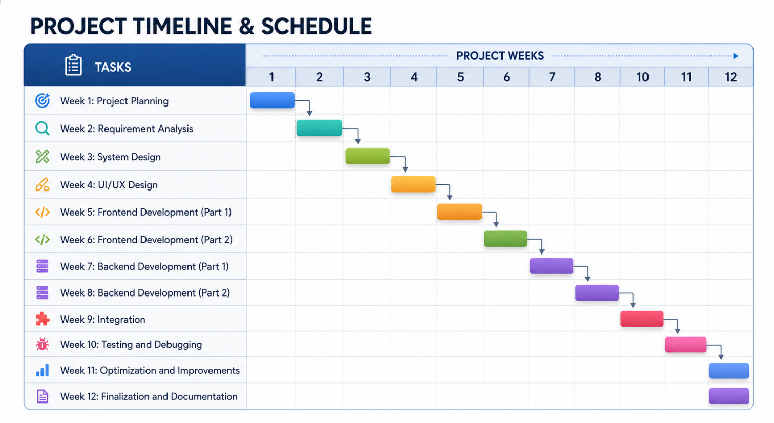

EXPECTED OUTCOME

6.1 What the System Will Deliver

• A web-based marketplace for second-hand academic books

• Secure user registration and authentication

• Book listing and management features

• Search and filtering functionality

• Rating and review system

• Efficient management of educational resources

6.2 Final Result

After completion, the project will provide:

• A fully functional second-hand book marketplace

• Improved accessibility to affordable textbooks

• Reduced educational expenses for students

• Increased reuse of academic resources

• A trustworthy and organized platform for student book exchange

REFERENCES

• BooksMandala. Online Book Store.

• Daraz Nepal. E-commerce Platform.

• Facebook Marketplace.

• ThriftBooks. Used Book Marketplace.

• AbeBooks. Online Book Exchange Platform.

• Laudon, K. C., & Traver, C. G. (E-Commerce: Business, Technology, Society).

• Turban, E. (Electronic Commerce: A Managerial Perspective).

