Capstone Project Test Report
Goibibo Bus Booking Automation | Superset ID: 5097819
Project Name | Goibibo Bus Booking Automation
Module Name | Bus Search and Bus Booking
Domain Name | Travel / Online Bus Ticket Booking
Student Name | Aditya Pandey
Superset ID | 5097819

Simple Project Description
This capstone project automates the Goibibo bus booking workflow. The project validates bus search, filters, sorting, negative input validations, and an end-to-end booking journey up to the card payment page. The automation avoids real payment and focuses on validating the functional flow, page transitions, UI validations, and final payment form availability.

Test Strategy
The project follows two automation approaches: Selenium automation and BDD automation. Selenium WebDriver is used for browser interaction, element handling, waits, screenshots, logging, and page validation. The Selenium project is structured with Page Object Model so that page actions are separated from test cases, making the automation easier to maintain.
The BDD implementation uses Behave with Gherkin feature files. Feature files describe scenarios in readable Given-When-Then format, while Python step definitions execute the actual browser actions. Allure reporting is used to generate execution reports with scenario status, screenshots, logs, and environment details. The browser used for execution is Google Chrome.

Test Environment
Operating System | Windows
Browser | Google Chrome
Architecture | Page Object Model with BDD step definitions
Frameworks | Selenium WebDriver, Behave BDD, Allure Reports
Logs | Execution logs generated under reports/execution.log and logs directory
Screenshots | Step and final screenshots captured under reports/screenshots
Reports | Allure report generated under reports/allure-report
Dependencies | requirements.txt contains behave, selenium, allure-behave, webdriver-manager, undetected-chromedriver, setuptools

Test Execution
A total of 8 BDD scenarios were executed: 1 end-to-end booking scenario, 5 positive search scenarios, and 2 negative validation scenarios. The execution validates both happy-path behavior and invalid input handling. The final report shows 8 passed, 0 failed, and 0 skipped scenarios.

End-to-End Booking Test
This test validates the complete booking journey until the card payment page. It opens the bus module, searches buses from Delhi to Lucknow, selects a bus, chooses boarding and dropping points, selects a seat, enters passenger details, skips insurance, proceeds to payment, and verifies that the card payment page is displayed.

Positive Test 1 - Valid Bus Search
This positive test verifies that bus results are displayed when a valid source and destination are entered. It confirms that the basic search flow works and that the user can reach the bus results page successfully.

Positive Test 2 - AC Filter
This positive test verifies that the AC filter can be applied after loading bus search results. The expected behavior is that results should remain visible after applying the AC filter, proving that the filter interaction does not break the search result page.

Positive Test 3 - Sleeper Filter
This positive test verifies that the Sleeper filter can be applied on the bus results page. It checks that the filtered results are still displayed, confirming that the sleeper filter action is accepted by the application.

Positive Test 4 - Sorting by Price and Duration
This positive sorting validation verifies that results can be sorted by price and duration. The enhanced assertion extracts visible prices and durations from result cards and confirms that prices are in lowest-to-highest order and durations are in shortest-to-longest order.

Negative Test 1 - Same Source and Destination
This negative test validates the same-city error condition. It enters Delhi as both source and destination, clicks Search Bus, and asserts that the application displays the validation message: Source and Destination can't be same.

Negative Test 2 - Empty Source City
This negative test validates behavior when the source city is empty. It leaves the source blank, enters a destination, clicks Search Bus, and asserts that bus results should not be displayed because the input is invalid.

Test Outputs

Screenshots
The following screenshots are captured from BDD execution output and Allure report pages.
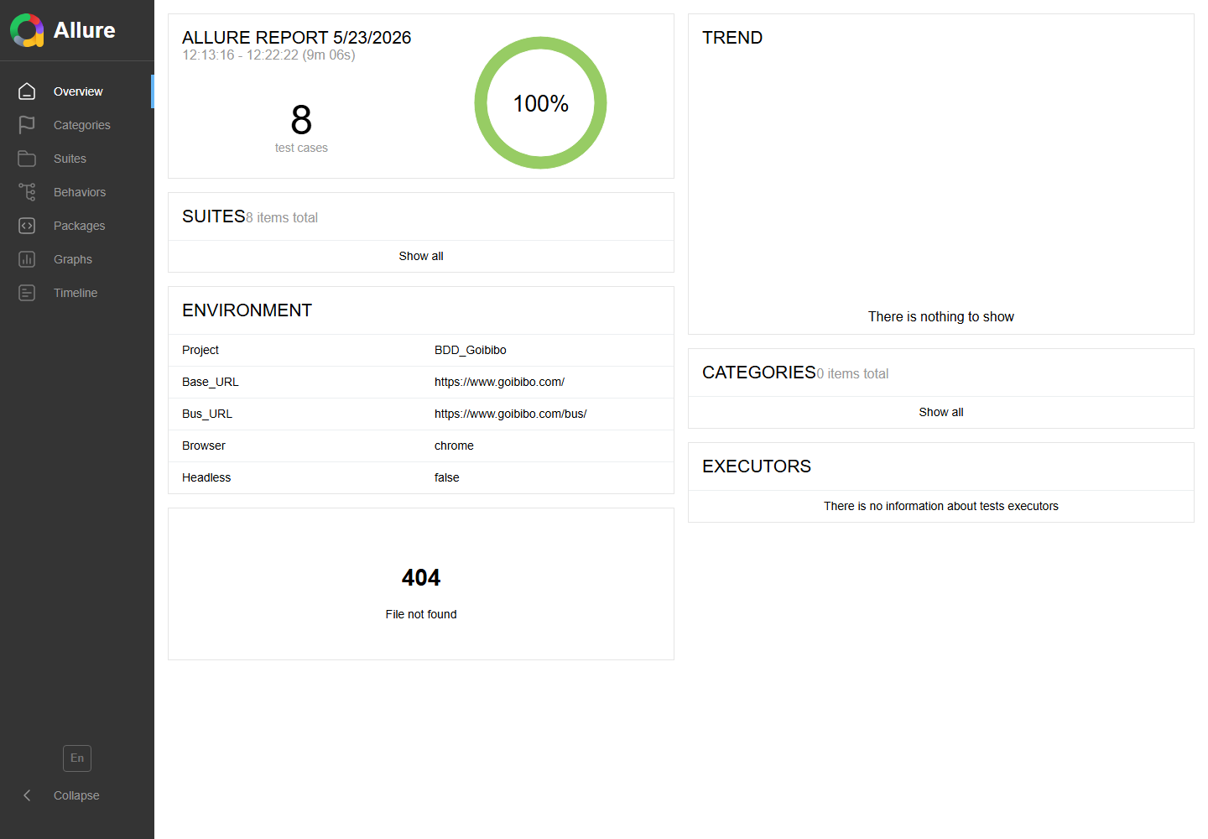
Allure Report Overview - 8 test cases, 100% pass rate
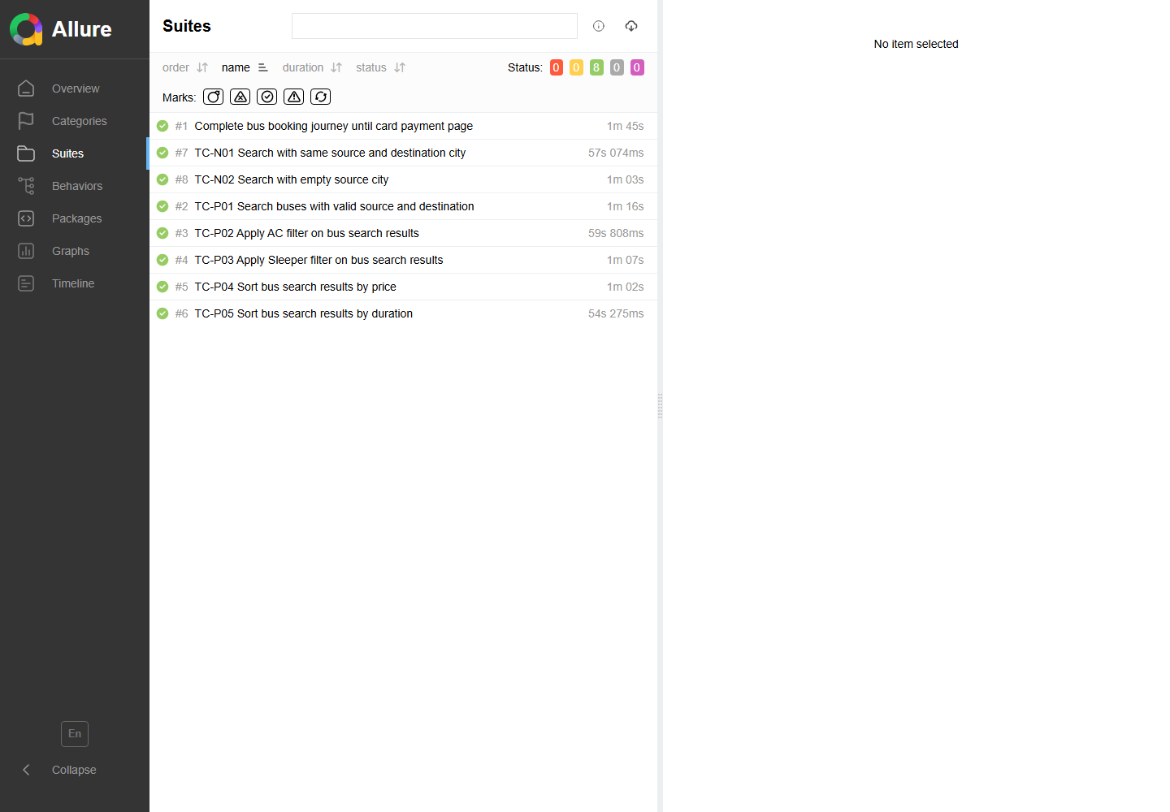
Allure Suites View - all executed BDD scenarios passed
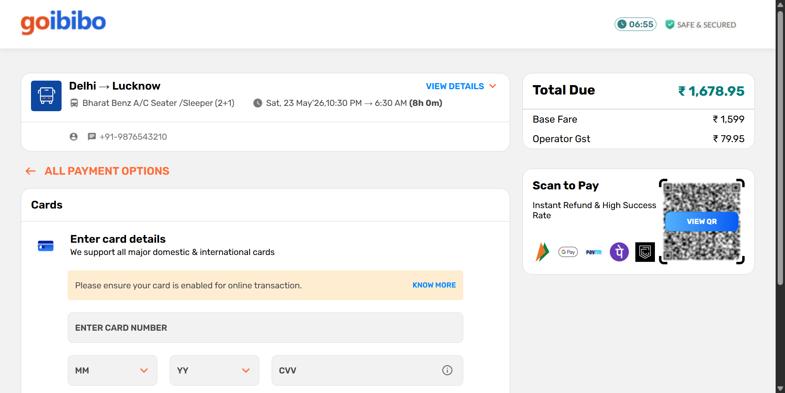
E2E Booking - Final Passed Screenshot
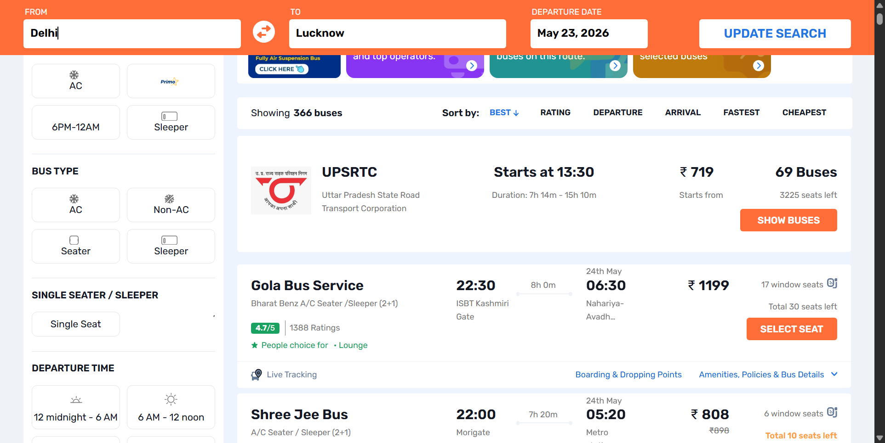
Positive - Valid Search
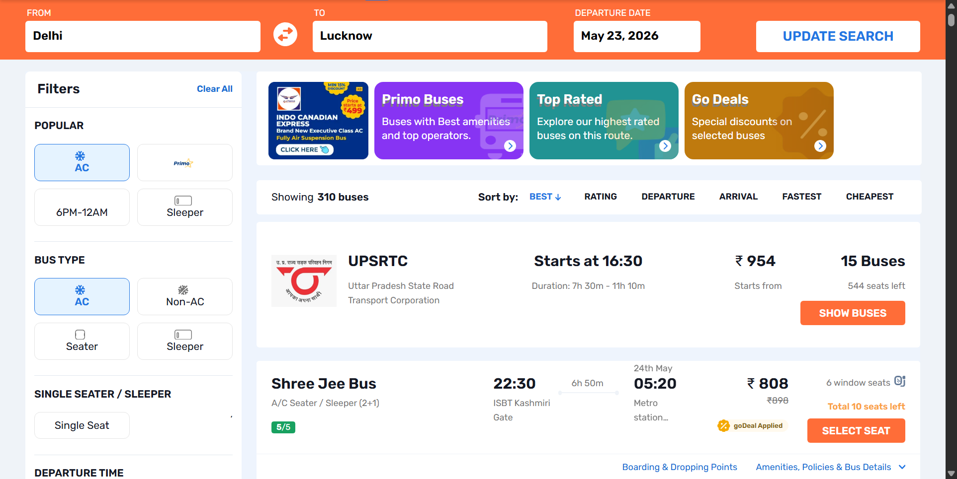
Positive - AC Filter
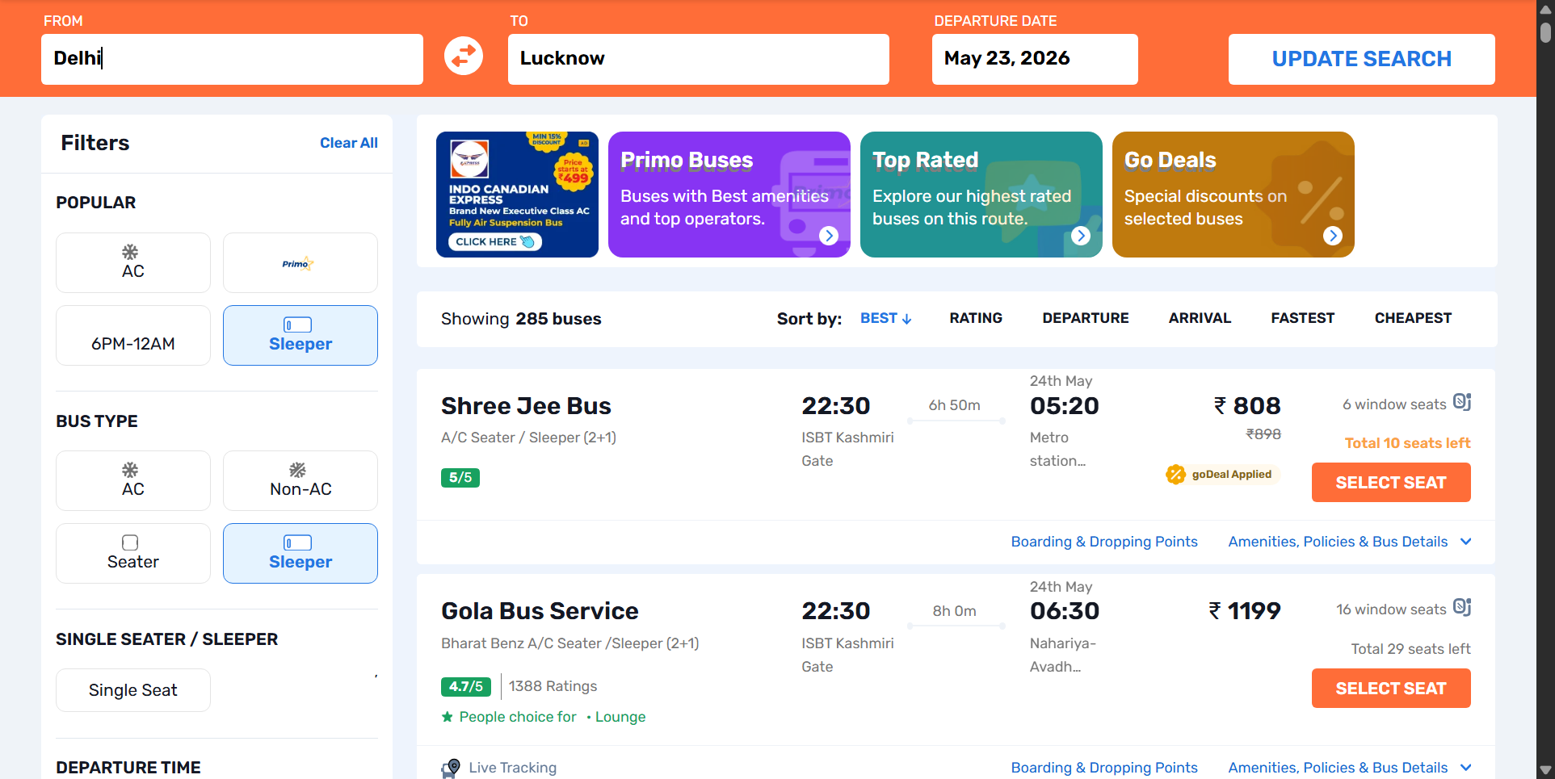
Positive - Sleeper Filter
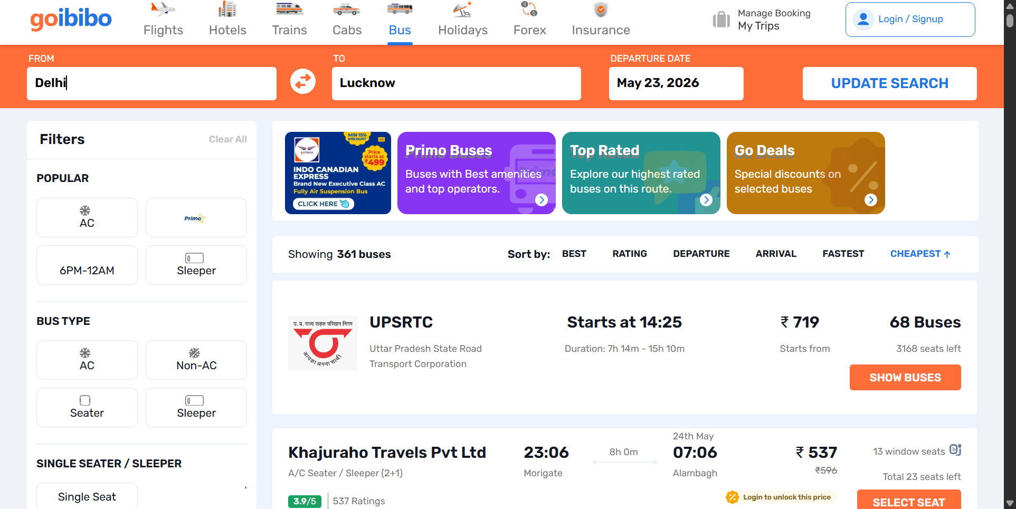
Positive - Price Sorting
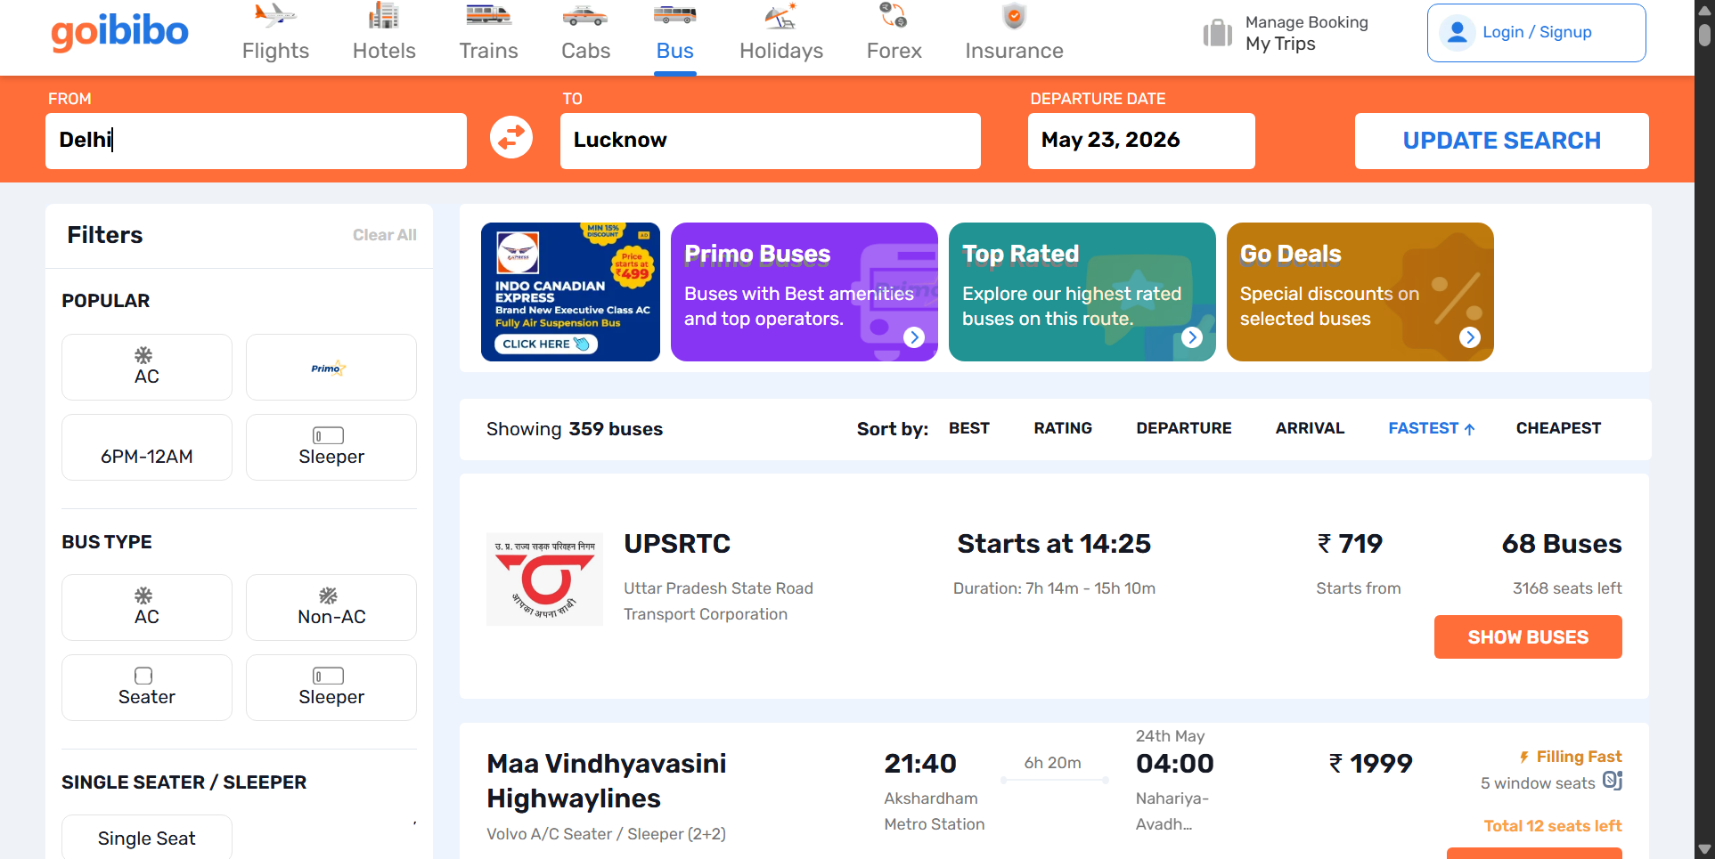
Positive - Duration Sorting
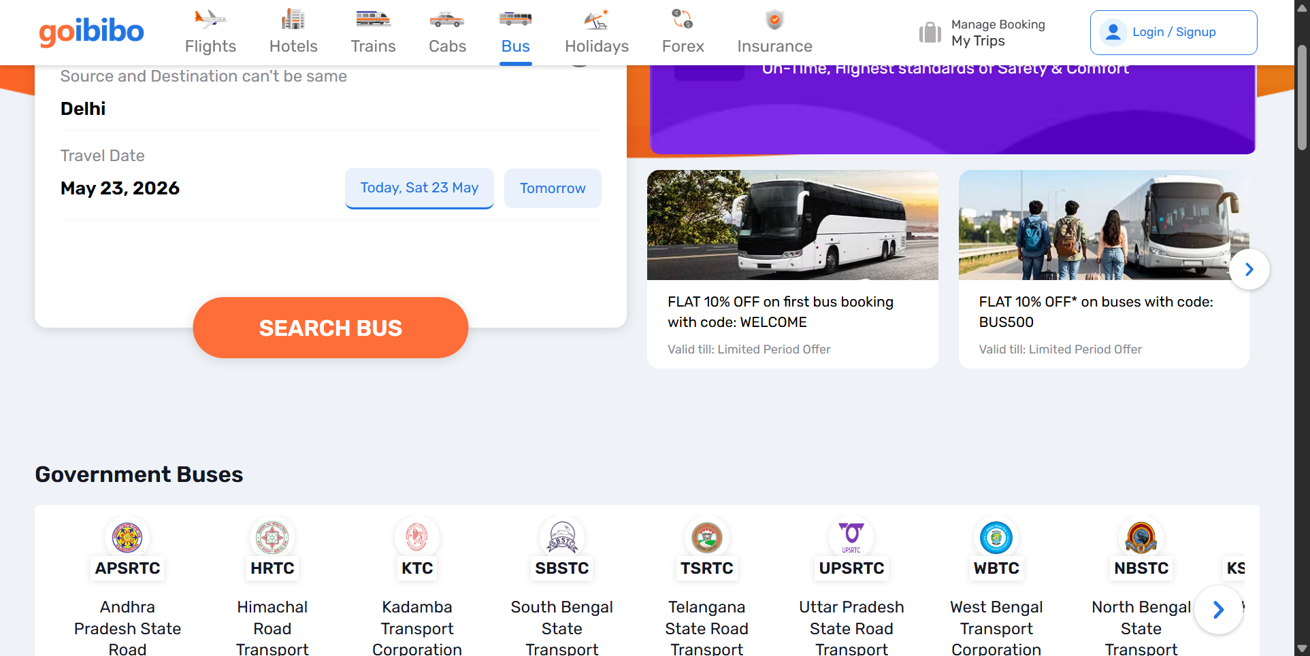
Negative - Same Source and Destination
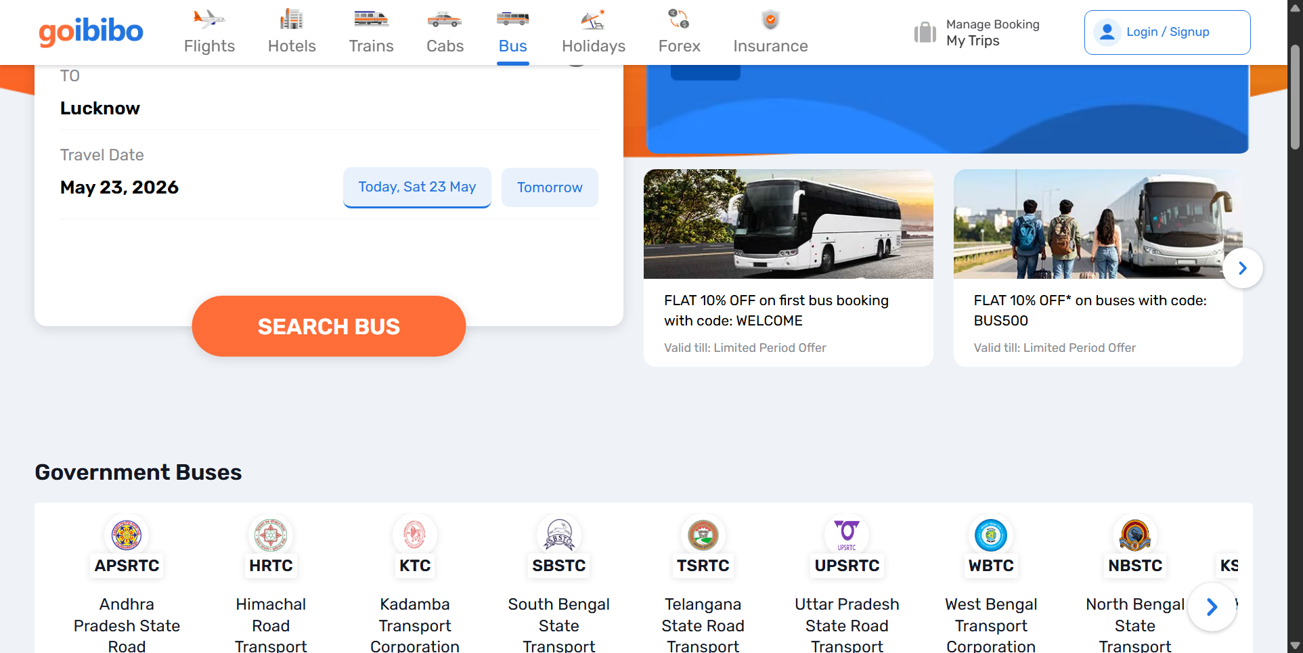
Negative - Empty Source City

Log Files - Sample Logs
Positive test sample log:
2026-05-23 02:55:08 | INFO | BDD_Goibibo | ========== BDD TEST RUN FINISHED ==========
2026-05-23 02:55:59 | INFO | BDD_Goibibo | ========== BDD TEST RUN STARTED ==========
2026-05-23 02:55:59 | INFO | BDD_Goibibo | ========== STARTING SCENARIO: TC-P01 Search buses with valid source and destination ==========
2026-05-23 02:55:59 | INFO | BDD_Goibibo | Launching Chrome with undetected-chromedriver.
2026-05-23 02:56:07 | INFO | BDD_Goibibo | Opening Goibibo home page: https://www.goibibo.com/
2026-05-23 02:56:11 | INFO | BDD_Goibibo | Optional click skipped for ('xpath', "(//span[contains(@class,'logSprite')] | //span[contains(@class,'close')] | //button[contains(@aria-label,'close') or contains(@aria-label,'Close')])[1]"): Message:
Stacktrace:
undetected_chromedriver!GetHandleVerifier [0xf4b593+105d3]
undetected_chromedriver!GetHandleVerifier [0xf4b6c4+10704]
undetected_chromedriver!(No symbol) [0xd51ea0]
undetected_chromedriver!(No symbol) [0xd9b28a]
undetected_chromedriver!(No symbol) [0xd9b52b]
Negative test sample log:
2026-05-23 03:05:51 | INFO | BDD_Goibibo | Closing browser.
2026-05-23 03:05:52 | INFO | BDD_Goibibo | ========== FINISHED SCENARIO: TC-P05 Sort bus search results by duration | Status.error ==========
2026-05-23 03:05:52 | INFO | BDD_Goibibo | ========== STARTING SCENARIO: TC-N01 Search with same source and destination city ==========
2026-05-23 03:05:52 | INFO | BDD_Goibibo | Launching Chrome with undetected-chromedriver.
2026-05-23 03:05:58 | INFO | BDD_Goibibo | Opening Goibibo home page: https://www.goibibo.com/
2026-05-23 03:06:02 | INFO | BDD_Goibibo | Optional click skipped for ('xpath', "(//span[contains(@class,'logSprite')] | //span[contains(@class,'close')] | //button[contains(@aria-label,'close') or contains(@aria-label,'Close')])[1]"): TimeoutException
2026-05-23 03:06:05 | INFO | BDD_Goibibo | Optional click skipped for ('xpath', "//span[@role='presentation']"): TimeoutException
2026-05-23 03:06:05 | INFO | BDD_Goibibo | Opening Bus module from home page navigation.
2026-05-23 03:06:11 | INFO | BDD_Goibibo | Optional click skipped for ('xpath', "(//a[contains(@href,'/bus')][.//*[normalize-space()='Bus'] or normalize-space()='Bus'] | //span[normalize-space()='Bus'])[1]"): TimeoutException
2026-05-23 03:06:11 | WARNING | BDD_Goibibo | Bus tab navigation failed, opening Bus URL directly. Error: Message: Bus tab was not clickable.
2026-05-23 03:06:23 | INFO | BDD_Goibibo | Optional click skipped for ('xpath', "(//span[contains(@class,'logSprite')] | //span[contains(@class,'close')] | //button[contains(@aria-label,'close') or contains(@aria-label,'Close')])[1]"): TimeoutException

Test Reports
Total Tests | Passed | Failed/Broken | Accuracy
8 | 8 | 0 | 100%
Final result: All 8 BDD scenarios passed successfully. The overall automation report accuracy is 100%, with no failed, broken, or skipped tests in the final Allure report.

