Share links and QR codes
Print this page, paste the links into WhatsApp or email, or print a QR code on a poster. Participants open the link on a phone. Nothing needs installing, and the page can be added to the home screen.
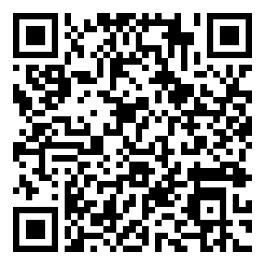 | DCHS students: the wellbeing check (all programmes and years)  Enrolled DCHS students, 18 or older. Share this one link and QR code with everyone.  https://EXAMPLE.github.io/salama/index.html?role=student&unit=DCHS-STU

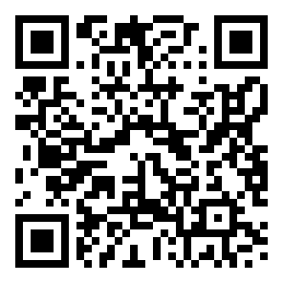 | Study portal (eight tabs, English and Kiswahili)  Researcher and committee view: student app, nurse console, dashboard, monthly report, design notes, survey, expert input, data export. Staff only.  https://EXAMPLE.github.io/salama/portal.html

For the study team only
Staff console: https://EXAMPLE.github.io/salama/console.html (sign-in required). Do not share this with participants.

