

ÇANKAYA UNIVERSITY
Software Engineering Department

SENG 491 – 492 Graduation Project
Software Design
Description

PleaseEye

Efe ÇELİK
Batuhan BAYAZIT
Barış Cem BAYBURTLU
Burak AYDOĞMUŞ

Version 1.0

Table of Contents
1 Introduction 1
1.1 Purpose 1
1.2 Scope 1
1.3 Definitions, acronyms, and abbreviations 1
1.4 References 1
1.5 Overview 1
1.6 Version History 1
2 Architecture 1
2.1 Clients 2
2.1.1 Mobile Phones 2
2.1.2 Tablets 2
2.1.3 Personal Computers 2
2.2 Application Server 2
2.3 Database Server 2
3 User Interface 2
3.1 Screen 1 3
3.2 Screen 2 3
3.3 … 3
4 High Level Design 3
4.1 Module 1 4
4.2 Module 2 4
4.3 Module ... 4
5 Low Level Design 4
5.1 Module 1 5
5.2 Module 2 5
5.3 Module … 5
6 Database Design 5
6.1 E-R Diagram 5
6.2 Tables 5
6.2.1 Table 1 5
6.2.2 Table 2 5
6.2.3 Table … 5
7 References 6

Introduction

Purpose
The purpose of this Software Design Document (SDD) is to provide a comprehensive architectural and detailed design for the PleaseEye - Hardware-Anchored Digital Content Authentication System.

This document translates the requirements specified in the Software Requirements Specification (SRS) v1.2 into a concrete technical solution. It details the design of the embedded firmware for the custom handheld camera unit, the backend verification infrastructure, and the web-based user interfaces. This document is intended for software developers, system architects, test engineers, and project supervisors (SENG 491-492) to guide the implementation and verification phases.

Scope
This document covers the design of the entire PleaseEye ecosystem, which consists of three main subsystems:
- Embedded Firmware (Handheld Device):
  - Drivers for the camera module (OV2640/OV5640) and on-device display (OLED/TFT).
  - Implementation of SHA-256 hashing and ECDSA signing using the Secure Element (ATECC608B/SE050).
  - Tamper detection logic and secure key storage management.
- Verification Backend Service:
  - A RESTful API handling manifest validation, cryptographic signature verification, and revocation list management.
- Web Verification Frontend:
  - A user interface for uploading media, displaying verification results, and browsing the "Authentic Feed."
The design focuses on software logic, data flow, and hardware-software interfaces. While the project involves custom hardware (a handheld camera with a screen), this document focuses on the software controlling that hardware.

Definitions, acronyms, and abbreviations
- API: Application Programming Interface.
- C2PA: Coalition for Content Provenance and Authenticity.
- ECDSA: Elliptic Curve Digital Signature Algorithm.
- ESP32-CAM: The microcontroller platform used for the handheld device.
- HMI: Human-Machine Interface (the on-device screen and buttons).
- I2C: Inter-Integrated Circuit (communication protocol between MCU and Secure Element).
- JSON: JavaScript Object Notation.
- Manifest: A JSON structure containing the cryptographic proof (hash, signature, metadata).
- OTA: Over-The-Air (firmware updates).
- SRS: Software Requirements Specification.
- Zeroize: The immediate and irreversible erasure of sensitive cryptographic keys.

References
[1] PleaseEye Team, "Software Requirements Specification (SRS) for PleaseEye," Version 1.2, 2025.
[2] Espressif Systems, "ESP32-CAM Series Datasheet," [Online].
[3] Microchip Technology, "ATECC608B CryptoAuthentication Device Summary Datasheet," [Online].
[4] Coalition for Content Provenance and Authenticity (C2PA), "C2PA Technical Specification," Version 1.3, [Online].
[5] Çankaya University Software Engineering Dept., "SENG 491 – 492 Graduation Project SDD Template," 2025.

Overview
The remainder of this SDD is organized as follows:
- Section 2 (Architecture): Describes the high-level system architecture, including hardware client specifications, application server logic, and database structure.
- Section 3 (User Interface): Provides mockups and descriptions for the handheld device's screen and the web-based verification portal.
- Section 4 (High Level Design): Details the system modules (Firmware, Backend, Frontend) and their interactions via class or block diagrams.
- Section 5 (Low Level Design): Explains the specific logic flow (flowcharts) for critical processes like Image Capture, Signing, and Verification.
- Section 6 (Database Design): Presents the Entity-Relationship (E-R) diagram and detailed table specifications for storing device identities and logs.
- Section 7 (References): Lists the resources used to produce this document.

Version History
Provide a table of table of changes to this document
Version No | Description of change | Date
1.0 | Initial Release | 27.12.2025

Architecture

Clients

Handheld Capture Device (Client)
The primary client is the custom PleaseEye handheld unit.
- OS/Firmware: FreeRTOS (via ESP-IDF or Arduino Core).
- Memory: Minimum 4MB PSRAM required for image buffering; 4KB secure EEPROM for keys.
- Input/Output:
  - Camera Module: OV2640/OV5640 for image capture.
  - Display: 1.3" - 2.4" OLED/TFT Screen (SPI) for viewfinder and status feedback.
  - Controls: Shutter button, Mode switch.
- Connectivity: Wi-Fi (802.11 b/g/n) for manifest upload.

Web Client (Mobile Phones & Tablets)
Users access the verification portal via standard mobile browsers.
- Browser: Chrome, Safari, Firefox (Latest stable versions).
- Functionality: Responsive design allowing users to view the "Authentic Feed" and check verification status of images on mobile screens.

Web Client (Personal Computers)
The primary interface for uploading heavy media files and analyzing detailed metadata.
- Browser: Chrome, Edge, Firefox.
- Requirements: Internet connection required for communicating with the Backend API.

Application Server
The backend logic processes verification requests and manages device states.
- OS: Linux (Ubuntu/Debian) or Containerized (Docker/Alpine).
- Runtime: Node.js (v18+) or Python (3.9+).
- Memory: Minimum 2GB RAM recommended for handling concurrent cryptographic verifications.
- Scalability: Stateless architecture supporting horizontal scaling behind a Load Balancer (Nginx).

Database Server
Persistent storage for device registries and logs.
- Software: PostgreSQL 14+ or compatible SQL database.
- Storage: SSD storage recommended for fast log retrieval.
- Backup: Daily automated backups required.

User Interface
A mockup of each screen should be provided in this section. Each element of the screen should be described (Title, label, entry field, button, etc.)

Screen 1: Handheld Device Viewfinder (On-Device)
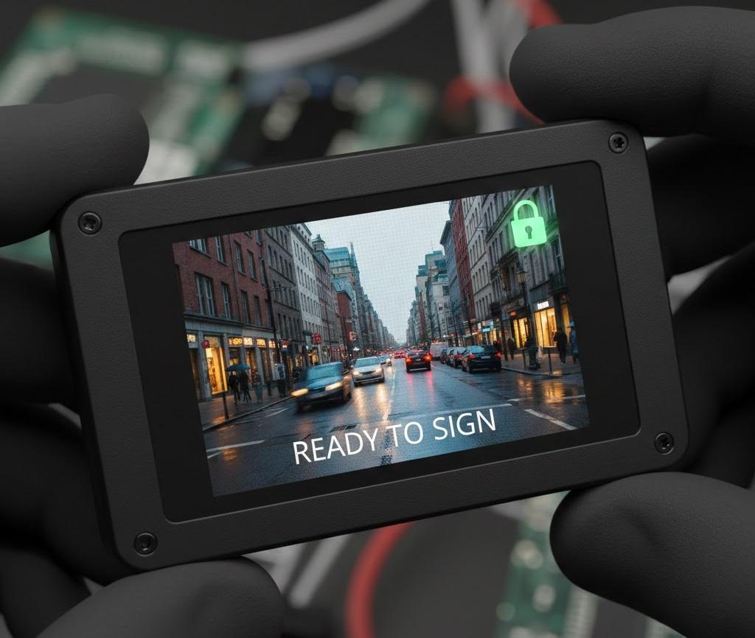
Title | Camera Live View
Viewfinder | Displays real-time video feed from the sensor.
Status Icons | Wi-Fi signal strength, Battery indicator, Security Lock (Green = Keys Secure, Red = Tampered).
Action | When the hardware shutter button is pressed, the screen freezes briefly and flashes "CAPTURED & SIGNED" to confirm the cryptographic operation.

Screen 2: Web Verification Portal (Upload)
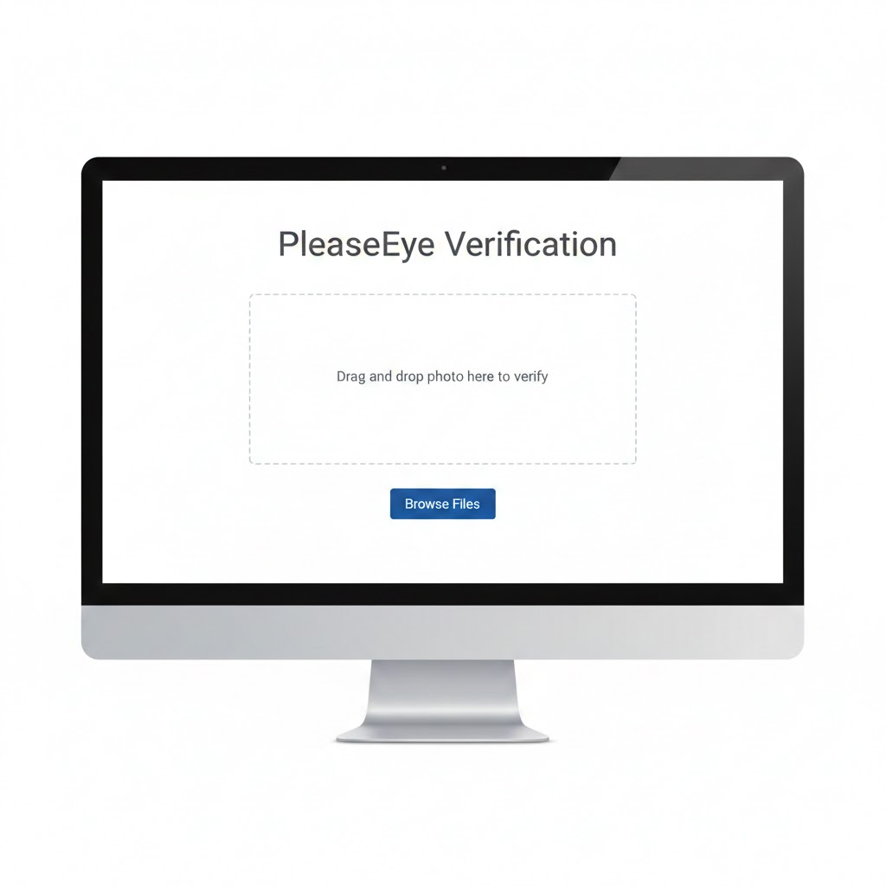

Title | Media Upload & Verification
Drop Zone | Accepts JPG, PNG, and JSON files.
Button | "Verify Media" triggers the API call.
Feedback | A progress spinner appears during the hashing and upload process.

Screen 3: Verification Result & Authentic Feed
Title | Verification Result.
Status Banner | A prominent banner displaying "VERIFIED" (Green) or "TAMPER DETECTED" (Red).
Metadata Panel | Displays the Device ID, Capture Timestamp, and Signing Method (ECDSA).
Authentic Feed | Below the result, a masonry-style grid (like Pinterest) shows other recently verified public photos.

High Level Design

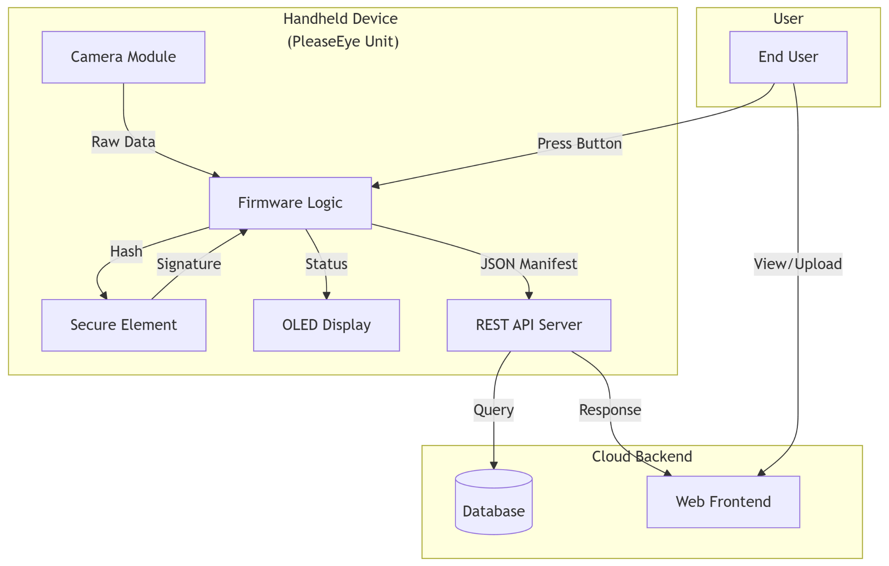

Module 1: Firmware Core (Embedded)
Brief Description: This module runs on the ESP32-CAM. It orchestrates the hardware components. It initializes the camera sensor, drives the OLED display to show the viewfinder, reads the physical shutter button state, and manages Wi-Fi connectivity. It acts as the coordinator for the cryptographic operations.

Module 2: Cryptographic Engine (Secure Element Wrapper)
Brief Description: This module abstracts the low-level I2C commands required to communicate with the ATECC608B/SE050 Secure Element. It handles key slot configuration, sends SHA-256 hashes to the chip, and retrieves the ECDSA signature. It ensures private keys never leave the hardware boundary.

Module 3: Verification Backend
Brief Description: A server-side application that exposes REST endpoints (/verify, /revocation). It receives media and manifests, re-calculates hashes, fetches the corresponding device's public key from the database, and validates the digital signature. It also serves the "Authentic Feed" data.

Low Level Design

Module 1: Image Capture & Signing Flow
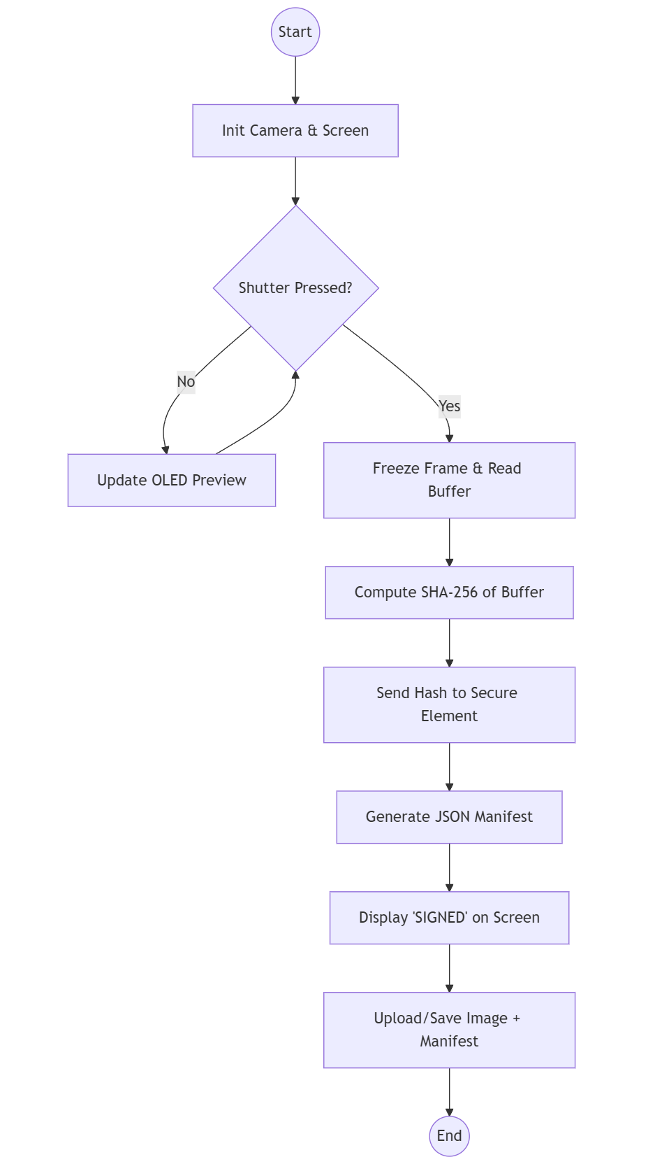

Description: The flow begins with initializing peripherals. The system enters a loop updating the display viewfinder. Upon button press, the image is captured into RAM. The SHA-256 hash is computed and sent to the Secure Element. The returned signature is packaged into a JSON manifest, and the user is notified via the screen.

Module 2: Backend Verification Logic
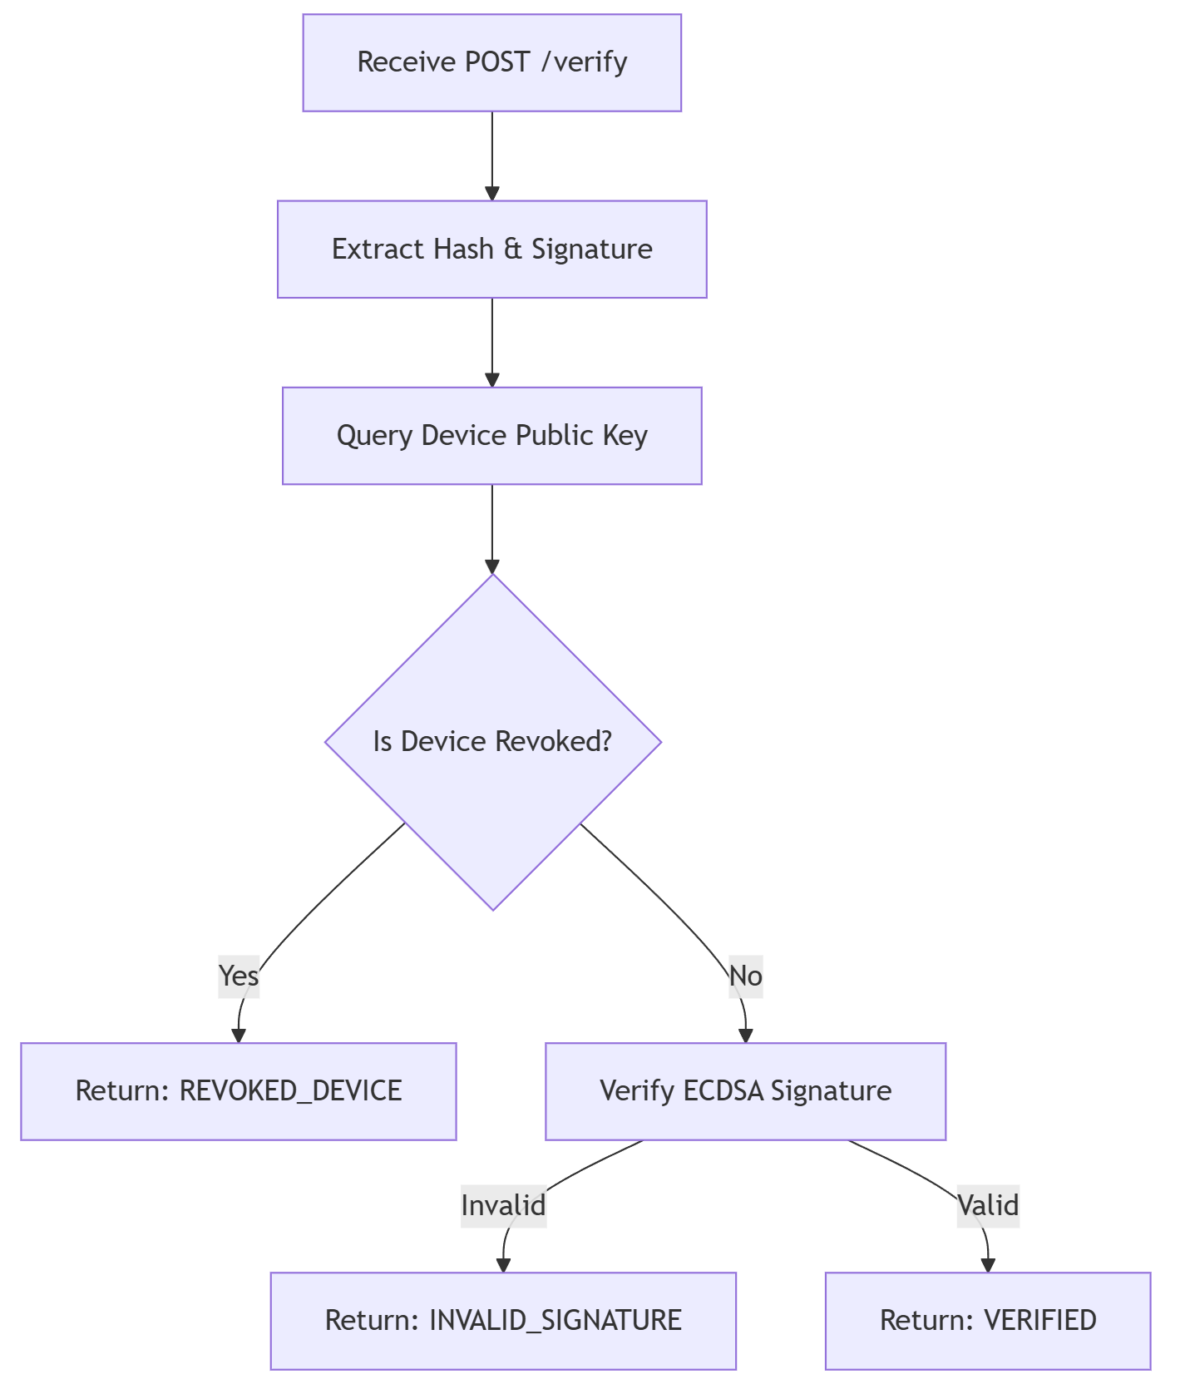

Description: When the backend receives a request, it extracts the metadata. It first checks the database to ensure the signing device has not been flagged as stolen or tampered (Revocation Check). If valid, it uses the stored public key to mathematically verify the ECDSA signature against the image hash.

Database Design

E-R Diagram
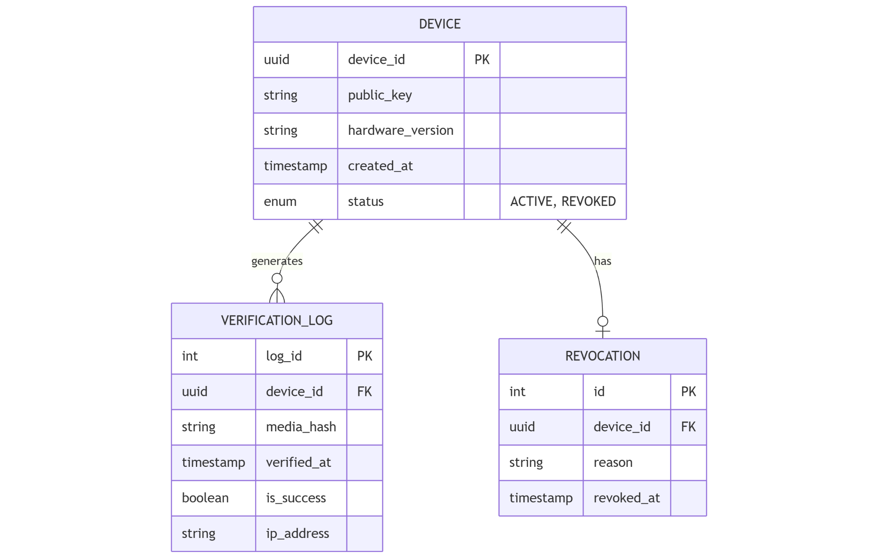

Tables

Table 1: DEVICES
Stores the identity and public keys of all authorized PleaseEye handheld units.
Attribute | Type | Key | Description
device_id | UUID | PK | Unique hardware identifier for the camera.
public_key | VARCHAR(256) |  | The hex-encoded public key (ECDSA P-256).
status | VARCHAR(20) |  | Current state: 'ACTIVE', 'REVOKED', 'COMPROMISED'.
created_at | TIMESTAMP |  | Date of device manufacturing/registration.

Table 2: VERIFICATION_LOGS
An immutable audit trail of every verification attempt performed by the system.
Attribute | Type | Key | Description
log_id | BIGINT | PK | Auto-incrementing unique ID.
device_id | UUID | FK | Reference to the capturing device.
media_hash | CHAR(64) |  | SHA-256 hash of the content verified.
is_success | BOOLEAN |  | True if signature verification passed.
verified_at | TIMESTAMP |  | Time when the verification occurred.

Table 3: REVOCATION_LIST
Maintains records of devices that are no longer trusted.
Attribute | Type | Key | Description
id | INT | PK | Unique ID.
device_id | UUID | FK | The device is being revoked.
reason | TEXT |  | E.g., "Device stolen", "Tamper sensor triggered".
revoked_at | TIMESTAMP |  | Time of revocation.

References
The resources used to produce this document should be listed here and referenced in the relevant text of this document
[1] PleaseEye Team, "Software Requirements Specification (SRS) for PleaseEye," Version 1.2, 2025.
[2] Espressif Systems, "ESP32-CAM Series Datasheet," [Online]. Available: https://www.espressif.com/en/products/socs/esp32
[3] Microchip Technology, "ATECC608B CryptoAuthentication Device Summary," [Online].
[4] Coalition for Content Provenance and Authenticity (C2PA), "C2PA Technical Specification," Version 1.3.
[5] Çankaya University Software Engineering Department, "Graduation Project SDD Template," 2025.

