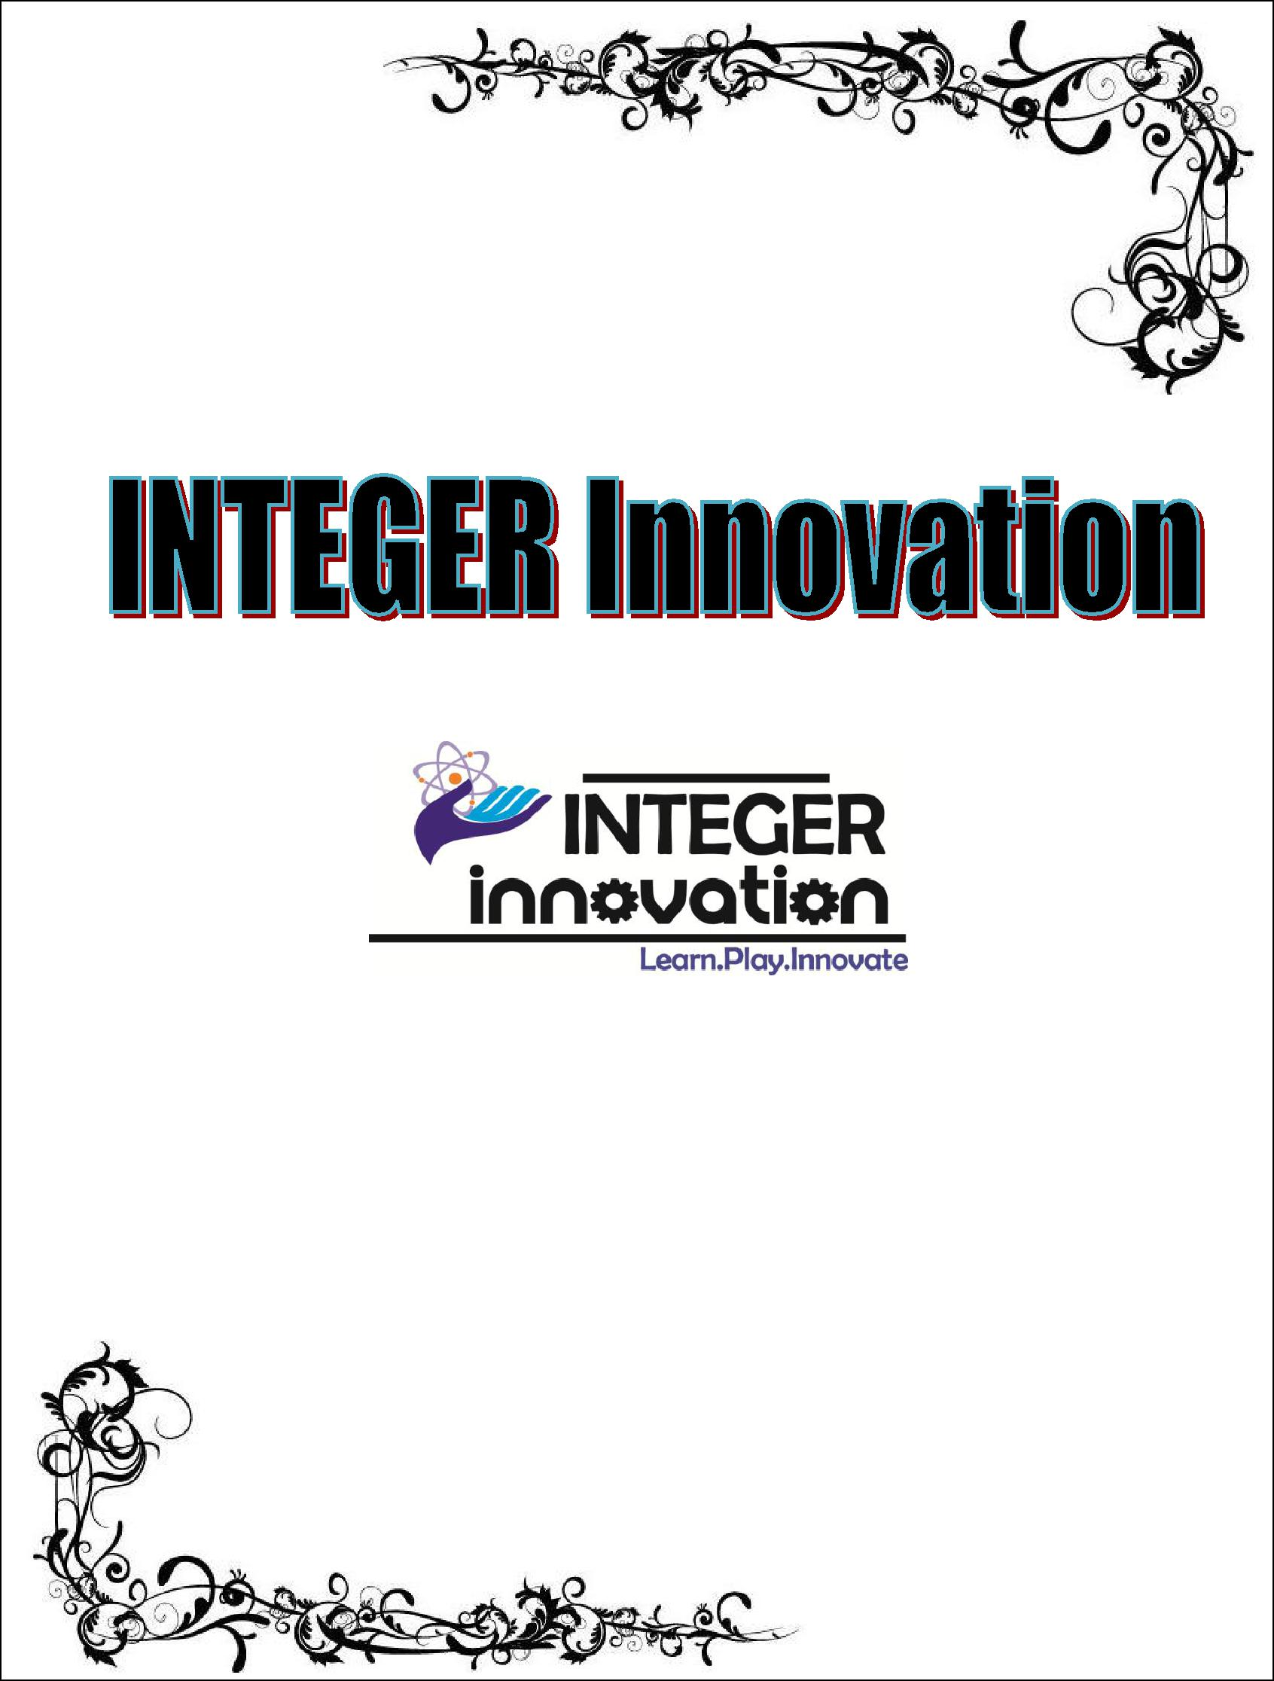

|  |  |  |  |  |  |  |
| --- | --- | --- | --- | --- | --- | --- |
|  |  |  |  |  |  |  |
|  |  |  |  |  |  |  |
|  |  |  |  |  |  |  |
|  | 2 | |  |  | INTEGER Innovation |  |
|  |  |  |  |  |  |  |

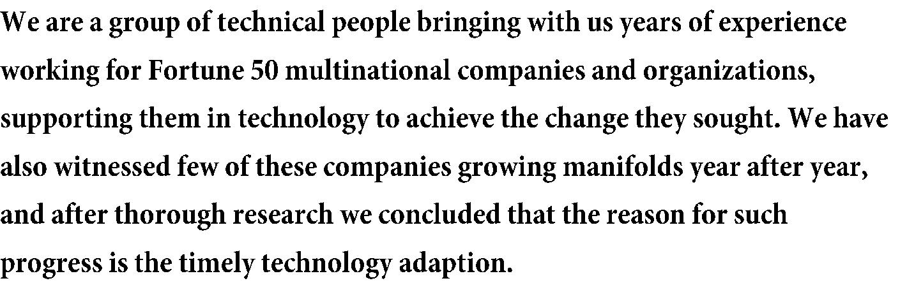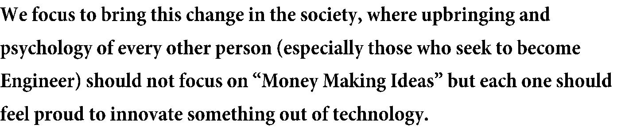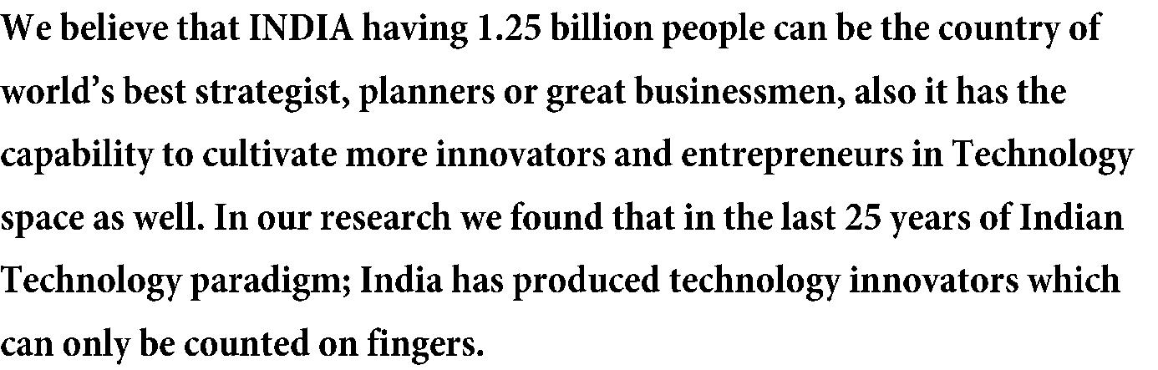

|  |  |  |  |
| --- | --- | --- | --- |
|  |  |  |  |
|  | 3 | INTEGER Innovation |  |
|  |  |  |  |

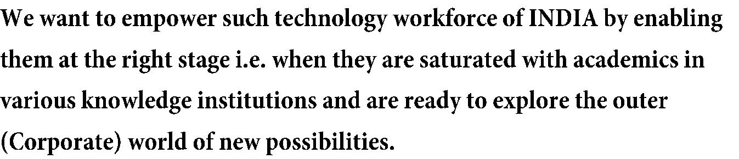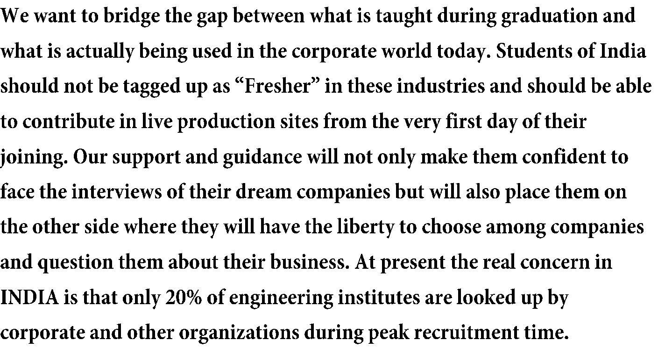

|  |  |  |  |  |  |
| --- | --- | --- | --- | --- | --- |
|  |  |  |  |  |  |
|  |  |  |  |  |  |
|  | 4 | |  | INTEGER Innovation |  |
|  |  |  |  |  |  |

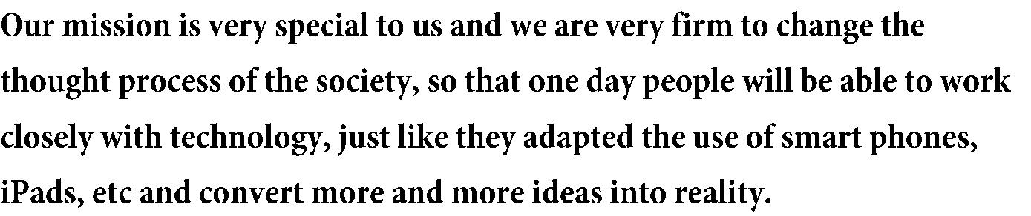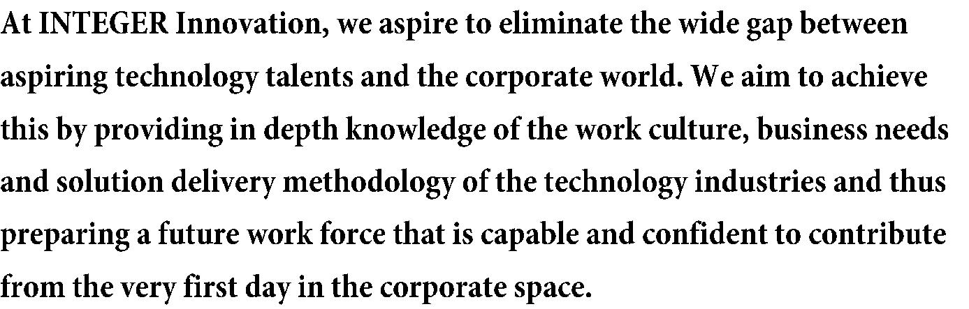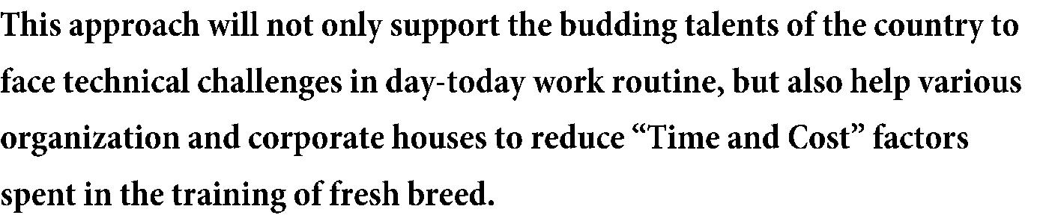



 **“Technopreneurship”- The mega event**

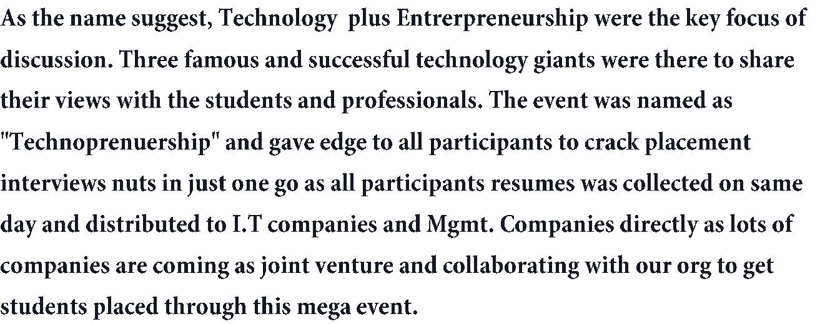

 **Corporate Workshop in Amity University, Gurgaon**

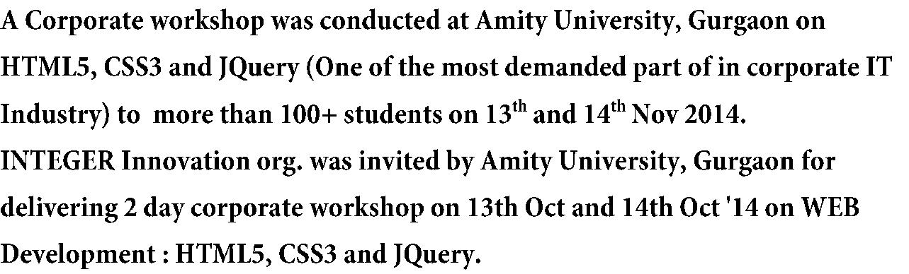

 **INTEGER Innovation at Google Development Group, Amity**

**University, Noida**

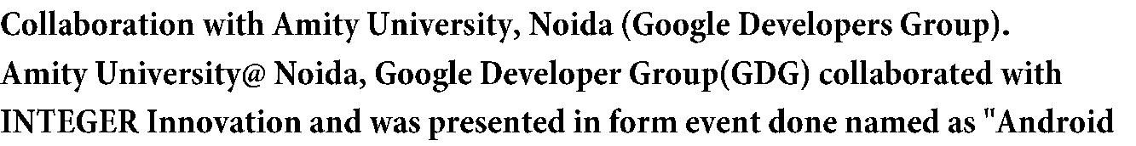

|  |  |  |  |  |  |
| --- | --- | --- | --- | --- | --- |
|  |  |  |  |  |  |
|  |  |  |  |  |  |
|  |  |  |  |  |  |
|  |  |  |  |  |  |
| 5 | | | INTEGER Innovation | |  |

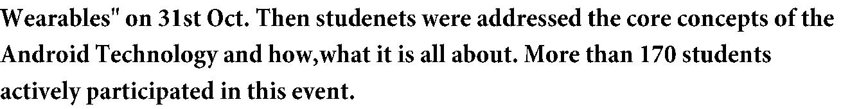

 **INTEGER Innovation at Manav Rachna International**

**University**

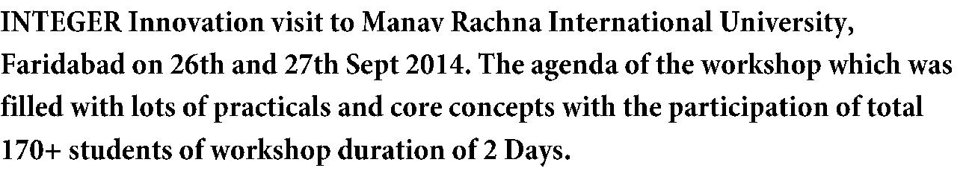

 **INTEGER Innovation at Droncharya College, Gurgaon**

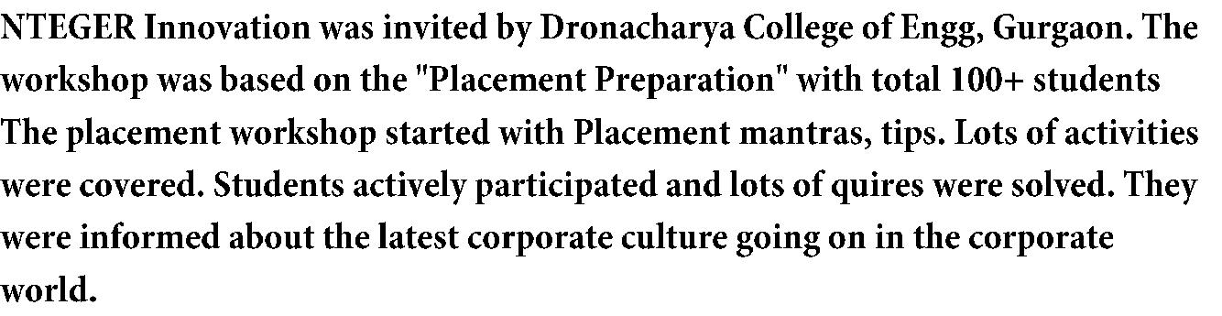

 **"CHAKRAVYUH” -The Ethical Hacking Workshop**

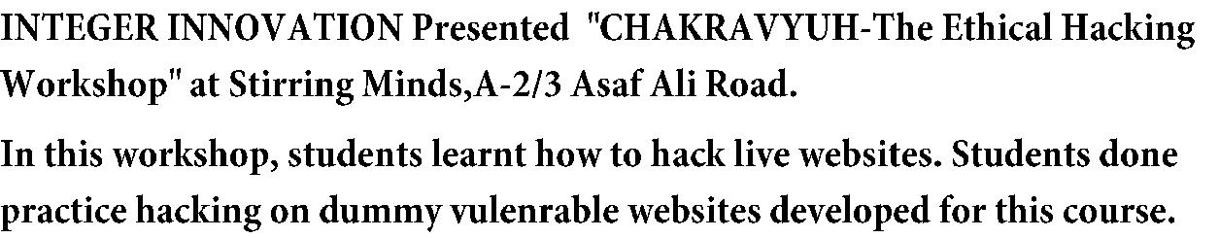

 **Corporate Web Development & LIVE Website**

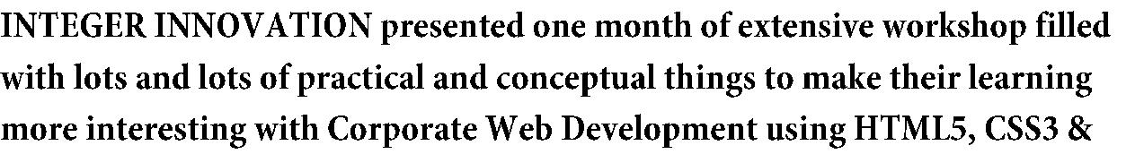

|  |  |  |  |  |  |
| --- | --- | --- | --- | --- | --- |
|  |  |  |  |  |  |
|  |  |  |  |  |  |
|  |  |  |  |  |  |
|  |  |  |  |  |  |
|  |  |  |  |  |  |
| 6 | |  |  | INTEGER Innovation | |

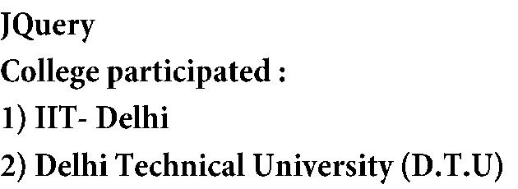



 **Corporate Workshop in Guru Premsukh College**

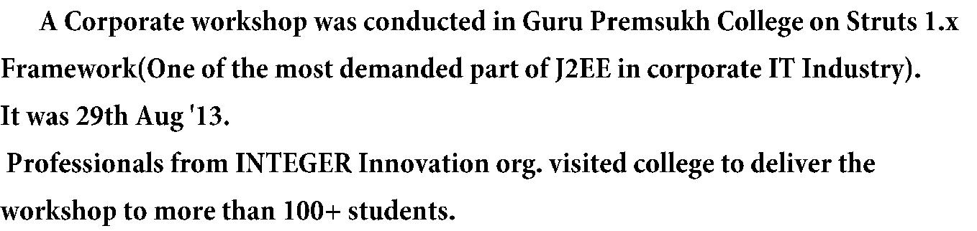

 **Guest Lecture at IMS Engineering College**

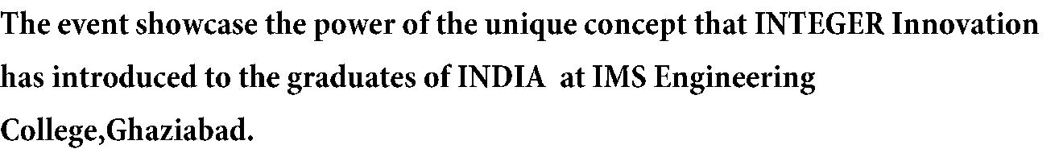

 **Awareness program on Six Sigma Process and its application at SRCC**

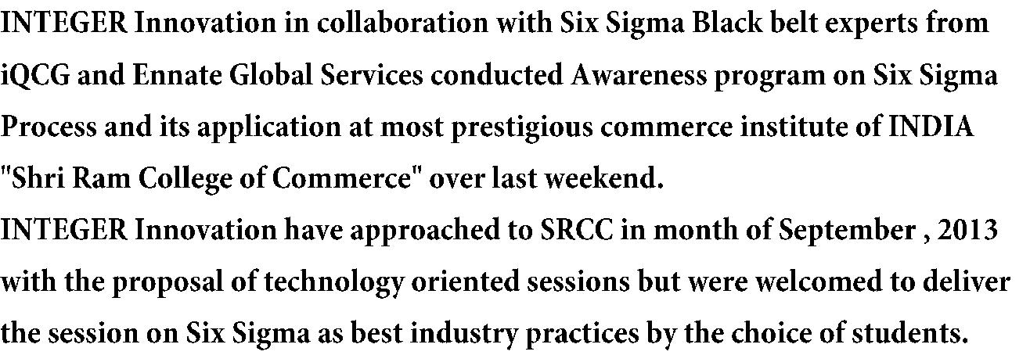

|  |  |
| --- | --- |
| 7 | INTEGER Innovation |

 **Corporate Android Development Workshop and**

**Internship**

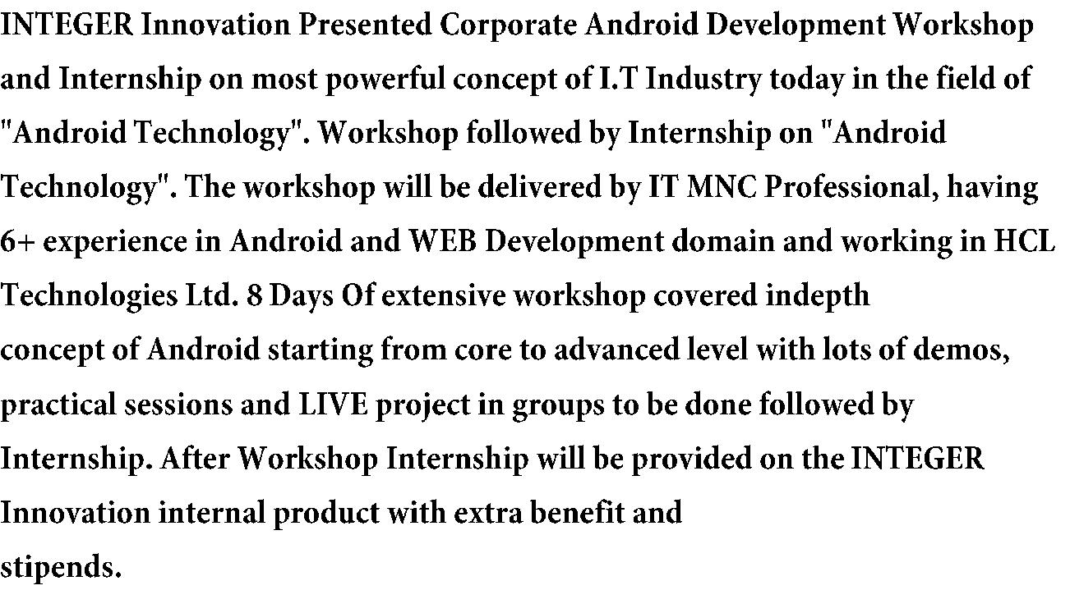

 **Fast Track Web Development Internship and**

**Workshop**

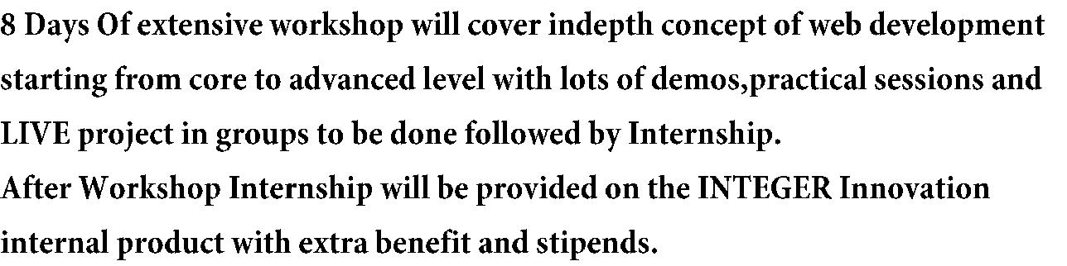

|  |  |
| --- | --- |
| 8 | INTEGER Innovation |