**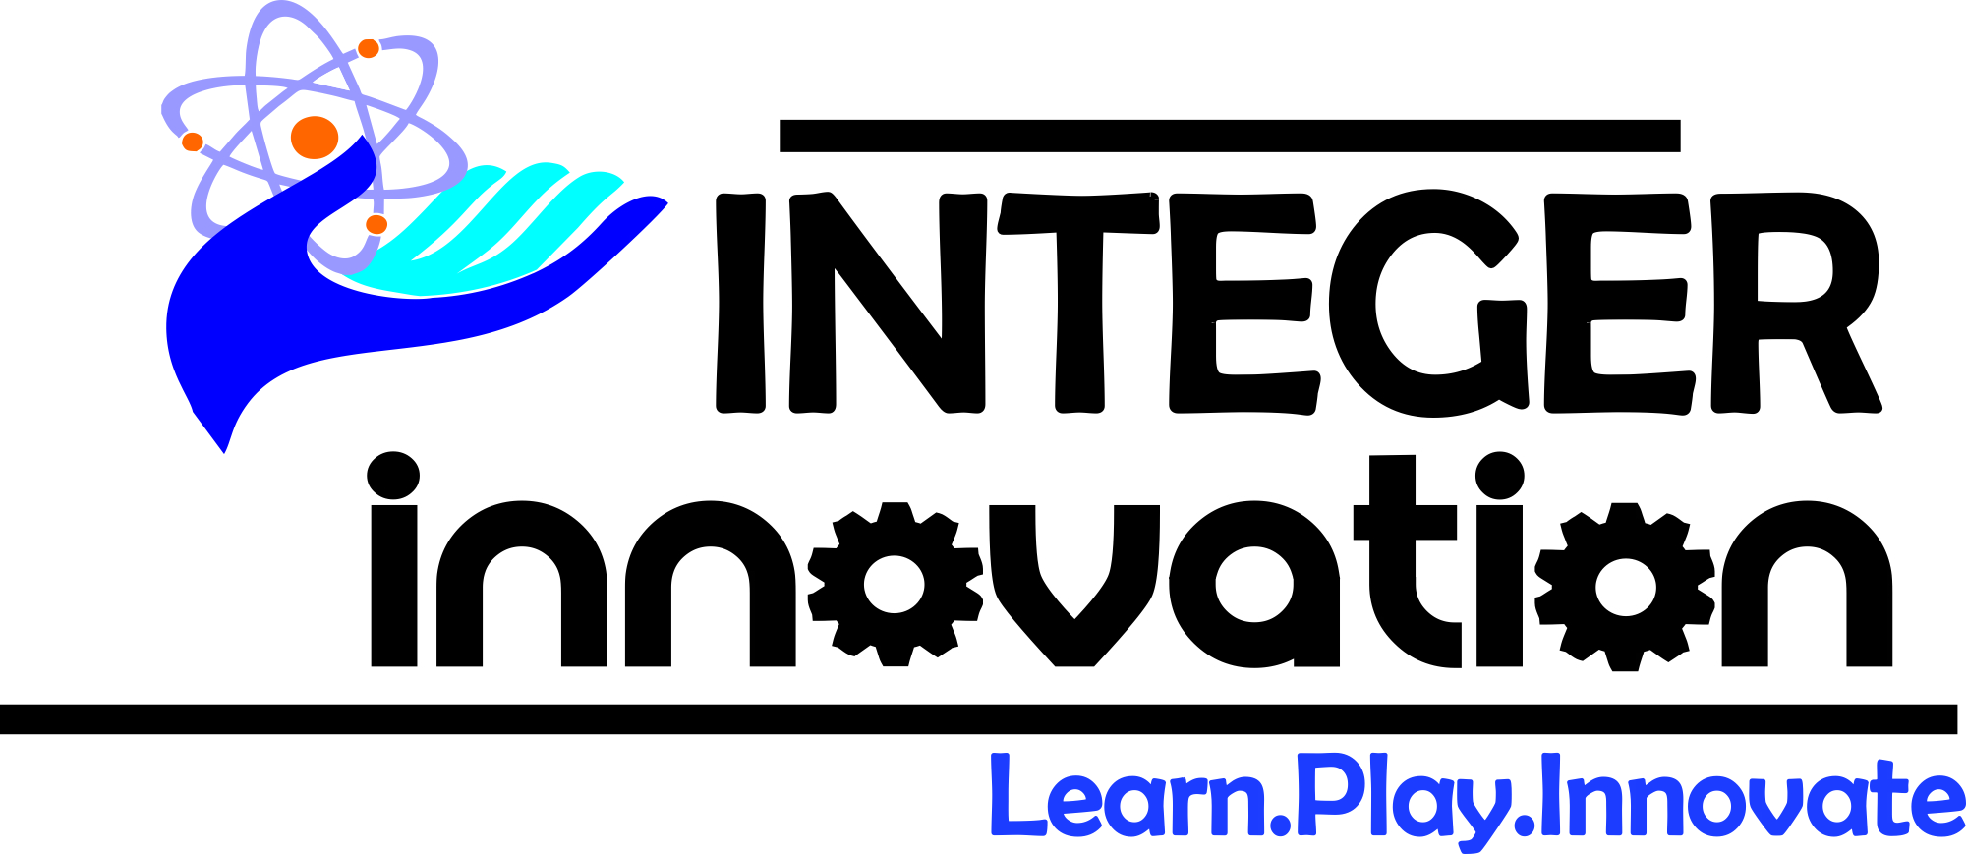  
INTEGER Innovation** ~*Learn.Play.Innovate*

❖ **Introduction**

Every organization needs a Web portal, Android Apps, iOS Apps, CMS applications, responsive websites applications, ERP solutions, SEO and more and we here at INTEGER Innovation intend to take care of your online presence. INTEGER Innovation is a multi -website development company (founded in March 16, 2013) and covering lots of domains apart from website development. We specialize in all domains of website from classy to simple, covering all technologies under one roof and a large number of other business domains, using state of the art technology tools, yet offering cost effective services.

❖ **Our Services**

End to end web based services offered by us for clients having different sets of requirements and innovative ideas. We walk the talk and focus on high performance deliverables. We are always ready to travel extra miles for customer satisfaction and personal objectives are always the byproduct. We are here for you!

* Website development
* Domain registration
* hosting
* Website design
* Content writing
* Graphic design
* SEO
* SMM
* Web application
* Website redesign
* E-commerce
* Social network
* Portfolio website
* Custom application and portal
* Mobile application,android,ios,windows
* **Why Choose Us** 
  + Help on making your venture an outstanding one
  + High quality deliverables and long lasting business relationships.
  + Timely responses and deliveries.
  + End to end solutions on business leveraging.
  + State of the art technological tools used.
  + We do not stop until your need is satiated.

❖ **Our Works**

Though it has been only few months since we entered into web development works the confidence our clients have shown in us has been commendable and we have always tried to live up to the expectations.

*Some of our works in this short span of time are:*

< --In Portfoilio-->

**The Squad**

**Yatin Sagar -**I am a professional website designer and developer with 2+ years Of experience in that is solidly grounded in creating a positive learning environment by building a high degree of rapport with customers, thus facilitating lasting change.

2) Knowledge of various other frameworks like Struts, MVC frameworks and more

3) Good experience in interacting with business analysts, developers, technical support and help them in base line the requirement specifications

4) Good knowledge in handling the Desktop, Web Application.   
  
5) Expertise in Web development and UXD platform.

6) Good experience in designing and developing the Android Apps.

7) Good interpersonal skills, commitment, result oriented, hard working with a quest and zeal to learn new technologies and undertake challenging tasks.

**PROFESSIONAL EXPERIENCE:**  
Developed more than 20+ websites on several platforms from one to other technology covering

**HTML , HTML5 ,CSS, CSS3, Javascript , JQuery, PHP and JQuery in Mobile development**

|  |  |
| --- | --- |
| **IT SKILLS:  WEB Developer & UXD Designer** |  |
|  | |
| **MVC Frameworks : Struts 1.x , 2.x,   Web Technologies : HTML , HTML5 ,CSS, CSS3   Javascript , JQuery, PHP  JQuery in Mobile development** |  |

**2) Vibhu –**

|  |
| --- |
| **IT SKILLS:  WEB Developer & UXD Designer** |
|  | |
| **MVC Frameworks : Struts 1.x , 2.x,   Web Technologies : HTML , HTML5 ,CSS, CSS3   Javascript , JQuery, PHP 6.0  JQuery in Mobile development** |

|  |  |
| --- | --- |
|  | Objectives  To handle challenging work and seek entrepreneurial ventures.  To prepare solid content and build efficient training processes.  Education  Bachelors of Technology (Computer Science) from Indraprastha University, Delhi (Completion year: 2008)      Experience  Freelance Trainer and Developer (2013 –current)  Handling technology-centric projects  Adaptation to different content platforms Building Course modules  Providing knowledge transfer  Sr. Software Engineer (2011 –2013)  Fagbokforlaget ([Type the company address])  Smaller teams, different platforms (more Open Source), online collaboration. Working in several web-based technologies like .NET, Silverlight, Javascript, Actionscript, UI/UX design, API design, Localization  Software Engineer (2009 –2011)  Accenture, India ([Type the company address])  Part of the entire delivery cycle at Six-Sigma. Performed in diverse, often concurrent roles as: Front-end developer, Daily build manager, Third-party UI Integration, Defect Fixing, UI and CSS Styles Liaison, Performance Testing Lead, Mock Testing (Non-subcutaneous testing)  Lead, Cross-browser compatibility reporting. |

|  |
| --- |
|  |

**(3) Virendra Sharma –   
Summary of Skills and Experience:**

**B.Tech (IT)** professional having **5+ years** of experience in the area of Software Development as **Lead Engineer and Programmer.**

1) I am a professional trainer, facilitator and developer with 4+ years Of development in that is solidly grounded in creating a positive learning environment by building a high degree of rapport with customers, thus facilitating lasting change.

2)Knowledge of various other frameworks like Struts, Hibernate, Springs, MVC frameworks, ORM Frameworks, JSF and more.

3) Good experience in interacting with business analysts, developers, technical support and help them in base line the requirement specifications

4) Good knowledge in handling the Desktop, Web Application.   
  
5) Expertise in Software Development Life Cycle (SDLC).

6) Good experience in designing and developing the Android Apps.

7) Command on Databases and tools.

8) Good interpersonal skills, commitment, result oriented, hard working with a quest and zeal to learn new technologies and undertake challenging tasks.

**PROFESSIONAL EXPERIENCE:**

Working as corporate and In-house software and website creator at PTMF and ACT  
(sooner to be at Samsung too)

|  |  |
| --- | --- |
| **IT SKILLS:  Software Development & Lead** |  |
|  | |
| **ORM Frameworks : Hibernate, JPA and more. MVC Frameworks : Struts 1.x , 2.x, JSF, Springs etc. Web Technologies : HTML ,CSS, CSS3, Javascript** |  |
|  | |
| **Languages** | **: C, C++, Core JAVA, Advanced   Java, Android Development** |