This lesson explains about XAMPP web server, its features and functions, and installation.
At the end of this session students will be able to:
- know the type of web server (C1, knowledge)
- know the methods and make the installation and configuration on the web server (C2, comprehension)
- use a web server (P4, Practical)
Learning outcomes :
:
Lab summary
Lab 1 (A): XAMPP WEB SERVER INSTALLATION

Introduction

XAMPP Windows 7.3.1 open-source web server was used for this practical session. XAMPP Web Server has been developed and in it contains Apache, MySQL, PHP and Perl packages. Users just need to download, install, and use it.

XAMPP in this discussion contains three versions:
- Linux version (tested for Ubuntu, SuSE, RedHat, Mandrake and Debian),
- Versions of Windows 2000, 2003, XP and Vista and Windows 7,
- Beta version for Mac OS X.

XAMPP is one of the open-source software and it is free. Apart from being easy to understand by new users, it also allows users to connect the PHP -based programming language with the MYSQL database system quickly and efficiently.

Users do not need to know in detail about how to link PHP programming developed with MYSQL database system. Users only need to know the name of the database used and its location and management method. Because most web server deployments share the same components as XAMPP, moving from a local test server to a live server is effortless.

The following are the packages contained in the XAMPP Windows 7.2.2 software:
  - Apache,
  - MySQL,
  - FileZilla,
  - Mercury,
  - Tomcat.

Download XAMPP Web Server Software
    - Download the latest XAMPP software from the following link https://www.apachefriends.org/index.html or search using the keyword ‘XAMPP download’.
    - Click on XAMPP for Windows.
    - Save the software to a directory of choice.
    - The software can also be installed on a USB pen drive and this will be known as a portable mini server.

Figure 1: Downloading XAMPP web server software

XAMPP Web Server Software Installation
    - Click on the downloaded software (*.exe) and click OK, Yes and Next if there are any popup windows displayed.
    - Leave the component selection by default as in Figure 2. Click the Next button
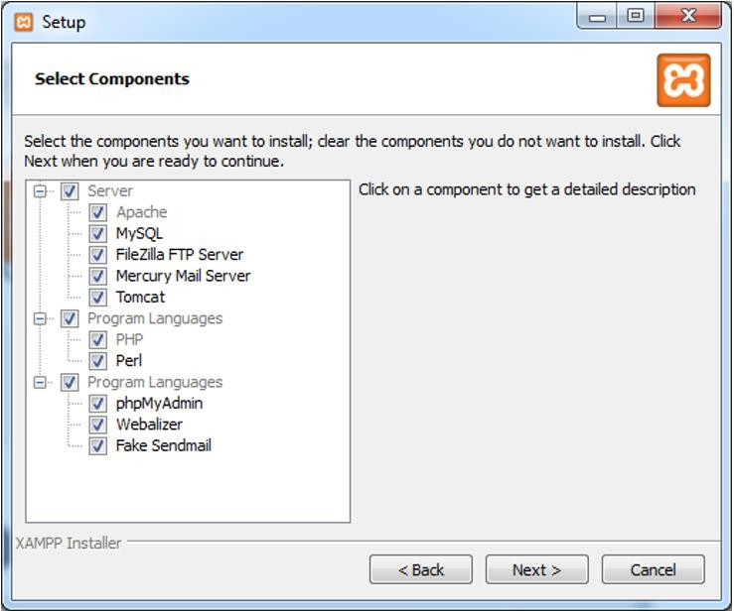
Figure 2: Default component settings
    - Set the Destination Folder to c:\xampp or name it according to the user's choice as illustrated in Figure 3.

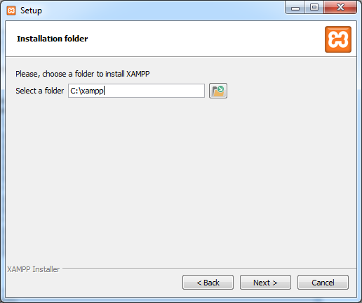
Figure 3: Destination Folder settings for XAMPP web server
    - The system installation is in progress as shown in Figure 4. Press the Next, Finish and Save (Language selection) buttons for all the popups shown.
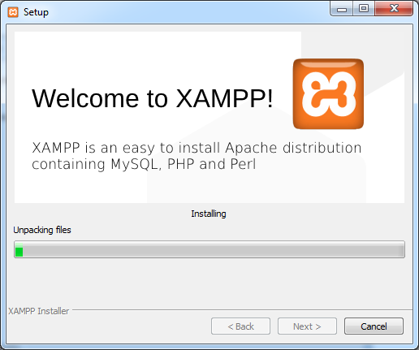
Figure 4: XAMPP web server installation

Starting XAMPP Web Server Software (Control Panel)
    - To start this web server, click Start on Apache and MySQL under the action menu as shown in Figure 5 (a).
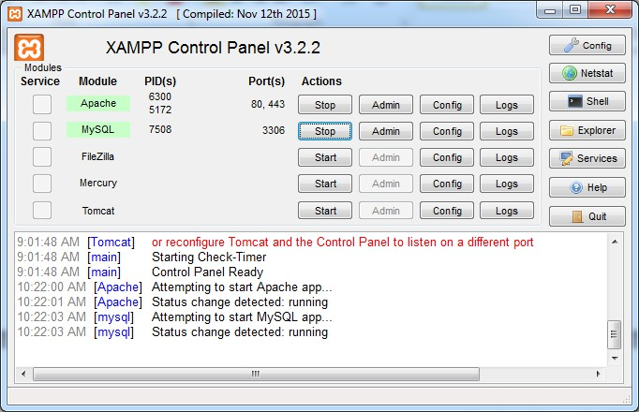
Figure 5(a): Control Panel for XAMPP web server
    - Click the Config button to activate it when the computer Restarts. Figure 5b shows the configuration of control panel. Make sure Apache and MySQL are at the √ mark and click Save on Autostart of modules (automatically activated when the computer Restarts).
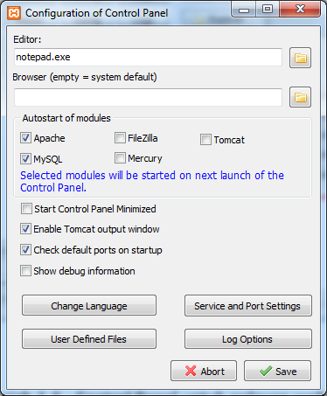
Figure 5 (b): Control Panel for XAMPP web server
    - Click Admin in Apache; a website display with the address http://localhost/dashboard/. Figure 6 shows the administrator website for

XAMPP web server.
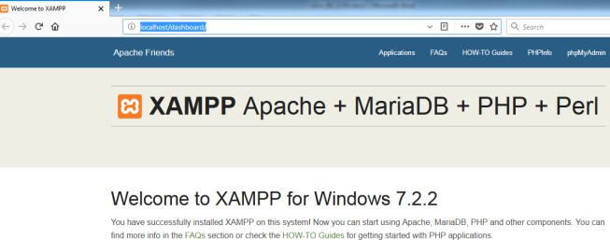
Figure 6: Administrator website for XAMPP web server

Directories for web servers.
    - This directory is in C:\xampp and the directory to place the user's website is in C:\xampp\htdocs as shown in Figure 7.
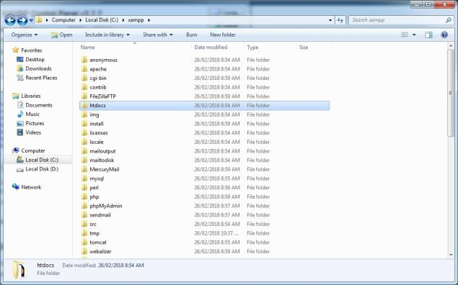

Figure 7: Directory for XAMPP server website and user website
    - To see if the developed website can be accessed, open any web browser (IE, Chrome, Firefox) and type http://localhost into the address bar until the XAMPP for Windows display appears, as shown in Figure 6.

=========================================================

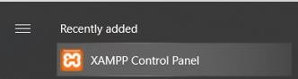 | - What about you?  - Have you finished installing the web server on your station?  - What did you learn today?  - Let us continue web authoring

