Lab 1 (B): WEB AUTHORING SOFTWARE
Lab summary | : This lesson covers the basic features common to the most popular web authoring software programs. It also describes the overall work environment and provides an overview of HTML techniques, and how to implement them using web authoring  tools.
Learning outcomes | : At the end of the session, students are able to  - know the types of web authoring tools (C1, knowledge)  - install and use selected web authoring tools (C2, understanding)  - create simple page using HTML and PHP code (P4, Practical)  - deploy the developed websites using Internet browsers (P4, Practical)  - create plain HTML or XHTML elements using web  authoring software instead of writing code (P4, Practical)

Web Authoring

    - Web authoring can be described as a category of software that allows users to develop websites in a desktop publishing format. The software will generate the HTML coding required for the layout of the Web page based on what the user has planned. Typically, users can switch between graphic design and HTML code and make changes to the website in the code design.

    - Web authoring tools are used to create Web content and include a variety of software programs that can be downloaded to a computer or access online. The World Wide Web Consortium, W3, released a guide to web authoring tools that establish basic industry standards for web accessibility. All major web authoring tool manufacturers follow W3 guidelines.

    - Several types of web authoring tools are as follows:

      - Visual Studio Code (VS Code)
      - Adobe Dreamweaver
      - Macromedia Dreamweaver
      - Microsoft Web Expression
      - Microsoft Frontpage
      - Notepad/notepad ++
      - KompoZer

Visual Studio Code

    - Visual Studio Code is one of the most popular and powerful text editors used by software engineers today.

    - In this article, we will go over the steps necessary to download a popular text editor called Visual Studio Code, also referred to as “VS Code.” By the end of the article, you will be able to create a folder in Visual Studio Code that contains an HTML document that you can open in your web browser.

Introduction
What are ‘text editors’?
    - Text editors, also called code editors, are applications used by developers to write code. They can highlight and format your code so that it’s easier to read and understand.

    - Using a text editor is part of creating your “development environment,” the set of tools that you use for working on coding projects. It will allow you to take what you’ve learned during lecture and put it into practice as you work on projects on your computer.
    - Specific to writing code, text editors provide several advantages:

- Language-specific syntax highlighting
- Automatic code indentation
- Color schemes to suit your preferences and make code easier to read
- Plug-ins, or add-on programs, to catch errors in code
- A tree view, or visual representation, of a project’s folders and files, so you can
conveniently navigate your project
- Key shortcuts, or combinations, for faster development
- Integrated Development Editors (IDE) allows you to not only edit, but also compile, and debug your code through one application or interface. While the
text editor we recommend isn’t considered an IDE, it has many IDE-like features that make life as a developer easier without needing a lot of resources that an IDE usually requires.

Choosing a Text Editor
    - There are several text editors to choose from. For example, Visual Studio Code is one of the most popular text editors used by developers. Other popular text editors you may have heard of are Atom and Sublime Text.

    - Any of these text editors mentioned are great for development but to make things easier, we suggest you start off with Visual Studio Code. Some of the benefits of this editor are:

- Free to use
- Open source, (meaning a program’s code can be viewed, modified, and shared)
- IDE-like features
- Supported by a large community of users and Microsoft
- When you are further along in your coding career, you can try other code editors to see what features work best with your personal development workflow.

Installing Visual Studio Code
    - So, we’ve chosen our text editor, now we just need to install it on our computer!
    - The installation process for computers running macOS, Windows, and Linux, (specifically Ubuntu and Debian), will be very similar and using Visual Studio Code across all of them will be the same.

Installing Visual Studio Code
- Download Visual Studio Code.  - https://code.visualstudio.com  - Windows users: This will download the latest version of Visual Studio Code as an .exe file.  - Mac users: This will download the latest version of Visual Studio Code  for Mac as a .zip file. | 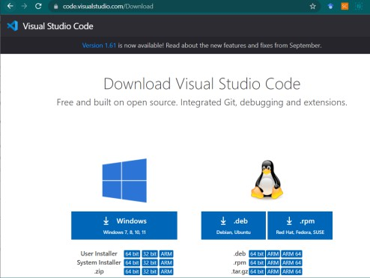  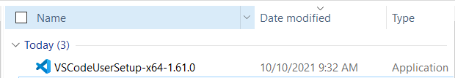
- Installation
  - Windows users: Open the .exe file by clicking on it and on run the installer.
Keep clicking ‘Next’ and then finally ‘Finish.’
  - Mac users: The downloaded .zip file should be in your ‘Downloads’ folder. Open the file. If you see this message, choose “Open.”
3. Post - Installation
Make sure you have your Visual Studio Code application saved in a place you know you will
easily be able to find it.

- Windows users: It will automatically be placed in your Start menu.
- Mac users: Click and drag the Visual Studio Code icon from the Downloads folder to the Applications folder.
    - That’s it, you’ve successfully installed your text editor and are ready to start coding!
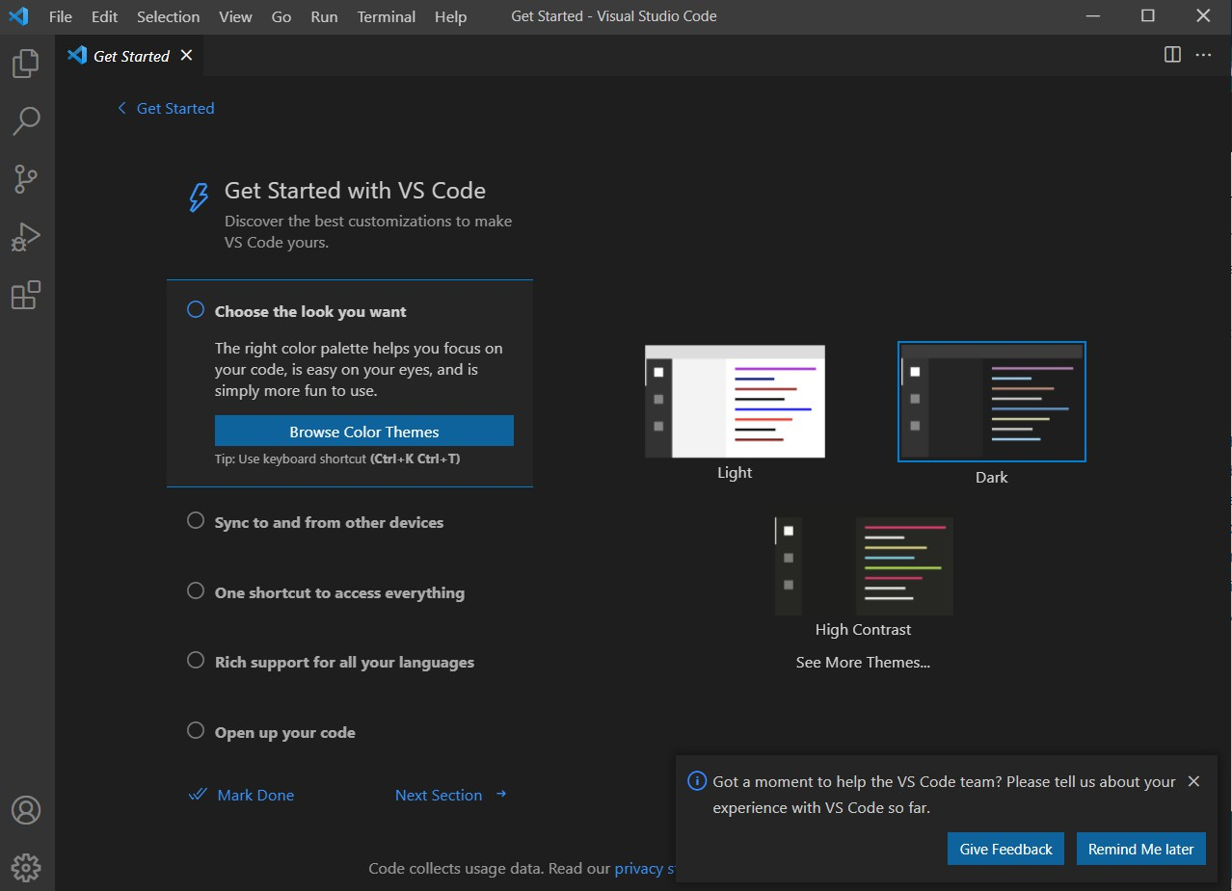
Practice: Use Visual Studio Code to start an off-platform project
As you move through various lessons, you may find yourself needing to create a project on your own computer. This can be tricky, but it’s an exciting step that signals that you are ready to work independently.

To do this, we’ll need to use the text editor we installed above. Let’s take a moment to try out Visual Studio Code.

Development folders?
    - Before using your text editor, it’s important to establish an organized file system. As the number and size of your projects grow, it becomes increasingly important to know where to save new projects and find old projects.
    - Most developers store their projects in an easy-to-find directory, (what you might be used to calling a ‘folder’). We recommend naming this directory projects. It will store all of your coding projects. Whenever you create a new project, no matter how small, you should always make a new folder inside your projects directory. You will find that single-file projects can quickly turn into large, multi-folder projects.

    - Below are the steps you need to follow to create a new folder for all of your programming projects. You will also learn how to load a new project folder into Visual Studio Code and make your very first “hello world” HTML project.

Practice: Let’s create a project
- Navigate to a folder using your file manager or the terminal.  - Create a new folder called projects.  - Mac users: This may be your User  account or “Home” folder.  - Windows users: You may want to save this on your C drive.  - Inside the projects folder, create a new folder called HelloWorld. Everything you add to this folder will be part of your HelloWorld project. | 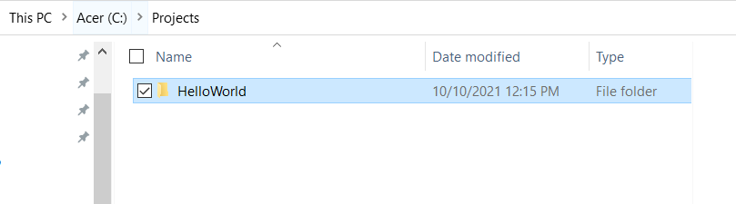

Practice: Open Visual Studio Code
- Click on the ‘Explorer’ icon on the  left-hand menu.  - Click on the button ‘Open Folder’ and choose your development folder.  - This will launch your file manager.  . | 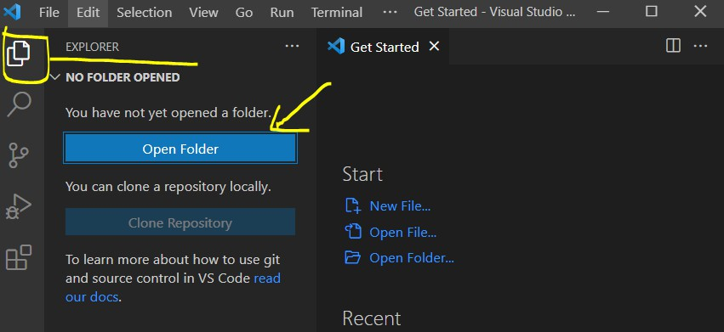
- Navigate to the HelloWorld folder and select Open. The folder will open in Visual Studio Code’s side pane.  - At this point, there should not be any contents in the folder. We’ll add a file in the next step | 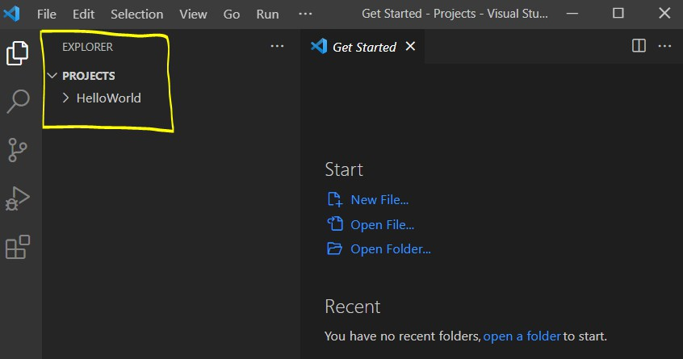
Practice: Add a file
- Once Visual Studio Code loads a project folder, you can add files.  - In Visual Studio Code’s Explorer pane, click on your development folder’s name.  - You’ll see four icons appear to the  right of the folder name.  - Click the ’New File’ icon. Type the new file’s name with its appropriate file extension >> index.html  - Press Enter when done. | 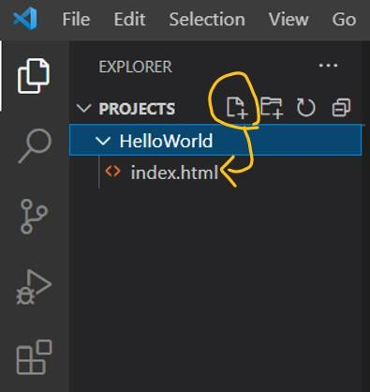

Practice: Begin Coding
i. Copy and paste the following HTML code:  <html>  <head>  <title>Hello World</title>  </head>  <body>  <h1>Hello World</h1>  </body>  </html> | 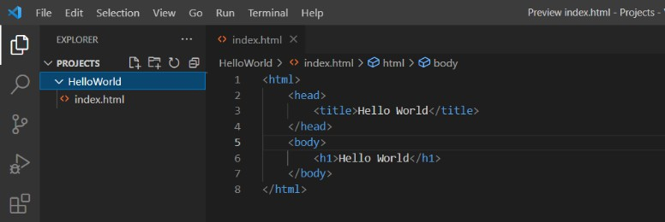  Syntax is the set of rules that tell us how to create correctly written code.  - Visual Studio Code and other text editors are able to interpret file extensions and provide language-specific syntax highlighting. Syntax highlighting is a tool for making code easier to read. Take a look at your index.html file.  - The text and tags are different colors. This is how Visual Studio Code highlights .html syntax.  - With each new language you learn, Visual Studio Code will highlight text in a way that makes your code easy to read.
ii. Save your file.
Practice: View your HTML file in the browser
At this point, your file is ready to be viewed in a web browser. The following steps should be taken outside of Visual Studio Code:  - Navigate to the index.html file in your Hello World folder through your file manager or terminal.  - Double click or open index.html. The page should open in your default web browser. | 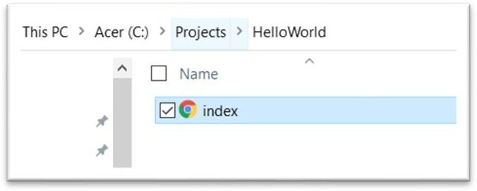  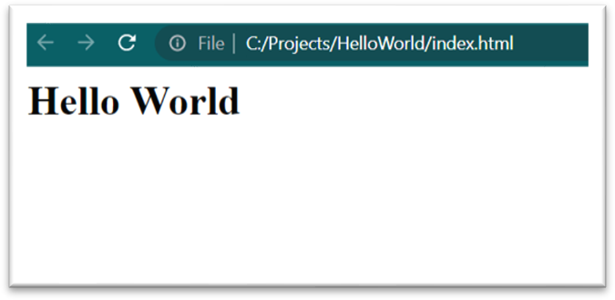

View your HTML file in Visual Studio Code
    - Visual Studio Code is built with extensibility in mind. From the UI to the editing experience, almost every part of VS Code can be customized and enhanced through the Extension API. In fact, many core features of VS Code are built as extensions and use the same Extension API. VS Code extensions let you add languages, debuggers, and tools to your installation to support your development workflow.
    - To allow us to view out HTML file in the Visual Studio Code, you need to install an HTML viewer extension. An example of such extension is HTML Preview.

Practice: View your HTML file in Visual Studio Code
Browse for extensions  - You can browse and install extensions from within VS Code.  - Bring up the Extensions view by clicking on the Extensions icon in the Activity Bar on the side of VS Code or the View:  Extension’s command  (Ctrl+Shift+X).  - This will show you a list of the most popular VS Code extensions on the VS Code Marketplace.  - Each extension in the list includes a brief description, the publisher, the download count, and a five-star rating. | 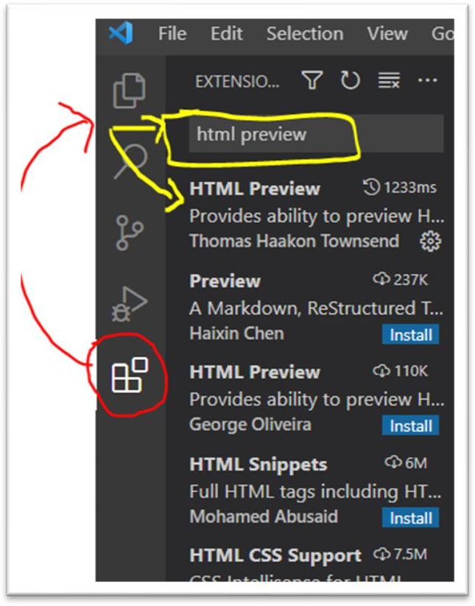

Install an extension  - Search the extension by typing the name in the search field.  - Type “HTML Preview” in the search field, and you should be able to see the following extension displayed in the Marketplace.  - To install an extension, click the Install button. Once the installation is complete, the Install button will change to  the Manage gear button. | 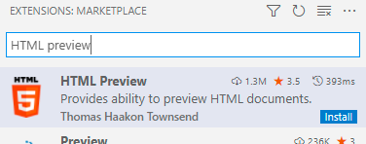
- This extension allows us to preview HTML files while editing them in VSCode.  - The extension can be activated in two ways:  - Toggle Preview  - ctrl+shift+v or cmd+shift  +v  - Open Preview to the Side - ctrl+k v or cmd+k v | 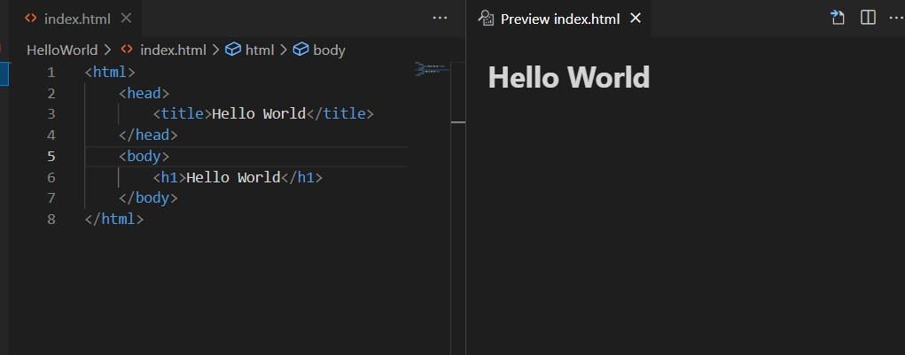

More Activities
The best way to learn a new software application is to explore it. Try adding additional components to your web page, including ordered and unordered lists, tables, form fields, and anything else that you're curious about. Keep your document organized using subheadings. If you add new sections to your document, add corresponding links to these sections from your home page. You may use a very popular extension called HTML

Boilerplate (by sidthesloth) that allows you to easily add various HTML components into you file.

Save your web page. Explore more.

