### ****Project:** Product Dissection for **Amazon Platform****

#### ****1. Platform Understanding (Research)****

**Amazon Overview:** Amazon is one of the largest e-commerce platforms globally, offering a wide range of products from electronics to clothing, groceries, and digital content. It provides services such as Amazon Prime, Amazon Web Services (AWS), and more. Users interact with Amazon through searching for products, adding items to their cart, purchasing, reviewing products, and managing their accounts.

**Key Features:**

* **Product Search and Filtering:** Users can search for products using keywords, filter by categories, price, ratings, and more.
* **Shopping Cart and Wishlist:** Users can add items to their cart or wishlist for future purchases.
* **Order Management:** Users can place orders, track shipments, and manage returns.
* **User Reviews and Ratings:** Customers can rate products and provide feedback, influencing future buyers.
* **Recommendations and Personalization:** Based on user behavior, Amazon provides personalized recommendations.
* **Seller Platform:** Third-party sellers can list their products on Amazon, manage inventory, and track sales.

#### ****2. Problem-Solving Analysis****

**Real-Life Problems Solved by Amazon:**

* **Convenience:** Amazon provides a one-stop shop for millions of products, allowing users to make purchases from the comfort of their homes.
* **Time-Saving:** The platform offers fast shipping options, including same-day delivery in certain areas.
* **Product Discovery:** Through recommendations and user reviews, Amazon helps users discover products that fit their needs.
* **Secure Transactions:** Amazon ensures secure payment methods, protecting users’ financial information.
* **Global Reach:** Amazon connects sellers and buyers worldwide, allowing for international trade and access to a global marketplace.

#### ****3. Case Study Development****

**User Scenario:** Sarah, a working professional, often finds herself busy and relies on Amazon for her shopping needs. She uses the platform to buy groceries, electronics, and gifts for her family. Recently, she had trouble finding a specific electronic gadget and was unsure of its quality. Using Amazon's search filters, reviews, and recommendations, she quickly found the product she needed, read through detailed user reviews, and made a purchase with confidence. The item was delivered within two days, and Sarah was able to track her order in real-time.

**Key Features Highlighted:**

* **Search and Filtering:** Enabled Sarah to quickly narrow down product options.
* **User Reviews:** Helped her make an informed purchase decision.
* **Order Tracking:** Provided peace of mind about the delivery process.

#### ****4. Schema Design****

**Entities and Attributes:**

* **Users:** UserID, Name, Email, Password, Address, PhoneNumber, PaymentDetails
* **Products:** ProductID, Name, Description, Price, Category, StockQuantity, SellerID
* **Orders:** OrderID, UserID, OrderDate, ShippingAddress, TotalAmount, PaymentStatus
* **OrderItems:** OrderItemID, OrderID, ProductID, Quantity, Price
* **Reviews:** ReviewID, UserID, ProductID, Rating, Comment, ReviewDate
* **Sellers:** SellerID, Name, ContactInfo, Rating
* **Cart:** CartID, UserID, CreatedDate
* **CartItems:** CartItemID, CartID, ProductID, Quantity

**Relationships:**

* **Users and Orders:** One-to-Many (A user can have multiple orders)
* **Products and OrderItems:** One-to-Many (A product can be part of multiple orders)
* **Users and Reviews:** One-to-Many (A user can write multiple reviews)
* **Products and Reviews:** One-to-Many (A product can have multiple reviews)
* **Sellers and Products:** One-to-Many (A seller can list multiple products)
* **Cart and CartItems:** One-to-Many (A cart can contain multiple items)

#### ****5. Rationale and Strategy****

The schema is designed to capture the core functionalities of Amazon, focusing on scalability and efficiency. The relationships are mapped to reflect how different entities interact, ensuring that data can be retrieved quickly and accurately to enhance user experience.

* **Scalability:** The schema supports adding more entities like wishlists, promotions, and more advanced personalization features without major restructuring.
* **Efficiency:** The design focuses on optimizing search queries, order processing, and user management.

#### ****6. ER Diagram (Visual Representation)****

I'll create an ER diagram that visually represents the relationships between the entities discussed above. This diagram will be a cornerstone for understanding the data architecture of the platform.

#### ****7. Presentation Skills****

I'll compile the solutions into a well-structured document and create an engaging video explaining five key aspects of the schema, focusing on user interactions, scalability, and how the design aligns with Amazon's business objectives.

#### ****8. Creativity and Presentation Quality****

The project will include visual aids like diagrams and flowcharts to enhance the clarity of explanations. The presentation will be polished and professional, ensuring it conveys the concepts effectively.

This project will provide a comprehensive understanding of Amazon's platform through the lens of data architecture, showcasing how thoughtful schema design drives functionality and user satisfaction.

**Company Overview:**

Amazon, founded by Jeff Bezos in 1994, has become a global leader in e-commerce, known for its customer-centric approach and vast product offerings. Headquartered in Seattle, Washington, Amazon has expanded its operations to over 100 countries, including India, where it has established itself as a dominant player in the online retail market. With its commitment to innovation, convenience, and reliability, Amazon has revolutionized the way people shop online, providing a seamless shopping experience to millions of customers worldwide.

**Product Dissection and Real-World Problems Solved by Amazon:**

Amazon, a global e-commerce powerhouse, has effectively addressed numerous real-world challenges through its innovative product offerings and technological advancements. By focusing on customer convenience, affordability, and trust, Amazon has transformed the online shopping experience, catering to the diverse needs of its customers.

Amazon's user-friendly interface and personalized shopping experience have set new standards in the e-commerce industry. The platform provides detailed product descriptions, customer reviews, and personalized recommendations, helping users make informed purchasing decisions and reducing the uncertainty often associated with online shopping. Amazon's robust return and refund policies further enhance customer confidence, making it a trusted platform for online purchases.

In conclusion, Amazon's product design has successfully tackled real-world problems by creating a platform that prioritizes customer convenience, affordability, and trust. Through its extensive product range, user-friendly interface, and reliable services, Amazon has redefined the e-commerce experience, making online shopping more accessible and enjoyable for millions of users globally.

**Case Study: Real-World Problems and Amazon's Innovative Solutions**

Amazon, a global e-commerce giant, has not only transformed the way people shop online but has also addressed significant real-world challenges through its innovative features. By understanding customer needs and leveraging cutting-edge technology, Amazon has emerged as a customer-centric platform that prioritizes convenience, affordability, and reliability.

**Problem 1: Limited Access to Products in Remote Areas**

**Real-World Challenge:**

Residents of remote areas often face challenges in accessing a wide range of products due to limited availability and logistical constraints.

**Amazon's Solution:**

Amazon recognized the need to democratize access to products across the globe. By leveraging its extensive logistics network, Amazon ensures that customers from remote areas have access to a diverse range of products. The platform's robust delivery infrastructure reaches even the most remote locations, solving the problem of limited access and expanding the reach of e-commerce worldwide.

**Problem 2: Trust and Reliability in Online Transactions**

**Real-World Challenge:**

Many consumers hesitate to shop online due to concerns about the security of transactions and the authenticity of products.

**Amazon's Solution:**

Amazon prioritizes trust and reliability in every transaction. By implementing secure payment gateways and stringent quality control measures, Amazon ensures that customers can shop with confidence. The platform also offers genuine products from trusted sellers, backed by comprehensive warranty and return policies. Through these initiatives, Amazon addresses the challenge of trust in online transactions, earning the confidence of millions of customers globally.

**Problem 3: Price Sensitivity and Affordability**

**Real-World Challenge:**

Price sensitivity is a significant factor influencing purchasing decisions, especially in price-conscious markets.

**Amazon's Solution:**

Amazon understands the importance of affordability for its customers. By offering competitive prices, frequent discounts, and exclusive deals, Amazon makes online shopping accessible to a wide range of consumers. The platform's commitment to affordability ensures that customers can find value for money across various product categories, addressing the challenge of price sensitivity and enhancing the overall shopping experience.

**Problem 4: Product Discovery and Decision-Making**

**Real-World Challenge:**

With a vast array of products available online, customers often struggle to discover relevant items and make informed purchasing decisions.

**Amazon's Solution:**

Amazon simplifies the product discovery process through intuitive search filters, detailed product descriptions, and customer reviews. The platform's recommendation algorithms analyze user preferences and browsing history to suggest personalized product recommendations, helping customers discover new items tailored to their interests. By empowering customers with relevant information and insights, Amazon addresses the challenge of product discovery, making shopping online more engaging and enjoyable.

**Conclusion:**

Amazon's journey from an online bookstore to a global e-commerce leader is a testament to its ability to understand customer needs and provide innovative solutions. By prioritizing convenience, affordability, and reliability, Amazon has reshaped the e-commerce landscape worldwide, making online shopping more accessible and enjoyable for millions of users. This case study highlights how Amazon's customer-centric approach and continuous innovation have established it as a trusted brand globally, setting new standards for excellence in e-commerce.

**Top Features of Amazon:**

**1. User Profiles:** Amazon allows users to create personalized profiles, providing insights into their shopping preferences and order history.

**2. Product Listings:** A core feature of Amazon is the extensive catalog of products across various categories, including electronics, fashion, home essentials, and more.

**3. Search and Filters:** Users can easily search for products and apply filters to narrow down their options based on price, brand, ratings, and other criteria.

**4. Secure Payment Options:** Amazon offers multiple secure payment options, including credit/debit cards, net banking, wallets, and cash on delivery, ensuring a seamless checkout experience.

**5. Customer Reviews:** Users can read and write reviews for products, sharing their experiences and insights to help other shoppers make informed decisions.

**6. Order Tracking:** Amazon provides real-time tracking updates for orders, allowing users to monitor the status of their deliveries and estimated delivery dates.

**Schema Description:**

The schema for Amazon comprises various entities that represent different aspects of the e-commerce platform. These entities include Shipment, Customer, Order, Payment, Cart, Product, Order_Item, Wishlist, and Category. Each entity has specific attributes that describe its properties and relationships with other entities.

**1. Shipment:** Manages shipping details for orders.

- shipment_id (Primary Key): A unique identifier for each shipment.

- shipment_date: The date when the shipment was made.

- address: The shipping address for the shipment.

- city: The city of the shipping address.

- state: The state of the shipping address.

- country: The country of the shipping address.

- zip_code: The zip code of the shipping address.

- Customer_custom (Foreign Key): References the customer who placed the order.

**2. Customer:** Stores user information for orders and interactions.

- customer_id (Primary Key): A unique identifier for each customer.

- first_name: The first name of the customer.

- last_name: The last name of the customer.

- email: The email address of the customer for communication.

- password: The password associated with the customer's account.

- address: The shipping address of the customer.

- phone_number: The phone number of the customer.

**3. Order:** Tracks purchase details and associated products.

- order_id (Primary Key): A unique identifier for each order.

- order_date: The date and time when the order was placed.

- total_price: The total price of the order.

- Customer_custo (Foreign Key): References the customer who placed the order.

- Payment_payme (Foreign Key): References the payment method used for the order.

- Shipment_shipm (Foreign Key): References the shipment associated with the order.

**4. Payment:** Manages transaction details for orders.

- payment_id (Primary Key): A unique identifier for each payment.

- payment_date: The date when the payment was made.

- payment_method: The method used for payment.

- amount: The amount paid for the order.

- Customer_custome (Foreign Key): References the customer who made the payment.

**5. Cart:** Stores selected items for potential purchase.

- cart_id (Primary Key): A unique identifier for each cart.

- quantity: The quantity of items in the cart.

- Customer_customer_id (Primary Key, Foreign Key): References the customer who owns the cart.

- Product_product_id (Foreign Key): References the product added to the cart.

**6. Product:** Represents items available for sale.

- product_id (Primary Key): A unique identifier for each product.

- SKU: The stock keeping unit of the product.

- description: A description of the product.

- price: The price of the product.

- stock: The available stock quantity of the product.

- Category_catego (Foreign Key): References the category to which the product belongs.

**7. Order_Item:** Tracks individual items within orders.

- order_item_id (Primary Key): A unique identifier for each order item.

- quantity: The quantity of the product in the order item.

- price: The price of the product in the order item.

- Product_prod (Foreign Key): References the product included in the order item.

- Order_order_i (Primary Key, Foreign Key): References the order to which the order item belongs.

**8. Wishlist:** Stores desired products for future purchase.

- wishlist_id (Primary Key): A unique identifier for each wishlist.

- Customer_customer_id (Primary Key, Foreign Key): References the customer who owns the wishlist.

- Product_product_id (Foreign Key): References the product added to the wishlist.

**9. Category:** Classifies products into distinct groups.

- category_id (Primary Key): A unique identifier for each category.

- name: The name of the category.

**Relationships:**

**- Customers and Orders:** The relationship between customers and orders allows Amazon to track individual customer purchases and manage order processing efficiently. It enables customers to place orders for products they intend to purchase, which is fundamental to an e-commerce platform.

**- Products and Categories:** Organizing products into categories helps users navigate through Amazon's vast inventory more easily. By categorizing products, customers can quickly find items of interest, leading to improved user experience and increased sales.

**- Customers and Payments:** The relationship between customers and payments facilitates secure transactions and ensures a smooth checkout process. It allows Amazon to process payments for orders made by customers using various payment methods, enhancing convenience and trust.

**- Customers and Wishlists:** Wishlists provide customers with a way to save products they are interested in purchasing later. This relationship enables customers to curate a list of desired items, enhancing engagement and encouraging repeat visits to the platform.

**- Customers and Carts:** The association between customers and carts enables users to add products to their carts before completing the purchase. This feature allows customers to review and modify their selections, providing flexibility and convenience during the shopping process.

**- Products and Orders:** The link between products and orders is crucial for inventory management and order fulfillment. It allows Amazon to track which products are included in each order, update stock levels accordingly, and ensure timely delivery to customers.

**- Customers and Reviews:** Customer reviews play a vital role in informing purchase decisions and building trust among users. By allowing customers to leave reviews for products they have purchased, Amazon fosters transparency and encourages user-generated content, which can influence buying behavior.

**ER Diagram:**

The ER diagram for Amazon depicts relationships among entities. Customers place orders, each comprising multiple items, associated with payments and shipments. Customers also maintain wishlists and carts, and provide reviews. Products are categorized, and each belongs to an order item. Payments are made by customers and associated with orders. Wishlists store desired products, while carts contain selected items. Reviews are left by customers for products. This ER diagram captures the core functionalities and interactions within Amazon's e-commerce platform, facilitating efficient order processing, inventory management, and customer engagement.

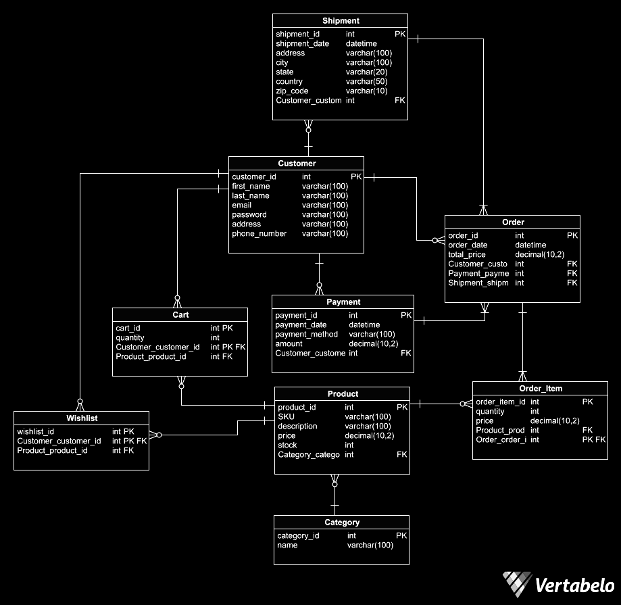

**Conclusion:**

In this case study, we explored the schema design of Amazon, a leading global e-commerce platform. Amazon's schema orchestrates seamless interactions between customers, orders, products, payments, and more. By intricately structuring entities and relationships, Amazon facilitates efficient order processing, inventory management, and user engagement. The schema reflects Amazon's commitment to providing a dynamic and customer-centric online shopping experience. By comprehensively understanding Amazon's schema, we gain insight into how the platform manages user interactions, product listings, and transactions, contributing to its prominence in the competitive e-commerce landscape.