



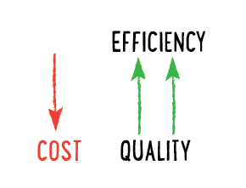

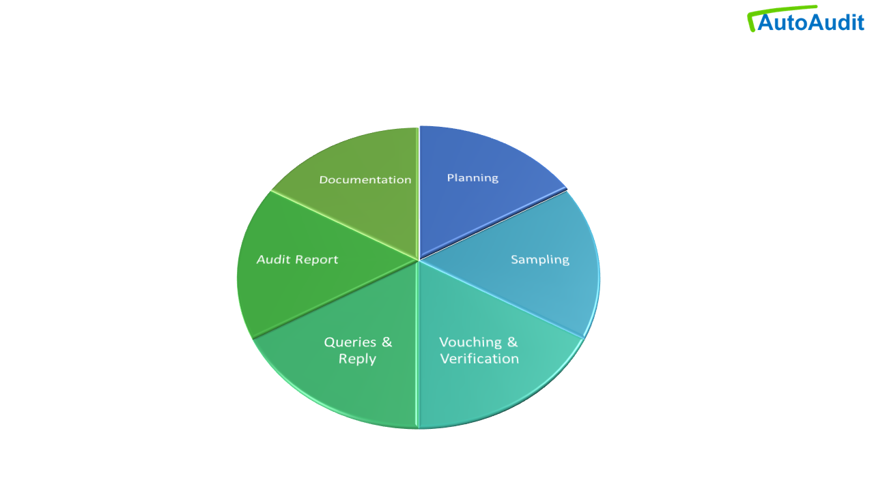

## Features

Audit Planning- Plan & manage tasks, Assign tasks to Team members.

Import Data- Seamlessly, import data for audit, from any of the data sources like -csv, xlsx, json, xml, sql or REST api.

Audit Sample- Select data for audit by Random sampling, or using Excel like filtering.

Audit Checklist- Set Audit Checklist or import from Excel templet on one click.

Vouching & Verification- Conduct Audit procedures online on the selected data.

Vouching - vouch the accuracy of the data, If values are wrong, then enter the correct value as verified against each field.

Verification- verify the internal controls as per checklist, put your remarks like cause and effect of the error.

Audit Queries- Audit Queries are auto generated. the Person responsible can see those queries from his login and he can submit his reply.

Auditor can accept or reject reply and compliance given by auditee.

Reports & Dashboard- real time reports for each data set are available indicating, total transactions, audited transactions and number of queries along with risk-based analysis.

Just on one click, generate risked based audit report and download it in word format

Audit Working papers- Auditor can maintain working papers and supporting documents online, which can be referred during audit easily.

Data Integrity

You can easily check, if the audited dataset is modified after checking or not, Just Import the current version of dataset, compare with audited dataset, and get the differences if any. The data modified after audit is highlighted.

Trust & Security

<https://docs.streamlit.io/streamlit-cloud/trust-and-security>

Are you tired of manually tracking and analyzing your company's financial data? Look no further than our internal audit software. With just a few clicks, you can easily access and review all of your financial information in one convenient location. Our software also includes built-in analytics tools to help you identify areas of risk and make informed decisions. Plus, with regular updates and top-notch security features, you can trust that your data will always be accurate and protected. Don't waste any more time and resources on manual audits. Try our internal audit software today and experience the difference it can make for your business."

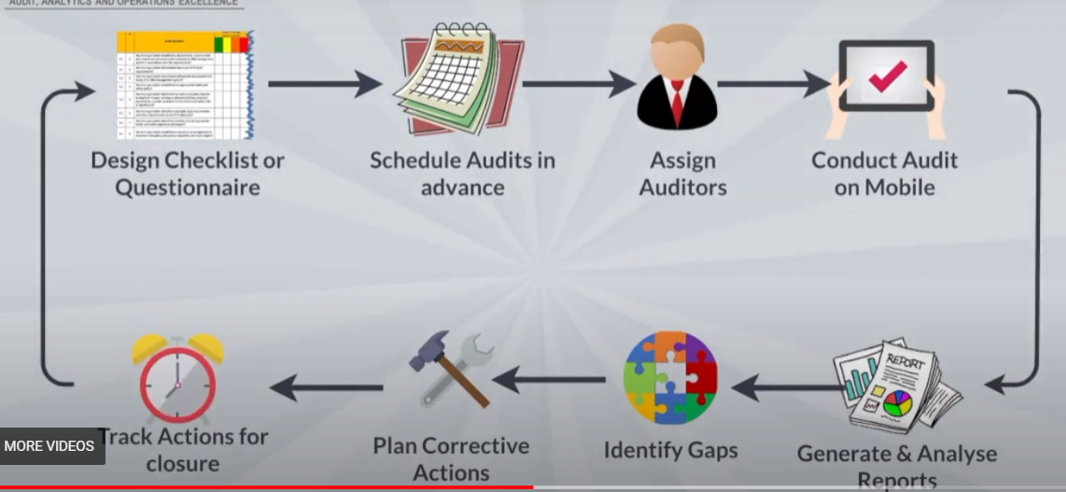

Features

Qaud

<https://qaud.app/Application/?gclid=Cj0KCQiAt66eBhCnARIsAKf3ZNELZr4Qek4o45CLqXHr-NILG2Wki9Gz43gUOE53i13nUe4rS1ofnUoaAvVDEALw_wcB#features>

auditboard

<https://www.auditboard.com/>

<https://assureai.in/features-and-benefits/>

<https://www.simsa.biz/>

hyperproof

sap auditmanagement

https://www.sap.com/products/financial-management/audit-management.html

<https://www.metricstream.com/products/internal-audit-management.htm>