Inhoud

**Geen inhoudsopgavegegevens gevonden.**

# Introduction

# Assignment

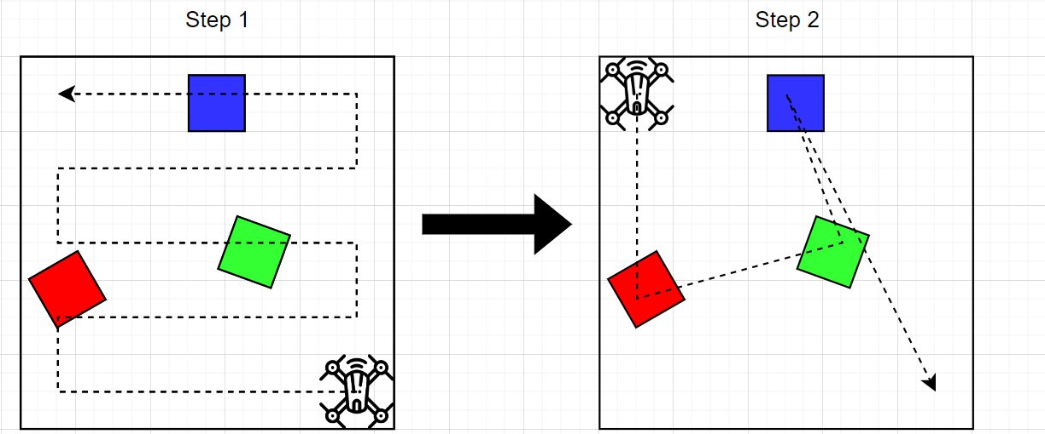

* The assignment is meant that the drone will go from red to green to blue.
* The three colors are put randomly in an square area with an random orientation.
* The drone has to first find the three colors.
* The moment it has found the three colors it will then go to each color in order of red to green to blue.
* Once it has been to the three colors it will then go back to its start position.