Tetris
Josh Simmons
CS 172 Final Project

Introduction
Tetris was one of the first incredibly popular video games. Next to Pong, it is probably the most known name in games. It's recommended by many as a great way to start programming graphics in games as it handles basic tiling, collisions, and other foundational cornerstones. I thought it would make a good final project, so here it is!

Requirements
There were a couple things I wanted to accomplish with this:
- I wanted it to be as legitimate as possible. There's an organization that owns Tetris (The Tetris Company, go figure), and they have released a set of specifications for Tetris games. I wanted to follow those as closely as possible.
- I wanted it to be made with completely free software. Any software used in making this game is completely free (and most of it under the GPL). Linux, G++, The Gimp, and SDL were the main ones. The version shown in class was compiled with DevC++ in Windows.

Postmortem
There were several big problems that occurred while I was making Tetris.
- The first and most obvious is that this is the first time I've used a graphics library for anything this big, so I had a lot of learning to do. Probably about a quarter of the time I've spent on this game has been spent reading up on how to use a certain function or data type. I think it was a worthy investment, though, as now I've got that much more knowledge under my belt.
- I couldn't figure out rotation for the life of me. I finally just sat down with a piece of paper and drew blocks til I figured it out. It turns out it was really easy, which was nice. The axises basically just flip.
- The way I wrote my check function didn't quite work for rotation. I tried modifying it but ended up just going with a separate rotocheck() funtion.
- Globals. They're evil. I already knew it was a bad thing to use em, but I couldn't think of any other way to do it without passing tons of arguments every with every function. This is the biggest mistake I made. With my next program/game I'll definitely find a way around it, but for now I'll just leave it.
- Sound effects. The sounds were always about ¾ of a second off of where they were supposed to be. I searched all over the internet, and it turns out this is a common issue with SDL_Mixer. Turns out the sound buffer has to be fully loaded before it'll play sounds (like, it'll load a second, then play), so I just had to make it smaller. Fixed.

Conclusion
Overall, I'm happy with the final product. Sure, it's got it's rough edges and the code's got the looks only it's coder could love, but I feel I've turned out a good clone. Next up, I think I'm doing a sidescroller for the Winter Funfest at a site I frequent. Should be one heck of a challenge.

Yay!
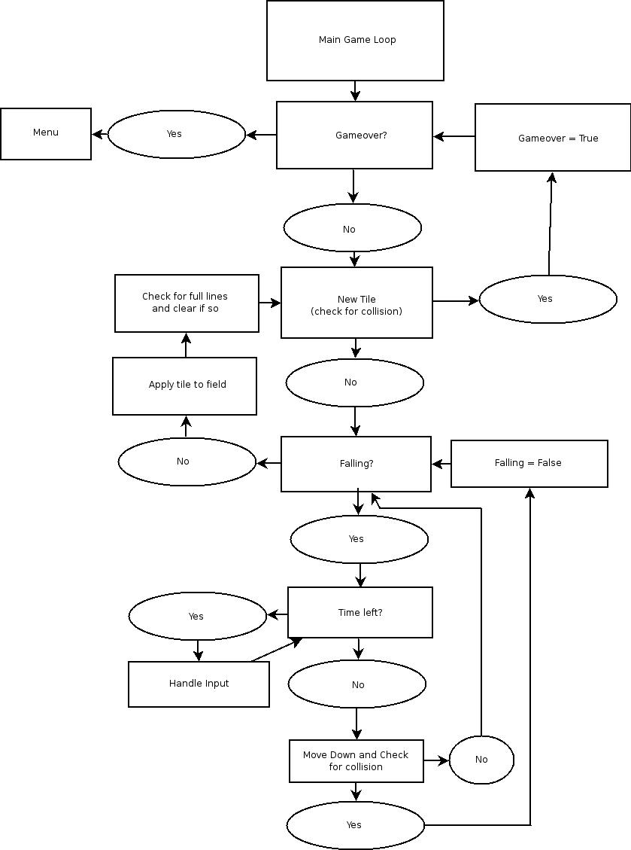
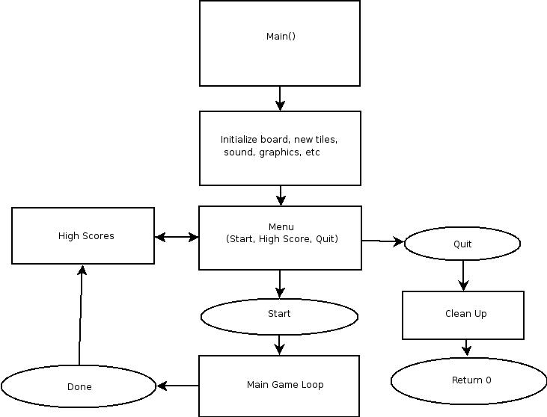
Flow Charts
Mmm... Diagrams.

