Adam Edwards
aedwar14@my.athens.edu
ID: 00130309
Assignment 3
Intro to Assembly & Computer Organization
Chap 4.9.1
1. What will be the value in EDX after each of the lines marked (a) and (b) execute?
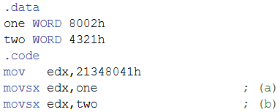
- a. edx = FFFF8002h b. edx = 00004321h
2. What will be the value in EAX after the following lines execute?
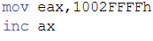
- eax = 10020000h
4. What will be the value in EAX after the following lines execute?
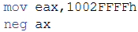
- eax = 10020001h
6. What will be the value of EAX and the Sign flag after the following lines execute?
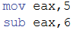
- eax = FFFFFFFFh, SF = 1 (bc result is negative)
8. What value will RAX contain after the following instruction executes?
- rax = 0000000044445555h
10. What value will EAX contain after the following instructions execute?
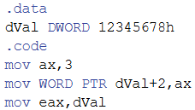
- eax = 00035678h
16. For each of the following statements, state whether or not the instruction is valid:
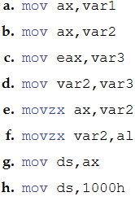
- a. not valid b. valid c. not valid d. not valid e. not valid f. not valid g. valid h. not valid
18. What will be the value of the destination operand after each of the following instructions execute in sequence?
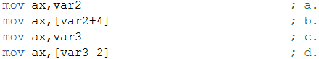
- a. 1000h b. 3000h c. FFF0h d. 4000h
Chap 4.9.2
1. Write a sequence of MOV instructions that will exchange the upper and lower words in a doubleword variable named three.
- Code:
mov ax, word ptr three
mov bx, word ptr three+2
mov three, bx
mov word ptr three+2, ax

8. Write a loop that iterates through a doubleword array and calculates the sum of its elements using a scale factor with indexed addressing.
- Code:
mov al, 80h
add al, 80h
Chap 4.10
2. Write a program with a loop and indexed addressing that exchanges every pair of values in an array with an even number of elements. Therefore, item i will exchange with item i+1, and item 1+2 will exchange with item i+3, and so on.
Chap 5.8.1
1. Which instruction pushes all of the 32-bit general-purpose registers on the stack?
- pusha
2. Which instruction pushes the 32-bit EFLAGS register on the stack?
- pushf
5. Challenge: Suppose MASM contained no PUSH instruction. Write a sequence of two other instructions that would accomplish the same as push eax.
- Code:
sub esp, 4
mov [esp] ,eax
18. Which statement is true about what will happen when the example code runs?
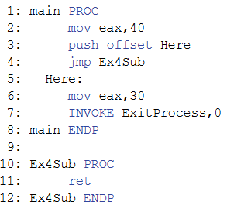
- c. EAX will equal 30 on line 6

20. What values will be written to the array when the following code executes?
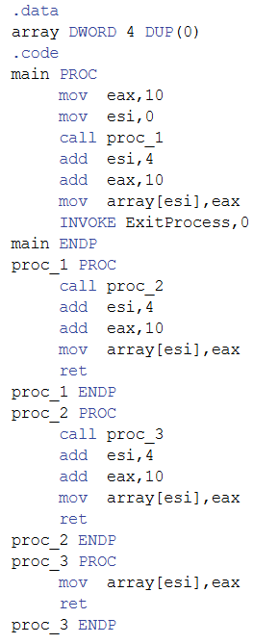
- The array will contain 10, 20, 30, 40
Chap 5.8.2
3. Functions in high-level languages often declare local variables just below the return address on the stack. Write an instruction that you could put at the beginning of an assembly language subroutine that would reserve space for two integer doubleword variables. Then, assign the values 1000h and 2000h to the two local variables.
- Code:

Sub esp, 8 ; space for two variables
mov [esp] ,1000h
mov [esp+4] ,2000h

5. Write a sequence of statements that display a subroutine’s return address. Be sure that whatever modifications you make to the stack do not prevent the subroutine from returning to its caller.
- Code:

mov eax. [esp]
call WriteHex
Chap 5.9
1. Write a program that displays the same string in four different colors, using a loop. Call the SetTextColor procedure from the book’s link library. Any colors may be chosen, but you may find it easiest to change the foreground color.
Input:
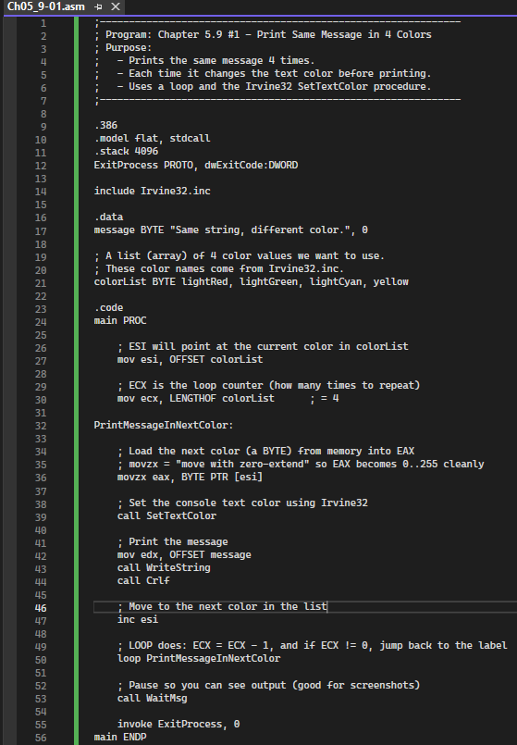
Output:
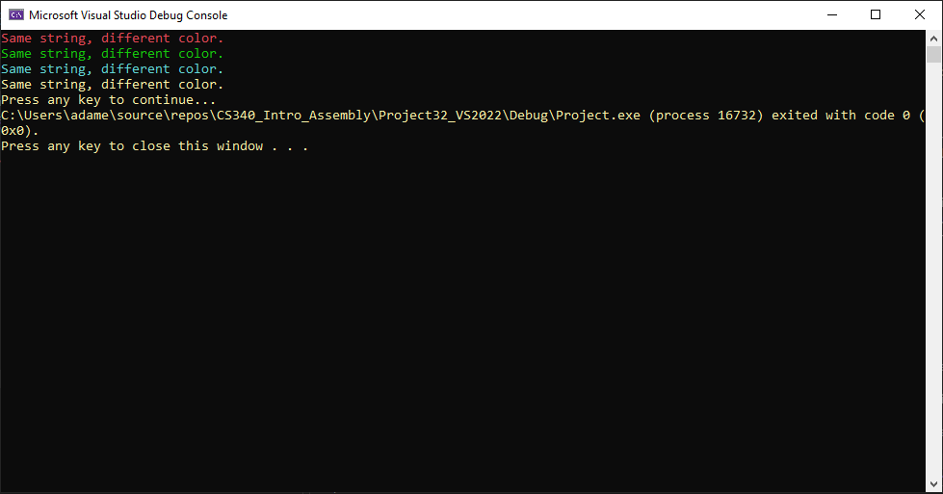

3. Write a program that clears the screen, locates the cursor near the middle of the screen, prompts the user for two integers, adds the integers, and displays their sum.
Input:
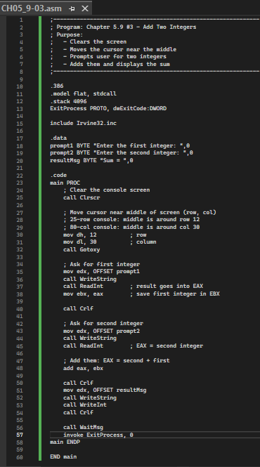

Output:
