Adam Edwards
CS 414 Programming Language
Dr. Lewis
Assignment 07
Part 1 - C++ Nonvirtual Diamond Outputs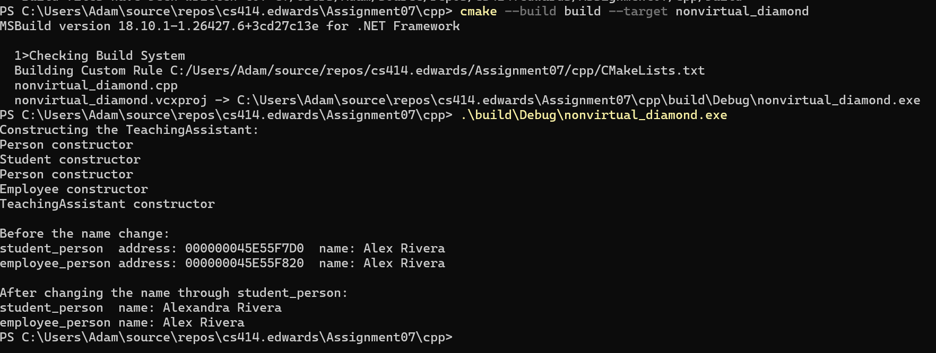
Figure 1
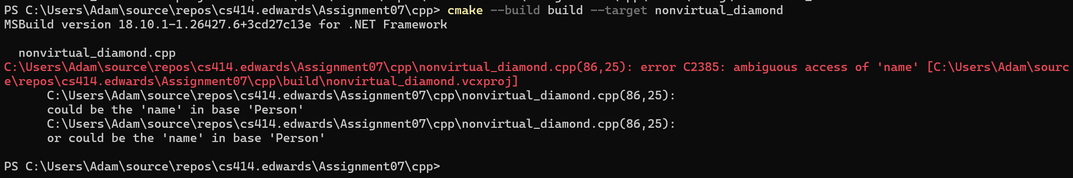
Figure 2
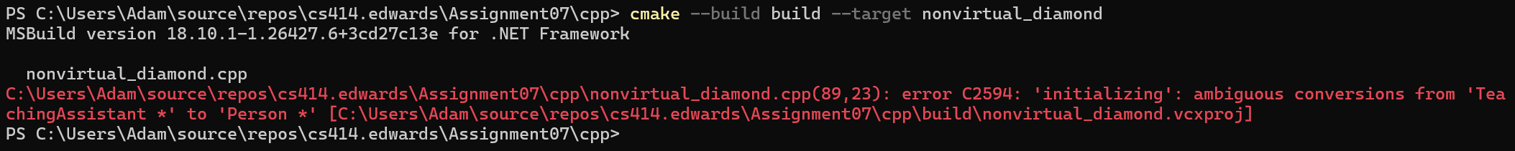
Figure 3
Student and Employee each inherit their own copy of Person, so the names can be different. The Person constructor runs twice because each copy needs to be initialized. The compiler rejects ta.name and Person* person = &ta because it cant tell which Person to use.
A class is the definition of an object, while a base-class subobject is the actual inherited part stored inside an object.

Part 2 - C++ Virtual Diamond Outputs
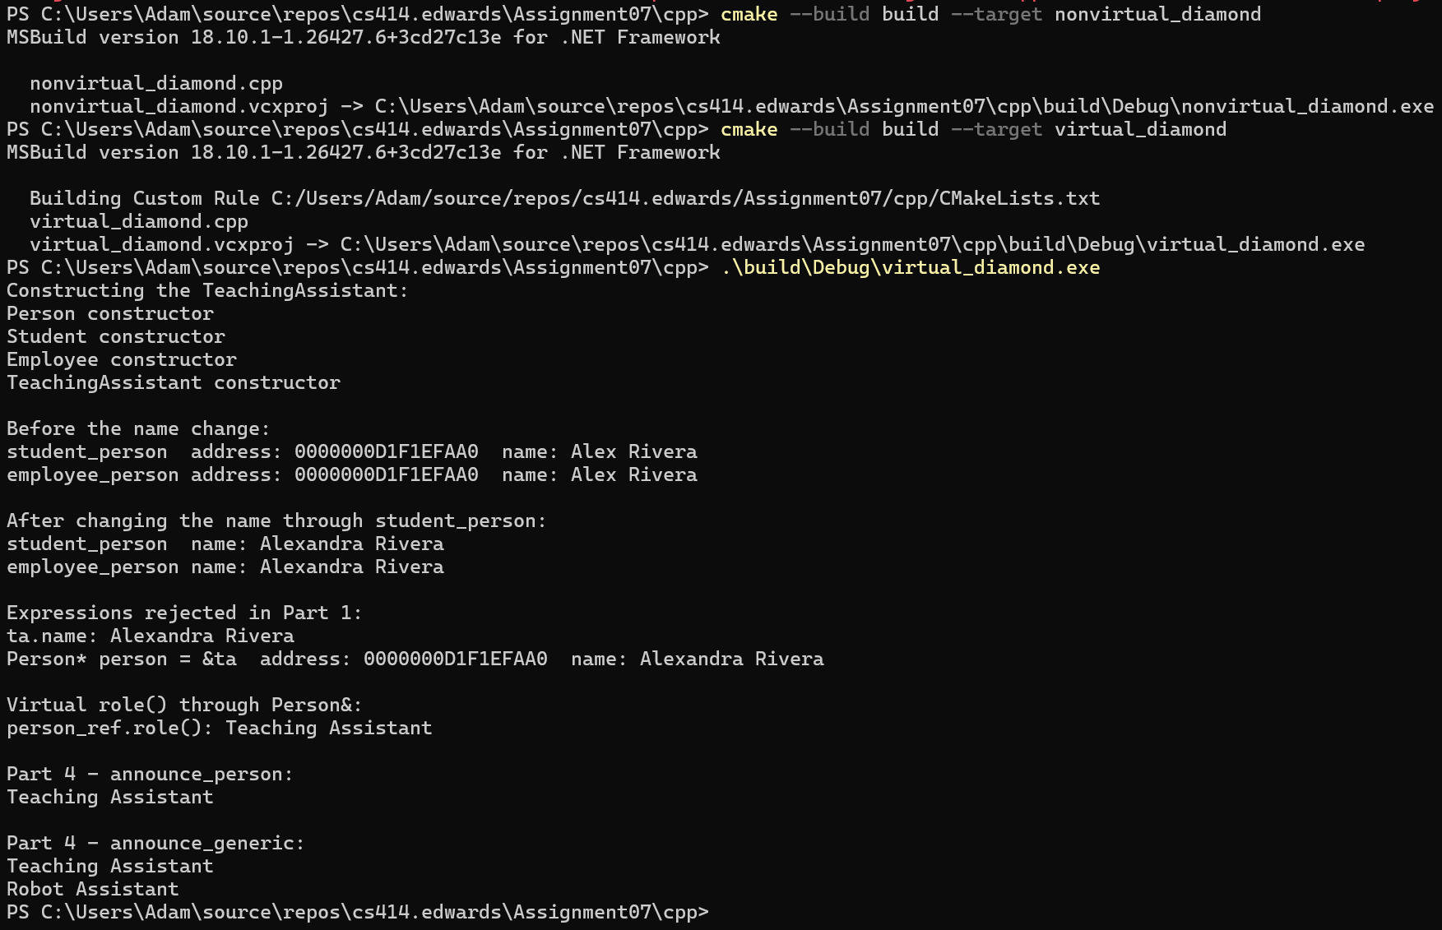
Figure 4
Figure 5
Virtual inheritance fixes the duplicate Person problem by making Student and Employee share one copy. TeachingAssistant has to initialize Person because its the most-derived class, and Person doesnt have a default constructor.
Virtual inheritance doesnt fix competing overrides because Student and Employee both override role(). The compiler cant choose between them, so TeachingAssistant needs its own override.

Part 3 - Python Cooperative Diamond Outputs
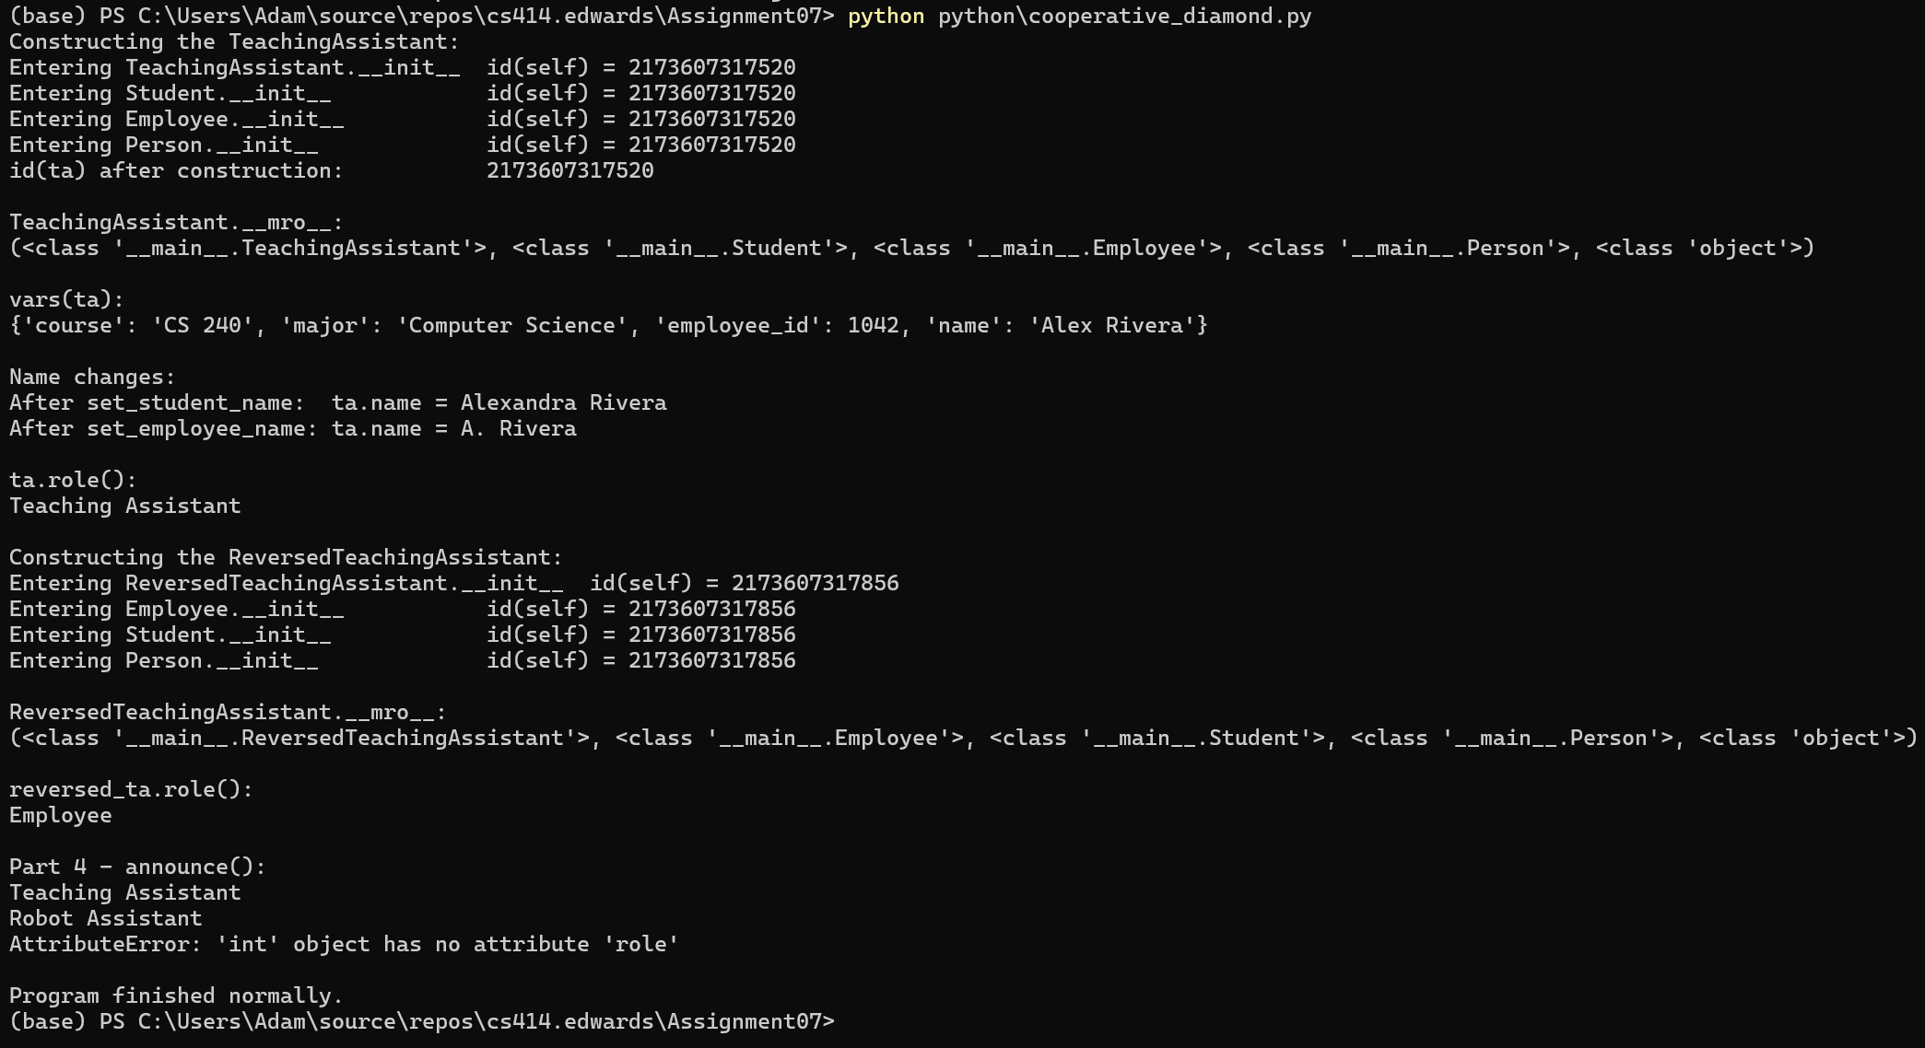
Figure 6
Prediction: ta.role() should return "Student" because Python follows the MRO and checks Student before Employee. Since TeachingAssistant doesnt have its own role() method, Python should use the first one it finds.
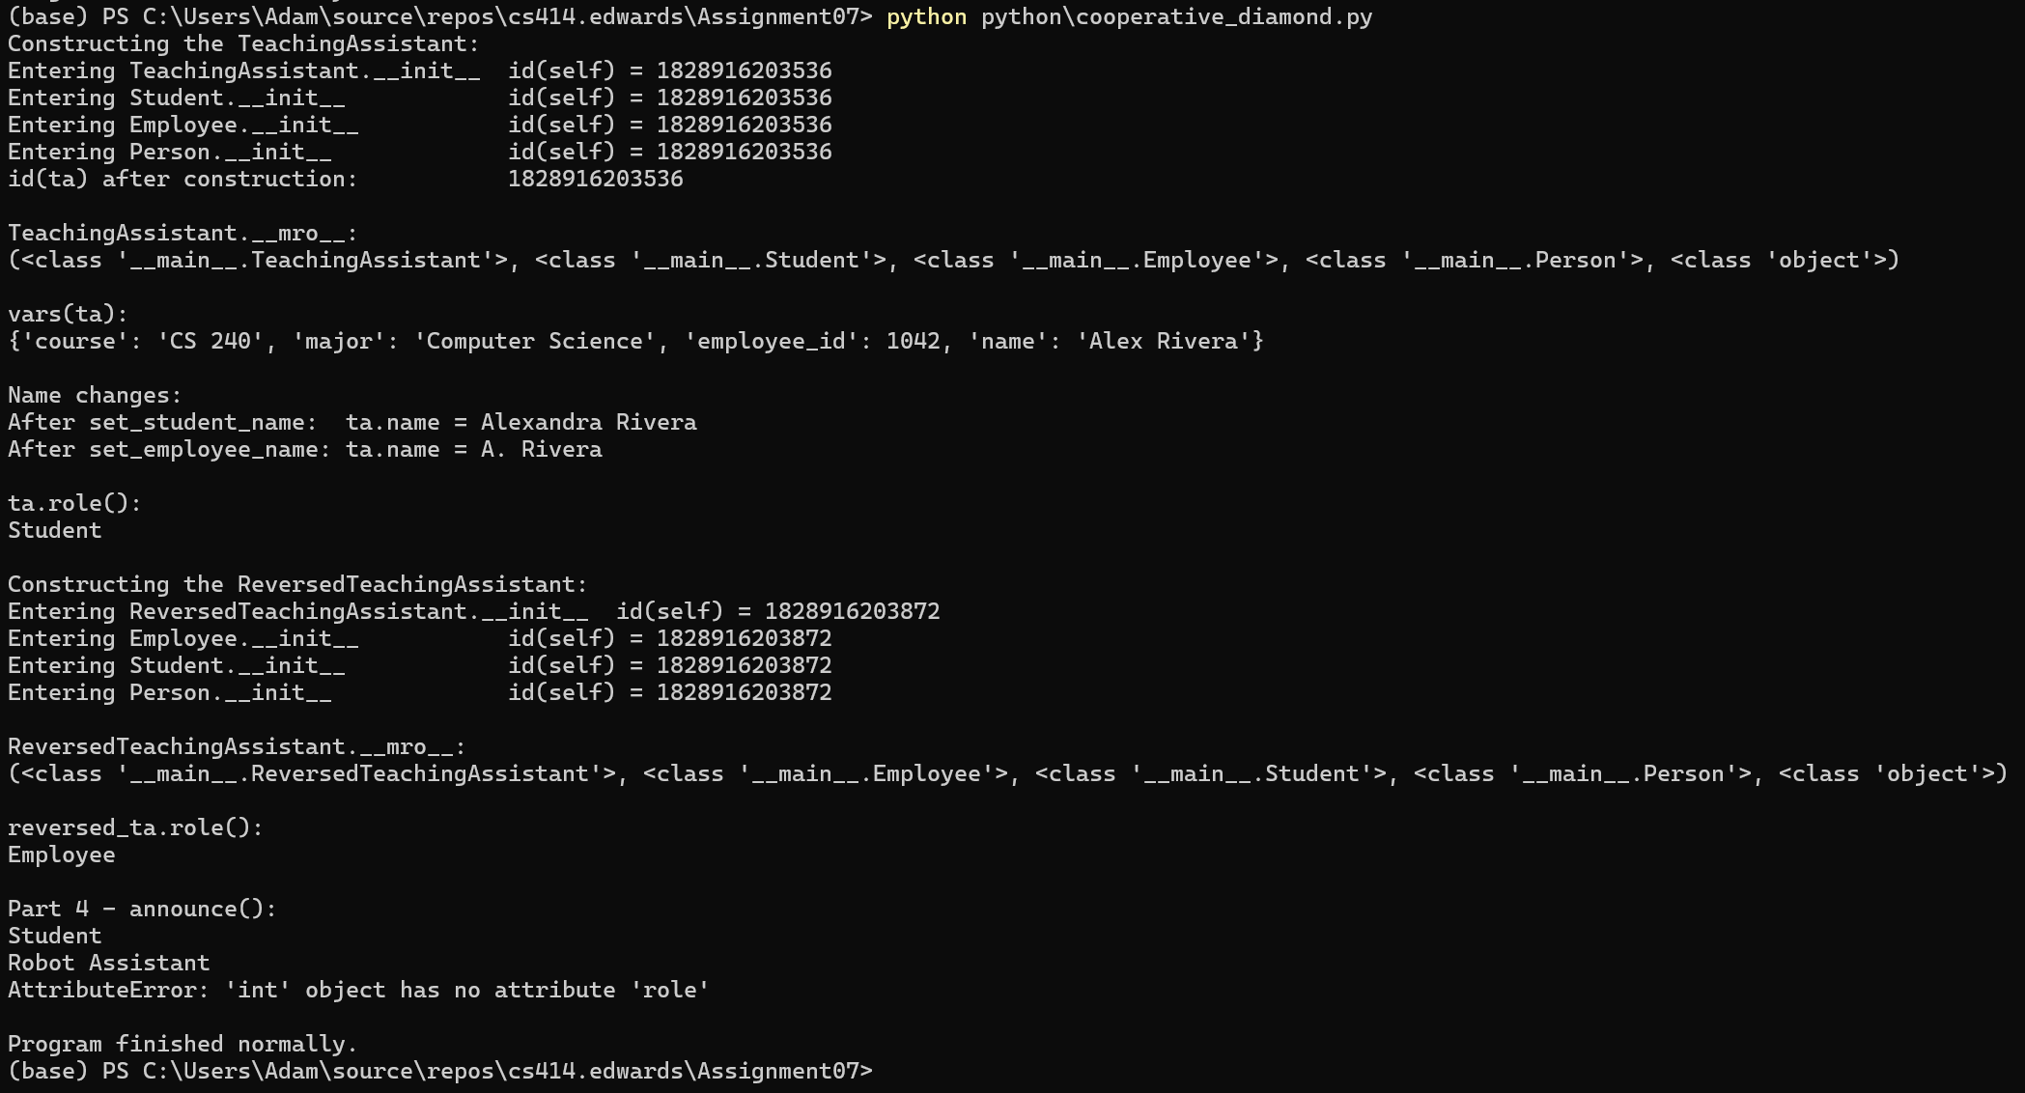
Figure 7
The initializers all show the same id(self) because Python uses one object instead of creating separate copies like C++. This is also why there is only one name attribute. Both Student and Employee change the same value, so the last change wins.
The MRO determines the order Python searches for methods. TeachingAssistant checks Student before Employee, so it uses Student.role() first. Reversing the base class order makes Employee come first instead.
super() follows the next class in the MRO, not necessarily the direct parent. This allows each initializer to run in order without calling the same class twice.

Part 4 - Polymorphism Without Common Ancestry Outputs
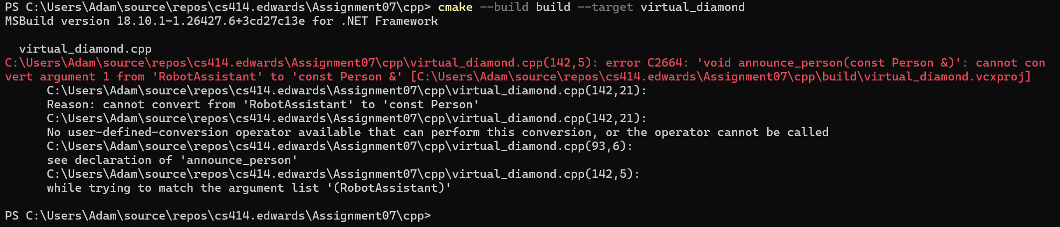
Figure 8
C++ inheritance-based polymorphism uses a Person reference and virtual functions to call the correct role() method at runtime. RobotAssistant doesnt inherit from Person, so the compiler rejects it even though it has a role() method.
C++ templates work differently because they dont require inheritance. They just need the object to have a role() method. Both TeachingAssistant and RobotAssistant work, but a missing method causes a compile-time error.
Python uses duck typing, which also doesnt require inheritance. It works as long as the object has a role() method. Unlike C++, Python doesnt catch a missing method until runtime, when it raises an AttributeError.

Part 5 - Analysis Report
1. What state is duplicated in the nonvirtual C++ diamond, and what changes under virtual inheritance?
In the nonvirtual version, Student and Employee each have their own copy of Person, including name. Virtual inheritance fixes this by making them share one Person, so changing the name through either side updates the same value.
2. How do virtual inheritance and virtual functions serve different purposes?
Virtual inheritance prevents duplicate copies of a base class. Virtual functions determine which version of a method runs at runtime. One handles shared data, while the other handles behavior.
3. Why does Pythons implementation avoid automatically creating two Person subobjects? Does that eliminate all possible initialization or naming conflicts?
Python uses one object instead of creating separate Person subobjects. The MRO makes sure Person only appears once in the initialization chain. Conflicts can still happen if classes use the same attribute names or dont properly call super().
4. Why can Python select an inherited role() using its MRO while the C++ virtual diamond requires a unique final override?
Python follows the MRO and uses the first role() method it finds. C++ doesnt automatically choose between Student and Employees overrides, so TeachingAssistant needs its own override to resolve the conflict.
5. Does sharing Pythons universal base object guarantee that a value supports role()? Explain using the integer experiment.
No. Just because everything inherits from object doesnt mean it has a role() method. When we passed 42 to announce(), Python raised an AttributeError at runtime because integers dont have that method.
6. Which design would you choose for this personnel model: multiple inheritance or composition with separate student and employee roles? Justify your choice.
I would choose composition because a person can have both student and employee roles without needing multiple inheritance. It would be easier to manage if someones roles change, and it avoids the duplicate data and method conflicts we saw in the experiments.

