BACKLOG
Source: BACKLOG.md

ZPGC Services - backlog
Living log. Diary dates start 27 June 2026. Official “Completed” on Stages 1-5 is the product line. This folder does not yet contain all of that.
Active folder (25 Sep 2026): C:\xampp\htdocs\CP2_V1.6 (adviser follow-up from frozen CP2_V1.5). Session cookie path here is /CP2_V1.6/.
Category | IDs
**Activity** | A-001 ... A-074 (continuous; no skipped IDs)
**Issue** | B-001 ... B-073 (continuous; no skipped IDs)
**Queued** | Q-001 ... Q-012 (later stages; not claimed in this folder)

How snippets are recorded (standard)
Existing diary text, screenshots, tables, and mermaid stay as they are. Every Activity and Issue also records code (or a phpMyAdmin action) plus a short explanation for readers who do not write PHP every day.
Log | Required snippet | Required explanation
**Activity** | **Fix snippet** - the code (or table-designer action) that made the work succeed or closed a B-issue | **In plain language:** what this does for a person using the site, in everyday words
**Issue** | **Causing snippet** - the code (or designer input) that produced the failure | **In plain language:** what you would see, then why that snippet caused it

Older entries may still say Executed snippet. Treat that as the Fix snippet. Do not delete it. Add Fix snippet / Causing snippet and In plain language when they are missing.
From now on, new Activity rows always include Fix snippet + In plain language. New Issue rows always include Causing snippet + In plain language.
Browser captures from this rebuild live in docs/screenshots/. Each image is named for the activity/issue it belongs to and is also embedded under that entry. phpMyAdmin captures: crop out the left navigation tree only (database list sidebar) - leave the main pane and results untouched; do not resize.
File | Belongs to
`screenshots/a001-b001-landing-apache-404.png` | A-001 / B-001
`screenshots/a002-b003-signup-stacked-under-login.jpg` | A-002 / B-003
`screenshots/timeline-official-development.png` | Official timeline
`screenshots/timeline-official-development-2.png` | Official timeline
`screenshots/a008-b009-signup-submit-404.png` | A-008 / B-009
`screenshots/a010-b011-user-php-404-lowercase-folder.png` | A-010 / B-011
`screenshots/a010-b011-user-php-404-after-url-casing.png` | A-010 / B-011
`screenshots/a010-b012-user-php-unstyled-main-wrap.png` | A-010 / B-012
`screenshots/a010-user-php-chrome-after-main-wrap.png` | A-010
`screenshots/a012-user-php-search-and-profile-circle.png` | A-012
`screenshots/a011-b013-settings-label-outside-nav-link.png` | A-011 / B-013 (first reload)
`screenshots/b013-id-settings-span-still-outside-nav-link.png` | B-013 (`id` added; span still outside `.nav-link`)
`screenshots/b013-settings-label-inside-nav-link.png` | B-013 (fixed)
`screenshots/a014-b014-admin-php-404-wrong-folder.png` | A-014 / B-014
`screenshots/b014-admin-url-after-move.png` | B-014 (URL they used after the move)
`screenshots/a016-b016-mailbox-unstyled-inner-head.png` | A-016 / B-016
`screenshots/a016-b016-settings-unstyled-inner-head.png` | A-016 / B-016
`screenshots/a017-b017-new-ticket-on-dashboard.png` | A-017 / B-017
`screenshots/a018-b018-empty-ticket-mngmnt-white-page.png` | A-018 / B-018
`screenshots/b019-tickets-enum-1064.png` | B-019
`screenshots/a022-b020-submit-ticket-form.png` | A-022 / B-020
`screenshots/a022-b020-after-submit-login-form.jpg` | A-022 / B-020
`screenshots/a023-b021-user1-not-activated.jpg` | A-023 / B-021 / B-023
`screenshots/a024-b022-admin-utilities-h1-still-dashboard.png` | A-024 / B-022
`screenshots/a024-b022-admin-analytics-h1-still-dashboard.png` | A-024 / B-022
`screenshots/a024-b022-admin-mailbox-h1-still-dashboard.png` | A-024 / B-022
`screenshots/a024-b022-admin-settings-h1-still-dashboard.png` | A-024 / B-022
`screenshots/a025-admin-utilities-user-list.png` | A-025 / B-024
`screenshots/a029-user-tickets-list-tickets-tab.png` | A-029 / B-027
`screenshots/a029-b027-dashboard-stray-table-headers.png` | A-029 / B-027 (before)
`screenshots/a029-b027-stray-table-mailbox-tab.png` | B-027 (before)
`screenshots/a029-b027-stray-table-settings-tab.png` | B-027 (before)
`screenshots/a030-fk-relation-view-saved.png` | A-030 (Relation view - FK saved)
`screenshots/a030-fk-good-insert-form.png` | A-030 (good row - Insert tab, before Go)
`screenshots/a030-fk-good-insert-success.png` | A-030 (good row - after Go)
`screenshots/a030-fk-good-tickets-tab.png` | A-030 (website Tickets tab)
`screenshots/a030-fk-bad-insert-sql.png` | A-030 (bad row - SQL tab, before Go)
`screenshots/a030-fk-bad-insert-1452-error.png` | A-030 (bad row - #1452 blocked)
`screenshots/a031-admin-tickets-list.png` | A-031 (after B-028 fix - optional)
`screenshots/b028-admin-tickets-compressed-columns.png` | B-028 (before - wrong column classes)
`screenshots/a032-assigned-to-column-added.png` | A-032 (Structure - `assigned_to` added)
`screenshots/a032-status-enum-expanded.png` | A-032 (Structure - status ENUM expanded)
`screenshots/a032-fk-tickets-assigned-saved.png` | A-032 (Relation view - `fk_tickets_assigned`)
`screenshots/a032-tickets-browse-assigned-null.png` | A-032 (Browse - existing rows NULL)
`screenshots/b029-status-assigned-compressed.png` | B-029 (before - Status + Assigned To squeezed)
`screenshots/b029-grid-collapsed-vertical-stack.png` | B-029 (after grid CSS - headers stack vertically)
`screenshots/b029-admin-tickets-five-columns-fixed.png` | B-029 (fixed - 5-column grid + dropdown)
`screenshots/a033-part2-assign-dropdown-retest.png` | A-033 Part 2 retest (`$tid` + dropdown shows tech name)
`screenshots/b031-techn-tickets-compressed-columns.png` | B-031 (before - `ticket-col-*`)
`screenshots/b031-techn-tickets-four-columns-fixed.png` | B-031 (after - four spaced columns)
`screenshots/b032-mailbox-no-live-update.png` | B-032 (Mailbox empty / no live poll)
`screenshots/b033-messages-table-missing-fatal.png` | B-033 (`messages` table missing - first send)
`screenshots/b033-messages-table-missing-fatal-retest.png` | B-033 (retest send - same fatal)
`screenshots/a035-create-messages-sql.png` | A-035 / B-033 (SQL - CREATE TABLE `messages`)
`screenshots/a035-create-messages-go-result.png` | A-035 / B-033 (Go - empty result = table created)
`screenshots/a035-messages-browse-empty.png` | A-035 / B-033 (Browse `messages` - zero rows)
`screenshots/b033-mailbox-hello-after-table.png` | B-033 (send **Hello** after table exists)
`screenshots/a035-mailbox-two-role-thread.png` | A-035 (two accounts - **Hello** + **Ho**)
`screenshots/a038-priority-column-add-form.png` | A-038 (Structure - add `priority` ENUM)
`screenshots/a038-priority-column-saved.png` | A-038 (Structure after Save; **B-035** Null = No)
`screenshots/b035-priority-change-null-ticked.png` | B-035 (Change - **Null** checked, Default **None**)
`screenshots/b035-priority-null-yes-saved.png` | B-035 (Structure after Save - Null **Yes**, Default **NULL**)
`screenshots/b034-queue-nine-slots-fixed.png` | B-034 (after - **0 / 9**, **used / 3**, no subtitle)
`screenshots/b038-dashboard-charts-blank.png` | B-038 (Dashboard charts blank - `dashbord` typo)
`screenshots/b039-settings-empty.png` | B-039 (Settings tab empty)
`screenshots/a041-performance-placeholder-tables.png` | A-041 (Performance - placeholder tables)
`screenshots/a041-tickets-queue-and-priority.png` | A-041 (Tickets - queue **2 / 9**, Priority dropdown)
`screenshots/b041-utilities-actions-empty.png` | B-041 (Utilities - empty Actions / no role filters)
`screenshots/b042-settings-theme-disabled.png` | B-042 (Settings theme disabled)
`screenshots/b043-dashboard-charts-blank-again.png` | B-043 (Dashboard charts blank again - CDN Chart.js)
`screenshots/b044-queue-zero-with-critical-pending.png` | B-044 (Queue **0 / 9** while Critical Pending tickets exist)
`screenshots/a045-queue-critical-moderate-working.png` | A-045 / A-046 (Queue **2 / 9** - Critical **1/3** + Moderate **1/3**)
`screenshots/a047-utilities-filters-and-actions.png` | A-047 (Utilities - role filters + Edit / Deactivate / Delete)
`screenshots/a047-utilities-edit-user-form.png` | A-047 (Utilities - Edit User form / role change)

screenshots/a056-b1-submit-new-ticket-form.png | A-056 B1 (Submit New Ticket form)
screenshots/a056-b2-ai-suggest-hardware-moderate.png | A-056 B2 (AI -> hardware / moderate)
screenshots/a056-b5-user-ticket-1005-pending.png | A-056 B5 (#1005 on user list)
screenshots/a056-c-admin-ticket-1005-assigned-queue.png | A-056 C (admin assign + queue 4/9)
screenshots/a056-d3-techn-status-confirming.png | A-056 D3 (techn -> Confirming)
screenshots/a056-e1-user-confirm-buttons.png | A-056 E1 (Solved / Not Solved Yet)
screenshots/a056-e3-not-solved-ongoing.png | A-056 E3 (Not Solved Yet -> Ongoing)
screenshots/a066-matplotlib-dashboard-top.png | A-066 (matplotlib Dashboard - cards + report + categories)
screenshots/a066-matplotlib-dashboard-bottom.png | A-066 (matplotlib Dashboard - satisfaction + severity)

Official Development Timeline
Stage | Milestone | Main activities | Official status | This folder | Backlog IDs
**1 - CP2** | Initial prototype | Login, registration, dashboards, role separation | Completed | Landing, login/signup, `user.php` / `techn.php` / `admin.php` shells | A-001-A-005, A-010-A-016, B-001-B-004, B-006-B-007, B-011-B-016, Q-004
**2 - v1.1** | Security improvement | Prepared statements, role validation, safer authentication | Completed | **Done** in `CP2_V1.1`. We moved here for v1.1.2. | A-006-A-009, B-005, B-008-B-010, Q-001-Q-003
**3 - v1.1.2** | Administration and ticket interface | Admin user management, account approval, ticket form UI | Completed | **This folder.** `tickets` INSERT (A-022). Admin panels (A-024). User list + polish (A-025-A-027). Activate (A-028). **Stage 3 v1.1.2 complete here.** | A-017-A-028, B-017-B-025, Q-011
**4 - v1.2** | Minimum Viable Product | Ticket persistence, workflow, technician functions, live chat | Completed | **Done** (A-029-A-036). Mailbox polls every 3 seconds. | A-029-A-036, B-026-B-033, Q-005, Q-006
**5 - v1.3** | Queue and analytics | Manual priority, 9-slot queue, Chart.js samples, theme | Completed | **Done** (A-037-A-045). Queue fixed at 9 slots. | Q-007, B-034-B-044
**6 - v1.4** | Confirmation workflow | User confirmation; Solved / Not Solved Yet | Completed | **Done** (A-049-A-051). Status `awaiting_confirmation`. | Q-012, B-045-B-048
**7 - v1.5** | AI Integration | Keyword AI, then Luna, auto-assign, low-priority tips, live charts | Extended in V1.6 | Built in `CP2_V1.5` (A-052-A-066). Live Luna needs API credits; otherwise `kw-quota`. | Q-008
**7b - v1.6** | Paper matrix, performance, profile | Submit scores the ticket; Tables 4-7; category performance; My Profile | **Current build** | **This folder** `CP2_V1.6` (A-067-A-076). | B-058-B-075
**8** | Testing and Evaluation | Functional, load, AI accuracy, user testing | **In progress** | Functional paths tested. Load test and accuracy study not run. | Q-009
**9** | Finalization | Documentation, deployment preparation, defense | **Planned** | Living docs, including `docs/VERSION_PROGRESS.md`. | Q-010

[Mermaid diagram - see source .md]
Team source (screenshots):
Official Development Timeline
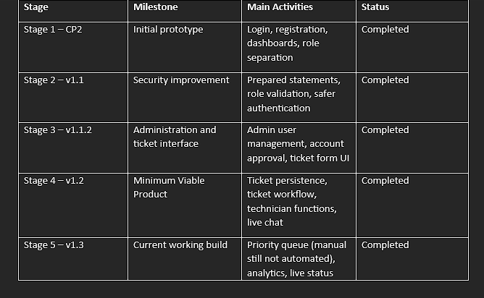
Official Development Timeline (continued)
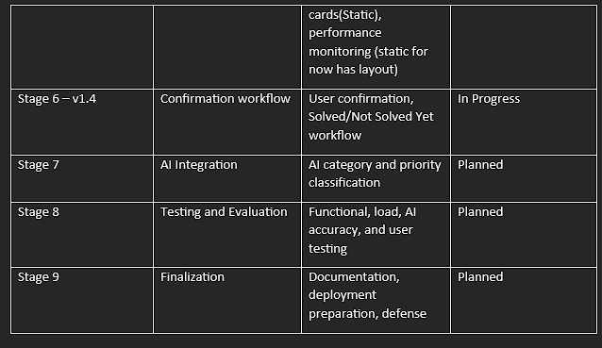

Diary dates (aligned to official stages)
Dates | Official stage | Notes
27 Jun - 13 Jul 2026 | Stage 1 | Landing, login/signup HTML/JS, Apache names
14 - 22 Jul 2026 | Stage 2 (start) | `users_db`, `config.php`
23 Jul - 5 Aug 2026 | Stage 2 (rest) | Prepared statements, sessions (Q-001-Q-003)
6 - 12 Aug 2026 | Stage 1 leftover + Stage 3 start | Dashboards / role pages (Q-004, A-010)
13 - 19 Aug 2026 | Stage 3 | Admin utilities, account approval, ticket form UI (Q-011)
20 - 26 Aug 2026 | Stage 4 | Tickets, workflow, techn, mailbox (Q-005, Q-006)
25 Aug - 10 Sep 2026 | Stage 4 (this folder) | A-029 user list; A-030 FK; A-031 admin list; A-032 `assigned_to`; B-026-B-028
27 Aug - 1 Sep 2026 | Stage 5 | Manual 9-slot queue, static cards (Q-007)
**2 - 15 Sep 2026** | Stage 6 **done** | Confirmation workflow (Q-012, A-049-A-051)
**16 - 20 Sep 2026** | Stage 7 **built** | AI in `CP2_V1.5` (Q-008). Live Luna needs API credits.
**25 Sep - 1 Oct 2026** | V1.6 **current** | Tables 4-7, performance, My Profile (A-067-A-076). See `docs/VERSION_PROGRESS.md`.
Later | Stages 8-9 | Functional tests in progress. Load, accuracy, and defense still open.

Activity log
Work completed and confirmed in the browser or phpMyAdmin. Fix snippet = the code that made it work. In plain language = the same idea without assuming PHP knowledge.

A-001 - Landing page HTML
- When: 27-28 June 2026 (2 days: markup + CSS path)
- Official stage: 1 - CP2
- Status: done
- What we did: Public welcome page: navbar, logo, Login, hero, Signup now!. Linked css/landing_page.css and images/ZPGC.com.png.
- File: pages/landing_page.php (first saved as .html; see B-001)
- Test: Go Live showed the maroon landing layout. Apache on landing_page.php was 404 until B-001.
- Fix snippet:
Rename: pages/landing_page.html -> pages/landing_page.php
- In plain language: The welcome page was saved with the wrong file ending. The live site asks for .php. After the rename, the same design opens at the Apache URL.
Apache 404 for landing_page.php while the file was still .html
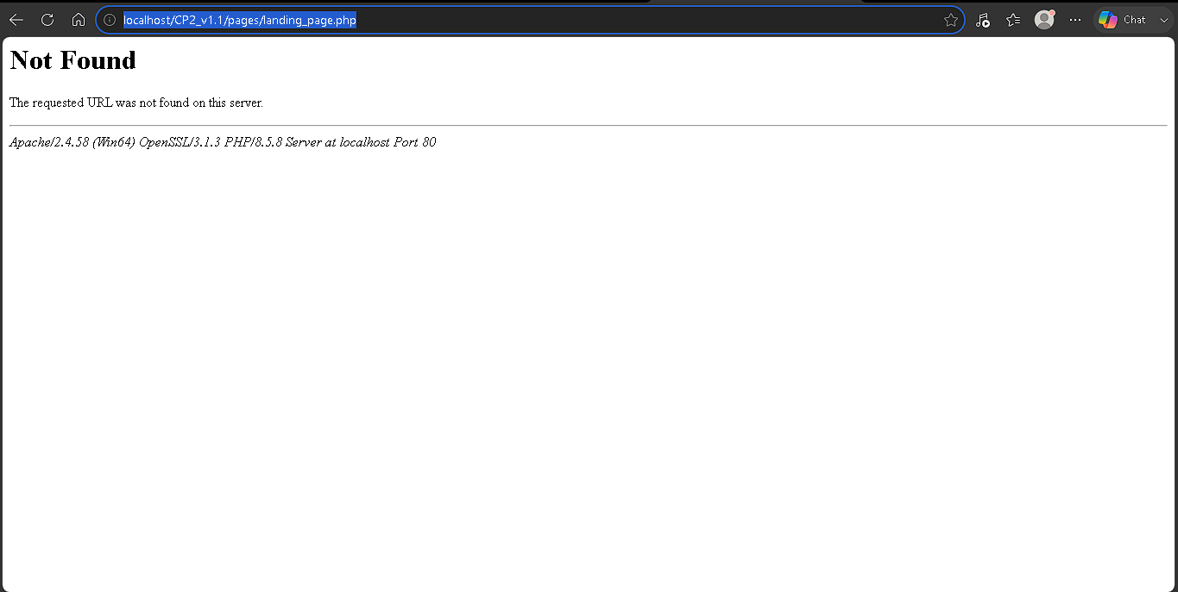

A-002 - Login / signup HTML form
- When: 30 June - 4 July 2026 (5 days: split panel, two forms, Role list)
- Official stage: 1 - CP2 (registration UI)
- Status: done
- What we did: Login/signup HTML skeleton (no PHP). Role: User, Admin, Technician. action="#". Linked css/login_signup.css.
- File: pages/login_signup.php
- Test: Go Live showed LOGIN. Signup stacked under LOGIN until B-003 (screenshot on that issue).
- Executed snippet (form we created):
<select name="role" required>
<option value="" disabled selected>Role</option>
<option value="user">User</option>
<option value="admin">Admin</option>
<option value="techn">Technician</option>
</select>
code (html)
- Fix snippet: same <select name="role"> block above.
- In plain language: Signup asks the person to pick User, Admin, or Technician. That choice is stored later as role. There is no PHP on this page yet - only the list on the form.

A-003 - Form toggle script
- When: 30 June 2026 (same stretch as A-002; selector fix 5-6 July)
- Official stage: 1 - CP2
- Status: done (B-003)
- File: js/script.js
- Fix snippet:
document.querySelectorAll(".form-box").forEach(function (form) {
form.classList.remove("active");
});
code (javascript)
- In plain language: The page has two boxes (LOGIN and SIGNUP). This script hides one and shows the other. The class name must match the HTML (.form-box). If it does not, both boxes stay visible (B-003).

A-004 - Landing buttons open login/signup
- When: 7-11 July 2026 (2 days links + 3 days query-string, B-004)
- Official stage: 1 - CP2
- Status: done
- What we did: Login -> login_signup ; Signup now! -> ?form=signup. Later names became .php for Apache.
- Executed snippet:
<button class="btnW"><a href="../pages/login_signup.php">Login</a></button>
...
<button class="btnR"><a href="../pages/login_signup.php?form=signup">Signup now!</a></button>
code (html)
- Fix snippet: the two landing <a href="..."> buttons above.
- In plain language: Login opens the login page. Signup now! opens the same page but asks it to show the signup box (?form=signup). B-004 happened until the script read that extra bit in the URL.

A-005 - Pages renamed to `.php`; forms use POST (`action="#"` until handler)
- When: 12-13 July 2026 (2 days: renames + landing links + method="post")
- Official stage: 1 - CP2 (Apache owns the pages before database work)
- Status: done (B-007: logo link .html -> .php)
- What we did: Renamed landing_page.html -> landing_page.php and login_signup.html -> login_signup.php. Updated landing Login / Signup now! hrefs to .php. Set both login and signup forms to method="post". Left action="#" because logic/user_mngmnt.php did not exist yet - submit stayed on the page until A-008 wired the handler (B-009).
- Files: pages/landing_page.php, pages/login_signup.php
- Test: http://localhost/CP2_V1.1/pages/landing_page.php and login_signup.php load on Apache. Form toggle and ?form=signup still work. Submit does not reach PHP yet.
- Fix snippet:
Rename: pages/landing_page.html -> pages/landing_page.php
Rename: pages/login_signup.html -> pages/login_signup.php
<form action="#" method="post">
code (html)
(Landing buttons - same as A-004 but with .php:)
<button class="btnW"><a href="../pages/login_signup.php">Login</a></button>
<button class="btnR"><a href="../pages/login_signup.php?form=signup">Signup now!</a></button>
code (html)
- In plain language: Apache looks for .php files. POST is how login and signup will send data later. # means “nowhere yet” until user_mngmnt.php exists. B-001 fixed the landing rename; this step also renamed login/signup and set POST on both forms.

A-006 - Created `users_db` and table `users`
- When: 14-19 July 2026 (6 days: drop old DB, designer, 7 columns, ENUM, Browse check)
- Official stage: 2 - v1.1 (safer auth needs a users table)
- Status: done
- What we did: New database users_db. phpMyAdmin table wizard (not SQL tab): name users, 7 columns, Save. Structure correct. Browse empty with headers id, first_name, last_name, email, password, role, status.
Column | Type | Length / values | Extra
`id` | INT | - | PRIMARY, A_I
`first_name` | VARCHAR | 100
`last_name` | VARCHAR | 100
`email` | VARCHAR | 255 | UNIQUE
`password` | VARCHAR | 255 | hash later
`role` | ENUM | `'user','admin','techn'`
`status` | ENUM | `'inactive','active'` | default `inactive`

- Fix snippet: phpMyAdmin table designer (not the SQL tab). Table name users, 7 columns as in the table above. Save.
- In plain language: This is a list of accounts. Each row is one person. status starts as inactive so they cannot log in until someone approves them.

A-007 - `logic/config.php` connection
- When: 20-22 July 2026 (3 days: file location, mysqli, browser test)
- Official stage: 2 - v1.1
- Status: done (test echo still in file; remove before user_mngmnt.php)
- What we did: Created logic/config.php. Opened http://localhost/CP2_v1.1/logic/config.php. Page showed Connected to users_db.
- Executed snippet:
<?php
$host = "localhost";
$user = "root";
$password = "";
$database = "users_db";
$conn = new mysqli($host, $user, $password, $database);
if ($conn->connect_error) {
die("Connection failed: " . $conn->connection_error);
}
echo "Connected to users_db";
code (php)
- Fix snippet: the config.php block above (mysqli to users_db).
- In plain language: This file is the phone line to MySQL. Other PHP files include it instead of repeating the host name. The echo was only a test message. B-005: the error property name is misspelled but you would only notice if MySQL were down.

A-008 - Signup INSERT works (prepared statement)
- When: 24 July 2026
- Official stage: 2 - v1.1
- Status: done
- What we did: After B-009, submitted sample User signup. Browser went to the login form (that redirect is the success header in user_mngmnt.php). phpMyAdmin -> users_db -> users -> Browse showed the new row.
- Files: pages/login_signup.php (method="post"), logic/user_mngmnt.php
- Confirmed: Row stored in MySQL. Hashed password, status inactive.
- Fix snippet:
$stmt = $conn->prepare(
'INSERT INTO users (first_name, last_name, email, password, role, status)
VALUES (?, ?, ?, ?, ?, ?)'
);
$stmt->bind_param('ssssss', $first_name, $last_name, $email, $hash, $role, $status);
code (php)
- In plain language: When someone clicks Signup, this writes a new row. The ? marks are placeholders so the typed name and email are not mixed into the SQL text (safer). The password is stored as a hash, not the plain password. The account is inactive until approval.
[Mermaid diagram - see source .md]

A-009 - Login: inactive vs unknown account
- When: 26 July 2026
- Official stage: 2 - v1.1
- Status: done
- What we did: Tested the login form after B-010 (; on session_start()).
- Email/password that exist in users_db (signup row, still inactive): account not yet activated. Stayed on LOGIN.
- Email/password not signed up: incorrect credentials. Stayed on LOGIN.
- Files: logic/user_mngmnt.php (password_verify + status), pages/login_signup.php (shows $login_error)
- Fix snippet:
if ($user['status'] !== 'active') {
$_SESSION['login_error'] = 'Account is not activated yet.';
header('Location: ../pages/login_signup.php');
exit();
}
code (php)
- In plain language: Login checks the password, then checks whether the account is allowed in. If status is still inactive, the person stays on LOGIN and sees that message. That is intended (A-009). To test tickets we later set one row to active in phpMyAdmin (B-021), not by deleting this check.
[Mermaid diagram - see source .md]

A-010 - `user.php` dashboard chrome
- When: 7 August 2026
- Official stage: 1 - CP2
- Status: done
- What we did: Created pages/user.php (data-page="dashboard", .main-wrap, logo ZPGC.com2.png, toggler, Dashboard .selected, main_interface.css). Rename B-011; class hyphen B-012.
- Test: http://localhost/CP2_V1.1/pages/user.php - grey sidebar, logo, highlighted Dashboard at the bottom (:last-child) until A-011 added Logout. Search and profile circle came later as A-012. behavior.js not in this file yet.
After B-012: grey sidebar, Dashboard at bottom
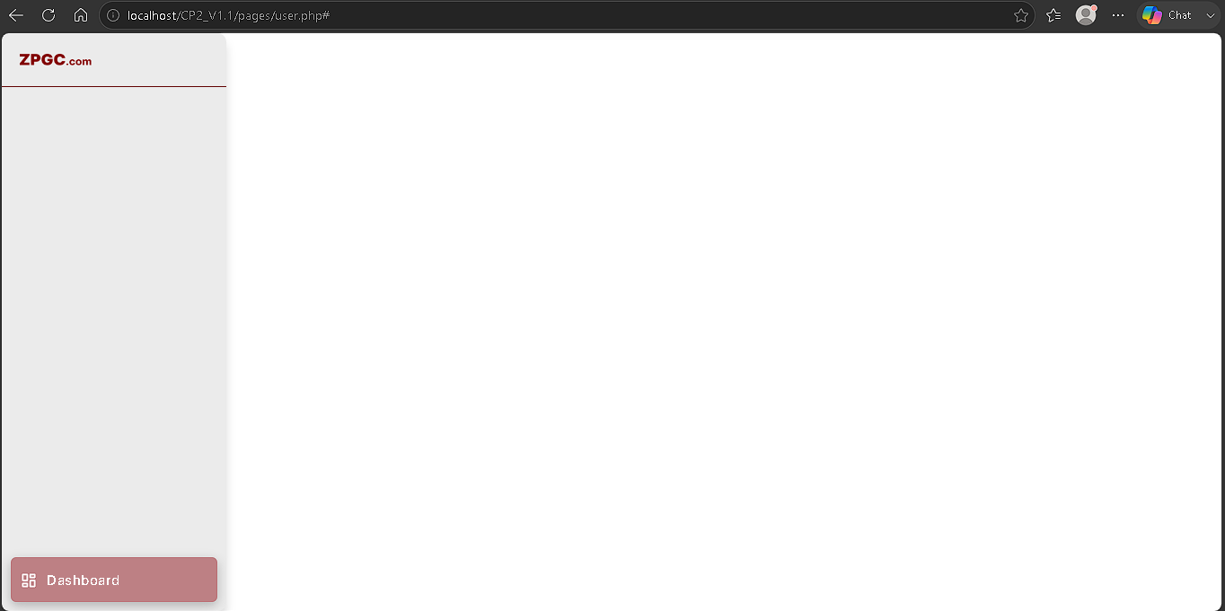
- Fix snippet:
<main class="main-wrap">
code (html)
- In plain language: The dashboard layout CSS looks for the class name main-wrap (with a hyphen). Underscore main_wrap meant the grey sidebar never applied (B-012).

A-011 - Remaining sidebar items on `user.php`
- When: 8 August 2026
- Official stage: 1 - CP2
- Status: done (B-013 later: Settings span inside .nav-link)
- What we did: After Dashboard, typed Tickets (data-nav="tickets"), Mailbox (data-nav="messages"), Settings (data-nav="settings"), Logout last (href="../pages/login_signup.php"). SVG d paths were typed in full. No behavior.js, search, or session guard yet.
- File: pages/user.php
- Test: Reload http://localhost/CP2_V1.1/pages/user.php - five labels; Dashboard still .selected; Logout at the bottom of the grey column. Settings label sits under the gear (B-013). Screenshot on B-013.
- Fix snippet (Settings, after B-013):
</svg>
<span class="link-text" id="settings">Settings</span>
</a>
code (html)
- In plain language: Icon and word must sit inside the same clickable row. If the word is outside that row, it drops under the gear.

A-012 - Showcase search bar and profile circle
- When: 9 August 2026
- Official stage: 1 - CP2
- Status: done
- What we did: After <h1>Dashboard</h1> in .showcase .head header, typed .search-bar-wrapper (icon + input type="search") and empty .profile-circle. No form, no search JS, no avatar. behavior.js still not linked.
- File: pages/user.php
- Test: Reload http://localhost/CP2_V1.1/pages/user.php - pill search with placeholder Search; empty grey circle on the right; sidebar unchanged.
Search bar and profile circle in the showcase header
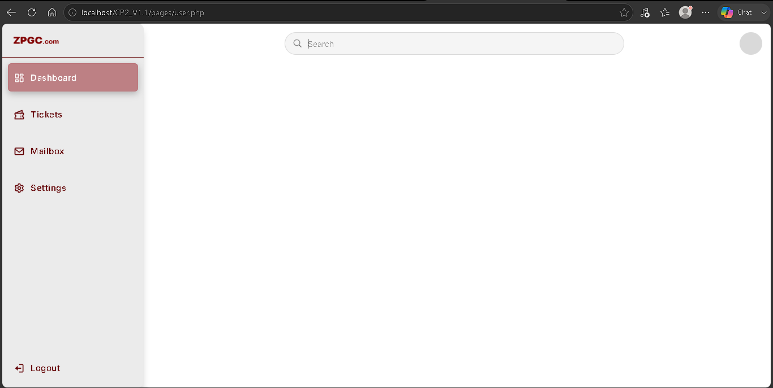
- Executed snippet:
<div class="search-bar-wrapper">
<svg class="search-icon" xmlns="http://www.w3.org/2000/svg" width="24" height="24"
fill="currentColor" viewBox="0 0 24 24">
<path
d="M18 10c0-4.41-3.59-8-8-8s-8 3.59-8 8 3.59 8 8 8c1.85 0 3.54-.63 4.9-1.69l5.1 5.1L21.41 20l-5.1-5.1A8 8 0 0 0 18 10M4 10c0-3.31 2.69-6 6-6s6 2.69 6 6-2.69 6-6 6-6-2.69-6-6">
</path>
</svg>
<input type="search" class="search-bar" placeholder="Search" aria-label = "Search">
</div>
<div class="profile-circle"></div>
code (html)
- Fix snippet: the search wrapper + empty profile circle above.
- In plain language: This draws the pill Search box and a blank circle for a profile picture later. Search does not filter anything yet.

A-013 - `behavior.js` sidebar collapse and nav highlight
- When: 10 August 2026
- Official stage: 1 - CP2
- Status: done
- What we did: Created js/behavior.js. Linked it at the bottom of user.php. Collapse uses class active on .main-head. Clicks on href="#" move .selected and body data-page. Logout still follows login_signup.php.
- Files: js/behavior.js, pages/user.php
- Test: Collapse/expand on hover and toggler works. Tickets / Mailbox / Settings take the rose highlight. Logout still opens login/signup.
- URL with no `#`: Normal. Those four links are href="#". The click handler calls event.preventDefault() so the browser never applies the fragment. The address bar stays http://localhost/CP2_V1.1/pages/user.php. If preventDefault were omitted, the URL would typically become user.php#. Not a bug; not a new issue ID.
[Mermaid diagram - see source .md]
- Executed snippet (initNavClickSelection, as typed):
link.addEventListener("click", function(event) {
const href = link.getAttribute("href") || "";
if (href && href !== "#") {
return;
}
event.preventDefault();
setSelectedNavItem(item);
});
code (javascript)
- Executed snippet (user.php):
<script src="../js/behavior.js"></script>
code (html)
- Fix snippet: the click handler and the <script src="../js/behavior.js"> include above.
- In plain language: Clicking Tickets (and the other # links) changes which panel you see without adding # to the URL. Logout is a real link, so it leaves the dashboard.

A-014 - `techn.php` shell (same nav as user)
- When: 11 August 2026
- Official stage: 1 - CP2
- Status: done (admin.php 404: B-014)
- What we did: Copied user.php to pages/techn.php. Title ZPGC Services | Technician. Same Tickets / Mailbox / Settings / Logout. Linked ../js/behavior.js.
- File: pages/techn.php
- Test: http://localhost/CP2_V1.1/pages/techn.php - same chrome as user. pages/admin.php Apache 404 (B-014).
- Fix snippet: pages/techn.php is a copy of user.php with title Technician. Same behavior.js link as A-013.
- In plain language: Technicians get the same left menu and top bar. The file must live in pages/, same as user.php.

A-015 - `admin.php` in `pages/` (Utilities + Analytics)
- When: 11 August 2026 (after B-014 move)
- Official stage: 1 - CP2
- Status: done (Analytics label wrap: B-015)
- What we did: Moved admin.php from logic/ to pages/. Nav: Dashboard, Utilities, Analytics, Mailbox, Settings, Logout. Same behavior.js.
- File: pages/admin.php
- Test: Page loads (B-014 fixed). Analytics text sits under the chart icon (B-015). Utilities label is on one row.
- Fix snippet: file lives at pages/admin.php (moved off logic/). Analytics span inside .nav-link (B-015).
- In plain language: Admin is a dashboard page, not a handler. If the file sits in logic/, the URL pages/admin.php is Not Found (B-014).

A-016 - In-page sections on `user.php` (`data-page` / `.page-content`)
- When: 12 August 2026
- Official stage: 1 leftover / Stage 3 UI start
- Status: done (Mailbox/Settings bar unstyled: B-016, then fixed)
- What we did: Wrapped showcase in #page-dashboard, #page-tickets, #page-messages, #page-settings. behavior.js already sets body data-page. CSS shows the matching #page-....
- Test: Clicking Dashboard / Tickets / Mailbox / Settings changes the h1. Search and profile sit in each panel. Mailbox and Settings were unstyled until B-016.
- Fix snippet:
<div class="head">
<header>
<h1>Mailbox</h1>
code (html)
- In plain language: Each sidebar item shows a different panel on the same page. The top bar must use the <header> tag so the search pill styles apply. <head> is the wrong tag (B-016).

A-017 - New Ticket control + `ticket.php` form (look only)
- When: 13 August 2026
- Official stage: 3 - v1.1.2 (ticket form UI)
- Status: done (B-017: toolbar moved inside #page-tickets)
- What we did: Added .tickets-toolbar / .btn-new-ticket linking to pages/ticket.php. Created ticket.php with ticket.css. Form action="#", method="post". No INSERT.
- Files: pages/user.php, pages/ticket.php
- Executed snippet (ticket.php form, as typed):
<form action="#" class="ticket-form" method="post">
code (html)
Submit button name="submit-ticket" (hyphen). Handler later will look for submit_ticket if we match original v1.2.
- Fix snippet: form action="#" at first; toolbar inside #page-tickets (B-017).
- In plain language: New Ticket is a button on the Tickets panel that opens a separate form page. It does not save a ticket by itself. If the button sits outside that panel, it also shows on Dashboard (B-017).

A-018 - Ticket form POSTs to `ticket_mngmnt.php`
- When: 14 August 2026
- Official stage: 3 - v1.1.2 (POST before INSERT)
- Status: done (blank page: B-018; later filled in A-019)
- What we did: Changed ticket.php action from # to ../logic/ticket_mngmnt.php.
- File: pages/ticket.php
- Executed snippet:
<form action="../logic/ticket_mngmnt.php" class="ticket-form" method="post">
code (html)
- Test: Submit -> URL http://localhost/CP2_V1.1/logic/ticket_mngmnt.php. White page (B-018), not Apache 404.
- Fix snippet: action="../logic/ticket_mngmnt.php" on the form (block above).
- In plain language: Submit sends the form to a PHP file in logic/. An empty file is not “page missing” (that would be 404). Empty PHP shows a white screen (B-018).

A-019 - `ticket_mngmnt.php` receives POST, no INSERT
- When: 15 August 2026
- Official stage: 3 - v1.1.2
- Status: done
- What we did: Typed PHP in logic/ticket_mngmnt.php: cookie params + session_start(), config.php, isset($_POST['submit-ticket']), trim on category/subject/description, header to user.php. No SQL.
- File: logic/ticket_mngmnt.php
- Test: Submit Ticket -> user.php. phpMyAdmin: no tickets row.
- Executed snippet:
if (isset($_POST['submit-ticket'])) {
$category = trim($_POST['category']);
$subject = trim($_POST['subject']);
$description = trim($_POST['description']);
header('Location: ../pages/user.php');
exit();
}
header('Location: ../pages/ticket.php');
exit();
code (php)
- Fix snippet: the isset($_POST['submit-ticket']) + header block above.
- In plain language: After Submit, the browser is sent back to the user dashboard instead of staying on a blank PHP file. At this step nothing is written to MySQL yet.

A-020 - Migrated here from `CP2_V1.1`
- When: 16 August 2026
- Official stage: 3 - v1.1.2
- Status: done
- What we did: v1.1 is done (CP2_V1.1). We are moving to v1.1.2 here. This folder is a full copy of CP2_V1.1 as of the split. Ticket files stay here. user_mngmnt.php / ticket_mngmnt.php cookie path is CP2_V1.1.2/logic/. Continue tickets table, INSERT, Utilities in this folder. v1.1 tree no longer has ticket.php.
- Demo: http://localhost/CP2_V1.1.2/pages/landing_page.php
- Test: Landing and user.php -> 200. Tickets tab shows New Ticket. pages/ticket.php -> 200. POST ticket_mngmnt.php -> 302 ../pages/user.php (no INSERT). v1.1 ticket.php stays 404.
- Fix snippet:
session_set_cookie_params(0, 'CP2_V1.1.2/logic/');
code (php)
- In plain language: v1.1 work stays in its own folder. This folder is v1.1.2. The cookie path string was updated so login/session belong to /CP2_V1.1.2/, not the old folder name. Ticket files live only here.

A-021 - phpMyAdmin: created table `tickets`
- When: 17 August 2026
- Official stage: 3 - v1.1.2
- Status: done (B-019 fixed on second Save)
- What we did: First Save failed (#1064, B-019). Corrected the designer (id PRIMARY A_I, six named columns, ENUM quotes, VARCHAR 255, no blank row). Second Save succeeded. users_db left list: tickets and users.
- Confirmed (Structure, no screenshot in this log):
Column | Type | Extra
`id` | INT | PRIMARY, A_I
`user_id` | INT | not UNSIGNED; no FK
`subject` | VARCHAR(255)
`description` | TEXT
`category` | ENUM hardware / software / account / network / other
`status` | ENUM `'pending'` | default `pending`

Indexes: PRIMARY on id only. Browse still empty until INSERT.
- Fix snippet: phpMyAdmin designer for table tickets. Six named columns as in the table above. category Length/Values: 'hardware','software','account','network','other'.
- In plain language: This is a list of help requests. Each row is one ticket. user_id says which account opened it. status starts as pending. We did not add a foreign key yet (that comes later).

A-022 - `ticket_mngmnt.php` INSERT (lookup `user_id` by email)
- When: 18 August 2026
- Official stage: 3 - v1.1.2
- Status: done (B-020 and B-021 cleared)
- What we did: After A-021, added SELECT id FROM users WHERE email = ? then INSERT INTO tickets (user_id, subject, description, category). status left to table default pending. Guard is isset($_SESSION['email']).
- File: logic/ticket_mngmnt.php
- Test (first): Filled ticket.php -> LOGIN. Browse empty (B-020).
- Test (after B-020/B-021): Submit Ticket -> user.php (dashboard). phpMyAdmin tickets Browse: row stored as expected.
- Fix snippet:
if (!isset($_SESSION['email'])) {
header('Location: ../pages/login_signup.php');
exit();
}
$email = $_SESSION['email'];
$find = $conn->prepare('SELECT id FROM users WHERE email = ?');
$find->bind_param('s', $email);
$find->execute();
$found = $find->get_result()->fetch_assoc();
// ...
$stmt = $conn->prepare(
'INSERT INTO tickets (user_id, subject, description, category)
VALUES (?, ?, ?, ?)'
);
$stmt->bind_param('isss', $user_id, $subject, $description, $category);
$stmt->execute();
code (php)
- In plain language: The ticket form does not send an email field. After login, the email is already stored in the session. This code finds that person's id, then writes a new tickets row. status is left as pending by the table default. Using $_POST['email'] instead always sent people to LOGIN (B-020).

A-023 - Login to test ticket INSERT (`user1@gmail.com`)
- When: 18 August 2026
- Official stage: 3 - v1.1.2 (needs an active session for A-022)
- Status: done (B-021: phpMyAdmin status -> active)
- What we did: Opened login_signup.php, entered user1@gmail.com and password, Login.
- Test (first): Stayed on LOGIN. Account is not activated yet.
- Test (after Browse `status` active): Login reached dashboard. Ticket submit then stored a tickets row (A-022).
- Fix snippet (test only, not the Admin Utilities page): phpMyAdmin -> users -> Browse -> user1@gmail.com -> set status to active.
- In plain language: Signup always creates inactive accounts. Login is supposed to block them. For this test we flipped one row to active in phpMyAdmin. A-028 later added Activate on Utilities so admins can approve without phpMyAdmin.

A-024 - Admin in-page sections (`data-nav` / `.page-content`)
- When: 20 August 2026
- Official stage: 3 - v1.1.2
- Status: done (B-022 fixed)
- What we did: data-nav="utilities" on Utilities. Five sibling .page-content blocks in .showcase (#page-dashboard, #page-utilities, #page-analytics, #page-messages, #page-settings). Empty .sidebar-spacer is a sibling of .showcase, not a wrapper.
- File: pages/admin.php
- Test (first): h1 stayed Dashboard (B-022).
- Test (after B-022): Click Utilities / Analytics / Mailbox / Settings -> h1 matches the sidebar item.
- Fix snippet:
<div class="sidebar-spacer"></div>
<section class="showcase">
<div class="page-content" id="page-dashboard">
<div class="head">
<header>
<h1>Dashboard</h1>
code (html)
(Other #page-* blocks are siblings of #page-dashboard, not nested inside it.)
- In plain language: Each menu item has its own titled strip. CSS hides the ones that do not match. Nested panels or putting Dashboard on the outer <section> kept the word Dashboard on screen.

A-025 - Utilities user list from `users_db`
- When: 21 August 2026
- Official stage: 3 - v1.1.2 (Q-011 user list)
- Status: done
- What we did: Top of admin.php: require_once config.php + SELECT all users. Inside #page-utilities, after .head, a <table> with while ($row = $users->fetch_assoc()) prints id, name, email, role, status.
- File: pages/admin.php
- Test: http://localhost/CP2_V1.1.2/pages/admin.php -> Utilities. Table shows signup rows (e.g. user1@gmail.com, active). Plain HTML table (no Activate button yet).
Utilities user list table
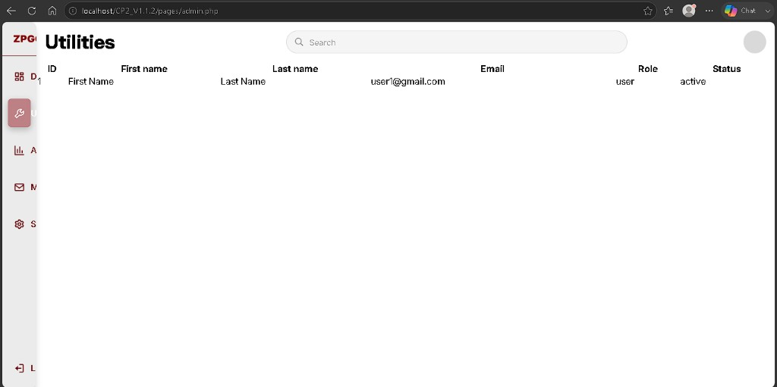
- Fix snippet:
<?php
require_once '../logic/config.php';
$users = $conn->query(
'SELECT id, first_name, last_name, email, role, status FROM users'
);
?>
code (php)
<table>
<tr>
<th>ID</th>
...
</tr>
<?php while ($row = $users->fetch_assoc()) { ?>
<tr>
<td><?php echo htmlspecialchars($row['id']); ?></td>
...
</tr>
<?php } ?>
</table>
code (html)
(Table sits inside #page-utilities, after the Utilities .head.)
- In plain language: When an admin opens Utilities, the page asks MySQL for every account and prints one table row per person. htmlspecialchars keeps names safe on screen. At this step the list was a plain table; A-027 styled it and A-028 added Activate.

A-026 - Login error banner (styled)
- When: 22 August 2026
- Official stage: 3 - v1.1.2 (Q-011)
- Status: done (B-023)
- What we did: On failed login, replaced the bare <p> under LOGIN with a pink alert box. Added .form-error in login_signup.css and showError() in login_signup.php. user_mngmnt.php still sets $_SESSION['login_error'] the same way (A-009); only the display changed.
- Files: css/login_signup.css, pages/login_signup.php
- Test: http://localhost/CP2_V1.1.2/pages/login_signup.php - wrong password -> pink banner under LOGIN, not gray text like “Don’t have an account?”. Same for an inactive account with correct password (B-021 / A-009 message).
- Fix snippet:
.form-error {
padding: 12px;
background-color: #bd8084;
border-radius: 6px;
text-align: center;
margin-bottom: 20px;
color: #7e030b;
font-weight: 600;
font-size: 14px;
width: 100%;
}
code (css)
function showError($error) {
if ($error !== '') {
return '<div class="form-error">' . htmlspecialchars($error, ENT_QUOTES, 'UTF-8') . '</div>';
}
return '';
}
$login_error = $_SESSION['login_error'] ?? '';
unset($_SESSION['login_error']);
code (php)
<h1>LOGIN</h1>
<?php echo showError($login_error); ?>
<h5>Enter your credentials to access, create, or track your tickets</h5>
code (php)
(Replaces echo '<p>' . htmlspecialchars($login_error) . '<p>'; - the old closing tag was also wrong.)
- In plain language: When login fails, the page shows a clear pink warning box under LOGIN, matching the reference system. The server still blocks wrong passwords and inactive accounts the same way as A-009; only the alert styling changed.

A-027 - Utilities card table (reference layout)
- When: 23 August 2026
- Official stage: 3 - v1.1.2 (Q-011)
- Status: done (B-024)
- What we did: Replaced the plain <table> from A-025 with the reference card list: .tickets-list, .tickets-list-header, .ticket-row, and .ucol-* columns (styles already in main_interface.css). PHP loads rows into $all_users[], then foreach prints each user. Name is one column; role and status use colored badges. Actions header stays; cells stay empty until Activate (next Q-011 step). No filter tabs or Add User yet.
- File: pages/admin.php
- Test: http://localhost/CP2_V1.1.2/pages/admin.php -> Utilities -> white card, aligned columns, #1 IDs, role pill, green Active / gray Pending. Same users_db rows as A-025.
- Fix snippet:
$all_users = [];
$result = $conn->query('SELECT id, first_name, last_name, email, role, status FROM users');
if ($result) {
while ($row = $result->fetch_assoc()) {
$all_users[] = $row;
}
}
$role_labels = [
'user' => 'User',
'techn' => 'Technician',
'admin' => 'Administrator',
];
code (php)
<div class="tickets-list">
<div class="tickets-list-header">
<span class="ucol-id">ID</span>
<span class="ucol-name">Name</span>
<span class="ucol-email">Email</span>
<span class="ucol-role">Role</span>
<span class="ucol-status">Status</span>
<span class="ucol-action">Actions</span>
</div>
<div class="tickets-list-body" id="utilities-users-body">
<?php foreach ($all_users as $u) {
$isActive = ($u['status'] === 'active');
$roleLabel = $role_labels[$u['role']] ?? ucfirst($u['role']);
?>
<div class="ticket-row">
<span class="ucol-id">#<?php echo (int) $u['id']; ?></span>
<span class="ucol-name"><?php echo htmlspecialchars($u['first_name'] . ' ' . $u['last_name']); ?></span>
<span class="ucol-email"><?php echo htmlspecialchars($u['email']); ?></span>
<span class="ucol-role">
<span class="profile-role-badge role-<?php echo htmlspecialchars($u['role']); ?>">
<?php echo htmlspecialchars($roleLabel); ?>
</span>
</span>
<span class="ucol-status">
<?php if ($isActive) { ?>
<span class="status-badge active-account">Active</span>
<?php } else { ?>
<span class="status-badge inactive-account">Pending</span>
<?php } ?>
</span>
<span class="ucol-action"></span>
</div>
<?php } ?>
</div>
</div>
code (html)
(Inside #page-utilities, after the Utilities .head. Replaces the A-025 <table>.)
- In plain language: Utilities still lists every account from the database, but it now uses the same white card layout and colored labels as the full admin screen. The Actions column was still empty until A-028 added Activate.

A-028 - Admin Activate pending account (Utilities)
- When: 24 August 2026
- Official stage: 3 - v1.1.2 (Q-011)
- Status: done (B-025)
- What we did: Created logic/user_admin_mngmnt.php with a prepared UPDATE users SET status = ? WHERE id = ?. On #page-utilities, each Pending row gets an Activate form in .ucol-action that POSTs id and status=active. Active rows show no button. Login still blocks inactive accounts in user_mngmnt.php (A-009); admin approval unblocks them without phpMyAdmin.
- Files: logic/user_admin_mngmnt.php, pages/admin.php
- Test: http://localhost/CP2_V1.1.2/pages/admin.php -> Utilities -> two accounts: one Active, one Pending with Activate under Actions. Click Activate -> row becomes Active; button gone. Log in as that user -> reaches dashboard; no Account is not activated yet. message (B-021 / A-009 behavior after approval).
No screenshot stored for this entry.
- Fix snippet:
if (isset($_POST['set_status'])) {
$id = (int) $_POST['id'];
$status = $_POST['status'];
if ($id <= 0 || $status !== 'active') {
header('Location: ../pages/admin.php');
exit();
}
$stmt = $conn->prepare('UPDATE users SET status = ? WHERE id = ?');
$stmt->bind_param('si', $status, $id);
$stmt->execute();
$stmt->close();
header('Location: ../pages/admin.php');
exit();
}
code (php)
(logic/user_admin_mngmnt.php - after session_start() and require_once 'config.php'.)
<span class="ucol-action">
<?php if (!$isActive) { ?>
<form action="../logic/user_admin_mngmnt.php" method="post">
<input type="hidden" name="id" value="<?php echo (int) $u['id']; ?>">
<input type="hidden" name="status" value="active">
<button type="submit" name="set_status" class="btn-update-status">Activate</button>
</form>
<?php } ?>
</span>
code (php)
(Inside the Utilities foreach ($all_users as $u) loop, replacing the empty .ucol-action from A-027.)
- In plain language: An admin can approve a new signup from Utilities with one click. MySQL flips that person to active; they can log in normally afterward. You no longer need phpMyAdmin for every new account (B-021 test workaround).

A-029 - User ticket list on `user.php` (Tickets tab)
- When: 25 August 2026
- Official stage: 4 - v1.2 (Q-006)
- Status: done (B-026, B-027)
- What we did: Top of user.php: session_start(), session guard, lookup user_id by $_SESSION['email'], then SELECT from tickets into $user_tickets[]. .tickets-list card inside #page-tickets (after .tickets-toolbar) prints ID, subject, description, and Pending badge per row. B-027: moved list inside the panel so it hides on other tabs and sits under New Ticket on Tickets.
- File: pages/user.php
- Test (first): Tickets tab showed data but table on every tab + huge gap (B-027).
- Test (after B-027): Dashboard, Mailbox, and Settings show only their own content. Tickets -> card directly under New Ticket; one row (monitor ticket, Pending).
Tickets tab - before: large gap
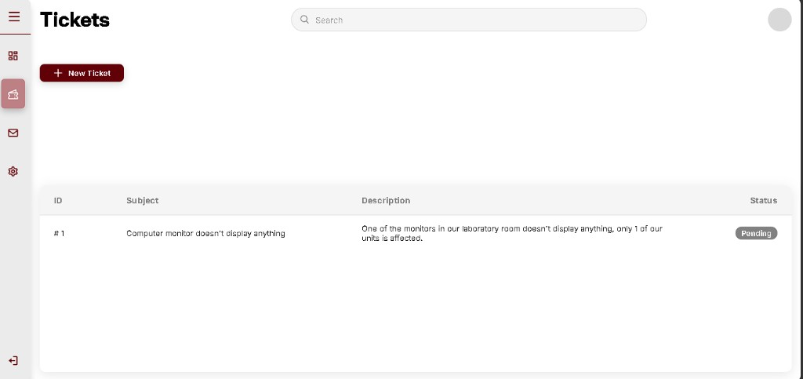
Dashboard - before: stray table
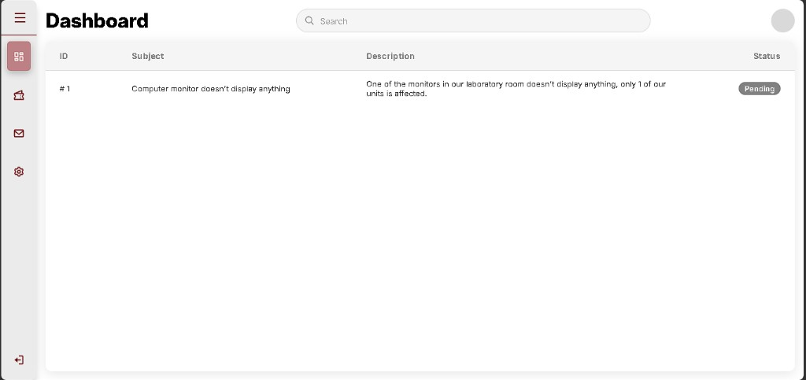
Mailbox - before: stray table
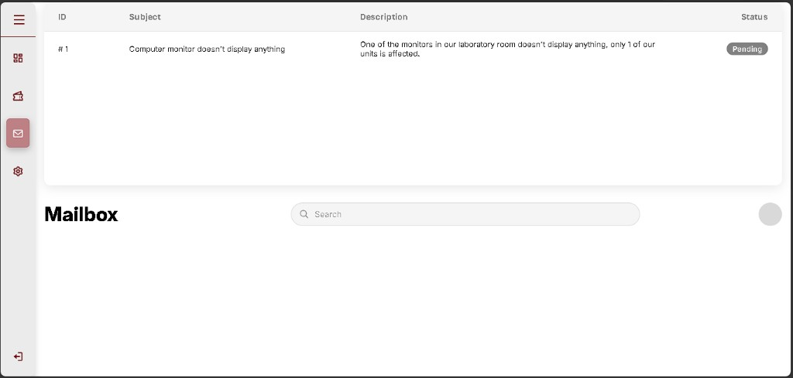
Settings - before: stray table
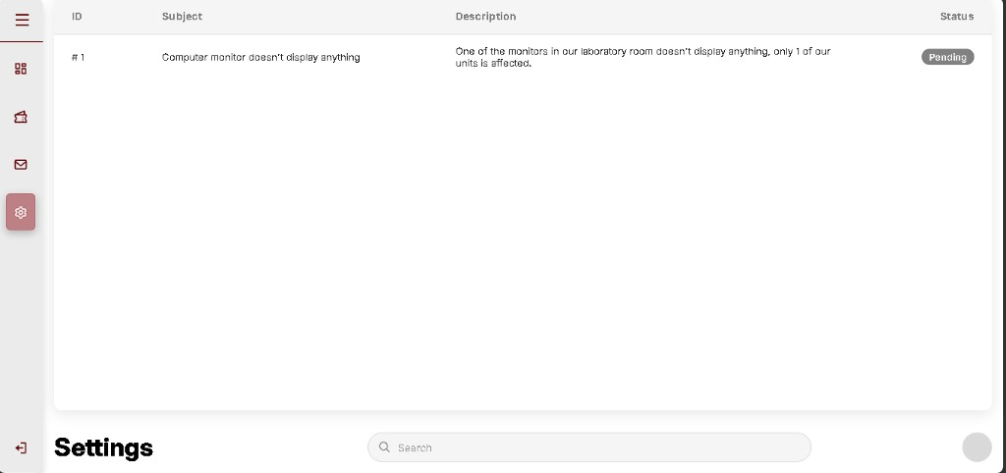
- Fix snippet:
$user_tickets = [];
$email = $_SESSION['email'];
$find = $conn->prepare('SELECT id FROM users WHERE email = ?');
$find->bind_param('s', $email);
$find->execute();
$found = $find->get_result()->fetch_assoc();
$find->close();
if ($found) {
$user_id = (int) $found['id'];
$stmt = $conn->prepare(
'SELECT id, subject, description, status FROM tickets WHERE user_id = ? ORDER BY id DESC'
);
$stmt->bind_param('i', $user_id);
$stmt->execute();
$result = $stmt->get_result();
while ($row = $result->fetch_assoc()) {
$user_tickets[] = $row;
}
$stmt->close();
}
code (php)
<div class="tickets-toolbar">...</div>
<div class="tickets-list">
<div class="tickets-list-header">...</div>
<div class="tickets-list-body" id="user-tickets-body">
<?php foreach ($user_tickets as $ticket) { ... ?>
</div>
</div>
</div>
code (html)
(.tickets-list is a child of #page-tickets, after .tickets-toolbar, before that panel's closing </div>.)
- In plain language: Logged-in users see their own tickets on the Tickets tab. The list only appears there - not on Dashboard, Mailbox, or Settings - and sits right under New Ticket like the reference system (B-027).

A-030 - Foreign key `tickets.user_id` -> `users.id` (phpMyAdmin)
- When: 2-3 September 2026 (2 days: FK types + Relation view)
- Official stage: 4 - v1.2 (Q-005)
- Status: done (FK saved + both tests passed)
- What we did: Pre-check: users.id and tickets.user_id both int(11); Browse showed one row (user_id = 1, pending monitor ticket). Structure -> Relation view on tickets: constraint fk_tickets_user, column user_id -> users_db.users.id, ON DELETE RESTRICT, ON UPDATE RESTRICT. Save succeeded (green success + ALTER below).
- Where: phpMyAdmin -> users_db -> tickets -> Structure -> Relation view (not SQL tab)
Relation view - fk_tickets_user saved
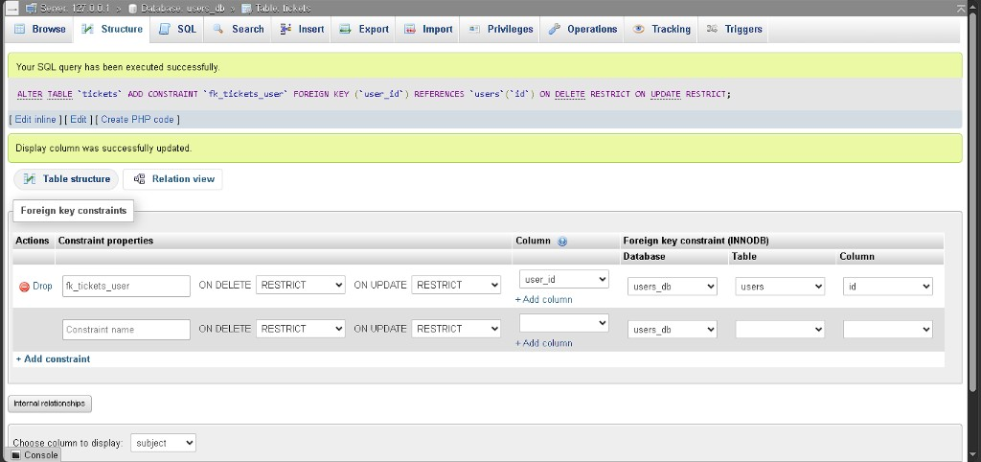
- Test (good row): Insert tab - id blank; user_id = First Name - 1 (dropdown); subject = FK Test Ticket; description = Testing FK with valid user; category = hardware; status = pending. Go -> 1 row inserted, id 4. Website Tickets tab shows the new row above the original monitor ticket.
- Test (bad row): SQL tab (not Insert) - Relation view makes user_id a dropdown of real users only, so 999 cannot be chosen on Insert. SQL tab with Enable foreign key checks on:
INSERT INTO tickets (user_id, subject, description, category)
VALUES (999, 'Test FK', 'user_id 999 does not exist', 'other');
code (sql)
Go -> #1452 - Cannot add or update a child row: a foreign key constraint fails (fk_tickets_user). No extra row added.
Good INSERT - Insert tab form (user_id 1)
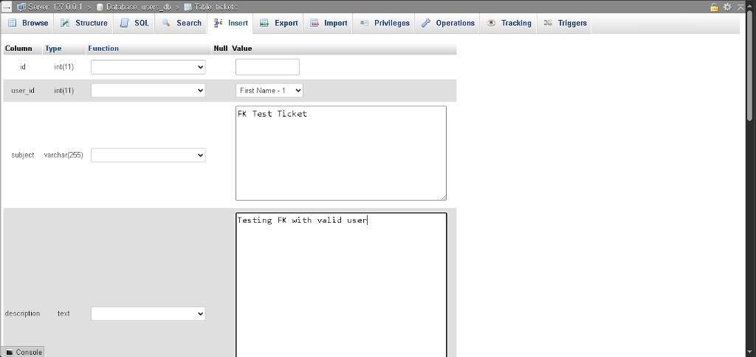
Good INSERT - 1 row inserted, id 4
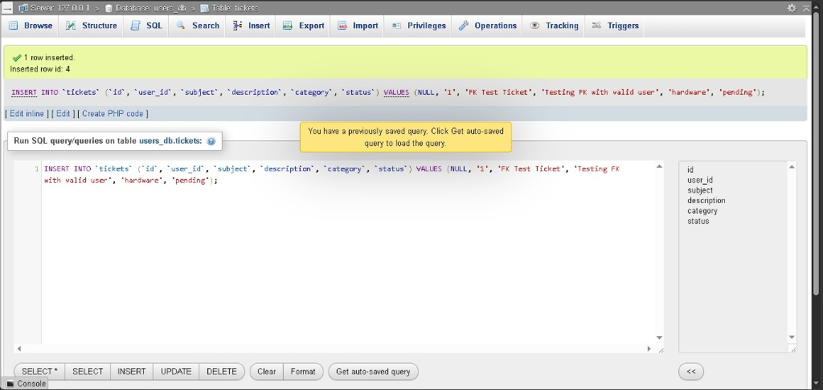
Tickets tab - FK test ticket + original row
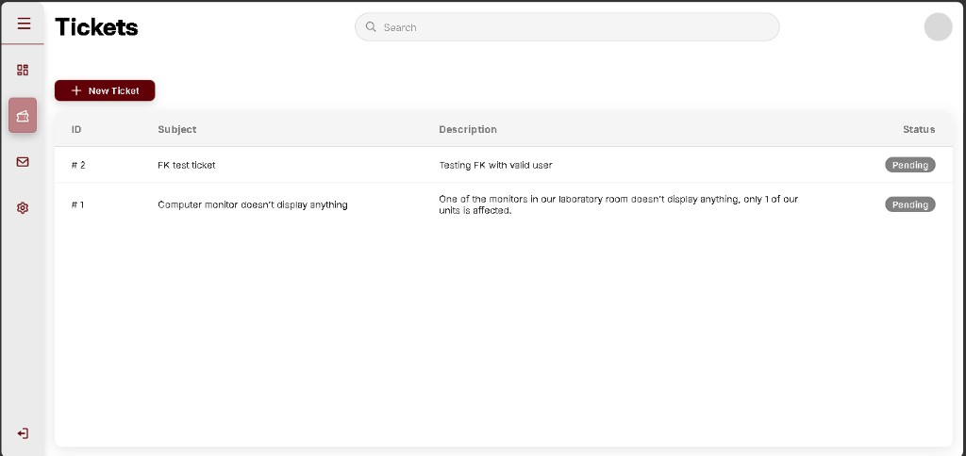
Bad INSERT - SQL before Go (user_id 999)
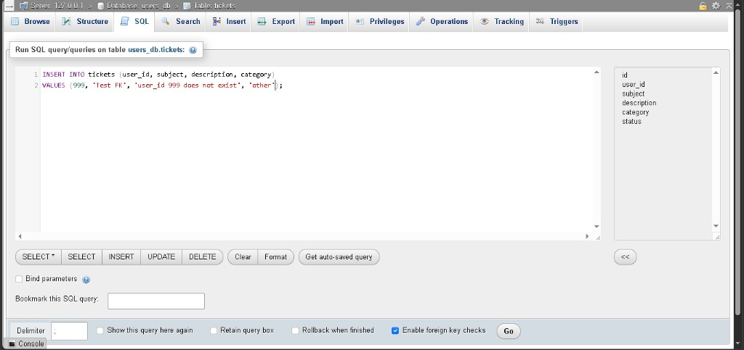
Bad INSERT blocked - #1452 fk_tickets_user
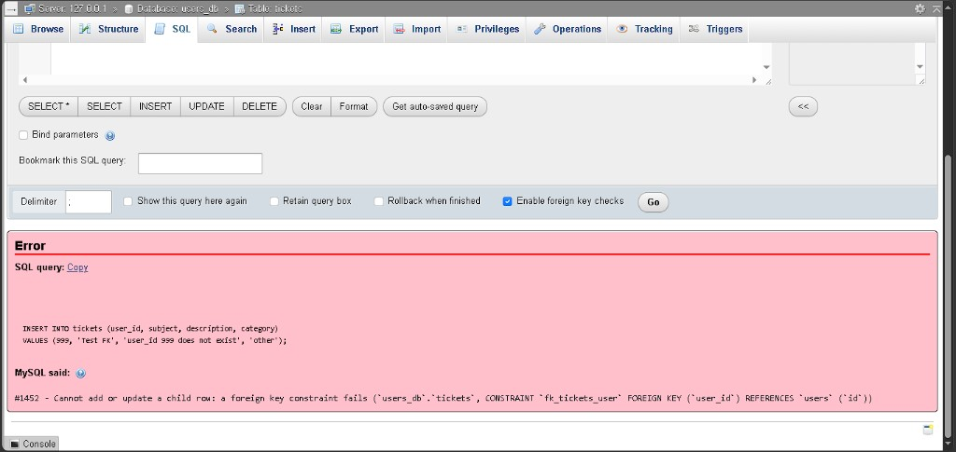
- Fix snippet (phpMyAdmin Relation view -> Save; SQL phpMyAdmin ran):
ALTER TABLE `tickets`
ADD CONSTRAINT `fk_tickets_user`
FOREIGN KEY (`user_id`) REFERENCES `users` (`id`)
ON DELETE RESTRICT ON UPDATE RESTRICT;
code (sql)
(Relation view fields: Constraint name fk_tickets_user; Column user_id; Database users_db; Table users; Column id.)
- In plain language: Every ticket must belong to a real account. MySQL checks user_id against users.id before it saves a ticket row. RESTRICT means you cannot delete a user who still has tickets without fixing those tickets first. Valid user_id = 1 saved ticket #4 through the Insert tab. The bad test used SQL because the Insert dropdown only lists existing users - you cannot pick a fake id there. MySQL still rejected user_id = 999 with error #1452, so the FK is working.

A-031 - Admin ticket list on `admin.php` (Tickets tab)
- When: 4 September 2026
- Official stage: 4 - v1.2 (Q-006)
- Status: done (B-028 fixed)
- What we did: Top of admin.php: $all_tickets[] from SELECT on tickets INNER JOIN users (all rows, newest first). Sidebar Tickets nav (data-nav="tickets"). New #page-tickets panel with .tickets-list inside it (same pattern as A-029 on user.php). While typing: fixed ehco -> echo, quert -> query, conn -> $conn (fatal Undefined constant "conn" without $). B-028: renamed ticket-col-* -> tickets-col-*.
- File: pages/admin.php
- Test: Tickets tab lists rows #4 and #1 - ID, Subject, Description, Pending in spaced columns (matches user.php layout). Dashboard / Utilities do not show the ticket table.
Admin Tickets tab - formatted list
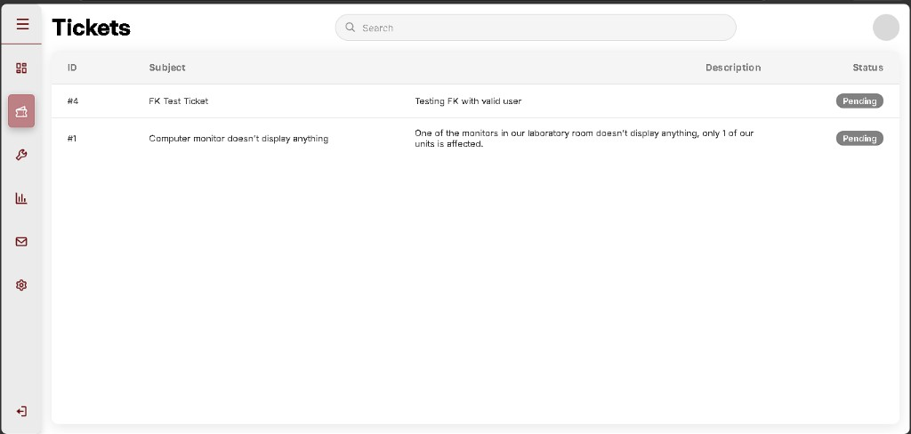
- Fix snippet (PHP - after $role_labels):
$all_tickets = [];
$ticket_result = $conn->query(
'SELECT t.id, t.subject, t.description, t.status,
u.first_name, u.last_name
FROM tickets t
INNER JOIN users u ON t.user_id = u.id
ORDER BY t.id DESC'
);
if ($ticket_result) {
while ($row = $ticket_result->fetch_assoc()) {
$all_tickets[] = $row;
}
}
code (php)
<li class="nav-list-item" data-nav="tickets">...</li>
code (html)
(#page-tickets sits after #page-dashboard, before #page-utilities. .tickets-list is inside #page-tickets.)
- In plain language: Admin sees every ticket in the database, not just one user’s. The JOIN adds submitter names for later columns. The list only shows on the Tickets tab because it lives inside #page-tickets, like B-027 on the user side.

A-032 - `tickets.assigned_to` + expanded `status` ENUM (phpMyAdmin)
- When: 5 September 2026
- Official stage: 4 - v1.2 (assign workflow prep)
- Status: done
- What we did: Structure on tickets: added `assigned_to` INT(11) NULL default NULL after user_id. Changed `status` ENUM from 'pending' only to 'pending','ongoing','processing','resolved' (default pending). Relation view: constraint `fk_tickets_assigned` - assigned_to -> users.id, ON DELETE SET NULL, ON UPDATE RESTRICT. `fk_tickets_user` unchanged. Browse: rows #1 and #4 still pending; `assigned_to` NULL on both.
- Where: phpMyAdmin -> users_db -> tickets -> Structure / Relation view
Structure - assigned_to column added
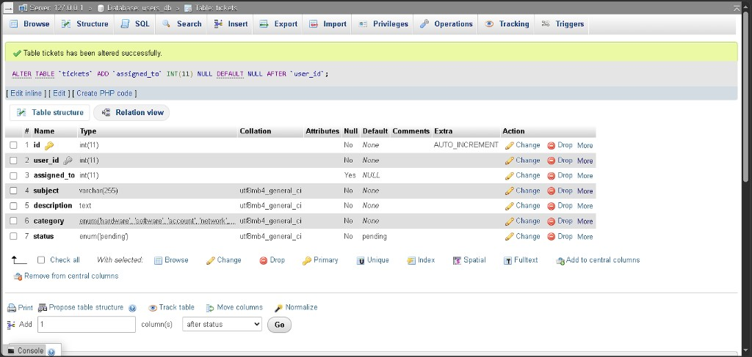
Structure - status ENUM expanded
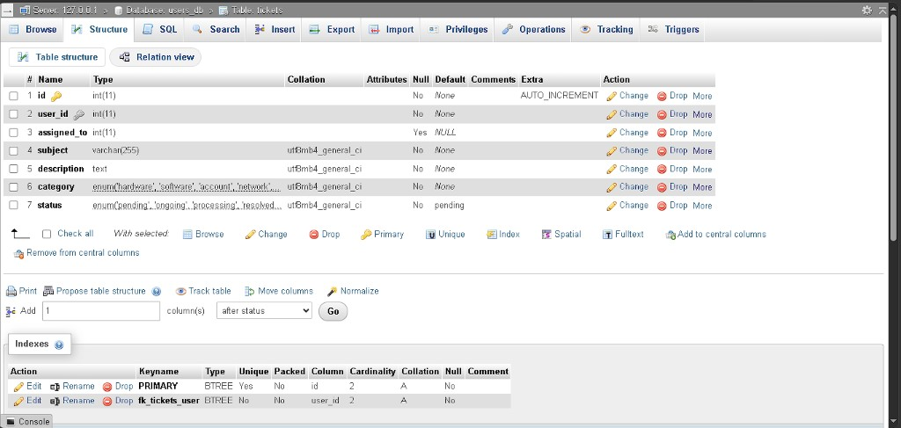
Relation view - fk_tickets_assigned saved
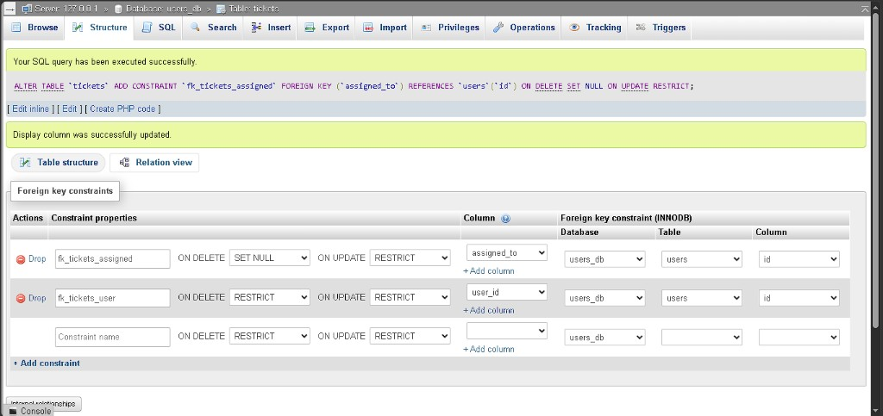
Browse - assigned_to NULL on existing rows
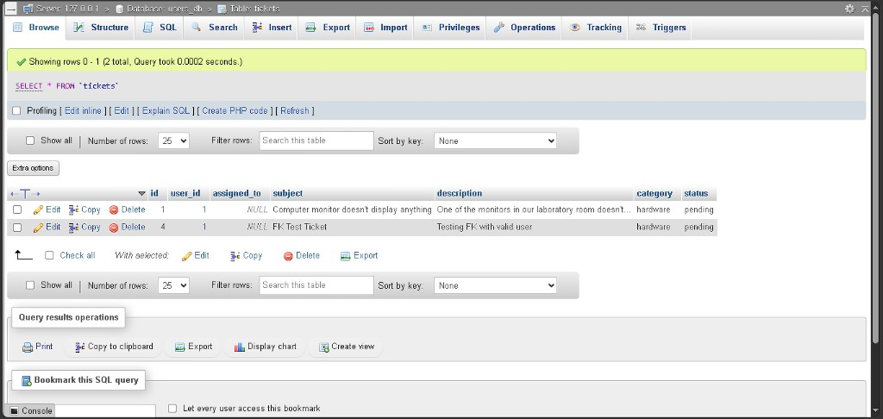
- Fix snippet (phpMyAdmin Structure + Relation view):
ALTER TABLE `tickets`
ADD `assigned_to` INT(11) NULL DEFAULT NULL AFTER `user_id`;
ALTER TABLE `tickets`
CHANGE `status` `status`
ENUM('pending','ongoing','processing','resolved')
NOT NULL DEFAULT 'pending';
ALTER TABLE `tickets`
ADD CONSTRAINT `fk_tickets_assigned`
FOREIGN KEY (`assigned_to`) REFERENCES `users` (`id`)
ON DELETE SET NULL ON UPDATE RESTRICT;
code (sql)
- In plain language: Each ticket can now record which technician owns it (assigned_to), or stay unassigned (NULL). Status can move through four workflow steps instead of only pending. SET NULL means if a technician row is removed, the ticket stays but assignment clears. Existing tickets were not broken - they still show pending with no assignee.

A-033 - Admin assign technician (in progress)
- When: 6-7 September 2026 (assign UI + retest)
- Official stage: 4 - v1.2 (Q-006)
- Status: in progress - Part 1-2 done; Part 3 logged as A-033 continued (19 Sep 2026)
- What we did (Part 1): At top of admin.php, load `$technicians[]` from active tech rows (role = 'techn', status = 'active'). Expanded `$all_tickets` query to include `t.assigned_to`. Removed temporary echo / print_r debug block after Part 1 test. User signing up a Technician account + Activate on Utilities (no active tech existed yet).
- What we did (Part 2): Tickets tab - Assigned To header + per-row <select> (Unassigned + active technicians). CSS `tickets-col-assigned` + `tickets-list-admin-five` grid. B-029 fixed. `$tid = (int) $ticket['id']` before each row; #<?php echo $tid; ?> and aria-label use $tid.
- Part 2 retest: Tickets tab - five columns aligned; #4 dropdown shows technician (First Name 4 Last N...); #1 Unassigned. Picking a name in the dropdown is UI-only until Part 3 - refresh reverts to whatever is in MySQL assigned_to.
A-033 Part 2 - assign dropdown retest
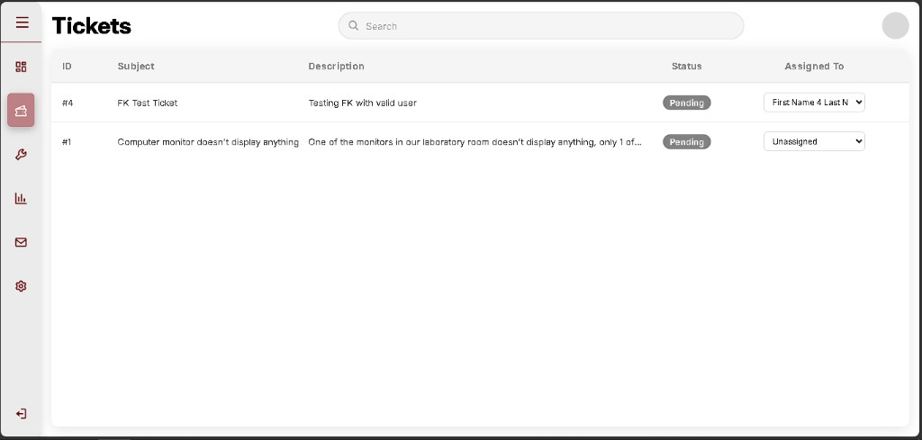
- Where: pages/admin.php, css/main_interface.css
- Fix snippet:
$technicians = [];
$tech_result = $conn->query(
"SELECT id, first_name, last_name
FROM users
WHERE role = 'techn' AND status = 'active'
ORDER BY last_name, first_name"
);
if ($tech_result) {
while ($row = $tech_result->fetch_assoc()) {
$technicians[] = $row;
}
}
$ticket_result = $conn->query(
'SELECT t.id, t.subject, t.description, t.status, t.assigned_to,
u.first_name, u.last_name
FROM tickets t
INNER JOIN users u ON t.user_id = u.id
ORDER BY t.id DESC'
);
code (php)
- In plain language: Before any dropdown appears, PHP must know (1) which technicians are allowed on the list, and (2) whether each ticket already has someone assigned. Part 1 only prepares that data; saving an assignment comes in Part 3.

A-033 (continued) - Assign Save + status (Part 3)
- When: 6-7 September 2026 (assign UI + retest)
- Official stage: 4 - v1.2
- Status: done (B-030 layout; form posts assigned_to + status)
- What we did: ticket_admin_mngmnt.php UPDATEs assigned_to and status. Admin Tickets row is a <form class="ticket-row"> with status <select>, assign <select>, Save. Assigned column widened to minmax(240px, 1fr).
- Where: pages/admin.php, logic/ticket_admin_mngmnt.php, css/main_interface.css
- Test: Tickets -> pick technician + status -> Save -> refresh keeps both; phpMyAdmin tickets Browse matches.
- In plain language: Admin can actually assign a technician and move the ticket through pending / ongoing / processing / resolved. Refreshing no longer throws the assignment away.

A-034 - Technician assigned-ticket list (`techn.php`)
- When: 8 September 2026
- Official stage: 4 - v1.2
- Status: done (B-031 fixed - retest 19 Sep 2026: four spaced columns)
- What we did: require_role('techn'). SELECT tickets WHERE assigned_to = current user. Tickets tab lists those rows. Mailbox include + logout. B-031 was ticket-col-* (no s); now tickets-col-*.
- File: pages/techn.php
- Fix snippet:
$stmt = $conn->prepare(
'SELECT id, subject, description, status FROM tickets WHERE assigned_to = ? ORDER BY id DESC'
);
code (php)
- In plain language: A technician only sees jobs assigned to them, not every ticket in the school.

A-035 - Mailbox UI + 3s poll (Q-006)
- When: 8-9 September 2026 (messages table + mailbox thread)
- Official stage: 4 - v1.2
- Status: done (B-033 closed 19 Sep 2026 - messages created; send works)
- What we did: Shared pages/mailbox_panel.php on user / admin / techn Messages tabs. message_mngmnt.php INSERT; fetch_messages.php JSON. js/behavior.js loads a thread on click. Poll matches data-page="messages" (B-032). phpMyAdmin CREATE TABLE messages with FKs to tickets and users.
- Files: pages/mailbox_panel.php, logic/message_mngmnt.php, logic/fetch_messages.php, js/behavior.js, database/v1.2_stage4.sql
- Test: SQL Go -> empty result; Browse messages empty; send Hello from techn -> maroon bubble; second account sees Hello left and sends Ho.
- In plain language: Chat now saves in MySQL. Both sides of a ticket can talk. Pane header can still say Select a ticket after a send (title not always refreshed).

A-036 - Shared session, logout, role guards (Q-003); B-002 signup
- When: 9 September 2026
- Official stage: 4 - v1.2
- Status: done
- What we did: Pages and handlers use logic/session_config.php (cookie path /CP2_V1.2/). require_role('admin'|'user'|'techn') on dashboards. Logout -> logic/logout.php. Public signup Role list is User + Technician only (B-002). Signup PHP already rejected admin.
- In plain language: You cannot open admin as a student. Logout really ends the session. Visitors cannot pick Administrator on the public form.

A-037 - Priority queue panel (look only; 12 slots)
- When: 10 September 2026
- Official stage: 5 - v1.3 (Q-007)
- Status: done (look only). B-034 closed - 4 -> 3 after screenshot.
- What we did: Admin Tickets tab - grey Priority queue card above the ticket list. Three bands: Critical / Moderate / Low. First draft used 4 slots per band (0 / 12). Linked dashboard_extra.css. Subtitle under the title was removed so the doc screenshot is title + 0 / 9 + bands only.
- Where: pages/admin.php (#page-tickets), css/dashboard_extra.css
- Fix snippet:
$queue_slots_per_band = 3;
$queue_total_slots = $queue_slots_per_band * 3;
code (php)
- In plain language: Admin can see a queue board on Tickets before counts are wired to MySQL. After B-034, each colour band is three seats (9 total). No subtitle under the title.
Priority queue - 9 slots, no description
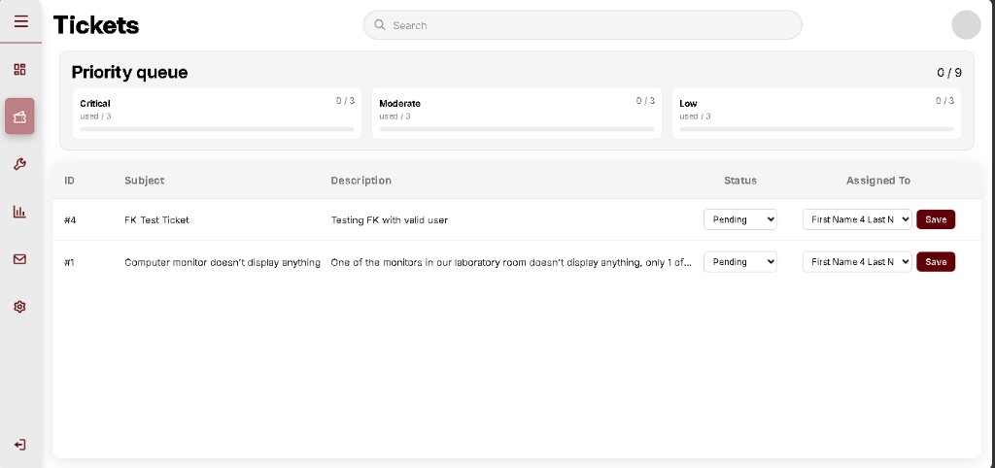

A-038 - phpMyAdmin: `tickets.priority` (Structure)
- When: 10-11 September 2026
- Official stage: 5 - v1.3 (Q-007)
- Status: done (B-035 closed - priority Null Yes, Default NULL)
- What we did: users_db -> tickets -> Structure -> Add 1 column after status. Name priority, Type ENUM, Length/Values 'critical','moderate','low'. First Save: Null = No (B-035). Change: tick Null, Default None, Save. Structure: column #8 Null = Yes, Default NULL. category already existed (#6).
Structure - add priority ENUM
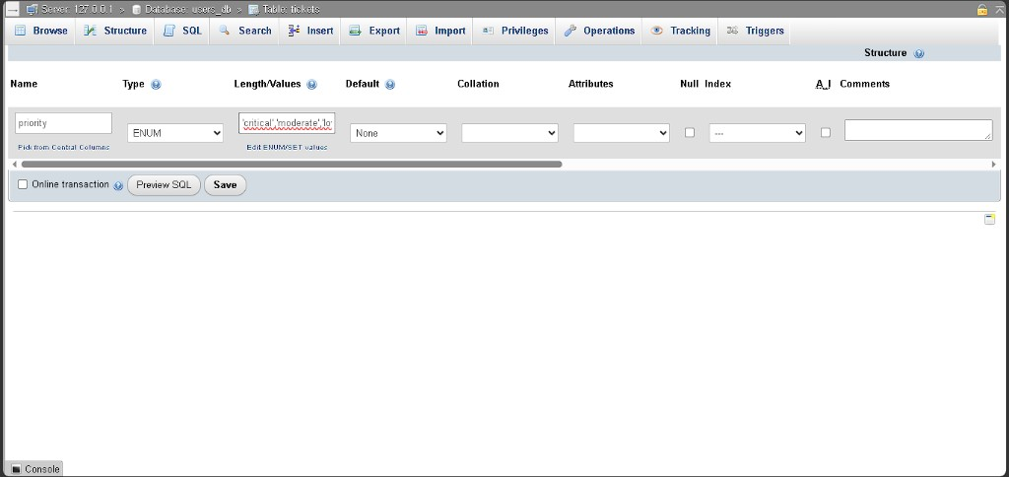
Structure - priority saved, Null No
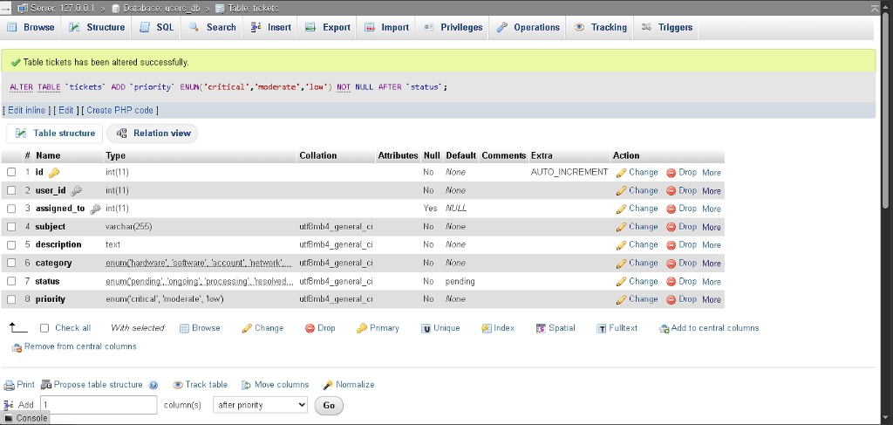
Structure - priority Null Yes after Change
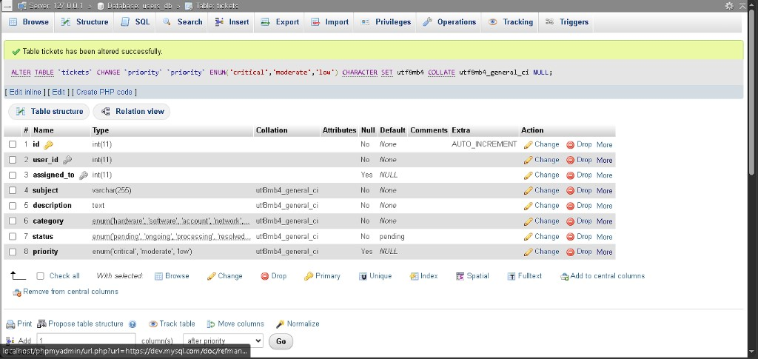
- Where: phpMyAdmin Structure (no SQL tab typed by hand; phpMyAdmin wrote the ALTER)
- Fix snippet (phpMyAdmin Structure Save):
ALTER TABLE `tickets`
ADD `priority` ENUM('critical','moderate','low') NOT NULL AFTER `status`;
code (sql)
- In plain language: Each ticket can store a queue colour, or stay empty (NULL) until it is put on the board.

A-039 - Queue counts from `tickets.priority`
- When: 11 September 2026
- Official stage: 5 - v1.3 (Q-007)
- Status: done (B-036 closed - 'high' -> 'critical')
- What we did: GROUP BY priority into $by_priority. Board uses $queue_counts and bar fill used / 3. First draft looked up 'high' (B-036); now 'critical'.
- Where: pages/admin.php
- Fix snippet:
'critical' => (int) ($by_priority['critical'] ?? 0),
code (php)
- In plain language: Critical, Moderate, and Low counts come from the same words stored in MySQL.

A-040 - Analytics status cards (static numbers)
- When: 11 September 2026
- Official stage: 5 - v1.3 (Q-007)
- Status: done (B-037 closed - replaced with original 5-card COUNT UI)
- What we did: First draft had three cards with literals 4, 2, 12. That did not match the original (Pending / Ongoing / Processing / Confirming / Resolved + icons).
- Where: pages/admin.php (#page-analytics)
- Causing snippet (B-037):
$analytics_pending = 4;
$analytics_ongoing = 2;
$analytics_resolved = 12;
code (php)
- In plain language: Those three numbers were a fake poster, not the original dashboard cards.

A-041 - Original status cards + sample charts; priority Save
- When: 12 September 2026
- Official stage: 5 - v1.3 (Q-007)
- Status: done pending screenshot
- What we did: Copied look-lock dashboard_status_cards.php (5 cards, filled icons). Counts from SELECT status, COUNT(*) GROUP BY status. Same cards on Dashboard and Analytics. Analytics also has original static Chart.js sample (Tickets Report, Categories, Satisfaction, Severity). Tickets list Priority dropdown; ticket_admin_mngmnt.php UPDATEs priority. Confirming stays 0 until Stage 6 ENUM. Charts stay sample (same as original comment: display only).
- Where: pages/partials/dashboard_status_cards.php, pages/partials/dashboard_charts.php, js/dashboard_static_charts.js, pages/admin.php, logic/ticket_admin_mngmnt.php
- Fix snippet:
$count_result = $conn->query('SELECT status, COUNT(*) AS cnt FROM tickets GROUP BY status');
code (php)
- In plain language: Card numbers follow real ticket statuses. Charts are the original sample drawings, not live MySQL. Priority on a ticket can be saved and the 9-slot board counts it.

A-042 - Close B-038-B-040; Settings shell; Performance / Tickets shots
- When: 12 September 2026
- Official stage: 5 - v1.3
- Status: done
- What we did: Fixed chart dashbord typo, Pending pendng filter, queue active-status rule. Settings Appearance + password. Logged Performance placeholders and Tickets queue/priority.
- Files: js/dashboard_static_charts.js, logic/priority_queue.php, logic/settings_mngmnt.php, pages/admin.php
- In plain language: Dashboard charts draw. Settings is no longer blank. Queue only counts work-in-progress tickets.
Performance placeholders
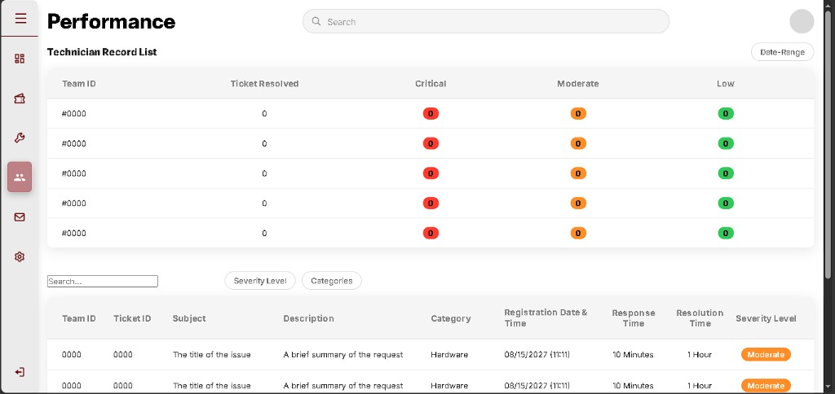
Tickets queue and priority
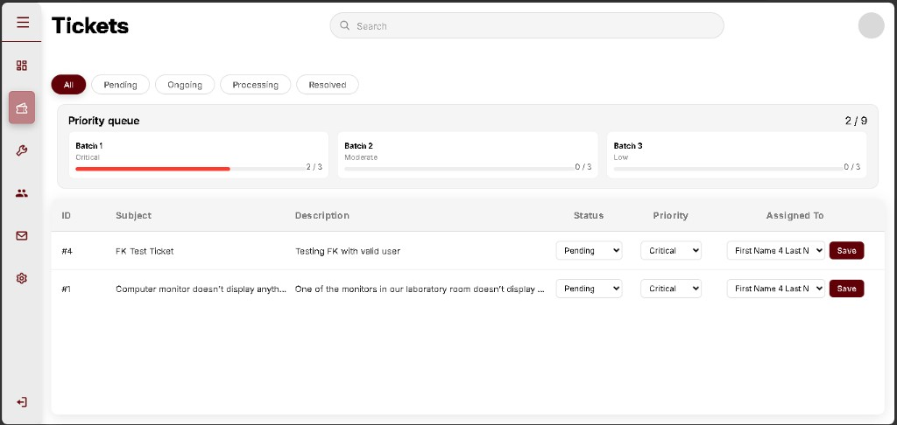

A-043 - Utilities filters/actions + working theme toggle
- When: 12 September 2026
- Official stage: 5 - v1.3
- Status: done
- What we did: Restored original Utilities toolbar (role filters + Add User), Edit / Activate-Deactivate / Delete actions, and full user_admin_mngmnt.php handlers. Settings theme Light/Dark saves via session + cookie and applies data-theme + theme.css.
- Files: pages/admin.php, logic/user_admin_mngmnt.php, logic/settings_mngmnt.php, logic/session_config.php, js/utilities_filter.js, css/theme.css
- In plain language: Utilities matches the original admin user desk. Theme actually switches the dashboard look.

A-044 - Fix B-043: local Chart.js for Dashboard samples
- When: 12 September 2026
- Official stage: 5 - v1.3
- Status: done
- What we did: Replaced CDN Chart.js with local js/chart.umd.js. Hardened dashboard_static_charts.js to redraw when returning to Dashboard.
- Files: js/chart.umd.js, js/dashboard_static_charts.js, pages/admin.php
- In plain language: Sample charts draw without needing the internet.

A-045 - Fix B-044: queue counts open prioritized tickets
- When: 13 September 2026
- Official stage: 5 - v1.3
- Status: done
- What we did: Priority queue again counts priority IS NOT NULL (not resolved). Squashed GitHub history to a single V1.3 commit.
- Files: logic/priority_queue.php
- In plain language: Set Priority to Critical and Save -> Batch 1 moves (e.g. 2 / 3, total 2 / 9).

A-046 - Queue retest OK; migrate folder to CP2_V1.4
- When: 13 September 2026
- Official stage: 5 -> 6 (v1.3 close / v1.4 start)
- Status: done
- What we did: Retest - Priority queue 2 / 9 (Critical 1/3, Moderate 1/3, Low 0/3) with two Pending tickets. Copied website to C:\xampp\htdocs\CP2_V1.4 (cookie path /CP2_V1.5/). Stage 6 work continues only in the V1.4 folder.
- In plain language: V1.3 queue is verified. New lessons use the V1.4 copy so V1.3 on disk (and GitHub tag V1.3) stays frozen.
Queue working - 2/9
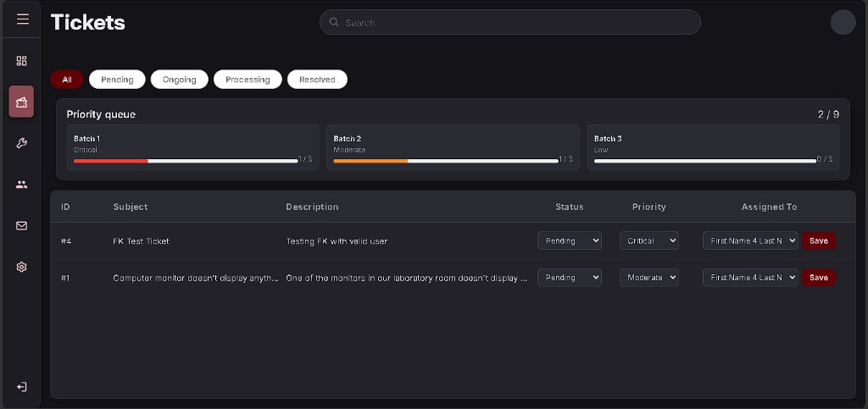

A-047 - Utilities filters + actions retest (closes B-041 shot)
- When: 13-14 September 2026
- Official stage: 5 - v1.3
- Status: done
- What we did: Retest after A-043 - Utilities shows All / User / Technician / Administrator / Pending Approval, Add User, and per-row Edit / Deactivate / Delete. Edit User form opens with name, email, and Role dropdown + Save Changes.
- In plain language: Admin can filter accounts by role and change role / deactivate / delete from Utilities (B-041 fixed and verified).
Utilities filters and actions
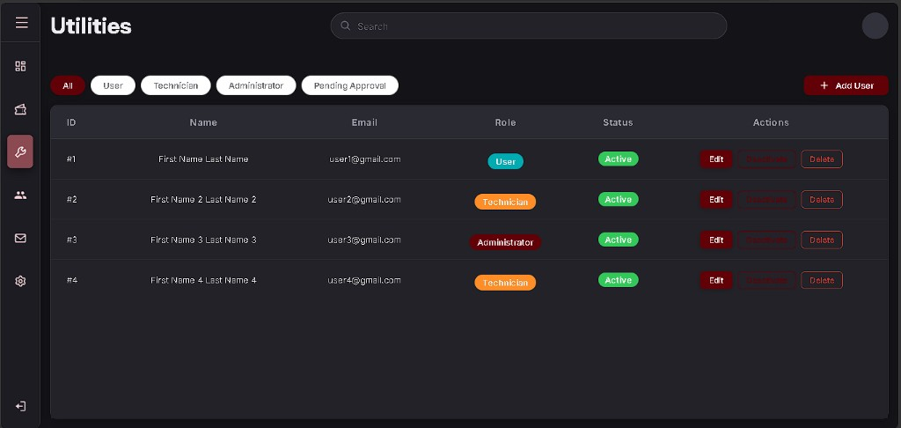
Utilities Edit User form
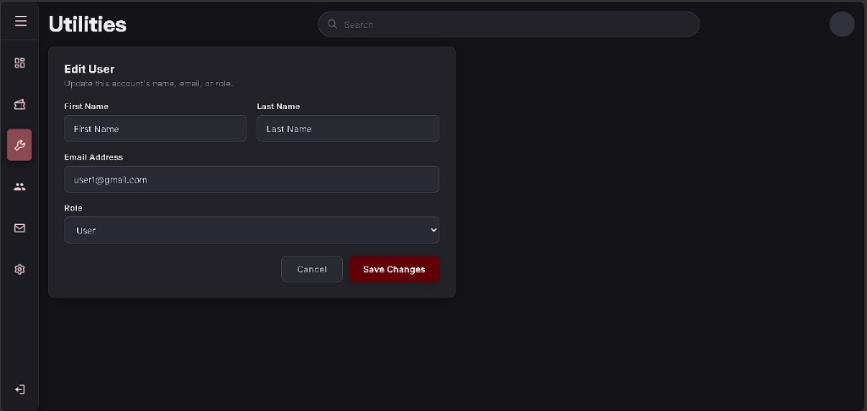

A-049 - phpMyAdmin: `awaiting_confirmation` on `tickets.status`
- When: 14 September 2026
- Official stage: 6 - v1.4 (Q-012)
- Status: done
- What we did: Structure -> Change status ENUM. Added awaiting_confirmation. Table altered successfully. Values now: pending, ongoing, processing, resolved, awaiting_confirmation (default pending).
- Where: users_db.tickets.status
- In plain language: MySQL can store the Confirming step between Processing and Resolved.
Structure - awaiting_confirmation saved
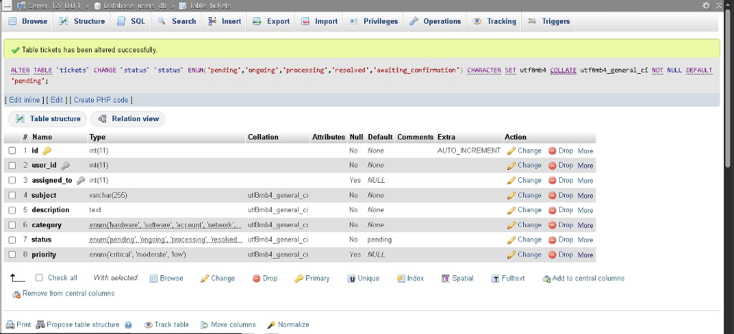

A-050 - Confirmation workflow UI + handlers (planted B-045-B-047)
- When: 14-15 September 2026
- Official stage: 6 - v1.4 (Q-012)
- Status: in progress (bugs open for screenshots)
- What we did: Technician Tickets - status dropdown + Save (ticket_techn_mngmnt.php). User Tickets - Confirm column with Solved / Not Solved Yet (ticket_confirm_mngmnt.php). Admin status list includes Confirming. Helpers in ticket_status.php. Intentional bugs B-045-B-047 left open for captures.
- Files: pages/user.php, pages/techn.php, pages/admin.php, logic/ticket_status.php, logic/ticket_confirm_mngmnt.php, logic/ticket_techn_mngmnt.php, css/main_interface.css
- In plain language: Stage 6 screens exist. Three planted typos/wrong rules will show up when you test - then we fix them.

A-051 - Stage 6 confirmation closed (B-045-B-047 fixed)
- When: 15 September 2026
- Official stage: 6 - v1.4 (Q-012)
- Status: done
- What we did: Logged screenshots for B-045-B-047. Fixed typo confirm check, removed Resolved from technician statuses, Not Solved Yet -> ongoing. Q-012 complete. Stage 7 = Python/Flask in CP2_V1.5.
- In plain language: Reporter can confirm fixes; tech cannot skip confirmation; rejected fixes go back to Ongoing.

A-052 - Python 3.13 + pip + Flask installed
- When: 16 September 2026
- Official stage: 7 - AI (Q-008)
- Status: done
- What we did: Installed Python 3.13.15 with PATH. Verified python / pip. Installed flask, flask-cors, requests. Sanity check printed Flask OK 3.1.3.
- Where: local PC + C:\xampp\htdocs\CP2_V1.5
- In plain language: The machine can run a Python web helper beside XAMPP.

A-053 - Flask keyword classifier (`ai/classifier_app.py`)
- When: 16-17 September 2026
- Official stage: 7 - AI (Q-008)
- Status: done (B-050 planted)
- What we did: Local Flask app on 127.0.0.1:5000 - GET /health, POST /classify. Keyword rules map subject/description -> category + priority (no paid OpenAI key required for this rebuild).
- Files: ai/classifier_app.py, ai/requirements.txt, ai/start_classifier.bat
Flask classifier running
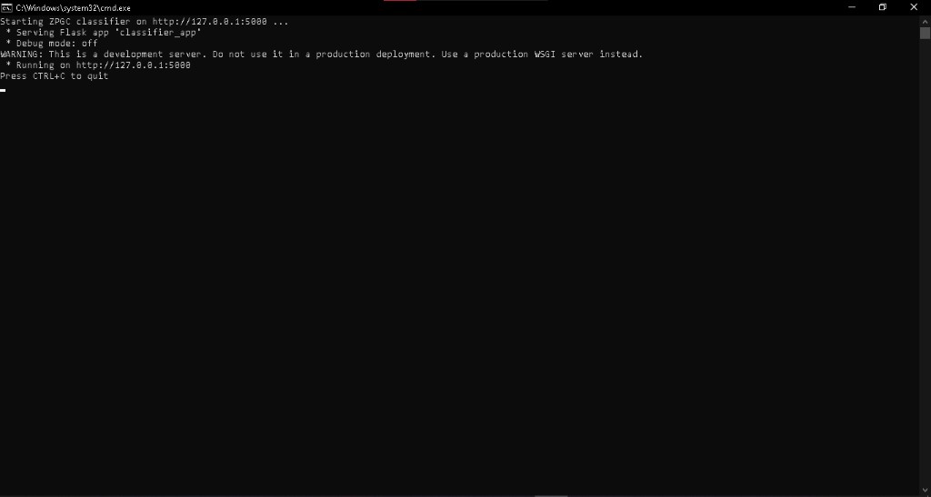
Health ok
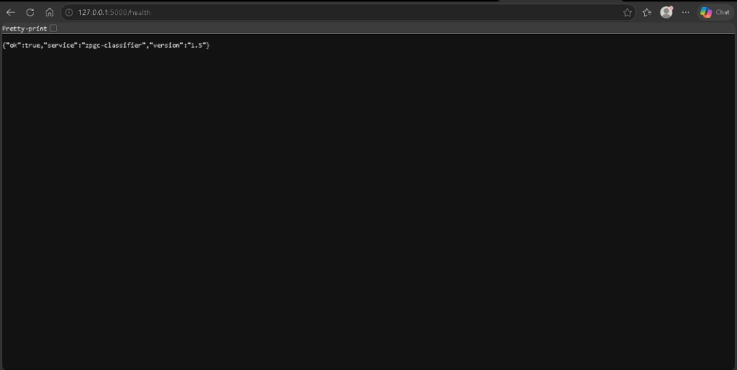
- In plain language: A small AI service guesses ticket category and urgency from the words you type.

A-054 - Ticket form Suggest with AI + PHP bridge
- When: 17 September 2026
- Official stage: 7 - AI (Q-008)
- Status: in progress (B-049-B-051 open for screenshots)
- What we did: New Ticket: subject/description -> Suggest with AI -> fills category/priority dropdowns. Bridge logic/ai_classify.php / ai_suggest.php + js/ticket_ai.js. Intentional bugs left for captures.
- Files: pages/ticket.php, logic/ai_classify.php, logic/ai_suggest.php, logic/ticket_mngmnt.php, js/ticket_ai.js, css/ticket.css
New Ticket with Suggest with AI
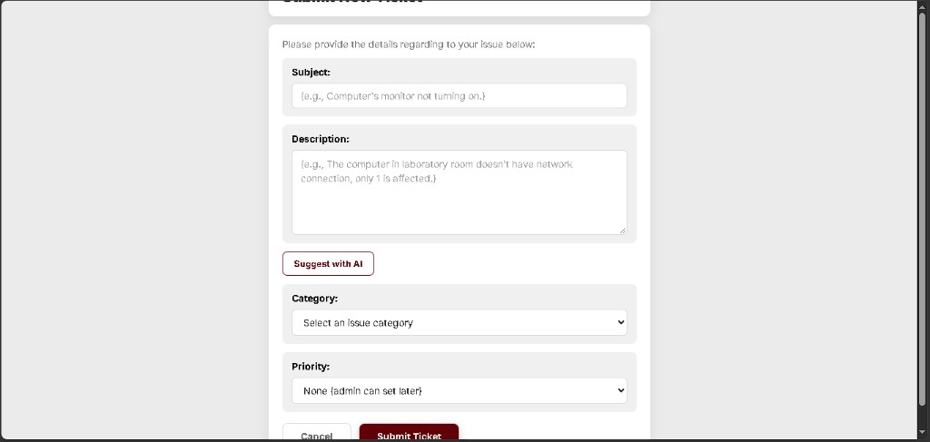
- In plain language: The ticket form can ask Flask for a suggestion; three planted mistakes will show up when you test.

A-055 - Stage 7 AI suggest verified (B-051 / B-052 closed)
- When: 17-18 September 2026
- Official stage: 7 - AI (Q-008)
- Status: done
- What we did: Confirmed Suggest with AI fills category + priority; Submit stores priority (#1004 Moderate; queue 3/9). Fixed New Ticket title clip. Planted bugs B-049-B-051 all closed; layout bug B-052 closed.
- Files: i/classifier_app.py, logic/ai_classify.php, logic/ticket_mngmnt.php, pages/ticket.php, css/ticket.css, js/ticket_ai.js
- In plain language: Stage 7 AI helper works end-to-end on the ticket form.

A-056 - Stage 8 testing (Q-009)
- When: 18 September 2026
- Official stage: 8 - Testing (Q-009)
- Status: nearly done (Settings/Utilities smoke optional)
- What we did: Full role path on #1005; B-053/B-054 found and fixed; Test G AI-down path on #1006.

Results
Test | Result | Evidence
**A1** Login page | **pass**
**B** New Ticket + AI + Submit | **pass** | #1005 hardware/moderate
**C** Admin assign / queue | **pass**
**D** Techn -> Confirming | **pass**
**E** Not Solved Yet -> Ongoing | **pass**
**F** Mailbox live | **pass** | chat Hello/Hi
**F** Techn sees Resolved | **pass** | after **B-054**
**G1** AI down -> clear error | **pass** | Cannot reach AI / port 5000
**G2-G3** Manual submit without AI | **pass** | #1006 Account/Moderate saved
**F** Settings / Utilities | **optional** | not blocking

B-054 techn Resolved
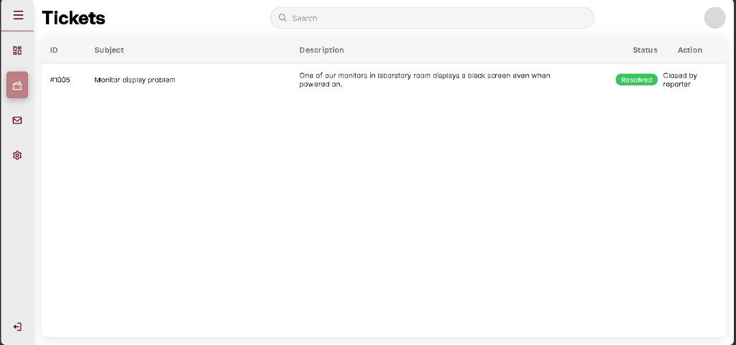
G1 AI down error
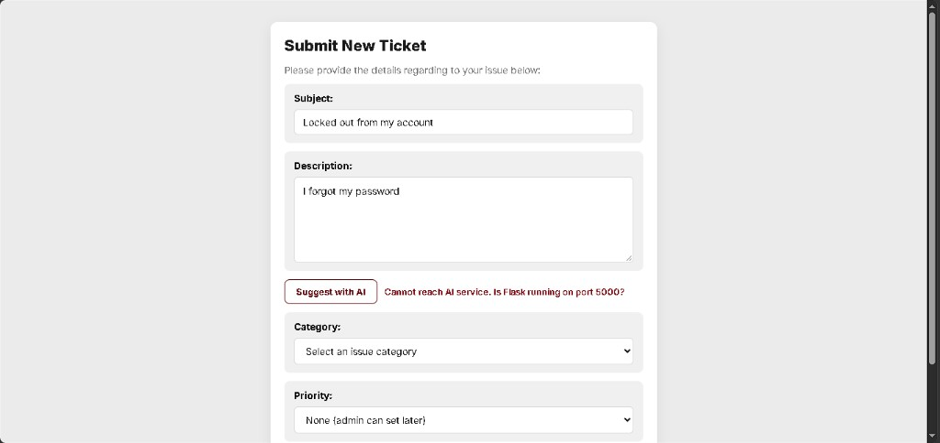
G3 ticket saved without AI
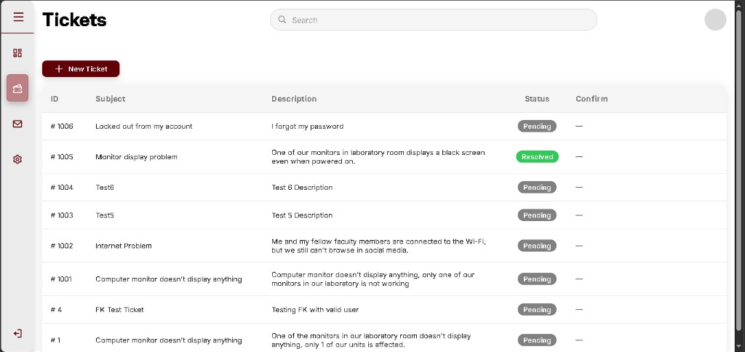
- In plain language: Stage 8 core checks passed. AI can be off and tickets still submit by hand. Technician now sees when a reporter closes a ticket.

A-057 - OpenAI gpt-5.6-luna classifier + secure API key
- When: 19 September 2026
- Official stage: 7 - AI Integration (paper model)
- Status: done (key optional until billing)
- What we did: Upgraded ai/classifier_app.py to call OpenAI `gpt-5.6-luna` when ai/.env has OPENAI_API_KEY; otherwise keyword fallback. Added ai/.env.example, gitignore for .env, docs/SETUP_OPENAI.md. Priorities mapped to DB ENUM critical|moderate|low. Endpoints: /classify, /suggest, /health.
- Fix snippet (ai/.env):
OPENAI_API_KEY=sk-your-key-here
OPENAI_MODEL=gpt-5.6-luna
OPENAI_REASONING_EFFORT=none
code (env)
- In plain language: The campus AI can use the real Luna model when you paste an API key. Without a key it still suggests category/priority using simple word rules so demos never break.
- Credits note: Free ChatGPT chat ≠ API. Trial API credit (if any) can test before buying $5; if balance is $0 you need prepaid API credit.

A-058 - Automatic ticket assignment
- When: 19 September 2026
- Official stage: 7 / FR auto-assign
- Status: done
- What we did: logic/ticket_assign.php picks the active technician with the fewest open tickets. On Submit, critical and moderate tickets auto-assign and move to ongoing. Admin can still reassign manually.
- Fix snippet:
$tech = ticket_auto_assign($conn, $ticket_id, 'ongoing');
code (php)
- In plain language: After you submit a serious or medium ticket, the system gives it to the least-busy technician automatically.

A-059 - Low-priority AI troubleshooting + escalate
- When: 19 September 2026
- Official stage: 7 / FR AI self-help
- Status: done
- What we did: Low-priority submit calls /suggest, stores tips in tickets.ai_guidance, leaves ticket unassigned. User Tickets shows AI troubleshooting tips and Still not fixed - Request Technician (ticket_escalate_mngmnt.php -> auto-assign). SQL: database/v1.5_openai_features.sql (ai_guidance, ai_method, created_at).
- In plain language: Small problems get step-by-step help first. If that fails, one click sends the ticket to a real technician.

A-060 - Live admin Dashboard charts
- When: 19 September 2026
- Official stage: 5 leftover / FR Dashboard
- Status: done (Performance deferred)
- What we did: logic/dashboard_stats.php builds counts from MySQL; admin.php injects window.DASHBOARD_CHART_DATA; charts JS reads live category/severity/week data. Satisfaction remains a proxy until a survey table exists. Technician Performance left for team consultation.
- In plain language: Admin Dashboard graphs now follow real tickets in the database, not fake sample numbers.

A-061 - Smoke test: AI suggest + auto-assign (#1007)
- When: 19-20 September 2026
- Official stage: 7 / 8 retest after Luna key + auto-assign
- Status: pass
- What we did / saw:
1. Flask /health -> openai_configured: true, model gpt-5.6-luna.
2. New Ticket: subject Locked out from my account / description I forgot my password -> Suggest with AI -> Category account, Priority critical, Confidence 72%.
3. Submit -> green flash: Ticket #1007 submitted and automatically assigned to a technician. Status Ongoing.
4. Technician Tickets shows #1007 with status Ongoing (assigned).
- In plain language: After AI sets Critical, the system hands the ticket to a technician without the admin clicking Assign.
- Note: 72% confidence matches the keyword path; Luna may still fall back until Billing/API credit is added. Auto-assign does not need Luna to work.

A-062 - Smoke test: low-priority AI tips + Request Technician (#1008)
- When: 20 September 2026
- Official stage: 7 / FR AI troubleshooting
- Status: pass (tests 1-2)
- What we did / saw:
1. Test 1 - Low submit + tips: New Ticket Changing profile picture / *I don't know how to change my profile picture* -> Priority Low -> Submit. Green flash: *Ticket #1008 submitted. Try the AI troubleshooting tips first...* Status Pending. Expanded AI troubleshooting tips (keyword steps) + button Still not fixed - Request Technician.
2. Test 2 - Escalate: Clicked Request Technician -> green flash: *Technician assigned to ticket #1008...* Status Ongoing. Technician Tickets shows #1008 Ongoing. Admin: Priority Low, Assigned To technician, queue 6 / 9 (Low 1/3).
- In plain language: Small problems get self-help first. If that fails, one click gives the ticket to a technician.

A-063 - Live Dashboard charts verified (Test 3)
- When: 20 September 2026
- Official stage: 5 leftover / FR Dashboard
- Status: pass
- What we did / saw: Admin Dashboard status cards matched DB (Pending 7, Ongoing 2, Resolved 1). Charts used live ticket counts: Categories Hardware 4 / Network 1 / Account 2 / Other 3; Severity Critical 29% / Moderate 43% / Low 29%; Report spiked on Sunday (Submitted 10, Resolved 1). Recent Ticket History showed #1008. Fallback/error banner text was removed. Matplotlib service confirmed (matplotlib: true); PNGs rendered for the paper stack.
- In plain language: The graphs finally followed the real tickets, same as the cards and history list.

A-064 - Dashboard UI restored to Chart.js look (live data)
- When: 20 September 2026
- Official stage: 5 / polish
- Status: done
- What we did: Matplotlib PNGs worked but looked like pasted science plots (axes titles “(live)”, default matplotlib style). Dashboard UI switched back to original Chart.js styling while still feeding live MySQL via DASHBOARD_CHART_DATA. Matplotlib kept for paper/PNG export (docs/SETUP_MATPLOTLIB.md).
- In plain language: The Dashboard looks like the original charts again, but the numbers are real-not the old fake poster.

A-065 - Chart validation + matplotlib docs look (clean titles)
- When: 20 September 2026
- Official stage: 5 / documentation
- Status: done
- Validation (live DB): Cards Pending 7 / Ongoing 2 / Resolved 1 (=10). Report Sun Submitted 10 / Resolved 1. Categories 4 / 0 / 1 / 2 / 3. Severity 2 / 3 / 2 (~29% / 43% / 29%). Satisfaction proxy 5 / 3 / 14 / 9 / 5 (not a real survey). Chart.js UI pass kept as A-064 screenshots; Dashboard switched back to matplotlib PNGs for paper docs with no “(live)” / fallback text. Chart.js revert path noted in docs/SETUP_MATPLOTLIB.md.
- In plain language: Every chart matches the real ticket counts. Docs shots use the matplotlib style without extra labels on the pictures.

A-066 - Document matplotlib Dashboard shots + revert to Chart.js UI
- When: 20 September 2026
- Official stage: 5 / documentation
- Status: done
- What we documented (matplotlib PNGs, clean titles):
- Status cards: Pending 7, Ongoing 2, Processing 0, Confirming 0, Resolved 1.
- Tickets Report: Sunday Submitted 10, Resolved 1.
- Categories: Hardware 4, Software 0, Network 1, Account 2, Other 3 (bar value labels on PNG).
- Customer Satisfaction proxy bars (~5 / 3 / 14 / 9 / 5).
- Severity donut: Critical 29%, Moderate 43%, Low 29%.
- Recent Ticket History header present (#1008 on prior shots).
- What we did after docs: Reverted Admin Dashboard UI to Chart.js live look (pages/partials/dashboard_charts.php canvases + dashboard_static_charts.js). Matplotlib PNG pipeline kept for paper (logic/dashboard_chart_png.php, ai/charts.py).
- In plain language: The matplotlib Dashboard screenshots are the ones for the paper. Day-to-day admin view is back to the smoother Chart.js charts with the same real numbers.
A-066 matplotlib Dashboard - top
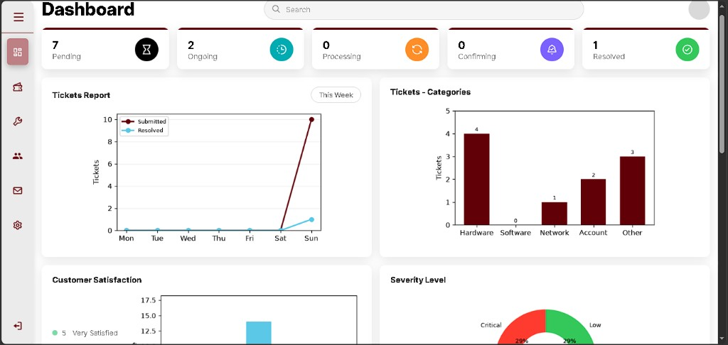
A-066 matplotlib Dashboard - bottom
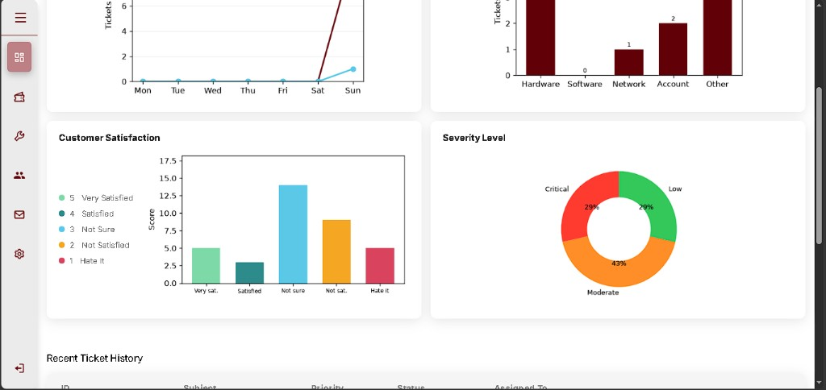

A-067 - Submit ticket auto-priority and auto-assign (V1.6)
- When: 25 September 2026
- Official stage: adviser follow-up after showcase
- Status: done (fixes B-056, B-057)
- What we did: Copied the showcase build into CP2_V1.6 (cookie /CP2_V1.6/). New Ticket no longer shows Priority or Suggest with AI. On Submit, Flask classifies priority (gpt-5.6-luna or keyword fallback; default moderate if the service is down) and the ticket is assigned to the least-busy active technician immediately.
- In plain language: The user only describes the problem and picks a category. The system sets how urgent it is and who will handle it.

A-069 - Priority score and 9-slot borrowing (paper tables 4-7)
- When: 28 September 2026
- Official stage: V1.6, after the revised paper tables
- Status: done (fixes B-059, B-060, B-061)
- What we did: Compared the live queue and classifier with Tables 4, 5, 6, and 7 in ZPGC Capstone Paper REVISED.docx. They did not match. Submit now scores urgency (1-3) × impact (1-3). Table 6 maps the score: 1-2 Low, 3-6 Moderate, 7 and above Critical. Table 5 adds +40 when 30 or more open tickets share the same subject, which forces Critical. The admin queue now selects a batch of at most 9 and gives unused lower slots to the highest severity that still has tickets (Table 7). Checked with tools/check_matrix.php (all cases pass).
- Paper conflict kept on purpose: the Table 4 figure says +30 points. Table 5 text says +40. The code follows Table 5.
- In plain language: A ticket is no longer labeled from one word. The system multiplies how bad it is by how many people it affects, then the queue fills nine seats and lends empty seats upward.

A-070 - Login fatal when MySQL is stopped (B-062)
- When: 28 September 2026
- Status: done
- What we did: Sign-in threw an uncaught mysqli_sql_exception because MySQL was not running. Started MySQL. config.php now turns off mysqli exceptions so a stopped database shows “Connection failed... Start MySQL” instead of a stack trace.
- In plain language: The login page can connect again. If MySQL is off, the page says to start it in XAMPP instead of dumping a fatal error.

A-071 - Score retest #1012 and restore Low self-help (B-063)
- When: 28 September 2026
- Status: done
- What we saw: Submit Changing profile picture / *I don't know how to do it.* Green message: *Ticket #1012 submitted. Priority set to Low (score 1)*. phpMyAdmin: urgency=1, impact_level=1, severity_score=1, priority=low, ai_method=kw-quota. Admin queue 9 / 9, Low 4 / 4 (+1 borrowed) because Critical only used 2 of 3 seats.
- What we fixed after that shot: Low tickets were still assigned immediately, so troubleshooting never appeared. A Low submit now stores tips, stays Pending and unassigned, and the user chooses These steps worked or Still not fixed - Request Technician. Moderate and Critical still assign on submit.
- In plain language: #1012 proved the score and the borrowed seat. Low problems now get steps first; a technician is only called if those steps fail.
Submit form
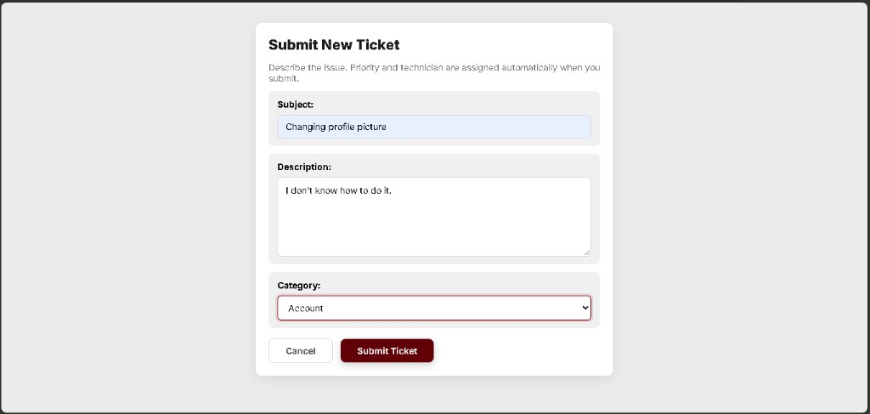
User #1012 score 1
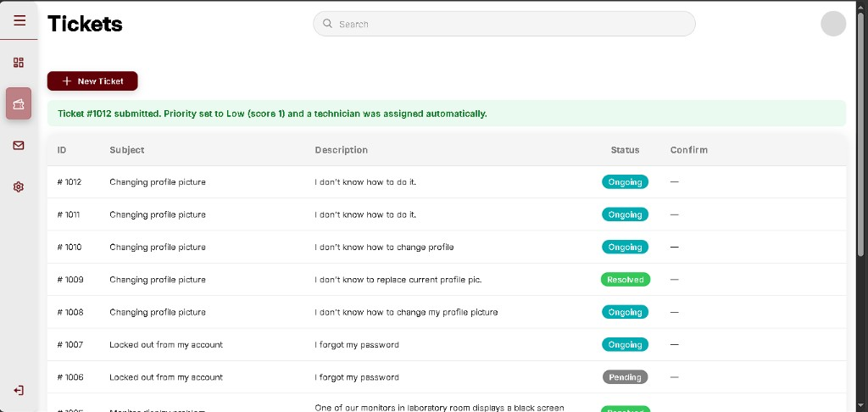
phpMyAdmin score columns
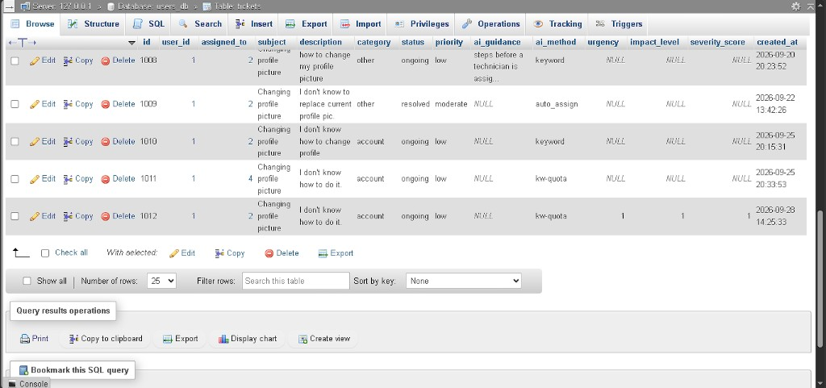
Queue Low borrowed
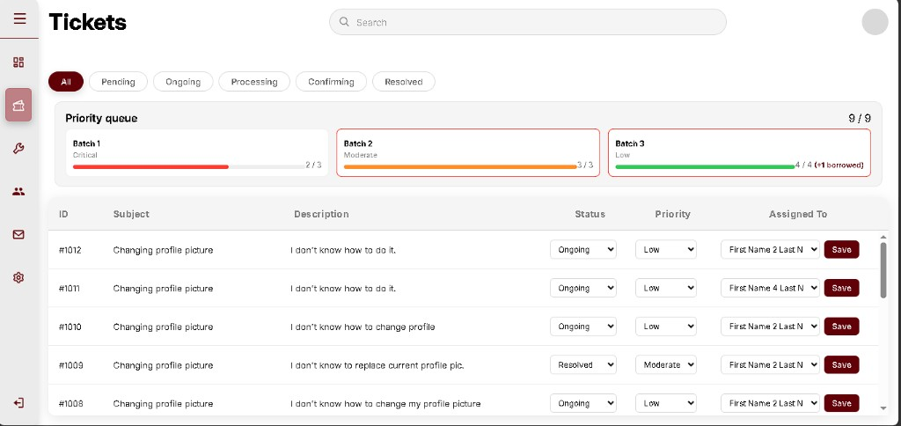

A-072 - Low self-help: steps worked (#1013) and request technician (#1014)
- When: 28 September 2026
- Status: done (B-064 found on the resolved row)
- What we did:
1. Submit Changing profile picture / *I don't know how to change my profile.* -> *Ticket #1013 submitted as Low (score 1). Try the troubleshooting steps first.* Status Pending. Tips opened, with These steps worked and Still not fixed - Request Technician.
2. Clicked These steps worked -> *Ticket #1013 marked resolved from the troubleshooting steps.* Status Resolved.
3. New ticket #1014 *I don't know how to replace my profile.* Same Low tips, then Request Technician -> *Technician assigned to ticket #1014.* Status Ongoing.
- In plain language: A small problem can be closed by the user after the steps, or handed to a technician if the steps fail.
#1013 tips pending
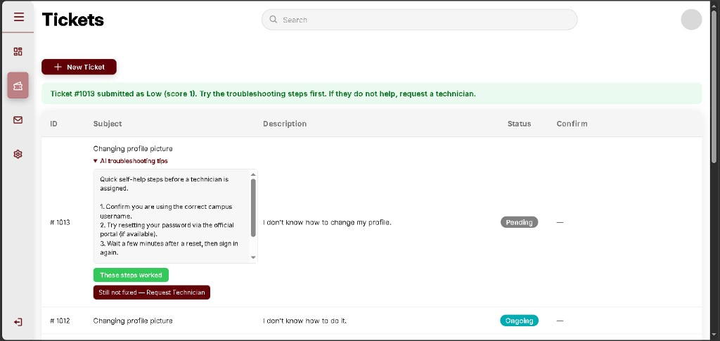
#1013 resolved
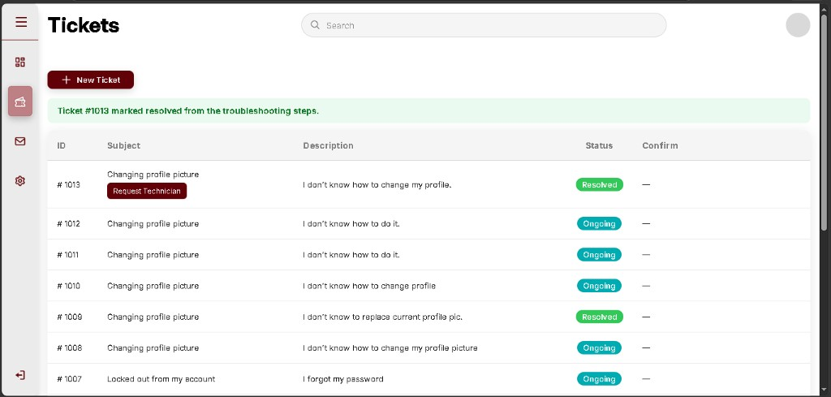
#1014 tips pending
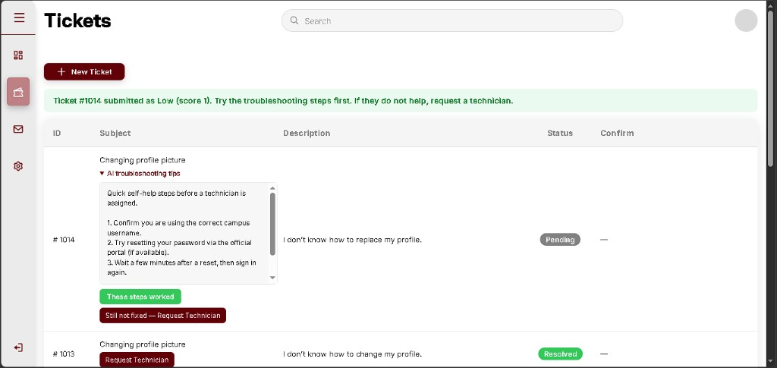
#1014 technician assigned
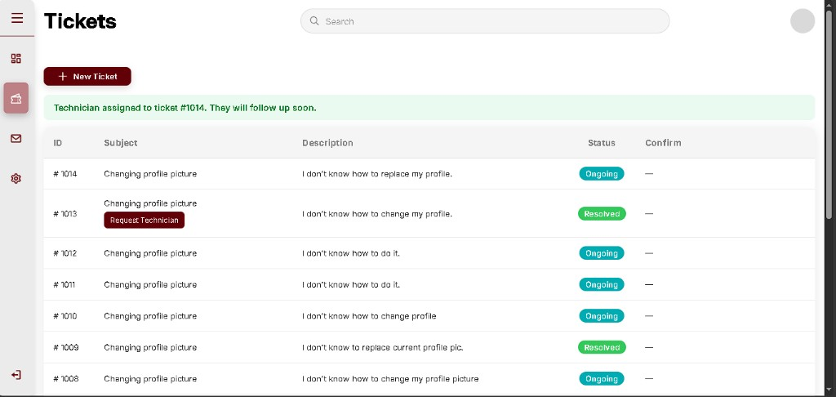

A-073 - Performance uses resolved tickets by category
- When: 30 September 2026
- Status: done (fixes B-065, B-066)
- What we did: Removed Team ID and the Technician Record List. The first table is Resolved by Category (total, Critical, Moderate, Low) from tickets whose status is resolved. The log below lists those same tickets: Category, Ticket ID, Subject, Description, registration time, response time, resolution time, and severity. Response time is registration to first technician assignment. Resolution time is registration to the moment it became resolved. Technician role routing stays out.
- In plain language: Performance now counts real closed tickets for each kind of problem, instead of fake team numbers.
- Retest (30 September 2026): Admin Performance. Resolved by Category shows Hardware 1 Low, Account 1 Low, Other 1 Moderate, Software and Network 0. The log lists #1013 Account Low, #1009 Other Moderate, and #1005 Hardware Low, with real registration dates. Response Time and Resolution Time are - because those tickets were closed before the clocks existed.
Performance category counts
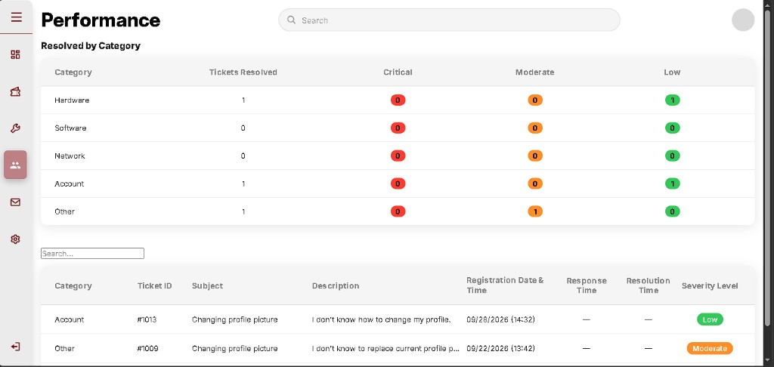
Resolved ticket log
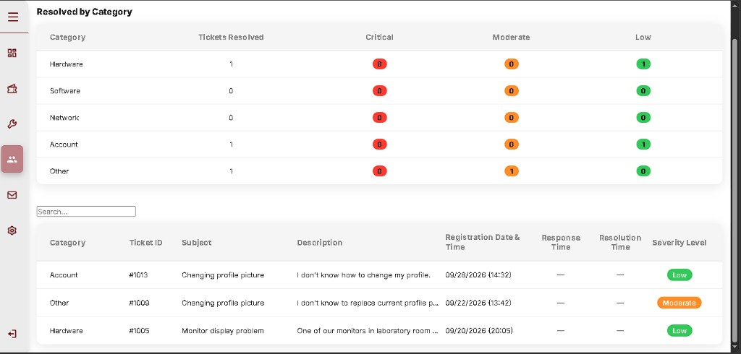

A-074 - Profile circle menu (settings and logout moved)
- When: 1 October 2026
- Status: in progress (B-067-B-069 still open for screenshots)
- What we did: Took Settings and Logout off the left sidebar on user, technician, and admin. The top-right circle opens Profile, Settings, and Logout. Settings still opens the existing settings page. Logout still uses logic/logout.php. Profile can save first name and last name.
- In plain language: The account controls now sit in the circle. Three problems are still on the page on purpose so they can be photographed before the fix.

Issue log
Problems found or introduced. Each entry: what was seen, Causing snippet, mermaid, executed or planned fix. In plain language explains the snippet for readers who do not write PHP every day.

B-001 - Apache 404 on landing; Go Live looked fine
- When: 29 June 2026 (1 day)
- Status: fixed
- What I saw: Go Live showed the welcome page. .../landing_page.php was Not Found.
Apache 404 - landing_page.php
- Cause: File was landing_page.html.
- Causing snippet: disk pages/landing_page.html vs URL landing_page.php.
- In plain language: The editor preview can open .html. The live Apache URL asked for .php, so it said Not Found.
- Solution executed: Rename to landing_page.php.
Rename: pages/landing_page.html -> pages/landing_page.php
[Mermaid diagram - see source .md]

B-002 - Public signup offers Administrator (authentic early UI)
- When: 30 June - 4 July 2026 (same stretch as A-002)
- Status: fixed (A-036, 9 September 2026)
- What I saw: On SIGNUP, the Role list includes User, Administrator, and Technician. A visitor could pick Administrator on the public page. The first real build did this; later versions take Administrator off the public list. Admin accounts should not be self-created from the welcome flow.
- Causing snippet (pages/login_signup.php signup form):
<select name="role" required>
<option value="" disabled selected>Role</option>
<option value="user">User</option>
<option value="admin">Administrator</option>
<option value="techn">Technician</option>
</select>
code (html)
- In plain language: Anyone signing up could claim to be an admin. PHP would store role = admin for that row. The product still has an admin role - it must not stay a public dropdown choice.
- Queued fix: Delete the Administrator <option> from this public form (keep User + Technician). Do not remove the admin role from the database or from admin-only creation paths.
- Solution executed (9 September 2026, A-036): Removed <option value="admin"> from login_signup.php. Handler already allowed only user / techn.
[Mermaid diagram - see source .md]

B-003 - Signup stacked under login
- When: 5-6 July 2026 (2 days)
- Status: fixed
- What I saw: Go Live on login_signup.html. LOGIN typed normally. Signup now! showed SIGNUP under LOGIN instead of replacing it.
Signup form concatenated below LOGIN
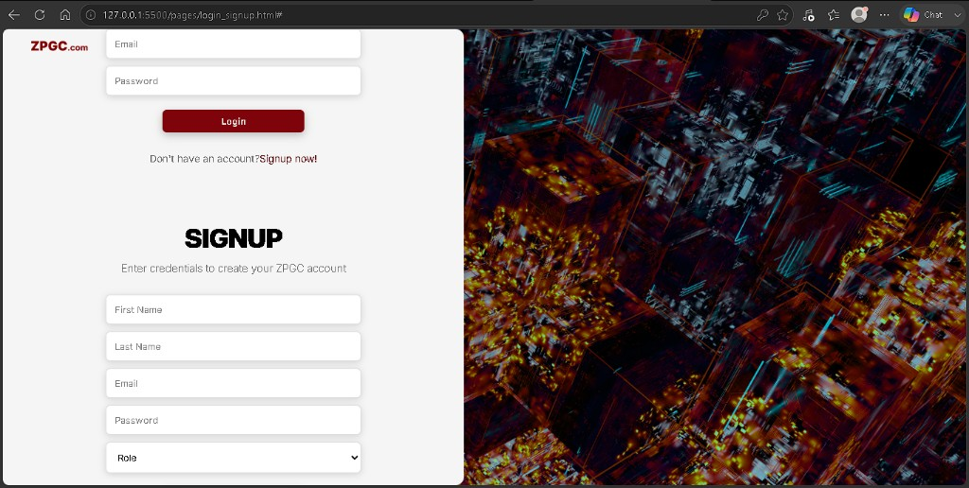
- Cause: JS used .formBox; HTML/CSS use .form-box.
- Causing snippet:
document.querySelectorAll(".formBox")
code (javascript)
- In plain language: The script looked for a class name that the HTML did not use. LOGIN never hid, so SIGNUP appeared underneath it.
- Solution executed:
document.querySelectorAll(".form-box").forEach(function (form) {
form.classList.remove("active");
});
code (javascript)

B-004 - Landing Signup now! opened LOGIN
- When: 9-11 July 2026 (3 days)
- Status: fixed
- Cause: Nothing read ?form=signup.
- Causing snippet: landing link login_signup.php?form=signup with no matching URLSearchParams code yet.
- In plain language: The Signup now! button added extra text to the URL. The page ignored it, so it always showed LOGIN.
- Solution executed:
window.addEventListener("DOMContentLoaded", function (form) {
var params = new URLSearchParams(window.location.search);
if (params.get("form") === "signup") {
showForm("signup-form");
}
})
code (javascript)

B-005 - `connection_error` vs `connect_error` (latent)
- When: 22 July 2026 (found on connect test)
- Status: open (page still printed Connected because MySQL was up)
- What I saw: Browser showed Connected to users_db.
- Cause: Success path never uses the die() line. The property on mysqli is connect_error. connection_error is empty, so a failed connect would die with a blank reason.
- Exact causing snippet:
die("Connection failed: " . $conn->connection_error);
code (php)
- In plain language: If MySQL is running, you never see this line. If MySQL is down, PHP should print why. The property name is misspelled, so the reason would be blank. Not fixed yet.
- Queued fix: $conn->connect_error in both the if and the die string.
[Mermaid diagram - see source .md]

B-006 - Stylesheet looked missing on first landing pass
- When: 28 June 2026 (1 extra day inside A-001)
- Status: fixed (simulated delay: wrong relative path, then ../css/landing_page.css)
- What I saw: Raw HTML, no maroon bar, until the link href went up one folder into css/.
- Causing snippet: href pointed at css/... from pages/ without ../.
- In plain language: The style file lives one folder up from the page. Without ../, the browser never found the maroon CSS.

B-007 - Logo link still used `.html` after rename to `.php`
- When: 12-13 July 2026 (inside A-005)
- Status: fixed
- What I saw: After landing_page.php / login_signup.php existed, the ZPGC logo on login/signup could still point at landing_page.html. On Apache that old name is Not Found (same class of bug as B-001).
- Causing snippet (pages/login_signup.php logo):
<a href="../pages/landing_page.html">
code (html)
- In plain language: The files were renamed to .php, but the logo link still asked for .html. Apache treats those as different filenames.
- Solution executed:
<a href="../pages/landing_page.php">
code (html)
[Mermaid diagram - see source .md]

B-008 - `config.php` 404 until it lived in `logic/`
- When: 21 July 2026 (1 day inside A-007)
- Status: fixed
- What I saw: .../pages/config.php Not Found. File belongs in logic/config.php.
- Causing snippet: URL pages/config.php while the file is logic/config.php.
- In plain language: Connection code lives with the other PHP handlers, not next to the HTML pages. The wrong folder in the address bar is Not Found.

B-009 - Signup submit: Apache 404
- When: 23 July 2026 (1 day, Stage 2)
- Status: fixed
- What I saw: Filled signup (User) and submitted. Browser showed Not Found.
Apache 404 on signup POST
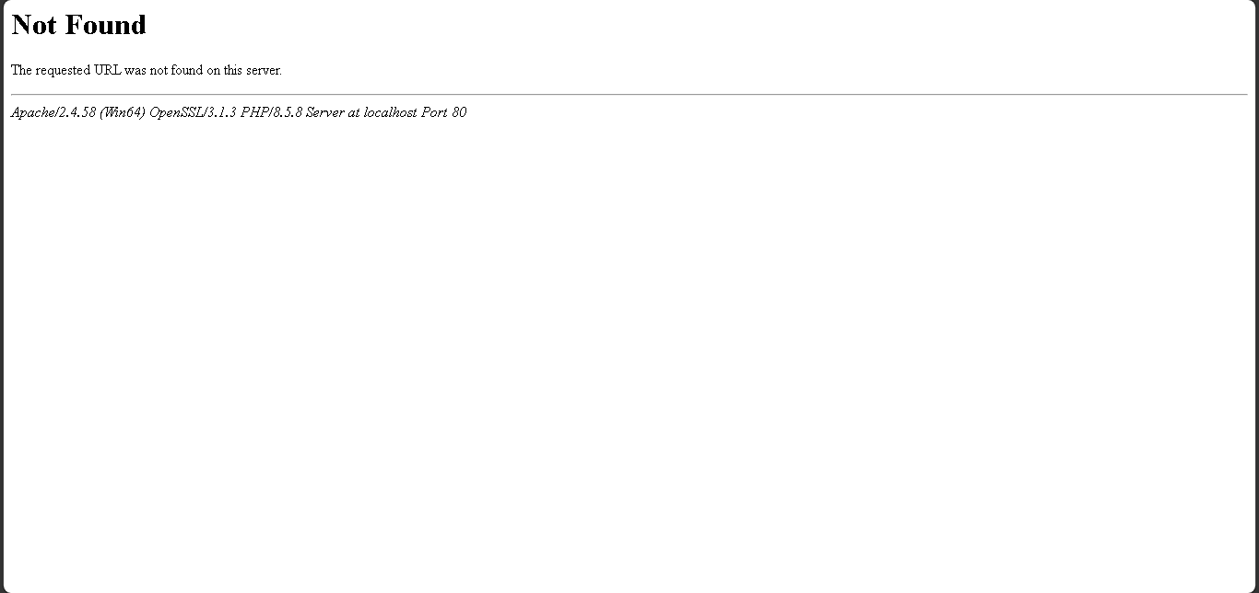
- Cause: Form action is user_mngmnt.php (underscore). Disk had logic/user.mngmnt.php (dot).
- Causing snippet: form action=".../user_mngmnt.php" vs filename user.mngmnt.php.
- In plain language: Submit posts to a filename with an underscore. The file on disk used a dot. Apache could not find it (404).
- Solution executed: Renamed to logic/user_mngmnt.php. Both forms method="post". Signup then inserted a row (A-008).
[Mermaid diagram - see source .md]

B-010 - `session_start()` missing semicolon (syntax errors)
- When: 25 July 2026 (Stage 2 login)
- Status: fixed
- What I saw: user_mngmnt.php - unexpected token require_once. login_signup.php - unexpected variable $login_error.
- Cause: session_start() had no ;.
- Causing snippet:
session_start()
code (php)
- In plain language: PHP needs a semicolon at the end of that line. Without it, the next lines look like a syntax error and login never runs.
- Solution executed:
session_start();
code (php)
Login tests recorded as A-009.

B-011 - Apache 404 on `user.php`
- When: 7 August 2026
- Status: fixed
- What I saw: http://localhost/CP2_v1.1/pages/user.php Not Found. Same 404 after switching the folder to CP2_V1.1. After rename, the URL loaded.
404 - folder casing `CP2_v1.1`
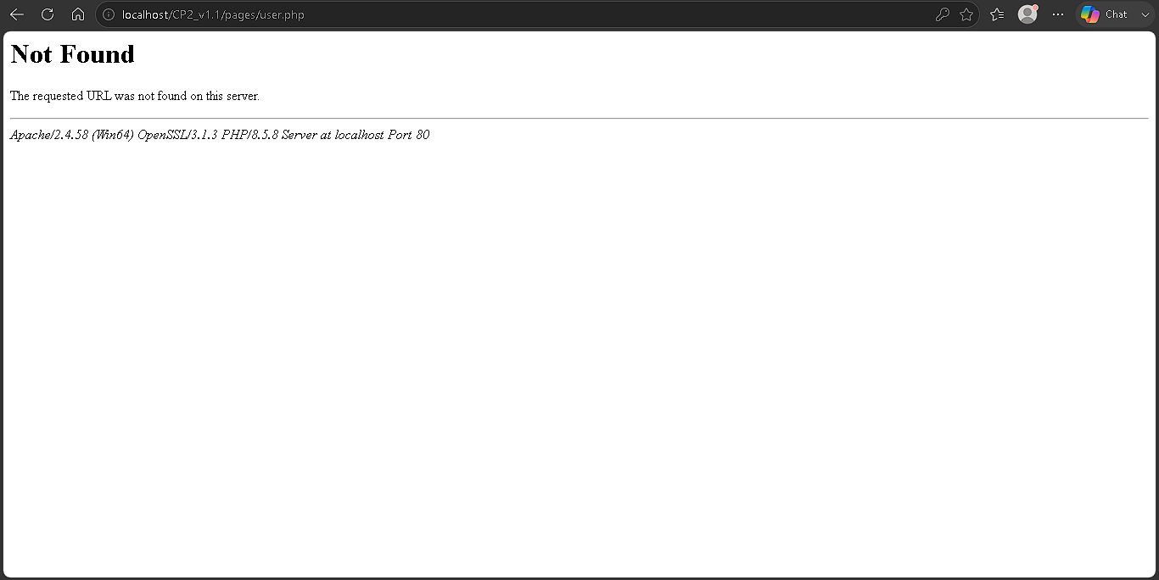
404 - `CP2_V1.1` URL, file still `users.php`
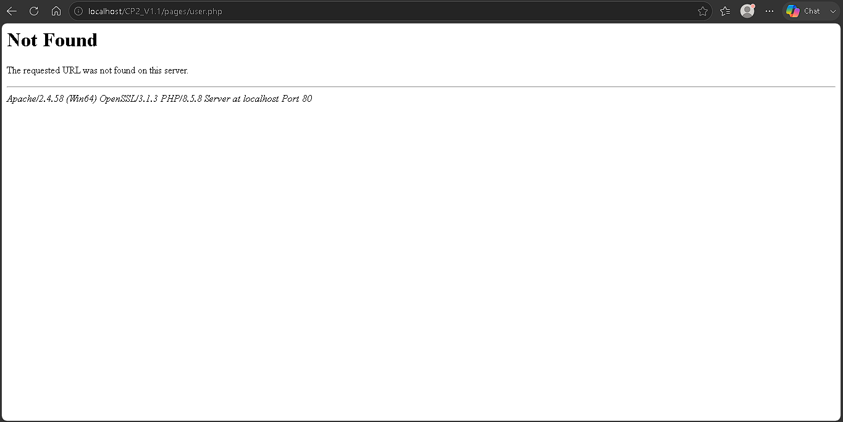
- Cause: File was users.php. URL is user.php.
- Causing snippet: disk pages/users.php vs URL pages/user.php.
- In plain language: The address bar asked for user.php. The file was named users.php. Apache treats those as different names.
- Solution executed: Renamed pages/users.php -> pages/user.php.

B-012 - Dashboard chrome: CSS layout not applied (`main_wrap`)
- When: 7 August 2026
- Status: fixed
- What I saw: user.php loaded; logo, Dashboard icon, and h1 stacked in the top-left on white. No grey sidebar until the class matched CSS.
Unstyled stack before `main-wrap`
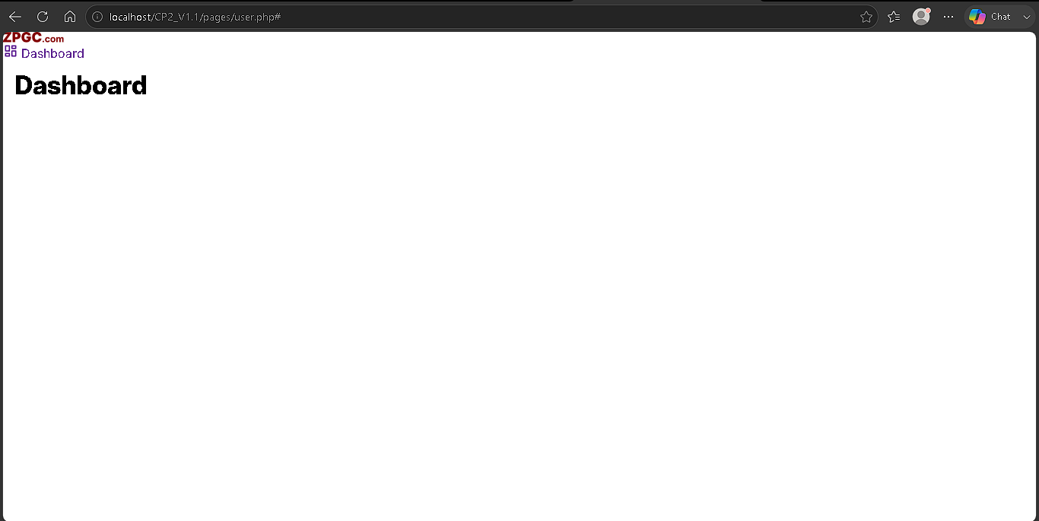
- Cause: class="main_wrap" vs CSS .main-wrap.
- Causing snippet:
<main class="main_wrap">
code (html)
- In plain language: CSS styles the name with a hyphen. The HTML used an underscore, so the grey sidebar rules never applied.
- Solution executed:
<main class="main-wrap">
code (html)
- After fix: Grey sidebar, logo, rose Dashboard control. Main area still mostly empty (search and extra nav not typed yet). Dashboard at sidebar bottom is :last-child until Logout is added. After-fix capture is on A-010.

B-013 - Settings label under the gear (not beside it)
- When: 8 August 2026 (A-011 reload)
- Status: fixed
- What I saw: Tickets, Mailbox, and Logout keep icon + text on one row. Settings puts the word under the gear.
Settings text under the icon
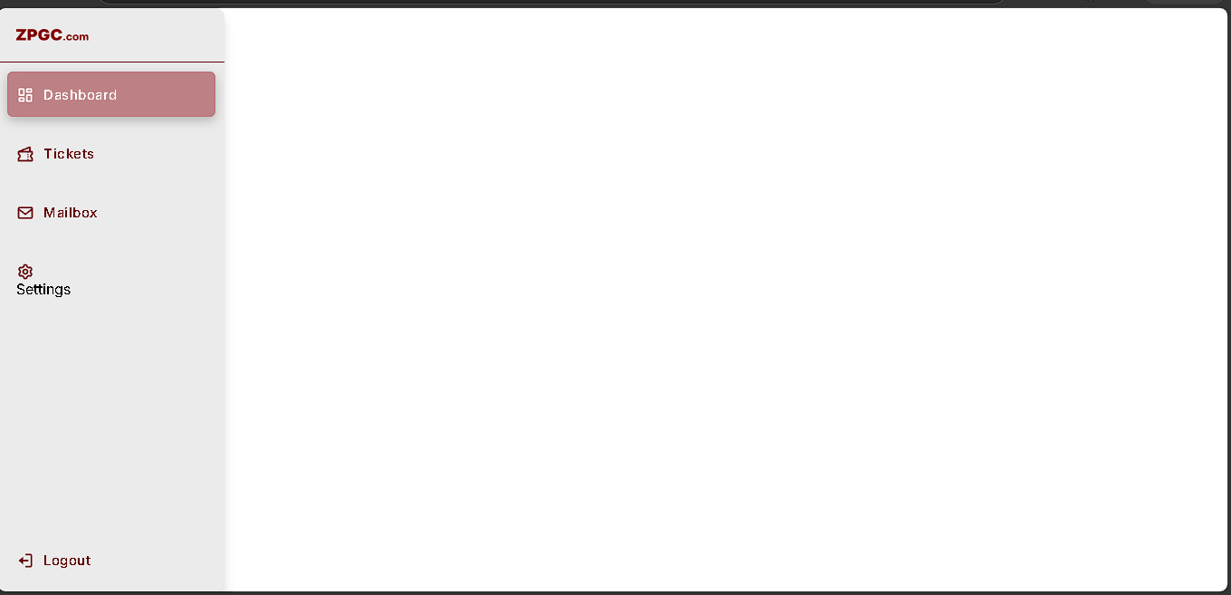
- Cause: .nav-link is display: flex (icon and .link-text on one row). Settings closed </a> before the <span>. The span is a sibling of the link, so it is not in that flex row.
- Tried (does not fix layout): id="settings" on the span. id names the element for later JS; main_interface.css has no #settings rule that changes display. Label still under the gear.
After adding id="settings" only - still wrapped
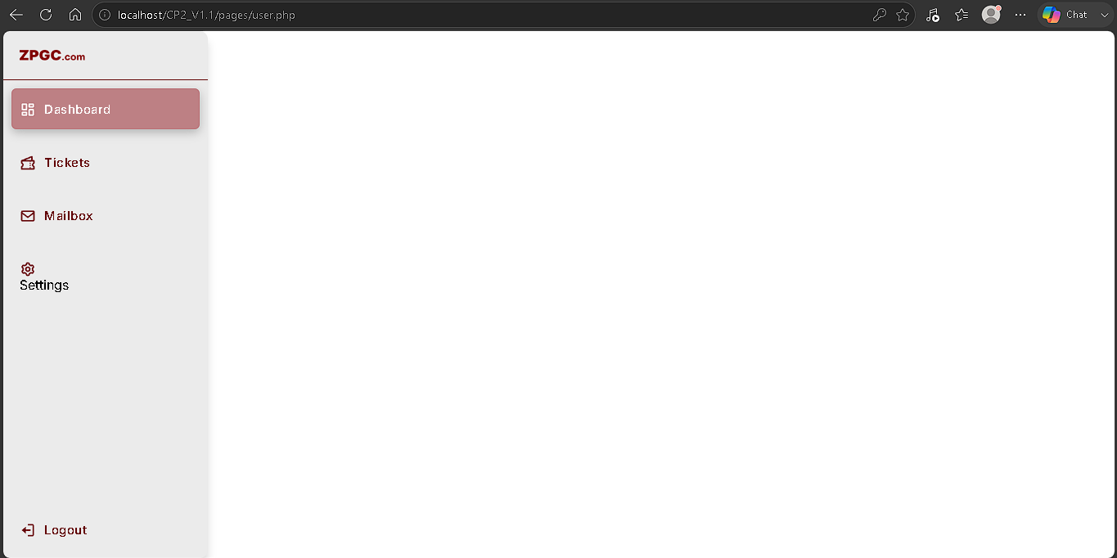
- Exact causing snippet (pages/user.php after that try):
</svg>
</a>
<span class="link-text" id="settings">Settings</span>
code (html)
- In plain language: The word Settings sat outside the clickable row. Flex layout only lines up children inside that row, so the word wrapped under the gear.
- Queued fix: Move the span inside .nav-link, after </svg>, same as Tickets/Mailbox. Keep id="settings".
<span class="link-text" id="settings">Settings</span>
</a>
code (html)
- Solution executed: Span is a child of .nav-link, immediately after </svg> (same order as Tickets/Mailbox). Note: “before the svg” would put the word to the left of the gear; the file on disk is svg then span.
</svg>
<span class="link-text" id="settings">Settings</span>
</a>
code (html)
Settings on one row with the gear
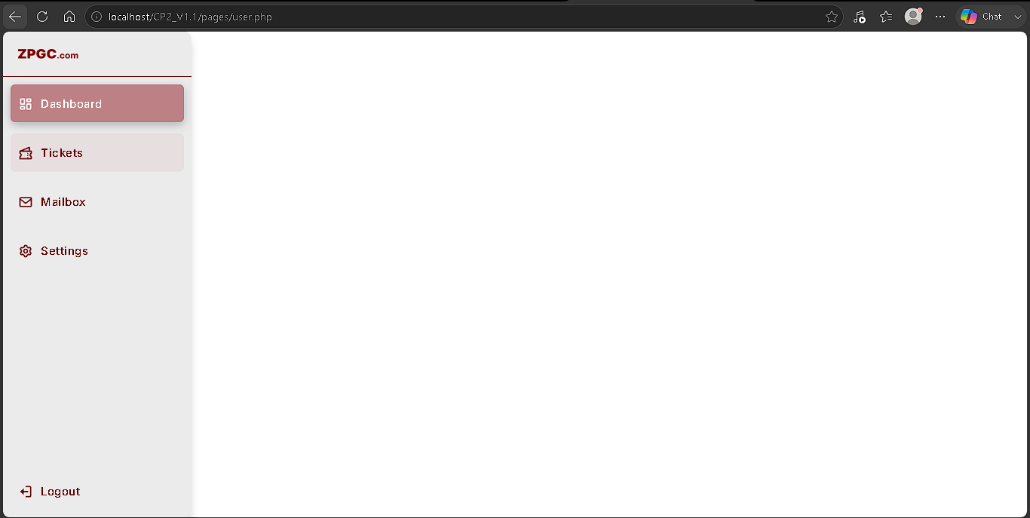
[Mermaid diagram - see source .md]

B-014 - Apache 404 on `admin.php`
- When: 11 August 2026 (A-014)
- Status: fixed
- What I saw: http://localhost/CP2_v1.1/pages/admin.php - Apache Not Found. user.php and techn.php loaded.
Apache 404 - pages/admin.php
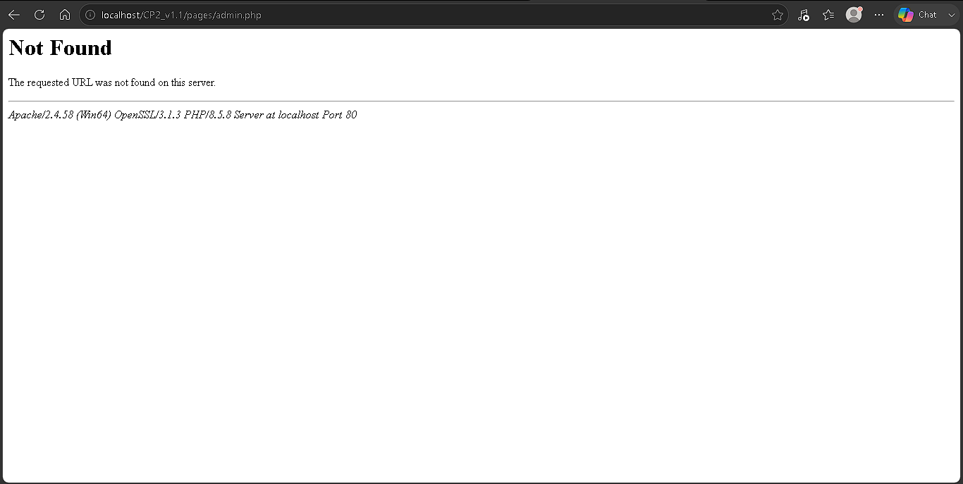
- Cause: The dashboard HTML lives at logic/admin.php. Apache asked for pages/admin.php. Same class of mismatch as B-008 (config.php in the wrong folder) and B-011 (users.php vs user.php). Folder casing CP2_v1.1 vs CP2_V1.1 is not why this 404 happened: pages/ has no admin.php.
- Exact causing location:
logic/admin.php <- file on disk
pages/admin.php <- URL
- In plain language: The browser asked for a file in pages/. The HTML was saved under logic/. Wrong folder = Not Found.
- Queued fix: Move (or save a copy as) pages/admin.php. Do not keep the role dashboard under logic/ (logic/ is for PHP handlers like user_mngmnt.php). After the move, use http://localhost/CP2_V1.1/pages/admin.php.
- Solution executed: File is now pages/admin.php. logic/admin.php is gone. Prefer URL casing CP2_V1.1 (cookie path later). Attached capture after the move still shows the old 404 URL; on disk the page is in pages/.
URL they used after the move
[Mermaid diagram - see source .md]

B-015 - Analytics label under the icon (`admin.php`)
- When: 11 August 2026 (A-015)
- Status: fixed
- What I saw: Admin page loads. Analytics text sits under the bar-chart icon (same layout as Settings on B-013).
- Cause: .nav-link is display: flex. Analytics closed </a> before the <span>, so the span is not a flex child.
- Exact causing snippet (pages/admin.php):
<li class="nav-list-item" data-nav="analytics">
<a href="#" class="nav-link">
<svg xmlns="http://www.w3.org/2000/svg" width="24" height="24" fill="currentColor"
viewBox="0 0 24 24">
<path d="M4 2H2v19c0 .55.45 1 1 1h19v-2H4z"></path>
<path d="M17 12h2v6h-2zm-5-8h2v14h-2zM7 9h2v9H7z"></path>
</svg>
</a>
<span class="link-text">Analytics</span>
</li>
code (html)
- In plain language: Same as Settings (B-013): the label was outside the link, so it sat under the icon.
- Queued fix: Same as B-013 - span inside .nav-link after </svg>:
</svg>
<span class="link-text">Analytics</span>
</a>
code (html)
- Solution executed: Span is inside .nav-link after </svg> (pages/admin.php).
- Still leftover: Utilities <li> still has data-nav="tickets". Change to data-nav="utilities" on the next pass.
[Mermaid diagram - see source .md]

B-016 - Mailbox / Settings top bar unstyled (`<head>` vs `<header>`)
- When: 12 August 2026 (A-016)
- Status: fixed
- What I saw: Dashboard and Tickets used the pill search and profile circle. Mailbox and Settings showed a stacked h1, a small magnifying-glass, and a raw Search box (no pill, no circle). Sidebar still collapsed.
Mailbox - unstyled search
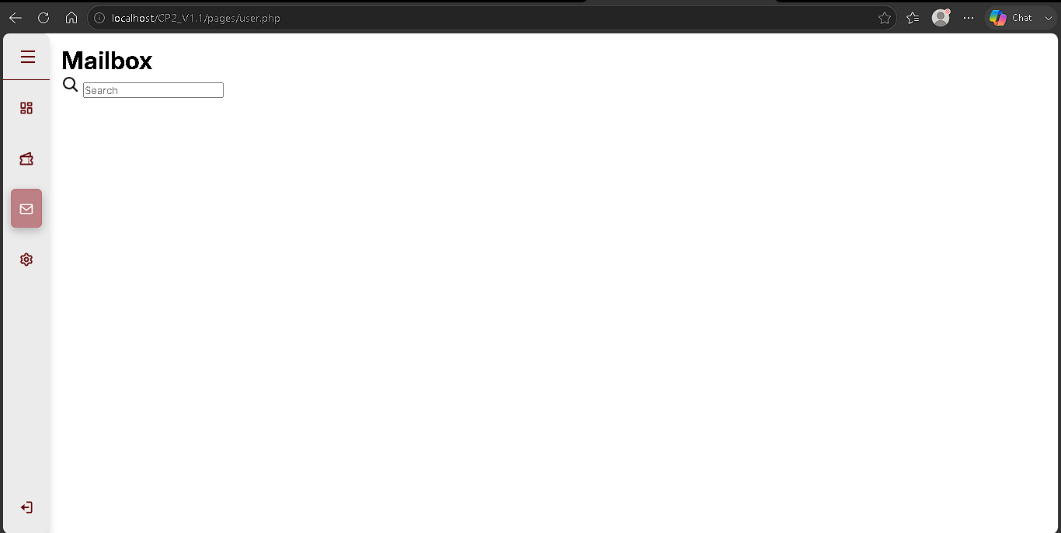
Settings - unstyled search
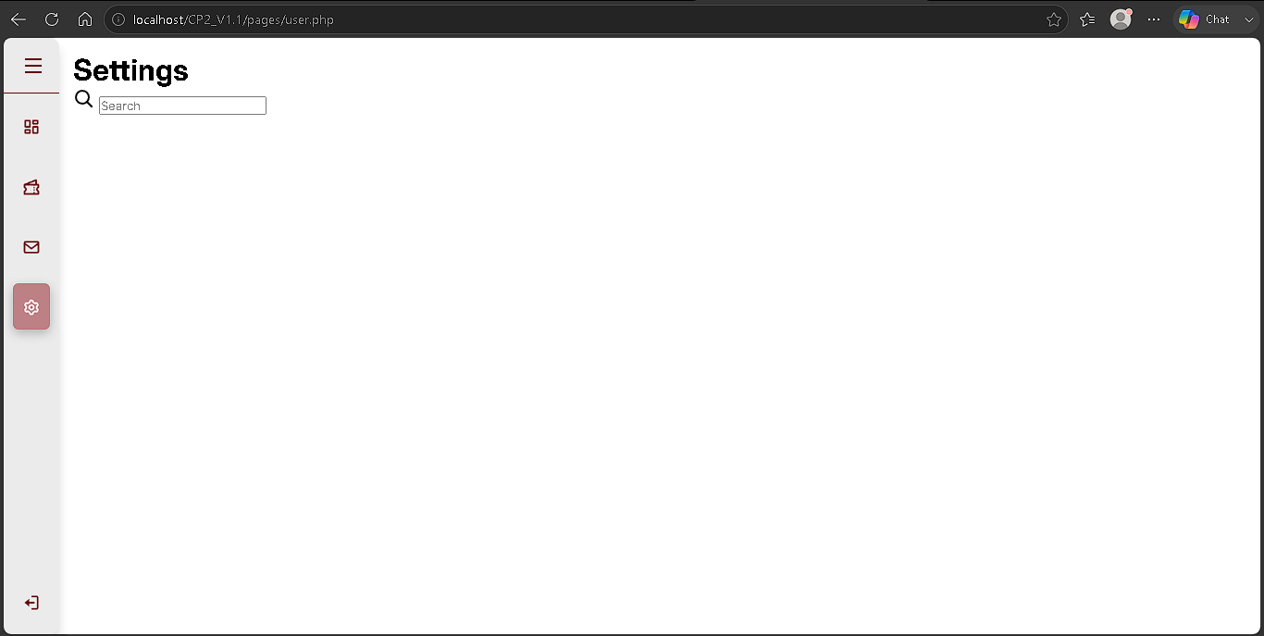
- Cause: Showcase CSS is .showcase .head header (class head on the wrapper, then a `<header>` element). Mailbox and Settings used `<head>` inside .head. <head> is the document-head tag, not the top bar. The header selector did not match, so search/profile rules did not apply. The browser may also move a nested <head> out of .showcase.
- Exact causing snippet:
<div class="head">
<head>
<h1>Mailbox</h1>
code (html)
- In plain language: CSS styles a <header> inside the top bar. Mailbox used <head>, which is the tag for the document title area, so the search pill never applied.
- Solution executed: Same inner tag as Dashboard/Tickets:
<div class="head">
<header>
<h1>Mailbox</h1>
...
</header>
</div>
code (html)
Same for Settings. Do not change main_interface.css for this.
[Mermaid diagram - see source .md]

B-017 - New Ticket shows on Dashboard
- When: 13 August 2026 (A-017)
- Status: fixed
- What I saw: user.php with Dashboard selected and h1 Dashboard. Maroon New Ticket still appears in the white area.
New Ticket on Dashboard
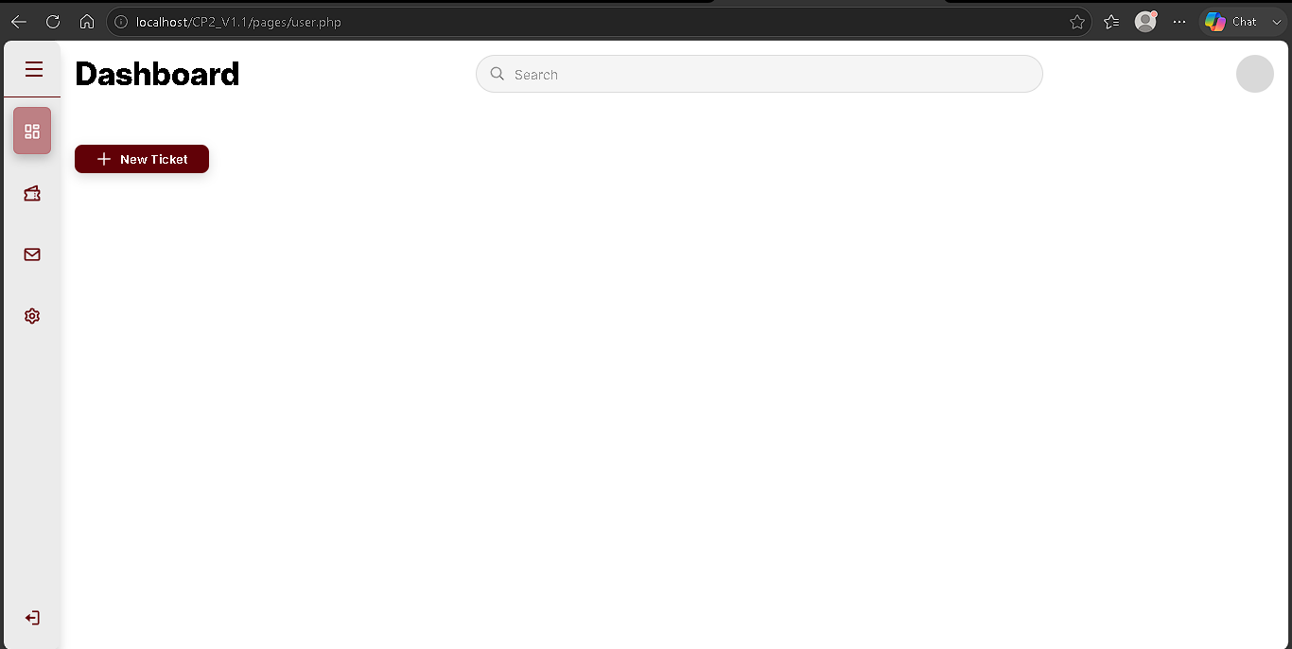
- Cause: .page-content is display: none except the matching #page-.... The toolbar was placed after #page-tickets closed, as a direct child of .showcase. It is not inside a .page-content, so it is never hidden.
- Exact causing snippet (pages/user.php):
</div>
<div class="tickets-toolbar">
<a href="../pages/ticket.php" class="btn-new-ticket">
code (html)
The </div> above ends #page-tickets. The toolbar is the next sibling.
- In plain language: Hidden panels only hide what is inside them. New Ticket sat outside the Tickets panel, so it stayed visible on Dashboard too.
- Queued fix: Move .tickets-toolbar inside #page-tickets, after the Tickets .head, before that page-content </div>. Do not change CSS.
- Solution executed: Toolbar is a child of #page-tickets (after .head, before that </div>). Mailbox #page-messages follows.
</div>
<div class="tickets-toolbar">
<a href="../pages/ticket.php" class="btn-new-ticket">
code (html)
[Mermaid diagram - see source .md]

B-018 - Submit Ticket: white page, not Apache 404
- When: 14 August 2026 (A-018)
- Status: fixed (A-019: header to user.php)
- What I saw: After submit, URL is http://localhost/CP2_V1.1/logic/ticket_mngmnt.php. The viewport is blank white. Not “Not Found”.
Blank ticket_mngmnt.php
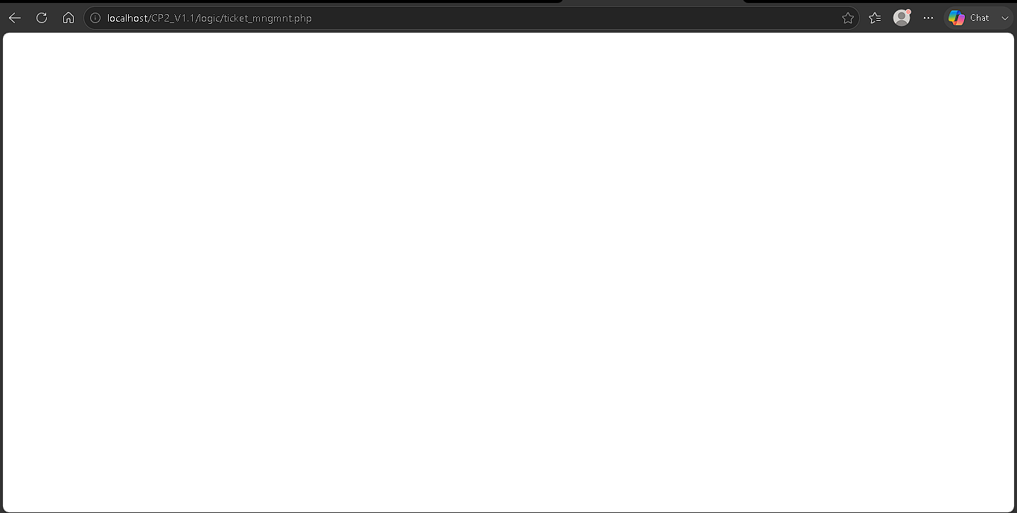
- Cause: Apache found the file. A missing URL would be 404. logic/ticket_mngmnt.php exists and is empty. PHP runs, prints nothing, so the browser shows a white page.
- Causing snippet: empty logic/ticket_mngmnt.php (no header, no HTML).
- In plain language: The address was correct, so this is not a 404. An empty PHP file has nothing to show, so the screen is white.
- Queued: Leave the file. Next lesson types PHP in it (then INSERT). Do not treat this as a CSS failure.
- Solution executed: ticket_mngmnt.php now runs header('Location: ../pages/user.php') on submit-ticket (A-019). White page gone. Still no INSERT.
[Mermaid diagram - see source .md]

B-019 - #1064 saving table `tickets`
- When: 17 August 2026 (A-021)
- Status: fixed
- What I saw: phpMyAdmin create-table form for tickets in users_db. Save showed MariaDB:
#1064 - You have an error in your SQL syntax; check the manual that corresponds to your MariaDB server version for the right syntax to use near 'network', 'other') NOT NULL , `status` ENUM('pending') NOT NULL DEFAULT 'pend...' at line 1
No tickets table in the left list (only users).
phpMyAdmin #1064 saving table tickets
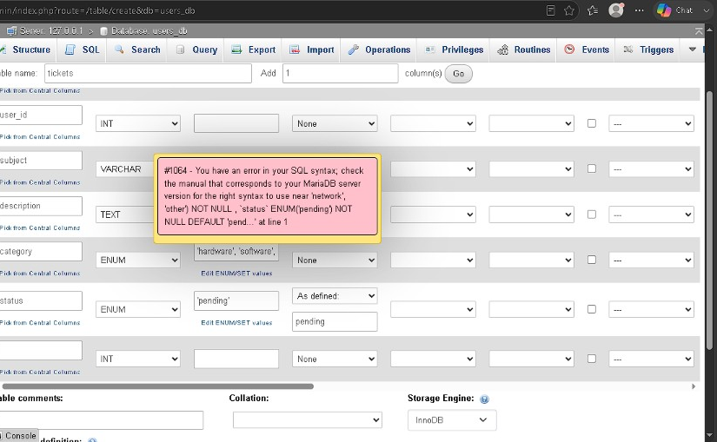
- Cause: phpMyAdmin builds CREATE TABLE from the designer. MariaDB rejected it at 'network', 'other'). That token sits in the category ENUM. Usual cause: a missing or extra ' in Length/Values for category (often around account), so the ENUM string is invalid before 'network'. An unnamed extra INT row can also make invalid SQL after status.
- Same Save attempt also had: no id PRIMARY A_I; subject VARCHAR with blank length; leftover blank column row.
- Causing snippet (designer Length/Values for `category`): a broken ENUM string that MariaDB reported near 'network', 'other').
- In plain language: phpMyAdmin turns the grid into SQL. If the category list is missing a quote, MySQL rejects the whole Save and the table is not created.
- Queued fix: Dismiss the error. Keep table name tickets. Six named columns only. category Length/Values exactly 'hardware','software','account','network','other' (straight quotes, every value quoted, commas between). Then Save again.
- Solution executed: Second Save. Table tickets exists. Structure matches A-021.
[Mermaid diagram - see source .md]

B-020 - Submit Ticket opens LOGIN; no `tickets` row
- When: 18 August 2026 (A-022)
- Status: fixed
- What I saw: http://localhost/CP2_V1.1.2/pages/ticket.php with Hardware / subject / description. Submit Ticket. URL became login_signup.php (LOGIN form). tickets Browse unchanged (empty).
Filled ticket form before submit
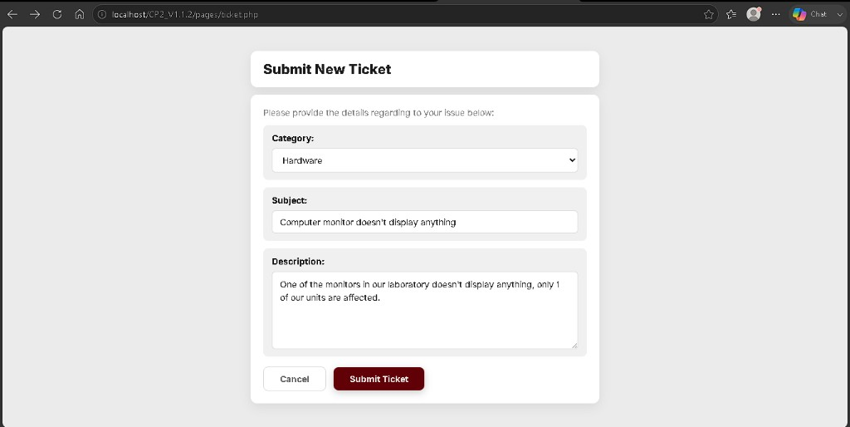
LOGIN after submit
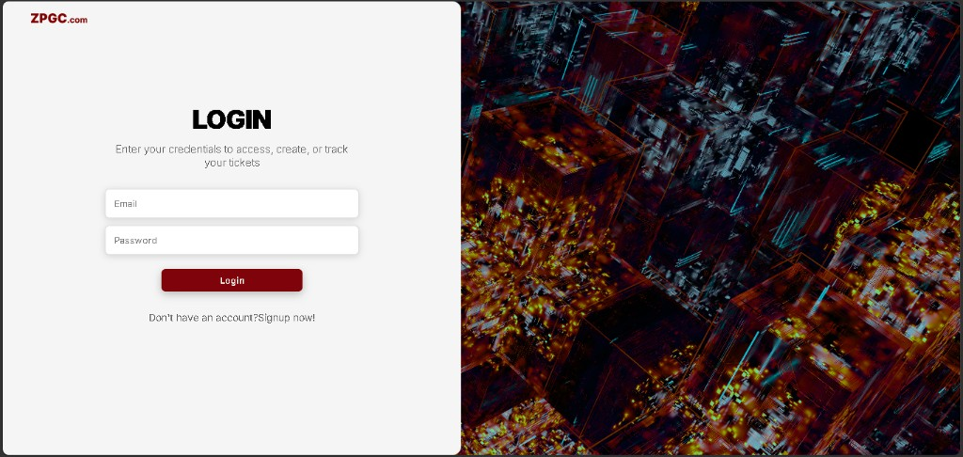
- Cause: Guard uses $_POST['email']. ticket.php has no name="email" field, so that key is never in POST. The header to login_signup.php runs every submit. INSERT never runs. Login stores email on $_SESSION['email'], not POST.
- Exact causing snippet (logic/ticket_mngmnt.php):
if (!isset($_POST['email'])) {
header('Location: ../pages/login_signup.php');
exit();
}
$email = $_SESSION['email'];
code (php)
- In plain language: The ticket form never sends an email box. The code asked POST for email anyway, so the check always failed and sent you to LOGIN. The INSERT never ran. Email after login lives in the session.
- Queued fix: Same if, but isset($_SESSION['email']). Do not add an email input on ticket.php. Then log in as an active user before submitting again.
- Solution executed: Guard is isset($_SESSION['email']). After B-021, Submit Ticket -> dashboard and a tickets row.
[Mermaid diagram - see source .md]

B-021 - Login `user1@gmail.com`: account not activated
- When: 18 August 2026 (A-023)
- Status: fixed (A-023 phpMyAdmin test row; ongoing approval via A-028 Activate)
- What I saw: http://localhost/CP2_V1.1.2/pages/login_signup.php. Email user1@gmail.com. After Login, gray text Account is not activated yet. Could not reach the dashboard to test tickets.
LOGIN: Account is not activated yet
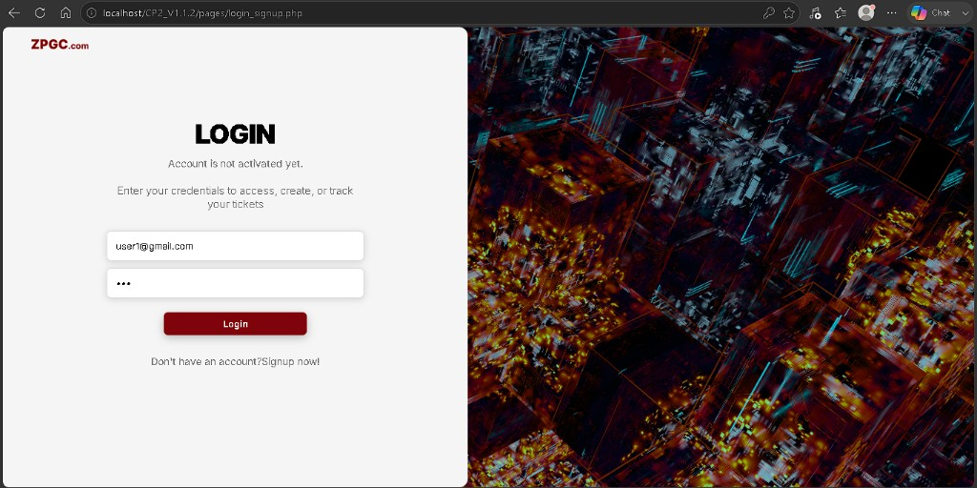
- Cause: Signup INSERT sets users.status to inactive (A-008). user_mngmnt.php refuses login unless status === 'active'. At the time of this test there was no Activate on Utilities yet (A-028).
- Exact causing snippet (logic/user_mngmnt.php):
if ($user['status'] !== 'active') {
$_SESSION['login_error'] = 'Account is not activated yet.';
header('Location: ../pages/login_signup.php');
exit();
}
code (php)
- In plain language: This is not a crash. Signup stores accounts as inactive on purpose. Login shows that message until status is active. For the first ticket test, phpMyAdmin flipped one row (A-023). After A-028, admins use Activate on Utilities instead.
- Queued fix (test only, A-023): phpMyAdmin -> users_db -> users -> Browse -> that row -> Change status from inactive to active. Save. Login again. Do not remove this check in PHP.
- Solution executed: user1@gmail.com set to active in phpMyAdmin for A-023. Login reached dashboard; ticket INSERT confirmed (A-022). user_mngmnt.php still requires active. A-028 adds Utilities Activate so new pending signups no longer need phpMyAdmin.
[Mermaid diagram - see source .md]

B-022 - Admin `h1` stays Dashboard
- When: 20 August 2026 (A-024)
- Status: fixed
- What I saw: Captures labeled localhost/CP2_v1.1/pages/admin.php. Utilities / Analytics / Mailbox / Settings highlighted. h1 still Dashboard.
Utilities selected, h1 Dashboard
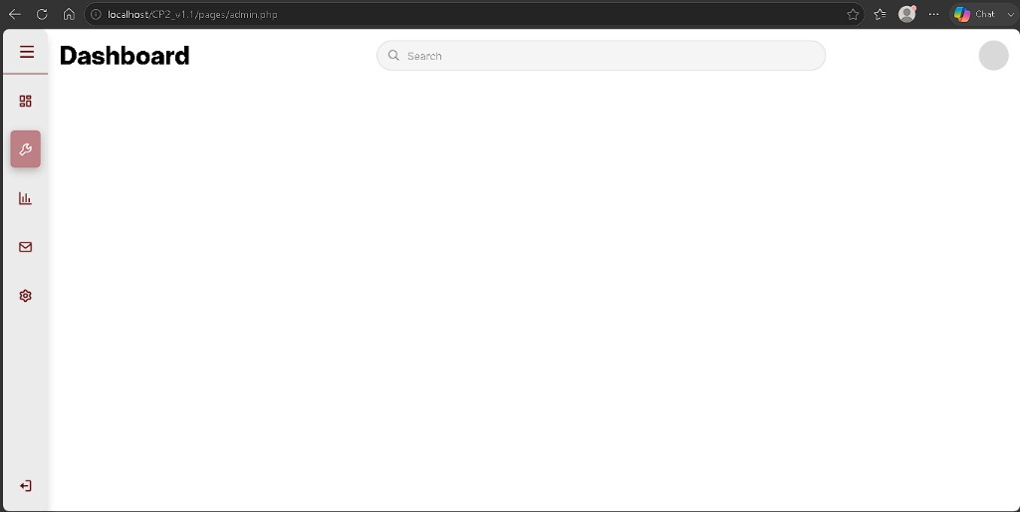
Analytics selected, h1 Dashboard
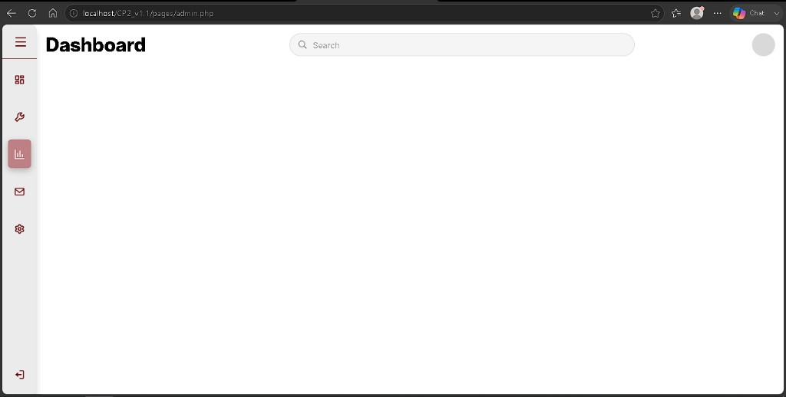
Mailbox selected, h1 Dashboard
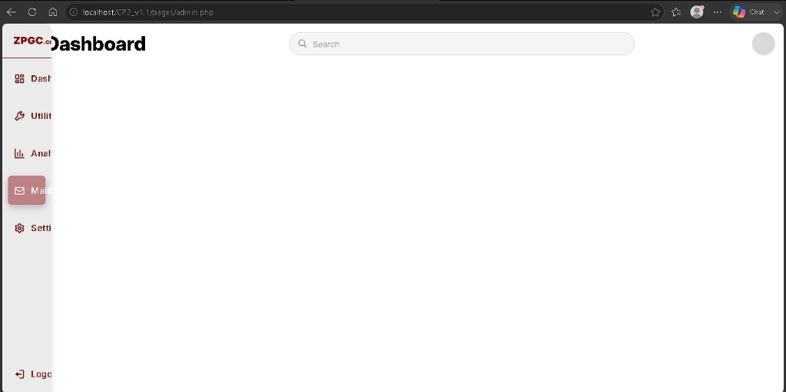
Settings selected, h1 Dashboard
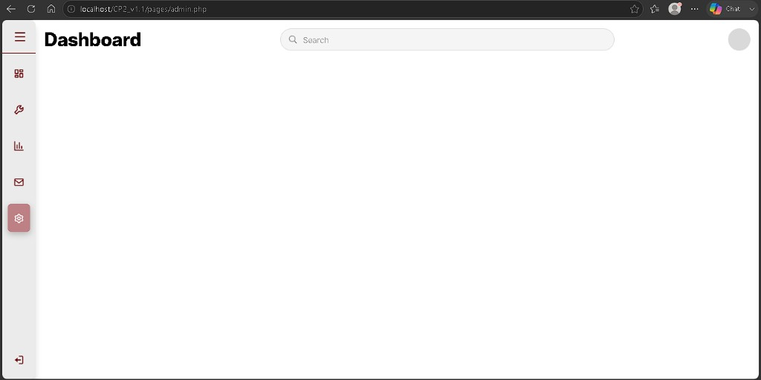
- Cause (two parts): (1) That URL is the v1.1 folder (CP2_v1.1 / CP2_V1.1), not CP2_V1.1.2. v1.1 admin.php has no .page-content panels. (2) In this folder, Dashboard h1 is not inside .page-content. id="page-dashboard" was put on <section class="showcase">. CSS only hides .page-content. The Dashboard bar never hides.
- Causing snippet (pages/admin.php in this folder):
<section class="showcase" id="page-dashboard">
<div class="head">
<header>
<h1>Dashboard</h1>
code (html)
- In plain language: The word Dashboard sits on the outer box, not in a hideable panel. Other titles can exist underneath, but you still see Dashboard. Also, testing /CP2_v1.1/ opens the old folder from A-020.
- Queued fix: Use http://localhost/CP2_V1.1.2/pages/admin.php. Change the section to <section class="showcase"> (no id). Wrap the Dashboard .head in <div class="page-content" id="page-dashboard"> like user.php. Do not nest other #page-* inside #page-dashboard. Do not put .showcase inside .sidebar-spacer.
- Solution executed: Sibling .page-content blocks; empty <div class="sidebar-spacer"></div> then <section class="showcase">. Click Utilities -> h1 Utilities (same for Analytics, Mailbox, Settings).
[Mermaid diagram - see source .md]

B-023 - Login error looks like gray helper text
- When: 22 August 2026 (A-026; seen earlier on A-009 / B-021)
- Status: fixed
- What I saw: http://localhost/CP2_V1.1.2/pages/login_signup.php. After a failed login (wrong password or inactive account), the message under LOGIN was small gray text - same look as “Don’t have an account?” - not an obvious error banner like the reference system.
LOGIN: Account is not activated yet - gray text
- Cause: The error was printed as a plain <p>. login_signup.css styles every p as muted gray (#787777, 14px). There was no .form-error class or alert box. The closing tag was also wrong (<p> instead of </p>).
- Causing snippet (pages/login_signup.php):
<?php if ($login_error !== '') {echo '<p>' . htmlspecialchars($login_error) . '<p>'; } ?>
code (php)
p {
color: #787777;
font-size: 14px;
}
code (css)
- In plain language: The page did show the right words, but they looked like normal hint text under the form, not a warning. Gray paragraph styling and a bare <p> tag hid the fact that login failed.
- Queued fix: Add .form-error in login_signup.css, showError() in login_signup.php, and <?php echo showError($login_error); ?> under LOGIN. Do not change user_mngmnt.php login rules (A-009).
- Solution executed: A-026 - pink .form-error banner; showError() wraps the message in a styled <div>.
[Mermaid diagram - see source .md]

B-024 - Utilities user list: plain table, misaligned columns
- When: 23 August 2026 (A-025; fixed A-027)
- Status: fixed
- What I saw: http://localhost/CP2_V1.1.2/pages/admin.php -> Utilities. User rows appeared, but as a raw HTML <table>: no white card, no column alignment, role and status as plain words (user, active) - unlike the reference admin Utilities screen.
Plain Utilities table before card layout
- Cause: A-025 correctly loaded users_db rows but used a default browser <table> with no main_interface.css list classes. The project’s styled Utilities list uses .tickets-list, .ticket-row, and .ucol-* (same pattern as tickets in the reference build).
- Causing snippet (pages/admin.php, A-025):
<table>
<tr>
<th>ID</th>
<th>First name</th>
<th>Last name</th>
...
</tr>
<?php while ($row = $users->fetch_assoc()) { ?>
<tr>
<td><?php echo htmlspecialchars($row['id']); ?></td>
...
</tr>
<?php } ?>
</table>
code (html)
- In plain language: The data was correct, but the page skipped the layout CSS the rest of the admin dashboard uses. Headers and cells did not line up, and there were no colored role or status pills.
- Queued fix: Keep the same SELECT and data; replace the <table> with .tickets-list / .ticket-row markup and badge spans (A-027). Still no Activate button yet.
- Solution executed: A-027 - card table, $all_users[] + foreach, .profile-role-badge and .status-badge for role and Active/Pending.
[Mermaid diagram - see source .md]

B-025 - No Activate on Utilities; admin could not approve in the app
- When: 24 August 2026 (A-028; queued since B-021 / A-025)
- Status: fixed
- What I saw: http://localhost/CP2_V1.1.2/pages/admin.php -> Utilities showed Active and Pending rows, but Actions was empty on Pending accounts. New signups stayed blocked at LOGIN (Account is not activated yet.). The only approval path was phpMyAdmin (B-021 test workaround), not the admin screen.
- Cause: A-025-A-027 listed users and styled the card table but never POSTed an approval action. There was no user_admin_mngmnt.php, and .ucol-action was an empty span.
- Causing snippet (pages/admin.php, before A-028):
<span class="ucol-action"></span>
code (html)
(No handler file on disk for set_status.)
- In plain language: The admin could see who was waiting, but could not approve anyone from the site. Every new signup needed a manual database edit until Activate existed.
- Queued fix: Add logic/user_admin_mngmnt.php with UPDATE users SET status = 'active' WHERE id = ?. In each Pending row, POST form with hidden id, status=active, and button name="set_status". Keep the inactive login check in user_mngmnt.php.
- Solution executed: A-028 - Activate on Pending rows; login succeeds after admin clicks it. Two-account test: one Active (no button), one Pending (Activate -> Active -> user logs in without the activation error).
[Mermaid diagram - see source .md]

B-026 - `user.php` parse error: missing semicolon on `header()`
- When: 25 August 2026 (A-029)
- Status: fixed
- What I saw: http://localhost/CP2_V1.1.2/pages/user.php - PHP syntax error, unexpected token "exit". Page would not load after adding the session guard and ticket query block at the top of user.php.
No screenshot stored for this entry.
- Cause: The header('Location: login_signup.php') line on the not-logged-in guard had no trailing semicolon. PHP treated the next line as part of the same statement and failed on exit(); - same class of mistake as B-010 (session_start()).
- Causing snippet (pages/user.php):
if (!isset($_SESSION['email'])) {
header('Location: login_signup.php')
exit();
}
code (php)
- In plain language: Every PHP statement must end with a semicolon. Without one after header(...), the file is invalid PHP, so Apache shows a parse error instead of the dashboard.
- Queued fix: Add ; after the header(...) line.
- Solution executed:
if (!isset($_SESSION['email'])) {
header('Location: login_signup.php');
exit();
}
code (php)
[Mermaid diagram - see source .md]

B-027 - User Tickets: table on every tab; huge gap on Tickets
- When: 25 August 2026 (A-029)
- Status: fixed
- What I saw: http://localhost/CP2_V1.1.2/pages/user.php after A-029 (list worked, markup wrong).
- Tickets tab: correct row data, but white card far below New Ticket (large gap vs reference).
- Dashboard, Mailbox, and Settings: ticket table (headers + #1 row) still visible above each tab's own h1 - table appeared on every tab.
Tickets tab - large gap between New Ticket and table
Dashboard - stray table on Dashboard tab
Mailbox - stray table above Mailbox header
Settings - stray table above Settings header
- Cause: .tickets-list was a sibling of #page-tickets, not inside it. #page-tickets closed after .tickets-toolbar. CSS only hides .page-content blocks per tab - the orphan .tickets-list stayed visible everywhere. Same class of mistake as B-017 (control outside its panel).
- Causing snippet (pages/user.php):
<div class="tickets-toolbar">
...
</div>
</div>
<div class="tickets-list">
code (html)
The first </div> ends #page-tickets. .tickets-list follows as the next sibling in .showcase.
- In plain language: The table lived outside the Tickets panel, so the site could not hide it when you switched tabs. On Tickets, flex layout could not attach the card to the toolbar, so a big empty gap appeared.
- Queued fix: Move the entire .tickets-list block inside #page-tickets, after .tickets-toolbar, before that panel's closing </div>. No CSS changes.
- Solution executed: Reparented .tickets-list inside #page-tickets. Retest: table only on Tickets; card sits directly under New Ticket; Dashboard / Mailbox / Settings clean.
<div class="tickets-toolbar">...</div>
<div class="tickets-list">...</div>
</div>
code (html)
[Mermaid diagram - see source .md]

B-028 - Admin Tickets: columns compressed (wrong class names)
- When: 4 September 2026 (A-031)
- Status: fixed
- What I saw: http://localhost/CP2_V1.1.2/pages/admin.php -> Tickets tab. Data loaded (#4, #1, subjects, descriptions, Pending badges) but ID / Subject / Description / Status ran together in one tight line - not the spaced card columns on user.php.
Admin Tickets - compressed columns
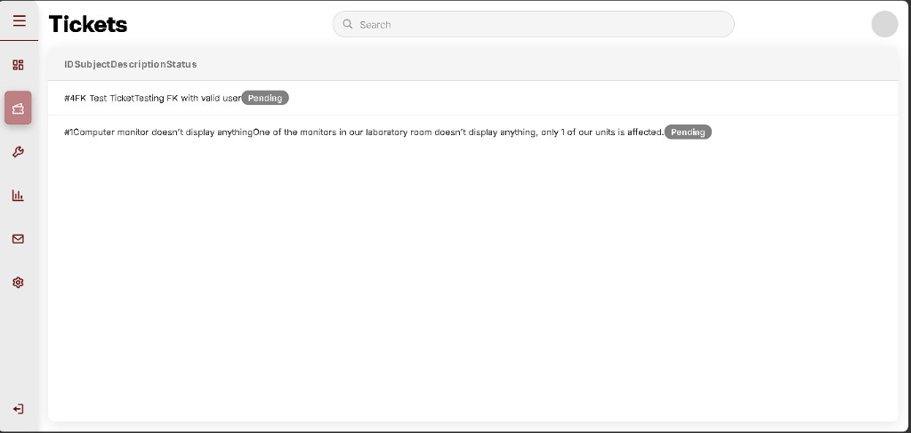
- Cause: main_interface.css grid rules target **.tickets-col-* (with an s). A-031 markup used .ticket-col-* (no s**). CSS never applied column widths, so spans stacked with no grid.
- Causing snippet (pages/admin.php):
<span class="ticket-col-id">ID</span>
<span class="ticket-col-subject">Subject</span>
code (html)
(user.php uses tickets-col-id, tickets-col-subject, etc.)
- In plain language: The HTML class names did not match the CSS file. The browser had no rules for ticket-col-id, so columns did not get their widths. Same data, wrong labels on the classes - like calling a CSS hook by the wrong name.
- Queued fix: In #page-tickets only, rename every ticket-col- -> tickets-col- (header + each row). No CSS changes.
<span class="tickets-col-id">ID</span>
<span class="tickets-col-subject">Subject</span>
<span class="tickets-col-description">Description</span>
<span class="tickets-col-status">Status</span>
code (html)
(Rename the same four classes on each .ticket-row span.)
- Solution executed: Find/replace ticket-col- -> tickets-col- in #page-tickets header and rows. Retest: columns align like user.php (#4 FK test ticket, #1 monitor ticket, Pending badges).
Admin Tickets - after fix

B-029 - Admin Tickets: Status + Assigned To compressed (5 columns, flex only)
- When: 6-7 September 2026 (A-033 Part 2)
- Status: fixed
- What I saw: admin.php -> Tickets tab. Five columns present (ID, Subject, Description, Status, Assigned To). Dropdown works (Unassigned + technician name), but Status and Assigned To headers overlap on the right; badges and dropdowns are squeezed into a narrow strip.
Status and Assigned To compressed
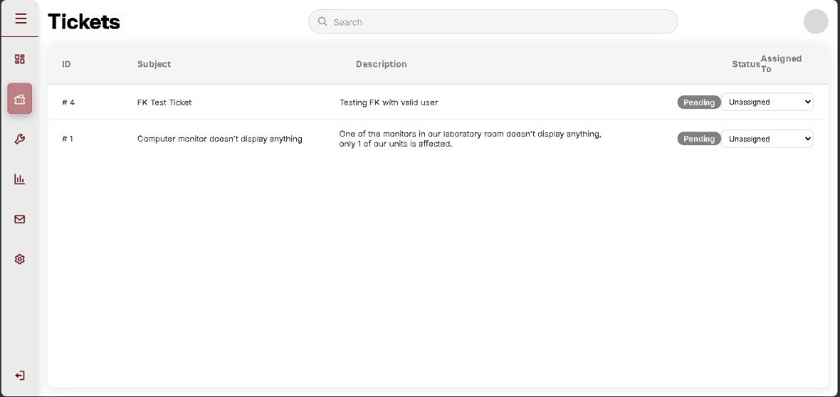
- Cause: main_interface.css column widths (.tickets-col-* flex rules) were written for four columns. Adding a fifth (.tickets-col-assigned) without a grid layout leaves Subject/Description taking most of the row; the last two columns fight for leftover space.
- Causing snippet (css/main_interface.css - flex-only, no 5-column grid):
.tickets-col-id { flex: 0 0 10%; }
.tickets-col-subject { flex: 1 1 30%; }
.tickets-col-description { flex: 1 1 30%; }
.tickets-col-status { flex: 0 0 12%; }
.tickets-col-assigned { flex: 0 0 18%; }
code (css)
(pages/admin.php uses <div class="tickets-list"> with no admin 5-column grid hook.)
- In plain language: Flex percentages alone do not reserve enough fixed space for Status and Assigned To when Description text is long. The last columns get crushed and header labels stack on top of each other.
- Queued fix (attempt 1): Add class `tickets-list-admin-five` on the admin .tickets-list div. In CSS, use `display: grid` with five explicit tracks for that class only (does not change user.php four-column list). Retest: Status and Assigned To each have their own column; long descriptions truncate with ellipsis.
Retest (same day) - worse layout: After adding tickets-list-admin-five + grid CSS, headers ID / Subject / Description stack vertically on the left; Status / Assigned To stack on the right; dropdown missing on rows.
Grid collapsed - vertical stack
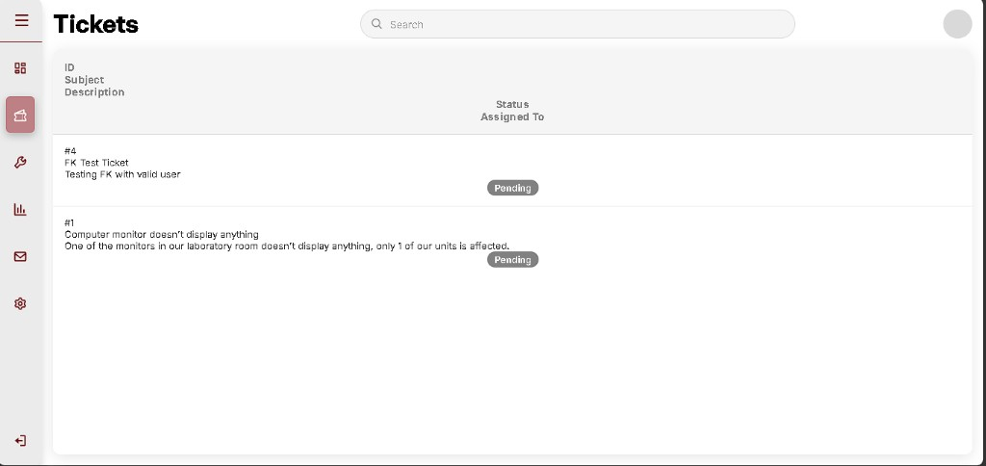
- Cause (two bugs):
1. Invalid `grid-template-columns` - minmax(140, 1fr) is missing `px` on 140. Browser drops the whole column rule; display: grid stays but flows as one column, so every header stacks vertically.
2. Row has 4 cells, header has 5 - Part 2 dropdown <span class="tickets-col-assigned"> was never saved inside the foreach loop. Grid cannot align rows to headers.
- Causing snippet 1 (css/main_interface.css):
minmax(140, 1fr); /* invalid - needs 140px */
code (css)
- Causing snippet 2 (pages/admin.php - row ends after Status, no Assigned To cell):
<span class="tickets-col-status">...</span>
</div> <!-- ticket-row closes - missing tickets-col-assigned -->
code (html)
- In plain language: The grid recipe had a typo, so the browser ignored the column widths and stacked everything in one vertical line. Even with a fixed grid, each data row must have the same five cells as the header - including the assign dropdown.
- Solution executed (attempt 2): minmax(140px, 1fr) in main_interface.css; `tickets-list-admin-five` on admin .tickets-list; Assigned To <select> inside each .ticket-row (5 cells match 5 headers).
Admin Tickets - five columns aligned
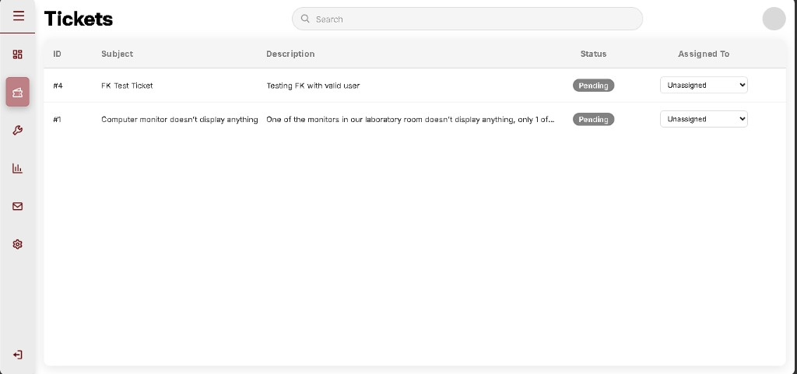
- Fix snippet (css/main_interface.css):
.tickets-list-admin-five .tickets-list-header,
.tickets-list-admin-five .ticket-row {
display: grid;
grid-template-columns:
72px
minmax(0, 1.1fr)
minmax(0, 2fr)
110px
minmax(140px, 1fr);
column-gap: 10px;
align-items: center;
}
code (css)
- In plain language: Grid gives each column a fixed “slot” on the row. Status and Assigned To no longer share one crushed strip; long descriptions ellipsize instead of pushing the right columns off-screen. Retest: #4 and #1 show Pending + Unassigned dropdown in separate columns.

B-030 - Admin Tickets: Save clipped / assign did not persist
- When: 6-7 September 2026 (A-033 Part 3)
- Status: fixed
- What I saw: Dropdown worked; no visible Save; refresh returned to Unassigned.
- Cause: Assigned To track minmax(140px, 1fr) + flex-wrap: nowrap hid the Save button. Dropdown change does not POST.
- Causing snippet: minmax(140px, 1fr) and a <select> with no form in Part 2.
- In plain language: The save control existed in code but sat off the edge of the column. Changing the list without submitting never updated MySQL.
- Solution executed: Row is a POST form; column minmax(240px, 1fr); overflow: visible.

B-031 - Technician Tickets: columns compressed (wrong class names)
- When: 8 September 2026 (A-034)
- Status: fixed
- What I saw: techn.php -> Tickets. Headers ran as IDSubjectDescriptionStatus. Rows #4 and #1 packed into one line with Pending badges. Same class of failure as B-028.
Techn Tickets - compressed columns
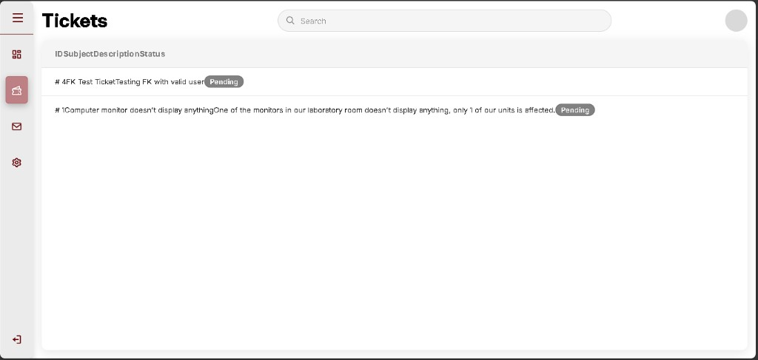
- Cause: CSS targets .tickets-col-*. Techn markup used .ticket-col-* (no s).
- Causing snippet (pages/techn.php):
<span class="ticket-col-id">ID</span>
<span class="ticket-col-subject">Subject</span>
code (html)
- In plain language: The class names do not match the stylesheet, so the browser never applies column widths.
- Solution executed: Find/replace ticket-col- -> tickets-col- on the techn Tickets header and rows.
Techn Tickets - four columns after fix
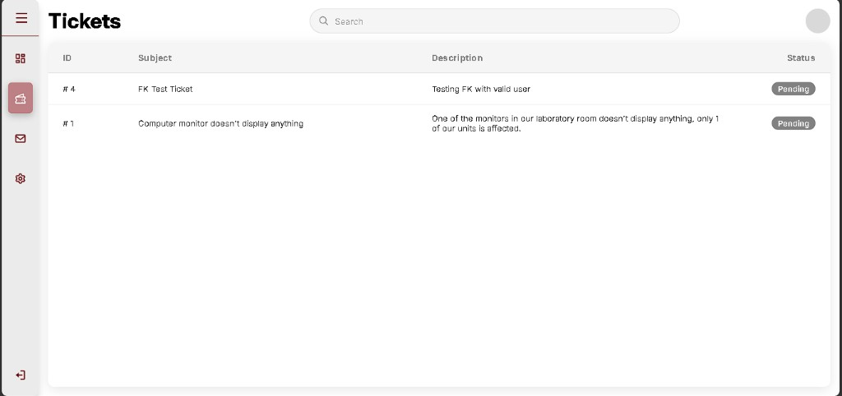
- Retest (19 Sep 2026): ID / Subject / Description / Status spaced. Rows #4 FK Test Ticket and #1 Computer monitor... with Pending badges. B-031 closed.

B-032 - Mailbox poll never runs (`data-page` typo)
- When: 8-9 September 2026 (A-035)
- Status: fixed (poll typo). Send unblocked after B-033.
- What I saw: Messages tab - thread FK Test Ticket highlighted, header title set, composer has Hello, chat pane still No conversation selected. Live poll never filled the thread.
Mailbox - thread selected, chat still empty
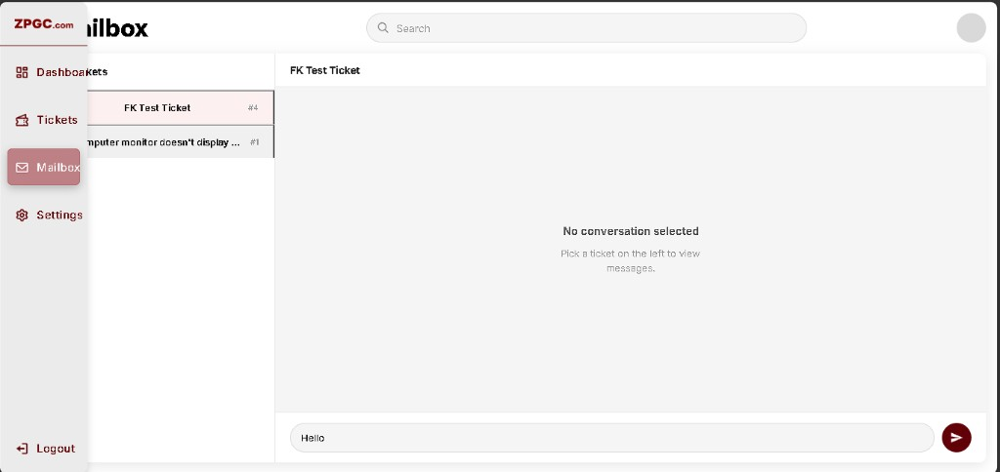
- Cause: Poll starts only if data-page === "message". The app sets data-page="messages" (with s). Fetch on click also returned nothing because messages did not exist yet (B-033).
- Causing snippet (js/behavior.js):
if (document.body.getAttribute("data-page") !== "message") {
return;
}
code (javascript)
- In plain language: The live updater looks for a tab name that does not exist, so it never ticks. Clicking a ticket can set the title without loading bubbles.
- Solution executed: "message" -> "messages" in startMailboxPoll().

B-033 - Send message fatals: `users_db.messages` does not exist
- When: 8-9 September 2026 (A-035)
- Status: fixed
- What I saw: Typed Hello and sent. White page: Table 'users_db.messages' doesn't exist in message_mngmnt.php line 37 (prepare() INSERT). Same page on a second send after B-031 retest.
Fatal - messages table missing
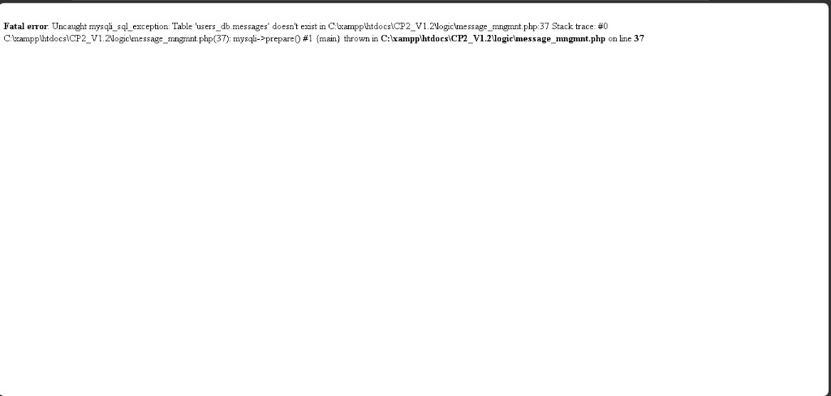
Fatal - send retest, still missing table
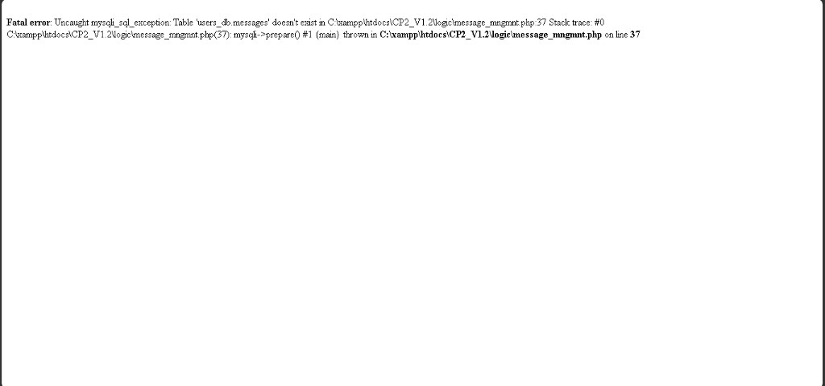
- Cause: Mailbox PHP was wired before the table existed. INSERT INTO messages has nowhere to go.
- Causing snippet (logic/message_mngmnt.php):
$stmt = $conn->prepare(
'INSERT INTO messages (ticket_id, sender_id, body) VALUES (?, ?, ?)'
);
code (php)
- In plain language: The chat form posts to PHP, but MySQL has no messages drawer yet, so PHP crashes instead of saving Hello.
- Solution executed: phpMyAdmin -> users_db -> SQL -> CREATE TABLE messages (FKs to tickets.id and users.id). Go returned an empty result (normal for CREATE). Left tree showed messages. Browse: columns id, ticket_id, sender_id, body, created_at, zero rows.
CREATE TABLE messages in SQL
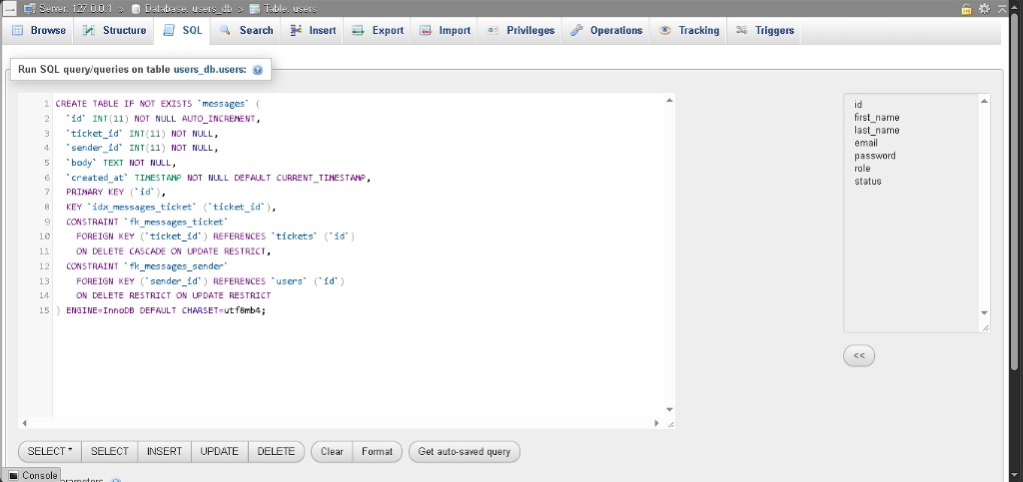
Go - empty result set
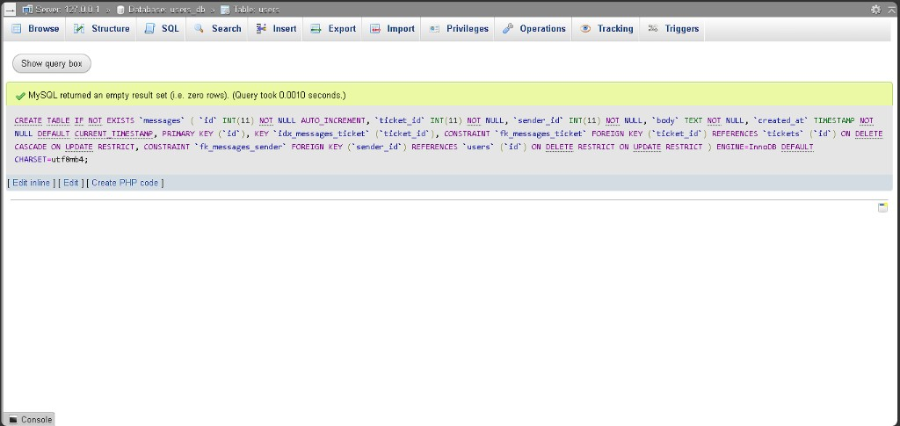
Browse messages - empty
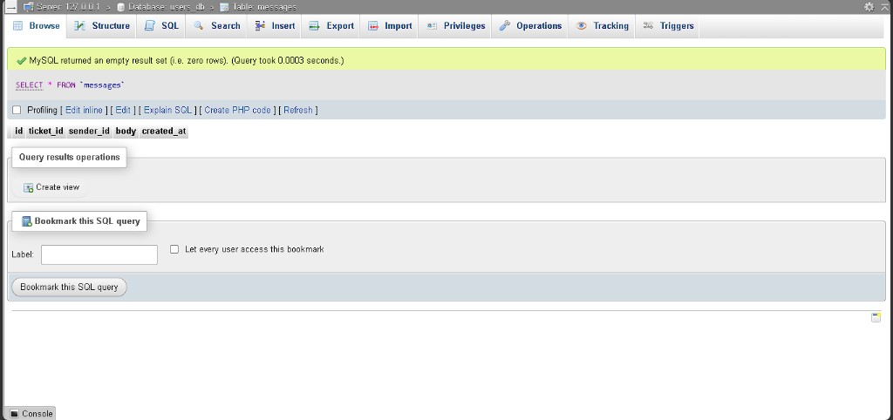
- Retest send: Mailbox -> FK Test Ticket -> Hello. No fatal. Maroon bubble on the right.
Mailbox - Hello after table exists
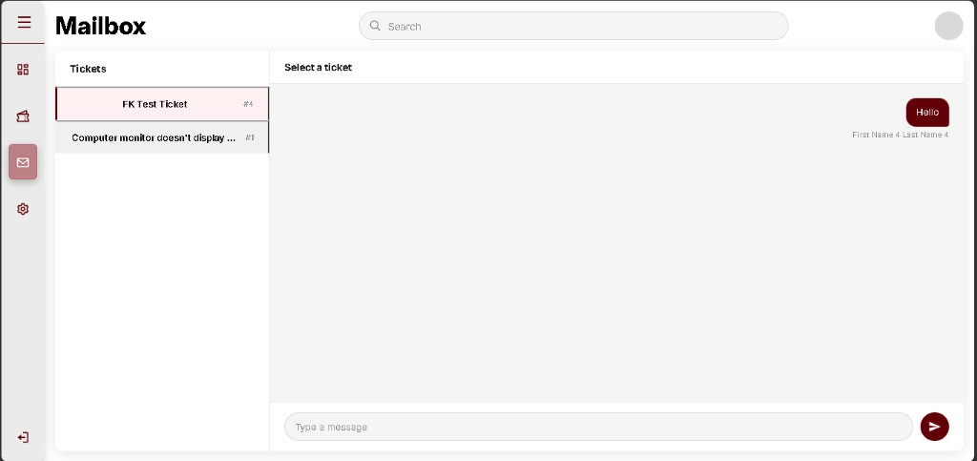
- Two-role thread: Other account sees Hello (white, left) and replies Ho (maroon, right).
Mailbox - Hello and Ho
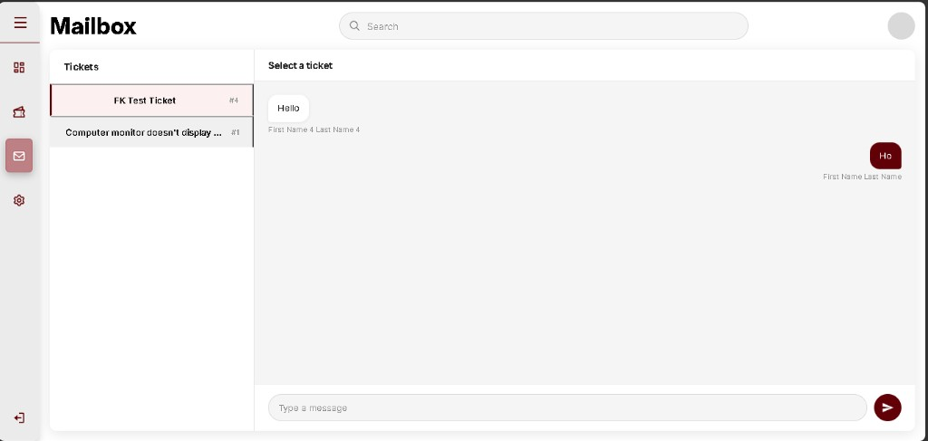
- Note: SQL tab breadcrumb was users_db.users; CREATE TABLE still built messages on users_db. Pane title stayed Select a ticket after send.

B-034 - Queue board shows 12 slots instead of 9
- When: 10 September 2026 (A-037)
- Status: fixed
- What I saw: http://localhost/CP2_V1.3/pages/admin.php -> Tickets. Grey Priority queue. Header 0 / 12. Critical / Moderate / Low each 0 / 4 and used / 4.
- Cause: $queue_slots_per_band = 4 (4+4+4). Spec is 3+3+3; panel used / 3.
- Causing snippet (pages/admin.php):
$queue_slots_per_band = 4;
$queue_total_slots = $queue_slots_per_band * 3;
code (php)
- In plain language: Someone treated each band as a batch of four, so the board advertises twelve seats. The school cap is nine (three per colour).
- Solution executed: $queue_slots_per_band = 3. Subtitle under Priority queue removed.
Queue board - 9 slots, no subtitle

B-035 - `priority` column is NOT NULL
- When: 10-11 September 2026 (A-038)
- Status: fixed
- What I saw: Add-column form: ENUM values quoted. After first Save, priority is Null = No. Change form: Null checkbox ticked (blue), Default None. Length/Values still ENUM 'critical','moderate','low' (left edge of the box may clip the c in critical).
Change priority - Null ticked
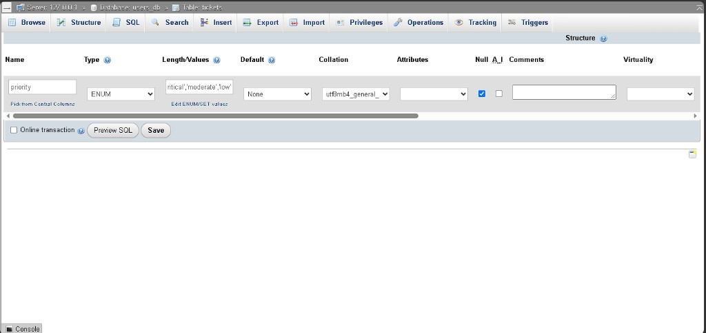
- Cause: Null checkbox left empty on the add-column row.
- Causing snippet (phpMyAdmin generated ALTER):
ALTER TABLE `tickets`
ADD `priority` ENUM('critical','moderate','low') NOT NULL AFTER `status`;
code (sql)
- In plain language: The colour field was required. Empty queue membership needs NULL (“not in a band yet”).
- Solution executed: Structure -> Change -> tick Null -> Default None -> Save. phpMyAdmin: CHANGE priority ... NULL. Structure list: Null = Yes, Default NULL.
Structure - priority Null Yes

B-036 - Critical band ignores ENUM `critical` (looks up `high`)
- When: 11 September 2026 (A-039)
- Status: fixed
- What you should see: phpMyAdmin Browse -> edit ticket #4 -> priority = critical -> Go. Reload admin Tickets. Critical still 0 / 3. Header still 0 / 9 if nothing else is queued.
- Cause: Critical count reads $by_priority['high']. MySQL stores critical.
- Causing snippet (pages/admin.php):
'critical' => (int) ($by_priority['high'] ?? 0),
code (php)
- In plain language: The board asks for a colour named high, but the table only has critical. So Critical never fills.
- Solution executed: 'high' -> 'critical'.

B-037 - Analytics cards are hardcoded (not live)
- When: 11 September 2026 (A-040)
- Status: fixed
- What you should see: Admin Analytics. Three cards Pending 4, Ongoing 2, Resolved 12. You do not have 12 resolved tickets. Numbers stay the same if you change statuses on Tickets.
- Cause: Literals in PHP, not COUNT(*).
- Causing snippet (pages/admin.php):
$analytics_pending = 4;
$analytics_ongoing = 2;
$analytics_resolved = 12;
code (php)
- In plain language: The cards are a poster, not a live tally. 12 is the same extra-slot story as the old 12-seat queue.
- Solution executed: Replaced with original 5-card markup + GROUP BY status (A-041). Charts remain original sample data.

B-038 - Dashboard charts blank (`dashbord` typo)
- When: 12 September 2026
- Status: fixed
- What I saw: Dashboard - five status cards OK. Tickets Report / Categories / Satisfaction / Severity chart panels empty (no Chart.js lines).
Dashboard - charts blank
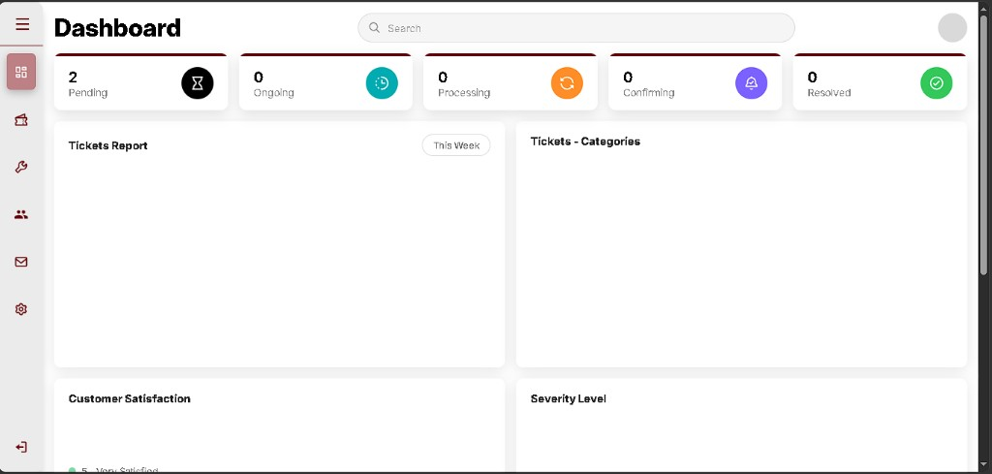
- Cause: Poll/init guard used data-page === "dashbord" (missing a). Body is dashboard.
- Causing snippet (js/dashboard_static_charts.js):
if (document.body.getAttribute('data-page') !== 'dashbord') {
return;
}
code (javascript)
- In plain language: The chart script looks for a page name that does not exist, so it never draws.
- Solution executed: 'dashbord' -> 'dashboard'.

B-039 - Settings tab empty
- When: 12 September 2026
- Status: fixed
- What I saw: Admin Settings - title and search only; white empty main pane.
Settings empty
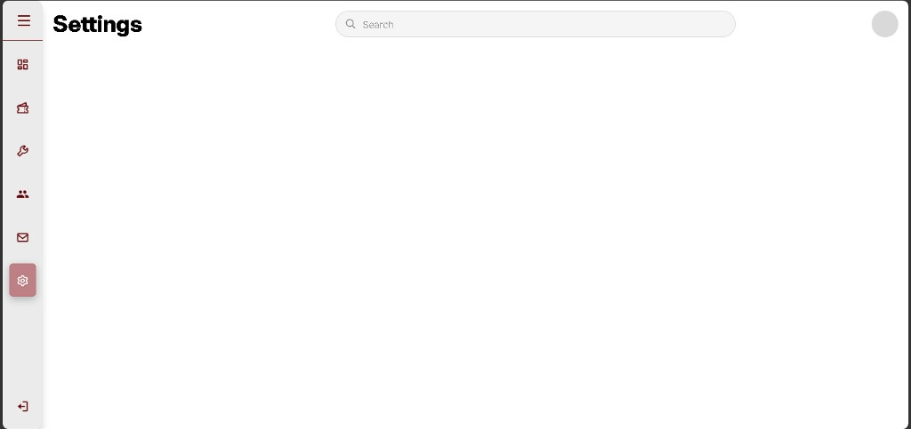
- Cause: #page-settings had header markup only; no Appearance / Security cards.
- In plain language: The sidebar opens Settings, but nothing was built under the title yet.
- Solution executed: Appearance card (theme look-only) + Security change-password form -> logic/settings_mngmnt.php.

B-040 - Pending filter typo + queue counted non-active tickets
- When: 12 September 2026
- Status: partially fixed - Pending filter typo closed; queue rule corrected in B-044
- What I saw: Tickets filter Pending used data-filter="pendng". Queue showed 2 / 9 while both tickets were still Pending.
- Causing snippets:
<button ... data-filter="pendng">Pending</button>
code (html)
- Solution executed (filter only): pendng -> pending.
- Note: Restricting the queue to ongoing/processing made Priority Save look broken on Pending tickets - see B-044.

B-041 - Utilities missing role filters and action buttons
- When: 12 September 2026
- Status: fixed
- What I saw: Utilities listed accounts with role/status badges, but Actions was empty for Active rows (Activate only on Pending). No All / User / Technician / Administrator / Pending Approval filters. No Edit, Deactivate, or Delete.
Utilities - empty Actions
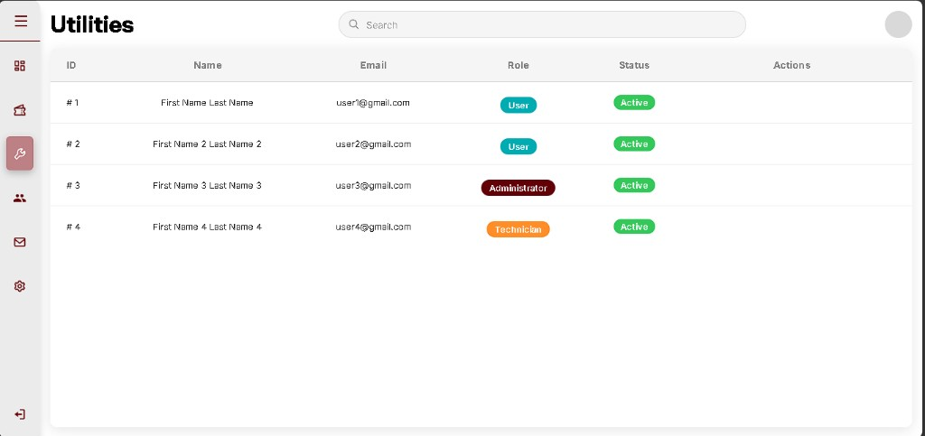
- Cause: Stage 3 ship stopped at Activate-only (A-028). Original admin Utilities had filters + Edit / Activate-Deactivate / Delete.
- Solution executed: Role filter tabs + utilities_filter.js; Edit form (role change); Activate/Deactivate; Delete with confirm; Add User. Handlers in user_admin_mngmnt.php. Verified A-047.

B-042 - Settings theme dropdown did nothing
- When: 12 September 2026
- Status: fixed
- What I saw: Appearance Theme select was disabled; note said save lands later. Light/Dark could not be toggled.
Settings - theme disabled
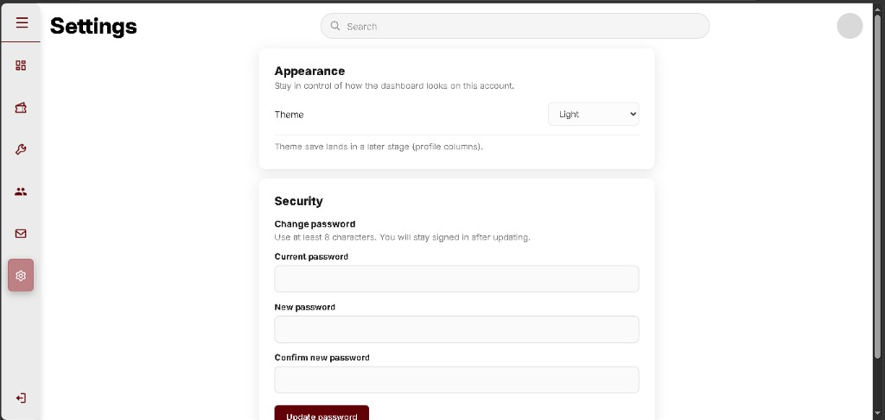
- Cause: Placeholder shell from A-042; no save path and no data-theme / theme.css wiring on admin.
- Solution executed: Enabled select + Save appearance -> settings_mngmnt.php (save_ui_theme). Admin <html data-theme> + theme.css.

B-043 - Dashboard sample charts blank again (CDN Chart.js)
- When: 12 September 2026
- Status: fixed
- What I saw: Dashboard status cards OK. Tickets Report / Categories / Satisfaction / Severity panels empty again (same look as B-038).
Dashboard charts blank again
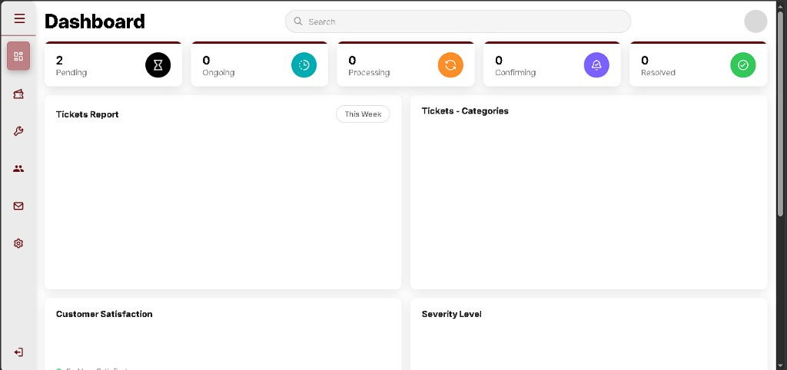
- Cause: Admin loaded Chart.js from cdn.jsdelivr.net. When the CDN was blocked/slow/offline, typeof Chart === 'undefined' and dashboard_static_charts.js returned without drawing. Original ships a local js/chart.umd.js.
- Solution executed: Vendored js/chart.umd.js; admin.php script tag points local. Charts re-init when data-page returns to dashboard + resize() after layout.

B-044 - Priority queue stayed **0 / 9** after Critical + Save
- When: 13 September 2026
- Status: fixed
- What I saw: Two tickets Pending + Critical + assigned. Priority queue still 0 / 9 / Batch 1 0 / 3.
Queue 0/9 with Critical Pending
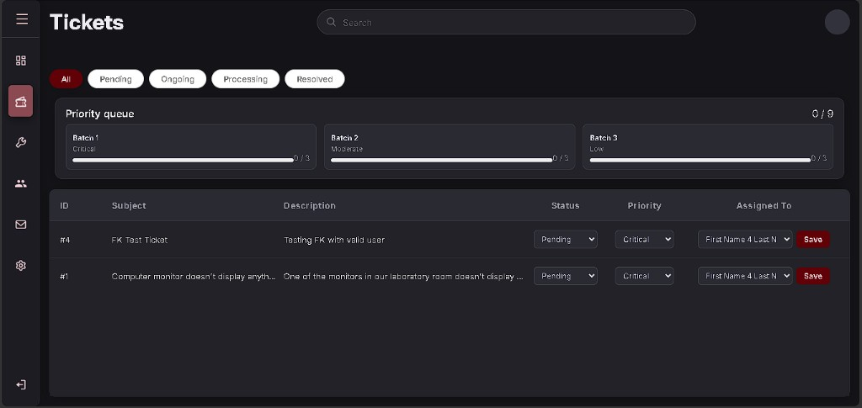
- Cause: After B-040 the counter required status IN ('ongoing','processing'). Stage 5 board (A-039 / A-041) counts open tickets with priority set - Save Priority should fill the bar while still Pending.
- Solution executed: WHERE priority IS NOT NULL AND status <> 'resolved'.

B-045 - Confirm buttons never appear (`awaiting_confirm` typo)
- When: 14-15 September 2026 (A-050)
- Status: fixed
- What I saw: Technician sets status Confirming. User Tickets shows Confirming badge but Confirm column is - (no Solved / Not Solved Yet).
Confirm column dash - no buttons
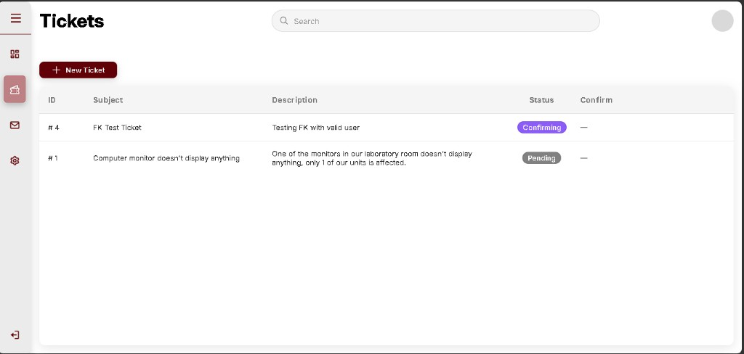
- Cause: User page checks the wrong string (missing ation).
- Causing snippet (pages/user.php):
$needsConfirm = ($st === 'awaiting_confirm');
code (php)
- Solution executed:
$needsConfirm = ticket_awaiting_confirmation($st);
code (php)
Confirm buttons after fix
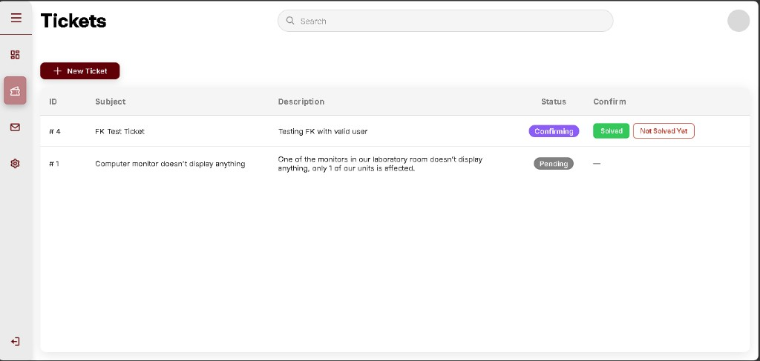

B-046 - Technician can still pick Resolved
- When: 14-15 September 2026 (A-050)
- Status: fixed
- What I saw: Technician status dropdown includes Resolved.
Techn dropdown includes Resolved
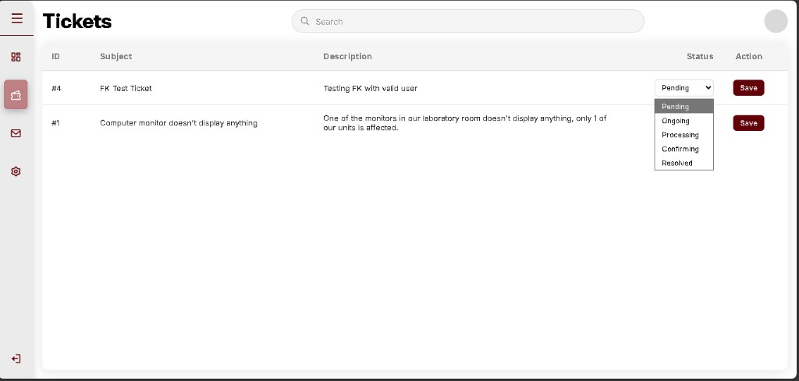
- Cause: Techn allowed list includes resolved.
- Causing snippet (logic/ticket_status.php):
return ['pending', 'ongoing', 'processing', 'awaiting_confirmation', 'resolved'];
code (php)
- Solution executed:
return ['pending', 'ongoing', 'processing', 'awaiting_confirmation'];
code (php)

B-047 - Not Solved Yet sends ticket to Pending (not Ongoing)
- When: 14-15 September 2026 (A-050)
- Status: fixed
- What I saw: After B-045 fix, Not Solved Yet showed success flash and ticket #4 status became Pending.
Not Solved Yet -> Pending
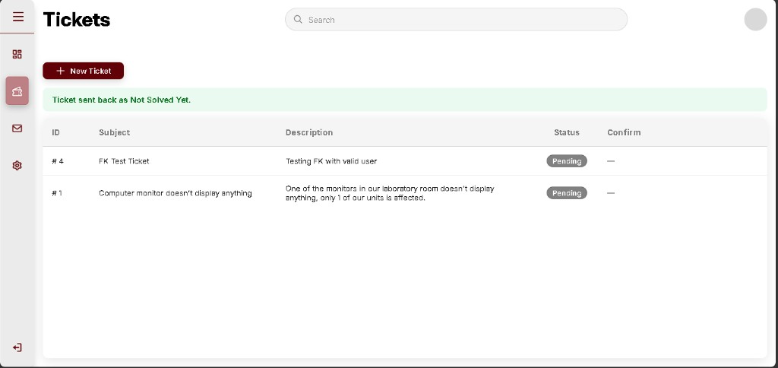
- Cause: Wrong reopen target in the confirm handler.
- Causing snippet (logic/ticket_confirm_mngmnt.php):
$newStatus = 'pending';
code (php)
- In plain language: Rejecting a fix should reopen active work (Ongoing), not send the ticket to the back of the new-request line.
- Solution executed:
$newStatus = 'ongoing';
code (php)

B-048 - ENUM list order puts `resolved` before `awaiting_confirmation`
- When: 14 September 2026 (A-049)
- Status: fixed (optional reorder documented)
- What I saw: After Structure Change, ENUM order was pending -> ongoing -> processing -> resolved -> awaiting_confirmation.
- Cause: Values appended at the end of the existing list in phpMyAdmin.
- In plain language: App works either way. Clearer workflow if Confirming sits before Resolved.
- Solution executed: Documented correct order in database/v1.4_stage6.sql. Run in phpMyAdmin SQL tab if desired:
ALTER TABLE `tickets`
MODIFY `status` ENUM(
'pending','ongoing','processing','awaiting_confirmation','resolved'
) NOT NULL DEFAULT 'pending';
code (sql)

B-049 - PHP calls wrong Flask port (`5001`)
- When: 17 September 2026 (A-054)
- Status: fixed
- What I saw: Flask /health OK on 5000. Suggest with AI on “Internet Problem” showed: Cannot reach AI service. Is Flask running on port 5000?
Cannot reach AI - wrong port
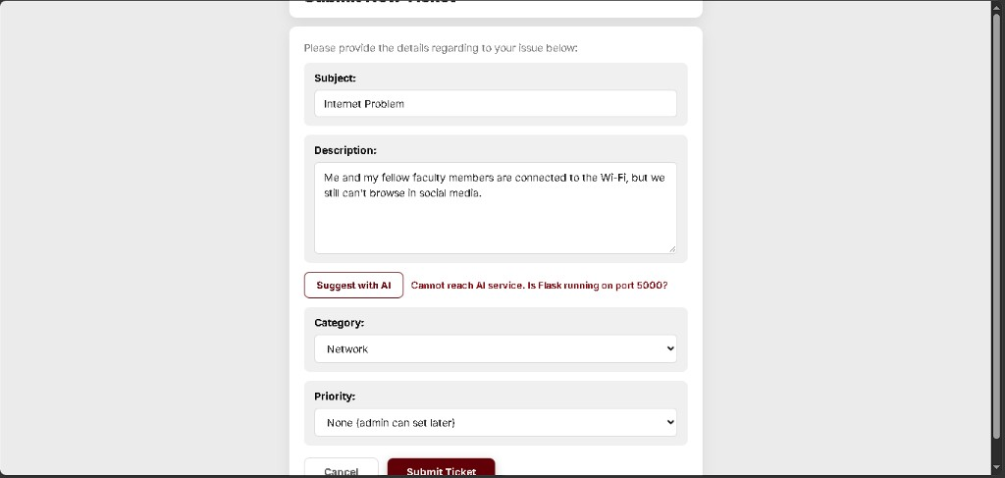
- Cause: Bridge URL used port 5001.
- Causing snippet (logic/ai_classify.php):
return 'http://127.0.0.1:5001/classify';
code (php)
- Solution executed: Point to the real Flask port.
return 'http://127.0.0.1:5000/classify';
code (php)

B-050 - Classifier returns `prioriy` instead of `priority`
- When: 16-17 September 2026 (A-053)
- Status: fixed
- What I saw: Suggest with AI on locked-out / forgot password: Category Account, message Priority missing from AI response, suggestion box Priority: -, Priority dropdown still None.
Priority missing from AI JSON
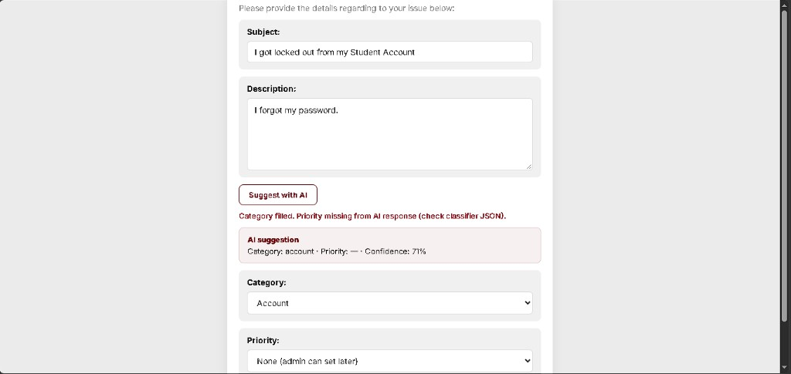
- Cause: JSON key typo in Flask response.
- Causing snippet (ai/classifier_app.py):
"prioriy": result["priority"],
code (python)
- Solution executed: Rename key to priority. Restart Flask after this change.
"priority": result["priority"],
code (python)
After fix - Category + Priority filled
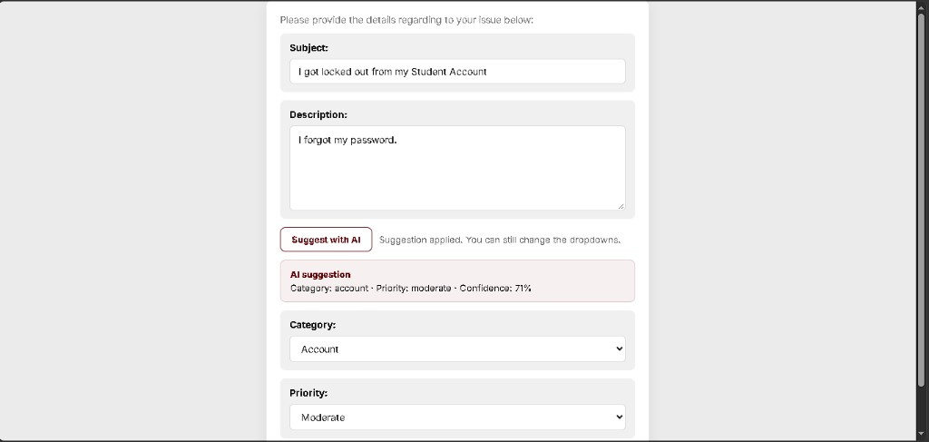

B-051 ? Submit Ticket ignores priority column
- When: 17 September 2026 (A-054)
- Status: fixed
- What I saw: AI Suggest set Category other / Priority moderate. After Submit, admin Tickets showed #1003 Test5 with Priority None. Queue stayed 2 / 9 (Moderate still 1/3).
AI Suggest Moderate before Submit
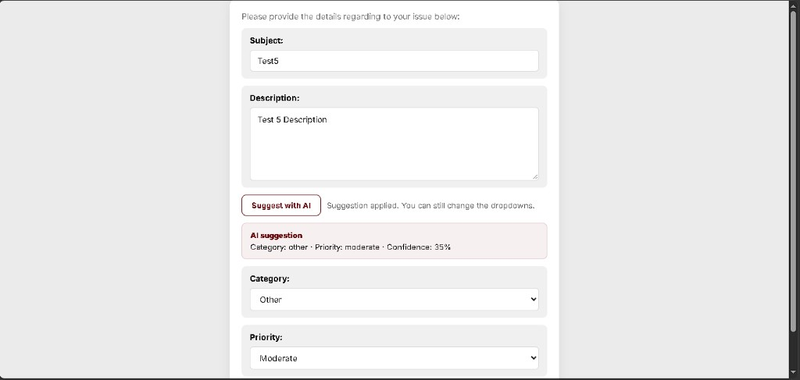
Admin Priority None after Submit
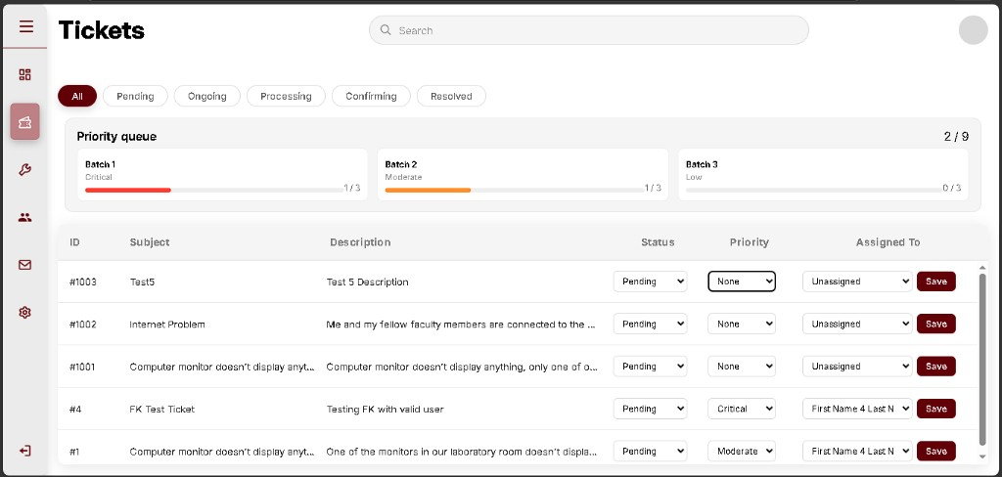
Retest - #1004 Moderate saved; queue 3/9
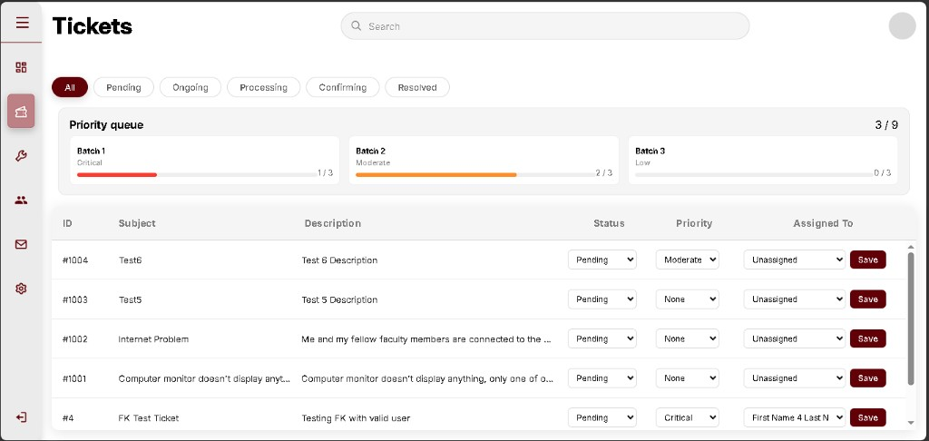
- Cause: INSERT omitted priority.
- Causing snippet (logic/ticket_mngmnt.php):
'INSERT INTO tickets (user_id, subject, description, category) VALUES (?, ?, ?, ?)'
code (php)
- Solution executed: Insert priority when the form sends critical/moderate/low.
'INSERT INTO tickets (user_id, subject, description, category, priority) VALUES (?, ?, ?, ?, ?)'
code (php)

B-052 - New Ticket title clipped at top of viewport
- When: 17-18 September 2026
- Status: fixed
- What I saw: Submit New Ticket heading was cut off at the top of the page (only the lower half of the letters showed). Bottom actions were easy to miss on a short viewport.
Title clipped
Title still clipped after first CSS pass
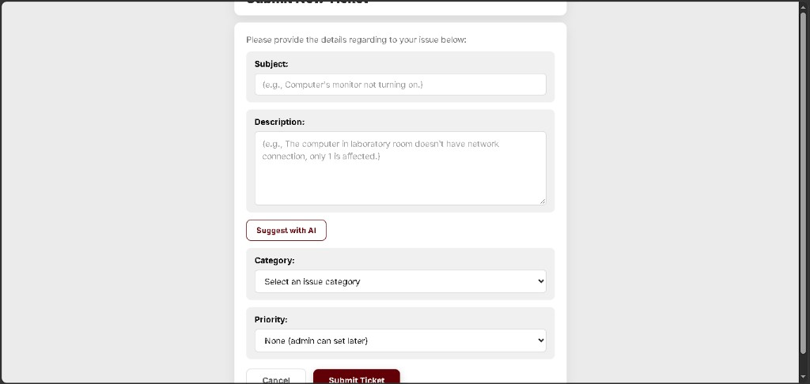
- Cause: Tall form + ody vertical flex centering pushed the separate header card above the fold. First fix (lex-start) was not enough.
- Solution executed: Put the title inside the form card; remove body flex centering; cache-bust CSS ( icket.css?v=20260920).
Title fully visible
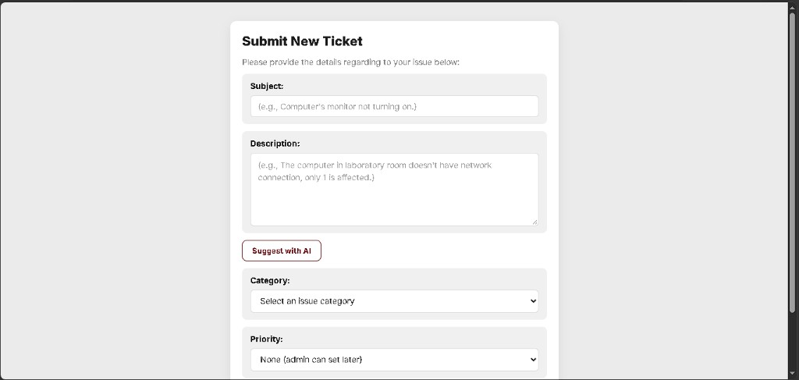
- In plain language: The page now starts with a full readable title, then the fields.

B-053 - New Ticket sends logged-in user to login page
- When: 18 September 2026 (Stage 8 test B)
- Status: fixed
- What I saw: On user Tickets, + New Ticket left the tickets list and opened LOGIN instead of Submit New Ticket.
User Tickets before click
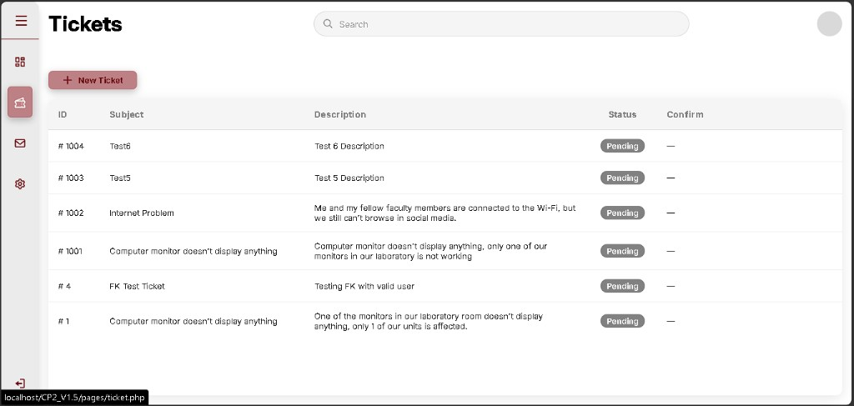
Landed on login
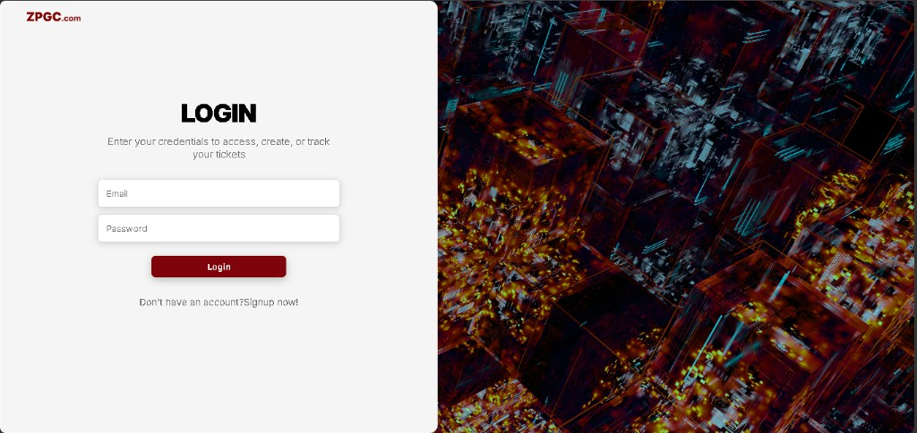
- Cause: login_signup.php called bare session_start() (cookie path /) while the rest of the app starts sessions with path /CP2_V1.5/. Session cookie mismatch made
equire_role('user') on icket.php think the user was logged out.
- Causing snippet (pages/login_signup.php):
`php
session_start();
`
- Solution executed: Use shared session_config.php on the login page; set cookie path /CP2_V1.5/ explicitly; New Ticket link icket.php (same folder).
`php
require_once '../logic/session_config.php';
`
- Retest: Log out -> log in again as user -> Tickets -> + New Ticket -> Submit New Ticket form (not login).

B-054 - Technician still shows Pending after ticket is Resolved
- When: 18 September 2026 (Stage 8 F - mailbox OK)
- Status: fixed
- What I saw: User #1005 Resolved. Admin Resolved filter shows Resolved. Technician Tickets still showed status dropdown Pending. Mailbox chat worked live.
User Resolved
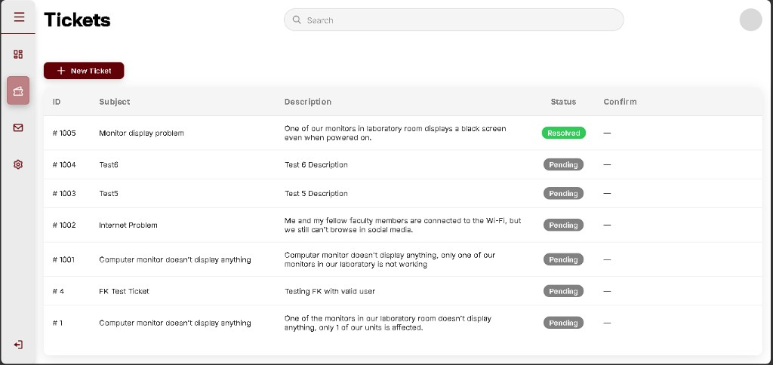
Techn dropdown still Pending
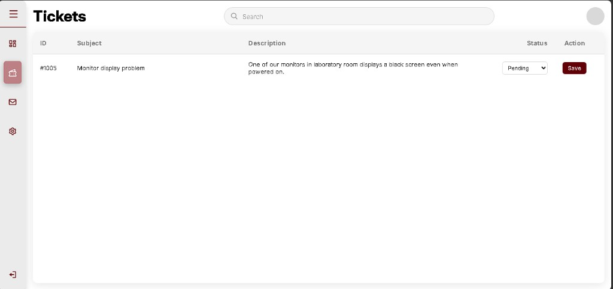
Mailbox live
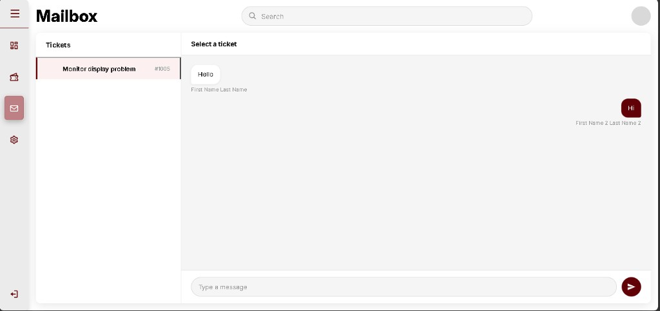
- Cause: Techn status <select> only lists allowed statuses (no
esolved). When DB status is
esolved, no <option> matches, so the browser displays the first option (Pending).
- Causing snippet (pages/techn.php): loop only over icket_techn_allowed_statuses().
- Solution executed: If status is not editable by techn (e.g. resolved), show a Resolved badge + “Closed by reporter” instead of a misleading dropdown.
- Retest: Techn Tickets -> #1005 should show green Resolved (not Pending).
Techn Resolved badge OK
- Retest result: pass - Resolved + Closed by reporter.

B-055 - Dashboard charts showed sample data while history was live
- When: 20 September 2026 (Test 3)
- Status: fixed (A-063)
- What I saw: Status cards (Pending 7 / Ongoing 2 / ...) and Recent Ticket History (#1008) were correct. Tickets Report / Categories / Satisfaction still looked like the old demo numbers (~50 submitted, category bars ~70-95, satisfaction 35/30/20/10/5).
- Cause: Cached old dashboard_static_charts.js sample arrays; live JSON was injected after the script tag; matplotlib endpoint not wired into Flask yet.
- Causing snippet: hardcoded Chart.js sample datasets + script order.
- In plain language: The cards told the truth; the pretty graphs were still showing a fake poster from an earlier build.
- Solution executed: Live Chart.js UI (original look) + matplotlib PNG pipeline for paper; removed fallback banner text. See A-063 / A-064.

B-056 - Priority is chosen by the user instead of the system
- When: 25 September 2026 (showcase feedback)
- Status: fixed (A-067)
- What I saw: Submit New Ticket still had a Priority dropdown (None / Critical / Moderate / Low). The adviser said priority must be set when the client presses Submit, not by the client.
- Cause: The form posted priority and the handler trusted that value.
- Causing snippet (pages/ticket.php):
<select name="priority" id="priority">
<option value="" selected>None (admin can set later)</option>
<option value="critical">Critical</option>
<option value="moderate">Moderate</option>
<option value="low">Low</option>
</select>
code (html)
- In plain language: The person reporting the issue could pick how urgent it was, or leave it blank. That should be decided by the system from the description.
- Solution executed: Remove the dropdown. On submit, classify priority automatically.

B-057 - Suggest with AI is a separate click
- When: 25 September 2026 (showcase feedback)
- Status: fixed (A-067)
- What I saw: Classification only ran if the user clicked Suggest with AI. Submit did not run the AI by itself. Low-priority tickets also waited for self-help instead of assigning a technician right away.
- Cause: The suggest button called ai_suggest.php; submit used the posted priority and only auto-assigned when the user had already set critical/moderate.
- Causing snippet (pages/ticket.php):
<button type="button" id="btn-ai-suggest" class="btn-ai-suggest">Suggest with AI</button>
code (html)
- In plain language: AI was optional. The adviser wants Submit itself to process the ticket and assign a technician.
- Solution executed: Remove the button. Submit classifies priority and assigns a technician for every new ticket.

B-058 - Automatic priority came from keywords, not Luna (#1010)
- When: 25 September 2026 (V1.6 submit test)
- Status: fixed (A-068)
- What I saw: Submit New Ticket no longer shows Priority or Suggest with AI. Subject Changing profile picture, description I don't know how to change profile, category Account. After Submit: *Ticket #1010 submitted. Priority set to Low and a technician was assigned automatically.* Row status Ongoing. phpMyAdmin: priority=low, assigned_to=2, status=ongoing, `ai_method=keyword`.
- Cause: OpenAI returned HTTP 429 credit_balance_exhausted (no API credits left). The classifier hid that error and used keywords. The phrase how to then forced priority low.
- Causing snippet (ai/classifier_app.py): a failed Luna call returned None with no reason, then:
elif re.search(r"\b(minor|small|question|how\s+to)\b", blob, flags=re.IGNORECASE):
priority = "low"
code (python)
- In plain language: The ticket was filed and given to a technician. Urgency was not from GPT-5.6 Luna. The API account has no credits, so the backup word rules ran and “how to” made it Low. The green message did not say Luna was skipped.
- Solution executed (A-068): Record fallback_reason=quota and save ai_method=kw-quota instead of a plain keyword success. Luna runs again after API credits are added and Flask is restarted.

A-068 - Record when Luna is skipped for lack of credits
- When: 25 September 2026
- Official stage: V1.6 follow-up to B-058
- Status: done
- What we did: Reproduced /classify for the #1010 text. The API error is credit_balance_exhausted. Classifier now sets method to kw-quota when that happens. Submit stores that method. Assignment still proceeds so tickets are not blocked.
- Fix snippet:
if "insufficient_quota" in text or "credit_balance_exhausted" in text:
_LAST_OPENAI_ERROR = "quota"
code (python)
- In plain language: If the paid AI has no credits, the ticket still gets a priority and a technician, but the record shows it was the backup, not Luna.
- Still required for real Luna: add API credits at platform.openai.com, then restart ai\start_classifier.bat.
- Retest #1011 (25 September 2026): user submit -> priority Low, status Ongoing. Admin shows Low and Assigned To First Name 4. That technician’s list shows #1011 Ongoing. phpMyAdmin: assigned_to=4, priority=low, ai_method=kw-quota.
Admin #1011 Low and assigned
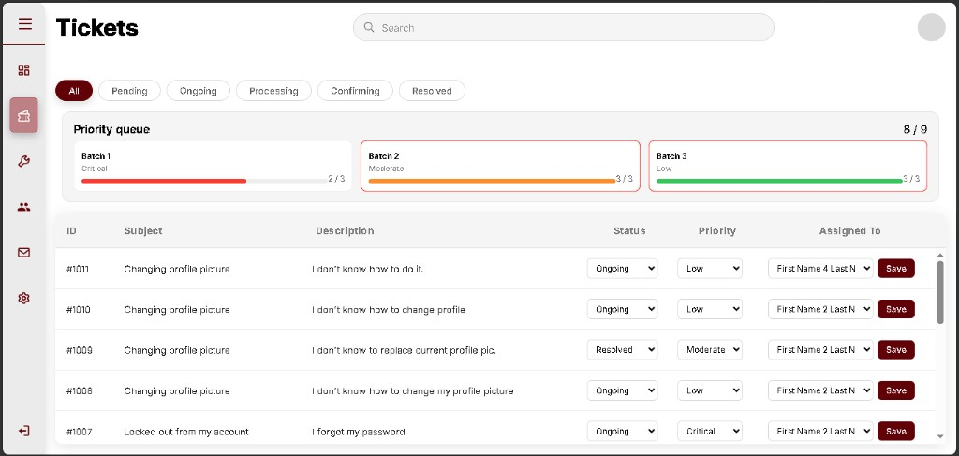
Technician #1011 Ongoing
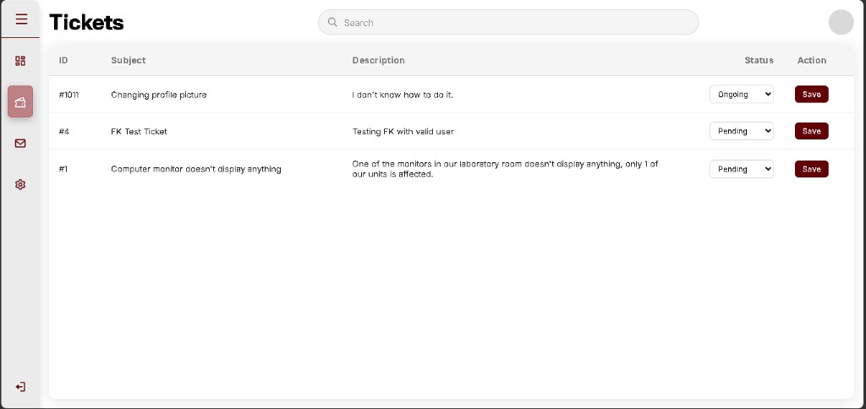
phpMyAdmin #1011 kw-quota
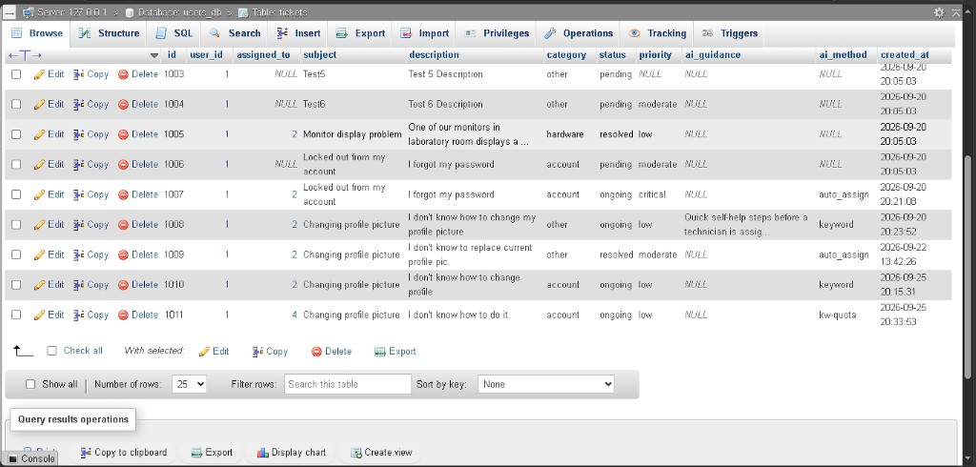

B-059 - Priority was a word label, not an urgency × impact score
- When: 28 September 2026
- Status: fixed (A-069)
- What I saw: Tables 4 and 6 score urgency times impact, then map 1-2 Low, 3-6 Moderate, 7+ Critical. #1011 became Low only because the text contained “how to”. No score was stored.
- Cause: Submit stored the classifier’s priority word.
- Causing snippet (logic/ticket_mngmnt.php before A-069):
$priority = $ai['priority'] ?? null;
code (php)
- In plain language: The system picked Low or Critical from wording. It never multiplied how urgent the problem is by how many people it hits.
- Solution executed: logic/severity_matrix.php computes the score and stores urgency, impact_level, and severity_score.

B-060 - Queue did not lend empty slots
- When: 28 September 2026
- Status: fixed (A-069)
- What I saw: Table 7 borrows unused Low or Moderate seats so a batch still processes up to 9. The panel always used a hard cap of 3 per color and counted every open ticket. Empty Low seats were not given to Critical.
- Cause: The band builder set limit to 3 and borrowed only when the raw count was already over 3.
- Causing snippet (logic/priority_queue.php before A-069):
'limit' => $baseLimit,
'borrowed' => max(0, $used - $baseLimit),
code (php)
- In plain language: If nobody filed a Low ticket, those three seats stayed empty instead of being used for a Critical one.
- Solution executed: priority_queue_allocate() fills each color up to 3, then gives leftover seats to Critical, then Moderate, then Low.

B-061 - Keyword urgency forced every impact to a single user
- When: 28 September 2026 (while wiring A-069)
- Status: fixed
- What I saw: The first wiring trusted urgency from the keyword classifier. That value came from the old Low/Moderate/Critical label, and impact was always 1. “Campus server down, whole laboratory cannot work” would score 3×1 = 3 (Moderate) instead of 3×3 = 9 (Critical).
- Cause: Submit used the AI urgency whenever it was 1, 2, or 3, including the keyword backup.
- Causing snippet:
$urgency = (int) ($ai['urgency'] ?? 0);
if ($urgency < 1 || $urgency > 3) {
$urgency = $axes['urgency'];
}
code (php)
- In plain language: A building-wide outage was treated like one person’s problem, because the backup classifier does not know the impact column of Table 4.
- Solution executed: Use the text estimate for urgency and impact unless the method is openai. Table 6 then maps the product.

B-062 - Sign-in fatals: MySQL connection refused
- When: 28 September 2026
- Status: fixed (A-070)
- What I saw: Opening login produced a white fatal page: No connection could be made because the target machine actively refused it in logic/config.php line 7.
- Cause: MySQL was not running, so port 3306 refused the connection. PHP 8 throws mysqli_sql_exception from new mysqli() before the connect_error check can run, so the page never reached die().
- Causing snippet (logic/config.php):
$conn = new mysqli($host, $user, $password, $database);
code (php)
- In plain language: The database program was off. Signing in tried to talk to it and the page crashed instead of saying MySQL was stopped.
- Solution executed: Start MySQL from the XAMPP Control Panel. In config.php, call mysqli_report(MYSQLI_REPORT_OFF) so a future outage prints “Start MySQL in the XAMPP Control Panel” instead of a fatal trace.

B-063 - Low ticket skipped troubleshooting and went straight to a technician
- When: 28 September 2026 (after #1012)
- Status: fixed (A-071)
- What I saw: #1012 was Low (score 1) but the green message said a technician was assigned. The user list had no AI troubleshooting tips. The adviser still wants Low tickets to show steps first, then let the user say whether they worked. If not, transfer to a technician.
- Cause: After A-067, every submit called ticket_auto_assign, including Low. Tips are only shown when ai_guidance is stored and assigned_to is empty, so the steps never appeared.
- Causing snippet (logic/ticket_mngmnt.php):
$tech = ticket_auto_assign($conn, $ticket_id, 'ongoing');
code (php)
- In plain language: A small “how to” ticket jumped the self-help step and landed on a technician immediately.
- Solution executed: Low submit saves troubleshooting text and stays Pending. Buttons: These steps worked (Resolved) and Still not fixed - Request Technician. Moderate and Critical still assign immediately.

B-064 - Resolved Low ticket still shows Request Technician
- When: 28 September 2026 (A-072, #1013)
- Status: fixed
- What I saw: After These steps worked, #1013 was Resolved, but a Request Technician button stayed under the subject.
- Cause: The fallback button checked “unassigned and Low” and did not check that the ticket was already resolved. Self-help closes the ticket without assigning anyone, so that button still matched.
- Causing snippet (pages/user.php):
} elseif ($unassigned && ($ticket['priority'] ?? '') === 'low') {
code (php)
- In plain language: A ticket the user already closed still offered to call a technician.
- Solution executed: Hide that button when the status is resolved.
- Retest (28 September 2026): User Tickets list. #1013 is Resolved and the subject line has no Request Technician button. #1014 stays Ongoing after a technician was requested.
#1013 resolved, button gone
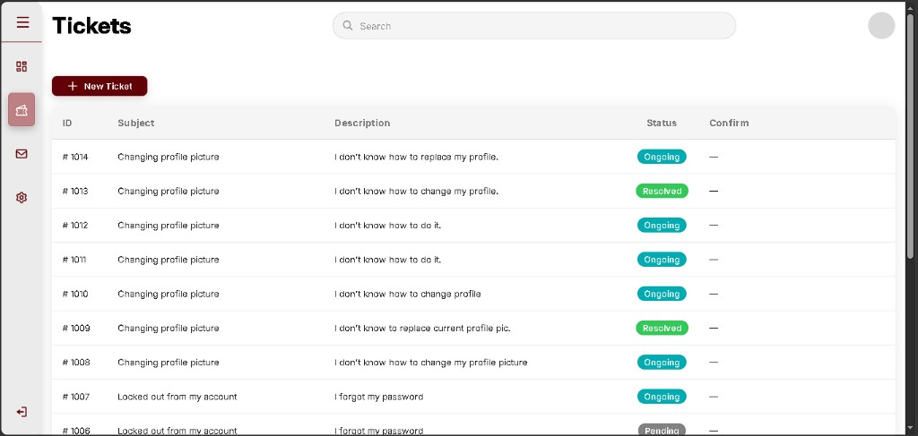

B-065 - Performance tab shows fake team rows
- When: 30 September 2026
- Status: fixed (A-073)
- What I saw: Performance showed Technician Record List with Team ID #0000 and zeros, and a second list of Ticket ID 0000, subject “The title of the issue,” and date 08/15/2027. None of that was a real ticket. The meeting said the label should be Category, and both lists should use resolved tickets.
- Cause: The page looped a hardcoded placeholder instead of querying tickets.
- Causing snippet (pages/admin.php):
<?php for ($i = 0; $i < 5; $i++) { ?>
<span class="pcol-teamid">#0000</span>
code (php)
- In plain language: The performance page was a poster of sample rows. Closing a real ticket did not change those numbers.
- Solution executed: Count resolved tickets per category, and list each resolved ticket under that table.
Placeholder team list
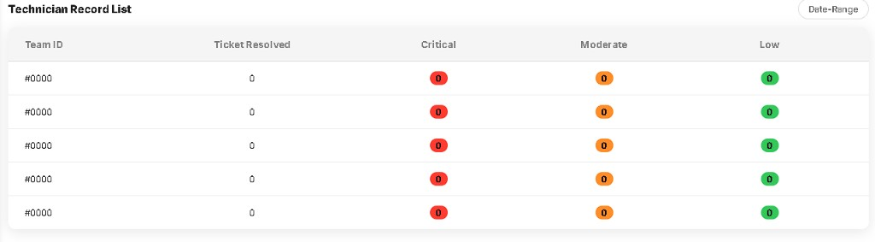
Placeholder ticket log
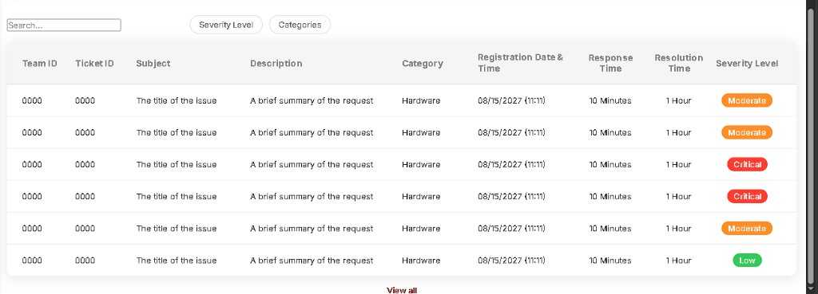

B-066 - Response and resolution times were not stored
- When: 30 September 2026
- Status: fixed (A-073)
- What I saw: The sample log said every ticket took 10 Minutes to respond and 1 Hour to resolve. The tickets table had created_at only, so those durations could not come from the database.
- Cause: Nothing wrote a time when a technician was assigned or when the ticket became resolved.
- Causing snippet: no responded_at or resolved_at columns before database/v1.6_performance_times.sql.
- Retest (1 October 2026): #1015 Account Low shows Response Time and Resolution Time filled (about 40 hours), not a dash. Account resolved count is 2. Older rows #1013, #1009, and #1005 still show -. This shot is enough for the clocks. The long duration text is squeezed in the column.
#1015 clocks filled
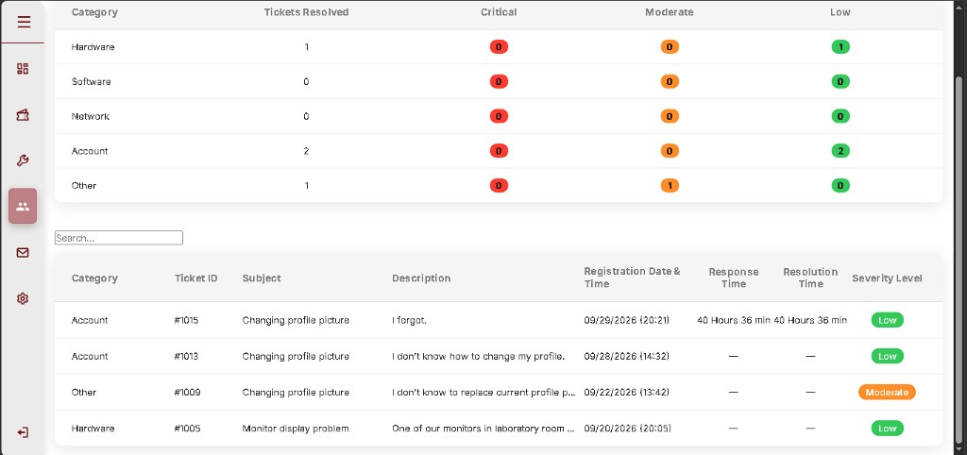
- Solution executed: Add responded_at and resolved_at. Set the first when a technician is assigned, and the second when the ticket is marked resolved.
- In plain language: The clocks on the performance log were made up. Existing closed tickets still show -. A ticket closed after the clocks were added shows a real duration.

B-067 - Sidebar item sticks to the bottom after Logout moved
- When: 1 October 2026
- Status: fixed
- What I saw: After Settings and Logout left the sidebar, Mailbox sits at the bottom of the grey bar. User and technician show a gap between Tickets and Mailbox. Admin shows the same gap under Performance.
- Cause: CSS puts margin-top: auto on the last sidebar item, which used to be Logout.
- Causing snippet (css/main_interface.css):
.nav-list-item:last-child { /* margin-top: auto */ }
code (css)
- In plain language: The last icon is pushed down as if it were still the logout button.
- Solution executed: Set the last sidebar item’s margin-top back to 0 so Mailbox stays under the other items.
User Mailbox at bottom
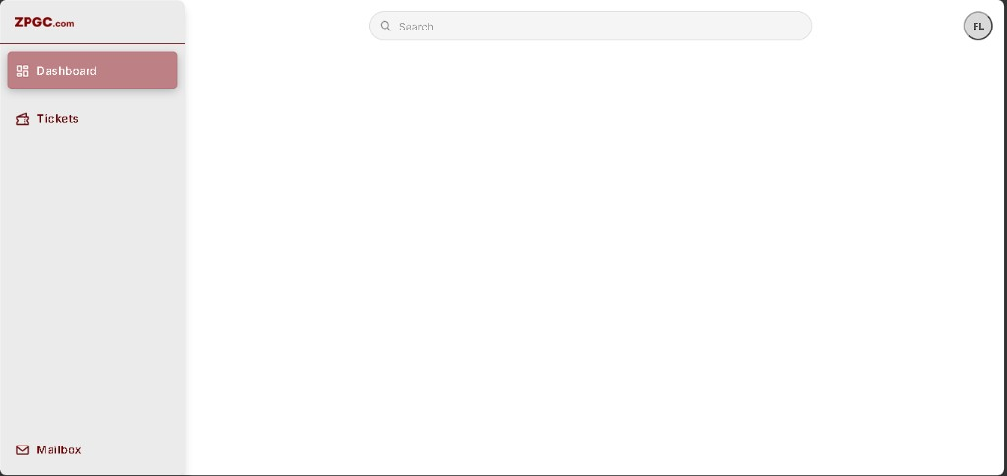
Technician Mailbox at bottom
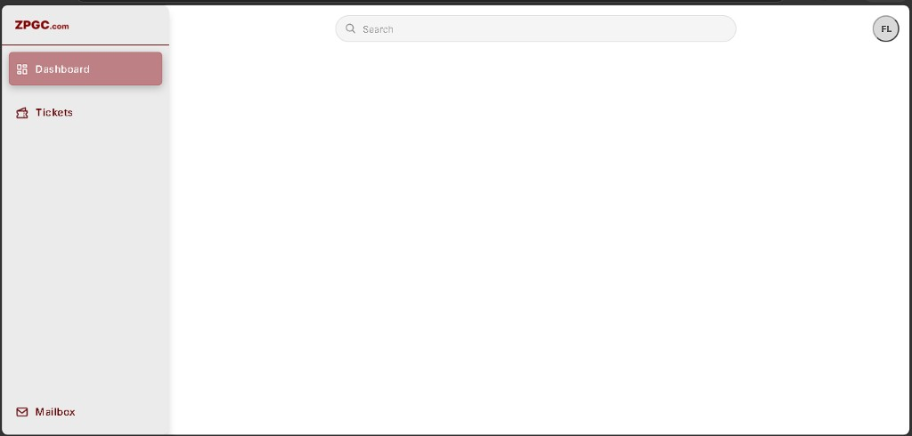
Admin Mailbox at bottom
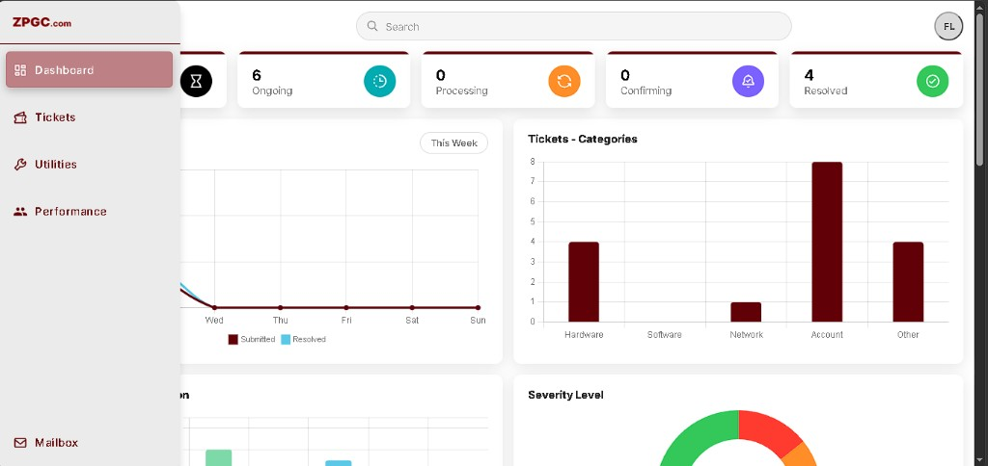

B-068 - Profile email looks editable but does not save
- When: 1 October 2026
- Status: fixed
- What I saw: Profile has an Email box. Changing it and clicking Save profile keeps the old email.
- Cause: The input is named contact_email. The save handler only updates first name and last name.
- Causing snippet (pages/partials/profile_panel.php):
<input type="email" id="profile-email" name="contact_email" required>
code (html)
- In plain language: The email box invites a change, then ignores it.
- Solution executed: Name the field email and update users.email plus the signed-in session.

B-069 - Profile role shows the database word
- When: 1 October 2026
- Status: fixed
- What I saw: The Role box shows user, techn, or admin instead of User, Technician, or Administrator.
- Cause: The field prints users.role with no label map.
- Causing snippet (pages/partials/profile_panel.php):
echo htmlspecialchars((string) $profile['role']);
code (php)
- In plain language: The role is the short code stored in the table, not the name a person would read.
- Solution executed: Show User, Technician, or Administrator. The page now follows My Profile: avatar, name, personal information, and a working email.

B-070 - Profile circle does not open the menu
- When: 1 October 2026
- Status: fixed
- What I saw: The circle shows initials (FL) on user, technician, and admin, but clicking it does not open Profile, Settings, or Logout.
- Cause: The menu CSS set display: flex on .profile-dropdown, which overrides the hidden attribute, and the document click handler closed the menu in the same click.
- Causing snippet (css/main_interface.css):
.profile-dropdown { display: flex; }
code (css)
- In plain language: The account menu was forced visible in a way the click logic could not keep open, so the circle looked dead.
- Solution executed: Hide the menu with .profile-dropdown[hidden] { display: none !important; } and open it only on the circle click.
User circle, no menu
Admin circle, no menu
Technician circle, no menu

B-071 - User and technician dashboards are blank
- When: 1 October 2026
- Status: fixed
- What I saw: User and technician Dashboard show only the title and search bar. The rest of the page is white. Admin Dashboard still shows the charts.
- Cause: Those two dashboards had a header and no body. Ticket lists live on the Tickets tab only.
- Causing snippet (pages/user.php dashboard block ended after the header):
</header>
</div>
</div>
code (html)
- In plain language: Opening Dashboard as a user or technician looked like the page failed to load.
- Solution executed: Show the same status cards (Pending, Ongoing, Processing, Confirming, Resolved) counted from that person’s tickets. That first pass still did not match the paper, so the paper layout is B-073.

B-072 - Settings from the circle returns to Dashboard
- When: 1 October 2026
- Status: fixed
- What I saw: Profile and Logout from the circle work. Settings, on user, technician, and admin, lands back on Dashboard. User and technician Settings pages were also empty under the title.
- Cause: The page switcher only changes tabs that still have a sidebar item. Settings was removed from the sidebar, so ?tab=settings was ignored and the selected item stayed Dashboard.
- Causing snippet (js/behavior.js):
var item = document.querySelector('.nav-list-item[data-nav="' + tab + '"]');
code (javascript)
- In plain language: Settings had nowhere to go, so the site showed Dashboard again. The user and technician settings screens also had no form.
- Solution executed: Treat Settings like Profile. Put Appearance and Security (password) on all three roles.
User dashboard before paper layout
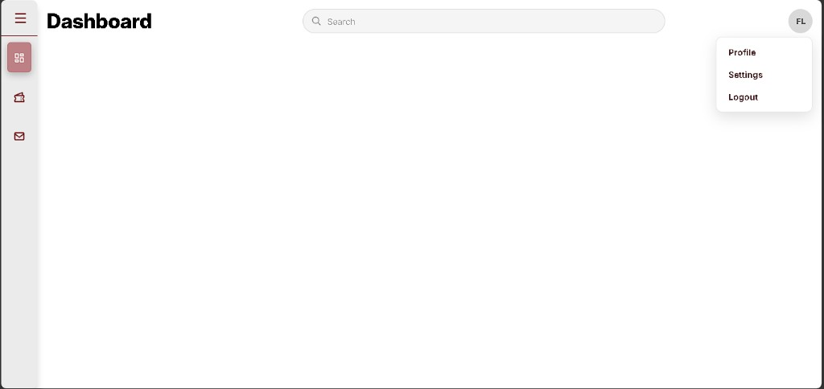
Technician dashboard before paper layout
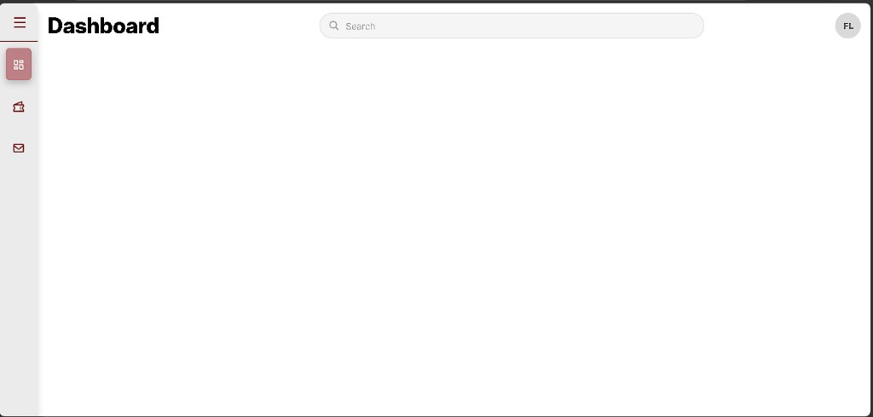

B-073 - User and technician dashboards do not match the paper
- When: 1 October 2026
- Status: fixed
- What I saw: The paper user dashboard has Ongoing, Processing, and Resolved counts plus a ticket list. The technician dashboard has those plus Pending, and a ticket table with category and severity. Both pages were a title bar and blank space.
- Cause: Only the admin dashboard was built out.
- In plain language: A user or technician opening Dashboard did not see the summary the paper shows.
- Solution executed: User dashboard shows Ongoing, Processing, and Resolved plus recent tickets. Technician dashboard adds Pending and shows category and severity on the assigned list.

B-074 - Profile page crashes on bind_param
- When: 1 October 2026
- Status: fixed (A-075)
- What I saw: Opening the user page shows a fatal error at the top right. The rest of the page is blank under the search bar. The message is Call to a member function bind_param() on false in logic/profile_user.php, from current_profile_user() in pages/partials/profile_panel.php, included by pages/user.php line 118.
- Cause: My Profile selects phone, email_notify, sms_notify, and preferred_language from users. Those columns were not on the table. MySQL errors are turned off in logic/config.php, so prepare() returns false instead of throwing. The next line calls bind_param() on that false value.
- Causing snippet (logic/profile_user.php):
$stmt = $conn->prepare(
'SELECT id, first_name, last_name, email, role, phone, email_notify, sms_notify, preferred_language
FROM users WHERE id = ? LIMIT 1'
);
$stmt->bind_param('i', $id);
code (php)
- In plain language: The profile query asked for columns the users table did not have. The database call failed quietly, then PHP tried to bind a parameter to that failed call and stopped the page.
- Solution executed: Add the four columns with database/v1.6_user_profile_columns.sql and apply it to users_db. Check that prepare() returned a statement before calling bind_param().
Profile fatal error on user page
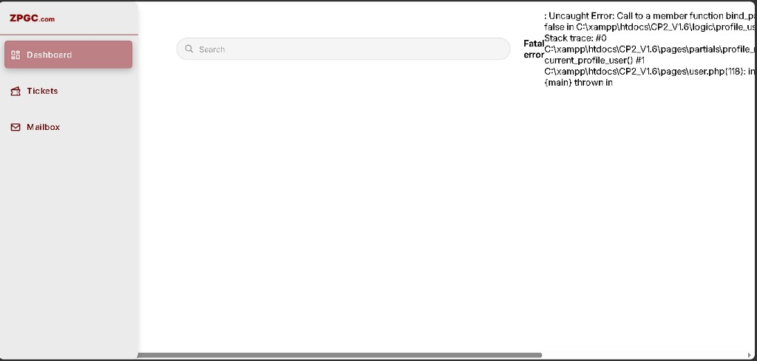

A-075 - Add users profile columns so My Profile loads
- When: 1 October 2026
- Official stage: V1.6 follow-up to B-074
- Status: done
- What we did: users had id, name, email, password, role, and status only. Added phone (varchar 30, nullable), email_notify (default on), sms_notify (default off), and preferred_language (default English). Applied the script in phpMyAdmin’s database users_db. Profile load and profile save now check prepare() before bind_param().
- Fix snippet (database/v1.6_user_profile_columns.sql):
ALTER TABLE `users` ADD COLUMN `phone` VARCHAR(30) NULL DEFAULT NULL AFTER `status`;
ALTER TABLE `users` ADD COLUMN `email_notify` TINYINT(1) NOT NULL DEFAULT 1 AFTER `phone`;
code (sql)
- In plain language: The table now has a place for the phone number and contact preferences the profile query reads, so opening the account page no longer dies on a failed database statement.

B-075 - My Profile is a plain form, not the paper layout
- When: 1 October 2026
- Status: fixed (A-076)
- What I saw: After the column crash was fixed, My Profile for a technician showed a grey circle with initials, the full name, the word Technician, and one card of text boxes: First name, Last name, E-mail, Role, and a maroon Save profile button. Image 4 of the paper is different: avatar with a small dot, name only, then two cards side by side. Personal Information lists Name, E-mail, and Phone Number with icons and a pencil. Contact Preferences lists E-mail Notifications, SMS Notifications, and a Preferred Language dropdown.
- Cause: The page still used the short settings form. The icon rows and toggles from the paper were not in the markup.
- Causing snippet (pages/partials/profile_panel.php):
<label for="profile-first-name">First name</label>
<input type="text" id="profile-first-name" name="first_name" required>
code (html)
- In plain language: The profile page worked, but it looked like a data-entry form. The paper shows an account card with icons, edit pencils, and notification switches.
- Solution executed: Rebuild My Profile as the two cards. Use the boxicon SVGs for name, e-mail, phone, SMS, and language. Pencils open the fields. Switches and the language list save with the profile.
My Profile form before the paper layout
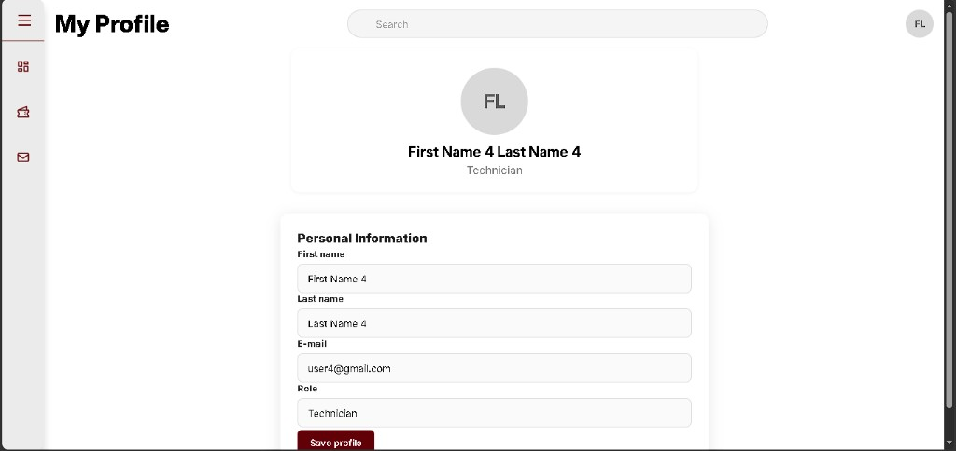

A-076 - My Profile matches the paper cards and icons
- When: 1 October 2026
- Official stage: V1.6 follow-up to B-075
- Status: done
- What we did: Header stays My Profile. The identity block is the initials circle, a small dot, and the full name. Personal Information shows Name, E-mail, and Phone Number with the supplied icons and a pencil on each row. Contact Preferences shows E-mail Notifications and SMS Notifications as switches, and Preferred Language as a full-width list (English or Filipino). Save writes first_name, last_name, email, phone, email_notify, sms_notify, and preferred_language.
- In plain language: My Profile now follows Image 4: two cards, the planned icons, and working contact choices.
- Retest (1 October 2026): User account user1@gmail.com. My Profile shows the green Profile saved. message, initials FL, name First Name Last Name, e-mail user1@gmail.com, phone 09111111111, E-mail Notifications on, SMS Notifications off, and Preferred Language English. phpMyAdmin users id 1 matches: phone=09111111111, email_notify=1, sms_notify=0, preferred_language=English. Ids 2-4 still have a null phone and the column defaults.
My Profile saved, two cards
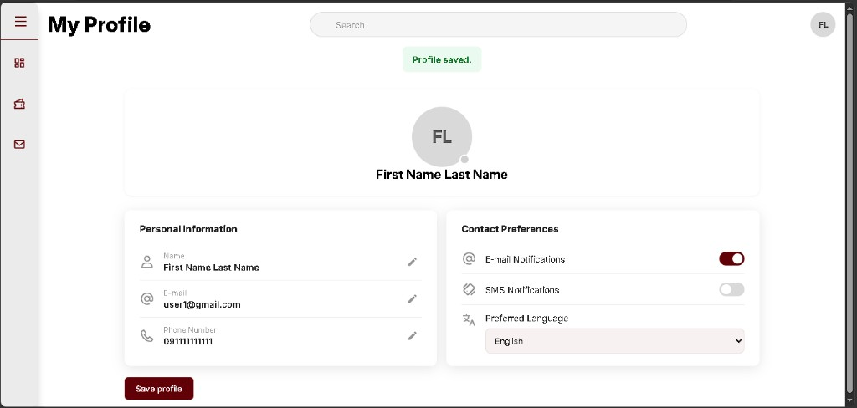
users row for the saved phone and switches
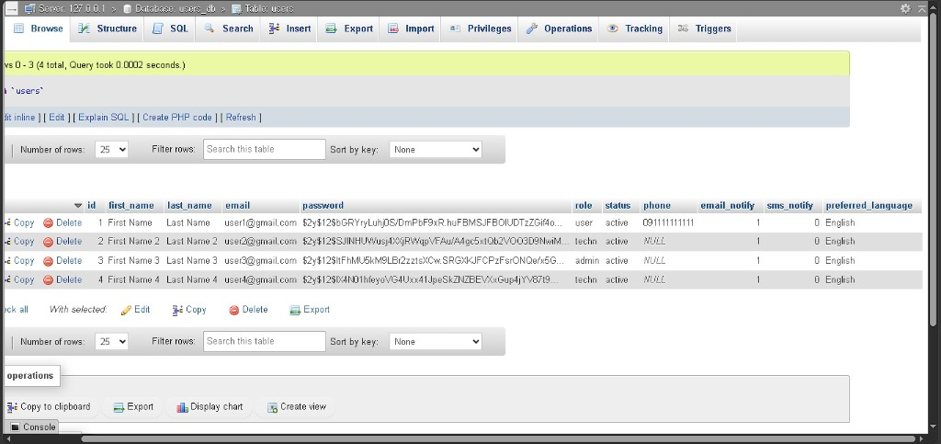

Queued log
Later official stages. Do not claim these until the files exist in this folder (CP2_V1.1.2).

Q-001 - Prepared statements and safer login/signup - Stage 2
- When: 23-29 July 2026 (7 days)
- Official stage: 2 - v1.1
- Status: queued (signup/login PHP already started in A-008 / A-009; leftover: flash polish, echo gone from config)
- Planned problem: first draft WHERE email = '$email'. History only; ship ? + bind_param.

Q-002 - `session_unset()` wipes another tab - Stage 2
- When: 30 July - 2 August 2026 (4 days)
- Official stage: 2 - v1.1
- Status: queued

Q-003 - Shared session cookie path - Stage 4
- When: queued until all role pages are guarded
- Official stage: 4 - v1.2 (cookie path /CP2_V1.2/)
- Status: done (A-036). Cookie path /CP2_V1.2/. Guards on admin.php / user.php / techn.php. Logout via logic/logout.php.

Q-004 - Dashboards and role separation - Stage 1 leftover
- When: 6-12 August 2026 (7 days)
- Official stage: 1 - CP2
- Status: queued leftover (A-016 in-page titles; A-017 ticket.php; B-017 fixed)
- Planned problem: dummy profile name; href="#"; search does nothing yet.

Q-011 - Admin users, approval, ticket form UI - Stage 3
- When: 13-19 August 2026 (7 days; work logged through 24 August 2026 in this folder)
- Official stage: 3 - v1.1.2
- Status: done in this folder (A-017-A-028, B-017-B-025)
- Maps to: admin user management, account approval (inactive -> active via A-028), ticket form UI (POST before INSERT A-018-A-022).

Q-005 - errno 150 on tickets FK - Stage 4
- When: 20-22 August 2026 (3 days; logged 2-3 September 2026 as A-030)
- Official stage: 4 - v1.2
- Status: done in this folder (A-030). No errno 150 - users.id and tickets.user_id both int(11) before Save.

Q-006 - Workflow, technician, live chat - Stage 4
- When: 23-26 August 2026 (4 days; mailbox/FK follow-through logged 2-9 September 2026 in this folder)
- Official stage: 4 - v1.2
- Status: done in this folder (A-029-A-036). messages table exists; send + two-role thread verified.
- Done here: A-029-A-036. B-002 closed. B-030-B-033 closed.
- Narrative report (V1.2): Mailbox doesn't update in real time when new messages are generated.
- When we build mailbox: poll only when the Messages tab is active (POLL_MS = 3000).

Q-007 - Manual priority queue, static analytics - Stage 5
- When: 27 August - 1 September 2026 (6 days; close-out logged 10-14 September 2026)
- Official stage: 5 - v1.3
- Status: done in this folder (A-037-A-045). B-034-B-044 closed. Live 3+3+3 queue from tickets.priority, Dashboard cards + sample Chart.js (local), Performance placeholder tables, Utilities filters/actions, Settings theme toggle.
- Narrative report (V1.3): Batches add extra slots; board shows 12 instead of 9 - reproduced as B-034, fixed to 9 slots.
- Shipped: 3+3+3; panel used / 3; priority Save; queue counts only assigned ongoing/processing.

Q-012 - Confirmation workflow - Stage 6
- When: 2 September 2026 -> (official In Progress; confirmation work 14-15 September 2026 in this rebuild)
- Official stage: 6 - v1.4
- Status: done - confirmation workflow closed (A-049-A-051; B-045-B-048)
- Maps to: user confirmation; Solved / Not Solved Yet; status awaiting_confirmation on tickets.
- First setup: docs/SETUP_V1.4.md + phpMyAdmin Structure for awaiting_confirmation (database/v1.4_stage6.sql).

Q-008 - AI category and priority - Stage 7
- When: 16 September 2026 -> (folder CP2_V1.5; Luna/matplotlib through 20 September 2026)
- Official stage: 7
- Status: extended - keyword AI done (A-052-A-055); Luna + auto-assign + low-pri tips + live dashboard (A-057-A-060). Paste API key when $5 / trial credit is ready.
- Maps to: AI category and priority classification (paper 1.4-1.5); auto-assign; low-priority troubleshooting.

Q-009 - Testing and evaluation - Stage 8
- Official stage: 8
- Status: in progress - core tests pass; retest after Luna key + auto-assign paths
- Maps to: functional, load, AI accuracy, user testing.

Q-010 - Finalization - Stage 9
- Official stage: 9
- Status: Planned
- Maps to: documentation, deployment preparation, defense.

Next development step
Active folder: C:\xampp\htdocs\CP2_V1.6. Progress by version: docs/VERSION_PROGRESS.md.
Still short of the revised paper:
- Live Luna classification (API credits are exhausted, so submit records kw-quota).
- Email and SMS switches are saved and not sent. There is no admin audit log and no real satisfaction rating.
- Stage 8 still needs a load test and an accuracy study. Stage 9 (deployment and defense) has not started.
Docs last synced: 1 October 2026 (VERSION_PROGRESS.md; timeline through A-076).

