STAGE6 LOG
Source: STAGE6_LOG.md

Stage 6 log
Later close-out (1 October 2026): Q-012 is done (A-049-A-051, B-045-B-048). The working system is C:\xampp\htdocs\CP2_V1.6. See docs/VERSION_PROGRESS.md. The notes below are the session as it was written on 14-15 September 2026.

A-049 - phpMyAdmin: `awaiting_confirmation` on `tickets.status`
- When: 14-15 September 2026
- Official stage: 6 - v1.4 (Q-012)
- Status: done
- What we did: Structure -> Change status ENUM. Added awaiting_confirmation. Table altered successfully.
- Where: users_db.tickets.status
Structure - awaiting_confirmation saved
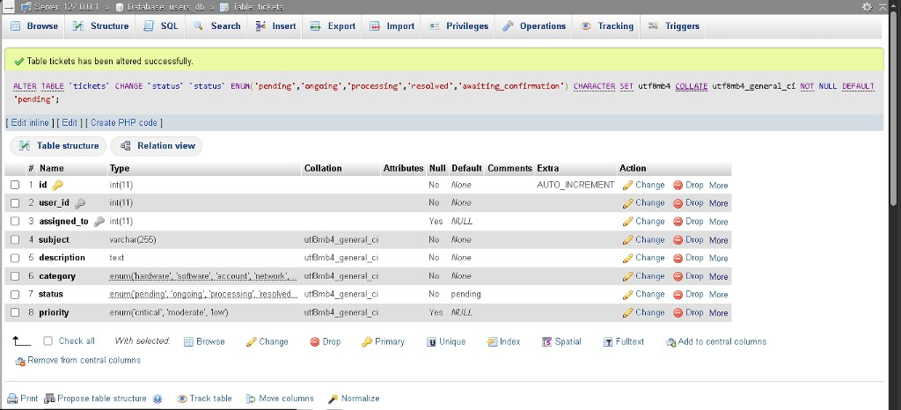

A-050 - Confirmation workflow UI + handlers
- When: 14-15 September 2026
- Official stage: 6 - v1.4 (Q-012)
- Status: done (B-045 / B-046 fixed; B-047 still open)
- What we did: Technician status Save; User Confirm column; Admin Confirming filter. Planted bugs captured and partially fixed.
Techn set Confirming on ticket #4
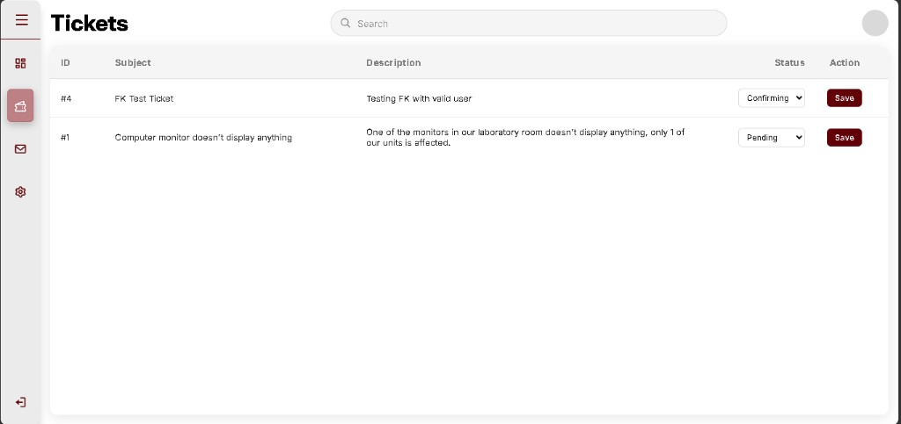

B-045 - Confirm buttons never appear - **fixed**
Confirm column dash - no buttons
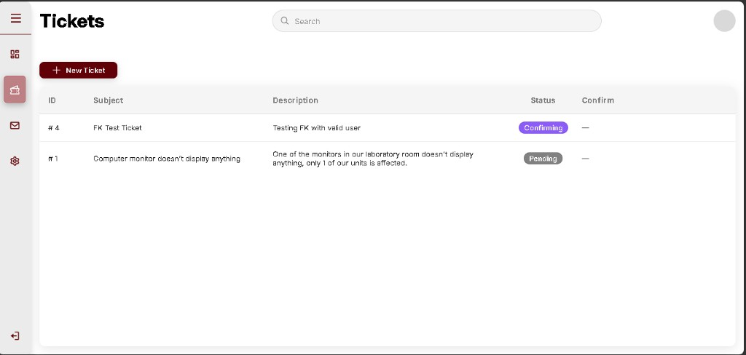
Fix: $needsConfirm = ticket_awaiting_confirmation($st);

B-046 - Technician can still pick Resolved - **fixed**
Techn dropdown includes Resolved
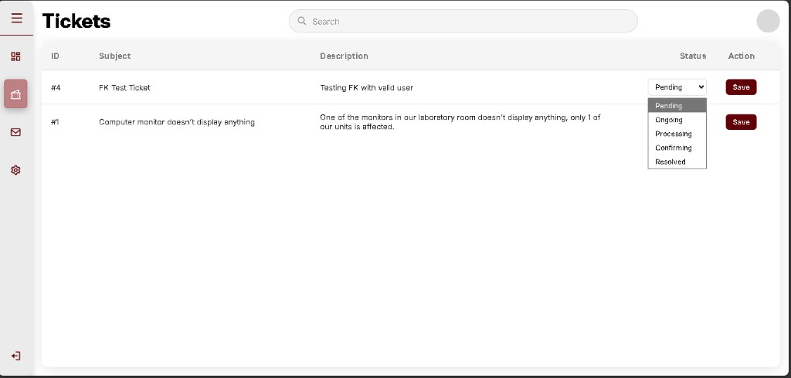
Fix: Remove 'resolved' from ticket_techn_allowed_statuses().

B-047 - Not Solved Yet -> Pending (not Ongoing) - **open**
Still planted. Capture after B-045 fix: click Not Solved Yet, status becomes Pending.

B-048 - ENUM order (optional) - **open**

Next
Ctrl+F5 -> User Tickets -> ticket #4 should show Solved / Not Solved Yet.
- Capture the buttons working (optional good shot).
- Click Not Solved Yet -> status Pending -> that is B-047. Send that shot, then we fix.
- No Python until Stage 6 closes.

