TRANSITPH: A COMMUNITY-DRIVEN MOBILE APP FOR CAMANAVA PUBLIC TRANSPORT NAVIGATION THROUGH CROWDSOURCED ROUTE INFORMATION IN COLLABORATION WITH THE PAANO PUMUNTA COMMUNITY
A Thesis
Presented to the Faculty of
Information and Communications Technology Program
STI College Caloocan

In Partial Fulfilment
of the Requirements for the Degree
Bachelor of Science in Computer Science
Neri-Zon M. Bagabaldo
Jenny Bonde
Christian Paul C. Madrigal

<Date Approved>

ENDORSEMENT FORM FOR ORAL DEFENSE

TITLE OF RESEARCH: TransitPH: A Community-Driven Mobile App
for CAMANAVA Public Transport Navigation
through Crowdsourced Route Information in
Collaboration with the Paano Pumunta
Community

NAME OF PROPONENTS: Neri-Zon M. Bagabaldo
Jenny Bonde
Christian Paul C. Madrigal

In Partial Fulfilment of the Requirements
for the degree Bachelor of Science in Computer Science
has been examined and is recommended for Oral Defense.

ENDORSED BY:

Ms. Rachel Arca
Thesis Adviser

APPROVED FOR ORAL DEFENSE:

Ms. Mary Joyce Aspiras
Thesis Coordinator

NOTED BY:

Mr. Francis P. Gubangco
Program Head

November 7, 2026

APPROVAL SHEET
This thesis titled TransitPH: A Community-Driven Mobile App for CAMANAVA Public Transport Navigation through Crowdsourced Route Information in Collaboration with the Paano Pumunta Community, prepared and submitted by Neri-Zon M. Bagabaldo; Jenny Bonde; and Christian Paul C, Madrigal, in partial fulfillment of the requirements for the degree of Bachelor of Science in Computer Science has been examined and is recommended for acceptance and approval.
Ms. Rachel Arca
Thesis Adviser
Accepted and approved by the Thesis Review Panel
in partial fulfillment of the requirements for the degree of
Bachelor of Science in Computer Science

<Panelists’ Given Name MI. Family Name> | <Panelists’ Given Name MI. Family Name>
Panel Member | Panel Member

<Panelists’ Given Name MI. Family Name>
Lead Panelist

APPROVED:
Ms. Mary Joyce Aspiras | Mr. Francis P. Gubangco
Thesis Coordinator | Program Head

November 7, 2026

ACKNOWLEDGEMENTS
The researchers would like to thank the following:
Thesis Coordinator, <state his/her contributions to your research>;
Thesis adviser, <state his/her contributions to your research>;
Thesis Review Panel, <state their contributions to your research>;
Parents and/ or Guardian, <state their contributions to your research>;
Friends and inspirations, <state his/her contributions to your research>; and
Others <state his/her contributions to your research>;

ABSTRACT
Title of research: TransitPH: A Community-Driven Mobile App for Camanava
Public Transport Navigation through Crowdsourced Route
Information in Collaboration with the Paano Pumunta
Community

Researchers: Neri-Zon M. Bagabaldo
Jenny Bonde
Christian Paul C. Madrigal

Degree: Bachelor of Science in Computer Science

Date of Completion: <Month year of graduation>

Keywords: Crowdsourced; Commuter App; CAMANAVA; Navigation

Commuters in the CAMANAVA, particularly foreign travelers, provincial students and newcomers to urban areas, struggle to find reliable and localized information on routes, fares, and informal modes of transport such as tricycles and habal-habal. Existing navigation and ride-hailing applications do not fully cover these modes, while the knowledge shared in commuter communities such as the Paano Pumunta Facebook group is difficult to search and verify. This study developed TransitPH, a community-driven mobile application for CAMANAVA public transport navigation built in collaboration with the Paano Pumunta Community and initially focused on the CAMANAVA region (Caloocan, Malabon, Navotas, and Valenzuela). This study aimed to develop route guides, fare matrices, and transport schedules; to provide cost-efficient commuting options for students and low-income travelers; to unify localized commuting information for foreigners and provincial residents; and to transform existing community transit knowledge into a structured, searchable, and verified database.
The system was developed using the Modified Agile Methodology, which covers planning, design, development, testing, evaluation, and deployment. The mobile application was built with Flutter, supported by Firebase and Supabase on the back end and by OpenStreetMap, OpenRouteService, OSRM, and Open-Meteo for mapping, routing, and weather data, together with a web-based administrator dashboard for route verification and moderation. Requirements were gathered through a researcher-designed questionnaire and interview, and the responses were analyzed using descriptive analysis. [KULANG PA SUMMARIZTION NG RESULTS OF SYSTEM TESTING TAPOS EVALUATION HERE. THEN STATE DITO YUNG CONCLUSIONS AND RECOMMENDATIONS NA DEN]. Amen wala pang 150-280 words ituh.

TABLE OF CONTENTS
 |  | Page
Title Page |  | i
Endorsement Form for Proposal Defense |  | ii
Approval Sheet |  | iii
Acknowledgments |  | iv
Abstract |  | v
Table of Contents |  | vi
List of Tables |  | vii
List of Figures |  | Viii
List of Appendices |  | ix
Introduction |  | 1
 | Background of the problem
 | Overview of the current state of technology
 | Objectives of the study
Scope and limitations of the study
Review of related literature/studies/systems
Methodology
Results and Discussions
Conclusion
References
Appendices

LIST OF TABLES
Table |  | Page
1 | Hardware requirements for Windows administrator(s) | 57
2 | Hardware requirements for Android users | 58
3 | Hardware requirements for mobile and website system development | 58
4 | Software requirements for website application administrator(s) | 59
5 | Software requirements for mobile application users | 59
6 | Front-end software requirements of the mobile application development | 61
7 | Front-end software requirements of the administrator website development | 61
8 | Front-end software requirements of the landing page website development | 62
9 | Back-end software requirements of the mobile application development | 64
10 | Back-end software requirements of the administrator website development | 64
11 | Back-end software requirements of the landing page website development | 65

LIST OF FIGURES
Figure |  | Page
1 | Foreign literature and study | 41
2 | Local literature and study | 41
3 | Modified Agile methodology | 45
4 | Conceptual framework | 47
5 | System Architecture of TransitPH | 50
6 | Use Case Diagram | 51
7 | Dataflow diagram level 0 | 52
8 | Dataflow diagram level 1 user management | 53
9 | Dataflow diagram level 1 route management | 54
10 | Dataflow diagram level 1 community feed | 54
11 | Dataflow diagram level 1 gamification mobile | 55
12 | Dataflow diagram level 1 admin dashboard | 55
13 | Overall HIPO diagram of TransitPH | 56
14 | Part 1 HIPO diagram for commuter side | 57
15 | Part 2 HIPO diagram for commuter side | 58
16 | Part 3 HIPO diagram for commuter side | 59
17 | HIPO diagram for moderator side | 60
18 | Part 1 HIPO diagram for superadmin side | 61
19 | Part 2 HIPO diagram for superadmin side | 62
20 | Entity-relationship diagram of TransitPH (Cloud Firestore) | 63
21 | Entity-relationship diagram of the GTFS dataset (Supabase) | 63

LIST OF APPENDICES
Appendix |  | Page
 | A. Calendar of Activities
 | B. Actual Thesis Expenses
 | C. User’s Manual
 | D. Admin Manual
 | E. Curriculum Vitae of Researchers
Add columns if the number of tables is more than four by pressing tab.

INTRODUCTION
Transportation plays a central role in shaping how people access work, education, and essential services. The efficiency and reliability of transport systems directly influence commuters’ productivity, satisfaction, and quality of life. Over time, transportation has evolved from basic manual systems to complex networks of automobiles, trains, and aircraft, reflecting society’s continuous effort to improve mobility and connectivity. According to Small et al. (2024), the way a transportation system functions greatly affects a city’s structure and its ability to sustain prosperity. Similarly, Shi et al. (2024) emphasize that transportation infrastructure serves as the lifeblood of economic development by facilitating trade, enabling the movement of people and goods, and supporting industrialization and urbanization.
While transportation infrastructure sustains economic growth and societal development, its most immediate impact is experienced in the daily act of commuting. For millions of people, commuting represents the tangible intersection of transportation systems, individual well-being and productivity, which is especially felt by commuters unfamiliar with the area. In a study conducted by He et al. (2023), new-town commuters with higher travel satisfaction reported greater work-life balance and enhanced subjective well-being. Over the course of history, transportation has evolved alongside technological advancements. The digital age has transformed commuting practices through innovations such as ride-hailing services, GPS navigation, and route-tracking applications. These tools have enhanced accessibility, accuracy, and efficiency in daily travel, allowing commuters to plan their journeys with greater ease. According to Macedo et al. (2021), Real Time Information Systems (RTI) for public transport are expected to improve travel experience, affect users’ perception in terms of reliability of service and allow passengers to make more informed decisions.
Despite such progress, commuting continues to present numerous challenges. Foreign travelers and individuals from provincial regions often experience difficulties navigating unfamiliar transit systems due to language barriers and limited access to reliable information (Monteiro, 2021). Furthermore, problems such as traffic congestion, inconsistent scheduling, and the lack of commuter-centered platforms persist. These realities highlight the pressing need for an inclusive solution capable of addressing both efficiency and accessibility.
In response to the challenges faced by commuters in navigating the CAMANAVA public transport system, the study introduces TransitPH, a community-driven platform designed to enhance accessibility, efficiency, and inclusivity in everyday travel. Developed in collaboration with the Paano Pumunta Facebook community, an active network of over 400,000 members who regularly share commuting routes and navigation tips, TransitPH harnesses crowdsourced route information to bridge informational gaps and support commuter decision-making. A formal collaboration with the community administrator enables user migration and beta testing, facilitates the integration of existing community-shared routes, promotes wider adoption of the application, and establishes content verification standards consistent with community practices. This collaboration allows TransitPH to build upon a trusted and existing knowledge base, effectively addressing the cold-start problem common in crowdsourced systems while transforming community knowledge from social media into a structured, searchable, and reliable public transport navigation platform.

Background of the problem
Transportation is a vital component of modern society, serving as a backbone for economic growth, education, tourism, and daily productivity. Despite recent advances, commuting continues to be one of the most persistent challenges in urban environments such as Metro Manila, particularly in the CAMANAVA (Caloocan, Malabon, Navotas, and Valenzuela) area. Systemic issues in infrastructure, service reliability, and commuter information create inefficiencies and reduce overall traveler satisfaction. In a study by Navarro & Latigar (2022), they found that Philippines continues to suffer from inadequate and poor-quality road infrastructure compared to its ASEAN neighbors. These problems are especially magnified for vulnerable groups such as foreigners and provincial students who are unfamiliar with local commuting practices.
General Problems
There is a lack of reliable, transparent, and inclusive transportation information.
Commuters in the Philippines face significant challenges in accessing reliable, transparent, and inclusive transportation information. The lack of a unified and user-friendly platform that consolidates accurate routes, fares, and travel updates contributes to confusion, inefficiency, and inconvenience. As a result, many individuals, particularly foreign travelers, provincial students, and new urban commuters, are left vulnerable to overcharging, misinformation, and unsafe travel choices. This fragmented and inconsistent transport information system highlights the need for a more efficient and accessible solution that addresses the diverse commuting experiences within the country
While existing ride-hailing and navigation applications provide some assistance, they fail to fully address issues unique to the Philippine commuting context, leaving gaps in inclusivity and accessibility.
Specific Problems
- Exploitation of foreign commuters
Foreign travelers may be overcharged or scammed by tricycle or habal-habal drivers due to lack of transparent fare information and language barriers.
- Struggles of provincial students and new commuters
Individuals newly arriving in urban centers often lack knowledge about optimal routes, reliable transport modes, or safe transfer points, leading to delays, increased costs, or unsafe travel.
- Lack of reliable and accessible transportation information and service quality
Many commuters experience fragmented transit connections between terminals or modes, unclear scheduling, inconsistent service standards for informal transport modes, and limited platforms consolidating trusted, localized transport info.
- Inefficient knowledge sharing in online transit communities
While Facebook groups like "Paano Pumunta" serve hundreds of thousands of commuters with route advice, the same questions are asked repeatedly, answers are difficult to search and reference, and information quality varies without systematic verification. This creates inefficiency for both question-askers and community contributors, with valuable route information becoming lost in comment threads.
These challenges are not merely theoretical but are supported by measurable evidence. According to Roquel et al. (2021), despite the extensive transit network in Metro Manila, intermodal connections between public transportation services remain fragmented, resulting in inefficient transfers and reduced route reliability. Beyond infrastructure concerns, the lack of an integrated, trustworthy, and accessible platform for transport information continues to burden commuters who depend on informal networks or scattered online discussions. Although some online communities provide valuable insights, the absence of systematic organization and verification often leads to redundant inquiries and inconsistent information. These issues highlight the need for a digital solution that consolidates reliable route data, streamlines knowledge sharing, and leverages community participation. Addressing these concerns will not only enhance the commuting experience but also promote inclusivity and trust within the Philippine public transport ecosystem.

Overview of the current state of the technology
Over the past decade, technological innovations have transformed commuting practices in urban centers. Real-time route tracking and traffic update applications such as Google Maps and Waze have significantly changed how commuters navigate congested urban areas. These platforms provide alternative routes, estimated arrival times, and traffic alerts, allowing users to avoid delays and plan their trips more effectively. Studies have shown that real-time navigation applications like Waze support sustainable traffic management by helping users minimize disruptions and travel uncertainty (Gumasing et al., 2023). While these tools are highly useful for private car owners and some public transport users, they are less effective when it comes to local transport modes that are not integrated into formal mapping systems.
Ride-hailing services such as Grab and Angkas have also contributed to commuting by offering cashless transactions and increased convenience. These services provide a level of ease and reliability that traditional commuting methods often lack. However, their adoption is not universal. Many groups remain excluded from ride-hailing platforms due to barriers such as affordability, lack of service availability in certain areas, and technology requirements that limit access for individuals who are less tech-savvy or do not own smartphones (Bayne et al., 2021). As a result, ride-hailing tends to cater primarily to middle- and upper-income groups while leaving significant gaps in inclusivity for students, low-income travelers, and older commuters.
Localized applications such as Sakay.ph focus more on public transport routes, specifically jeepneys, buses, and trains. Sakay.ph, for instance, provides route guidance to destinations through its mobile application. These platforms are valuable in delivering fare and scheduling information for daily commuters. However, they fall short in addressing informal or community-based transport modes like tricycles and habal-habal, which remain vital in provincial and suburban contexts. Consequently, provincial students new to the city and foreign travelers often struggle to navigate these systems effectively.
The researchers’ proposed system seeks to address these gaps by combining the strengths of real-time navigation, ride-hailing accessibility, and localized commuting information while extending coverage to informal modes of transport. By creating a community-driven platform that emphasizes transparency, community, and accessibility, the system aims to reduce instances of overcharging, provide guidance for commuters unfamiliar with the area, and ensure that information about both formal and informal transport is easily and readily accessible. In this way, the researchers will contribute to making urban transportation more reliable and supportive for vulnerable groups.

Objectives of the study
Develop a mobile-based commuting support system that improves route accessibility, affordability, and inclusivity
The objective of this study is to design a mobile-based commuting support system that overcomes current transport app limitations by offering more accessible routes, cost-efficient options, and inclusive features for all types of commuters.
Specific Objectives:
In response to the challenges previously discussed, TransitPH seeks to develop an efficient and inclusive transport platform designed to improve the overall commuting experience. The following objectives outline the key aims of the project:
- To develop route guides, fare matrices, and transport schedules for accessible commuter navigation
By focusing on giving commuters clear and reliable information about their travel options. By offering detailed route guides, updated fare matrices, and transport schedules, the platform aims to help users plan their trips more efficiently, avoid confusion, and reduce the time spent figuring out unfamiliar routes. It ensures that commuters can make informed decisions based on accurate and up-to-date data.
- To develop cost-efficient commuting options for students and low-income travelers.
The system aims to support individuals who rely heavily on public transportation but are constrained by limited budgets. By suggesting affordable routes, comparing fare options, and highlighting low-cost transport alternatives, the platform promotes financial accessibility. This helps ease the daily commuting burden of students and low-income earners, allowing them to travel conveniently without overspending.
- To unify localized commuting information, beginning in the CAMANAVA region, into a platform accessible to foreigners and provincial residents.
The system seeks to create an inclusive system that consolidates transportation data across different cities and modes of travel. Many foreigners and provincial residents struggle with fragmented or inconsistent information about local transport systems. By integrating this data into a single, user-friendly platform, the project aims to bridge the knowledge gap and provide a smoother, safer, and more informed commuting experience for all users, regardless of familiarity with the area.
- To transform existing community transit knowledge into a structured, searchable, and verified database
By partnering with the Paano Pumunta community, the system aims to capture and organize the collective commuting knowledge shared daily on social media. This reduces redundant questions, improves information discoverability through structured search functionality, and preserves valuable route information that would otherwise be lost in social media comment threads. The platform bridges the gap between informal social knowledge-sharing and formal, persistent information systems.

Scope and limitations of the study

Scope
The scope of this study covers the design and development of TransitPH, a community-driven mobile app for CAMANAVA public transport navigation through crowdsourced route information in collaboration with the Paano Pumunta community.

- The application will be community-based, allowing users to contribute route information by uploading details about their commute, such as paths, stops, and estimated travel times. This will help ensure that the app remains accurate, up-to-date, and reflective of real commuter experiences.
- The application will initially focus on the CAMANAVA Region (Caloocan, Malabon, Navotas, and Valenzuela) due to the concentration of Paano Pumunta community members in this area, with system architecture designed to also accommodate Greater Manila.
- The application will provide real-time route tracking, traffic updates via user reporting, fare estimates, and localized commuting guides, with a focus on foreign travelers, provincial students, and residents unfamiliar with urban transport.
- The application will offer indirect benefits by reducing fare disputes, promoting transparency, and fostering commuter trust.
- The application will consolidate and make accessible commuting information through a shared platform, ensuring inclusivity and usability.
Limitations
- The research is limited to the development of a functional prototype and its preliminary testing.
- Users may need to rely on external sources for live traffic updates and route changes.
- The accuracy of fare data and route guides will depend on publicly available and crowd-sourced information, which may be subject to change over time.
- The application initially emphasizes public transport routes within the CAMANAVA area. However, the platform accepts and supports route contributions from all Philippine regions, with coverage expected to expand organically as user adoption grows.
- The application is currently developed for Android devices and is not available for iOS devices.
I. Front-End (User Side)
The front-end software is the interface the commuter (user) interacts with when using the TransitPH mobile application.
1.0 Account Module
This module manages all user authentication-related actions, such as registration, agreement to terms, email verification, login, and password recovery.
1.1 Sign Up Submodule
Allows new users to create an account by entering their email address and password and confirming the password. Passwords must be at least 8 characters long and contain an uppercase letter, a lowercase letter, a number and a special character, with no spaces; a checklist shows what is still missing while the user types. Users may also sign up with their Google account through the "Continue with Google" option. The display name starts as the part of the email before the @ and can be changed later in Settings.
1.2 Privacy Policy and Terms and Conditions Submodule
Shown right after account creation and again whenever the Privacy Policy or Terms and Conditions are updated. Users must review and accept both before using the app. Each document can be opened through the "Read document" button. Users who do not agree can choose "Decline and Exit App".
1.3 Email Verification Submodule
Send a verification link to the email address used during sign up. The user opens the link, confirms that the email has been verified, and then returns to the app and taps “I’ve Verified My Email” to continue. Users can also resend the verification email or sign out from this screen. Accounts created with Google skip this step.
1.4 Login Submodule
Enables users to access their accounts by entering their registered email and password, or by using "Continue with Google." Firebase Authentication checks the login details and manages the session. Accounts that are restricted or banned see a notice instead of the app, and a restriction shows the date it ends.
1.5 Forgot Password Submodule
Helps users recover or reset a forgotten password. Users can request a password reset link sent to their registered email address.
2.0 Onboarding Module
Appears only the first time the application is opened. It personalizes the user’s experience and introduces the main features of the app.
2.1 Category Selection Submodule
Asks users to choose the category that best describes them: Student, Employee, Foreigner, or New to Area. The selected category is used to recommend matching routes on the Home screen and to choose which announcements the user sees.
2.2 Welcome Walkthrough Submodule
A short walkthrough that introduces what the app can do. Users can press “Next” to go through each page or “Skip” to proceed directly to the app.
3.0 Allow Location Module
Requests and manages location permission so the app can determine the user’s current location. Users are asked to allow access “While using the app” and to turn on Location Accuracy. Location access is required for the navigation feature and for location-based services such as route suggestions and weather updates.
4.0 Home Module
Serves as the main page after logging in. Users can search for destinations, view recommended routes, check fare information, and access other transportation-related features.
4.1 Weather Submodule
Displays the current temperature and weather condition for the user's location in the Home header, with a storm notice when thunderstorm conditions are reported. Weather data comes from Open-Meteo.
4.2 Offline Routes Submodule
Displays routes the user has downloaded, which can be viewed even without an internet connection.
4.3 View Fare Matrix Submodule
Displays estimated fare ranges for different transport modes, based on each mode’s base fare and per-kilometer rate. This helps commuters anticipate transportation costs before choosing a route.
4.4 Community Members Submodule
Displays the number of registered commuters on TransitPH.
4.5 Routes Matching Your Tags Submodule
Displays routes that match the category the user selected during onboarding. Each route card shows origin and destination, integrity rating (1-100), short description, etc.
4.6 Recommended for You Submodule
Displays other suggested routes in the same card format. Users can open the full route details from each card.
4.7 Search Route Submodule
Opened through the “Where to?” search bar. Users can find community-shared routes between their starting point and destination, or generate new routes when no contributed route is available.
4.7.1 Omnibox Submodule
A unified search input with two fields: the starting point, which defaults to “Your location,” and the destination. It also lists the user’s recent searches, which can be cleared individually or all at once.
4.7.2 Popular Routes Submodule
Displays commonly used routes, along with their fare, travel time, and transport modes. Users can select a popular route without typing locations manually.
4.7.3 Community Routes Submodule
Displays user-contributed routes that match the selected starting point and destination. Each result shows the fare, estimated travel time, and transport modes used.
4.7.4 Generated Routes Submodule
Builds routes through the "Generate routes" button, using the GTFS transit data, community-contributed routes, or both. Options are ranked by travel time and by fare, and options that ride mostly on rider routes are marked as community routes.
4.7.5 Search and Route Tips Submodule
Accessed through the “⋮” menu on the route search page. It gives tips on how to search for routes and how to interpret route results.
4.8 Route Overview Submodule
Displayed after selecting or generating a route. It shows the route on the map together with the estimated travel time, distance, and fare.
4.8.1 Route Navigation Submodule
The "Start" button begins Follow Route using the user's current location. The app shows the ride the user is on, crosses out finished steps, warns "Get off soon" shortly before the end of a jeep, bus or train ride, and offers to find a way to the route start when the user is far from it.
4.8.2 Route Feedback Submodule
Allows users to upvote or downvote a route and to confirm whether its fare is accurate, its schedule is accurate and it is still operating. These answers feed the route's trust score.
4.8.3 Download Route Submodule
Allows users to download route information for later and offline access.
4.8.4 Fare Discount Submodule
A Student / PWD / Senior toggle that shows the discounted fare for eligible commuters. The discount applies to jeepney and bus fares only.
4.8.5 Route Steps Submodule
Displays the instructions for each part of the journey. Each step includes the transport mode, instruction, drop-off, and other route rules for proper commuting.
4.8.6 Report Route Issue Submodule
Allows users to report a problem on a route, such as a fare increase, a changed route or a cancelled service. The report shows a warning on every route on the same road for one day, unless a moderator keeps it longer. Reports can also be filed on generated routes.
4.9 Announcements Submodule
Shows announcements from the Super Admin as a pop-up when the user opens the app. Each announcement has a type (info, warning or critical), targets all users or one category, and appears only between its scheduled time and its expiry. Users can dismiss it.
5.0 Feed Module
A community-driven space where users can view posts, share updates and commuting tips, and interact with other members.
5.1 Community Feed Submodule
Displays posts from other users. Anonymous posts hide the author’s name and display “Anonymous” instead.
5.1.1 Comments and Votes Submodule
Allows users to comment on posts, reply to comments, and upvote or downvote posts. The author is notified of votes, comments and replies.
5.2 Post Submodule
Allows users to create a new post of up to 500 characters through the “New Post” button. Posts may include media from the gallery, camera, a video file, or a new recording.
5.3 Post Category Submodule
Classifies posts by topic, such as Discussion, Route Update, Delay Report, Safety Alert and Recommendation, so users can quickly identify their purpose.
5.4 Search Submodule
Allows users to search for posts, hashtags, and users. It also displays trending hashtags from community posts.
5.5 Notifications Submodule
Keeps users updated on activity related to their account, such as votes, comments, replies, achievements and route approval updates. It shows the number of unread notifications, and users can mark all notifications as read.
5.6 Report Post Submodule
Allows users to report a post for Spam, Inappropriate Content, Harassment, Misinformation, or Other. Reported posts are sent to moderators for review.
5.7 Delete Post Submodule
Allows users to delete their own posts from the feed.
6.0 Map Module
Displays an interactive map where users can explore places, search for routes, and contribute routes they know by mapping them and adding route information.
6.1 Search Places or Routes Submodule
Allows users to search for locations or point-to-point routes. Results are grouped into three sections: Directions To, Places, Community Routes.
6.2 Nearby Places Submodule
Displays nearby locations on the map, with category filters: All, Attractions, Schools, Hospitals, Malls and Parks. Users can hide the place pins or center the map on their current GPS location.
6.3 Select City Submodule
A dropdown menu of available regions (e.g., CAMANAVA) that lets users move the map to a specific area.
6.4 Weather Widget Submodule
Displays the current weather condition and temperature for the user’s area on the map screen.
6.5 Isometric Mode Submodule
Tilts the map from the flat top-down view into a 3D view where buildings stand up, and back again with the "Flat view" button.
6.6 Hide Pins Submodule
Hides map pins of nearby locations when clicked.
6.7 Find User GPS Submodule
Points and zooms directly to user GPS Location when clicked.
6.8 Contribute a Route Submodule
Opened through the “(+)” button beside the search bar, which activates Contribute Mode. Users build a route step by step, one step per transport mode used. A user can have at most 3 routes waiting for review at a time.
6.8.1 Search Location Submodule
Available only in Contribute Mode. It lets users search for a place to draw near instead of finding it manually on the map.
6.8.2 Route Drawing Widget Submodule
Users tap points on the map to set the origin and trace the route toward the destination. The widget automatically calculates the distance, ETA, and estimated fare of each step.
6.8.3 Transport Step Details Submodule
Allows users to enter information for each transport step: the transport mode, instruction, fare and schedule, and whether passengers board anywhere along the route or only at designated stops, which can be set on the map.
6.8.4 Route Details Submodule
Allows users to input the last required information before submitting for review. Users can also review, reorder, edit, or delete route steps here.
6.8.5 Quick Link Submodule
Allows users to share a route without submitting it for approval. The generated link lets others view the route in a web browser for 24 hours. Routes shared this way do not appear in the app as approved routes.
6.9 Contribution Tutorial Submodule
Opened through the “?” button. It displays an interactive step-by-step guide on how to create and share routes. A “Load Example” button loads a premade sample route so users can see how a finished route looks.
7.0 Profile Module
Displays user-specific information, such as profile picture, display name, email, selected category, daily usage streak, number of contributions, and distance traveled.
7.1 Achievements Submodule
Displays milestones reached while using the app, with rarity levels and progress tracking. Examples include “Community Hero” for 50 route contributions and “Daily Rider” for using the app 7 days in a row.
7.2 Badges Submodule
Displays the badges the user has earned, such as Contributor, Explorer, Veteran Commuter and Community Mentor.
7.3 My Contributions Submodule
Lists all routes the user has contributed.
7.4 Settings Submodule
Allows users to manage their account, notification preferences, privacy settings, app preferences, storage, and other application settings.
7.4.1 Edit Profile Submodule
Allows users to update their profile picture and display name.
7.4.2 Notification Settings Submodule
Allows users to turn on or off route approval updates and new discussion notifications.
7.4.3 Preferences Submodule
Allows users to select their preferred language, choose a distance unit, toggle the translate bubble, change the map style, or change the appearance (System, Light or Dark).
7.4.4 Privacy Submodule
Allows users to control whether their email address is visible on their profile.
7.4.5 Storage Submodule
Allows users to clear the cache of auto-generated routes. Downloaded routes are removed from the Downloaded Routes screen.
7.4.6 About Submodule
Displays the application version and last update date. It also gives access to the Privacy Policy, the Terms of Service and Post Feedback.

7.4.7 Log Out Submodule
Allows users to log out of their TransitPH account.
8.0 Update Module
Check the latest version and update link from Firebase Remote Config when the app starts. If a newer version exists, the app shows an update prompt; when the Super Admin turns on "force update", users must update to continue.

II. Front-End (Moderator Side)
1.0 Moderator Panel Module
A restricted-access module intended solely for moderators. It is used to review pending routes and route corrections, view route trust scores, review reported posts, restrict users, review user feedback, and handle route issue reports, so that the information shared on TransitPH stays accurate and reliable.
1.1 Route Panel Submodule
Displays all pending route submissions and riders' suggested corrections for moderator review. Approving a correction updates the route it corrects. Users are notified when their submitted routes are approved or rejected.
1.2 Trust Panel Submodule
Displays routes together with their trust scores. Scores range from 1 to 100 and are calculated automatically from the route approval, riders' confirmations of fare, schedule and operation, and how recent the confirmations are. Moderators use them to see which routes need checking. Users see the score as the integrity badge on route cards.
1.2.1 Route Info Card Submodule
Presents detailed information about each submitted route, including its trust rating, approval status, and total number of route steps.
1.3 Post Panel Submodule
Displays user posts reported for Spam, Inappropriate Content, Harassment, Misinformation, or Other reasons that require moderator review and action.
1.4 Users Panel Submodule
Displays the list of current application users, including their assigned roles and active status. It allows moderators to restrict users who have accumulated multiple violations for up to 7 days, and to lift a restriction. Only the Super Admin can ban a user.
1.4.1 Users Info Card Submodule
Displays specific user information, such as assigned role and active status, and contains the Restrict and Lift Restriction buttons for moderation.
1.5 Feedback Panel Submodule
Displays feedback submitted by users through the Post Feedback option in Settings. This feedback is used to improve the application and its services.
1.6 Reports Panel Submodule
Displays rider reports of problems on routes, such as a fare increase or a changed route. A report shows for one day; a moderator can keep it longer or remove it.
III. Back - End (Admin Side)
The Super Admin dashboard is the administrative web interface that manages system data, user activities, routes and app content. It is accessible only to the Super Admin account.
0.0 Login Module
Allows the Super Admin to sign in with an email and password. A captcha protects the form, and five failed attempts lock sign-in for one hour. Accounts without the superadmin role cannot enter the dashboard.
1.0 Dashboard Module
The central overview panel for administrators. It displays essential data summaries and insights so admins can quickly assess system performance, user engagement, and recent activities.
1.1 Summary Cards Submodule
Displays key statistics: total, active, restricted and banned users, and pending, approved and rejected routes.
1.2 Graphs and Charts Submodule
Shows two charts: User Growth, with registered users over time, and Routes Contributed, with new routes submitted per week.
1.3 Recent Activity Submodule
Displays the latest activity in the system: new user registrations, route submissions, posts and reports.
2.0 User Management Module
Manages all registered accounts within the system and ensures proper handling of user-related actions.
2.1 User Information Submodule
Displays a list of users with their name, email, role, status, join date and number of routes. The Super Admin can search and filter users.
2.2 Edit and Delete User Submodule
Allows the Super Admin to change a user's role, restrict a user for up to 7 days, ban or unban a user, lift a restriction, or delete a user. Deleting also removes the user's posts, routes, feedbacks and notifications.
3.0 Moderators Module
Manages moderator accounts and their privileges.
3.1 Moderator Information Submodule
Displays each moderator's information, such as name, email, status and the number of routes approved.
3.2 Remove Moderator Submodule
Allows the removal of moderator privileges from any moderator account.
4.0 Routes Management Module
Handles all route-related data, allowing admins to review and moderate user-submitted transit routes.
4.1 Routes Management Submodule
Displays a full list of routes with their start, end, contributor, date, status, views, votes and trust score. The Super Admin can search, filter by status, and preview a route on the map.
4.2 Accept and Reject Route Submodule
Enables the Super Admin to approve or reject submitted routes, or delete outdated or incorrect ones, one at a time or in bulk. The contributor is notified of the decision.
4.3 Report Routes Submodule
Lists rider reports of problems on routes. The Super Admin can keep a report longer than its one-day life or remove it.
5.0 Post Moderation Module
Used for reviewing community posts and reports and managing content visibility in the feed.
5.1 Post Review Submodule
Shows reported posts and all posts in two tabs. The Super Admin can approve, reject, flag or delete a post.
6.0 Announcement Module
Allows the administrator to create and manage modal notices for app users by audience.
6.1 Announcement Information Card Submodule
Displays announcement information such as title, type, audience, status, scheduled date and expiry. It also holds the Activate / Deactivate and Delete buttons.
6.2 Create Announcement Submodule
Allows the Super Admin to create an announcement with a title, message, type (info, warning or critical), target audience, a send time (now or scheduled) and an expiry date.
7.0 Feedback and Reports Module
Allows the admin to track and resolve user feedback and content reports.
8.0 App Configuration Module
Allows administrators to manage and update the configuration values used during mobile application startup checks. These values are synchronized with the Remote Config service so the application always retrieves the latest settings.
8.1 Update Checker Submodule
Manages the configuration data required for application version checking, so the mobile app can verify and apply the latest available updates.

Review of related literature/studies/systems
I. Foreign Literature
Recent studies have examined the growing sophistication of commuter mobile applications and transport management systems across developed nations. Bian et al. (2023) conducted an extensive review of U.S. transit applications, identifying common features such as schedule displays, route mapping, and digital fare integration. They emphasized that while multimodal integration is expanding, many systems still rely on static data due to limited real-time information networks. Similarly, Schweiger (2024) analyzed the role of Computer-Aided Dispatch (CAD) and Automatic Vehicle Location (AVL) technologies, noting that these innovations enhance efficiency but are often difficult for smaller agencies to adopt due to cost and technical barriers. Together, these studies highlight how data integration remains a critical determinant of commuter app effectiveness.
In terms of accessibility and equity, Zhang et al. (2021) and Jahangir et al. (2024) explored how information availability influences mobility and social inclusion. Zhang et al. (2021) found that spatial inequalities and limited access to transport information significantly reduce opportunities for marginalized groups. Jahangir et al. (2024) supported this, revealing that poor wayfinding and lack of real-time updates contribute to social exclusion, particularly for low-income commuters. Durand (2022) added that digital transport systems, if designed without inclusivity in mind, risk excluding those with limited digital literacy or access to smartphones. Collectively, these studies underline the necessity of designing commuter platforms that prioritize usability and inclusivity.
The operational and economic dimensions of fare management were discussed by da Silva et al. (2022), who argued that inconsistent fare systems hinder commuter trust and efficiency. Their research suggested that digital standardization of fare computation and display promotes transparency and planning. Ashraf et al. (2023) further demonstrated that real-time transit information significantly reduces perceived waiting times and improves passenger satisfaction, showing the psychological value of live data during commutes. Supporting these findings, Inturri et al. (2021) emphasized that improved accessibility of transit information and services directly enhances user satisfaction and promotes sustainable mobility. Together, these studies highlight that accurate and timely fare, route, and schedule data are central to building commuter trust and ensuring long-term adoption of digital transit platforms.
Moreover, Husnina et al. (2022) investigated mobile public transport applications for urban rail passengers and found that facilitating conditions (e.g., app reliability, interface simplicity) significantly influence usage intention among commuters. Complementing these findings, Rizki et al. (2024) examined how the evolution of transport super‑apps affects user behaviour over time and discovered that apps with evolving functions and strong data reliability foster higher user engagement and longer‑term adoption. Together, these studies suggest that commuter behaviour and adoption intent toward digital mobility tools are strongly shaped by interface design, data reliability, and functional evolution of the application.
In addition to formal transport systems, digital communities and online knowledge-sharing platforms play a crucial role in supporting commuter information exchange. Zhang et al. (2021) examined virtual community dynamics and found that factors such as trust, reciprocity, and reputation motivation significantly influence the quality and frequency of user knowledge sharing. Their findings suggest that when communities foster cooperative and trustworthy environments, the shared information becomes more accurate and beneficial to members. This insight is highly relevant to commuter networks, where social media groups often serve as informal yet vital sources of route and traffic updates. However, such unstructured platforms may lack verification and permanence, underscoring the need for structured commuter systems that preserve community knowledge while improving accessibility and reliability.
Overall, these foreign studies demonstrate a global shift toward data-driven, user-centered, and multimodal transport solutions. However, they also highlight that such systems often depend on infrastructure and technological capacity not yet prevalent in developing contexts. This gap underscores the relevance of creating adaptable commuter systems, such as TransitPH, that can function effectively even under limited data and connectivity conditions.
II. Local Literature
Recent research in the Philippines highlights the critical need for more reliable and integrated public transport systems. Tiglao et al. (2024) emphasized that gaps in unified route and vehicle data, as well as unreliable schedules, hinder efficient commuting and suggested that digital platform apps could help by providing real-time updates, trip planning tools, and collaborative data sharing among commuters, transport providers, and authorities. Complementing this, Fillone et al. (2024) investigated the usability of a GPS-based commuter app in Iloilo City, finding that users benefited from enhanced route guidance and real-time updates, thereby demonstrating a clear demand for commuter-focused mobile applications. Together, these studies underscore the potential of technology-driven solutions to enhance the commuting experience in the Philippines.
Expanding on this, Velasco et al. (2024) examined the adoption of mobile bus ticketing systems in the country, revealing that commuters increasingly value digital payment and scheduling features that minimize waiting times and improve convenience. Similarly, Velasco, Santos, and Rivera (2024) highlighted the growing role of mobile applications in tourism transport, emphasizing that clear interfaces and real-time travel data contribute to smoother navigation for both local and foreign commuters. These studies collectively stress the significance of practical and accessible digital transport innovations.
In terms of localized commuting modes, Cueto (2024) analyzed ride-hailing services in Olongapo City and identified factors influencing user adoption, such as affordability, service reliability, and app accessibility. In a similar regional context, Tuliao et al. (2025) introduced TriGO, an Android-based application designed to improve tricycle commuting in Ilagan City. Their findings confirmed that app-based systems can streamline fare transparency and enhance commuter satisfaction, even in smaller urban centers.
Further, Lara et al. (2024) developed Routie, a navigation app tailored to Filipino commuters, which integrates route mapping and transport information. Their study showed that localized and user-friendly design elements significantly increase commuter trust and usability. Complementing this, Galvez (2025) investigated the factors influencing commuter satisfaction in Quezon City and concluded that service reliability, comfort, and availability of route information remain central determinants of commuter behavior.
Lastly, Mayo and Taboada (2020) ranked the factors affecting public transport mode choice among Metro Cebu commuters, finding that convenience, safety, and accessibility largely drive transport preferences. Their analytical hierarchy model provides a useful framework for evaluating how digital commuter platforms can address these priorities in future transport modernization efforts.
Collectively, these local studies highlight the growing potential of digital tools to modernize the Philippine commuting landscape. While app-based transport systems such as ByaHero, Routie, and TriGO show the ingenuity of Filipino developers in addressing region-specific issues, the fragmented nature of their deployment reveals the need for a unified CAMANAVA platform. TransitPH aims to address this gap by integrating route planning, fare computation, and real-time updates in a single, inclusive commuter system designed for both metropolitan and provincial users.
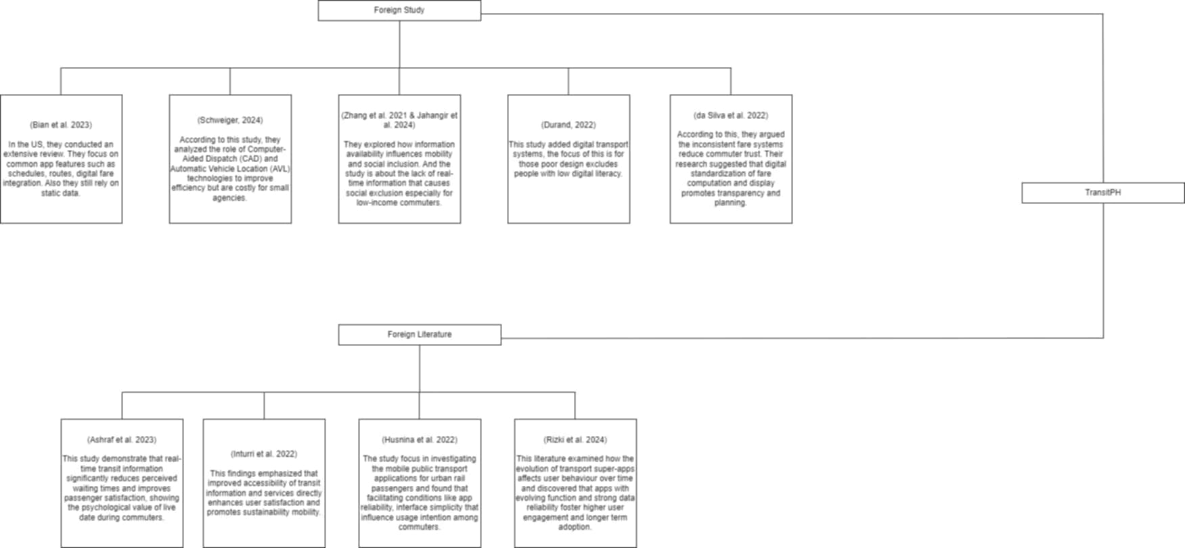 Figure 1. Foreign literature and study

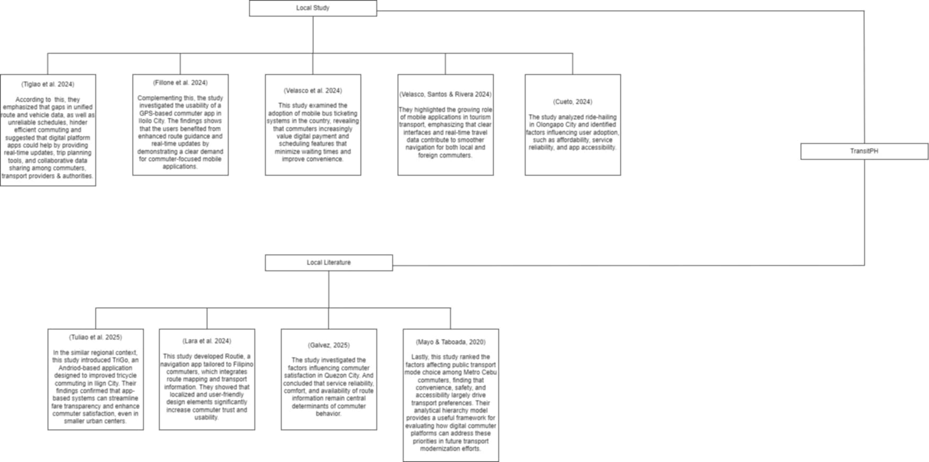

Figure 2. Local literature and study

Synthesis
The reviewed literature collectively underscores the growing significance of commuter-oriented mobile applications in enhancing accessibility, efficiency, and overall commuter satisfaction. Both foreign and local studies emphasize that digital mobility systems are vital in promoting data-driven, reliable, and user-friendly transport solutions. Foreign researchers particularly highlight the importance of real-time information accuracy, integrated transport networks, and commuter trust as key factors influencing the long-term adoption of such systems. Inturri et al. (2022) demonstrated that synchronized route and timing data can significantly improve commuter confidence and perceived reliability, while Ashraf et al. (2023) linked these technological improvements to reduced travel uncertainty and increased user satisfaction. These findings suggest that transport platforms thrive when users can depend on accurate information and efficient system design.
Local studies affirm similar patterns but place greater emphasis on contextual challenges such as infrastructure limitations and inconsistent transport data. Lara et al. (2024) introduced Routie, an application that aids Filipino commuters by providing accessible route information, addressing the fragmented nature of local commuting systems. Velasco et al. (2024) explored mobile bus ticketing adoption in the Philippines, showing that digital fare systems enhance transparency and convenience for both passengers and operators. Tuliao and Tandayu (2025) developed TriGO, an Android-based tricycle application aimed at improving local commuting through better coordination between drivers and passengers. Likewise, Cueto (2024) analyzed ride-hailing services in Olongapo City and revealed that mobile-based transport options are reshaping commuting behavior and promoting urban mobility. These local studies collectively reflect the Philippines’ gradual transition toward technology-driven solutions that prioritize accessibility, affordability, and commuter trust.

Comparatively, while foreign research tends to focus on technological innovation and system-wide integration, local studies emphasize practical implementation and adaptation to local conditions. Both bodies of work converge on the understanding that reliable, real-time, and context-aware commuting tools are essential to improving public transport experiences. Nonetheless, gaps remain in local research, particularly concerning unified route databases, intermodal transport integration, and the standardization of fare systems. Addressing these issues is critical to achieving large-scale adoption and commuter confidence.
In conclusion, this study builds upon existing literature with the proposed comprehensive and unified commuting platform that integrates route guidance, fare computation, and accessibility features. By consolidating these elements, the project seeks to enhance commuter trust and contribute to the modernization of the Philippine transport system through a more efficient and inclusive digital platform.

METHODOLOGY
The methodology outlines the research methods and procedures applied in the development of TransitPH: A Community-Driven Mobile App for CAMANAVA Public Transport Navigation through Crowdsourced Route Information in Collaboration with the Paano Pumunta Community, a commuter-oriented mobile application proposed by the researchers to address existing issues in public transportation accessibility and navigation. The study aims to develop a functional system that provides commuters with an easier way to view routes, schedules, and directions. This study utilizes the Modified Agile Methodology for the development process.
The Modified Agile Methodology follows the same iterative process as the traditional Agile framework but incorporates adjustments suited for small-scale, academic, or resource-limited projects. The process is as follows: Planning, Design, Development, Testing, Evaluation, and Deployment. The model allows the development team to iteratively plan, design, develop, test, and refine the system until the final version meets the desired functionality and usability standards.

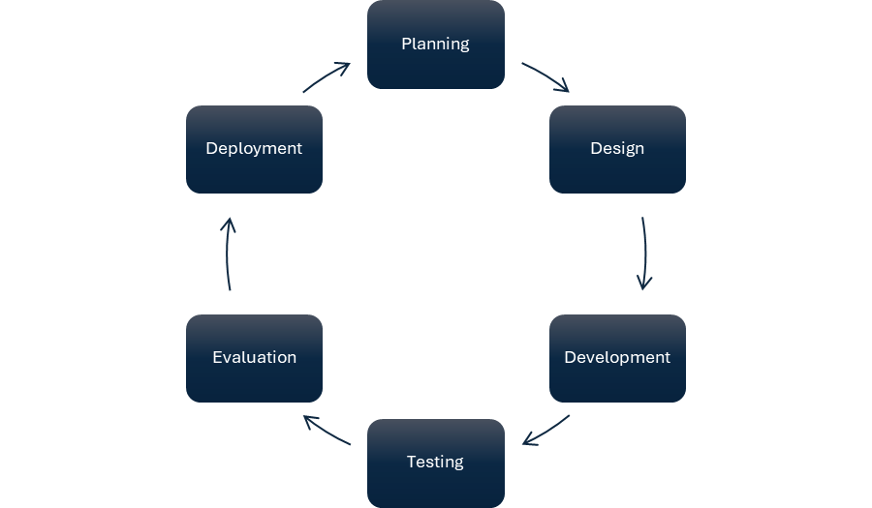Figure 3. Modified Agile methodology
Planning
During this phase, the researchers conducted surveys and informal interviews with students and daily commuters to determine common commuting difficulties such as locating routes, unclear schedules, and confusing navigation systems. Based on these findings, the scope and objectives of TransitPH were defined, focusing on features like real-time route display, schedule viewing, and user-friendly map navigation.
Design
The developers designed the TransitPH interface using wireframes and layout drafts that reflected the proposed system requirements. A clean and simple user interface was prioritized to ensure visual friendliness and ease of navigation for commuters. The design focused on clarity, accessibility, and responsiveness, ensuring that users can quickly view routes, schedules, and navigation options with minimal effort. Colors and layouts were chosen to maintain a commuter-friendly experience while emphasizing usability on mobile devices.
Development
In this phase, the researchers began the iterative construction of TransitPH using sprint cycles, a key element of the Modified Agile Methodology. Each sprint focused on implementing specific features such as route display, fare matrix viewing, or schedule navigation, followed by immediate testing and feedback collection. The application was developed using the Flutter framework, allowing for cross-platform deployment.
Testing
After each development sprint, the system underwent rigorous testing, including functionality testing, performance evaluation, and user acceptance testing (UAT) to verify its reliability and usability. The goal was to identify errors, assess responsiveness, and ensure that all implemented features operated as intended. User feedback and system testing was also conducted to identify interface issues or areas needing improvement. This included both internal testing by the researchers and external testing by the client to verify stability and performance.
Evaluation
During this stage, the researchers assessed the system’s overall effectiveness and usability based on user experience and performance outcomes. The evaluation involved gathering client feedback on navigation accuracy, ease of use, and satisfaction with the system’s main features. Adjustments and refinements were made according to the evaluation results to enhance user experience and ensure that the system met the identified commuter needs.
Deployment
The final system was presented to evaluators and tested in simulated commuting scenarios. The feedback collected at this stage is used to verify the app’s performance, stability, and usability. The results will confirm the system’s effectiveness in assisting commuters with route navigation and schedule tracking.
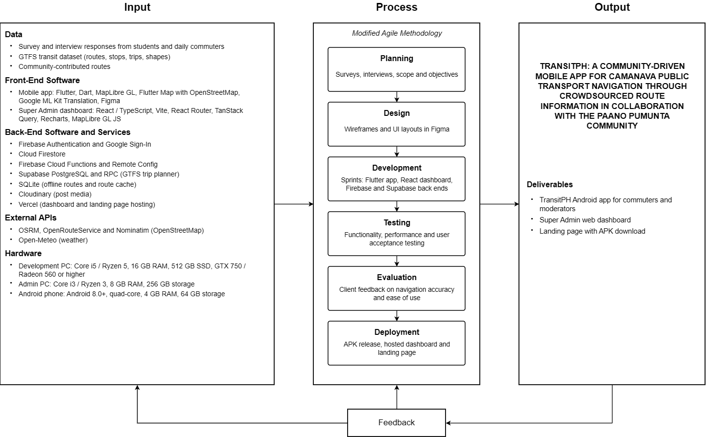

Figure 4. Conceptual framework

Respondent/Participant
The respondents of the study were 50 users who represented the target user and conceptual basis of the commuter application. The clients were purposively selected based on their relevance to the study and their familiarity with transportation challenges commonly encountered by commuters. The clients provided feedback through a questionnaire and additional clarifying discussions to identify essential system features and user experience requirements. Participation was voluntary, and the respondents were informed about the purpose of the study and how the data would be used strictly for academic purposes. The confidentiality of the client’s identity was maintained throughout the process.

Research Instrument
The primary instrument utilized in the study was a researcher-designed questionnaire and interview intended to gather comprehensive data concerning the client’s desired features, system functionality, and interface expectations. The instrument included both closed-ended questions, to quantify levels of importance or agreement, and open-ended questions, to obtain qualitative feedback. Prior to administration, the instrument underwent content validation by the research adviser to ensure its relevance, clarity, and alignment with the study’s objectives. The responses obtained served as the primary input for the conceptualization and development of the TransitPH prototype.

Data Gathering Procedure
The data collection process began with the preparation and validation of the survey questionnaire. After approval by the research adviser, the questionnaire was administered to the client, who provided online responses detailing the desired functionalities, layout preferences, and expected outcomes for the proposed commuter application. The responses were reviewed and organized by the researchers, who identified recurring themes and prioritized requirements based on the client’s stated needs. The summarized findings became the foundation for the design and development of the researcher’s system.

Data Analysis
The data collected from the client were analyzed using descriptive analysis. Closed-ended questions were summarized using counts and percentages to reflect their response pattern, while open-ended responses were analyzed qualitatively by categorizing them into thematic groups (e.g., experiences, accessibility, and inclusivity). The results of the analysis were used to determine the most relevant and essential features to create the TransitPH system. The client’s prioritized feedback guided the researchers in refining the design and functionalities, ensuring that the final system accurately reflected the identified commuter needs.

System Architecture
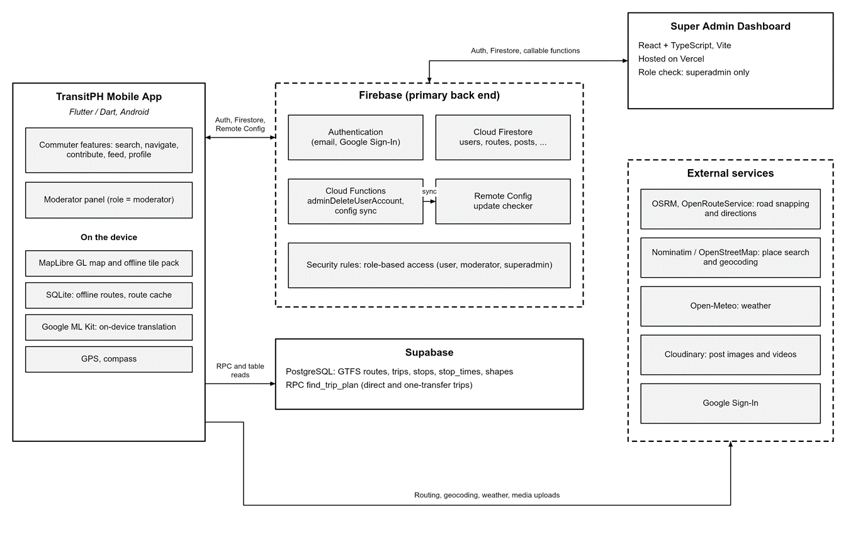Figure 5. System Architecture of TransitPH
The Flutter mobile app and the React Super Admin dashboard both use Firebase (Authentication, Cloud Firestore, Cloud Functions and Remote Config) as the primary back end. Supabase PostgreSQL stores the GTFS transit dataset and runs the trip-planning function. External services provide road snapping, geocoding, weather and media hosting.

Use case diagram
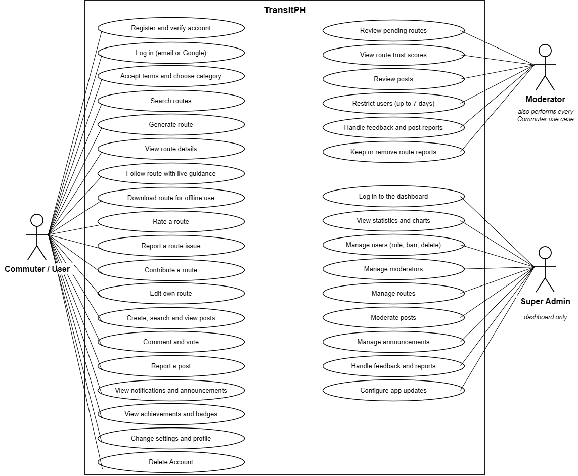
Figure 6. Use Case Diagram
NEEDS DESCRIPTION??

System design specification
Data Flow Diagram
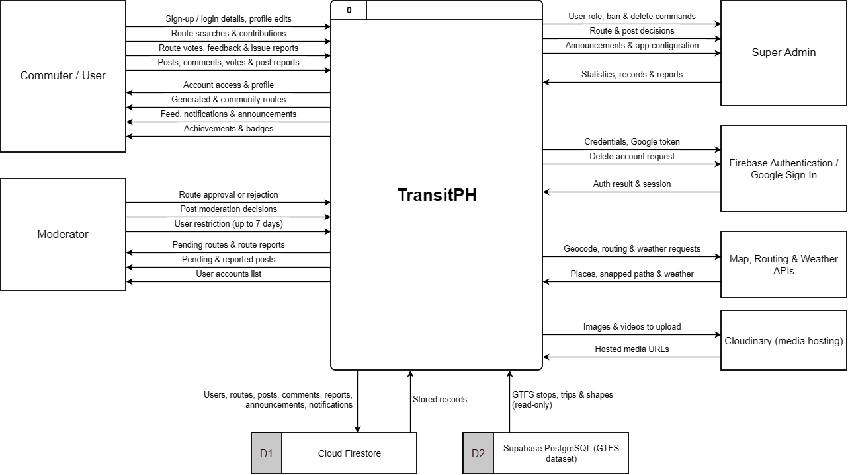Figure 7. Data flow diagram level 0
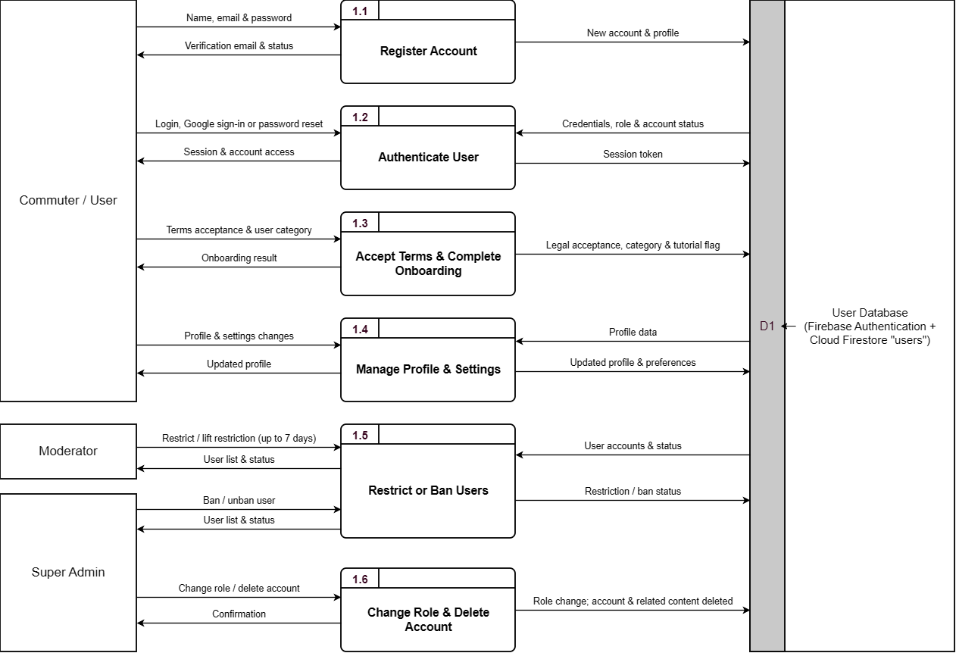Figure 8. Data flow diagram level 1 user management
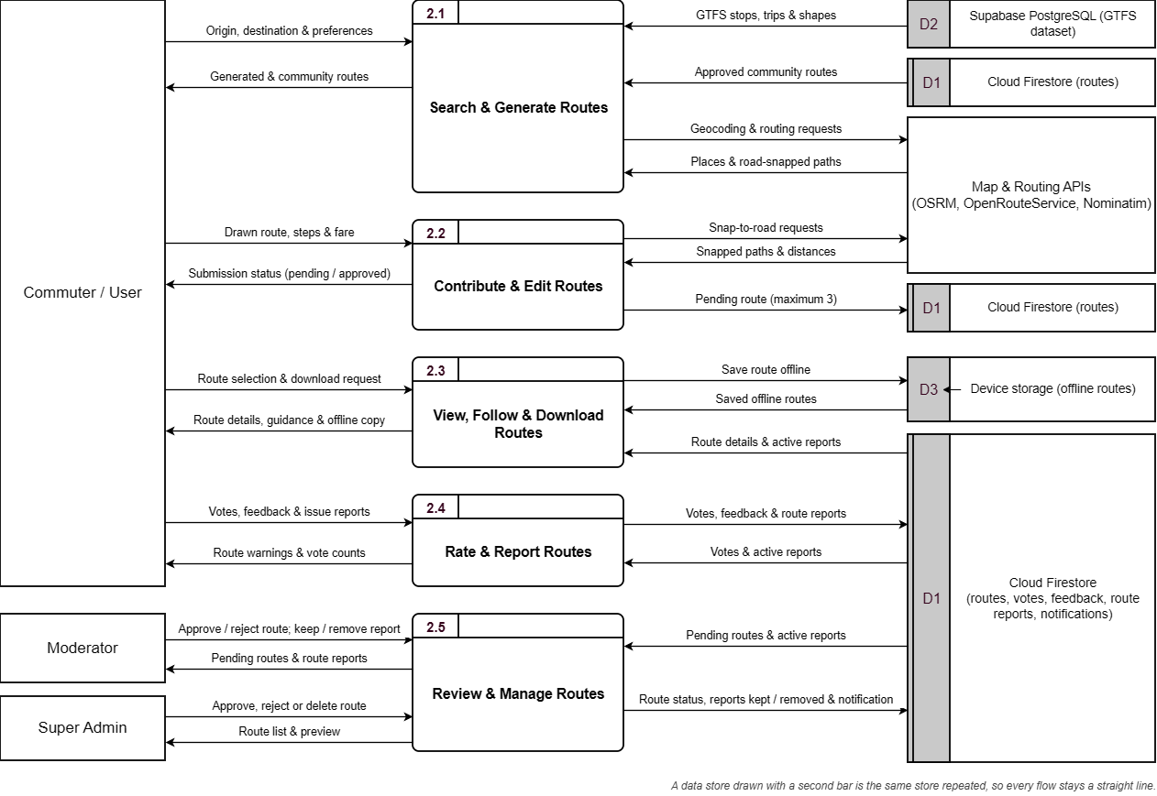

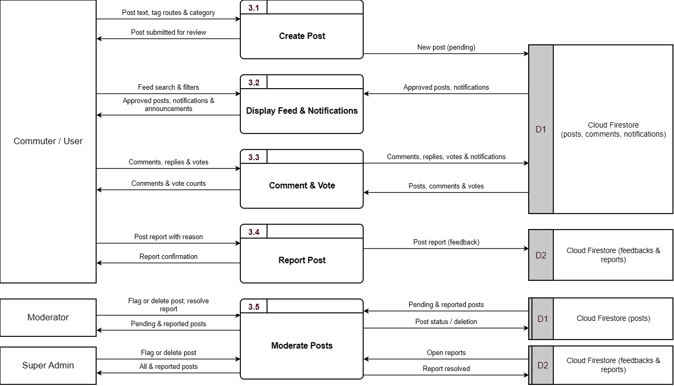
Figure 9. Data flow diagram level 1 route management

Figure 10. Data flow diagram level 1 community feed
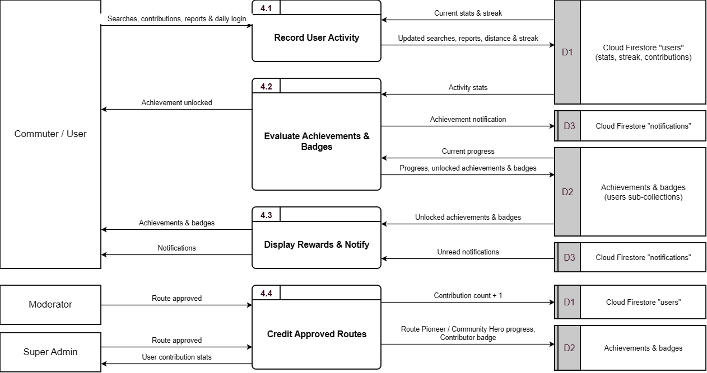

Figure 11. Data flow diagram level 1 gamification module
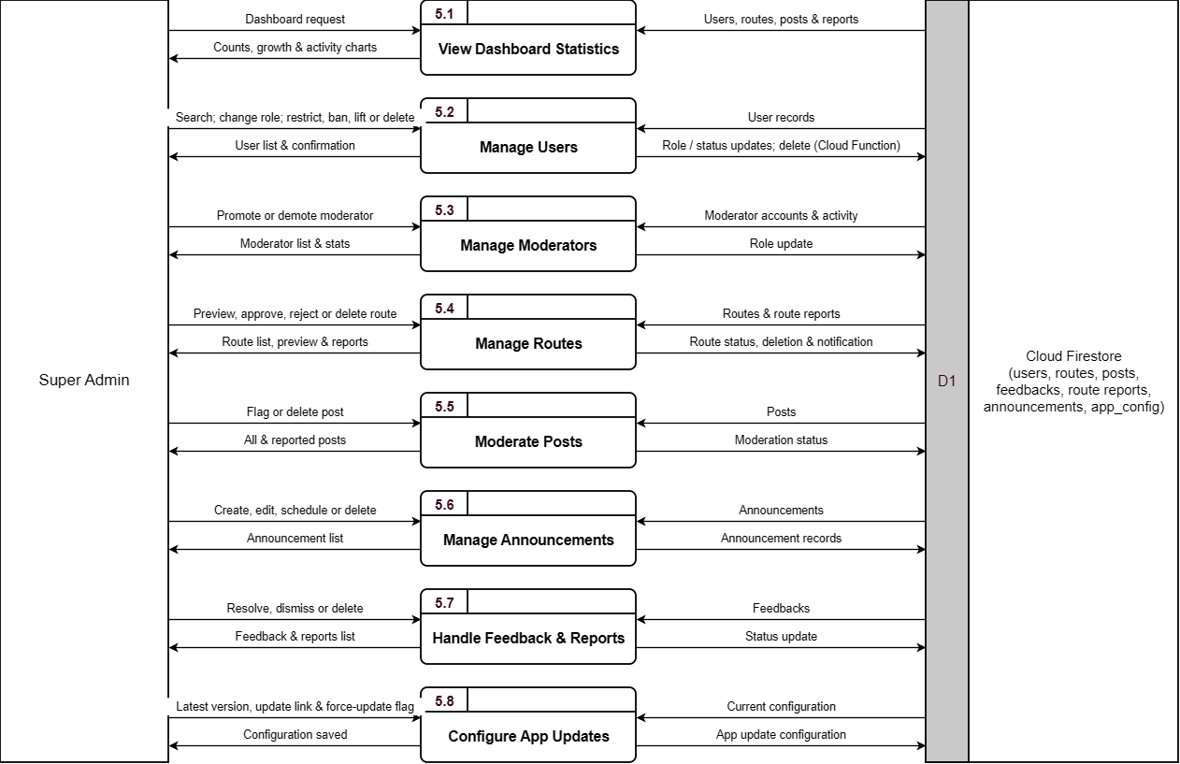
Figure 12. Data flow diagram level 1 admin dashboard
Hierarchical Input-Process-Output (HIPO) Diagram
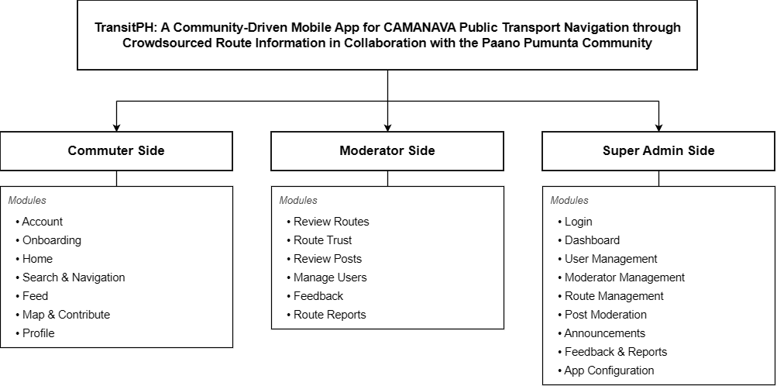
Figure 13. Overall HIPO diagram of TransitPH
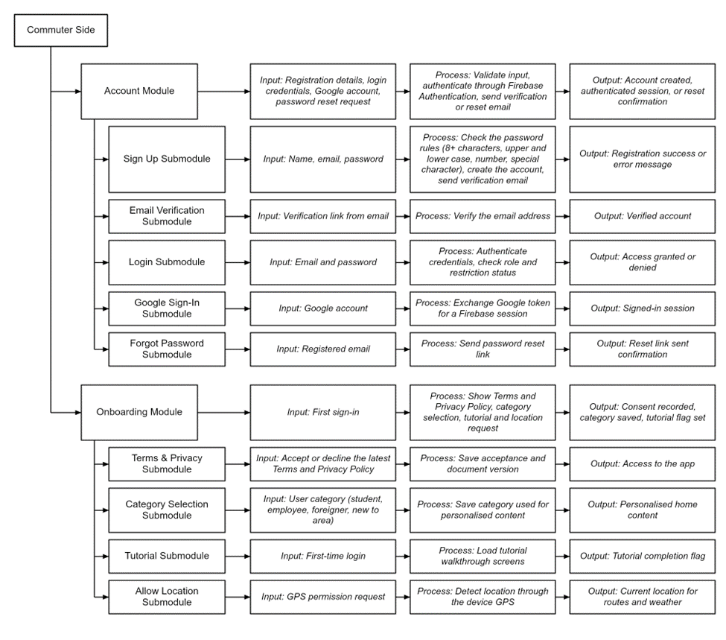
Figure 14. Part 1 HIPO diagram for commuter side
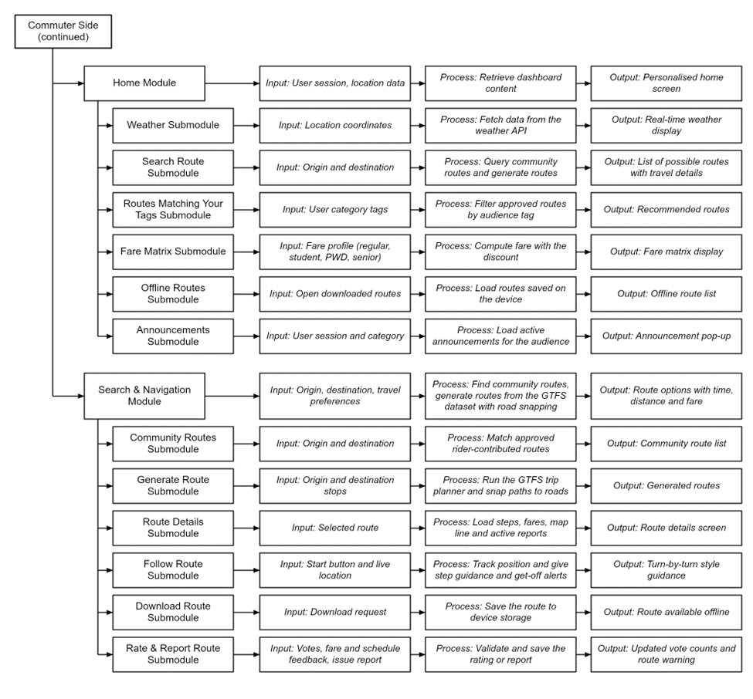
Figure 15. Part 2 HIPO diagram for commuter side

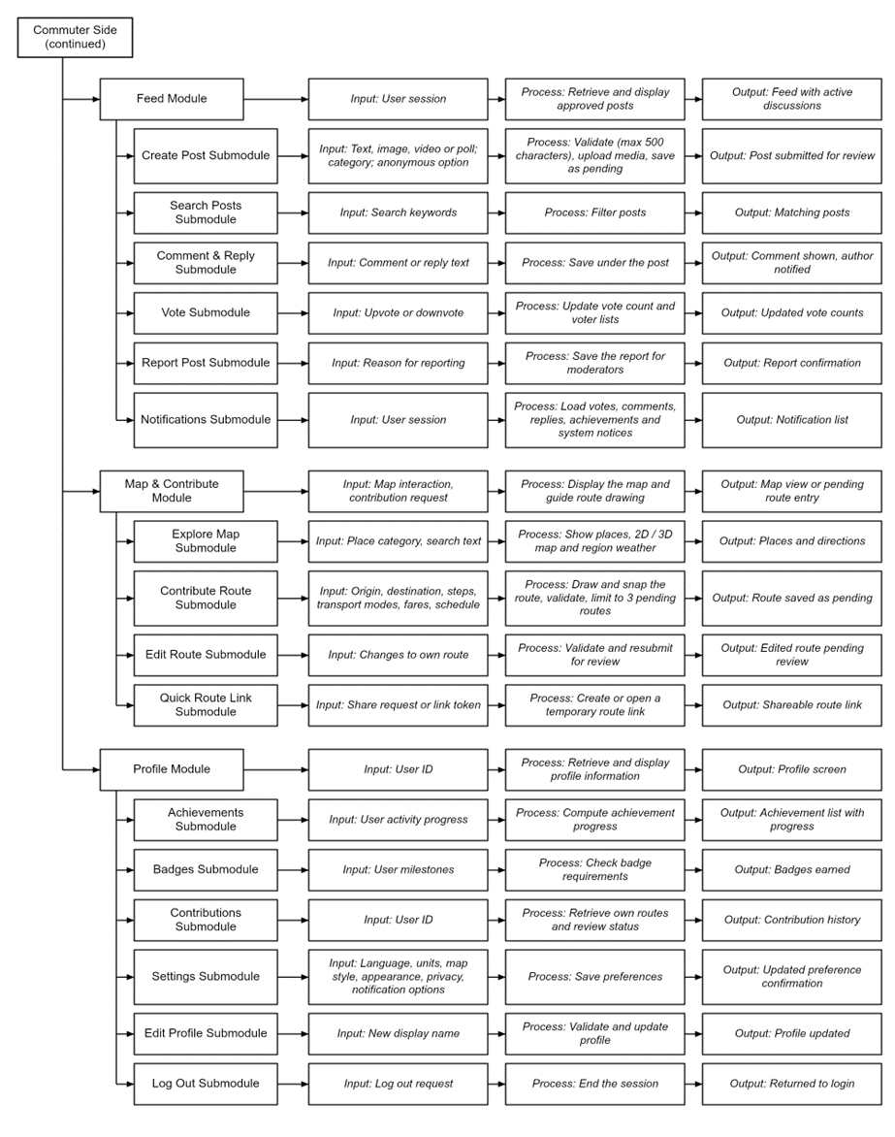
Figure 16. Part 3 HIPO diagram for commuter side

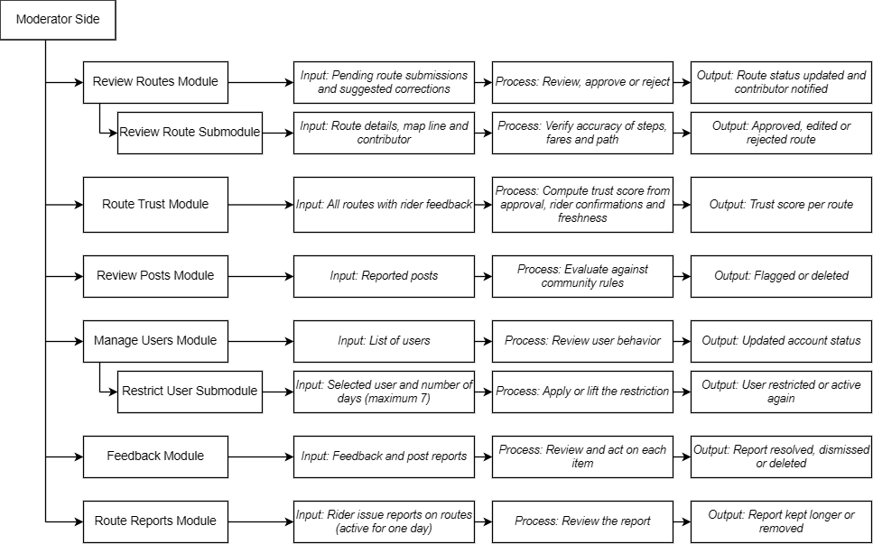
Figure 17. HIPO diagram for moderator side
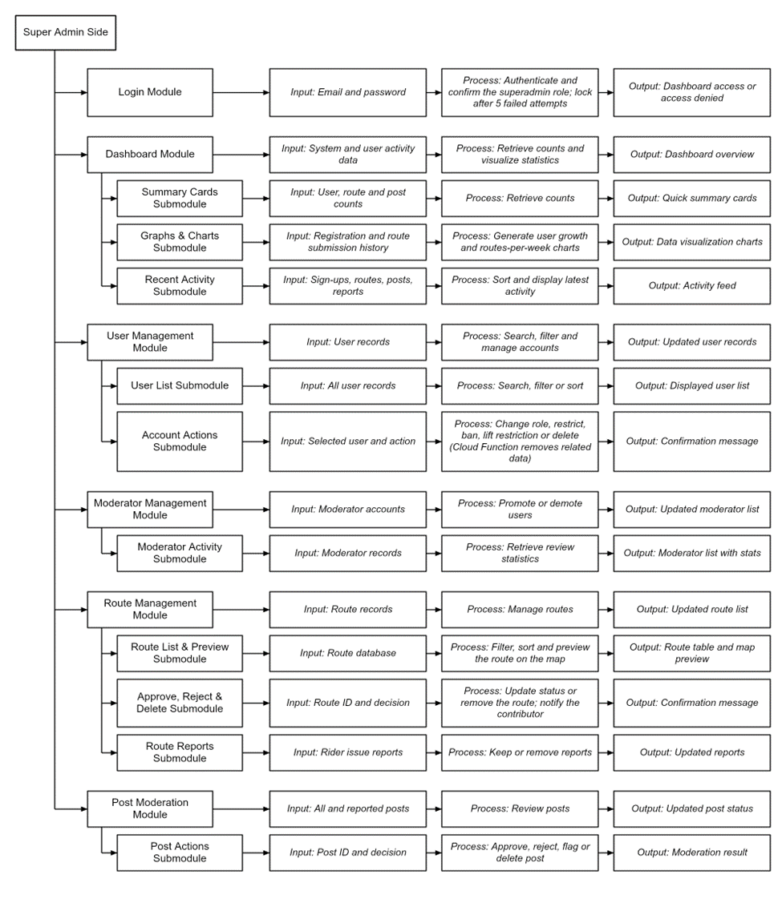
Figure 18. Part 1 HIPO diagram for superadmin side
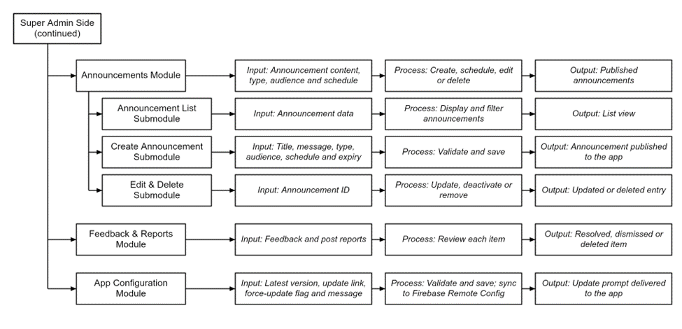

Figure 19. Part 2 HIPO diagram for superadmin side

Entity-Relationship Diagram
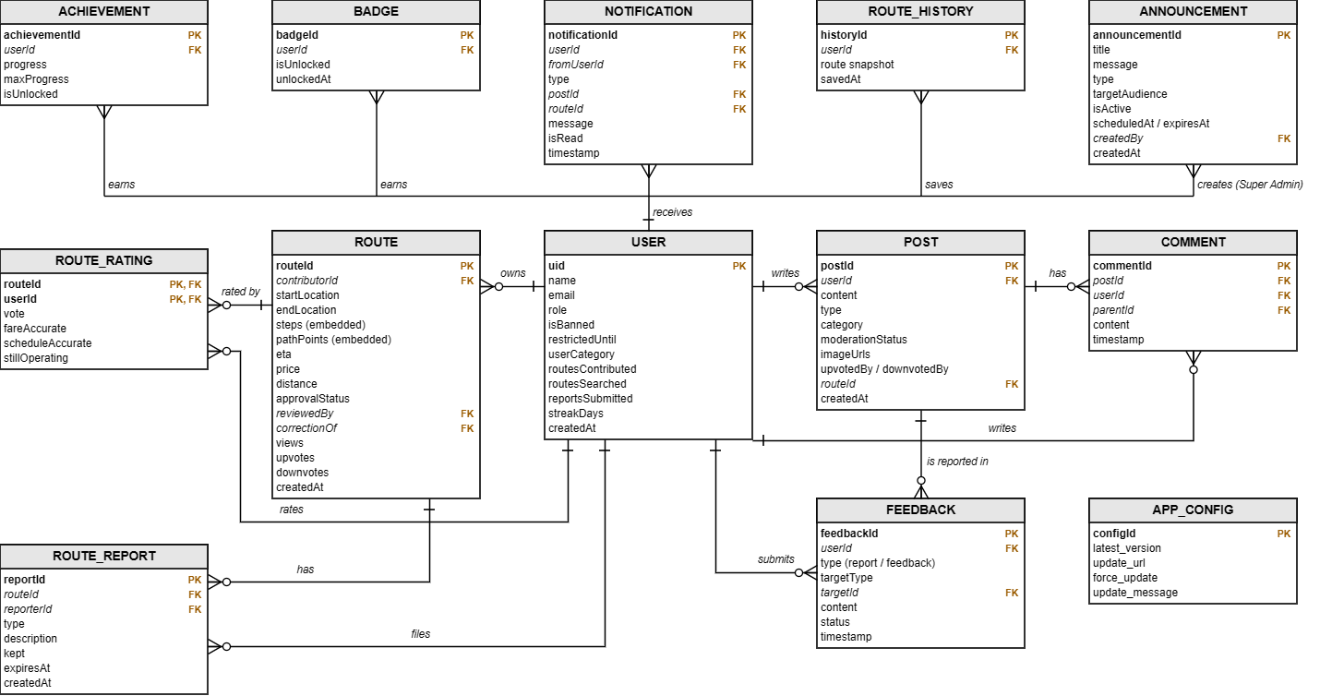

Figure 20. Entity-relationship diagram of TransitPH (Cloud Firestore)

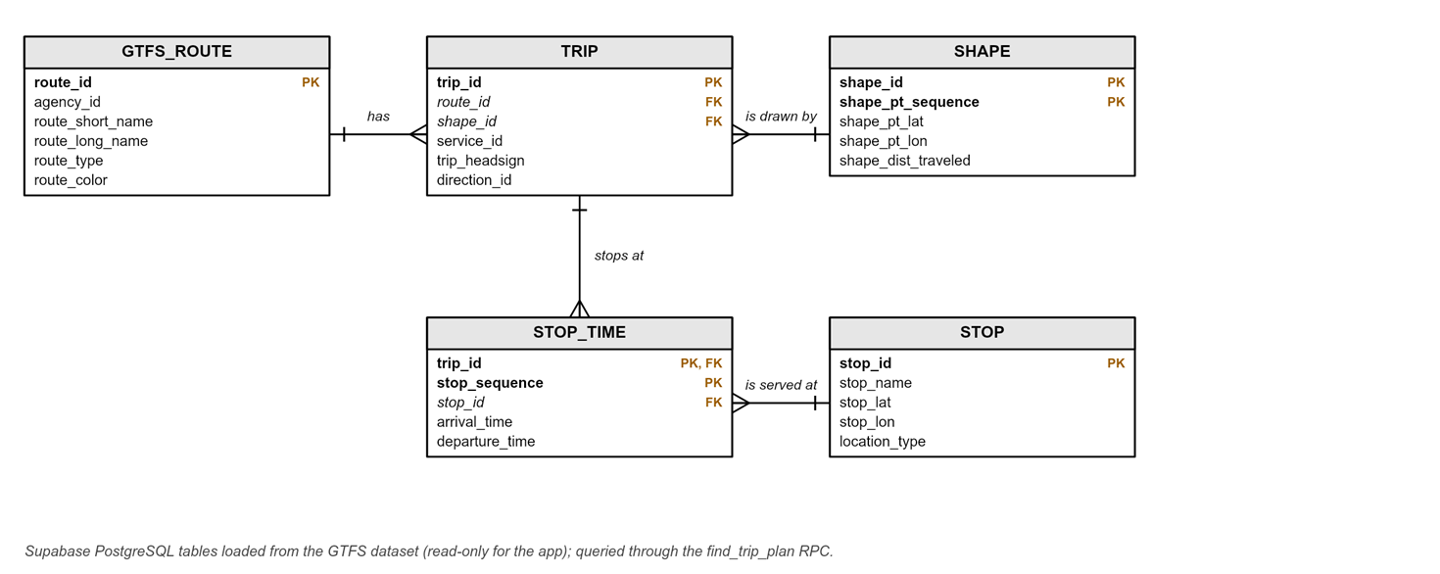
Figure 21. Entity-relationship diagram of the GTFS dataset (Supabase)

Hardware/Software
Hardware
The project does not require specialized hardware components for the TransitPH system itself. All functionality is implemented in software and run on standard consumer devices. However, a compatible device is essential to operate the application, whether for development, testing, or end-user use.
Hardware | Description
Processor: Intel® Core™ i3 (and above) or AMD Ryzen™ 3 (and above) | Ensures smooth system performance and responsiveness when managing large amounts of user data.
RAM: 8 GB minimum (16 GB recommended) | To handle the background processes efficiently.
Storage: At least 256 GB of storage | A minimum of 256 GB is necessary for system files and local data caching.
Graphics: Integrated Graphics (either Intel or AMD) or NVIDIA GTX 750 or higher | Allows for smoother operations and enhanced data visualization.
Table 1. Hardware requirements for Windows administrator(s)

Hardware | Description
Processor: Quadcore Processor or higher | Ensures smooth app performance and quick response.
RAM: 4 GB minimum (6 GB or higher recommended) | A minimum of 4 GB for stable operations and a 6 GB or higher for faster routes loading and multitasking
Storage: At least 64 GB of storage or higher | Gives enough space to install the app and store cached data.
Table 2. Hardware requirements for Android users
Hardware | Description
Processor: Intel® Core™ i5 (and above) or AMD Ryzen™ 5 (and above) | To handle compiling and emulation during development
RAM: 16 GB minimum (32 GB recommended) | To handle the background processes and multitasking.
Storage: At least 512 GB SSD storage or higher | For faster loading times, compiling, and handling large number of files used in the system
Graphics: NVIDIA GTX 750 or higher and Radeon 560 or higher | Helps with app simulation and handling hardware accelerated tasks.
Table 3. Hardware requirements for mobile and website system development
Software | Description
OS: Windows 10 and Mac OS X and above | Supported operating systems for running the admin web interface.
Microsoft Edge (or any modern browser) | A web browser is required to access the admin page.
Table 4. Software requirements for website application administrator(s)

Software | Description
OS: Android 8.0 (Oreo or higher) | Supported operating systems for running the application on Android devices.
Table 5. Software requirements for mobile application users
Front-End Software
The front-end component of the TransitPH prototype was developed using Flutter, an open-source user interface (UI) framework. Flutter, which utilizes the Dart programming language, enables the development of a cross-platform application through a single, unified codebase. This approach ensures consistency in design and functionality across various operating systems, including Android, with provisions for future web deployment.
To enhance the visual presentation and functionality of the interface, the Flutter Map package was employed together with the OpenStreetMap API to incorporate interactive mapping features. This allows users to view transit routes, station locations, and trip progress in real time. The front-end design emphasizes usability, responsiveness, and accessibility to provide a seamless user experience for commuters. In addition, a web-based landing page was developed using HTML and CSS to introduce TransitPH, present its key features, and guide users on how to access the application.

Software | Description
Flutter | Cross-platform UI framework for building mobile and web apps with a single codebase. Also Implements Flutter Compass, which reads the phone’s compass so the map and user marker face the same way as the user during Follow Route.
Dart | Programming language used with Flutter for efficient, high-performance front-end development.
Visual Studio Code | Lightweight IDE for coding, debugging, and managing Flutter/Dart projects.
OpenStreetMap | OpenFreeMap / OpenStreetMap data
Figma | Design tool for creating prototypes, wireframes, and UI mockups before development.
MapLibre GL | Open-source map engine that draws every map in the app (browsing, route view, Follow Route and route drawing), with smooth zoom, 3D tilts and 3D buildings.
Google ML Kit Translation | Translates app text on the device (for example, English and Filipino), and works offline once the language is downloaded.
Geolocator | A flutter plugin used to access the user’s current location for location-based features and navigation
Table 6. Front-end software requirements of the mobile application development
Software | Description
React / TypeScript | Builds admin pages (users, posts, routes, settings, etc.) and UI behavior.
Vite | Dev server and production build tool for the website dashboard.
React Router | Handles page navigation in the admin panel without full page reloads.
TanStack Query | Fetches Firestore backed data and keeps UI synced with server state.
Recharts | A charting library used to display data through interactive charts and graphs.
MapLibre GL JS | A JavaScript library used to display interactive maps on the web.
Radix UI and Lucide Icons | UI components and icon libraries used to create accessible interface elements and visual icons.
Table 7. Front-end software requirements of the superadmin website development
Software | Description
HTML | Defines the structure and content of the landing page website.
CSS | Styles the website’s layouts, colors, fonts, and responsive design.
JavaScript | Adds interactive and dynamic functionality to the website.
Google Fonts | Provides font styles used to improve the readability and visual appearance of the website.
Table 8. Front-end software requirements of the landing page website development

Back-End Software
The back-end system/database of the TransitPH system is implemented using a hybrid approach, utilizing both Firebase Database and Supabase for data handling. Firebase is the primary backend service, storing and providing real-time data synchronization through the Firestore. This allows instant updates for routes, discussions, reports, and system changes. Furthermore, Firebase Authentication will be implemented for handling the user login information and security to prevent data leaks. To complement this, Supa base Postgres SQL will be integrated for structured data management of the routing, more specifically the General Transit Feed Specification. It also supports Remote Procedure Call, allowing improved execution of complex SQL queries to be handled for complex trip planning.

In addition to Firebase, the system integrates external Application Programming Interfaces (APIs) to enhance its functionality. The OpenMeteo API is used to deliver real-time weather information, assisting users in planning their trips based on current weather conditions. Meanwhile, the OpenStreetMap API serves as the foundation for map and geolocation data, enabling accurate route visualization and navigation. Additionally, the OpenRouteService is integrated to provide advanced routing features such as distance calculation, route optimization, travel time estimation, and multi-modal navigation support, further improving the system’s route planning capabilities. Together with OSRM, which provides accurate road snapping, ensure the reliability, scalability, and responsiveness of the system in real-time operation. The web-based landing page is deployed through Vercel, a cloud platform that provides hosting, automatic deployment, and global content delivery for fast and reliable access. Its custom domain was registered through Name.com and linked to Vercel, giving TransitPH a professional and publicly accessible web address.

Software | Description
Firebase/Firestore | Cloud-based database for real-time data storage, user info, routes, reports, and admin page management.
Firebase Authentication | Authentication handles sign-in and sessions.
Supabase | Implements PostgreSQL (GTFS storing for route planning transit paths) and Remote Procedure Call (runs server-side SQL logic for complex trip planning).
OpenRouteService | An API used to generate road-following routes for walking and driving.
OpenMeteo | Weather API provides real-time data like temperature, precipitation, and humidity.
Nominatim (OpenStreetMap) | Searches places and addresses in the Philippines
OSRM (Open-Source Routing Machine) | Provides road geometry/snapping between points to make routes follow real roads.
SQLite | Provides functionality for offline mode and caching of auto generated routes in the app
Cloudinary | Cloud storage for the profile picture of the users.
Google Sign-In | Let’s users log in with their Google account through Firebase Authentication
Firebase Cloud Functions | A serverless computing service used to perform backend operations
Firestore Security Rules | Rules that control data access and permissions based on user roles and authentication.
Table 9. Back-end software requirements of the mobile application development
Software | Description
Firebase Authentication | Authenticates admin users and keeps auth session state.
Cloud Firestore | dashboard’s CRUD target for users, routes, posts, feedback, announcement, and app configuration.
Firebase Cloud Functions | A serverless service used to execute backend operations, such as managing user accounts and related data.
Vercel Hosting | A hosting platform used to deploy and serve the TransitPH super-admin website online.
Table 10. Back-end software requirements of the administrator website development
Software | Description
Vercel | Host and deploy the landing page website, making it accessible online.
Name.com | Provides domain registration and DNS management for the landing page website.
QR API | Generates a QR code containing the download link to the TransitPH APK hosted on GitHub releases, allowing users to scan the code and download the application.
Table 11. Back-end software requirements of the landing page website development

RESULTS AND DISCUSSIONS
This chapter presents the results of the User Acceptance Testing (UAT) conducted for the TransitPH application. The evaluation involved fourty-three (43) respondents, all moderators and members of the Paano Pumunta Facebook community, who used the application for their actual commutes. A survey questionnaire based on the ISO/IEC 25010 software quality model was used to assess eight characteristics: functional suitability, performance efficiency, compatibility, usability, reliability, security, maintainability and portability. Each item was rated on a four-point Likert scale, where 1 means Strongly disagree and 4 means Strongly agree. The responses were analyzed using the weighted mean and interpreted based on the scale shown in the tables. The findings for each UAT section are presented and discussed below.
1.1 Interpretation scale
Table 12 shows the scale used to interpret the weighted mean of each item and characteristic. A four-point Likert scale was used to measure the respondents’ level of agreement with each statement, ranging from 1 (Strongly disagree) to 4 (Strongly agree). The range of each interpretation was obtained by dividing the difference between the highest and lowest possible scores by the number of categories, giving an interval of 0.75.
Mean range | Interpretation
3.25 – 4.00 | Strongly agree
2.50 – 3.24 | Agree
1.75 – 2.49 | Disagree
1.00 – 1.74 | Strongly disagree
Table 12. Interpretation Scale for Weighted Mean
1.2 User Acceptance Testing Results
This section presents the results of the UAT for each of the eight (8) ISO/IEC 25010 quality characteristics. For each characteristic, a table shows the number of responses per rating, the weighted mean of each item, and its corresponding interpretation, followed by a discussion of the findings.
1.2.1 Functional Suitability
Indicator | 1 | 2 | 3 | 4 | Mean | Interpretation
Generates routes from starting point to destination | 0 | 1 | 11 | 31 | 3.70 | Strongly agree
Fares and travel times are close to actual | 1 | 1 | 18 | 23 | 3.47 | Strongly agree
Step-by-step directions are accurate | 0 | 2 | 15 | 26 | 3.58 | Strongly agree
Shows current and next step, and alerts before the stop | 0 | 0 | 18 | 25 | 3.58 | Strongly agree
Features help plan and complete the commute | 0 | 2 | 8 | 33 | 3.72 | Strongly agree
Overall |  |  |  |  | 3.60 | Strongly agree
Table 13. Weighted mean for functional suitability
Table 13 presents the respondents' evaluation of the functional suitability of TransitPH, which obtained an overall weighted mean of 3.60, interpreted as Strongly Agree. Features that help plan and complete the commute received the highest rating (3.72), with 33 of the 43 respondents strongly agreeing that the features implemented in the system helps with commuting. Accurate generated routes from starting point to destination received a mean of 3.70, indicating that the point to point route was implemented properly. While still rated high, step-by-step direction accuracy has 4.7% of people disagreeing with the accuracy, and 2.3% strongly disagreeing with fares and travel time shown is realistic. This indicates that there may be differing calculation/route sharing for each region that needs to be better specified.
1.2.2 Performance Efficiency
Indicator | 1 | 2 | 3 | 4 | Mean | Interpretation
Routes appear within an acceptable time | 0 | 5 | 18 | 20 | 3.35 | Strongly agree
Map loads, moves and zooms smoothly | 0 | 2 | 17 | 24 | 3.51 | Strongly agree
Live location updates quickly while following a route | 0 | 1 | 16 | 26 | 3.58 | Strongly agree
Battery efficient with minimal mobile data usage | 0 | 5 | 14 | 24 | 3.44 | Strongly agree
Overall |  |  |  |  | 3.47 | Strongly agree
Table 14. Weighted mean for Performance Efficiency
Table 14 shows that the performance efficiency of TransitPH obtained an overall weighted mean of 3.47, interpreted as Strongly Agree. This was the lowest overall mean among the eight characteristics, although it remains within the Strongly Agree range. Live location updates while following a route received the highest rating (3.58), with 26 respondents strongly agreeing, and the smoothness of the map (3.51) was also rated highly. Acceptable route generation time (3.35) and battery and mobile data efficiency (3.44) received the lowest ratings, with five respondents rating each item 2 (Disagree). Route generation requires processing and a network request, and battery use rises when GPS tracking runs during navigation, so these two items may reflect the demands of the feature rather than a defect. Two respondents mentioned slight lag in their comments, one of them while creating a custom route.
1.2.3 Compatibility
Indicator | 1 | 2 | 3 | 4 | Mean | Interpretation
Works normally while other apps are running | 0 | 1 | 9 | 31 | 3.65 | Strongly agree
Route following works in the background, and alerts appear alongside other notifications | 0 | 1 | 21 | 21 | 3.47 | Strongly agree
Works with the phone's GPS, location settings and Google sign-in | 0 | 2 | 13 | 28 | 3.60 | Strongly agree
Overall |  |  |  |  | 3.57 | Strongly agree
Table 15. Weighted mean for Compatibility
Table 15 shows that compatibility obtained an overall weighted mean of 3.57, interpreted as Strongly Agree. The ability of TransitPH to work normally while other apps are running received the highest rating (3.65), with 31 of the respondents strongly agreeing. Background route following and integration with the phone's GPS, location settings and Google sign-in received a mean of 3.47 and 3.60 respectively. The latter had two respondents disagreeing, which may be due to differences in location settings, battery optimization or other phone configuration that may affect user experience.

1.2.4 Usability
Indicator | 1 | 2 | 3 | 4 | Mean | Interpretation
Easy to understand what each screen and button is used for | 0 | 3 | 12 | 28 | 3.58 | Strongly agree
Learned to search for and follow a route through the welcome cards and tutorial | 0 | 2 | 9 | 32 | 3.70 | Strongly agree
Contributing a route is easy to do | 1 | 4 | 16 | 22 | 3.37 | Strongly agree
Handles unusual or unexpected situations properly | 0 | 5 | 16 | 20 | 3.35 | Strongly agree
Colors, text and icons are clear, readable and pleasant in light and dark mode | 0 | 4 | 9 | 30 | 3.60 | Strongly agree
Overall |  |  |  |  | 3.52 | Strongly agree
Table 16. Weighted mean for Usability
Table 16 shows that the usability of TransitPH obtained an overall weighted mean of 3.52, interpreted as Strongly Agree. The welcome cards and tutorial button received the highest rating (3.70), with 32 respondents strongly agreeing.. The clarity of the user interface in both light and dark mode (3.60) and the ease of understanding each screen and button (3.58) were also rated highly. While contributing a route is easy to was also rated highly (3.37), it is one of the lowest in the 8 characteristics with 11.6% of respondents either disagreeing or strongly disagreeing with the ease of contribution. Contributing a route involves drawing and selecting different modes, which is a more complex task than searching for a route and may explain the lower rating. Several respondents also suggested improving the layout and visual design, simplifying the dashboard and adding a mode for senior users.
1.2.5 Reliability
Indicator | 1 | 2 | 3 | 4 | Mean | Interpretation
Runs without crashing or freezing | 0 | 2 | 10 | 31 | 3.67 | Strongly agree
Available and works whenever needed | 0 | 2 | 14 | 27 | 3.58 | Strongly agree
Downloaded routes and built-in map work with weak or no internet | 0 | 4 | 12 | 27 | 3.53 | Strongly agree
Route, account, contributions and settings are kept after losing signal or reopening the app | 0 | 4 | 14 | 25 | 3.49 | Strongly agree
Overall |  |  |  |  | 3.57 | Strongly agree
Table 17. Weighted mean for Reliability
Table 17 presents the results for reliability, which obtained an overall weighted mean of 3.57, interpreted as Strongly Agree. The highest-rated item was that the app runs without crashing or freezing (3.67), with 31 of 43 respondents strongly agreeing, followed by availability whenever needed (3.58). Offline use of downloaded routes and the built-in map (3.53) and continuing a route after losing signal or reopening the app (3.49) received the lowest means, with four respondents rating each item 2 (Disagree). Even so, both remained within the Strongly Agree range, and respondents who commented on offline use described it as helpful, which supports the app's ability to maintain service under weak or no internet connection.

1.2.6 Security
Indicator | 1 | 2 | 3 | 4 | Mean | Interpretation
Account is protected by a login, and only the owner can edit the profile and contributions | 0 | 3 | 9 | 31 | 3.65 | Strongly agree
Location is only used during app use and never shown to other users | 0 | 0 | 14 | 29 | 3.67 | Strongly agree
Contributed routes and posts are reviewed by moderators before publishing | 0 | 5 | 13 | 25 | 3.47 | Strongly agree
Terms and Conditions and Privacy Policy are explained, and consent is asked before using data | 0 | 0 | 7 | 36 | 3.84 | Strongly agree
Overall |  |  |  |  | 3.66 | Strongly agree
Table 18. Weighted mean for Security
Table 18 shows that the security of TransitPH obtained an overall weighted mean of 3.66, interpreted as Strongly Agree, the second highest among the eight characteristics. The clear explanation of the Terms and Conditions and Privacy Policy, together with requests for consent and permissions, received the highest rating in the entire survey (3.84), with 36 of 43 respondents strongly agreeing and none rating below 3. Use of location only while the app is in use or a route is followed, and never shown to other users, was rated 3.67, and login protection of accounts and contributions was rated 3.65. Moderator review of contributed or edited routes and user posts received the lowest rating (3.47), with five respondents rating it 2 (disagree). This may be because moderation happens behind the scenes, so users have little direct evidence that it takes place.

1.2.7 Maintainability
Indicator | 1 | 2 | 3 | 4 | Mean | Interpretation
Notifies when a new version is available, and updating is easy | 0 | 2 | 15 | 26 | 3.56 | Strongly agree
Reported problems are acted on, and corrections show up in the app | 0 | 4 | 14 | 25 | 3.49 | Strongly agree
Overall |  |  |  |  | 3.52 | Strongly agree
Table 19. Weighted mean for Maintainability
Table 19 presents the results for maintainability, which obtained an overall weighted mean of 3.52, interpreted as Strongly Agree. Notification of new versions and ease of updating received a mean of 3.56, with 26 of 43 respondents strongly agreeing. Reported problems are acted on and corrected, received a slightly lower mean of 3.49, with four respondents rating it 2 (disagree). Because this item depends on how quickly reported problems are resolved and released, some respondents may not have had the chance to observe the full report-to-correction cycle during testing.
1.2.8 Portability
Indicator | 1 | 2 | 3 | 4 | Mean | Interpretation
Easy to download and install on an Android phone | 0 | 3 | 5 | 35 | 3.74 | Strongly agree
Adjusts well to the phone's screen size and settings, such as light or dark mode | 0 | 2 | 8 | 33 | 3.72 | Strongly agree
Installing and updating through the in-app update prompt is straightforward | 0 | 3 | 9 | 31 | 3.65 | Strongly agree
Overall |  |  |  |  | 3.71 | Strongly agree
Table 20. Weighted mean for Portability
Table 20 shows that the portability of TransitPH obtained an overall weighted mean of 3.71, interpreted as Strongly Agree, the highest among the eight characteristics. Ease of downloading and installing the app on an Android phone received the highest rating (3.74), with 35 of 43 respondents strongly agreeing, followed by adjusting to the phone's screen size and settings such as light and dark mode (3.72) and installing and updating through the in-app update prompt (3.65). No respondent rated any item lower than disagree, and the three items that were at most three respondents. Two respondents suggested making the app available through the Google Play Store or App Store, which could make installation even easier for users.
1.3 Summary of results
Quality characteristic | Mean | Interpretation
Functional suitability | 3.60 | Strongly agree
Performance efficiency | 3.47 | Strongly agree
Compatibility | 3.57 | Strongly agree
Usability | 3.52 | Strongly agree
Reliability | 3.57 | Strongly agree
Security | 3.66 | Strongly agree
Maintainability | 3.52 | Strongly agree
Portability | 3.71 | Strongly agree
Overall | 3.58 | Strongly agree
Table 21. Summary of Weighted Mean for User Acceptance Testing
Table 21 summarizes the weighted mean of the eight quality characteristics. TransitPH obtained a grand weighted mean of 3.58, interpreted as Strongly Agree, and all eight characteristics fell within the Strongly Agree range (3.26 to 4.00). Portability (3.71) and Security (3.66) received the highest means, while Performance Efficiency (3.47) received the lowest. Of the 1,290 ratings collected (43 respondents across 30 items), 825 (64.0%) were 4 (Strongly agree), 386 (29.9%) were 3 (Agree), 77 (6.0%) were 2 (Disagree) and 2 (0.2%) were 1 (Strongly disagree). The two lowest-rated items were route generation time and the handling of unusual or unexpected situations (both 3.35), followed by ease of contributing a route (3.37). These items, together with the respondents' comments on user interface design, traffic information and app store availability, point to areas for future improvement. The overall mean remains 3.58 when the three respondents who had not yet tested the features are excluded.

CONCLUSION
The first part of this section is your summary, followed by the conclusion/s, and the last part is/are your recommendation/s.
This section summarizes the results based on the results and discussion chapter. If there are only three specific questions or objectives, there are only three results summarized in this section and no presentation of tables or figures. A good summary should be comprehensive. A summary must be concise. Your summary should be considerably shorter than the source. Avoid repetitive details. A summary must be coherent and independent. You are expected to maintain your own voice throughout the summary. Don’t simply quote other researcher’s works; instead use your own words to express your understanding of what you have read. After all, your summary is based on your interpretation of the findings, points, or ideas. However, you should be careful not to create any misinterpretation or distortion by introducing comments or criticisms of your own
Conclusions should unite with the findings and accomplishments of the study. If there are three summaries, there should also be three conclusions. Conclusions are arranged as they appear in the findings. Moreover, rejection and acceptance of hypotheses, if applicable, are explained under conclusion. Only conclusions which are based definitely on the findings or results should be made. Mere opinions which have no basis of facts and findings have no place in the conclusions of the study.
Recommendations are based on the conclusions. It may include further research of the study and/or enhancement of the developed system.
In the succeeding paragraphs, there should be no indentations, paragraphs are justified with left alignment. Delete this highlighted section and replace it with your content.

REFERENCES
Ashraf, M. T., Dey, K., Carrola, A., & Shi, X. (2023). Impacts of real-time transit information on transit accessibility – A case study. Journal of Public Transportation, 25, 100043. ISSN 1077-291X. doi.org/10.1016/j.jpubtr.2023.100043
Bayne, A., Siegfried, A., Beck, L. F., & Freund, K. (2021). Barriers and facilitators of older adults' use of ride share services. Journal of Transport & Health, 21, 101055. sciencedirect.com/science/article/pii/S2214140521000852
Bian, J., Li, W., & Lee, C. (2023). Current practices and emerging trends of transit apps for fixed-route bus services in the US. Journal of Public Transportation, 25(1), Article 100052. sciencedirect.com/science/article/pii/S1077291X23000139
Cueto, A. (2024). An analysis of ride-hailing services as mode of public transport in Olongapo City, Philippines. Transportation Science Society of the Philippines. studocu.com/ph/u/120052629?sid=01762779386&page=1
da Silva, D., Klumpenhouwer, W., Karner, A., Robinson, M., Liu, R., & Shalaby, A. (2022). Living on a fare: Modeling and quantifying the effects of fare budgets on transit access and equity. researchgate.net/publication/360282065_Living_on_a_fare_Modeling_and_quantifying_the_effects_of_fare_budgets_on_transit_access_and_equity
Durand, P. (2022). Access denied? Digital inequality in transport services. Transport Reviews, 42(5), 603–623. tandfonline.com/doi/full/10.1080/01441647.2021.1923584
Fillone, J., Tamon, R., & Torrendon, L. (2024). The usability of ByaHero: A GPS-based app for navigating public transportation routes in Iloilo City, Philippines. International Journal of Research in Engineering and Science. Retrieved November 11, 2025, from ijres.org/papers/Volume-12/Issue-11/121197100.pdf
Galvez, L. M. C., Katon, P. K. R., & Valdez, K. G. P. (2025). Exploring the factors influencing commuters' satisfaction and the use of public utility buses in Quezon City, Philippines. International Review of Social Sciences Research, 5(1), 73–105. doi.org/10.53378/irssr.353147
Gumasing, M. J. J., Bermejo, F. J. C. S., Elpedes, K. T. C., Gonzales, L. F. E., & Villajin, A. C. V. (2023). Antecedents of Waze mobile application usage as a solution for sustainable traffic management among Gen Z. Sustainability, 15(13), 10186. doi.org/10.3390/su151310186
He, S. Y., Chen, X., & Tao, S. (2023). Long commutes, work-life balance, and well-being: A mixed-methods study of Hong Kong's new-town residents. Journal of Planning Education and Research, 45(1), 135–147. doi.org/10.1177/0739456X231188301
Husnina, S., Mokhtar, S., Shah, M., Husny, Z., Sinniah, G., & Abdul Ghani, N. (2022). Mobile public transportation application: Factors influencing urban rail transit passengers' use. Journal of Cognitive Sciences and Human Development, 8, 179–198. researchgate.net/publication/364078084_Mobile_Public_Transportation_Application_Factors_Influencing_Urban_Rail_Transit_Passengers'_Use
Inturri, G., Giuffrida, N., Le Pira, M., Fazio, M., & Ignaccolo, M. (2021). Linking public transport user satisfaction with service accessibility for sustainable mobility planning. ISPRS International Journal of Geo-Information, 10(4), 235. researchgate.net/publication/350693098_Linking_Public_Transport_User_Satisfaction_with_Service_Accessibility_for_Sustainable_Mobility_Planning
Jahangir, S., Karim, R., & Ahmed, T. (2024). Unequal access to public transport and transport-related social exclusion: A systematic review. PubMed Central. ncbi.nlm.nih.gov/pmc/articles/PMC11308260
Lara, M., Santos, J., & Rivera, P. (2024). Routie: An application to help aid commuters in the Philippines. ResearchGate. researchgate.net/publication/382616376_Routie_An_Application_to_Help_Aid_Commuters_in_the_Philipines
Macedo, E., Teixeira, J., Sampaio, C., Silva, N., Coelho, M., Glinos, M., & Bandeira, J. (2021). Real-time information systems for public transport: User perspective. Transportation Research Procedia, 52, 732–739. doi.org/10.1016/j.trpro.2021.01.088
Mayo, F., & Taboada, E. (2020). Ranking factors affecting public transport mode choice of commuters in an urban city of a developing country using analytic hierarchy process: The case of Metro Cebu, Philippines. Transportation Research Interdisciplinary Perspectives, 4, 100078. doi.org/10.1016/j.trip.2019.100078
Monteiro, M. M., de Abreu e Silva, J., Ingvardson, J. B., Nielsen, O. A., & Pinho de Sousa, J. (2021). Public transport use and satisfaction by international students and researchers. Sustainability, 13(15), 8417. doi.org/10.3390/su13158417
Navarro, A. M., & Latigar, A. G. (2022). Road and rail transport infrastructure in the Philippines: Current state, issues, and challenges (PIDS Discussion Paper Series No. 2022-15). Philippine Institute for Development Studies. pids.gov.ph/publication/discussion-papers/road-and-rail-transport-infrastructure-in-the-philippines-current-state-issues-and-challenges
Rizki, M., Joewono, T., & Susilo, Y. (2024). The influence of app function evolution on transport SuperApp use behaviour over time. Transportation, 52, 2075–2116. doi.org/10.1007/s11116-024-10485-6
Roquel, K. I. D., Abad, R. P., & Fillone, A. (2021). Proximity indexing of public transport terminals in Metro Manila. Sustainability, 13(8), 4216. doi.org/10.3390/su13084216
Schweiger, H. (2024). Transit fare payment and computer-aided dispatch (CAD)/automatic vehicle location (AVL): Review and recommendations. ResearchGate. researchgate.net/publication/385352040_Transit_Fare_Payment_and_Computer-aided_Dispatch_CADAutomatic_Vehicle_Location_AVL_Review_and_Recommendations
Shi, J., Bai, T., Zhao, Z., & Tan, H. (2024). Driving economic growth through transportation infrastructure: An in-depth spatial econometric analysis. Sustainability, 16(10), 4283. doi.org/10.3390/su16104283
Small, K. A., Verhoef, E. T., & Lindsey, R. (2024). The economics of urban transportation (3rd ed.). Routledge. doi.org/10.4324/9781315157375
Tiglao, N. C. C., Ng, A. C. L., Tacderas, M. A. Y., & Tolentino, N. J. Y. (2023). Crowdsourcing, digital co-production and collaborative governance for modernizing local public transport services: The exemplar of General Santos City, Philippines. Research in Transportation Economics. sciencedirect.com/science/article/pii/S0739885923000689
Tuliao, E., & Tandayu, R. (2025). TriGO: An Android-based app for enhancing tricycle commuting in the City of Ilagan, Philippines. Scientific Journal of Engineering, and Technology, 2, 128–133. doi.org/10.69739/sjet.v2i2.971
Velasco, R., Santos, J., & Rivera, P. (2024a). Elevating Philippine tourism: A mobile app approach. ResearchGate. researchgate.net/publication/383288460_Elevating_Philippine_Tourism_A_Mobile_App_Approach
Velasco, R., Dela Cruz, M., & Tan, J. (2024b). Mobile bus ticketing system: Development and adoption in the Philippines. ResearchGate. researchgate.net/publication/341125687_An_evaluation_of_the_benefits_of_mobile_fare_payment_technology_from_the_user_and_operator_perspectives
Zhang, J., Ma, Y., & Lyu, B. (2021). Relationships between user knowledge sharing in virtual community with community loyalty and satisfaction. Psychology Research and Behavior Management, 14, 1509–1523. doi.org/10.2147/PRBM.S331132
Zhang, L., Liu, H., & Chen, Y. (2021). Research on accessibility and equity of urban transport. Journal of Urban Planning and Development, 147(4), 04021034. onlinelibrary.wiley.com/doi/10.1155/2021/1103331

APPENDICES

APPENDIX A. GANTT CHAR

MONTH | JUNE |  |  |  | JULY |  |  |  | AUGUST |  |  |  | SEPTEMBER |  |  |  | OCTOBER |  |  |  | NOVEMBER |  |  |  | DECEMBER |  |  |  | JANUARY |  |  |  | FEBRUARY |  |  |  | MARCH
ACTIVITY
Planning
Title Proposal
Finding Client
C1: Introduction
C2: Methodology
Consultation
20% System
40-50% System
60-70% System
70-80% System
Debug and Test
Moderator Acc
90% Admin Web
Consultation
Obj 1 Progress
Obj 2 Progress
80-90% System
95-100% System
Appendix
Obj 3 Progress
Obj 4 Progress
Debugging App
UAT
Landing Page
C3: Results&Disc.
C4: Conclusion
TE

ACCOMPLISHMENT AND CONSULTATION FORM
THESIS 1 & 2

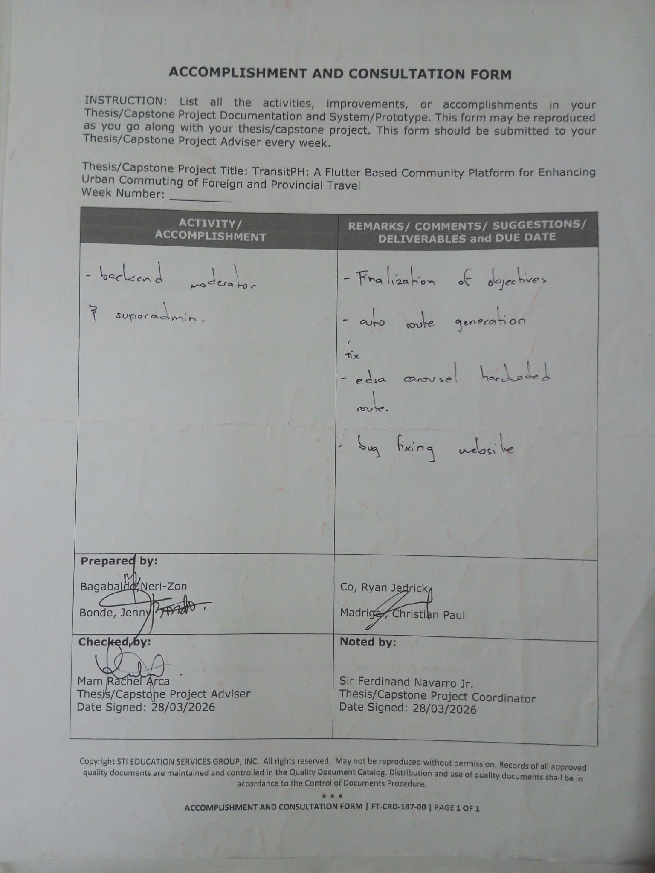
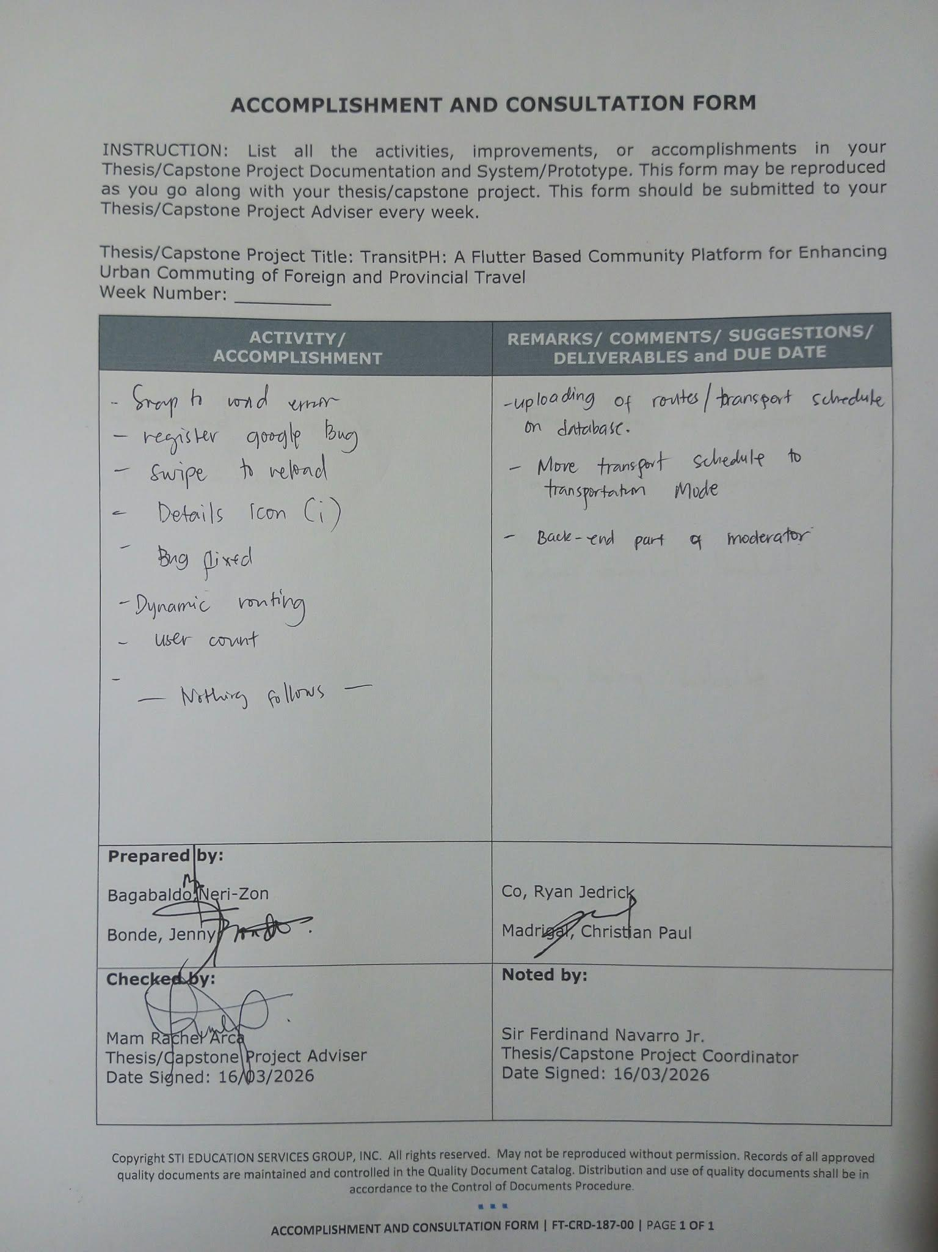
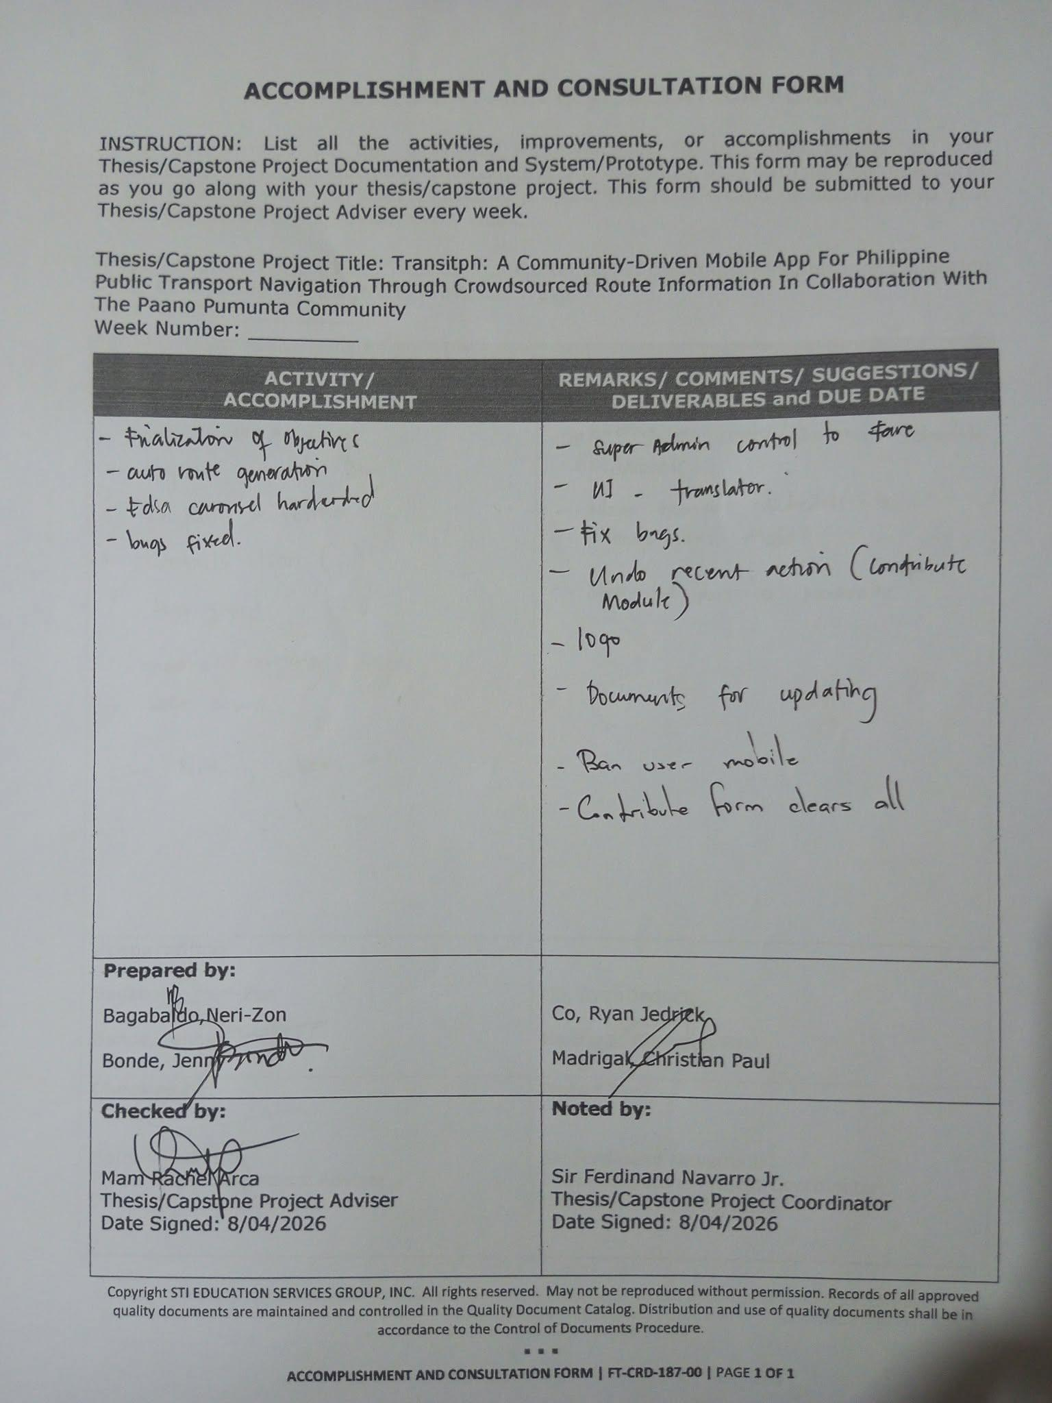
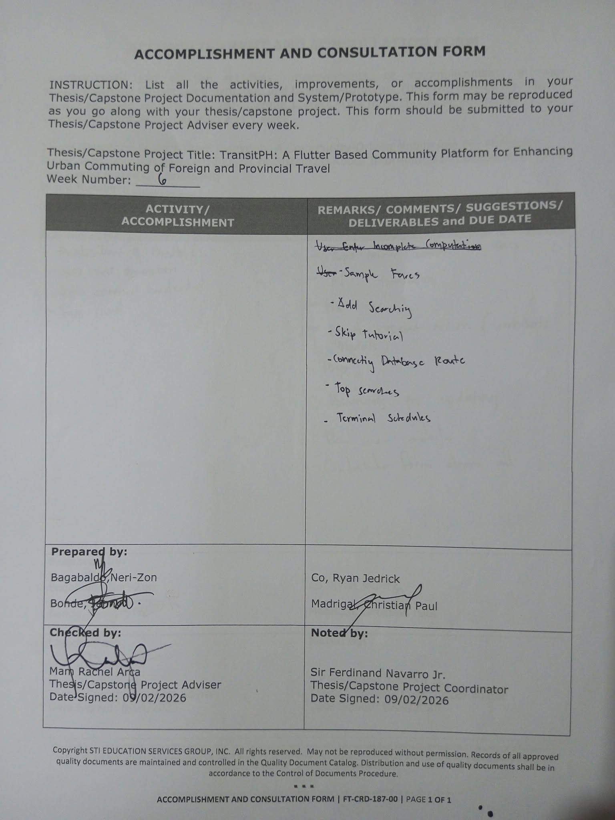
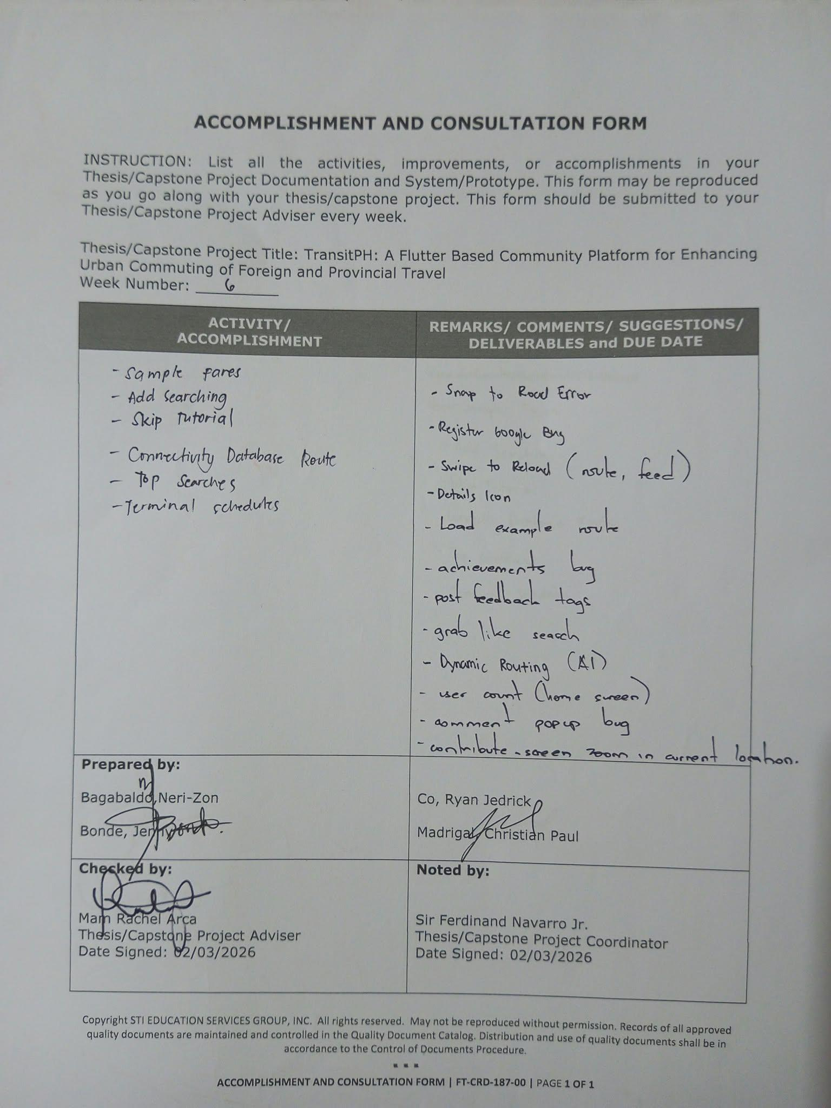
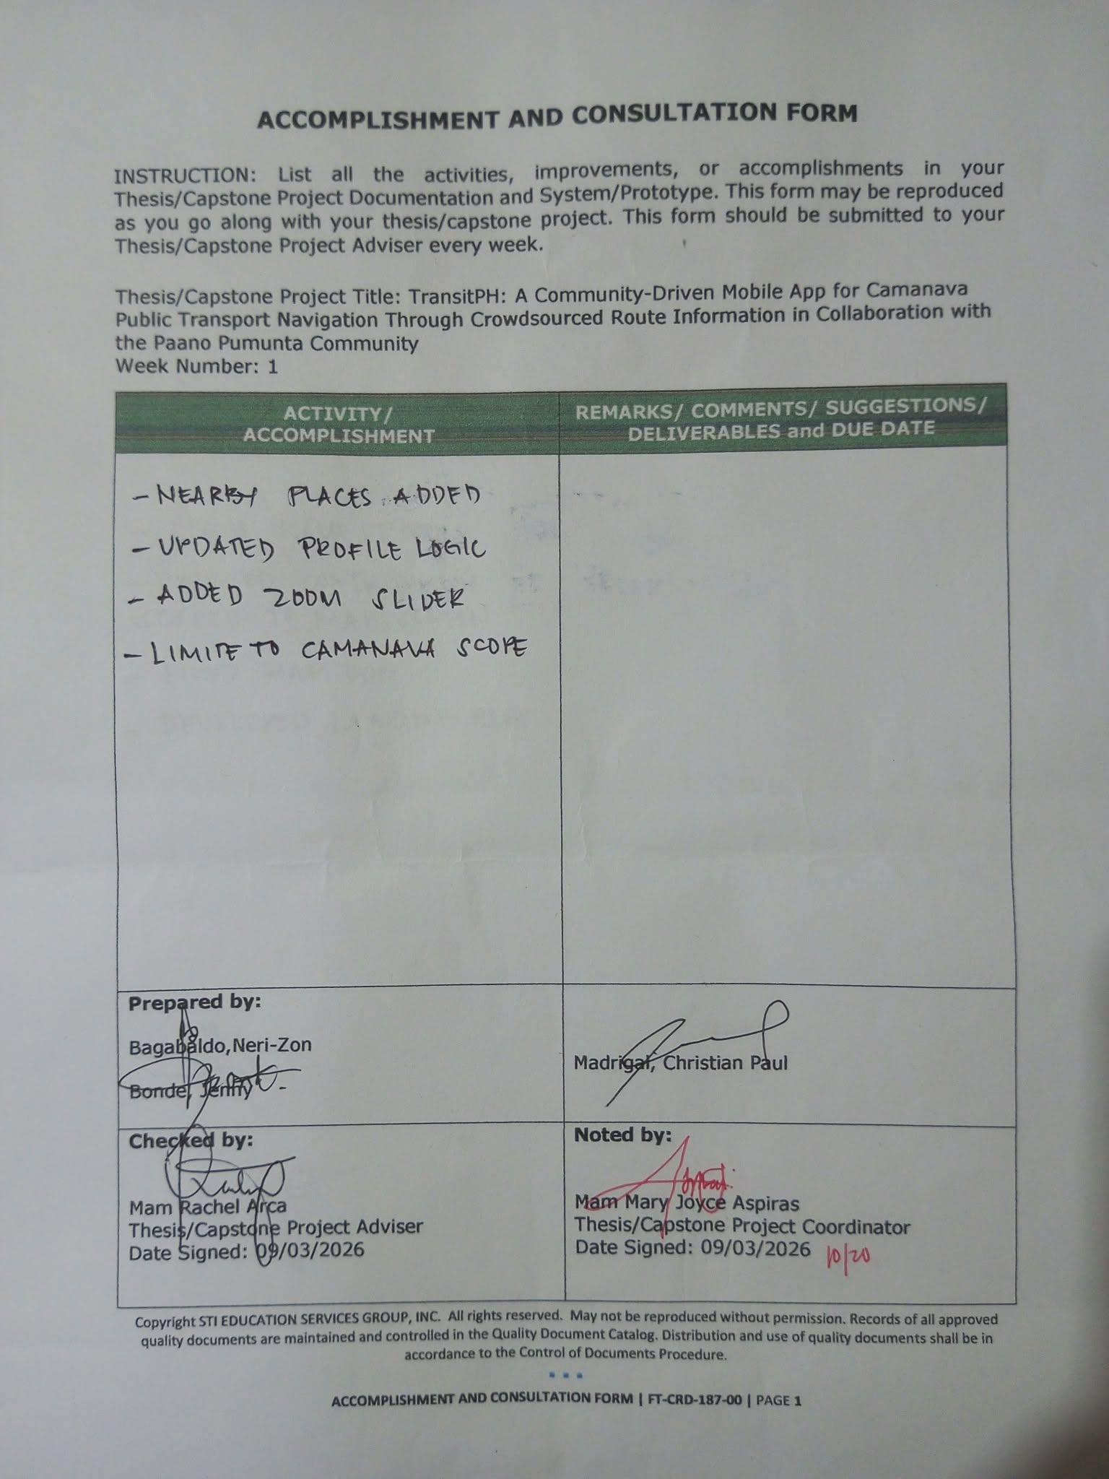
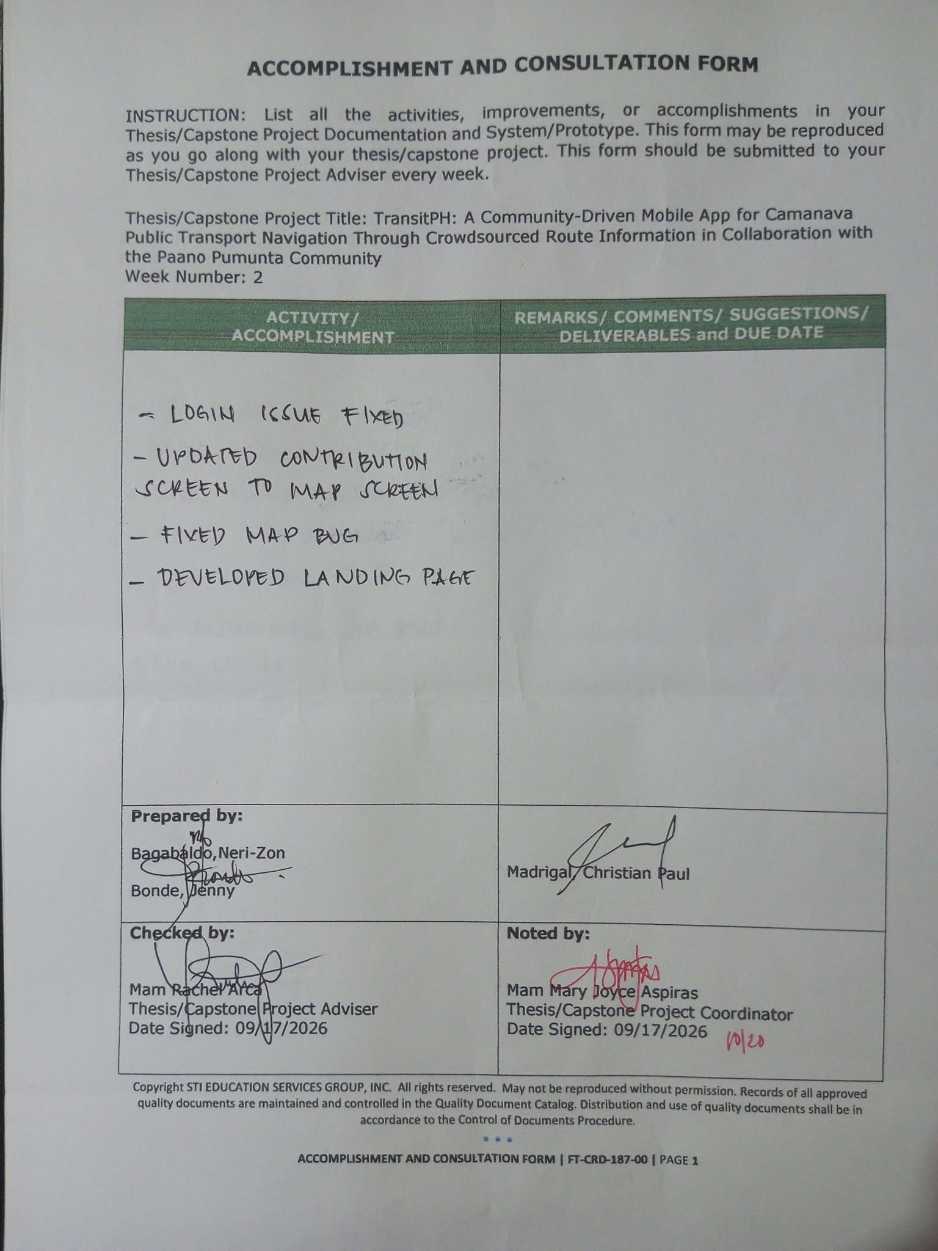
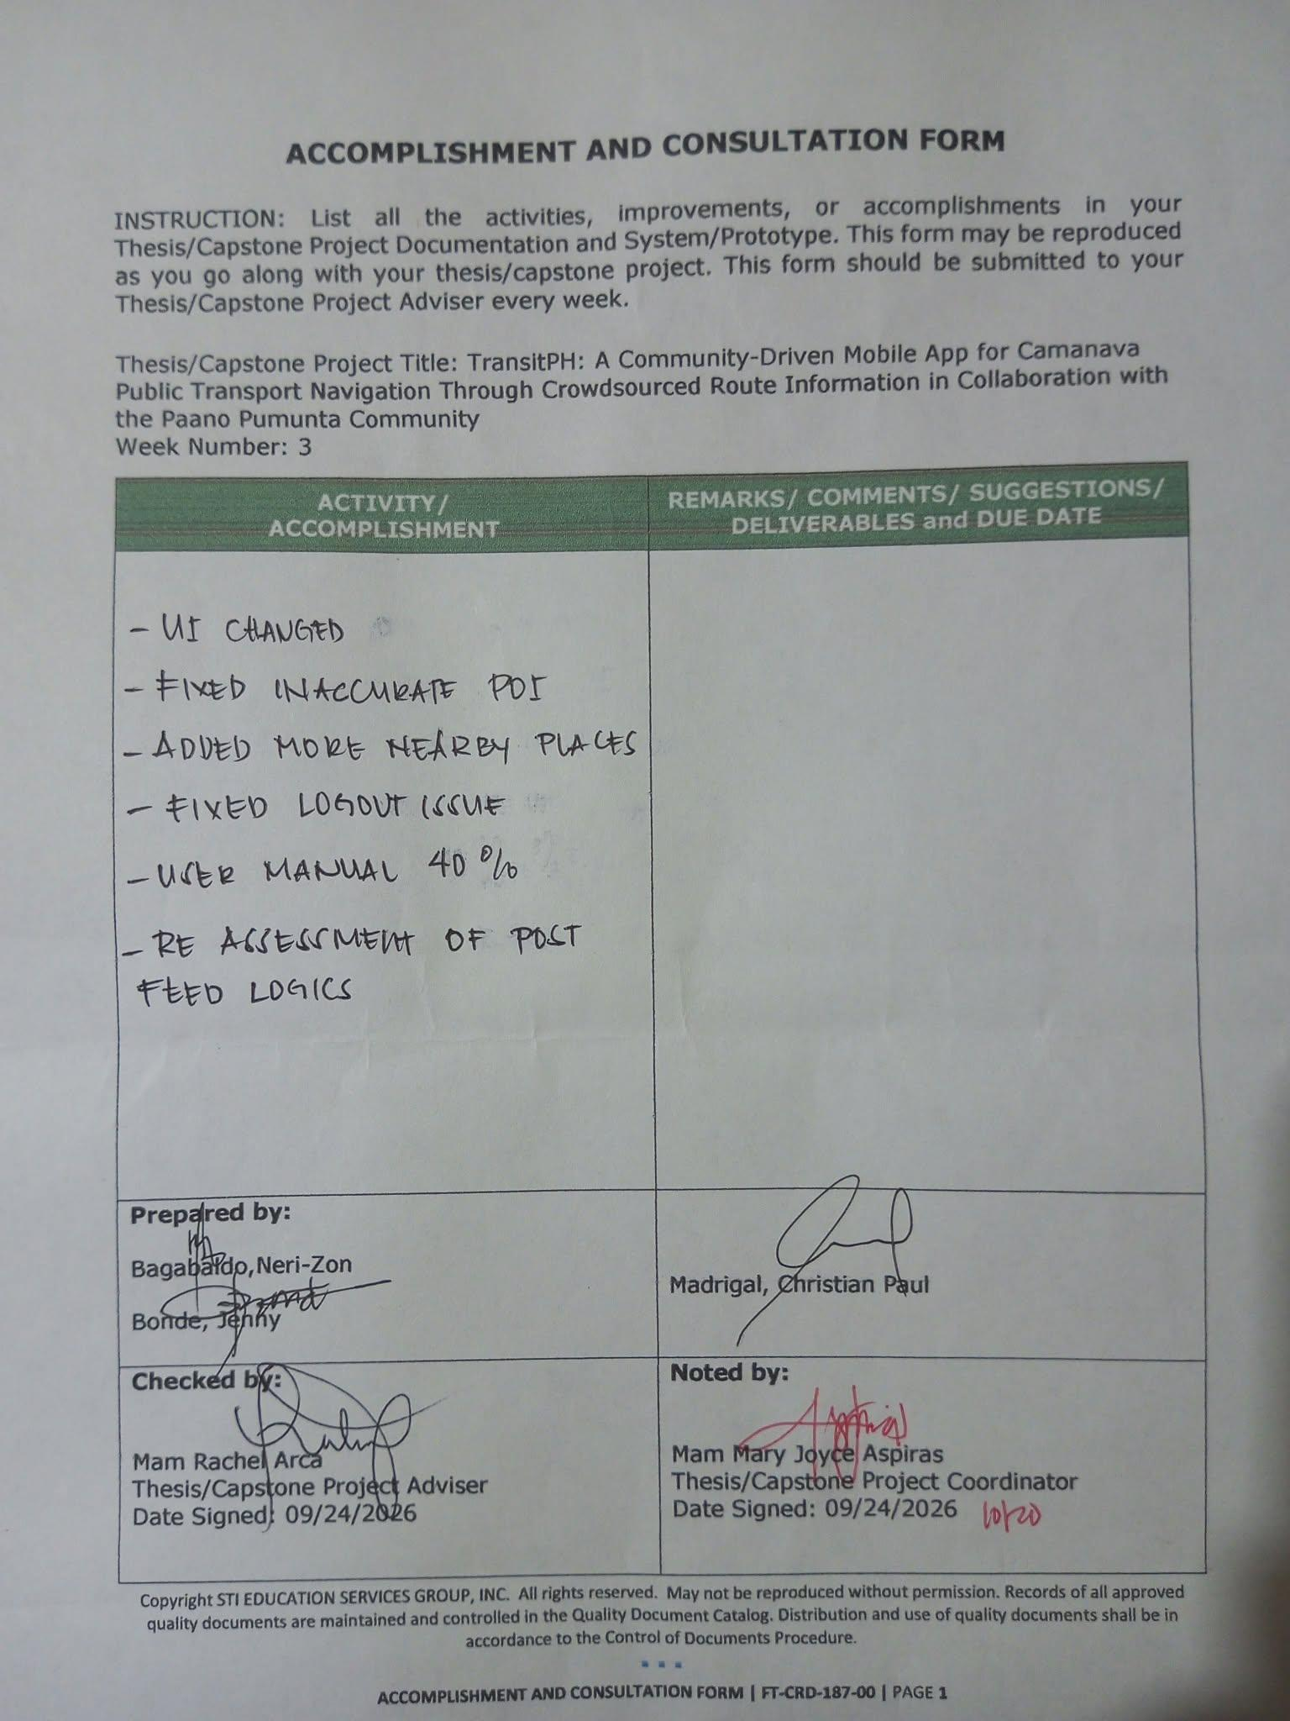
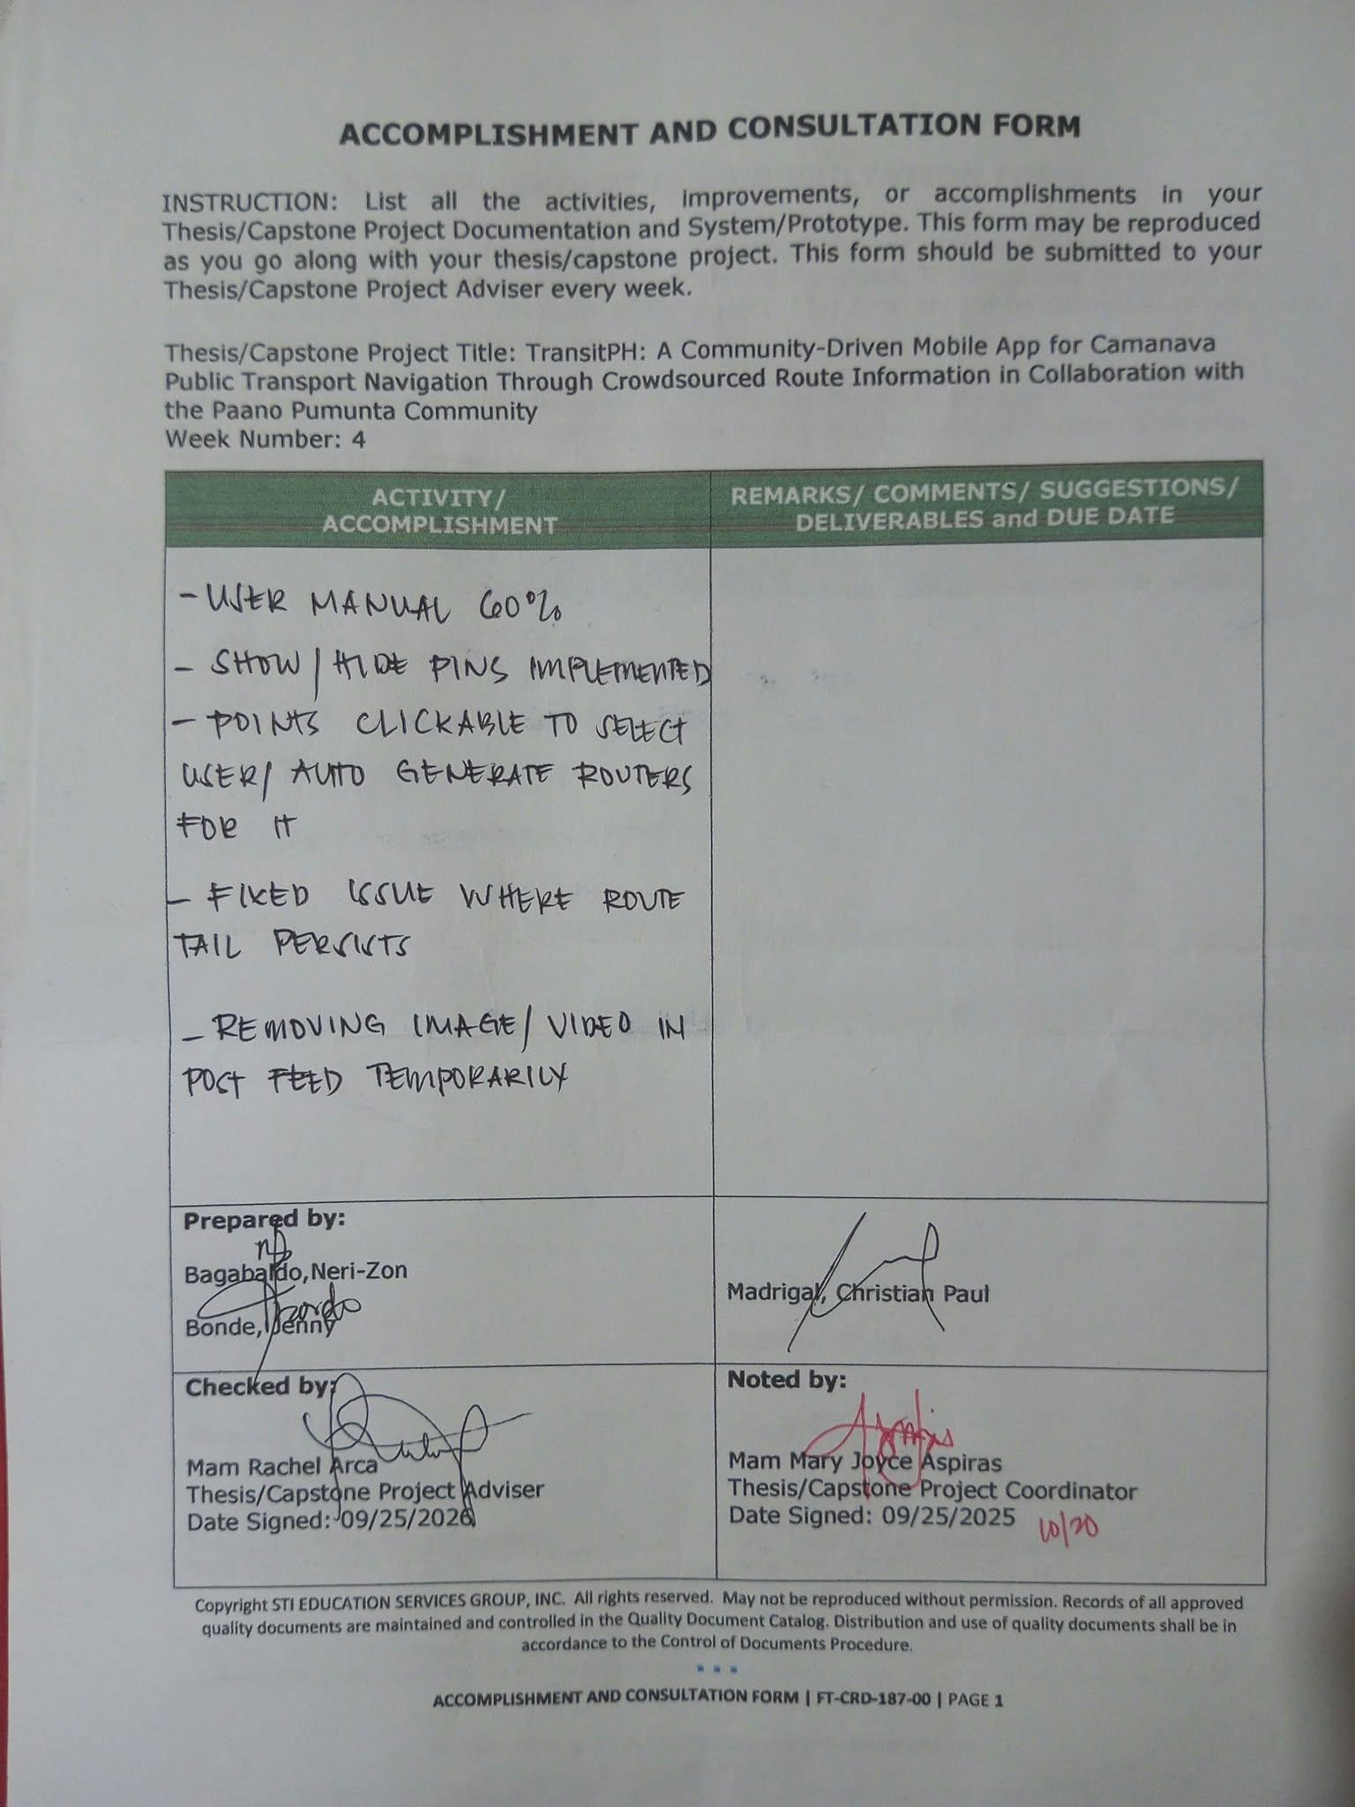

APPENDIX B. ACTUAL THESIS EXPENSES

THESIS EXPENSES

Quantity | Specifics | Approximate Cost | Actual Cost

Prepared by:

Neri-Zon M. Bagabaldo Jenny Bonde

Christian Paul C. Madrigal

Noted by:

<Name of Parent/Guardian of Researcher> <Name of Parent/Guardian of Researcher>

<Name of Parent/Guardian of Researcher>

Approved by:

Ms. Rachel Arca Ms. Mary Joyce Aspiras
APPENDIX C. USER’S MANUAL
USER MANUAL

TRANSIT PH
A Community-Driven Transit Routing Platform for CAMANAVA

Version: 0.1.22
Platform: Android
Developed By:
Bagabaldo, Neri-Zon
Bonde, Jenny
Madrigal, Christian Paul

STI College Caloocan
2026
INTRODUCTION

Transit PH is a mobile application designed to help commuters navigate the CAMANAVA area (Caloocan, Malabon, Navotas, and Valenzuela) through community-contributed route information. It allows users to explore routes, view transportation details, and contribute routes they know to help other commuters. The application also provides a feed where users can share posts and a profile section where they can view their contributions and achievements. TransitPH aims to make finding routes and getting around CAMANAVA easier through community participation. This manual explains how to install, set up, and use TransitPH to find routes, view fares, and navigate your trip.

INSTALLING TRANSITPH
SYSTEM REQUIREMENTS
Android 8.0 and above, 150 MB of free storage, active internet connection, and location permission enabled.
INSTALLING TRANSITPH
STEP 1: Go to https://transiph.app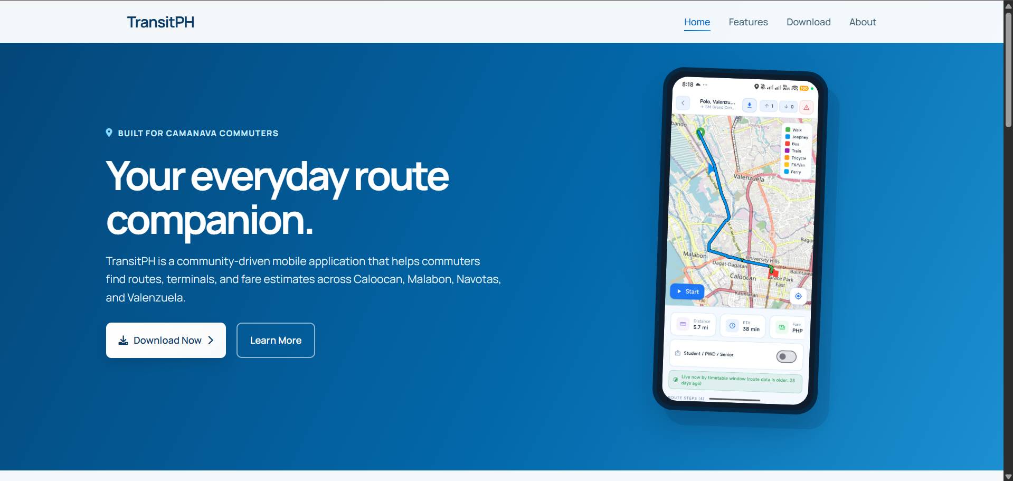
Figure 1: TransitPH Landing Page
STEP 2: Click the Download to navigate to the Download section.
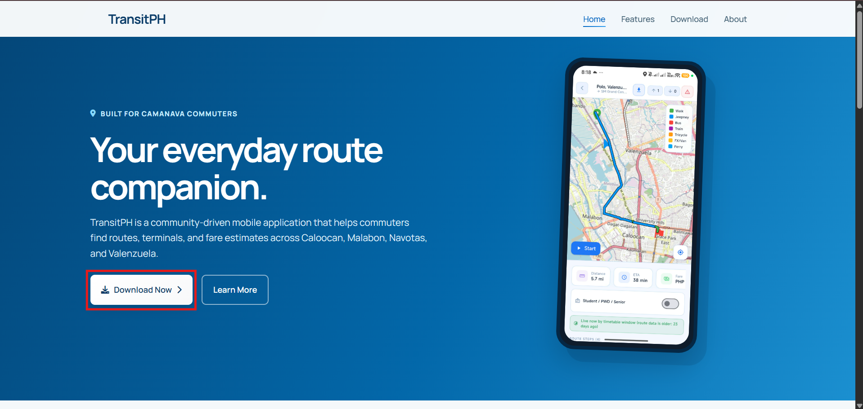
Figure 1.2: Landing Page Showing Download Button

STEP 3: Click or press the “Download APK” button, or scan the QR code using your mobile device to download the APK.
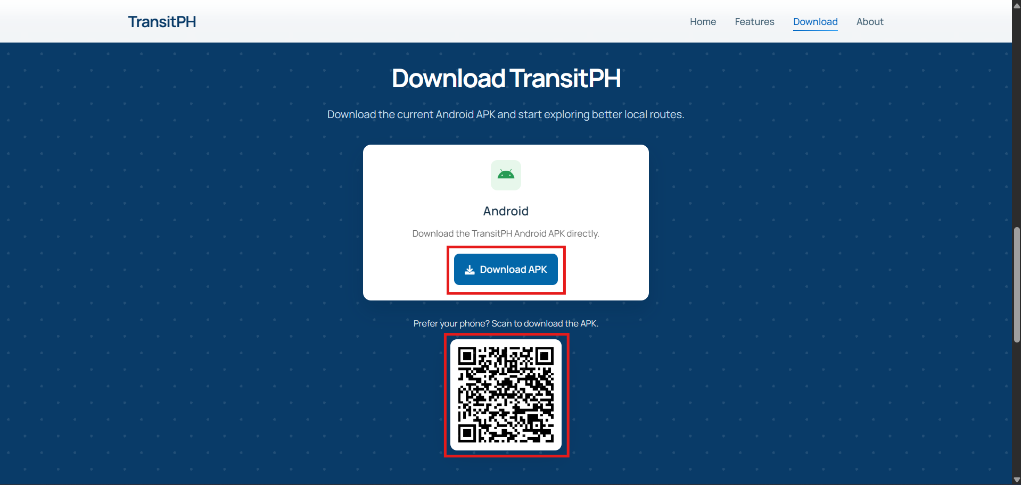
Figure 1.3: TransitPH Download Page with APK Download Button and QR Code

STEP 4: Install the downloaded APK, then open the TransitPH app.

ACCOUNT REGISTRATION
- Sign Up with Email
STEP 1: Click or press the Sign Up.
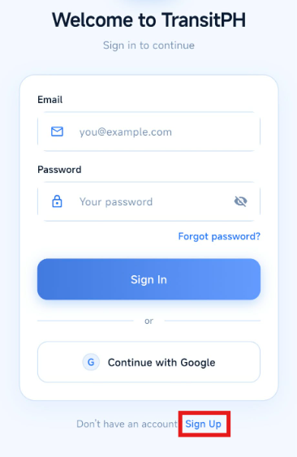
Figure 2.1: TransitPH App Login Page with Sign Up Button Highlighted

STEP 2: Fill in the text fields with your corresponding account information, then click the Create Account button.
NOTE: Make sure to follow the instructions of making at least 8 characters with 2 of: uppercase, lowercase, numbers, and symbols.

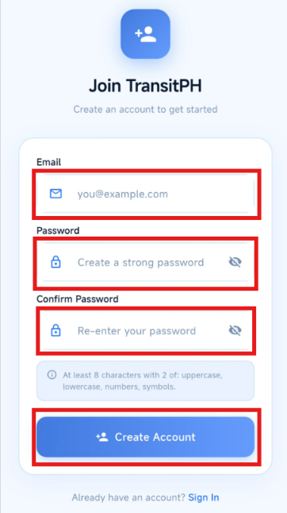
Figure 2.2: Sign Up Screen Highlighting Required Fields and Create Account Button

STEP 3: After creating an account, you will be redirected to the Privacy Policy and Terms and Conditions page. If you agree to the terms, press Accept and Continue. If you do not agree, press Decline and Exit the App button.

NOTE: You can press Read Document to view the Privacy Policy and Terms and Conditions before accepting.

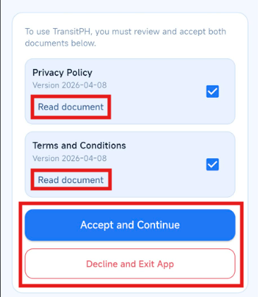
Figure 2.3: Privacy Policy & Terms and Agreements Screen Highlighting Read Document and Buttons to use

STEP 4.1: Open the email sent to your inbox and click the verification link.
STEP 4.2: Wait for the page to load and make sure it displays “Your email has been verified.”
STEP 4.3: Return to the TransitPH application and click I’ve Verified My Email to continue using the application.

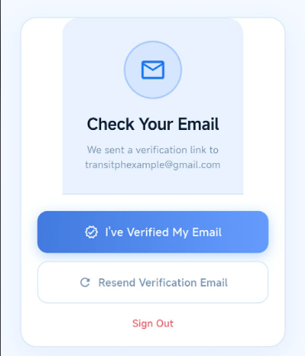
Figure 2.4: Email Verification Screen

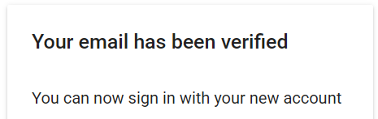
Figure 2.5: Email Verified Sample

- Sign Up with Google
STEP 1: Click or press the “Continue with Google” button, then select the Google account you want to use.
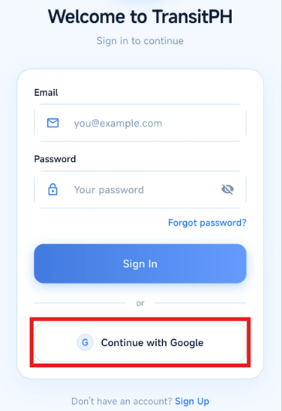
Figure 3.1: Login Page with Continue with Google Button Highlighted

STEP 2: After signing in with Google, refer to Figure 2.3.

GETTING STARTED WITH THE APP
APP INTRODUCTION
STEP 1: The first time you open the TransitPH application, you will be redirected to the Welcome Screen. Select a category that best describes you to personalize your experience. The available options include Student, Employee, Foreigner, and New to Area.
Student: for budget-friendly routes to school etc.
Employee: Commuter routes for the workplace
Foreigner: Tourist – friendly guidance
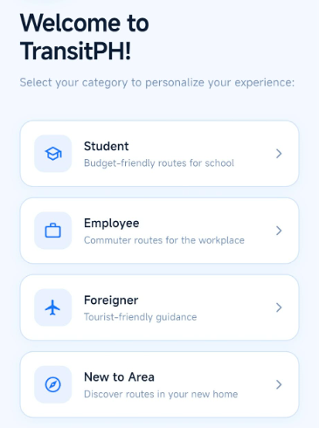
New to Area: Discover new routes
Figure 4.1: TransitPH Category Selection Screen
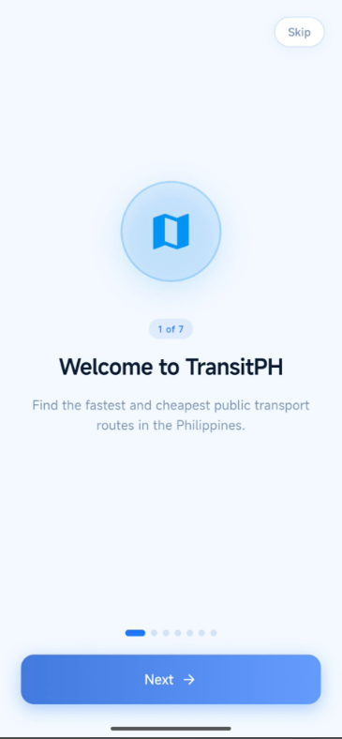
STEP 2: After choosing a category, you will be introduced to the Welcome Page. You can press Next to learn more about what the app can do, or press Skip to proceed directly to the app.

Figure 4.2: TransitPH Welcome Screen

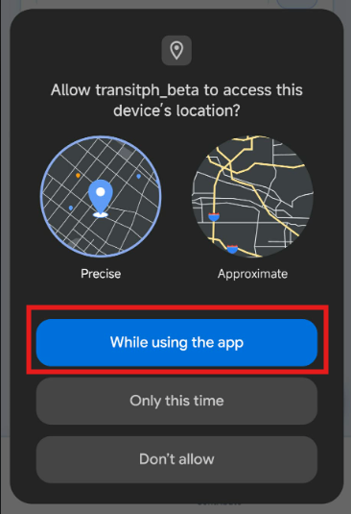
STEP 3: Next, you will be asked to allow location access. This permission is required for the app's navigation feature to determine your current location.
Figure 4.3: Allow Location Access for App

STEP 3.1: When the location permission prompt appears, select “While using the app” and “Turn on” to enable location access.
NOTE: Location access is required for TransitPH's navigation feature to determine your current location, and for app services to properly function.
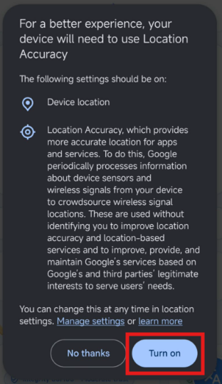
Figure 4.4: Turn On Location Access
STEP 4: Finally, you will be redirected to the TransitPH main/home page. From here, you can access the Home, Feed, Contribute, and Profile sections.
Home - The main page where you can interact with the app and access its features.
Feed – Allows you to share your thoughts, create posts, and interact with other users.
Contribute – Allows you to contribute routes that you know within CAMANAVA to help the community.
Profile – Allows you to edit your profile and view your achievements, badges, contributions, and other account information.
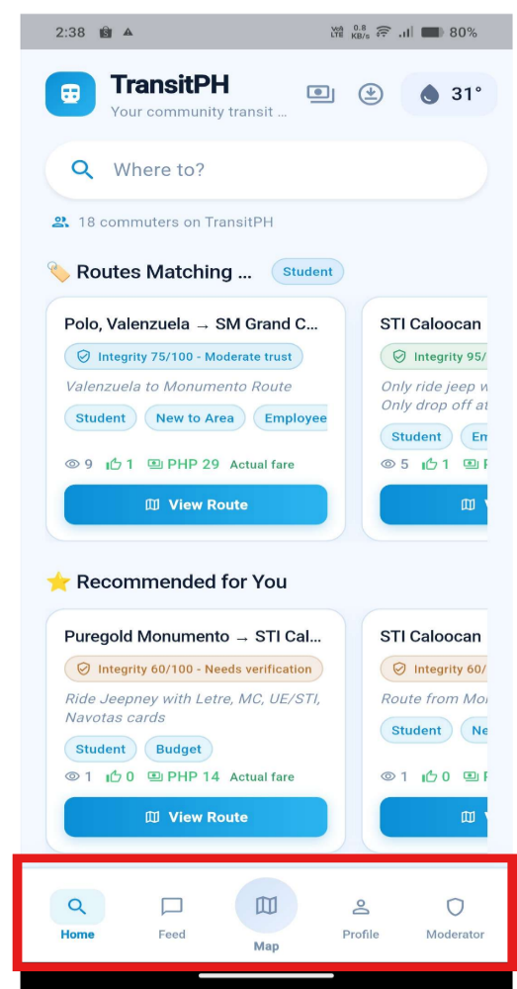
Moderator - Allows authorized moderators to review and manage user-submitted routes and reports to help ensure that the information shared on TransitPH is accurate and reliable.
Figure 4.5 Home Page TransitPH App
HOMEPAGE
The Home page is the main page of TransitPH where users can search for destinations, view routes, check fare information, and access other transportation-related features, refer to the image above.

TransitPH Header – Displays the TransitPH logo, application name, and tagline.
Figure 5.1: TransitPH Header

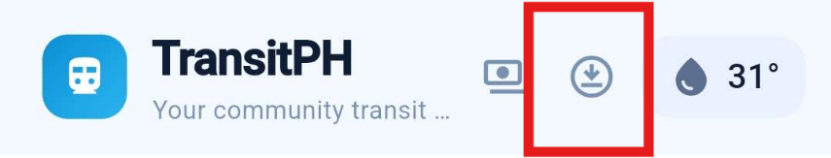
Open Offline Routes – Displays downloaded routes that are available to use even offline.
Figure 5.2 Open Offline Routes

Where to – When selecting, displays the route search page, where users can search for their desired destination and find available routes.

NOTE: On the route search page, users can view and access Search and Route Tips by pressing the “:” icon in the right corner.
Figure 5.3 Where to Search Bar


Community Members – Displays the number of active TransitPH community members.
Figure 5.4 Community Members Count

Routes Matching Your Tags – Display routes that match the category selected by the user, such as Student, Employee, Foreigner, or New to Area. Users can select View Route to view the route details.
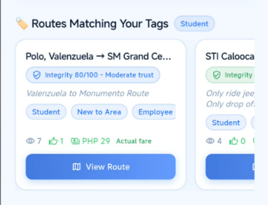
Refer to “APP INTRODUCTION, STEP 1” for instructions on selecting a category.
Figure 5.5 Routes Matching Your Tags

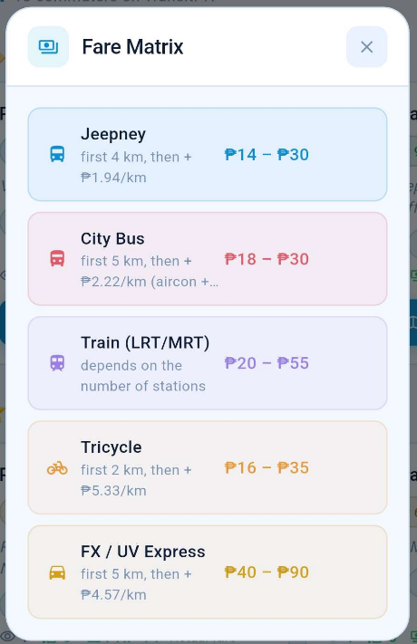
Fare Matrix – Displays fare pricing estimates for different transport modes.
Figure 5.6 Fare Matrix

Search Route – Allows users to select their starting location and destination to find available community-shared routes or generate new routes for their trip.
Generated Routes – Uses existing database records, community-contributed data, or both to generate a route when no existing contributed route is available.

Community Routes – Displays routes contributed by users that match the selected starting point and destination.
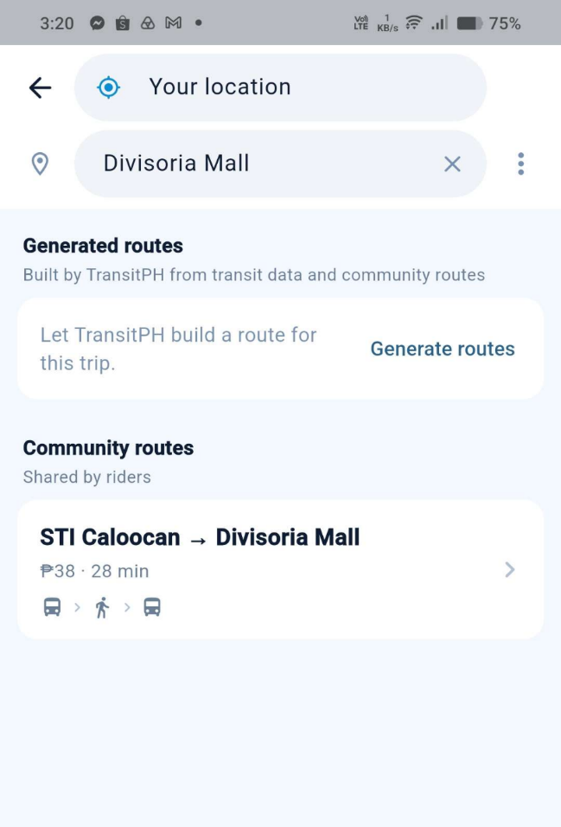

Figure 5.7 Search Route Screen
FEED
The Feed is the community section of TransitPH where users can view posts, share their thoughts, and interact with other members of the community.
  - Search Post Button
Opens up a new page and shows the search to look for specific post that you're looking for
  - Notification Button
Opens up a new page and shows the notification related to your account e.g. Likes, Comments, Route Approval, etc.
  - Normal Post Card
This is what a normal post of a user looks like.
  - Anonymous Post Card
This is what the anonymous post looks like which hides the user’s name of the one who posted and replaces it with Anonymous.
  - New Post Button
Open up a create post pop up where you can see the fields to be filled to create a post.
  - Delete Post Button
Used to delete your own post in the feed.
  - Report Post Button
Opens up a report pop up that lets you report the post if it’s about Spam, Inappropriate Content, Harassment, Misinformation, etc.
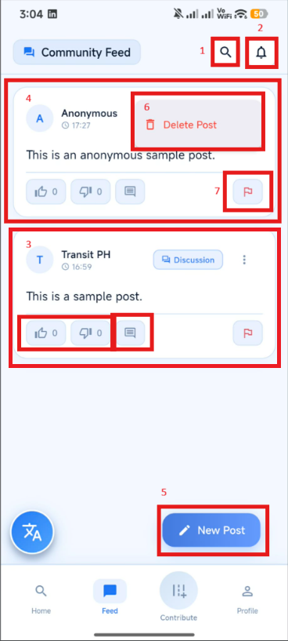
Figure 6.1: Feed Screen

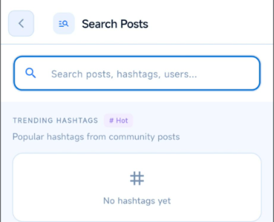
Search Post Screen – Allows users to search for posts they want to find.
Figure 6.2 Search Post Screen

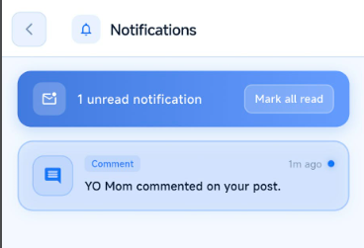
Notification Screen – Allows users to look for notifications you receive, e.g. Comments, Likes, Route Approval, etc.
Figure 6.3: Notification Screen and Sample Notification

New Post Pop Up – Used to create posts here in the feed, a box will pop up for fields that you need to fill based on the context of your post.

Category – Allows the user to pick a category on what their post is all about.
Location – Allows the user to tag a route to their post.
Post Anonymously – Allows the user to post anonymously
Publish Post Button – Allows the user to publish the post they created
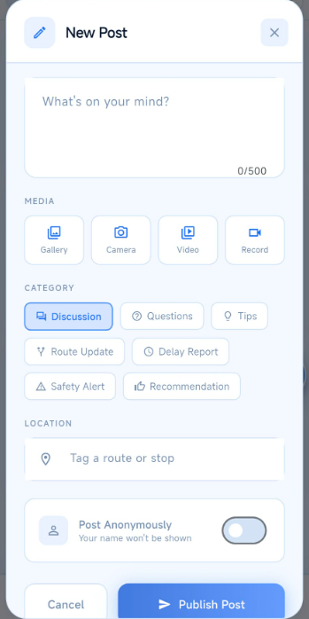
Cancel Button – Allows the user to cancel the post they created.
Figure 6.4: New Post Screen

Report Post Pop Up – Allows the user to report the post that might be Spam, Inappropriate Content, Harassment, Misinformation, etc.
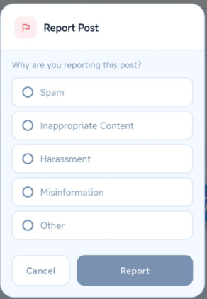
Report Button – Allows users to submit the post that they wanted to report.
Figure 6.5: Report Post Pop Up

MAP SCREEN
Allows users to contribute known routes by mapping them on the provided map and adding the necessary route information to share with the community.
    - Search Bar - Opens the search screen, allowing users to find locations or point-to-point (P2P) routes.
    - Nearby Places – Displays nearby locations on the map with filters for different place categories.
    - Contribute Button – Opens up the Contribute Mode for user route contribution.
    - Tutorial Button – Opens a tutorial to guide users through the app’s features and navigation.
    - Hide Pin/Find Location – Toggles the visibility of Nearby Places pins and centers the map on the user’s current GPS location.
    - City Selector – Displays a dropdown menu of available cities for easier map navigation.
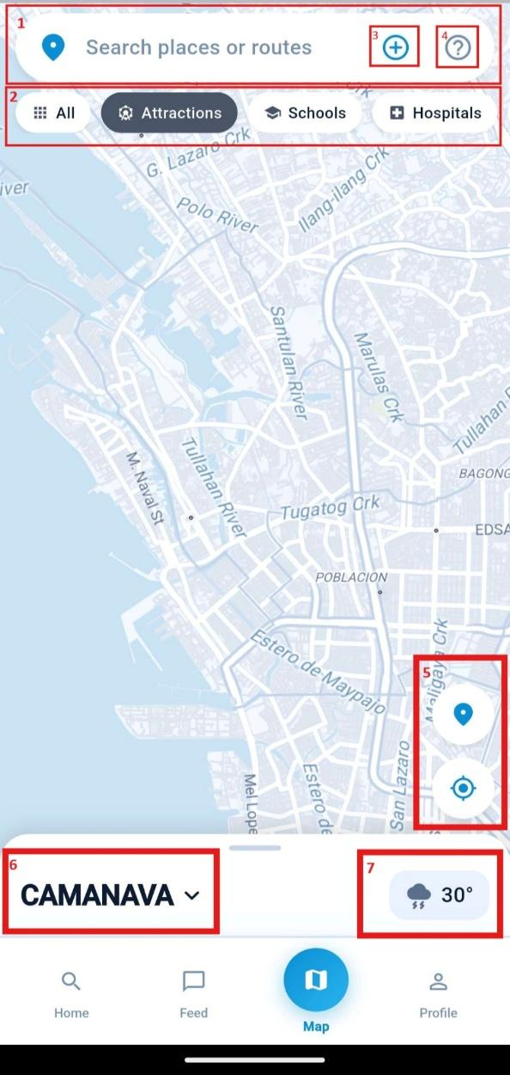
    - Weather Widget – Displays the current weather conditions and temperature for your area.
Figure 7.1: Contribute Screen
Help Pop Up – Allows users to view instructions on what they can do on the Contribute screen.
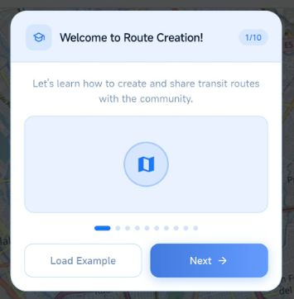
Load Example Button – Gives an example premade route to give the user an idea on how it looks.
Figure 7.2: Help Pop Up
Search Places or Routes – Allows users to search for locations, get directions to a selected place, or find community-contributed routes near the searched location.
Directions To – Redirects users to the Search Route screen with the selected location automatically set as the destination.
Places – Displays suggested places matching the user's search query.
Community Routes – Displays community-contributed routes that match or are near the searched location.
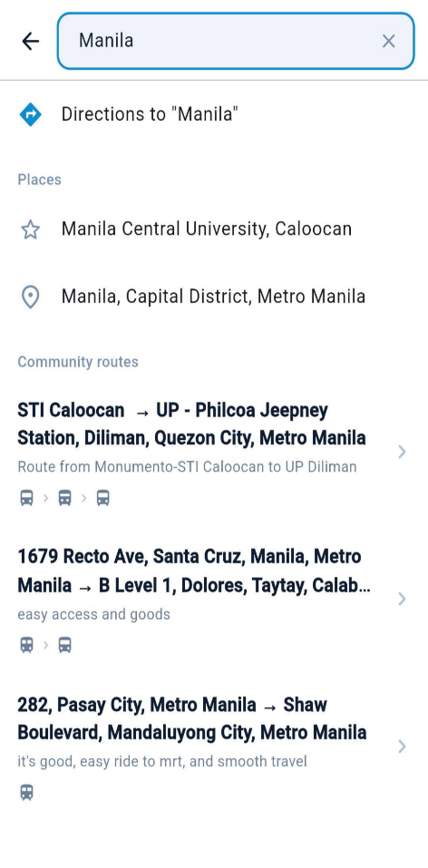
Figure 7.3: Search Places or Routes Screen
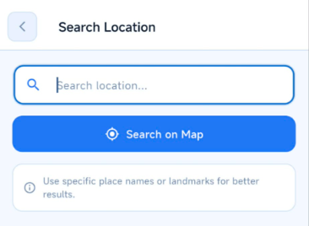
Search Location – Allows users to search for a location instead of finding it manually on the map. Only appears when in Contribute Mode.

Figure 7.4: Search Screen

Widget – Allows users to calculate the distance and eta between the starting point and endpoint of the route without measuring it manually, and also comes with different tools to use in creating a route.
NOTE: Used for selecting type of transport route, and has advanced settings such as Expressways for expressway transport and Road Snapping.
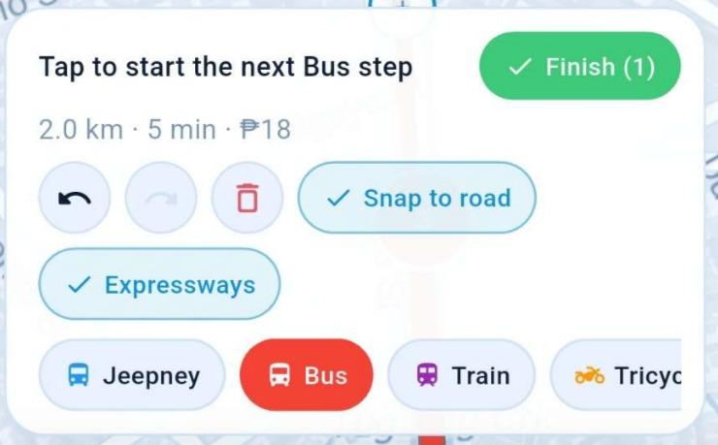
Figure 7.5: Widget Control
Route Details – Allows users to enter the necessary information about the route they created.
Basic Info – Display a text box to enter your starting point and your destination.
Route Tags – Add tags that describe your commute route
Description – Write a short description of your route. This section also has the Generate Quicklink and Finish Route buttons.
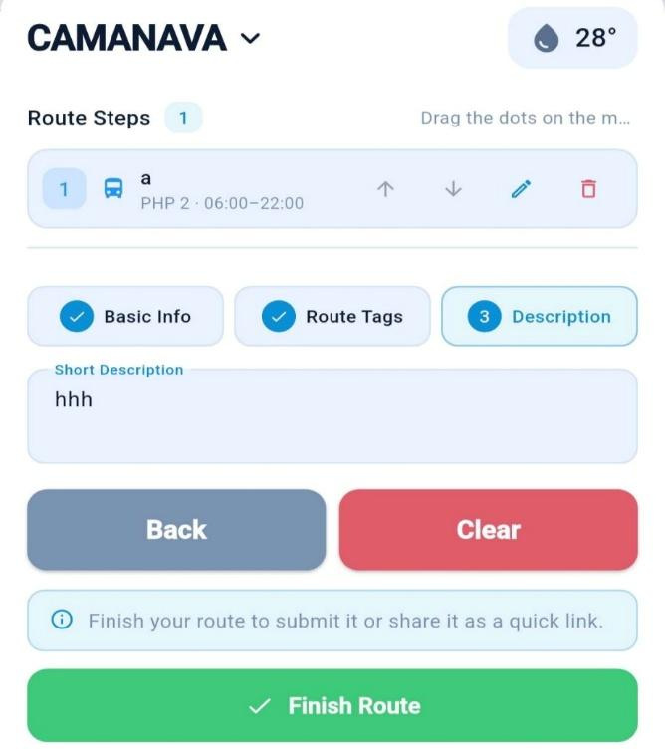
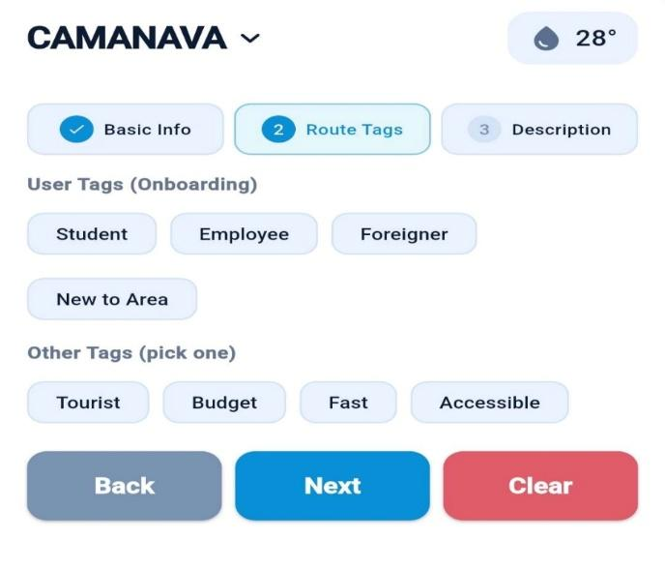
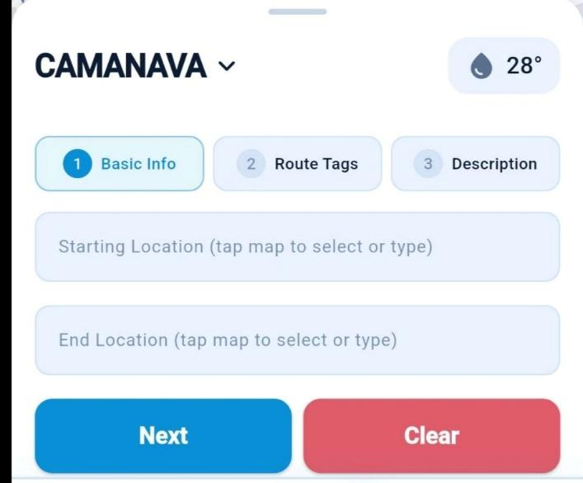
Figure 7.6: Route Details
Transport Mode Info – Allows users to add information about the selected mode of transportation.
Instruction – Allows users to add instructions to tell the other users what to do in that transport mode.
Details – Allows users to add more additional details e.g. jeepney route, etc.
Actual Fare – Allows users to add the fare of the specific transportation mode based on their knowledge.
Specify Board Off – Allows users to specify if a transport can drop off anywhere along the route or specified stops.
Add Stops – Allows users to specify stops of current transport.
Schedule – Allows users to put a schedule of the specific transportation mode for more specific information.

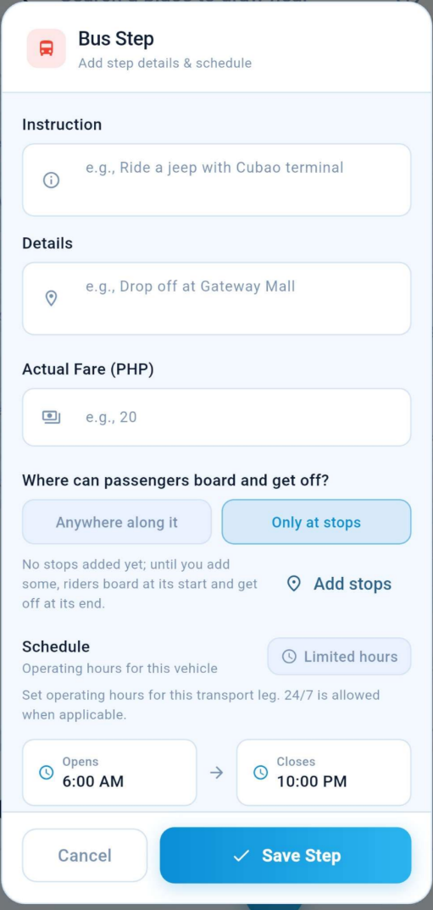
Figure 7.8: Transport Mode Info

PROFILE SCREEN
Allows users to view their account information, achievements, badges, and contributions.
Achievements – Display milestones you have reached while using the app.
Badges – Displays quests you have completed within the app.
Contributions – Displays a list of all the contributions you have made.
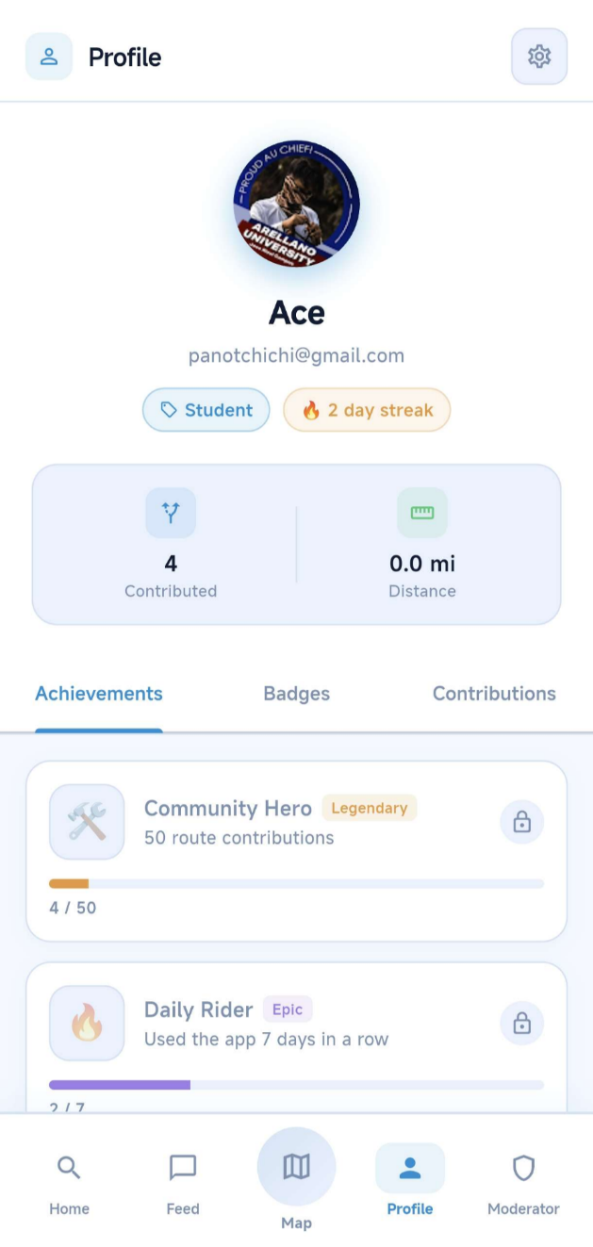
Settings – Redirects user to Settings Screen.

Figure 8.1: Profile Screen
SETTINGS SCREEN
Allows users to manage their account, notification preferences, privacy settings, app preferences, storage, and other application settings.
Account – Allows users to view and edit their profile information.
Notifications – Allows users to manage notifications for route approval updates, community discussions, and weekly activity summaries.
Preferences – Allows users to select their preferred language and distance unit. Also allows users to modify the map style according to their preference.
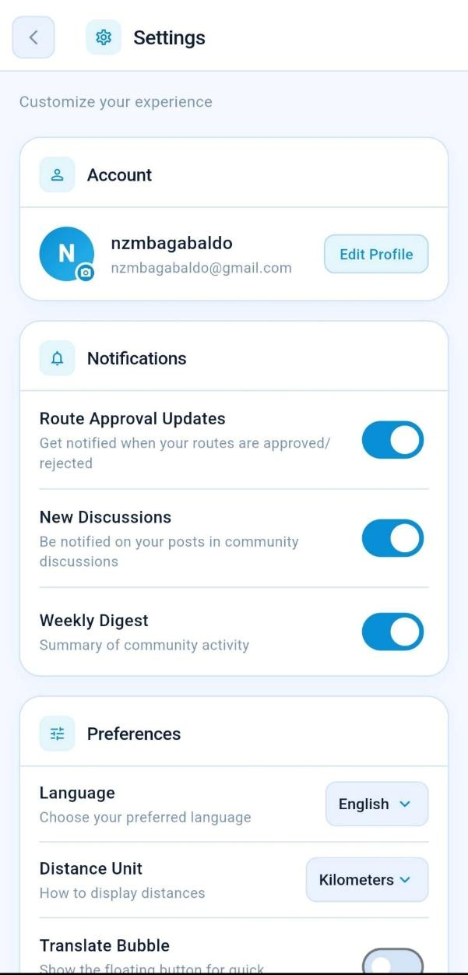
Figure 9.1: Settings Screen I
Privacy – Allows users to control whether their email address is visible on their profile.
Storage – Allows users to clear downloaded routes.
About – Displays the application version, last update information, Privacy Policy, Terms of Service, Contact Support, and Post Feedback.
Log Out Button – Allows users to log out of their TransitPH account.

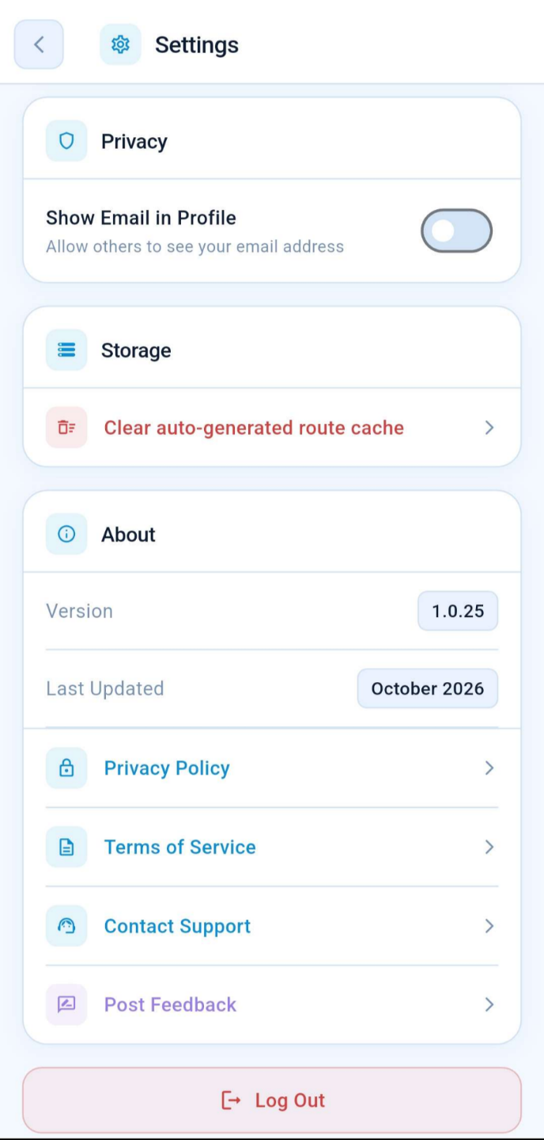
Figure 9.2: Settings Screen II
USING TRANSITPH
HOW TO SEARCH FOR A ROUTE
STEP 1: From the TransitPH Home screen, tap the “Where to?” search box to begin
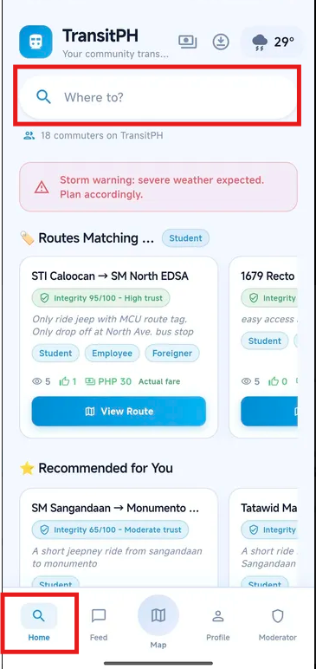
searching for your destination.

Figure 10.1: Navigating to Search Screen

STEP 2: You will be redirected to the search screen. Type the name of the place or destination you want to go to in the search box.
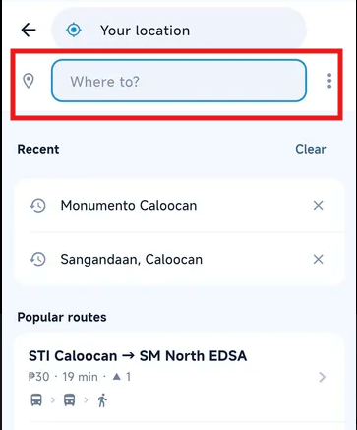
Figure 10.2: Search Screen
STEP 3: Wait for the search results to appear. If matching locations are available, select your desired destination from the list of suggestions.
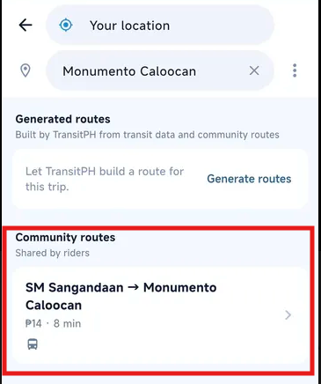
Figure 10.3: Community Routes
STEP 4: After selecting your destination, follow the available route information displayed by the application.
NOTE: If no matching locations appear in the search results, proceed to the How to Generate a Route section of this manual for instructions on finding or generating a route to your destination.

HOW TO GENERATE A ROUTE
STEP 1: Navigate to the route search screen by following the instructions shown in Figures 10.1 and 10.2.
STEP 2: Enter your desired destination in the search box. Tap “Generate a Route” to generate possible routes to your destination.
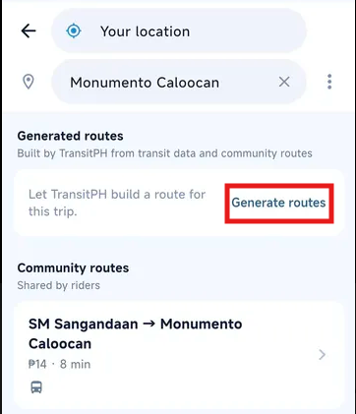
Figure 10.4: Generate Route
STEP 3: Wait for the application to generate the available route options.
STEP 4: Review the generated route options and select the route that best suits your needs.
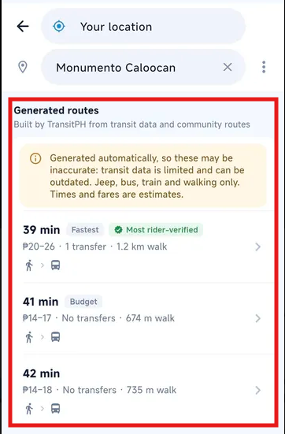
Figure 10.5: Generated Routes

OVERVIEW OF THE ROUTE
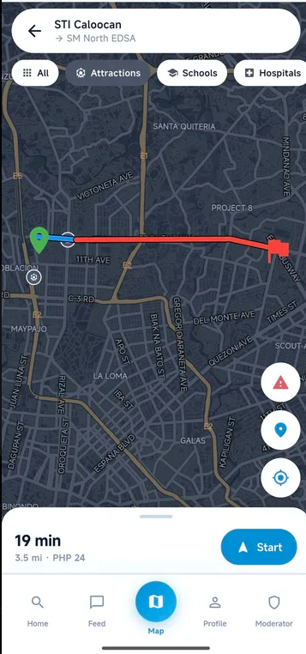
Route Screen - After selecting a destination or generating a route, the application displays the route overview. This section shows the selected destination, the route on the map, the estimated travel time, distance, and fare.
Figure 11.1: Route Screen
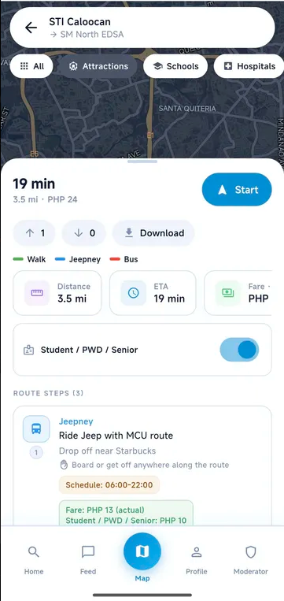
The Estimated Travel Time, Distance, and Fare displays the estimated time needed to complete the trip, the total route distance, and the estimated fare. The Start Button starts route navigation using the user's current location. The Route Feedback buttons allow users to upvote or downvote a route, while the Download Button allows users to download route information for later access. The Transportation Legend shows the colors used to identify different transportation modes on the map, such as walking, jeepney, and bus. The Distance, ETA, and Fare Details provide a more detailed view of the estimated distance, estimated time of arrival (ETA), and fare. The Student / PWD / Senior Discount option allows eligible commuters to view the applicable discounted fare. Lastly, the Route Steps section displays instructions for each part of the journey, including the transportation mode, route information, drop-off location, operating schedule, and fare.
Figure 11.2: Route Information
HOW TO CREATE A POST

STEP 1: Navigate to the Feed section using the bottom navigation bar.
Figure 12.1: Navigating to Feed Screen
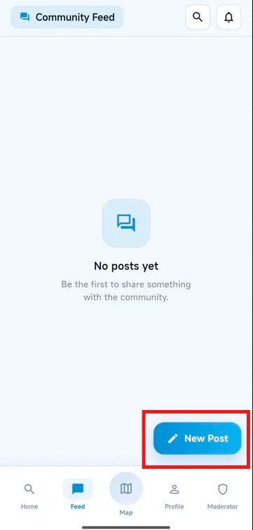
STEP 2: From the Feed section, tap the New Post button located at the lower-left corner of the screen.
Figure 12.2: Publish a Post
STEP 3: Enter the content you want to share in the post field.
STEP 4: Review your post, then tap the Publish Post button to publish it to the Feed.

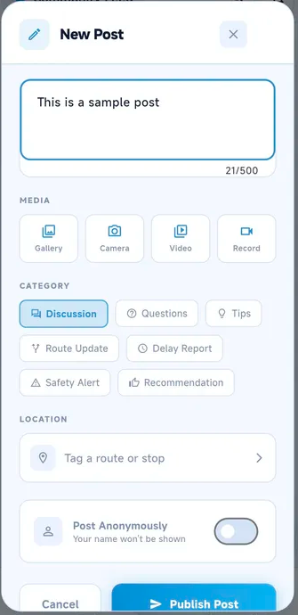
Figure 12.3: Publishing a Post
STEP 5: Once published, your post will appear in the Feed, where other users can view and interact with it.
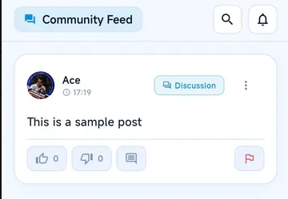
Figure 12.4: Sample Post

HOW TO CONTRIBUTE A ROUTE
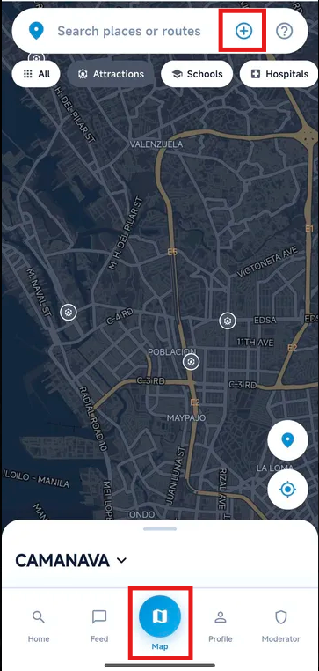
STEP 1: Navigate to the Map section using the bottom navigation bar. Tap the (+) Plus button beside the Search places or routes search bar to start creating a route.
Figure 13.1: Map Screen Navigation
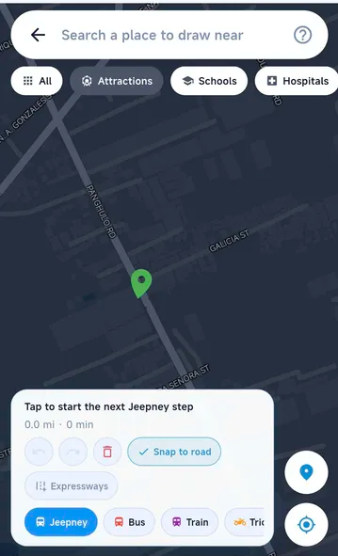
STEP 2: Select the starting point of your route by tapping the desired location on the map.
Figure 13.2: Add Origin
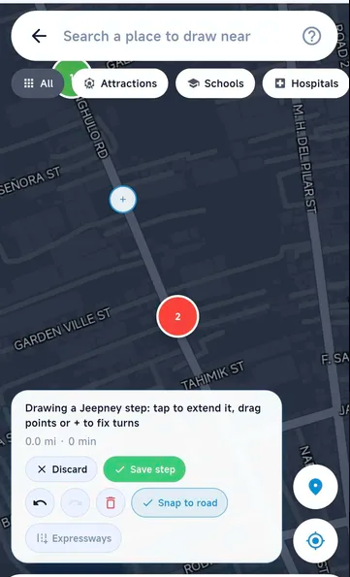
STEP 3: Tap another point on the map to draw the route toward your destination. Continue adding points as needed to trace the route. Once you have completed the transportation step, tap Save Step.
Figure 13.3: Adding Destination

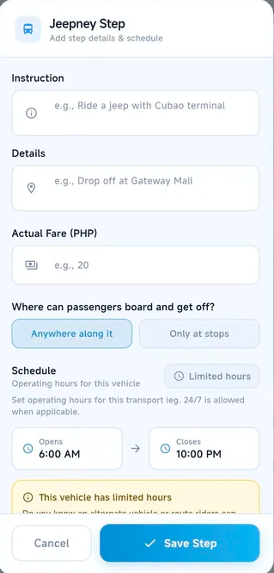
STEP 4: Fill in the required step information, including the route instructions, drop-off details, actual fare, boarding and drop-off rules, and operating schedule. Tap Save Step when finished.
Figure 13.4: Filling Step

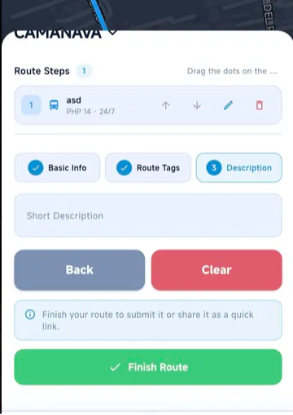
STEP 5: Complete the route information by filling in the required details under Basic Info, Route Tags, and Description. Review the route steps, then tap Finish Route to submit your contribution for review.
Figure 13.5: Finishing Route
STEP 6: Wait for a moderator or administrator to review and approve your submitted route. Once approved, the route can become available to other TransitPH users.
NOTE: If you want to share your route without submitting it for moderator or administrator approval, you can generate a Quick Link. This link allows other users to view your route through a web browser for 24 hours. Routes shared through a Quick Link will not appear in the TransitPH application as approved routes.

APPENDIX D. ADMIN MANUAL
ADMIN MANUAL

TRANSITPH

A Community-Driven Transit Routing Platform for CAMANAVA

Version: 1.0.34
Platform: Android
Developed By:
Bagabaldo, Neri-Zon
Bonde, Jenny
Madrigal, Christian Paul

STI College Caloocan
2026
ADMIN MANUAL
TRANSIT PH
The Super Admin Login Screen allows authorized super administrators to access the TransitPH web-based management system. The user must enter their registered email address and password in the designated fields to log in. After providing the required credentials, the user can click the Sign in to console button to access the Super Admin Dashboard.
Only authorized super administrators can access the system's administrative features.
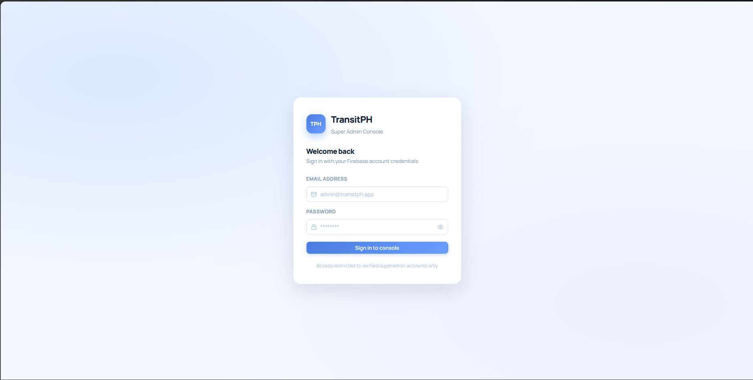
Figure 1: TransitPH Super Admin Login Screen

Email | The field where the super admin enters their registered email address.
Password | The field where the super admin enters their account password.
Show / Hide Password | Allows the super admin to view or hide the entered password.
Sign in to console | Submits the entered credentials for authentication.

The Super Admin Dashboard serves as the main overview page of the TransitPH management system. It displays summary information about registered users, active users, restricted and banned users, and the status of contributed routes. It also provides charts showing user growth and route contributions over time.
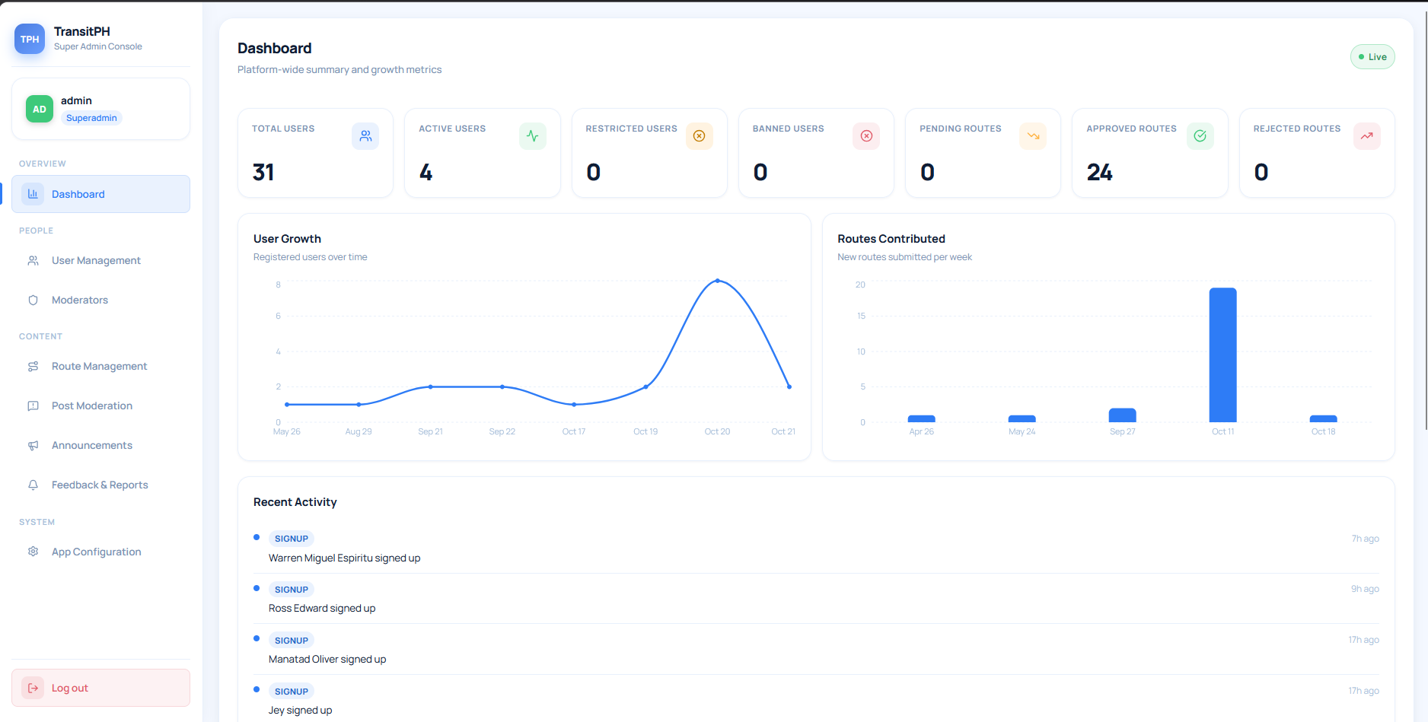
Figure 2: Dashboard Screen

Total Users | Shows the total registered users of TransitPH App.
Active Users | Shows the total active users of TransitPH App.
Restricted Users | Shows the total restricted users of TransitPH App.
Banned Users | Shows the total banned users of TransitPH App.
Pending Routes | Shows the unapproved routes.
Approved Routes | Show the total routes that have been approved by superadmin or moderator.
Rejected Routes | Shows the total rejected routes.
User Graphs | Shows the growth of the users in the app over time.
Routes Contributed | Shows the growth of the route that has been contributed to the app over time.
Recent Activity | Shows the recent activities of the users in the app

The User Management page allows the super admin to view and manage user accounts registered in TransitPH. It displays each user's name, email address, account status, registration date, and number of contributed routes.
The page also provides a search bar and a status filter to help the super admin find specific accounts. The super admin can change a user's role, restrict or ban an account, and delete a user account using the available action buttons.
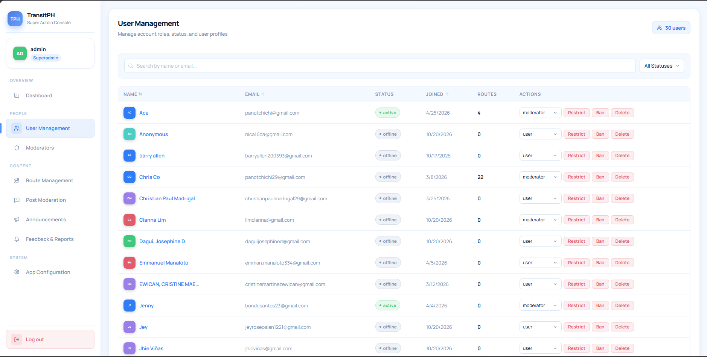Figure 3: User Management Screen
Users Count | Displays the total number of registered users.
Search Bar | Search for the specific user’s name.
Status Filter | Filters user if they are Active, Offline, Restricted, or Banned.
User Information Table | Displays the name, email, status, join date, and the number of routes contributed by the user.
Role Selection | Allows the superadmin to change the user’s assigned role, such as a User or Moderator.
Restrict Button | Allows the superadmin to restrict the user’s account.
Ban Button | Allows the superadmin to ban the user’s account.
Delete Button | Allows the superadmin to delete the user’s account.

The Moderator Management page allows the super admin to view and manage moderator accounts registered in TransitPH. It displays each moderator’s name, email, status, and routes/posts moderated.
The page also provides an action bar for reverting moderator permissions into user only if a situation occurs where it needs to be done.
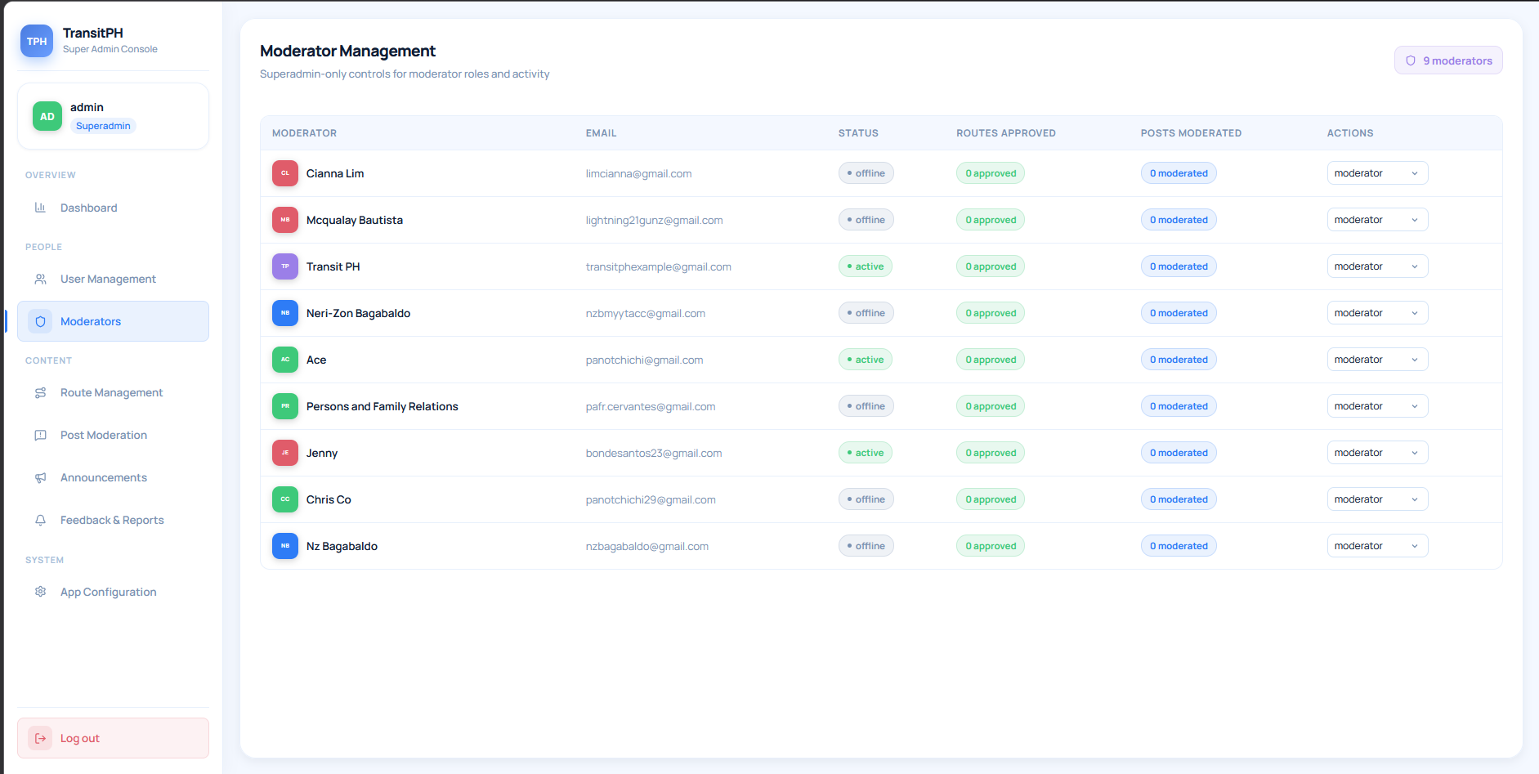
Figure 3: Moderator Management Screen

Moderator Count | Displays the total number of registered users that are moderators.
Moderators | Displays moderator name.
Email | Displays moderator’s email.
Moderator Status | Displays if the moderator is either online or offline.
Routes Approved | Shows current number of routes approved by the moderator.
Post Moderated | Shows current number of posts moderated by the moderator.
Action Button | Allows the superadmin to remove moderator permission from an account.

The Route Management page allows the super admin to view and manage public transport routes submitted by users. It displays information about each route, including its origin, destination, contributor, submission date, approval status, number of views, votes, and trust score.
The page provides a search bar for finding routes by origin or destination and a status filter for viewing routes based on their current status. The super admin can select individual routes, preview their details, and delete routes when necessary.
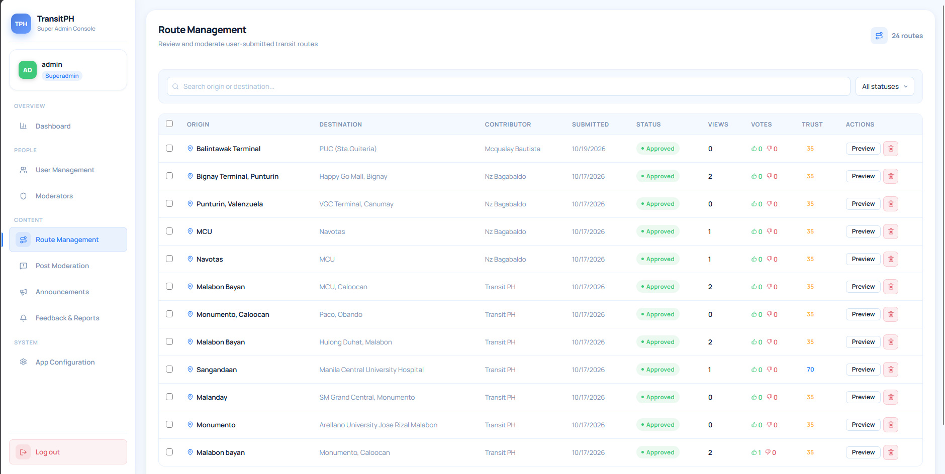
Figure 4: Route Management
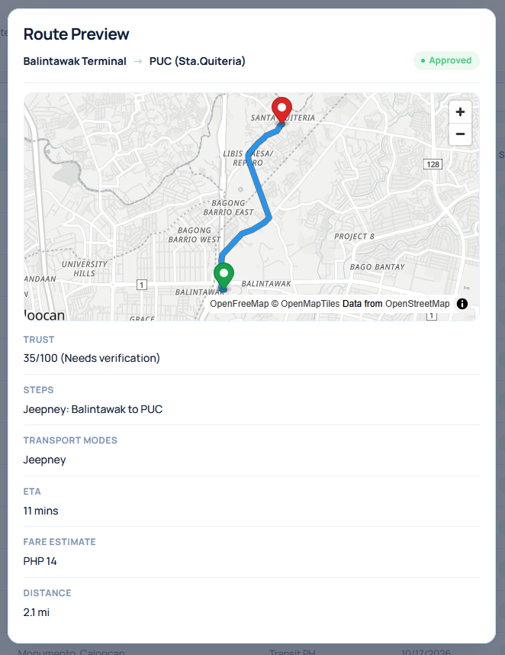
Shows the Route Preview of the contributed route by the user.
Figure 4.1: Route Preview
Route Count | Shows the total number of routes contributed to the app
Search Bar | Allows the super admin to search for routes by origin or destination.
Status Filter | Filters route according to their status e.g. Pending, Approved, or Rejected
Route Information Table | Displays the origin, destination, contributor name, submission date, status, views votes, and trust scores.
Selection Checkboxes | Allows the super admin to select multiple routes from the table.
Preview Button | Allows the super admin to preview the route that has been contributed to the app.
Delete Button | Allows the super admin to delete the contributed route.

The Post Moderation page allows the superadmin to see posts that are currently posted in the feed page of the application. It also shows reported posts that are flagged by either users or moderators.
For unflagged posts, a view button for viewing the post’s content is available, but for reported posts the superadmin can either dismiss the report or remove the posts if a rule is deemed to have been violated.
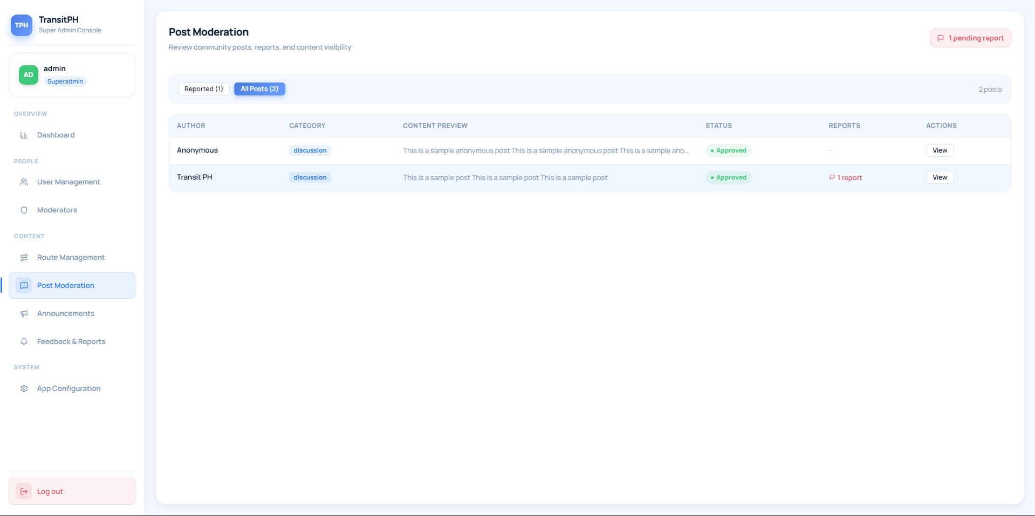Figure 5: Post Moderation (All Posts)

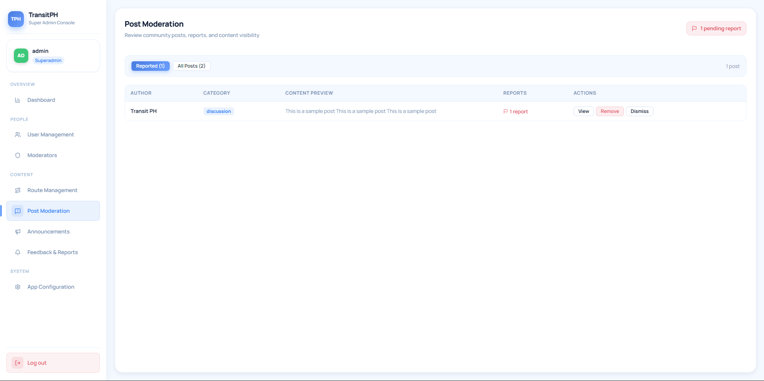Figure 5.1: Post Moderation (Reported Posts)

Author Bar | Shows the name of the user that created the post.
Category Bar | Displays the category of the user post.
Status Bar | Displays if a post is approved or rejected.
Report Bar | Displays if a report flag is currently placed in a post.
View Button | Displays the full information of the user post.
Dismiss Button | Visible only in Report Bar, allows the superadmin to dismiss the report flag in posts that are falsely reported.
Remove Button | Visible only in Report Bar, allows the superadmin to remove a post that has been flagged.

The Announcements page allows the super admin to create and manage announcements displayed to TransitPH users. It shows the title, type, intended audience, status, scheduled publication date, and expiration date of each announcement.
The super admin can create a new announcement using the New Announcement button. Existing announcements can be deactivated or deleted using the available action buttons.
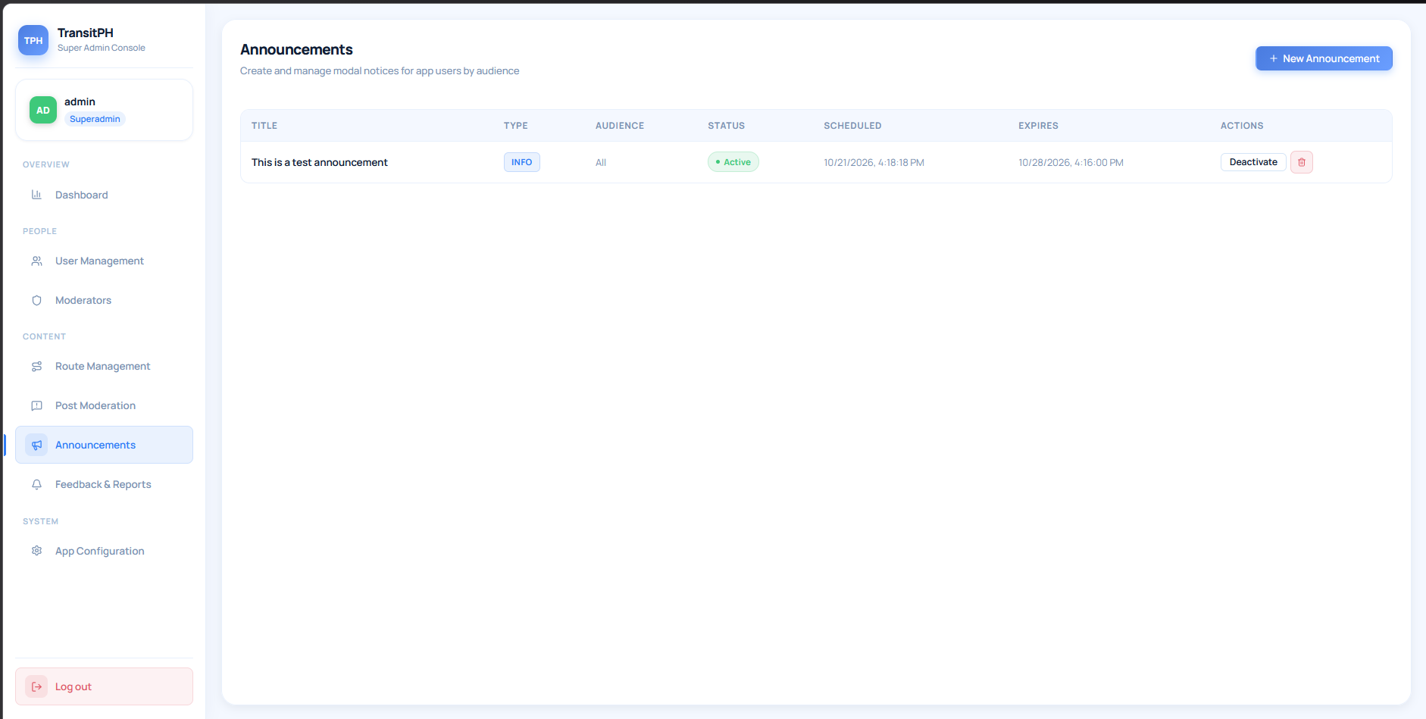Figure 6: Announcement Screen
New Announcement Button | Opens a form for creating new announcements.
Announcement Info | Displays the announcement’s title, type, target audience, status, scheduled release, and the expiration of announcement.
Activate / Deactivate Button | Activate or temporarily deactivate the announcement.
Delete Button | Deletes the published announcement.

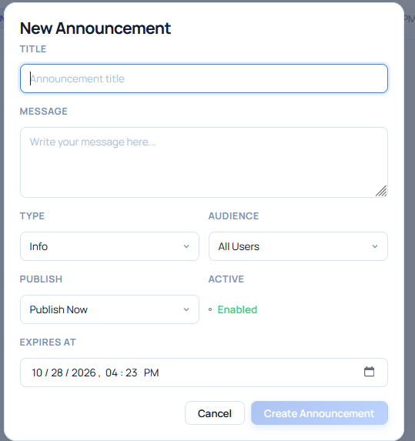
To create an announcement, the super admin clicks the New Announcement button on the Announcements page. A form appears where the super admin can enter the announcement details and configure its publication settings.
Figure 6.1: Create Announcement
Announcement Title | Enter the title of the announcement.
Announcement Message | Enter the message of the announcement
Type | Select either Info, Warning, or Critical as announcement type.
Audience | Select the target audience of the announcement based on their tags.
Publish | Select if either publish now or a scheduled announcement.
Expires At | Expiry date of the announcement.
Create  Announcement Button | Submits the form and creates the announcement
Cancel Button | Cancel the creation of the announcement.

The Feedback & Reports page allows the super admin to monitor route reports and user feedback submitted through TransitPH. The page includes a Route Reports section for displaying reports associated with routes, along with a status filter for viewing entries based on their current status.

The super admin can use the status filter to view entries according to their current status. For pending feedback, the super admin can select Resolve to mark the entry as addressed or Dismiss to dismiss it.
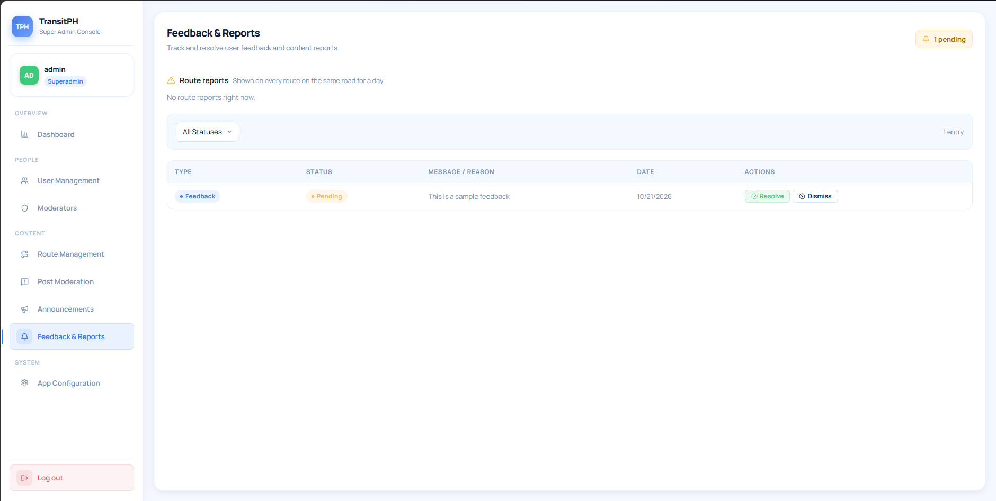Figure 7: Feedbacks and Reports
Pending Count | Shows the number of unresolved Feedbacks & Reports.
Route Reports Section | Displays route reports submitted by the user, e.g. heavy traffic congestion, road closure, etc.
Status Filter | Filter to view either Pending, Resolved, or Dismissed feedback.
Feedbacks  Information Table | Displays the type, status, message or reason, and submission date.
Resolve Button | Resolves the feedback of the user.
Dismiss Button | Dismisses the feedback of the user.

App Configuration allows superadmin to update the current version of users by pushing updates in the application itself. This makes it so that users never need to continuously download the newer apk whenever a new update is released.
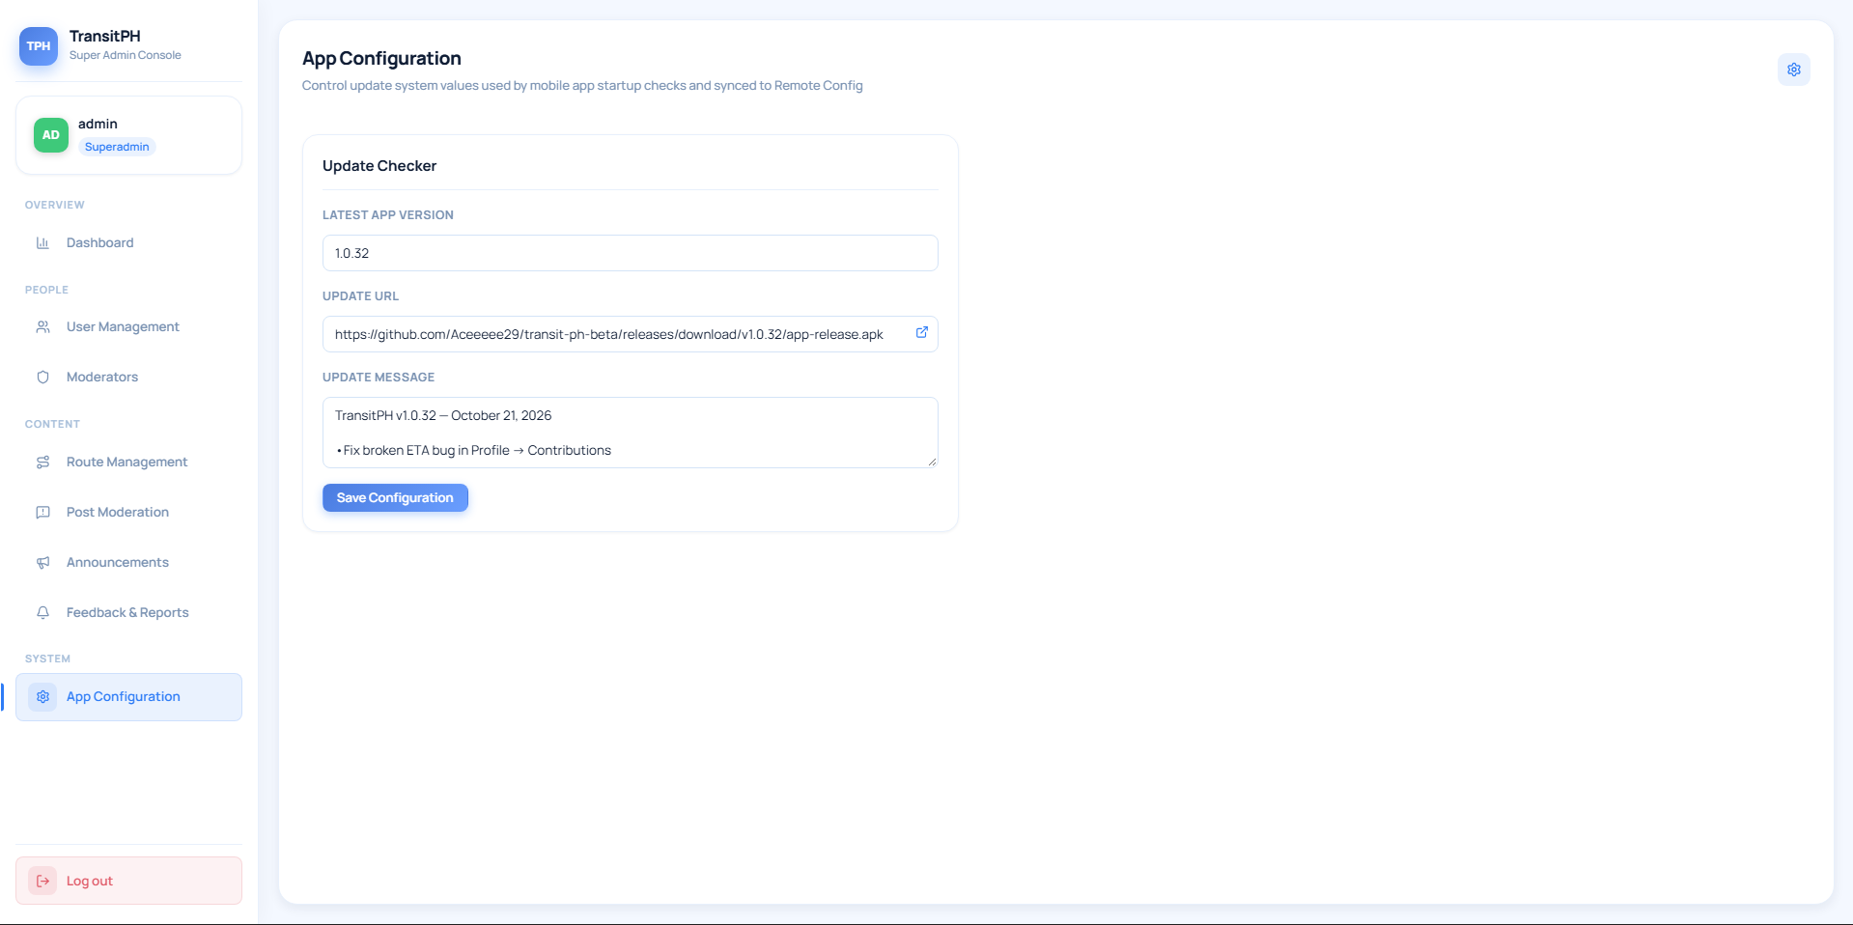 Figure 8: App Configuration
Latest App Version | Enter the app version to be released.
Update URL | Enter the URL for the application link to be released.
Update Message | Sends an update log dialogue box of all new implementations and/or fixes for users.
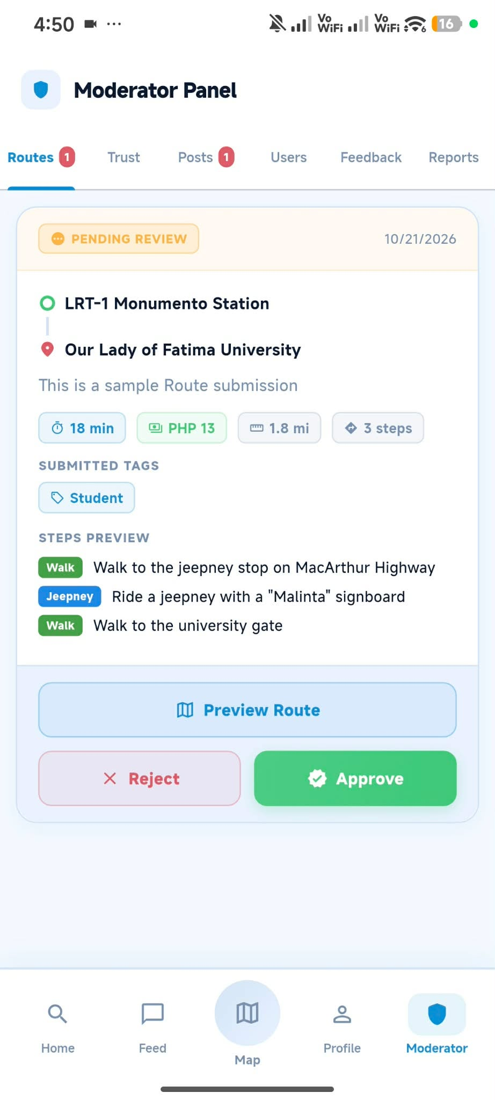
The Routes tab in the Moderator Panel allows moderators to review user-submitted public transport routes before they are added to the app's available route information. Each submission displays its review status, submission date, origin, destination, route description, estimated travel time, fare, distance, number of steps, and submitted tags.
Moderators can review the route details and preview the route before deciding whether to approve or reject the submission.
APPENDIX E. CURRICULUM VITAE OF RESEARCHERS
Curriculum Vitae of
NERI-ZON M. BAGABALDO
Lt. 8&10 Blk. 8 Green Meadows Sbdv., Punturin, Valenzuela City
nzmbagabaldo@gmail.com
09917976855

EDUCATIONAL BACKGROUND
Level | Inclusive Dates | Name of school/ Institution
Tertiary | 2023-Present | STI College Caloocan
TechVoc | 2020-2023 | Punturin National High School
High School | 2017-2020 | Charis Christian School
Elementary | 2010-2017 | Charis Christian School

SKILLS
SKILLS | Level of Competency | Date Acquired
C# Programming | Beginner | 2024
Java Programming | Intermediate | 2023
Python Programming | Beginner | 2024

Curriculum Vitae of
JENNY BONDE
772 Taganahan St. Bagumbayan South, Navotas City
Bondesantos23@gmail.com
09663104853

EDUCATIONAL BACKGROUND
Level | Inclusive Dates | Name of school/ Institution
Tertiary | 2023-Present | STI College Caloocan
TechVoc | 2019-2022 | Ligao National High School
High School | 2016-2019 | Ligao National High School
Elementary | 2009-2016 | Binanowan Elementary School

SKILLS
SKILLS | Level of Competency | Date Acquired
C# Programming | Beginner | 2024
Java Programming | Intermediate | 2023
Python Programming | Beginner | 2024

Curriculum Vitae of
CHRISTIAN PAUL C. MADRIGAL
131 Galicia Street Panghulo, Obando, Bulacan
christianpaulmadrigal29@gmail.com
09152291833

EDUCATIONAL BACKGROUND
Level | Inclusive Dates | Name of school/ Institution
Tertiary | 2023-Present | STI College Caloocan
TechVoc | 2020-2023 | Arellano University Jose Rizal Campus
High School | 2017-2020 | Panghulo National High School
Elementary | 2010-2017 | Panghulo Elementary School - Main

SKILLS
SKILLS | Level of Competency | Date Acquired
Java Programming | Intermediate | 2024
C# Programming | Beginner | 2024
Flutter Programming | Beginner | 2025

TRAININGS, SEMINARS OR WORKSHOP ATTENDED
Inclusive Dates | Title of Training, Seminar or Workshop
2018 | Robotics Training – University of the East – Caloocan

