Amarilda Celhaka

Assignment: Database Design

4/13/2019

Problem #1

**Customers.CustomerID** is primary key

**Orders.OrdersID** is primary key

**Orders.CustomerID** is foreign key (related with Customers table)

OrderLineItems table uses composite key that uniquely identifies each rows, **OrderID** and **OrderSequence**. This can be avoided by using only a single column as index key eg using OrderLineItemID as a primary key to identify each row and dropping the OrderSequence/

**Products.ProductID** is primary key.

The relationship between databases is **many-to-many** which is indicated by the round connector(indicates the one side of the relationship) and the triangular connector (indicates the many side of the relationship)

Problem #1 & #2

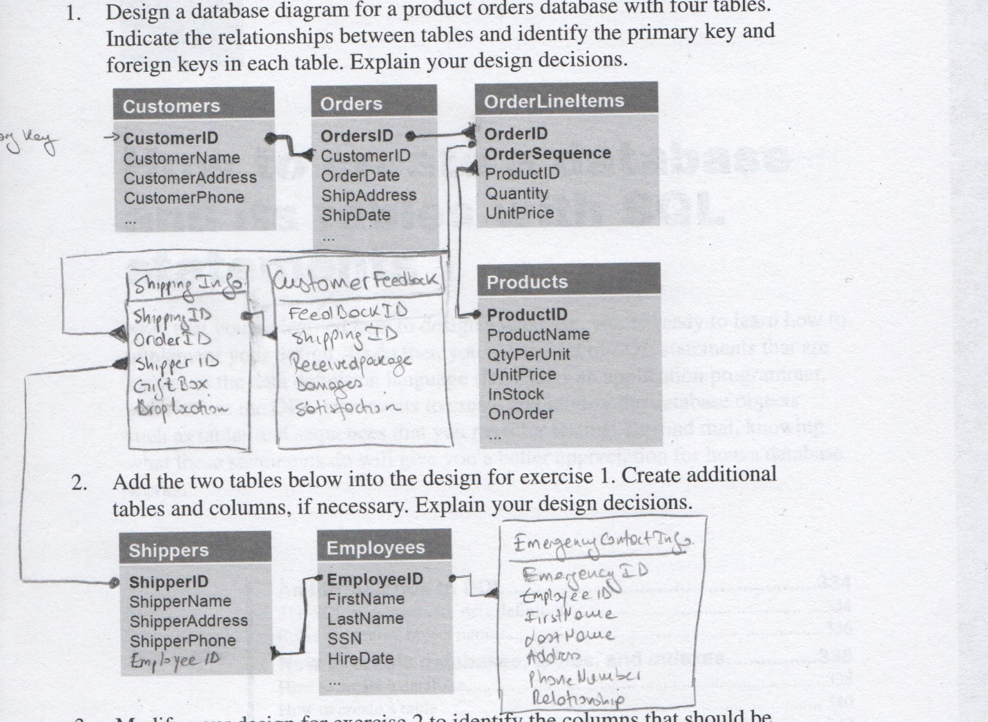

I created 3 more tables:

**ShippingInfo** that contains information about the shipping (included a gift box, gift message, dropLocation …), with primary key ShippingID and foreign key ShipperID.

**CustomerFeedback** table will be a table to keep information about customerFeedback (overall satisfaction, arrived on time or not, damages, if never received ….), has a primary key FeedbackID and foreign key ShippingID.

Last table is the **EmergencyContactInfo** is a table that will provide the employee emergency contact information with columns such as EmergencyID (primary key) EmployeeID (foreign key) , relationship of the employee with the person, and all the information about the person (name, phone number, email, address …)