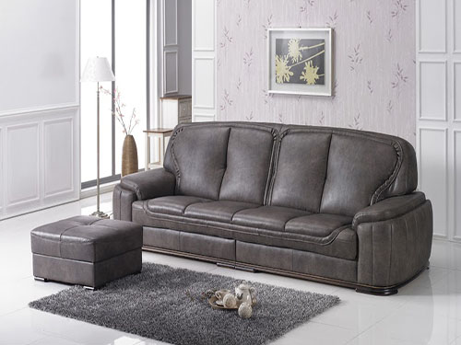

Size: 2m-W x 1m-H

Color: Grey

Amount: 10

Price : 500$

Type: Sofa

Description: When you purchase a sofa, you want the most comfortable one you can find for your money. A comfortable sofa allows you to spend many hours relaxing with your family. Look for a sofa that suits your lifestyle as well as your interior décor. Pick a sofa appropriately sized for your living space, so you can enjoy its comfort without bumping into bulky seating as you pass by.