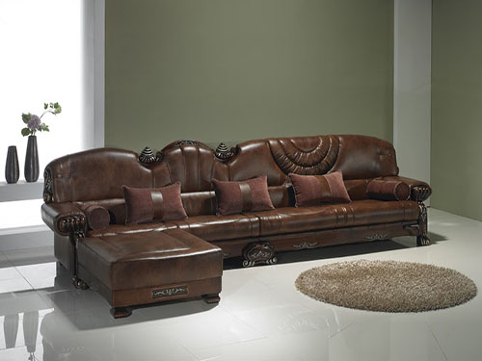

Size: 2m-W x 70m-H

Color: Brown

Material: Microfiber

Amount: 20

Price : 540$

Type: Sofa

Description: Home Style. Our Grove Park dual reclining sofa captures all the feelings of home. From the extra-cozy microfiber to plush seating and pillowtop arms, you'll want to settle right in! Dacron-wrapped cushions give a full look and feel, and full chaise pad recliners offer addictive head-to-toe comfort. The mocha color creates a warm atmosphere, and accent stitching adds visual interest to the familiar, casual style.