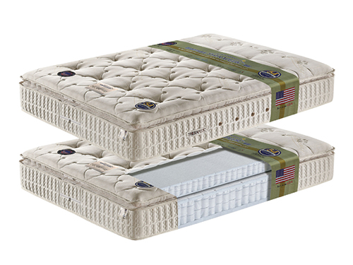Size: 2m-W x 30cm-H

Color: White

Material: Stretch Knit

Amount: 20

Price : 120$

Type: Matteress

Description: Restful Reverie. Combining superior craftsmanship, current bedding advancements, and a classic look, our Stearns & Foster Amy Luxury Plush Euro Pillowtop collection redefines consummately comfortable and supremely satisfying sleep. Each mattress blends high-quality materials with deep-down comfort and support. The exclusive Indulge Quilt™ combines deluxe fibers with tension-relieving foams and the Euro pillowtop supplies that extra cushion to cradle your body in indulgent comfort.