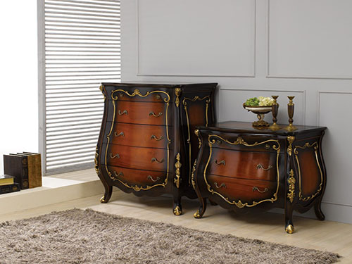

Size: 75cm-W x 80cm-H

Color: Brown & black

Material: Poplar Solids and Cherry Veneers

Amount: 15

Price : 600$

Type: Small Cabinet

Description: Slatted Style. The simple, sturdy vertical lines of our Arts & Crafts nightstand speak to the motifs of the design movement of the same name. The closely spaced slats in the door front and the mortise and tenon accents on the front corners bring to mind the related mission-furniture style and work with the chocolate-finished mersawa veneers for a rich, contemporary look. Burnished metal, ring-shaped drawer and door pulls add a rustic finishing touch to this versatile piece.