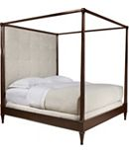

Size: 175cm-W x 190cm-H

Color: White and brown

Material: Wood

Amount: 16

Price : 200$

Type: Bed

Description: Stylishly Aligned. Strong European inspiration combines with design-savvy touches in our Bally White II Queen wall bed, making your fashionable taste unmistakably known. The crisp white finish creates a cool, fresh feeling, while the opaque glass tops on the LED-lit pier nightstands add a sense of polished style. Peek-through cutouts and brushed nickel hardware round out this chic bed.