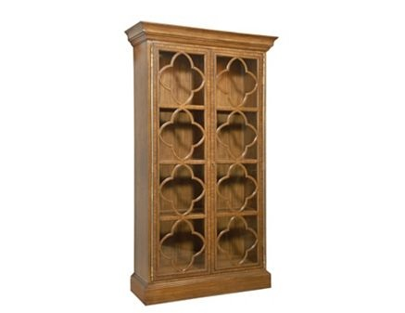

Size: 75cm-W x 130cm-H

Color: Gold & Yellow

Material: Poplar Solids

Amount: 20

Price : 200$

Type: Small cabinet

Description: Curved Concept. Your eye will delight in the beautiful veneers and curved lines of our Vanderbilt media chest. With just a hint of art deco style, this piece boasts a subtly S-curved front frame and luscious, diagonally set Prima Vera veneers. The ample storage compartments with rear wire management openings are ideal for media components. Sleek, burnished metal drawer pulls and a warm brown cherry finish give this cultured piece the perfect finishing touch.