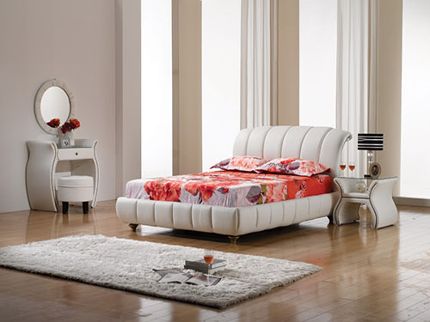

Size: 2m-W x 50cm-H

Color: White

Material: Microfiber

Amount: 5

Price : 344$

Type: Bed

Description: Stylishly Aligned. Strong European inspiration combines with design-savvy touches in our Bally White II Queen wall bed, making your fashionable taste unmistakably known. The crisp white finish creates a cool, fresh feeling, while the opaque glass tops on the LED-lit pier nightstands add a sense of polished style. Peek-through cutouts and brushed nickel hardware round out this chic bed.