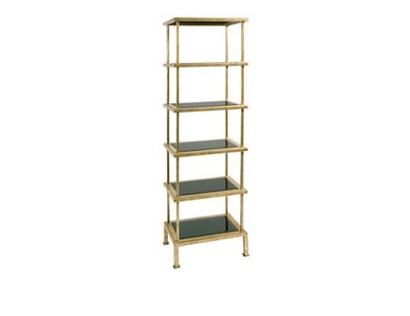

Size: 50cm-W x 100cm-H

Color: Black & Yellow

Material: Poplar Solids

Amount: 13

Price : 200$

Type: Bookcase

Description: Curved Concept. Your eye will delight in the beautiful veneers and curved lines of our Vanderbilt media chest. With just a hint of art deco style, this piece boasts a subtly S-curved front frame and luscious, diagonally set Prima Vera veneers. The ample storage compartments with rear wire management openings are ideal for media components. Sleek, burnished metal drawer pulls and a warm brown cherry finish give this cultured piece the perfect finishing touch.