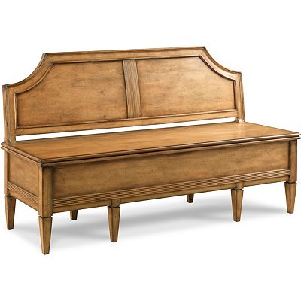

Size: 125cm-W x 50cm-H

Color: Brown

Material: Wood

Amount: 26

Price : 180$

Type: Bench

Description: Style Authority. Get taken away by the casual yet compelling beauty of our Keystone side chair! It's as ready for a place in an open-concept kitchen as it is in a dining nook. The Parsons-style design provides the practicality of full back support as well as easy-clean faux leather in a deep brown finish. Espresso-toned wood legs and supports keep the look perfectly grounded.