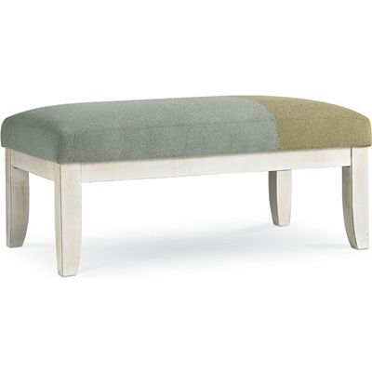

Size: 100cm-W x 40cm-H

Color: White

Material: Wood

Amount: 20

Price : 100$

Type: Chair

Description:Style Authority. Get taken away by the casual yet compelling beauty of our Keystone table! It's as ready for a place in an open-concept kitchen as it is in a dining nook. The genuine stone veneers of the tabletop pair wonderfully with the espresso-finished wood, creating an arresting style that catches the eye.